MAKING HEALTHY CAMPUS BY TREATING OPEN SPACE

ABSTRACT
This paper examines the architectural and landscape design strategies for open spaces facilities targeting stress reduction for learning environments of university campuses in a compact urban areas. Literature reviews provide three prevailing perspectives for physical design techniques and operations- healing gardens where greenery and plants produce restorative effects, flexible spaces that accommodate functional needs of different activities, and green buildings that incorporate open space as a catalyst for integrated ecosystem. Corresponding design approaches (landscape design, spatial design and green design) . A comparison of two university campuses with different urban contexts is conducted to identify challenges and opportunities for applying these design approaches. For a compact campus, high-dense surroundings may limit the size of an open space and may ruins the circulation and accessibility. on the other side, a small open space may provide its users more intimate contact with natural restorative elements and also a more controllable microclimate for physical comfort. A healthy campus should encompass diverse open spaces to satisfy different purposes.In this research Finally, a framework that integrates the three approaches will combined to produce a proper design.
KEYWORDS- Healthy campus,Open space,Healing gardens,Green building.

INTRODUCTION
Universities are the generator of ideas and creative thinking by connecting the unique and active researchers with the large source of knowledge. But most of the students are affected to high levels of stress in their student life. Surveys continously showing an increasing number of university students who are experiencing stress due to interpersonal conflicts, self esteem problems, financial issues , time management, frustration and emotional family problems. As a result it is heading towards an imbalance between environmental demands and human response capabilities has been disturbing physical ill health .The stressful university life also affects student's academic performance . In this sense, design of campus is far beyond providing a place for study. It should also be healing ,serving functional as well as mental needs. Open spaces located between buildings and working as joints of surrounding environments, provide a sense of direction in a campus by integrating and organizing different places and elements; they also can provide an esthetic sense by involving attractive surroundings and creating visual surprises. Many creative and innovative ideas occur in outdoor environments, away from formal classes and discussions. The natural scenery and a relaxing atmosphere in open spaces encourage meetings and discussions, and provide fresh air for stressed scholars .On the other end , a large number of university campuses in the world have taken the lead in a green or sustainable building revolution. In green building assessment tools such as Leadership in Energy and Environmental Design (LEED), open spaces as the sphere for micro-ecology and sustainable environments are believed to lead to a healthy community where plants, natural habitats, pavements, shades and lights jointly create an eco-system and microclimate in addition to supplying comfort and sustenance for users . The dual role for social interaction and environmental enhancement—mutually reinforcing one another, features an open space in healthy campus life. How to design open spaces to alleviate students' stress and to promote healthy campus life? To answer this question, this paper conducts a literature review to identify in what way an open space may influence human stress.
What is open space between buildings in a campus?
Open spaces between buildings in a campus typically refer to the areas of land that are not covered by buildings or other structures. These areas can include lawns, gardens, walkways, plazas, or other open spaces that are designed to provide outdoor space for students, faculty, and visitors to gather, relax, and interact.The purpose of these open spaces is to create a welcoming and inviting atmosphere on the campus, as well as to promote socialization, physical activity, and a sense of community. They can also serve as important spaces for events such as concerts, outdoor lectures, or sports activities.In addition to their social and cultural significance, open spaces between buildings in a campus can also have environmental benefits. They can help to reduce the heat island effect by absorbing heat and providing shade, as well as support biodiversity by providing habitats for plants and animals.Overall, open spaces between buildings in a campus play an important role in enhancing the quality of life for those who live, work, and study on the campus, as well as contributing to the sustainability and overall aesthetic appeal of the campus.

TYPES OF CAMPUS OPEN SPACES
Open spaces in a campus can serve a variety of purposes, including recreation, socializing, and studying. Some common types of open spaces that can be found on a campus include:

QUAD OR PLAZA: A central open space on a campus that may include a large lawn area, benches, trees, and often surrounded by buildings.

COURTYARD: An open space that is surrounded by buildings and typically features benches, tables, or other seating areas for students to gather and socialize.

ATHLETIC FIELDS: Fields that are used for sports like football, soccer, baseball, and track and field.

AMPHITHEATRE: An outdoor space with tiered seating, often used for performances or lectures.

PARKS: Open spaces that offer a natural setting for walking, jogging, picnicking, or relaxing.

GARDENS: Open spaces that may feature various plants, flowers, and trees and serve as a peaceful area for studying, relaxation or for educational purposes.

OUTDOOR DINING ARES: Spaces that provide seating for students to eat and socialize outside, often with access to food trucks or mobile kitchens.

BIKE PATH: Open spaces that are designated for biking, which can be an efficient and environmentally friendly way for students to move around campus.

MEDITATION AND REFLECTION AREA: Spaces that offer a quiet and peaceful setting for reflection, prayer, or meditation.

Overall, open spaces on a campus can help create a sense of community and offer students and faculty a place to relax, socialize, or enjoy the natural environment

CASE STUDY

Karadeniz Technical University campus,
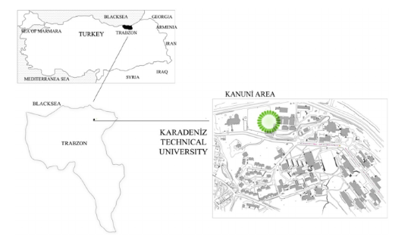

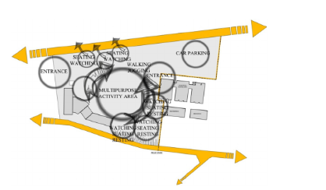
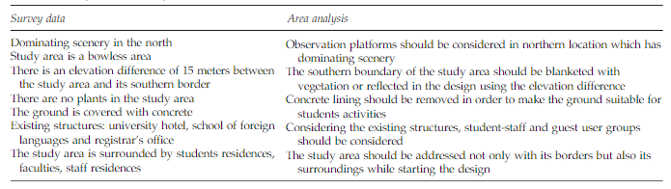
CONCLUSION OF CASE STUDY
Discussion and Conclusion
The design study of Kanuni Park was carried out due to the lack of social and cultural activity spaces allowing for various activities and different uses for the uses of open spaces in Karadeniz
Technical University campus, and the Program- ming-Design- Construction -Occupancy and Post- Occupancy Evaluation processes were evaluated. Within the scope of this study, activity lists were prepared in line with the needs and requirements of the student-staff and guests, and spaces, where these activities could be performed, were designed. Finally, the post-occupancy evaluation process, which is the evaluation received from users during and after occupancy stages of the designed spaces, was completed, and re-programming data were obtained.

LANDSCAPE
Restorative design elements include retreat, fascination, and exposure to nature. Certain types of settings such as religious sanctuaries, hospitals and other therapeutic facilities are explicitly designed with restorative intent. Such settings may uplift the human spirit and promote healing.

1. LAWNS- If possible, a lawn area should be maintained or grown. The sight of lush green is largely welcomed by people. Lawn areas provide a large amount of green and create a playing surface for users of all ages. In addition, the fresh fragrance from newly mown or watered grass is quite charming

2. TREES- Trees that are already large or will be large at maturity should be planted. People respond positively to large trees. The striking appearance of trees can easily become the leading attraction of a site and the shade from large canopies is the most welcomed feature outdoor. They are natural habitats for birds and other small animals. Trees are the dispensable elements in most of the spiritual symbolic gardens in campus.

3. COLOUR FULL PLANTS -Implementing color variation in planting, especially flowers, is another approach to attract people. People enjoy viewing and being in the presence of color and flowers. Research has found that scenery with flowers is very effective in emotion mitigation and reducing feelings of “discourage”.

4.DENSE PLANTING- An area can be densely planted with a variety of trees, shrubs and flowers. A densely planted area provides much more visual interest than a sparsely or mono-planted one. Plants are a source of beauty, shade and color. Without these diverse plants, the area would always be regarded as boring and bare.
SPATIAL DESIGN
COURTYARD-A courtyard that is a form of open space surrounded by buildings can produce natural stimulation via offering scenery and views for surrounding buildings. Window views can effectively facilitate restoration for indoor users. Moreover, visual connection with open spaces would lead to active use of open spaces. Many building users may be lured outside by the awareness of an open space and visit it spontaneously. Visual accessibility to greenery along one's path will increase the usage of those areas.
CIRCULATION- An open space connects different areas of a campus by an axial street, which may form a strong spatial structure in a campus. However, circulation space provides far more than transportation. Well planned circulation can control over stimulation through minimizing exposure to noisiness and congestion.
PRIVATE SPACES-Private spaces are an important consideration in design, as they can provide a sense of security, comfort, and relaxation. Creating private areas within a larger space can help individuals feel more at ease and in control of their environment. This can be achieved through the use of partitions, screens, or furniture arrangements that define separate areas for different activities or purposes.
GREEN DESIGN
An open space can be perceived as an ecosystem, which offers habitats, sustains creatures, harvest rainwater and forms its own microclimate. Covered by greenery, open space provides an urban “natural refuge” for insects, small animals and people. It is an important habitat for native plants and animals and helps preserve local biodiversity
ASSESSMENT- The general case studies on different campuses can provide many good examples. However, they may not consider specific campus conditions and open space accessibility. This section conducts an assessment of abovementioned design elements in two university campuses with different urban contexts.
CONCLUSION
The essential concept of healthy design, which is used originally in hospitals to accelerate patients' recovery, has been applied to open spaces design, in which natural features assist users in relaxing and restoring their minds from stress. Combined with ideas to healing gardens, architectural stimulation, and green building approaches, this paper studies exemplary cases of contemporary campus design with an aim to provide campus open space design guidelines. The guidelines could be incorporated into landscape design, spatial design and green design practice. Landscape design is looking at creating natural environments and sensational connections for restoration; spatial design is looking at arranging easily accessed spaces to provide good sense of orientation and order for different activities; and green design is looking at building an eco-system inclusive of sustainability features as well as physical comfort.

Framework for healthy campus open space design

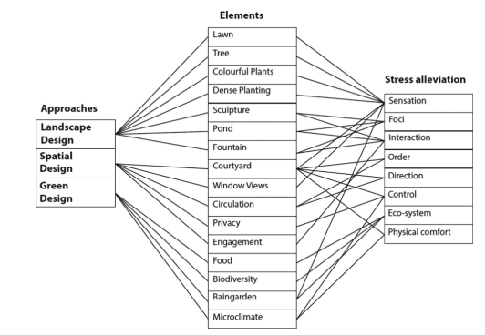
The design guidelines and case studies modify the qualitative evaluation of people's well-being to a quantitative estimation through methods of landscape design, spatial design and green design.

