IOT BASED HEALTH MONITORING
SYSTEM FOR SMART HOSPITAL
MANAGEMENT

Mrs M Radha .,M.E., (Ph.D)., Saran N, Suresh K,
Assistant Professor Department of ECE, Department of ECE,
Department of ECE, Francis Xavier Engineering College, Francis Xavier Engineering College,
Francis Xavier Engineering College, Tirunelveli, India Tirunelveli, India
Tirunelveli, India

Pon Arasu K, Naveen Babu,
Department of ECE, Department of ECE ,
Francis Xavier Engineering College, Francis Xavier Engineering College,
Tirunelveli, India Tirunelveli, India

Abstract – During pandemic situation monitoring patient’s body conditions like monitoring temperature, pulse rate and oxygen level etc. it becomes very tough to doctor’s. To avoid that difficulties we implemented this technique which can monitor, manage and maintain the patient using our technique. The main theme of our paper is that we are monitoring pulse-rate, oxygen level and temperature of the user by using following sensors. Health is always a major concern in every growth the human race is advancing in terms of technology. So using our project application we can automatically calculate and notice changes in patient’s health conditions. Once it is released, the whole system pauses with respect to the health of the patient and the ill person in the remote environment. It will automatically monitor the health and the various health parameter of the patient by a regular interval of the time. If any irregular activities or imbalance in the actual parameter of the patient it automatically alert the doctors and the hospital authority. It also suggest the needy medicine for the immediate reflex action to save the patient life. It will be upload all the data about patient’s condition to cloud and alerts patients and doctor through SMS. Here the application can assist the patients by showing the proper prescription. So the overall idea of our project is very helpful for the people to monitor their health during the pandemic and emergency situation.

Keywords: Arduino UNO, ECG sensor, Temperature sensor, pulse Oximeter sensor, Node MCU (Wi-Fi Module)

- INTRODUCTION

Health is always a major concern in every growth the human race is advancing in terms of technology. Like the recent corona virus attack that has ruined the economy of China to an extent is an example how health care has become of major importance. Technology plays the foremost role in healthcare not only for sensory devices but also in communication and recording. It is vital to observe varied medical parameters and post operational days. So the most recent development in healthcare communication methodology, IoT is customized. IoT is a catalyst for the healthcare and plays distinguished role in many applications.
The core objective of this project is the design and implementation of a smart patient health tracking system that uses Sensors to track patient health and uses internet to inform their loved ones in case of any issues. The objective of developing monitoring systems is to reduce health care costs by reducing physician office visits, hospitalizations, and diagnostic testing procedure. Each of our bodies utilizes temperature and also pulse acknowledging to peruse understanding wellbeing. IoT based patient health monitoring system is a generic term given to any medical equipment that has internet capability and can measure one or more health data of a patient who is connected to the device such as heartbeat, body temperature, blood pressure, ECG, steps etc. The equipment can record, transmit and alert if there is any abrupt change in the patient’s health.

II. LITERATURE SURVEY

- Hassan Harb et al [2021] IEEE, A Sensor-Based Data Analytics for Patient Monitoring in Connected Healthcare Applications. Energy-efﬁcient data analytics mechanism for a real-time patient monitoring and assessment. To detect this repeated collision and introduce a phase shift between the two transmission sequences in order to avoid.
- Lizheng Liu et al [2020] IEEE, A Smart Dental Health-IoT Platform Based on Intelligent Hardware, Deep Learning, and Mobile Terminal. An Home smart dental Health-IoT system based on intelligent hardware, deep learning and mobile terminal. Drawbacks : High hardware design and the eﬃciency of image acquisition device.

- Justinas Miseikis et al [2020] IEEE, Lio-A Personal Robot Assistant for Human-Robot Interaction and Care Applications. In a mobile robot platform with multifunctional arm explicitly designed for human robot interaction and personal care assistant task. Drawbacks : The identification of the issues and to increases the level of autonomy is difficult. framework for senior consideration. This presents a senior consideration robot framework for senior individuals. A senior consideration robot framework give human robot communication application and checking administration. The ZigBee innovation is utilized for this biomedical checking.

- P.Shubha, M.Meenakshi, 2019[1] , implemented health care Assistive Robot , which mainly focuses on the design & development of the assistive robot for the disabled and for the patients in need.

- Mohammad Farag, Mohammad Hayyan Alsibai, 2019[2] proposed Getting a handle on and situating task for particular consistent an Articulated Robotic ARM is utilized for object discovery and restriction, vision guide robot has greater capacity, usefulness and adaptivity in mechanical sequential construction systems than ordinary robots.

- Uthman Baroudi [2017] IEEE, Robot-Assist Ed Maintenance of Wireless Sensor Networks Using Wireless Energy Tran. In this paper, we presented a robot-assisted energy maintenance framework using wireless energy transfer for WSNs. Drawbacks: Increasing maintenance costs and operational complexity.

- Victor Ababii, Viorica Sudacevschi, 2014[7], proposed the sensor network configuration dependent on the portable multi robot framework. Framework geography is a disseminated figuring engineering comprises of Local Area Network (LAN), with Wireless Access focuses (WAP), a bunch of expert versatile robots with entryway highlights.

- Ali Ravari, Ahmad Fakharian, 2013[8], proposed about the way following and Obstacle aversion of a FPGA based versatile Robot by means of fluffy calculation, this fluffy calculation is executed on the FGPA based portable Robot called MRTQ, which could be viewed as installed for line following and Obstacle evasion reason.

- Cheonshu Park, Sangseung Kang, 2012[9], examined about the assistance robot framework for senior consideration. This presents a senior consideration robot framework for senior individuals.
- A senior consideration robot framework give human robot communication application and checking administration.

- METHODOLOGY

IoT based health monitoring systems for smart hospital management typically involve the use of sensors and devices connected to the internet to collect and transmit patient data to a central system for monitoring and analysis. The data is then used to track vital signs, monitor disease progression, and make treatment decisions. The methodology typically involves the following steps: Sensor deployment: Sensors are placed on patients and in hospital rooms to collect data on vital signs, such as heart rate, blood pressure, and oxygen levels. Data collection: The sensor data is transmitted to a central system for storage and analysis.

BLOCK DIAGRAM

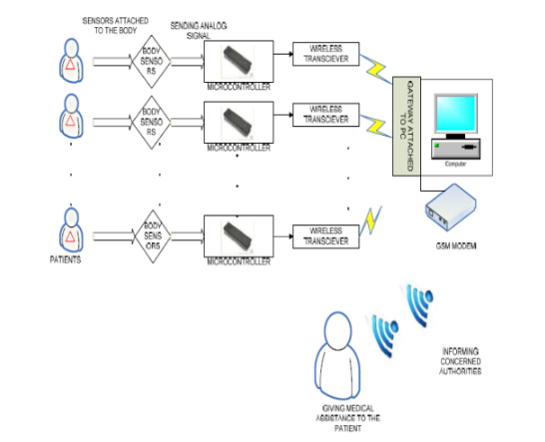

- EXIXTING SYSTEM

In the existing system we use active network technology to network various sensors to a single PMS. Patients various critical parameters are continuously monitored via single PMS and reported to the Doctors or Nurses in attendance for timely response in case of critical situations. The sensors are attached to the body of the patients without causing any discomfort to them. In this PMS we monitor the important physical parameters like body temperature, ECG, heart beat rate and blood pressure using the sensors which are readily available. Thus the
analog values that are sensed by the different sensors are then given to a microcontroller attached to it. The microcontroller processes these analog signal values of health parameters separately and converts it to digital values using ADC converter. Now, the digitalized values from more than one microcontroller are sent to the central PMS. Each of the sensors attached microcontroller with a transceiver will act as a module which has its own unique ID. PC of the Central PMS. The gateway is attached to the PC i.e. Central PMS which is situated in the medical center, is capable for selecting different patient IDs and allowing the gateway to receive different physical parameter values the patient specified by the ID. The software designed using Graphical User Interface (GUI) can operate on different physical parameters of each patient, consecutively with a specified time interval for each patient.

IV.PROPOSED SOLUTION

The main objective is to design a Patient Monitoring System (PMS) with two-way communication i.e. not only the patient’s data will be sent to the doctor through SMS and email on emergencies, but also the doctor can send some suggestions to the patient or guardians through SMS or Call or Emails. And Patient or guardian can able to track patient’s location at any point in time through Google Map which would enable to send medical services in case of an emergency for non-bed ridden patients.

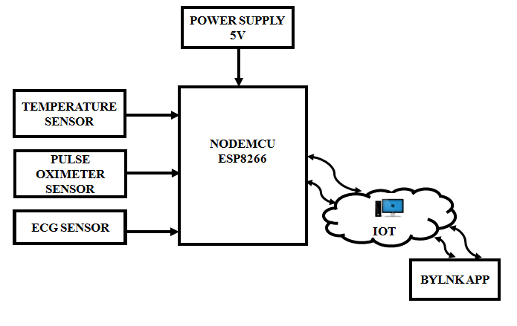
This project proposes a IOT based smart health monitoring system for heart patients. IoT Based ECG and Heart rate Monitoring, We will learn how to monitor Heart and ECG rates with AD8232 ECG Sensor and ESP8266(nodemcu). The sensors and Wi-Fi module are used for patient’s health care monitoring. The smart sensors such as temperature sensor, pulse sensor, and proximity sensor are used for measure the physical quantities like temperature, pressure, pulse etc. The ECG Sensor is used to monitor the ECG signal. This sensor is a cost-effective board used to measure the electrical activity of the heart. This electrical activity can be charted as an ECG or Electrocardiogram and output as an analog reading. ECGs can be extremely noisy, the AD8232 Single Lead Heart Rate Monitor acts as an op-amp to help obtain a clear signal from the PR and QT Intervals easily. Then, by connecting ECG leads to the chest or hand, we will generate an ECG signal.

To develop a IOT based Wireless Health Monitoring system. To develop health monitoring system i.e. it measures body temperature rate and Heartbeat rate. To sense the heart signal that is the ECG signal using the ECG sensor and monitor it using the Blynk App in a Smartphone. To design a system to store the patient data over a period of time using database management in IoT.

V.HARDWARE REQUIREMENT

A. Arduino UNO
The Arduino UNO is a microcontroller board based on the ATmega328P. It has 14 digital input/output pins, 6 analog inputs, a 16 MHz quartz crystal, a USB connection, a power jack, an ICSP header, and a reset button. The board is programmed using the Arduino software (IDE) and can be used to control a variety of devices and sensors. It is commonly used in projects such as robotics, home automation, and internet of things (IoT) applications.
The Arduino UNO is the board to get started with electronics and coding. If this is your first experience tinkering with the platform, the UNO is the most robust board you can start playing with. The UNO is the most used and documented board of the whole Arduino famil. The Arduino Uno is an open-source microcontroller board based on the Microchip ATmega328P microcontroller and developed by Arduino.cc and initially released in 2010.

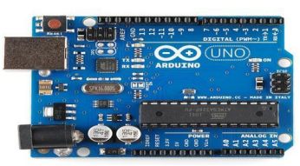

B.Atmega328P
ATmega328P is a high performance yet low power consumption 8-bit AVR microcontroller that's able to achieve the most single clock cycle execution of 131 powerful instructions thanks to its advanced RISC architecture. It can commonly be found as a processor in Arduino boards such as Arduino Fio and Arduino Uno
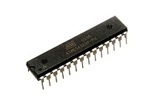
C.Pulse Oximeter
A pulse oximeter is Medical device that indirectly monitors the oxygen saturation of a patient blood (as opposed to measuring oxygen saturation directly through a blood sample) and changes in blood volume in the skin, producing that may be further processed into other measurement. The pulse oximeter may be incorporated into a multiparameter patient monitor. Most monitors also display the pulse rate. Portable, battery-operated pulse oximeters are also available for transport or home blood-oxygen monitoring.

A pulse oximeter sensor is a device that non-invasively measures the oxygen saturation of a person's blood. It uses infrared light to detect the oxygen saturation, or the amount of oxygen bound to hemoglobin in the blood. The sensor is typically placed on a finger or earlobe and can be used to monitor oxygen levels in people with chronic respiratory conditions, such as asthma and COPD, as well as in patients recovering from surgery.
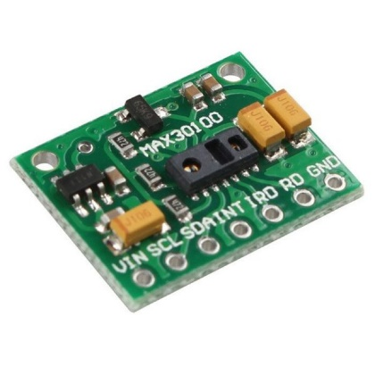
D. Node MCU (Wi-fi-Module)
NodeMCU allows developers to use the Lua programming language to interact with the ESP8266's GPIOs, and it also includes support for a variety of external libraries, such as the DHT11 sensor and the DS18B20 temperature sensor. The NodeMCU development board includes a USB-to-Serial converter, which makes it easy to program and communicate with the ESP8266. NodeMCU is commonly used in Internet of Things (IoT) applications such as home automation, smart devices, and wearable technology.

Node MCU is an open-source LUA based firmware developed for the ESP8266 wi-fi chip. By exploring functionality with the ESP8266 chip, Node MCU firmware comes with the ESP8266 Development board/kit that Node MCU Development
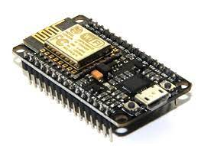

E.ECG Sensor

An electrocardiogram (ECG) is a simple test that can be used to check your heart's rhythm and electrical activity. Sensors attached to the skin are used to detect the electrical signals produced by your heart each time it beats.
An ECG sensor, also known as an electrocardiogram sensor, is a device that is used to measure the electrical activity of the heart. It is typically composed of multiple electrodes that are placed on the skin of the chest, arms, and legs. These electrodes pick up the tiny electrical signals that are generated by the heart muscle as it contracts and relaxes, and they transmit this information to a machine that records the electrical activity and generates a visual representation of it, called an ECG trace or an electrocardiogram. ECG sensors are commonly used in medical settings to diagnose and monitor heart conditions, but they can also be used in research and fitness or wellness related projects.

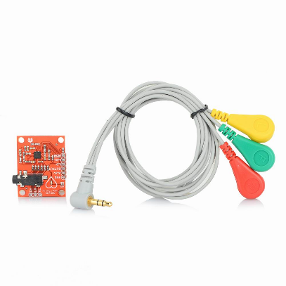

F.DHT 11

The DHT11 is a low-cost humidity and temperature sensor. It uses a capacitive humidity sensor and a thermistor to measure the surrounding air, and sends digital signals on a single data pin to a microcontroller. The DHT11 is often used in projects such as weather stations and home automation systems. It is considered a basic and low cost sensor. The DHT11 is a low-cost digital temperature and humidity sensor. It uses a capacitive humidity sensor and a thermistor to measure the surrounding air, and sends digital data to a microcontroller.

The sensor is simple to use and requires only a single digital pin for communication. It is commonly used in projects such as weather stations, home automation systems, and smart thermostats. It has relatively low accuracy and resolution compared to other sensors in the same category.

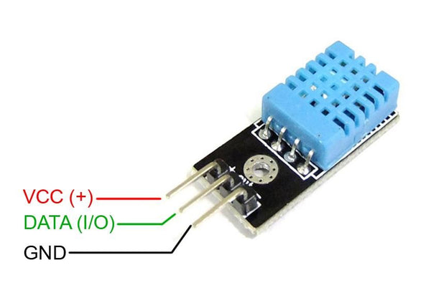
This is the diagram of the DHT 11 sensor it is mainly used to measure the temperature of a person using this sensor.

VI.SOFTWARE REQUIREMENTS

A . Dart Programming Language

Dart is an open-source, object-oriented programming language developed by Google. It is intended for building web, server, and mobile applications. Dart is similar to other popular programming languages like Java and C#, and it can be used to create both client-side and server-side applications. It also includes a built-in package manager (pub) and a virtual machine (Dart VM) for executing Dart code. Dart was first announced in 2011 and has since grown in popularity, particularly for building mobile apps with the Flutter framework.

B. Flutter Frame Work for app Development

Flutter is an open-source, UI software development kit created by Google. It is used to develop mobile apps, web apps, and desktop apps. Flutter uses the Dart programming language, and it allows for the creation of high-performance, high-fidelity apps for both iOS and Android platforms, as well as for web and desktop, with a single codebase. Flutter's widgets incorporate all critical platform differences such as scrolling, icons, fonts, and navigation to provide full native performance on both iOS and Android. The framework also includes a rich set of customizable widgets, which are fast and responsive and it's also known for its fast development cycles and "Hot Reload" feature, which allows for quicker iteration and bug fixing



C. Android Studio

Android Studio is the official integrated development environment (IDE) for Google's Android operating system. It is based on the IntelliJ IDEA Java IDE and is built specifically for Android development. Android Studio provides a complete set of tools for developing, testing, and deploying Android apps, including a visual layout editor, code editor, and debugging tools. It also includes a built-in emulator for testing apps on different Android devices and versions. Additionally, it includes a software development kit (SDK) manager, which makes it easy to download and install the latest Android SDKs and other tools. Android Studio also offers built-in support for version control systems such as Git and Subversion, making it easy for developers to collaborate on projects. It is free and open-source and available for Windows, macOS, and Linux.

D .Android Emulator

An Android emulator is a software program that allows developers to test their Android apps on a computer. It creates a virtual environment that mimics the features and functionality of an actual Android device, allowing developers to test their apps as if they were running on a real device. The Android emulator is included as part of the Android Studio IDE and can be used to test apps on different Android versions and devices, including smartphones, tablets, and wearables. The emulator provides a wide range of features, including GPS location simulation, camera and microphone integration, and access to the device's sensors and hardware buttons. It also allows developers to test apps with different screen resolutions, aspect ratios, and densities, which is important for ensuring that the app looks and behaves correctly on different devices. It is considered as one of the most important tools for developers to test their app before publishing it.

E. Blynk Mobile Application

Blynk is a mobile application and platform that allows users to easily control and monitor electronic devices using their smartphone or tablet. The app is available for both iOS and Android devices and can be used to control a wide range of devices, including home appliances, smart lights, and various sensors.

One of the key features of Blynk is its ability to connect to a wide range of devices and platforms. The app can connect to various microcontroller boards such as Arduino, Raspberry Pi, and ESP8266, as well as other devices that support MQTT and HTTP protocols. This allows users to control and monitor their devices from anywhere, at any time.

Another important feature of Blynk is its user-friendly interface. The app includes a variety of pre-built widgets, such as buttons, sliders, and dials, which can be easily configured to control different devices. Users can also create their own custom widgets, using the Blynk editor, and can customize the layout of the app to suit their needs.

Blynk also includes a variety of tools for monitoring and analyzing data from connected devices. The app allows users to view data from sensors in real-time and can also be configured to send push notifications or email alerts when certain conditions are met. This makes it easy for users to stay informed about the status of their devices and respond quickly to any issues that may arise.

In addition to its core features, Blynk also offers a range of advanced features for more advanced users. For example, the app includes support for multiple projects, which allows users to manage multiple devices and control them from a single app.

The app also offers a cloud-based server, which allows users to access their devices from anywhere in the world.

Overall, Blynk is a powerful and user-friendly app that offers a wide range of features for controlling and monitoring electronic devices. Its ability to connect to a wide range of devices and platforms, and user-friendly interface makes it easy for users of all skill levels to control and monitor their devices with ease.

F .Arduino IDE

The Arduino IDE is open-source and available for Windows, Mac, and Linux operating systems. It is widely used by hobbyists, students, and professionals for a variety of projects, including robotics, home automation, and Internet of Things (IoT) devices. The ease of use and accessibility of the Arduino IDE make it a popular choice among those interested in learning about electronics and programming, and the wide range of projects that can be created using the platform makes it a versatile tool for professionals as well.

One of the key features of the Arduino IDE is the library manager, which allows users to easily import and use pre-existing libraries for specific functions and devices. These libraries provide a set of predefined functions that can be easily called in the code, eliminating the need to write complex code for specific functionality. This feature makes it easy for users to add functionality to their projects, such as connecting to sensors or controlling motors.

VII.. FLOW CHART

The Working methodology of our proposed project is in detailed manner in the below flow chart . Arduino UNO module was coded by us in a system . which is coded with respect to blue dot application,initiates when it is provided with a Bluetooth network. The environment is captured by temperature sensor, and heart rate is ECG and it is connection and movement is captured with the help of the application developed using the flutter and with the help of the cloud application.

Once it is released, the whole system pauses with respect to the health of the patient and the ill person in the remote environment .it will automatically monitor the health and the various health parameter of the patient by a regular interval of the time . if any irregular activities or imbalance in the actual parameter of the patient it automatically alert the doctors and the hospital authority . it also suggest the needy medicine for the immediate reflex action to save the patient life.

After this regular routine checkup the data of the various parameter of the patient .the collected data is upload in the cloud for the future purpose and reference. The uploaded data is not only used for reference and it also used for the continuous data analysis of the patient and to better understanding of the disease for getting new medicine and better antibodies to fight against the specific disease for protecting the future generation for betterment of the human community.

The Arduino IDE also includes a compiler, which converts the code written by the user into machine language that the microcontroller can understand. This process is transparent to the user, and the IDE will automatically compile the code and upload it to the board. The built-in debugger allows the user to monitor the code execution and detect errors, making it easy to troubleshoot and fix issues.

The working principle of our proposed project is as illustrated in the above flow chart. Raspberry PI module which is coded with respect to Blue dot application, initiates when it is provided with a Bluetooth network.

Once it is released, the entire system pauses w.r.t movement and it will move automatically in forward direction by time delay as we programmed, then the primary objective is carried out such as delivering medicines, foods etc., and also contactless monitoring of patient’s readings such as temperature, pulse rate, oxygen level. These Readings are uploaded to the cloud for future reference and also alerts medical staffs through SMS.

The flow of the system is given in the figure. This will explain how the system works.

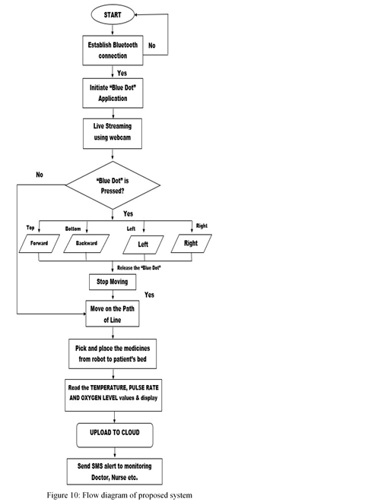

VIII. EXPERIMENTAL RESULT

Our paper explains about the system used to monitor the condition of the health of the defected person by the use of the system which made up of the various sensor and equipment . So that fear of the effect of the rate of the dieases and the rate of the death is gradually death. The cloud and the mobile application is used to made record’s of the particular patient and also helps to make communication between patient and the doctor . in result it helps doctor to take necessary action. This system ensure the contactless connection and assistance and patients monitoring.

Then the conclusion of the system is given in the next page of this paper.

IX. CONCLUSION

In conclusion, an IoT-based health monitoring system for smart hospital management can greatly improve patient care and hospital efficiency. By using sensors and other IoT devices to collect data on patients' vital signs and medical history, healthcare providers can quickly and easily access important information to make informed decisions about treatment. Additionally, by automating many routine tasks, such as medication reminders and appointment scheduling, the system can help reduce the workload on hospital staff and improve patient outcomes. Overall, the implementation of an IoT-based health monitoring system can lead to a more efficient and effective healthcare system, with better care for patients and improved hospital management.

X.ACKNOWLEDGMENT

In the acknowledgement section, it is appropriate to express gratitude to those who have helped during the development and implementation of the IoT-based health monitoring system for smart hospital management. Some individuals or organizations that may be acknowledged include ,The research team or collaborators who worked on the project. Funding agencies or organizations that provided financial support for the project.

Medical professionals or hospitals that provided access to patients or facilities for testing and implementation.Any companies or organizations that provided technical assistance or donated equipment or software,,Colleagues or peers who provided feedback or support during the development process.It is also appropriate to acknowledge any limitations or challenges faced during the development and implementation of the system,and to express appreciation for any future opportunities for improvement and further research.

XI.REFERENCES

- Lizheng Liu;Jiawei Xu;Yuxiang Huan;Zhuo Zou;Shih-Ching Yeh;Li-Rong Zheng, Year:2020, “A Smart Dental Health-IoT Platform Based on Intelligent Hardware, Deep Learning, and Mobile Terminal”,IEEE Journal of Biomedical and Health Informatics, vol.24,no.3.
- Justinas Mišeikis;Pietro Caroni;Patricia Duchamp;Alina Gasser;Rastislav Marko;Nelija Mišeikienė;Frederik Zwilling;Charles de Castelbajac;Lucas Eicher;Michael Früh;Hansruedi Frühm, Year:2020, “Lio-A Personal Robot Assistant for Human-Robot Interaction and Care Applications”,IEEE Robotics and Automation Letters, vol.5, no.4.
- Hassan Harb;Ali Mansour;Abbass Nasser;Eduardo Motta Cruz;Isabel de la Torre Díez, Year:2021, “A Sensor-Based Data Analytics for Patient Monitoring in Connected Healthcare Applications”, IEEE Sensors Journal, vol.21, no.2, pp. 974 - 984.
- G. López, L. Quesada, and L. A. Guerrero, “Alexa vs. Siri vs. Cortana vs. Google Assistant: a comparison of speech-based natural user interfaces,” in Advances in Intelligent Systems and Computing, pp. 241–250, Springer, Champions, 2017.
- Y. Liu, S. Garg, J. Nie et al., “Deep anomaly detection for timeseries data in industrial IoT: a communication-efficient ondevice federated learning approach,” IEEE Internet of Things Journal, vol. 8, no. 8, pp. 6348–6358, 2021.
- A.Dorri, S. S. Kanhere, R. Jurdak, and P. Gauravaram, “Blockchain for IoT security and privacy: the case study of a smart home,” in 2017 IEEE International Conference on Pervasive Computing and Communications Workshops (PerCom Workshops), pp. 618–623, Kona, HI, USA, 2017.
- Novi Sad, Serbia, “Security measures of enabling technologies in Internet of Things (IoT): a survey,” in Zooming innovation in consumer electronics international conference (ZINC), pp. 28–31, June 2016.
- H. Javdani and H. Kashanian, “Internet of things in medical applications with a service-oriented and security approach: a survey,” Health and Technology, vol. 8, pp. 39–50, 2018

