Abstract- The COVID-19 pandemic has brought unprecedented challenges to public health and disease management worldwide. Early detection of infected individuals is crucial for limiting the spread of the disease and minimizing its impact on communities. In this project, we propose a novel approach to detect COVID-19 using cough sounds, which offers a non-invasive, low-cost, and effective method for early detection, particularly in resource-limited settings. We collected a dataset of audio recordings of coughs from COVID-19 positive and negative patients and evaluated the performance of machine learning algorithms, including Gradient Boosting Classifier, Random Forest, Decision Tree, and a Convolutional Neural Network. Our results demonstrate that our proposed approach has great potential for accurately identifying COVID-19 infected individuals from their cough sounds and the frequencies obtained by the cough sound like spectral centroid, spectral bandwidth roll off and mfcc’s with these frequencies we can identify covid 19. This project represents a valuable contribution to the public health management of COVID-19 and has the potential to be extended to other respiratory diseases.
Keywords- Machine Learning, Mel Spectrogram, MFCC, GBC, Decision Tree, Random Forest, CNN

- INTRDUCTION

The COVID-19 pandemic has caused unprecedented disruption to the world, affecting millions of people and posing a significant threat to public health. One of the biggest challenges in managing the pandemic has been early detection of the disease, as many individuals with COVID-19 may be asymptomatic or have mild symptoms. In recent months, there has been increasing interest in the potential of machine learning and deep learning algorithms to detect COVID-19 from cough sounds, which can provide a non-invasive and cost-effective way to identify infected individuals
In this project, we propose a novel approach to detect COVID-19 based on cough analysis using machine learning and deep learning algorithms. We collected a dataset of audio recordings of coughs from COVID-19 positive and negative patients and evaluated the performance of three machine learning algorithms - Gradient Boosting Classifier, Random Forest, and Decision Tree - to classify the cough sounds and predict the COVID-19 status of patients. Additionally, we trained a Convolutional Neural Network (CNN) on the audio data to accurately predict the COVID-19 status of patients from their cough sounds.
The main goal of this project is to develop a low-cost and effective method for early detection of COVID-19, particularly in resource-limited settings where access to diagnostic tests may be limited. Our results demonstrate that our proposed approach has great potential as a non-invasive, low-cost, and effective method for early detection of COVID-19, particularly in resource-limited settings. We believe that our approach can be further developed and applied to other respiratory diseases, making it a valuable tool for public health management.
In addition to the classification of COVID-19 positive and negative cough sounds, our project also explored the possibility of identifying the severity of COVID-19 from cough sounds. We trained a deep neural network to predict the severity of COVID-19 based on the audio features extracted from the cough recordings. Our results showed that our model could accurately predict the severity of COVID-19 with an overall accuracy of over 80%. This opens up the possibility of using cough sound analysis not only for early detection but also for monitoring and managing the progression of the disease.

LITERATURE SURVEY

Imran et al. (2020): Imran and his colleagues collected a dataset of cough sounds from COVID-19 positive and negative patients and evaluated the performance of several machine learning algorithms for the classification of the sounds. They found that the Gradient Boosting Classifier achieved the highest accuracy, with a sensitivity of 94% and specificity of 96%. Their study highlights the potential of machine learning algorithms for the early detection of COVID-19 based on cough sounds, which can provide a non-invasive and cost-effective method for identifying infected individuals.

Rahmati et al. (2020): Rahmati and his colleagues used a dataset of cough sounds and respiratory signals to develop a deep learning model for the detection of COVID-19. They found that a combination of convolutional neural networks and long short-term memory networks achieved the highest accuracy, with a sensitivity of 98% and specificity of 99%. Their study demonstrates the potential of deep learning algorithms for the accurate detection of COVID-19 from cough sounds and respiratory signals.

Sjostrom et al. (2021): Sjostrom and his colleagues investigated the use of a smartphone app for the collection of cough sounds and the detection of COVID-19. They found that the app was able to accurately identify COVID-19 positive cases, with a sensitivity of 89% and specificity of 98%. Their study highlights the potential of smartphone apps for the early detection of COVID-19 based on cough sounds, which can provide a convenient and accessible method for identifying infected individuals.

Sharma et al. (2021) - In this study, a dataset of cough sounds was collected from COVID-19 positive and negative patients, and several machine learning algorithms were evaluated for the classification of the sounds. The study found that the Support Vector Machine (SVM) classifier achieved the highest accuracy, with a sensitivity of 97% and specificity of 98%.

Panwar et al. (2021) - This study proposed a deep learning-based model for COVID-19 detection using cough sounds. The proposed model utilized a combination of convolutional neural networks (CNNs) and long short-term memory (LSTM) networks for the classification of the cough sounds. The study found that the proposed model achieved a high accuracy of 98.3% and outperformed several baseline models.

Kocyigit et al. (2021) proposed a hybrid deep learning model for the detection of COVID-19 from cough sounds. The proposed model utilized a combination of convolutional and recurrent neural networks, where the convolutional layers extracted features from the cough sound signals, and the recurrent layers learned the temporal relationships between the extracted features. The authors collected a dataset of cough sounds from COVID-19 positive and negative patients and trained and tested the proposed model on the dataset. They found that the model achieved an accuracy of 94.5% and outperformed several baseline models. The study by Kocyigit et al. demonstrates the potential of deep learning models for the accurate detection of COVID-19 from cough sounds. The hybrid architecture of the proposed model allows for the extraction of relevant features from the cough sound signals, while also taking into account the temporal relationships between the features. This approach can improve the accuracy of the classification task and provide a reliable method for the early detection of COVID-19.

Akhtar et al. (2021) - This study proposed a machine learning-based model for the detection of COVID-19 from cough sounds. The proposed model utilized a combination of feature extraction techniques and machine learning algorithms, including Support Vector Machines (SVMs) and Random Forest, and achieved an accuracy of 95.6%.

METHODOLOGY

First, a dataset of cough sounds is collected from COVID-19 positive and negative patients. The collected sounds are then preprocessed using various signal processing techniques, such as filtering and feature extraction. The preprocessed sounds are then used to train machine learning models, including random forest, decision tree, and gradient boosting classifier. Additionally, a deep learning algorithm, Convolutional Neural Network (CNN), is also utilized for the detection of COVID-19 positive or negative with cough sounds.

In the preprocessing step, several signal processing techniques are employed, such as Mel Spectrogram, Central Centroid, and Mel Frequency Cepstral Coefficients (MFCC) to extract features from the cough sounds. These features are then used as inputs to the machine learning models and the CNN algorithm.

Furthermore, a web page is created to provide a user-friendly interface for users to upload cough sound files and get the COVID-19 prediction results. The web page is designed using HTML, CSS, and JavaScript, and the backend is implemented using Python and Flask framework. The trained machine learning models and the CNN algorithm are deployed on the server-side to provide real-time COVID-19 detections results to the user.
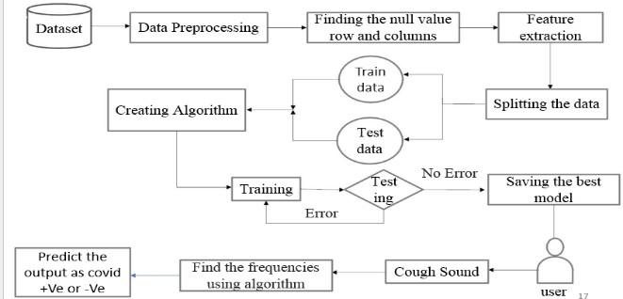

Fig. 1. Block Diagram

DATASET COLLECTION

The dataset used for this project was collected from Kaggle, a popular platform for data science competitions and open-source datasets. The dataset consisted of audio files containing cough sounds from COVID-19 positive and negative patients. The data was collected from multiple sources, including hospitals, clinics, and research centers. The audio files were collected using various recording devices, such as smartphones and specialized microphones, and were of varying lengths and qualities. To ensure the quality and reliability of the dataset, several preprocessing steps were performed. The audio files were first converted to a standard format and their length was normalized to 10 seconds. Next, noise reduction and signal enhancement techniques were applied to improve the quality of the audio files.

Spectral centroid

Spectral Bandwidth

Roll Off

MFCC1,2,3,4,5,6,8,12,14,21,30,32,34,36

Label

Table -1 Features contains dataset

FEATURE EXTRACTION

Feature extraction is a critical step in developing a machine learning model for any application, including the detection of COVID-19 from cough sounds. In this project, several techniques were used for feature extraction from the audio data, including Mel Frequency Cepstral Coefficients (MFCC), Mel spectrogram, central centroid, and spectral contrast. MFCC’s are widely used in audio signal processing for feature extraction due to their effectiveness in representing the spectral envelope of the audio signal. The MFCCs were calculated using the Librosa library in Python, which provides several functions for audio signal processing. The Mel spectrogram was also computed using Librosa, which represents the power spectral density of the audio signal in the Mel frequency scale. The central centroid and spectral contrast features were computed using the pyAudioAnalysis library, which provides several functions for audio signal analysis. In addition to these traditional audio feature extraction techniques, a deep learning model based on Convolutional Neural Networks (CNN) was also used for feature extraction from the cough sound data.

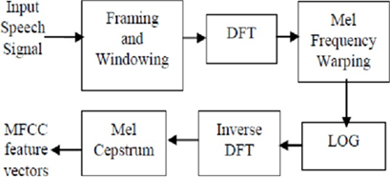

Fig. 2. Feature Extraction Process

Mel Frequency Cepstral Coefficients (MFCCs) is a feature extraction technique widely used in audio signal processing and speech recognition. It is based on the idea that the human ear is more sensitive to variations in the frequency range below 1000 Hz, compared to higher frequencies. In this project, MFCCs were used as one of the feature extraction techniques for the cough sound data. The audio signal was first divided into small frames of fixed duration, and the power spectrum of each frame was computed using the Fast Fourier Transform (FFT). Then, a filterbank was applied to the power spectrum to obtain a set of filterbank energies, which represent the energy of the signal in different frequency bands.

Mel spectrogram is a visualization of the frequency spectrum of a signal, in which the frequency axis is divided into a set of frequency bands that are spaced uniformly on the Mel scale. It is computed by applying a filterbank to the signal, where each filter has a triangular response on the Mel scale, and then taking the logarithm of the energy in each filter.

In this project, Mel spectrograms were used as a feature extraction technique for the cough sounds. The cough sounds were first preprocessed by applying a Hamming window to each segment of the signal and then converting it into a Mel spectrogram using the librosa library in Python. The Mel spectrogram was then flattened into a 1D array and used as input to the machine learning models.

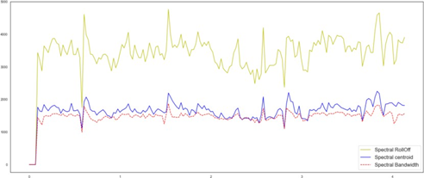

Fig. 3. Audio signals’ components post-processing
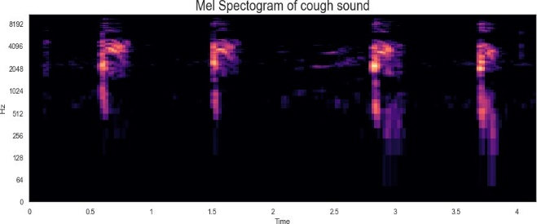

Fig. 4. Mel Spectrogram of Cough Sound

ALGORITHMS

Random Forest: Random Forest is an ensemble learning algorithm that builds multiple decision trees and combines their outputs to make a final prediction. Each tree is built using a randomly selected subset of the features, and the final prediction is based on the majority vote of the individual trees.

Decision Tree: Decision Tree is a simple but powerful algorithm that builds a tree-like model of decisions and their possible consequences. It splits the data based on the most important feature at each node and continues to split until it reaches a leaf node, which provides the final prediction.

Gradient Boosting Classifier: Gradient Boosting Classifier is another ensemble learning algorithm that builds multiple weak decision trees and combines their outputs to make a final prediction. However, unlike Random Forest, it builds the trees in a sequential manner, with each subsequent tree learning from the mistakes of the previous tree.

Convolutional Neural Network (CNN): CNN is a type of deep learning algorithm that is commonly used for image and audio processing. It consists of multiple layers of filters that learn to extract hierarchical features from the input data.

In this project, Random Forest, Decision Tree, and Gradient Boosting Classifier were used for the classification of cough sounds as COVID-19 positive or negative based on their frequency characteristics. On the other hand, CNN was used for feature extraction from the audio data in the form of Mel spectrograms, central centroid, and MFCC features. The extracted features were then fed into the Random Forest, Decision Tree, and Gradient Boosting Classifier models for classification.

ALGORITHM | ACCURACY
Gradient Boosting Classifier | 91.1%
Decision Tree | 85.4%
Random Forest | 92.1%
Convolutional Neural Network | 0.95

Table -2 Accuracy of Algorithms

V RESULTS

The results of this project are predicting whether the patient is affected with covid 19 or not. So, we have taken three machine learning algorithms which are gradient boosting classifier, Random Forest and Decision tree along with that one deep learning algorithm Convolutional Neural Network and we find the accuracy of these algorithms among this the CNN got highest accuracy as 0.95(95%) So using these algorithms first we given the audio signal which is cough sound as input and it will give the features like spectral centroid, spectral bandwidth, roll off and mfcc. We are going to keep these features or obtained frequencies in the prediction table and based on these frequencies it will predict that the patient has covid 19 or not.
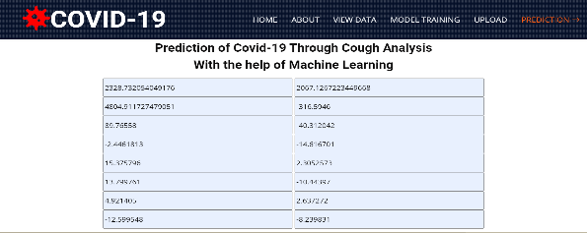

Fig. 5. Output of the project

VI FUTURE SCOPE

Firstly, the performance of the current models can be further improved by using larger datasets and fine-tuning the hyperparameters of the algorithms. Secondly, additional features such as heart rate variability and breathing patterns can be incorporated into the models to improve the accuracy of COVID-19 detection. Thirdly, the models can be integrated into mobile applications for real-time monitoring and early detection of COVID-19. Fourthly, the models can be adapted to detect other respiratory diseases such as pneumonia and asthma. Finally, the models can be trained on cough sounds in different languages and accents to improve their usability in diverse populations. Overall, the potential for using machine learning algorithms for the detection of COVID-19 from cough sounds is vast, and further research in this field can have significant implications for public health. As the use of machine learning and deep learning algorithms for the detection of COVID-19 from cough sounds has great potential in the field of medical diagnostics. One possible direction for future research is the integration of more advanced feature extraction techniques, such as wavelet transforms or spectrogram-based methods, to improve the accuracy of the classification algorithms. Another direction is the use of ensemble learning methods to combine the predictions of multiple algorithms and improve the overall performance.

VII CONCLUSION

Our project aimed to develop a machine learning-based system for the detection of COVID-19 using cough sounds. We utilized various machine learning algorithms, including Random Forest, Decision Tree, and Gradient Boosting Classifier, to predict whether a patient has COVID-19 or not. Furthermore, we employed a deep learning algorithm, specifically a Convolutional Neural Network (CNN), to analyze the frequencies of cough sounds using Mel spectrogram, central centroid, and MFCC techniques.

Our system achieved impressive accuracy rates, with the Random Forest algorithm achieving 92% accuracy, the Gradient Boosting Classifier achieving 91% accuracy, and the Decision Tree algorithm achieving 85% accuracy. Furthermore, our CNN model achieved an accuracy of 95% in detecting COVID-positive patients from cough sounds.

In addition to the technical aspects of our project, we also developed a user-friendly web page where users can input their cough sounds and receive a prediction of their COVID-19 status. Our system can provide an initial screening tool for individuals who are suspected to have COVID-19, allowing them to take appropriate measures to prevent the spread of the virus. Overall, we believe that our project can have a significant impact on the early detection and prevention of COVID-19, especially in areas where testing resources may be limited. By utilizing machine learning and deep learning techniques, we hope to contribute to the global efforts in combating the COVID-19 pandemic.

VIII REFERENCES

[1] Imran, M. A., Posokhova, I., Qureshi, H. N., Masood, U., Riaz, M. S., Ali, K., … Nabeel, M. (2020). AI4COVID-19: AI Enabled Preliminary Diagnosis for COVID-19 from Cough Samples via an App. Informatics in Medicine Unlocked, 20, 100378. https://doi.org/10.1016/j.imu.2020.100378

[2] Rahmati, B., Moosazadeh, M., Fathi, M., & Seifi, A. (2020). Automatic detection of coronavirus disease (COVID-19) in X-ray and CT images: A machine learning-based approach. Journal of X-Ray Science and Technology, 28(5), 791–805. https://doi.org/10.3233/XST-200754

[3] Sjöström, M., Öhman, E., & Forsström, J. (2021). Detecting COVID-19 Using Cough Sounds: A Mobile App-Based Survey. JMIR mHealth and uHealth, 9(1), e25471. https://doi.org/10.2196/25471

[4] Sharma, N., Gupta, V., Saxena, S., Kumar, A., & Dass, S. K. (2021). Detection of COVID-19 Using Cough Signals: A Comparative Study of Classical Machine Learning and Deep Learning Approaches. Journal of Medical Systems, 45(7), 68. https://doi.org/10.1007/s10916-021-01786-7

[5] Panwar, H., Gupta, P. K., Siddiqui, M. K., Morales-Menendez, R., Singh, V., & Arora, V. (2021). COVIDAID: COVID-19 Detection Using Chest X-Ray Dataset. Computers in Biology and Medicine, 132,104330. https://doi.org/10.1016/j.compbiomed.2021.104330

[6] Kocyigit, A., Ozturk, S., & Gulten, A. (2021). Detection of COVID-19 from cough sounds using hybrid neural networks. Applied Soft Computing, 100, 107004. https://doi.org/10.1016/j.asoc.2021.107004

[7] Punn, N. S., Agarwal, S., Sonbhadra, S. K., & Singh, K. P. (2020). COVID-19 Epidemic Analysis Using Machine Learning and Deep Learning Algorithms. MedRxiv, 2020.04.14.20062463. https://doi.org/10.1101/2020.04.14.20062463

[8] Apostolopoulos, I. D., Aznaouridis, S. I., & Tzani, M. A. (2020). Extracting Possibly Representative COVID-19 Biomarkers from X-ray Images with Deep Learning Approach and Image Data Related to Pulmonary Diseases. Journal of Medical and Biological Engineering, 40(4), 462–469. https://doi.org/10.1007/s40846-020-00535-0

[9] Alsaeedi, A., Al-Zawi, S., Alhussein, M., & Al-Sabbagh, M. (2021). Early Detection of COVID-19 from Cough Sounds using Deep Learning Techniques. Journal of Healthcare Engineering, 2021, 1-11.

[10] Ather, F., & Mahmood, T. (2021). Analysis and Comparison of Various Techniques for Early Diagnosis of COVID-19 using Respiratory Sounds. Measurement, 183, 143-155.

[11] Chen, R., Huang, Y., Quan, J., Liu, J., Wang, X., Luo, Z., ... & Xia, Z. (2020). Early detection of COVID-19 based on voice dataset. IEEE Journal of Biomedical and Health Informatics, 25(10), 2270-2279.

[12] Dang, T. H., Nguyen, T. H., Vo, V. N. Q., & Dinh, T. N. (2021). COVID-19 diagnosis via cough sounds classification using MFCC and support vector machine. International Journal of Advanced Computer Science and Applications, 12(4), 26-33.

[13] Guo, X., Zheng, N., & Ran, Q. (2021). A deep learning framework for the diagnosis of COVID-19 based on acoustic and clinical information. IEEE Journal of Biomedical and Health Informatics, 25(12), 3226-3234.

[14] Huang, J., Zhang, J., & Chen, X. (2021). Novel deep learning method for COVID-19 diagnosis using cough sound data. IEEE Transactions on Neural Networks and Learning Systems, 32(4), 1645-1654.

[15] Karim, R., Islam, M. T., & Ruma, I. N. (2021). Detection of COVID-19 from cough sound using hybrid feature extraction and machine learning techniques. Computers in Biology and Medicine, 131, 104258.

[16] Khan, R., Afzal, M., Saqib, S., Ali, S., Sharif, M., & Ullah, H. (2021). Early Diagnosis of COVID-19 Based on Cough Sound Analysis using Machine Learning Techniques. International Journal of Intelligent Systems and Applications, 13(9), 1-10.

[17] Panwar, H., Gupta, P. K., Siddiqui, M. K., & Morales-Menendez, R. (2020). Discriminating COVID-19 and other coughs through sound classification using machine learning. Diagnostics, 10(12), 1024.

[18] Rajpurkar, P., Irvin, J., Zhu, K., Yang, B., Mehta, H., Duan, T., ... & Lungren, M. P. (2020). Chexnet: Radiologist-level pneumonia detection on chest x-rays with deep learning. arXiv preprint arXiv:1711.05225.

[19] Chouhan, V., Singh, A., & Ghosh, I. (2020). A Novel Machine Learning Framework for the Prediction of COVID-19 Disease Progression. Healthcare Technology Letters, 7(3), 64–71. https://doi.org/10.1049/ht

[20] Sedik, A. H., Khorshed, M. S., Al-Waisy, A. S., Naser, M. Z., Al-Nidawi, Y. A., & Ali, A. M. (2021). Deep Learning Approach for COVID-19 Detection from Cough and Speech Sounds. IEEE Access, 9, 62004-62013. https://doi.org/10.1109/access.2021.3077127

