Incorporation of AI And Blockchain
With Autonomous Cars
Suraj Shinde

* Computer Science Engineering, Jawahralal Darda Institute Of Engineering And Technology,Yavatmal*

Abstract-
AI and Blockchain are two disruptive technologies that have the potential to change business models and impact the society. which enables analysis, decisions and self-learning on trusted and shared data stored on the Blockchain. Autonomous agents in multi agent environment can the collaborate, act and take decisions. Decentralized AI can help improve system performance by processing relevant data, as well as perform parallel processing across nodes based on different objectives. This paper reviews concepts of Blockchain, AI, power of combining these two technologies, and different platforms providing these capabilities.

Keywords- Blockchain Technology, Ethereum, Artificial
Intelligence, Autonomous, Driverless cars, Self-driving cars,
Public ledger.

- INTRODUCTION
A
rtificial intelligence (AI) refers to the simulation of human intelligence in machines that are programmed to think like humans and mimic their actions. The term may also be applied to any machine that exhibits traits associated with a human mind such as learning and problem-solving.
Artificial intelligence leverages computers, data, and machines to mimic the problem-solving and decision-making capabilities of the human mind. It also encompasses the subfields of machine learning and deep learning technologies. These technologies use AI algorithms to train data for making predictions and classifications.
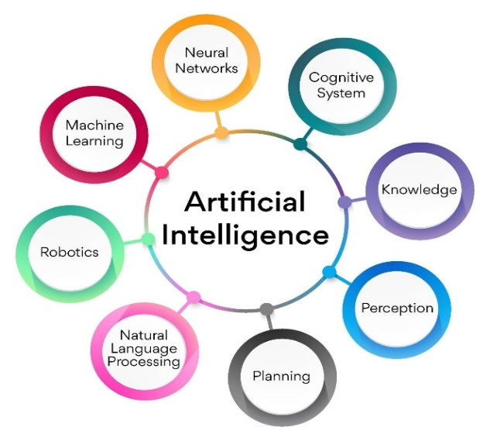

Blockchain is one of the major tech stories of the past decade. Everyone seems to be talking about it—but beneath the surface chatter there’s not always a clear understanding of what blockchain is or how it works. Despite its reputation for impenetrability, the basic idea behind blockchain is pretty simple. And it has major potential to change industries from the bottom up.
Blockchain is a technology that enables the secure sharing of information. Data, obviously, is stored in a database. Transactions are recorded in an account book called a ledger. A blockchain is a type of distributed database or ledger—one of today’s top tech trends—which means the power to update a blockchain is distributed between the nodes, or participants, of a public or private computer network.This is known as distributed ledger technology, or DLT. Nodes are incentivized with digital tokens or currency to make updates to blockchains. Blockchain allows for the permanent, immutable, and transparent recording of data and transactions. This, in turn, makes it possible to exchange anything that has value, whether that is a physical item or something less tangible.

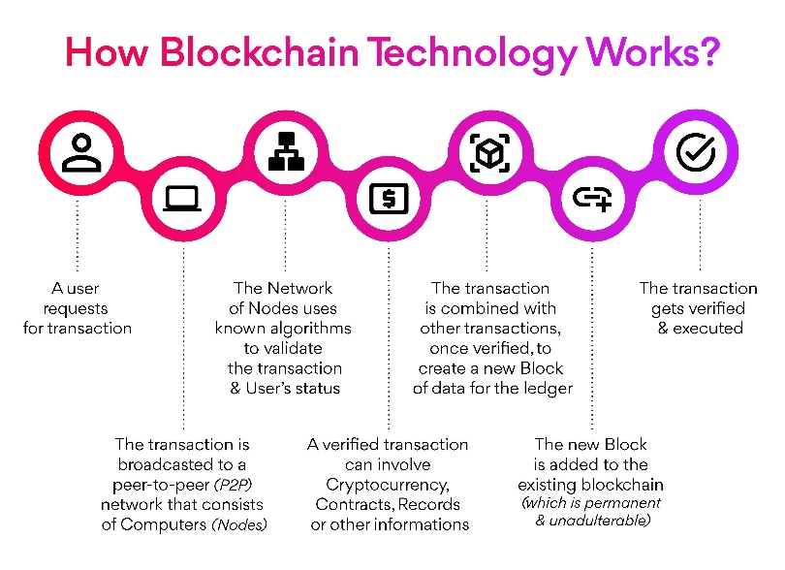

- INTERLINKING OF THE BLOCKCHAIN TECHNOLOGY AND AI:
Blockchain technology is interlinked with AI in many ways. Below are the major integrations:

1. Transparent data source
You need ample data to train an AI application. As blockchain is the most transparent technology, it is a reliable source of refined data. Due to the traceability of nodes, the source of data can be verified efficiently.
2. Autonomous system
The decentralized ledger technology ensures that no single server handles all the operations of the AI application. The autonomous system drives the decentralization for managing the AI training and operations without being supervised.
3. Privacy protection
Cryptographic techniques strengthen privacy throughout the network which runs AI training and operations. When you have a robust privacy system you can train and supply AI systems as they are competitive and have higher complexity.

4. Distributed computing power
To train and maintain AI, you require a lot of firepowers. Blockchain technology takes that responsibility and helps to get through it. It also takes care of the space requirements like hardware and software, storage, and maintenance cost.
5. Security
Blockchain’s smart contracts are not secure enough. The blockchain revolves around the rigidness of the contract, when there are loopholes you can exploit and harm the applications easily. For minimizing such vulnerabilities, AI is used to generate more secure and smart contracts.
6. Reading efficiency
The low query performance often limits blockchains as they have limitations in their data storage modes. The blockchain applications sacrifice the reading efficiency for achieving a more write-intensive approach with level DB-a write-intensive DMS.
While using AI, the data storage methods help to enhance the usage of blockchain. A proposed novel TTA-CB protocol lowers the issues of data storage through PSO algorithms. When you do rigorous testing and training, AI eventually helps in improving the speed of data queries.
7. Authenticity
Blockchain’s digital record provides insights into the AI framework and the provenance of the data which is used, it also addresses the challenges of explainable AI. It helps you in improving your trust in data integrity and the recommendations the AI provides. When you are using blockchain for storing and distributing AI modes it provides an audit trail, and pairs blockchain and AI to enhance data security.
8. Augmentation
AI reads data comprehensively and rapidly. It also understands and processes the data at a great speed by bringing higher intelligence to the blockchain-based business networks. When you provide access to larger data within or outside the organizations, blockchain will help the AI scale and provide more actionable insights, manage model sharing and data usage, and create a transparent and trustworthy data economy.
9. Automation
Automation, AI, and blockchain will bring newer values to business processes that span different parties like adding, removing friction, and increasing speed and efficiency. AI models embedded in smart contracts execute on blockchain to resolve disputes and select the most sustainable shipping methods.
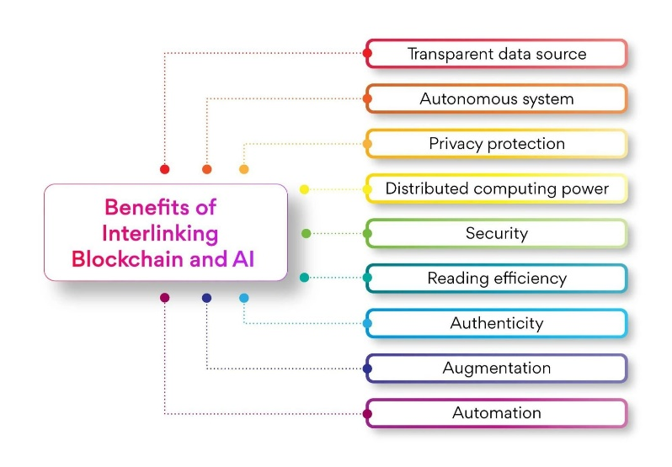
Blockchain technology with its distributed ledger and cryptography enables faster and more secure data management. This efficient data management with blockchain enables self-driving cars to analyze and judge traffic in real-time, reduce accidents, identify best routes, and reduce travel time.
Autonomous cars rely on sensors, actuators, complex algorithms, machine learning systems, and powerful processors to execute software. Autonomous cars create and maintain a map of their surroundings based on a variety of sensors situated in different parts of the vehicle

- LITERATURE SURVEY

Our proposed method involves technologies of two different domains so the literature survey is also a thorough research on these two domains. One research domain describes the techniques which are being implemented to train the autonomous cars and different ideas that are being used to further improve the efficiency while the other research domain involves the various ways in which blockchain can be applied and the case studies where it is used to simplify an otherwise difficult task.
In Pinyaphat Tasatanattakool, Chian Techapanupreeda “Blockchain: Challenges and Applications”, the various applications of Blockchain technology are discussed. The paper mainly stresses on how the blockchain is often used interchangeably with Bitcoin. Although Bitcoin uses Blockchain technology, it’s only one of the many applications of it.
Shuai Wang, Jing Wang, Xiao Wang, Tianyu Qiu in the paper “Blockchain Powered Parallel Healthcare Systems Based on the ACP approach” describes a method on how blockchain can be used to share data in a hospital management system with a decentralized log book which keeps track of all the activities taking place in the hospital.
Rahul A. R. in the paper “AI in Blockchain Technology: The possibilities of integrating AI with Blockchain”: proposes the various possibilities that can be brought out in our everyday life if these two domains are integrated. A thorough research and analysis on a number of journals and research papers suggested that reinforcement learning with deep neural networks are being implemented to train the autonomous cars. The current approach still has a wide scope for development as the domain of AI is relatively new and so is the existence of autonomous cars.
Through a research of a number of journals and preexisting research papers, various techniques that are currently being used to train autonomous cars through artificial intelligence are analyzed. Most of the sources indicate the usage of reinforcement learning with deep learning algorithms to carry out the training task. The current training technique has a wide scope of further improvement as the domain is relatively new and it has not been too long since autonomous cars have come to existence. Only after a thorough research on both the domains, the idea struck that the key to simplify the training task of one of the most technologically advanced invention of decades lies in Blockchain Technology and that the difference this implementation can bring about is significantly very hug.

- PROBLEM STATEMENT

The purpose of this paper is to present a method to reduce the amount of taken to train the autonomous cars. This can be done by linking the autonomous cars that has to be trained in a blockchain network. The novel approach or the existing method is, a car has to be trained until it can drive safely without any accidents. This process, as it seems, is a cumbersome task since the car has to learn to drive as safely as a human does. This is the case for only one car. Imagine the case where hundreds or thousands of cars being manufactured in a bulk and training each of them individually until they become ready to drive safely on roads. All these cars have to be individually trained on the same training algorithms again and again.
In this paper we propose a technique where a single car in the blockchain is trained using AI algorithms and this experience or data is visible to all other cars in the network. In this way the need to train each car is eliminated. This greatly reduces the resources and human efforts thereby increasing the training speed.
The main idea is aimed to simplify the training process of autonomous, self-driving, driver less cars using an artificially intelligent blockchain network of a number of autonomous cars. At present, each car is trained individually until each of them learns how to drive safely on roads without any accident. Training an autonomous car to drive safely just like a human does is a cumbersome task. It involves lot of resources, time and human efforts before a car finally learns to drive on its own. Knowing that training one car itself is a tedious task, it can be imagined how hard can it be for a production company to train all its autonomous cars individually, one at a time. For example, if thousand cars are produced in a lot, all of them will have to be trained separately. Hence, the same training algorithms have to be carried out again and again for thousand times.
This paper proposes a technique to train all the cars produced in a lot just by training one single car, i.e., only one car has to be trained using reinforcement learning and rest all other cars in that lot will automatically learn driving just from that one single car’s experience simultaneously thereby reducing the resources, time and efforts required by a significantly large extent.
- Real-Life Application
1. FINALIZE Finalize is a software platform that uses blockchain and machine learning to build applications aimed at improving civil infrastructure. The company’s tools automate and speed up construction industry workflow, management, and verification processes, and its technology also integrates with wearables to meet safety regulations. Finalize aims to make crucial processes more efficient while maximizing ROI in an industry whose revenues are projected to hit $15.5 trillion by 2028.
2. BLACKBOX AI Blackbox AI develops artificial intelligence tools for emerging technologies. The company’s engineers create a customized information architecture that powers everything from machine learning and natural language processing to blockchain tools. Besides developing infrastructure for blockchains, the company also offers consultation services that focus on how their products can maximize a blockchain’s potential. Blackbox AI’s engineers are from some of the largest tech organizations in the world (including Apple, Intel, NVIDIA and MIT), and they have devised AI- based tools for everything from virtual reality to natural language processing.

- ADVANTAGES AND DISADVANTAGES

Advantages of Blockchain:
- Data Integrity:
Blockchain technologies are designed in such a way that any block or even a transaction that adds to the chain cannot be edited, which ultimately provides a very high range of security. 2. Free from Censorship:
Blockchain technology is considered free from censorship as it does not have control of any single party rather it has the concept of trustworthy nodes for validation and consensus protocols that approve transactions by using smart contracts.
- Verifiable:
Blockchain technology is used to store information in a decentralized manner so everyone can verify the correctness of the information by using zero-knowledge proof through which one party proves the correctness of data to another party without revealing anything about data.

Disadvantages of Blockchain:
- Power Use:
The consumption of power in the Blockchain is comparatively high due to mining activities. Keeping a real-time ledger is one of the reasons for this consumption because every time it creates a new node, it communicates with each and every other node at the same time.
- Cost:
Each crypto transaction also demands high energy. There are very fewer chances that this issue can be resolved by the advancement in technology. The other factor is that the storage problem might be covered by energy issues that cannot be resolved.
- Immaturity:
Blockchain is only a couple-year-old technology so people do not have much confidence in it, they are not ready to invest in it yet several applications of blockchain are doing great in different industries but still it needs to win the confidence of even more people to be recognized for its complete utilization.

Advantages of Artificial Inteligence:
- Reduction in Human Error:
One of the biggest advantages of Artificial Intelligence is that it can significantly reduce errors and increase accuracy and precision. The decisions taken by AI in every step is decided by information previously gathered and a certain set of algorithms.
- Zero Risks:
Another big advantage of AI is that humans can overcome many risks by letting AI robots do them for us. Whether it be defusing a bomb, going to space, exploring the deepest parts of oceans, machines with metal bodies are resistant in nature and can survive unfriendly atmospheres.
- 24x7 Availability:
There are many studies that show humans are productive only about 3 to 4 hours in a day. Humans also need breaks and time offs to balance their work life and personal life. But AI can work endlessly without breaks. They think much faster than humans and perform multiple tasks at a time with accurate results.

Disadvantages of Artificial Inteligence:
- High Costs:
The ability to create a machine that can simulate human intelligence is no small feat. It requires plenty of time and resources and can cost a huge deal of money. AI also needs to operate on the latest hardware and software to stay updated and meet the latest requirements, thus making it quite costly. 2. No creativity:
A big disadvantage of AI is that it cannot learn to think outside the box. AI is capable of learning over time with pre-fed data and past experiences, but cannot be creative in its approach. A classic example is the bot Quill who can write Forbes earning reports. These reports only contain data and facts already provided to the bot.
- Unemployment:
One application of artificial intelligence is a robot, which is displacing occupations and increasing unemployment (in a few cases). Therefore, some claim that there is always a chance of unemployment as a result of chatbots and robots replacing humans.

- FUTURE SCOP

We have proposed the integration of blockchain technology and artificial intelligence for the purpose of training autonomous cars. In the future the research would be focused on integrating the training algorithms in the blockchain network to physically implement the proposed system. Further research would also be carried to find out the extent to which modularity of this system can be achieved making the training process easier to implement and flexible.
We have proposed introducing blockchain technology to the training process of autonomous cars in this paper. Future work will focus on embedding the training algorithms within a blockchain network in order to put the proposed system into action. Also, the future work will explore the extent of modularity that this system can bring forth making the learning process more and more simple and flexible.
- CONCLUSION
Since a large number of cars are learning simultaneously through the training of one, the training time and complexity are greatly reduced. The complexity is reduced from n to 1 where n is the total number of times the training is to be repeated .

- REFERENCES

[1] Spyros Makridakis, Antonis Polemitis and George Giaglis, “Implications of Artificial Intelligence (AI) and Blockchain as Drivers of the Fourth Human Revolution” Sci Fed Journal of Artificial Intelligence, vol. 1 issue 2, pp. 1–9,
[2] Quoc Khanh, Nguyen and Quang Vang Dang, “Blockchain Technology for the Advancement of the Future” in 4’th International Conference on Green Technology and Sustainable Development, 2018, p. 483-486.
[3] 2018Thang N. Dinh and My T. Thai, “AI and Blockchain: A Disruptive Integration” COMPUTER, pp. 48–53, Sept. 2018
[4] Spyros Makridakis, Antonis Polemitis, George Giaglis and Soula Louca. (2018) IntechOpen. [Online]. Available: http://dx.doi.org/10.5772/intechopen.75668
[5] Khaled Salah, M. Habib Ur Rehman, Nishara Nizamuddin and Ala Al-Fuqaha, “Blockchain for AI: Review and Open Research Challenges” IEEE Access, vol. 7, pp. 10127–10149, Jan. 2019
[6] Vasco Lopes and Luis A. Alexander, “An Overview of Blockchain Integration with Robotics and Artificial Intelligence,” Universidade da Beira Interior and Instituto de Telecomunica¸c˜oes, pp 1-15, Sept. 2018.
[7] Tshilidzi Marwala and Bo Xing, “Blockchain and Artificial Intelligence,” University of Johannesburg, 2018.
[8] Singularity Net, “A Decentralized, Open Market and Network for AIs,” White paper 2.0, Feb. 2019.
[9] Qulei Ren, Ka Lok Man, Muqing Li, and Bingjie Gao, “Using Blockchain to Enhance and Optimize IOT-based Intelligent Traffic System” in International Conference on Platform Technology and Service, 2019, p 1-4
[10] Vijay Arya, Sayandeep Sen, and Palani Kodeswaran, “Blockchain Enabled Trustless API Marketplace,” IBM Research, 2018. 5, Nov. 2018
[11] Matt Turck, “AI and Blockchain: An Introduction,” First Mark Capital, June 2018

- AUTHORS
First Author – Suraj Bhausaheb Shinde, BE CSE Jawaharlal Darda Institute of Engineering And Technology, Yavatmal .

Correspondence Author – Suraj Bhausaheb, shindesuraj7083@gmail.com,7083459089.

