

  - INfINITE SERIES REPRESENTATION OF PI
-SARATH KRISHNAN.R
24TH MARCH 2023

ABOUT THE AUTHOR

Mr.Sarath Krishnan.R is currently pursuing bachelors in Computer Science and Engineering from College of Engineering Trivandrum. He was born on 13th August 2002 in Thiruvananthapuram district of Kerala. He was born as son of Sri.K.V.Krishnakumar(Late) and Smt. Resmi.P.S. He completed his primary education from St.Xaviers UP School ,Thirupuram and completed high school and senior secondary schooling from Viswabharathy Public School ,Neyyatinkara.He is very much passionate in the field of mathematics.

TABLE OF CONTENTS
1.INTRODUCTION
2.RELATED WORKS IN INFINITE SERIES OF PI
3.DERIVATION OF INFINITE SUMMATION OF PI
4.EXPERIMENTATIONAL PROOF
5.CONCLUSION

INTRODUCTION.
Succinctly, pi—which is written as the Greek letter for p, or π—is the ratio of the circumference of any circle to the diameter of that circle. Regardless of the circle's size, this ratio will always equal pi. In decimal form, the value of pi is approximately 3.14. But pi is an irrational number, meaning that its decimal form neither ends (like 1/4 = 0.25) nor becomes repetitive (like 1/6 = 0.166666...). (To only 18 decimal places, pi is 3.141592653589793238.) Hence, it is useful to have shorthand for this ratio of circumference to diameter. According to Petr Beckmann's A History of Pi, the Greek letter π was first used for this purpose by William Jones in 1706, probably as an abbreviation of periphery, and became standard mathematical notation roughly 30 years later.
Pi is most commonly used in certain computations regarding circles. Pi not only relates circumference and diameter. Amazingly, it also connects the diameter or radius of a circle with the area of that circle by the formula: the area is equal to pi times the radius squared. Additionally, pi shows up often unexpectedly in many mathematical situations. For example, the sum of the infinite series
1 + 1/4 + 1/9 + 1/16 + 1/25 + ... + 1/n2 + ... is π²/6
The importance of pi has been recognized for at least 4,000 years. A History of Pi notes that by 2000 B.C., "the Babylonians and the Egyptians (at least) were aware of the existence and significance of the constant π," recognizing that every circle has the same ratio of circumference to diameter. Both the Babylonians and Egyptians had rough numerical approximations to the value of pi, and later mathematicians in ancient Greece, particularly Archimedes, improved on those approximations. By the start of the 20th century, about 500 digits of pi were known. With computation advances, thanks to computers, we now know more than the first six billion digits of pi.

I will show you an example of first 1000 decimal places of pi, π=3.1415926535 8979323846 2643383279 5028841971 6939937510 5820974944 5923078164 0628620899 8628034825 3421170679 8214808651 3282306647 0938446095 5058223172 5359408128 4811174502 8410270193 8521105559 6446229489 5493038196 4428810975 6659334461 2847564823 3786783165 2712019091 4564856692 3460348610 4543266482 1339360726 0249141273 7245870066 0631558817 4881520920 9628292540 9171536436 7892590360 0113305305 4882046652 1384146951 9415116094 3305727036 5759591953 0921861173 8193261179 3105118548 0744623799 6274956735 1885752724 8912279381 8301194912 9833673362 4406566430 8602139494 6395224737 1907021798 6094370277 0539217176 2931767523 8467481846 7669405132 0005681271 4526356082 7785771342 7577896091 7363717872 1468440901 2249534301 4654958537 1050792279 6892589235 4201995611 2129021960 8640344181 5981362977 4771309960 5187072113 4999999837 2978049951 0597317328 1609631859 5024459455 3469083026 4252230825 3344685035 2619311881 7101000313 7838752886 5875332083 8142061717 7669147303 5982534904 2875546873 1159562863 8823537875 9375195778 1857780532 1712268066 1300192787 6611195909 2164201989
In this we know that value of pi is irrational,because it is not repeating and non recurring and is continuing infinitely after decimal places.There is no specific pattern in the number and we cannot predict what value comes after a particular number.But if we are able to represent pi in an equation we can predict what value comes after what.Since pi is a constant which connects radius to circumference,pi can also be considered as a value connecting radius to the area.So I have found out a mechanism to derive formula of pi in an infinite summation.I constructed an equilateral triangle in a circle whoe vertices are touching the circle.I called it phase 1 triangle.In the region between side of phase 1 triangle and arc I constructed an isosceles triangle whose base is the side of phase one triangle and the opposite vertex touches the circle.We can constructed 3 such kinds of triangles.I called them phase 2 triangles.I constructed another triangles whose base is the longest side of phase 2 triangle and the vertex opposite to the base touches the circle.It is known as phase 3 triangles and we can construct 6 such kinds of triangles.I found out a specific pattern in the area of triangles and the number of triangles and iterate it to infinity.The summation of area of all the triangles will be equal to the area of the circle.This my unique discovery and the results came out successful.

RELATED WORKS.

An exact formula for $π$ in terms of the inverse tangents of unit fractions is Machin's formula
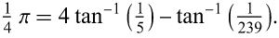 | (5)
There are three other Machin-like formulas, as well as thousands of other similar formulas having more terms.
Gregory and Leibniz found
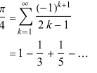
(Wells 1986, p. 50), which is known as the Gregory series and may be obtained by plugging x=1 into the Leibniz series for .x and tan inverse x

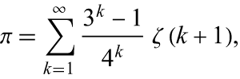is another representation for pi

An infinite sum series to Abraham Sharp (ca. 1717) is given by
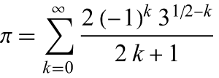

In 1666, Newton used a geometric construction to derive the formula
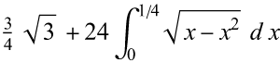

=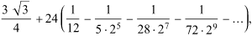

Plouffe in 2006 gave beautiful formula
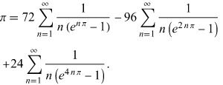

A slew of additional identities due to Ramanujan, Catalan, and Newton are given by Castellanos (1988ab, pp. 86-88), including several involving sums of Fibonacci numbers. Ramanujan found

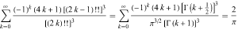

These are some related works in infinite series representation of pi.For more infinite series visit https://mathworld.wolfram.com/PiFormulas.html

DERIVATION OF INFINITE SUMMATION OF PI

SARATH’S INFINITE SERIES REPRESENTATION OF PI

Fig1.0
In a circle of radius”R” an equilateral triangle is constructed in such a manner that all the vertices of the equilateral triangle will be touching the circle.Using trigonometry we can find that the side of equilateral triangle is 2Rcos30.So the area of the equilateral triangle is $\frac{\sqrt{3}{(2Rcos30)}^{2}}{4}=\frac{3\sqrt{3}R^{2}}{4}sq units.$This is known as phase 1 triangle.There will be three regions 1,2&3 as represented in fig 1.0.In these three regions we are going to construct isosceles triangles.
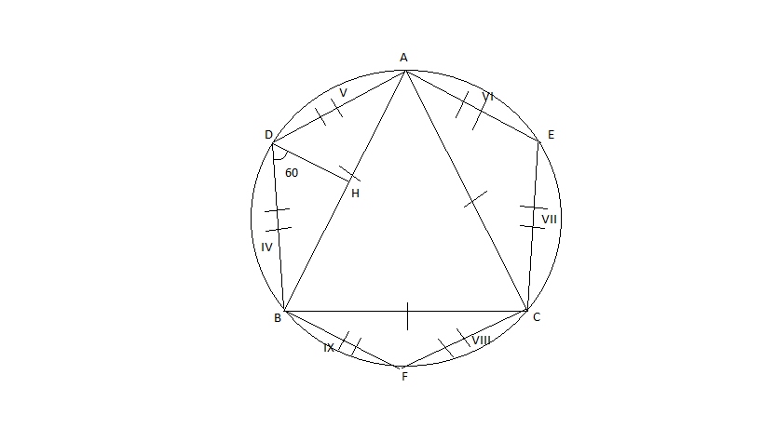
fig.1.1
Three triangles ADB,AEC and CBF are equal and are isosceles triangles.We have to find the area of these triangles(phase2 triangles)
Considering triangle ADB ,AB=base=2Rcos30,
When you consider the polygon ADBFCE the angle ADB is 120 degrees.In a regular polygon having n equal sides,each angle will be equal to (n-2)*180/n
So angle ADB =(6-2)*180/6=120,and angle BDH is half of angle ADB so angle BDH =60 degrees.
Considering triangle BDH
tan 60=BH/DH
DH=Rcos30/tan60
So area of triangle ABD is0.5*AB*DH
Ie,0.5*(2Rcos30)*Rcos30/tan60=$R^{2}*\cos^{2}30*cot60$
Here we can construct three such kind of phase 2 triangles.So total area of phase 2 triangles is $3R^{2}\cos^{2}30cot60$

From fig 1.1 there are six regions iv,v,vi,vii,viii,ix
Each of these regions are equal.So in this region we can construct another isosceles triangle(phase 3 triangles).We will be able to construct 6 such kind of phase 3 triangles.
Considering triangle BDH sin60=BH/BD,
Sin60=Rcos30/BD
BD=Rcos30/sin60

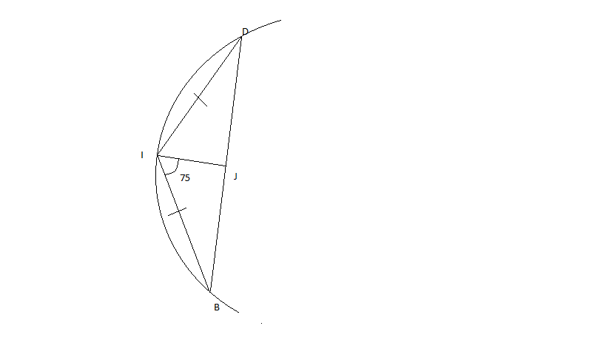fig1.2
BJ=BD/2=Rcos30/2sin60
tan 75=BJ/IJ
IJ=Rcos30/(2sin60*tan75)
Area of triangle BID=0.5*BD*IJ
=0.5*(Rcos30/sin60)*(Rcos30/(2sin60*tan75))
=$R^{2}\cos^{2}30/(4\sin^{2}60*tan75)$
There will be six such kind of triangles.

The value of side BI can be calculated from triangle BIJ,ie
Sin75=BJ/BI
From that BI will be equal to Rcos30/(2sin60*sin75)

In region between line BI and arc BI as in fig 1.2 we can construct another isosceles triangle.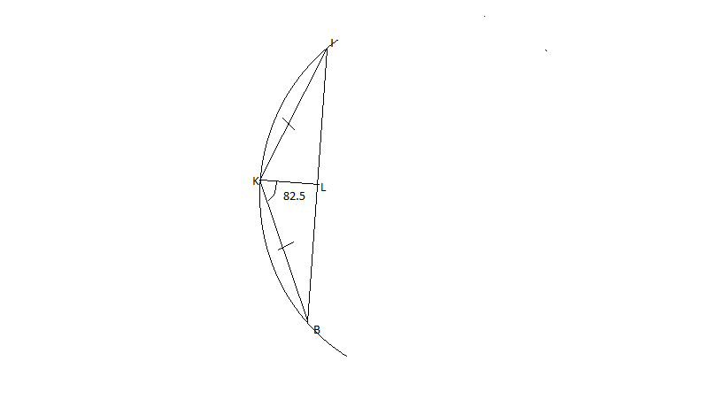
Fig 1.3
The angle BKI is part of a regular polygon having 24 sides so
angle BKI=(24-2)*180/24=165 degrees
so angle BKL is half of angle BKI ie,82.5 degrees
so tan82.5=BL/KL
BL=BI/2
BL=Rcos30/(4*sin60*sin75)
Substituting value of BL we get KL
KL=Rcos30/(4*sin60*sin75*tan82.5)
So area of triangle BKI=0.5*BI*KL
=$\frac{R^{2}\cos^{2}30}{16\sin^{2}60\sin^{2}75tan82.5}$ can construct 12 such kinds of triangles(phase 4 triangles)

In region between arc BK and side BK from figure 1.3 we can construct another isosceles triangle (phase 4 triangle)
Using trigonometry we can find out side BK=Rcos30/(4sin60*sin75*sin82.5)(ref.fig1.3)
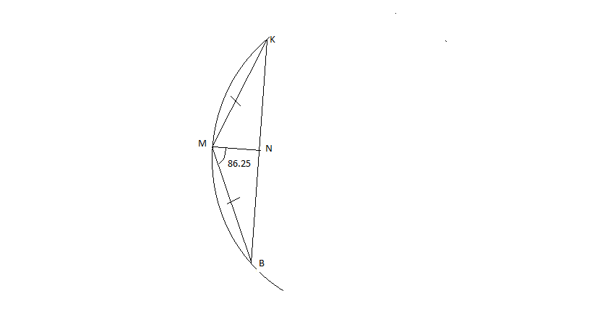
Fig1.4
BN=BK/2 ,BN=Rcos30/(8sin60*sin75*sin82.5)
tan 86.25=BN/MN, MN=BN/tan86.25
MN=Rcos30/(8sin60*sin75*sin82.5*tan86.25)
Area of triangle BMK(phase 4 triangle)=0.5*BK*MN=
$\frac{R^{2}\cos^{2}30}{64\sin^{2}60\sin^{2}75\sin^{2}82.5tan86.25}$ can construct 24 such kinds of triangles

Similarly in region between arc BM and side BM we can construct phase 5 triangle.
The area of phase 5 triangle can be done by the previous steps
The area comes out to be $\frac{R^{2}\cos^{2}30}{256 \sin^{2}60\sin^{2}75\sin^{2}82.5\sin^{2}86.25tan88.125}$
We can construct 48 such kind of phase 5 triangles
Similarly we can construct 96 phase 6 triangles
The area of phase 6 triangle =$\frac{R^{2}\cos^{2}30}{1024\sin^{2}60\sin^{2}75\sin^{2}82.5\sin^{2}86.25\sin^{2}88.125tan89.0625}$
Similarly we can construct 192 phase 7 triangles
The area of phase 7 triangle is =$\frac{R^{2}\cos^{2}30}{\begin{aligned}4096\sin^{2}60\sin^{2}75\sin^{2}82.5\sin^{2}86.25\sin^{2}88.125\sin^{2}89.0625tan89.53125 \\ \\ \end{aligned}}$
The process goes and goes on infinite number of times

If you observe closely on these equations you can observe a pattern from phase 3 triangle onwards.So I found out the pattern for infinite summation
So the area of circle=ar(phase1 triangle)+3 ar(phase 2triangle)+6*ar(phase 3 triangle)+12 ar(phase 4 triangle)+24 ar(phase 5 triangle)+48 ar(phase 6 triangle)….3×$2^{n-2}×ar(phase n triangle)$…..continues upto infinity.
$$πR^{2}=\frac{3\sqrt{3}R^{2}}{4}+3{×R}^{2}\cos^{2}30cot60+6×\frac{R^{2}\cos^{2}30}{4\sin^{2}60*tan75}+$$
$$12×\frac{R^{2}\cos^{2}30}{16\sin^{2}60\sin^{2}75tan82.5}+24×\frac{R^{2}\cos^{2}30}{64\sin^{2}60\sin^{2}75\sin^{2}82.5tan86.25}+$$

$48×\frac{R^{2}\cos^{2}30}{256 \sin^{2}60\sin^{2}75\sin^{2}82.5\sin^{2}86.25tan88.125}+………..$ and series continues upto infinity

We can cancel $R^{2 }from both LHS and RHS$ and we will get infinite series representation for PI

$$π=\frac{3\sqrt{3}}{4}+3\cos^{2}30cot60+6×\frac{\cos^{2}30}{4\sin^{2}60*tan75}+$$
$$12×\frac{\cos^{2}30}{16\sin^{2}60\sin^{2}75tan82.5}+24×\frac{\cos^{2}30}{64\sin^{2}60\sin^{2}75\sin^{2}82.5tan86.25}+$$

$$48×\frac{\cos^{2}30}{256 \sin^{2}60\sin^{2}75\sin^{2}82.5\sin^{2}86.25tan88.125}+…continues upto inifnity$$
********************************************************************************************

$$π=\frac{3\sqrt{3}}{4}+3\cos^{2}30cot60+\sum_{n=1}^{infinity}{\frac{6×2^{n-1}×\cos^{2}30}{2^{2n}×\tan\left(\frac{\left(6×2^{n}-2\right)×180}{6×2^{n+1}}\right)\prod_{1}^{n}{\sin^{2}\frac{(6×2^{n-1}-2)×180)}{6×2^{n}}}}}$$

$$π=\frac{3\sqrt{3}}{4}+\frac{3\sqrt{3}}{4}+\left(\frac{9}{2}\right)\sum_{n=1}^{infinity}{\frac{2^{n-1}}{2^{2n}×\tan\left(\frac{\left(6×2^{n}-2\right)×180}{6×2^{n+1}}\right)\prod_{1}^{n}{\sin^{2}\frac{(6×2^{n-1}-2)×180)}{6×2^{n}}}}}$$

$π=\frac{3\sqrt{3}}{2}++\left(\frac{9}{2}\right)\sum_{n=1}^{infinity}{\frac{2^{n-1}}{2^{2n}×\tan\left(\frac{\left(6×2^{n}-2\right)×180}{6×2^{n+1}}\right)\prod_{1}^{n}{\sin^{2}\frac{(6×2^{n-1}-2)×180)}{6×2^{n}}}}}$

$π=\frac{3\sqrt{3}}{2}++\left(\frac{9}{4}\right)\sum_{n=1}^{infinity}{\frac{1}{2^{n}×\tan\left(\frac{\left(6×2^{n}-2\right)×180}{6×2^{n+1}}\right)\prod_{1}^{n}{\sin^{2}\frac{(6×2^{n-1}-2)×180)}{6×2^{n}}}}}$
is the simplified expression for pi

EXPERIMENTAL PROOF FOR THE ABOVE RESULT
On doing calculation with a very good calculator I obtained the following result
When n=1 I got value of pi as 3
When I put the value of n =2 I got value of pi as 3.105828541
When I put value of n=3 I got value of pi as 3.124511194
When I put value of n=4 I got value of pi as 3.131232784
When I put value of n=5 I got value of pi as 3.132914531
So the experimental observation suggests that as value of n increases the function approaches to value of pi.The function stagnates and reaches very near to pi for n=10 onwards because tan value approaches towards infinity or a very large value.

CONCLUSION
Pi is a constant which connects radius to the area of the circle.I devised a mechanism to represent the value of pi in an equation.I also performed some experiments to check the validity of the equation and the equation passed all the tests.The equation is very much valid and successful.

