GAS DETECTION USING MACHINE LEARNING
J.SWATHIKA [1], S.SUNDARESAN[2], N.VISHNU VARDAN [3],V.V.UMAIBHALAN,
Prof.D.MURUGESEN[5],

Swathika.J, Dept of ECE, SRM Valliammai Engineering college, Tamilnadu, India

- Sundaresan.S, Dept of ECE, SRM Valliammai Engineering College, Tamilnadu, India

Vishnu Vardan.N, Dept of ECE, SRM Valliammai Engineering College, Tamilnadu, India

- Umaibhalan.V.V, Dept of ECE, SRM Valliammai Engineering College, Tamilnadu, India

Mr.D.Murugesen ME.(A.P), Dept of ECE, SRM Valliammai Engineering College, Tamilnadu, India

ABSTRACT

Making houses more inclusive, safer, resilient and sustainable is an important requirement that must be achieved in every society. Gas leakage and fires in smart houses are serious issues that are causing people's death and properties losses. Currently, preventing and alerting systems are widely available. However, they are generally individual units having elementary functions without adequate capabilities of multi-sensing and interaction with the existing Machine-to-Machine (M2M) home network along with the outside networks such as Internet. Indeed, this communication paradigm will be clearly the most dominant in the near future for M2M home networks. In this paper, we are proposing an efficient system model to integrate the gas leakage and fire detection system into a centralized M2M home network using low-cost devices. Then, through machine learning approach, we are involving a data mining method with the sensed information and detect the abnormal air state changes in hidden patterns for early prediction of the risk incidences. This work will help to enhance safety and protect property in smart houses. The detection of volatile organic compounds (VOCs) has become a serious task in many fields, because the fast evaporation rate and toxic nature of VOCs could be dangerous ans also affect lungs at high concentration levels in air and working ambient for the health of human beings.

I INTRODUCTION

Thousands of people are dying because of inhaling Carbon monoxide (CO) gas each year, and in contrast to other poisons it has the highest accidental deaths – not only because of its deadly nature, but seeing, smelling or tasting it is impossible, and it doesn’t annoy mucous membranes or skin. CO is fast-acting. It’s often too late by the time victim notices symptoms of poisoning. Any carbon-based fuel (gas, coal, petroleum, etc.) incomplete combustion will result in producing Carbon monoxide.

III OBJECTIVE

- The objective of this project is to detect any leakage of LPG/CNG based car, small scale factories or in home appliances also.

- It will detect the leakage and will open the window and stop the supply of the current. Servo motor is there that could be attached with the window and will open the window by rotating it.

- For assistance and LCD of 16x2 is also there. An alarm is there also the stop the alert the user as soon as leakage is found.

EXISTING METHOD

- There are numerous techniques available now a days in order to detect any gas leakage or the spilling of gas from the cylinders.
- The arduino reads the voltage from the detector and uses it to calculate the modification in concentration.
- The gas detector is sensitive to many gases and actually gas kind cannot be determined.
- Instead, during the work, it is assumed that the gas sensing element has the same or the identical sensitivity for LPG and CH4, it may be thought about a sound assumption.

PROPOSED METHOD

- In this Proposed system we use machine learning approach to design efficient detectors that can signal the presence of a leakage.
- Low Cost and Easy Implementation.
- High Accuracy due machine learning.

BLOCK DIAGRAM

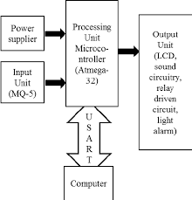

GAS SENSOR(MQ5)

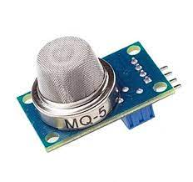
- The gas sensor module consists of a steel exoskeleton under which a sensing element is housed.
- This sensing element is subjected to current through connecting leads.
- This current is known as heating current through it, the gases coming close to 22 the sensing element get ionized and are absorbed by the sensing element.
- This changes the resistance of the sensing element which alters the value of the current going out of it.
- Image shows externals of a standard gas sensor module: a steel mesh, copper clamping ring and connecting leads.
- The top part is a stainless steel mesh which takes care of the following:
✓ Protecting the insides of the sensor.
✓ Exhibits an anti-explosion network that keeps the sensor module intact at high temperatures and gas pressures.

  - METHODOLOGY

- The MQ-5 gas sensor which is used in this work replaces the existing MQ-2 and MQ-4 sensor for better and efficient detection is used in detecting gases .

- This transmits a voltage signal which is proportional to the gas level and is sent to the arduino uno.

- This signal is sent by the arduino to the external peripherals. As a result, the buzzer signals an alarm sound and the led starts to glow.

- Simultaneously this change in output is transmitted through wi-fi network to the cloud in which the application is formulated that sends a notification to the mobile phone/laptop through the internet.
  - SIMULATION AND RESULTS
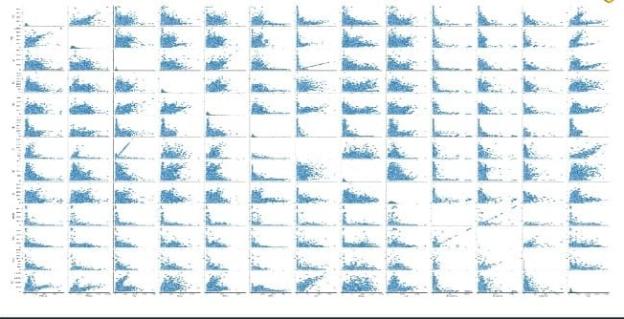

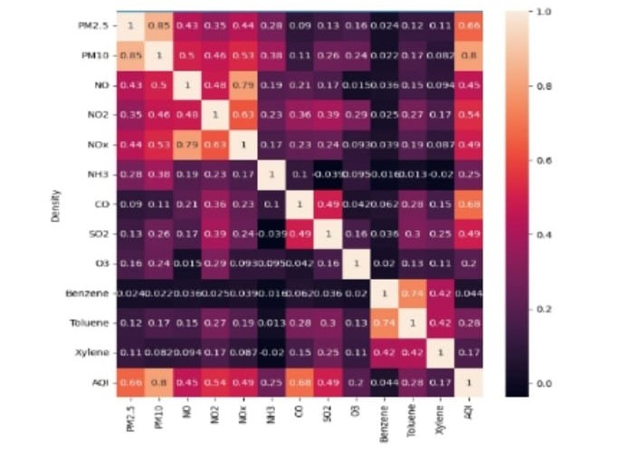

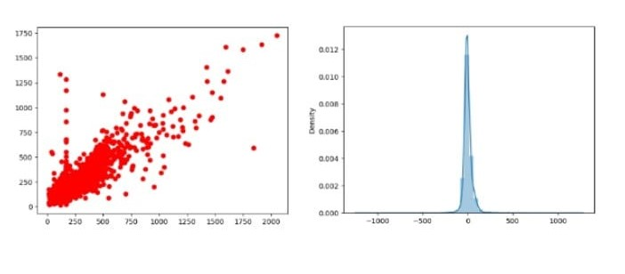

APPLICATION

- Data analytics for improved decisions
- Measure oxygen level accuracy
- Get immediate gas leak alerts

CONCLUSION AND FUTURE SCOPE

In recent households, the use of LPG is taking a big troll. From the use of cylinder up to the use of petroleum pipelines. The biggest threat in using this technology is security. And our project will prove to be boom for households and industries. This work has presented a methodology for gas leak detection in environment using the current technology.This system is not expensive and can be installed on every home easily. This paper consists of two sections transmitter part and the receiver part. In this, the automated booking of the latest LPG cylinder is enforced. With the assistance of the gas device and cargo device ready to able to observe the amount of the gas and also the gas leak. And at last with the application of GSM Module, a new LPG cylinder can be booked by the user. By this system, the users can be aware of their gas level and it also avoids the prior and delays booking of the cylinder. And also the components used here are commercially cheap when compared to other gas detectors. Hence this concept can also be widely used in the industries according to their requirements.

ACKNOWLEDGMENT

I would like to express my gratitude to my management, who gave me the wonderful opportunity to do this project on the topic of blind people's personal assistants, which also helped me in doing a lot of research and I came to know about so many things. I am really grateful to them. We acknowledge the support and guidance provided by our internal guide, MR. D. MURUGESEN. A.P (Sel.G). Without support, guidance and encouragement, this project could not be done. We also thank our Head of the Department for providing the opportunity to do this project, and we also thank other members who held onto our project. We express our sincere thanks to all.

REFERENCES

[1] The official website Petrobangla (government-owned national company to explore, produce, transport, manage and sell oil, natural gas and other mineral resources of Bangladesh, Accessed on Dec. 4, 2020. Available: http://petrobangla.org.bd/site/view/reports/
[2] P. C. Mandal, “Gas Leak Detection in Pipelines & Repairing System of Titas Gas,” Journal of Applied Engineering, vol. 2, no. 2, February, 2014.
[3] A. Agrawal, and L. Kumar, “IoT based Hazardous Gas Detection System using AVR Microcontroller,” International Research Journal of Engineering and Technology, vol. 4, pp. 3068, 2017.
[4] M. Newlin, and V. Venkatesa, “IoT Based Smart System for Controlling Co2 Emission,” International Journal of Scientific Research in Computer Science, Engineering and Information Technology, vol. 2, no. 2, 2017.
[5] J. Patil, J. Nadagouda, K. Hulloli, S. Harugeri, and S. ankali, “IoT Based Air Pollution Level Monitoring and LPG Cylinder Regulation and Security Syste,” International Journal of Engineering Science and Computing,in gas level detection which is posted in a volume of vol. 7p. 12541-1243, May 2017

