Intelligent Wireless Accident Alert System

Mohammed Riyaz M¹, Muthu Mariappan G², Pon Selvam M³, Prem Benyameen S⁴, Ramya. T⁵

^{1,2,3,4} UG Students, Electronics and Communication Engineering, Francis Xavier Engineering College
⁵Assistant Professor, Electronics and Communication Engineering, Francis Xavier Engineering College

Abstract- Smart accident detection systems are systems that automatically detect accidents. Iot can connect different hardware, especially sensors, and can do processing using the information received from sensors, which lead to accident detection. This project proposes and IOT based accident detection system Vibration sensor and Ultrasonic sensor are used in this system. With the rapid growth of population vehicles have become an absolute necessity in our daily life. Increasing vehicles causes lots of accidents and loss of life due to late information reaching to the rescue team and arrival of an ambulance.

Index Terms- Smart Accident System; Ultrasonic sensor; Accident Detection;

- INTRODUCTION

This equipment is mounted on the vehicle in such a way that it cannot be seen by anyone inside or outside the vehicle. Therefore, it is used as a secret unit to send business information to the supervisor on a regular basis or with any effect on the system. When a vehicle is stolen, the system’s location information can be used to locate the vehicle and alert the police for further action. Some vehicle tracking systems can also detect unauthorized vehicles and notify the vehicle owner. This has advantages over other methods for the same purpose. The accident warning system in it detects the situation and location of the accident and sends GPS coordinates to mobile phones, computers, etc. send to devices.

- Features
The often benefits shipping-based companies. Since it shows the location of each vehicle over time, Accordingly, They can create the necessary information. These tracking systems can create a complete inspection route by noting exactly where the vehicle is, where it stopped, and when each stop was made. It is also used for buses and trains to estimate their distance and the time it takes to reach a particular stop. These systems are used for data collection, data storage, data analysis, and finally data transmission. The vehicle reaches this location using the input from GPS and mobile communication and sends it to the desired phone/laptop via the GSM module. Vehicle tracking technology is one of the most dangerous technologies in tracking vehicle activities.

The security system uses the Global Positioning System GPS to locate the vehicle to be tracked or tracked, and then sends the control and information location to the repair site using radio or radio. At the monitoring station, vehicles are drawn on the map using various software, then, vehicle owners can monitor their vehicles in real-time.

Car tracking technology has become popular among expensive car owners because of its time tracking feature.
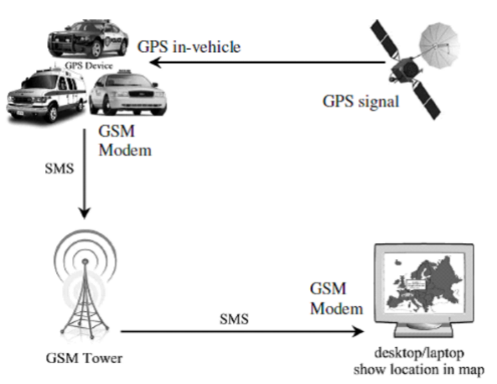
Fig 1.1 System Overview

- Literature Survey

- An automated IOT-based effective accident detection system. Immediately after the incident, the data files are sent to the network server, and a message is immediately sent to people and relevant organization who know the victim, such as the traffic control room, the nearby police station, and the ambulance service.
- Automatic Accident Detection and Human Rescue System(AADHRS) will detect accidents and save the victm’s life by informing the rescue team. A vibration sensor, Global System for Mobile (GSM), and Global Positioning System (GPS) are used in this system. After taking places of an accident, the system delivers a short message to a nearby rescue team and police station via the GSM module. The message includes the longitude and latitude values of the location.
- To solve the latency problem, the cloud has emerged as an environment that brings cloud-like resources closer to end devices.
- An automatic real-time driver fatigue detection system based on an image processing technique along with a cloud-based management platform.
- To deliver effective web application services there exists a GPS tracking facility to identify the exact location of , the Twilio service to pass the information.
- An enabling multi-sensor fusion-based longitudinal vehicle speed estimator is proposed for four-wheel-independently-actuated electric vehicles using a Global Positioning System and Beidou Navigation Positioning (GPS-BD) module, and a low-cost Inertial Measurement Unit (IMU). For accurate vehicle speed estimation, an approach combing the wheel speed and the GPS-BD information is first put forward to compensate for the impact of road gradient on the output horizontal velocity of the GPS-BD module, and the longitudinal acceleration of the IMU.
- Tracking maneuvering vehicles in a complex dynamic environment is a challenging problem for advanced driver assistance systems and autonomous driving systems.

- Proposed scheme

In this study, a system developed for the tracking of vehicles involved in an accident using GPS technology is presented. The GPS receiver transmits commands using the Arduino UNO controller. The system is fixed in the car. The GPS module sends the location value to the controller. To monitor data from sensors, use the Thing speak channel. This uses IOT technology to collect and visualize sensor data.
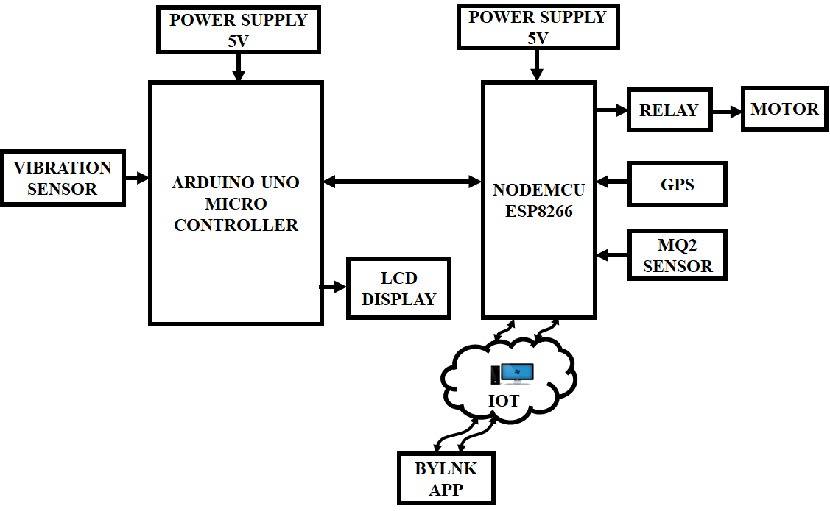
Fig 4.1 Block Diagram of the Proposed System

A compact power supply will power the Arduino board. The GPS will derive power from the Arduino board itself. The circuit is first initialized and the GPS module is enabled. The vibration sensor senses the abnormal vibration and gives the signal to the microcontroller. The MQ2 gas sensor is used to detect unwanted gas leakage in the environment. MQ-3 gas sensor has a high sense of Alcohol and has unprecedented affirmation from the inconvenience of gas, smoke, and vapor. Then the system goes into standby mode until the sensor button gives good results. When an accident is detected, the Arduino gets the current location of the vehicle using the GPS module and then sends the control as an alert to the emergency services, and/or the user can save people. The sensed signal is transmitted to the microcontroller and the code is developed in Embedded C. The Nodemcu wifi module is used to connect the system to the mobile and sent an alert to the human using Blynk App.

- Hardware components

To create the product, many materials are used to make it work it work flawlessly. All materials are purchased from different manufacturers. These parts are soldered to the pads. This system must have the hardware listed below.
- GPS
- MICROCONTROLLEER ATMEGA 328
- LCD DISPLAY
- POWER SUPPLY
- SWITCH
- CRYSTAL OSCILLATOR
- LM7805
- W10M BRIDGE RECTIFIER
- LED
- RESET BUTTON

- Modules

The various modules in the drowsiness and accident detection system are
- Accident and abnormal pulse detection
- Sleep detection
- Location tracking
- Message sending

- Modules Describtion

- ACCIDENT AND ABNORMAL PULSE3 DETECTION
In the project, vibration sensor will be associated with the arduino board. At the point when there is no vibration distinguished, vibration sensor yield will be 0 (low voltage), generally its yield will be 1(high voltage). At the point when the vibration is high, it may be expected as accident has happened. To affirm the circumstance, the beat rate of the driver must be checked. A heartbeat rate sensor is utilized to check the beat. The heartbeat sensor is a plug-and-play sensor for arduino and arduino compatibles. It tends to be utilized by under studies who need to incorporate live heart/beat rate information into their ventures. The heartbeat sensor adds intensification and noise dropping to the equipment. It is quicker and simpler to get solid heartbeat readings. Heartbeat sensor works with either a 3V or 5V power supply. The beat sensor is interfaced with arduino and the arduino is associated with the LCD show which shows the best qualities. At the point when the beat worth is additionally higher than ordinary worth, it will be considered as an accident that has been happening. At the point when the yield from vibration sensor is low, the vehicle is under ordinary condition. However, during this condition, if the beat worth is lower than ordinary worth, it is expected that heart is irregular.
- SLEEP DETECTION:
The eye-blink sensor is utilized to distinguish the closure of eyes. It works by passing the eye and eyelid territory with Proceedings of the Third I-SMAC International Conference (Social, Mobile, Analytics and IOT in the Cloud) (I-SMAC 2019) IEEE Xplore Chapter Number: CFP190S V-ART; ISBN: 978-7281-4365-1 978-1-7281-4365-1/19/$31.00©2019 IEEE 161 Licensed for use by Auckland University of Technology. Retrieved Jun 2,2020 07:52:19 UTC by IEEE Xplore. There are restrictions. Infrared light, at that point examining the adjustments in the reflected light utilizing a phototransistor and differentiator circuit. It works with a 5V power supply. Interface managed DC power supply of 5Volts to the eye blink sensor. The dark wire is ground, next center wire is yield and red wire is certain to supply. To check whether the sensor working, associate just two wires that is the 5V and ground wire. Leave the yield wire detached. At the point when eyes are shut, the LED will be off and the yield is at 0V. Put eye flicker sensor glass on face inside 15mm separation from eyes, and view the LED squinting on each Eye squint. At the point when the eye is open, the yield will be high. The yield is offered legitimately to microcontrollers for interfacing applications. A bell is associated with arduino. At the point when the yield from eye flicker sensor is low, the signal will be set to high. On the off chance that the driver feels sleepy, he will be cautioned by the ringer sound and he didn’t off the bell, it would be considered as the driver felt unconscious and something is irregular.
- LOCATION TRACKING GPS:
Represents Global Positioning System. It is utilized to follow the latitude and longitude of any area on the earth. It identifies the accurate UTC (Universal Time Coordinated). GPS module is utilized to follow the area of accident in this paper. The device gets the directions from satellite consistently, with time and date. To discover just the scope and longitude arranges, utilize the $GPGGA string. GPS module sends the information identified with following position, and it sends numerous information in NMEA group. NMEA arrangement comprises numerous sentences, where just one sentence is required. This sentence begins with $GPGGA and contains the directions, time and other helpful data. This refers to GPGGA Global Positioning System Fix data. Focus on the string $GPGGA by including commas in the sting. If the string $GPGGA is found, store it in an array, at which point the latitude is to be found after two commas and the longitude is to be found after four commas.
- MESSAGE SENDING:
SIM900 is a complete quad-band GSM/GPRS module that can be placed in operation to be used effectively in voice, SMS, and messaging with low power consumption. AT stands for maintenance. It is used to control the GSM module. There are also a few phone calls informing utilizing GSM with Arduino. For testing the GSM module, use AT direction. At the point when the GSM module gets AT order, it reacts with OK. It implies GSM module is functioning effectively.
- RESULT

The most important thing in the world today is to ensure the safety and security of public and private vehicles. Therefore, the vehicle is ready to find the exact location of the vehicle when it is lost or hidden somewhere. GPS technology is used for location tracking. Suitable for ship control, transportation, military use, school bus, public car etc. Thus this project presented a system to detect accidents automatically and give a clear way to emergency-purpose vehicles on the road so that they can reach their destination in the least time without stopping at traffic intersections. This system can be used effectively for better results in a city or a country with a large population like India.

SOFTWARE TOOL:
- Arduino IDE Software Tool
- Blynk
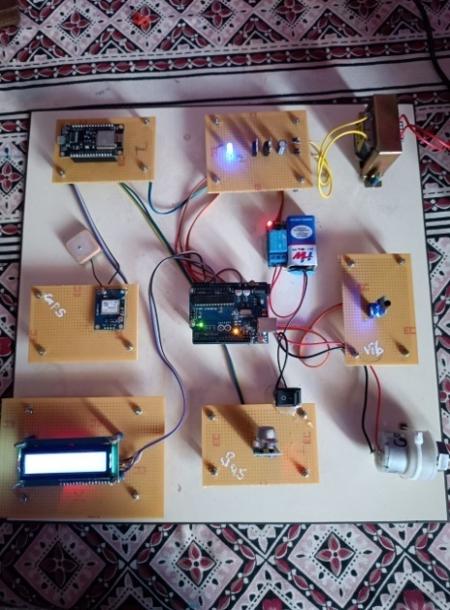
Fig: Hardware stimulation

- REFERENCES
- Girinath N; Dinesh Kumar J R; Dr. C. Ganesh Baby; Yahzhini S.T; Shopika P.k, 2021, Automatic Alert for Accident Detection and Rescue based on Wireless Technology”, IEEE Access, vol: 08, pp: 16573 – 16583.
- Nazia Parveen; Ashif Ali; Aleem Ali, 2020, “IOT Based Automatic Accident Detection and Emergency Alert System for Motorbikes", IEEE Access, vol: 07, pp:148163 – 148175.
- Rajvardhan Rishi; Sofiya Yede; Keshav Kunal; Nutan V. Bansode, 2020, Automatic Messaging System for Vehicle Tracking and Accident Detection”, IEEE Access, vol: 08, pp: 111536 – 11155.
- Pranav Chitale; Tanvi Dhope; Amodh Akhelikar; Surekha Dholay, 2020, "Smart Accident Recognition and Alerting System for Edge Devices", IEEE Access, vol: 08, pp: 122480 –122497.
- Himanshu Arora; Samyak Jain; Sanket Anand; Dharmveer Singh Rajoot; Neha Yadav, 2019, “Real Time Safety Alert System for Car”, IEEE , vol: 69, no: 11, pp: 12797 – 12806.
- S.Mohana Gowri; P.Anitha; D.Srivaishnavi; M.Nithya, 2019, “Internet of Things based Accident Detection System”, IEEE Access, vol: 07, pp: 53103 – 53114.
- Nicky Kattukkaran; Arun George, Mithum Haridas T.P, 2017, “Intelligent Accident Detection And Alert System for Emergency Medical Assistance”, IEEE Access, vol: 08, pp: 203854 – 203875.
- Hossam M. Sherif; M.Amer Shedid; Samah A. Senbel, 2014, “Real Time Traffic Accident Detection System using wireless Sensor Network”, IEEE vol: 03, no: 04, pp: 559 – 570.
- Amit Meena; Srikrishna Iyer; Monika Nimje; Saket Joglekar; Sachin Jagtap; Mujeeb Rahman, 2014, “Automatic Accident Detection and Reporting Framework for Two Wheelers”, IEEE vol: 05, no: 02, pp: 251 –264.
- Md. Syedul Amin; Md. Jubayer Jalil; M.B.I. Reaz, 2012, “Accident Detection and Reporting System Using GPS, GPRS, and GSM Technology”, IEEE vol: 20, no: 12, pp: 4538 –4552.

