“ONLINE & OFFLINE UNINTERRUPTED POWER SUPPLY (UPS) USING POWER MOSFET”

Mr.P.K.Vinkare¹, . Biradar Bhagvat ², Ulgulwad Komal ³ , Akkawar Sakshi , Karlekar Dipa ⁵
¹ Prof , Government Polytechnic , Nanded Maharashtra - 431602
²,³,⁴, ⁵ Students, Government Polytechnic , Nanded Maharashtra - 431602
---------------------------------------------------------------------***--------------------------------------------------------------------

-
Abstract - In this project, we make a portable 100 watt uninterruptable power supply (UPS) system.
It is proposed as a viable solution for low power applications. The power electronics device, which converts DC power to AC power at required output voltage, and frequency level is known as inverter. Here we can design UPS with online and offline. Using portable 12 V 14 Amp battery and IC4047 for proper frequency (PWM) maintaining. Using step up transformer boost AC current. Or DC battery to convert AC current called Inverters are used for many applications such as to run a laptop, TV or cell phone. This project focuses on design and develop portable of single-phase UPS with different mode like online , offline etc.
Design of UPS in such way that we can change its mode with single switch. Also its portable and lab purpose. Both AC output voltage and DC battery voltage can be measure by digital meters.

1. INTRODUCTION

What is UPS (Uninterruptible Power Supply)? UPS is an abbreviation for Uninterruptible Power Supply and the reason for its name is that it provides a constant supply of power without any interruption. In Normal operation, it draws current from the AC mains and during a power outage; it draws current from its backup source. A UPS system utilizes a DC power stored in the battery as its backup source. The UPS charges the battery from the AC mains through a Rectifier and charge controller circuit. At the same time, it supplies power to the output AC load. In case of power failure, the UPS utilizes this charged DC power in the battery and converts it into AC using an inverter and supplies it to the AC load. Now the switch over between the sources (AC mains and the battery in case of power failure) is instantaneous. But it does take some time. This time delay during the switching may affect some sensitive electronic equipment while other devices may tolerate it in a specific range. This is where Online UPS and Offline UPS comes into play.

Keywords :- UPS , Controller, AC/DC load , PWM MOSFET .

2. Objectives of UPS using power device :-

- Safety Where there is a risk to life or health such as in air traffic control, aviation ground lighting, medical equipment in hospitals, nuclear installations, oil refineries.

- Security against vandalism, espionage, or attack Area lighting, communication systems, military installations, etc.

- Data loss Situations in which the loss of data may be catastrophic and irretrievable such as data processing and long-term laboratory type of testing or experiment.

3. Literature survey :-

- Aaron M. Jungreis, Cary’s paper [4] presents the system using multiple auxiliary sources.According to Aaron, An electronic circuit, such as a UPS, interfaces a main ac power source and at least one
secondary power source to a load

- Pragya et al. in their paper [5] titled “A current and future state of art development of hybrid energy system using wind and PV-solar” proposed that - The wind and solar energy are omnipresent,
freely available, and environmental friendly

- Kaurav et al. [6] stated that Wind turbine is that system which extracts energy from wind by rotation of the blades of the wind turbine. Basically wind turbine has two types one is vertical and another is horizontal.

- Sivaramakrishna et al. [7] proposed an alternative energy harvesting approach based on
Nanoantennas that absorb the incident solar
radiation .The Nano-antennas target

4.COMPONENTS :-

List of the components

- Cooling fan
- TRANSFORMER
- RECTIFIER
- MOSFET
- Relay
- Regulated power iclm7815
- LED LIGHT

1) Cooling fan
Used to cool the heat sink 4.1 Cooling Fan A small fan is any fan inside, or attached to, a computer case used for active cooling, and may refer to fans that draw cooler air into the case from the outside, expel warm air from inside, or move air across a heat sink to cool a particular component. Generally these are found in axial and sometimes centrifugal forms. This project use dc cooling fan for cooling of inverter Mosfe

2) TRANSFORMERr :-
The transformer is used for connecting this system directly to 220V AC. It steps down 220V into 12V. A transformer is an electrical device that transfers electrical energy at one voltage from one circuit to other at a different voltage merely by magnetic coupling; the transfer
of energy doesn’t involve any kind of motion

3) Rectifier:

Single-phase circuits or multi-phase circuit comes under the rectifier circuits. For domestic applications single-phase low power rectifier circuits are used and industrial HVDC applications require three-phase rectification. The most important application of a PN junction diode is rectification and it is the process of converting AC to DC.

4) MOSFET :-

MOSFET stands for Metal Oxide Field Effect Transistor, MOSFET was invented to overcome the disadvantages present in FETs like high drain resistance, moderate input impedance, and slower operation. So a MOSFET can be called the advanced form of FET. In some cases, MOSFETs are also be called IGFET (Insulated Gate Field Effect Transistor). Practically speaking, MOSFET is a voltagecontrolled device, meaning by applying a rated voltage to the gate pin, the MOSFET will start conducting through the Drain and Source pin..

5) RELAY :-
A relay is an electrically operated switch. Many relays use an electromagnet to mechanically operate a switch, but other operating principles are also used, such as solid-state relays. Relays are used where it is necessary to control a circuit by a low-power signal (with complete electrical isolation between control and controlled circuits), or where several circuits must be controlled by one signal. The first relays were used in long distance telegraph circuits as amplifiers: they repeated the signal coming in from one circui

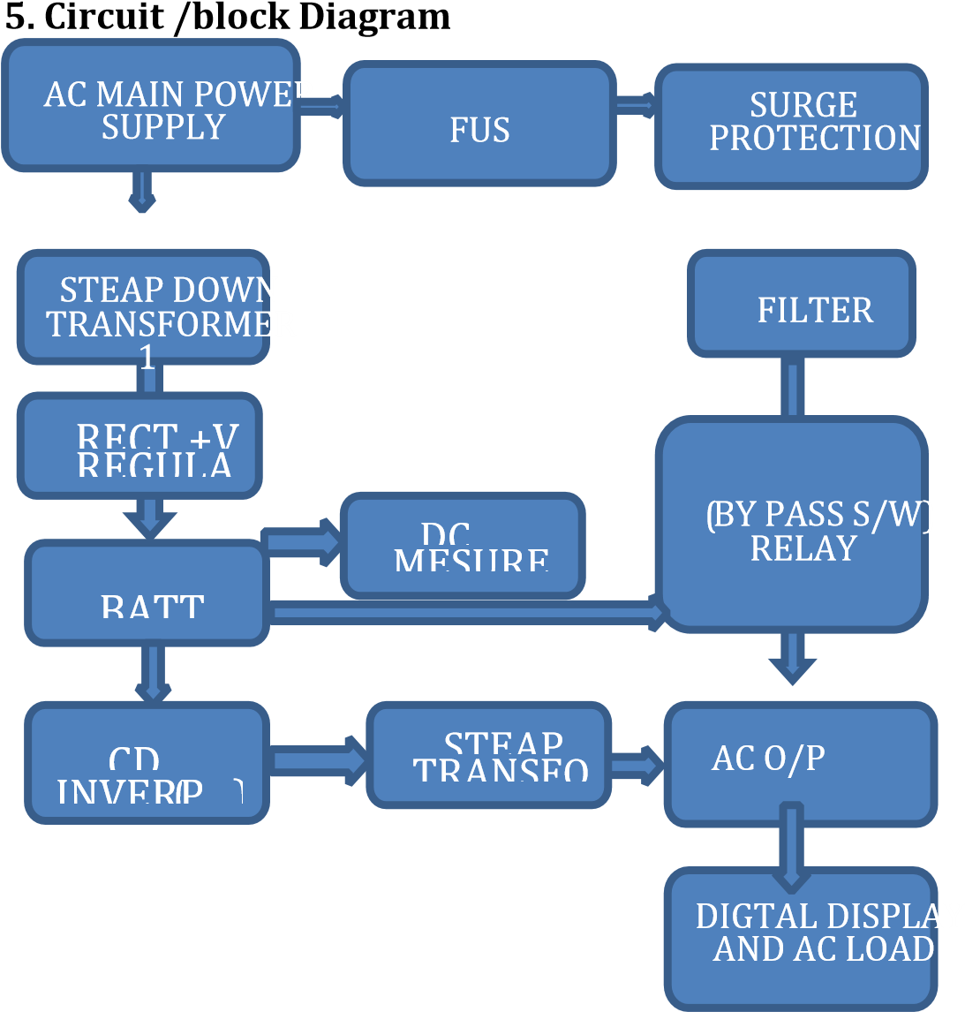

6) Working of Electric bicycle :-

The main power supply connected to ups ac line and simultaneously with steap down transformer. for ac line are uses surge protection with filter and fuse for ac main line goes to ac load against the relay switch or conversion relay board.

For second line uses step down transformer with rectifier and voltage with current regulator module which charge the battery also supply power to relay modules.

Dc power of battery can be measure volt meter and they connected with inverter ckt uses ic 4047 (pwm) with steap up transformer which create 220v ac they connected with output ac board against the relay board.

7) Advantages of electric bicycle:-

- Simple construction of ups
- Surge protection present
- Battery of 14amp gives min 2hour backup
- Using switch easy to change mode like online and offline
- Voltage and current both controller with module
- Digitally showing voltage of Dc and ac current.
- Emergency power supply.
- Maintain battery life

8) METHODOLOGY –

There are two types of our UPS project :

1. Online UPS

2. Offline UPS

A .Online ups :

What is Online UPS?
The Online UPS is a type of UPS that supplies power to the AC load through the Rectifier and
Inver
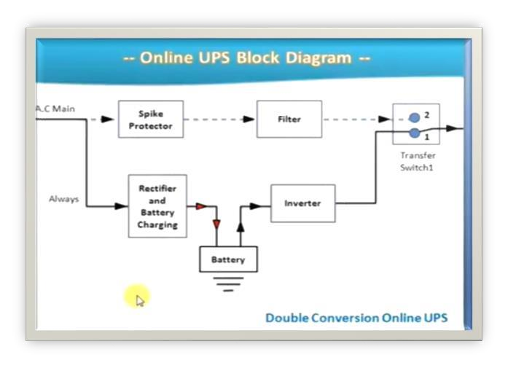
Fig :02

9) Actual Photo of electric Bicycle:-

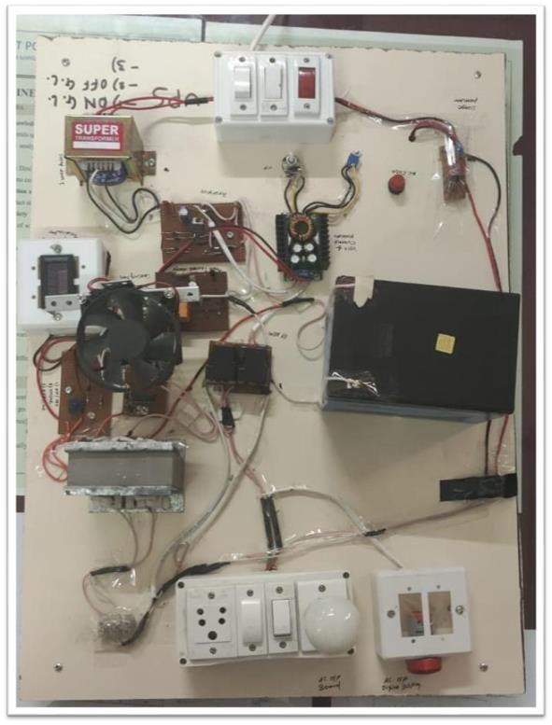
Fig :02

10) Result :-
From the working of UPS the result I got is “ The UPS is working fine , as soon as power got intrupted “. Online UPS is more efficient when very less delay time required in two or more connected devices.

11) Conclusion

The signal phase ups of 100watt successfully run on online and offline mode with up to 1hour backup by using 14amp battery

Fast change any mode and pure sine wave with 50hz frequency and 210v ac output using inverter (ic 4047) and steap up transformer.

The two led display continuously check voltage of battery and output ac load. In this way, I can successfully made ups with mode changing facility.

12) REFERENCES
1 Abdel-Rahim, N. M., & Quaicoe, J. E. (1996). Analysis and design of a multiple feedback loop control strategy for single-phase voltage-source UPS inverters. IEEE Transactions on Power Electronics, 11(4), 532–541.
2 | Botteron, F., & Pinheiro, H. (2007). A three-phase UPS that complies with the standard IEC 62040-3. IEEE Transactions on Industrial Electronics, 54(4), 2120– 2136.
3 | Branco, C. G. C., Cruz, C. M. T., Torrico-Bascope, R.  P., & Antunes, F. L. M. (2008). A nonisolated singlephase UPS topology with 110-V/220-V input-output voltage ratings. IEEE Transactions on Industrial Electronics, 55(8), 2974–2983.
4 | Das, P., Laan, B., Mousavi, S. A., & Moschopoulos, G. (2009). A nonisolated bidirectional ZVS-PWM active clamped DC-DC converter. IEEE Transactions on Power Electronics, 24(1–2), 553–558.
- Ni Song, Kang Wei PV grid-connected inverter certification [J]

- Authentication technology, 2010, (3):40-41. 2. Datasheet of 4047

- Ni Song Kang Wei PV grid-connected inverter certification [J] Authentication technology,2010, (3):40-41.

- Zhang Xin, Cao Renxian Solar photovoltaic power generation and

- inverter control [M]. Beijing: Machinery Industry Press, 2010.9:1

- Yan Huaguang, Zhang Xin, Yang Xiangjiang, Wang He, Fan Ying, Jiang Limin Li Taoyong PV inverter testing platform development [J] Grid 2011, 5(6):139-143

.

