Design of Microstrip Antennas Array for Wireless Applications by Using HFSS
¹ J.Swathi, ² B. Jhansi, ³ Y. Swarna Latha, ⁴ P.Chaitanya, ⁵ CH. Madhu
¹ Asst. Professor, ²³⁴⁵ Students
Dept. of ECE, Aditya Institute of Technology and Management (A)-Tekkali, AP

Abstract:

The modern wireless communication desires high gain, wide bandwidth and minimal size antennas that are efficient to provide improved performance over a wide range of frequency spectrum. This requirement leads to the design of microstrip patch antenna. This paper presents the design of compact 1X2 microstrip patch antenna array which uses the corporate feed technique for excitation. The proposed antenna is designed on FR-4 substrate with dielectric constant 4.4 and thickness 1.6mm. Dielectric constant and parameters like Return Loss, Gain and Radiation pattern are calculated using high frequency simulation software. The fabricated antennas results are to be compared with Simulation results. The antenna has been designed for the range 2.4 GHz.

Keywords: Microstrip antenna, corporate feed, FR-4 substrate, Microstrip antenna array

INTRODUCTION

As an interface between the transmitter/receiver and the propagation media, antenna is an essential part of any wireless communication (satellites, radars, aviation, medical applications etc.). The ever-increasing need for lightweight computing devices and the emergence of many systems, it is important to design a compact and more efficient antenna for communication [2, 10]. And there is a need for more compact antennas due to decrease in size of personal communication devices. As communication devices become smaller due to greater integration of electronics, the antenna becomes a significantly larger part of the overall package volume. For this purpose, Compact microstrip antenna is one of the most suitable for wireless application [2 ,3]. The word “Microstrip” comes because the thickness of this metallic strip is in micro- meter range. Microstrip patch antennas are well known, for the reason that they have some advantages due to their conformal and simple planar structure. They allow all the benefits of printed-circuit technology [3]. A huge number of papers are available on the investigation of various aspects of microstrip antennas. The essential features of a microstrip antenna are relative ease of construction, light weight, low cost and either compatibility to the mounting surface [4, 8] or, at least, an extremely thin projection from the surface. The major drawback of microstrip patch antenna is the narrow bandwidth. In single element antenna, the radiation pattern is equally very broad and the directivity is relatively low. This problem can be resolved by increasing the size of the element thus increasing the directivity. Other way to enlarge the antenna without changing the size of the particular elements is to assemble the radiating elements in a geometrical configuration known as an “array”. A Microstrip antenna array is very flexible antenna. It could be used to arrange required radiation pattern and scanning the beam of the antenna array. The performance of a microstrip patch antenna and array antenna strongly depends on several factors such as type of substrate, feeding technique, the thickness of dielectric and dielectric constant of substrate respectively. But it has few obstacles like narrow bandwidth,
Less gain and broad beam width. To increase the bandwidth, directivity and gain, the most common method is using multi- elements which are known as array. [7, 9] The efficiency of microstrip antenna arrays may be enhanced significantly by reducing losses in the feed network. Selection of dielectric substrate materials and their thickness are the primary parameters in terms of size and compactness a rectangular microstrip patch antenna. Compactness comes with a trade-off in bandwidth, directivity and gain. An array of patch antennas is used. This array improves the gain, band width and radiation pattern of the patch antenna [1, 9]. In this paper the designed microstrip antennas are also suitable for C and X band applications. The prolonged AM broadcast band or simply “X band” is a segment of the microwave radio region of the electromagnetic spectrum. X-band radar frequency sub-bands are used in the civil, military and government institutions for weather monitoring, air traffic control, maritime vessel traffic control, defense tracking, and vehicle speed detection for law enforcement. In radar engineering, its frequency variety is specified by the IEEE at 8.0 to 12.0 GHz. X band is used in radar applications including continuous-wave, pulsed, single polarization, dual-polarization, synthetic aperture radar, and phased arrays. In Ireland, Libya, Canada, the X is used for terrestrial broadband [1, 5, 6]. The proposed antenna is designed by the substrate material FR-4 and its dielectric constant 4.4 and height 1.6mm.

CORPORATE FEEDING NETWORK

Microstrip antennas are used in arrays and also used as single elements. By using array in communication systems we improve the performance of the antenna like increasing gain, directivity scanning the beam of an antenna system, and other functions which are difficult to do with the single element. The microstrip antenna array can be classified with different principle. The element of array can be divided in to form, linear, planar. The feed network of phased array can be categorized into parallel and series feed. The parallel

(Corporate) feed has single input port and multiple feed lines [1, 6, 9].
In the corporate feed configuration, the antenna elements are fed by 1: n power divider network with identical path lengths from the feed point to each element. The corporate-feed network is used to maintain power splits of 2n (i.e., n = 2; 4; 8; 16; etc.). Corporate-feed arrays are in general and adoptable. This method has more control of the feed of each element and is absolute for scanning phased arrays, multiband arrays. Thus, it provides better directivity as well as radiation efficiency and minimize the beam fluctuations over a band of frequencies compared to the series feed array. The phase of each element can be controlled by using phase shifters while amplitude can be adjusted using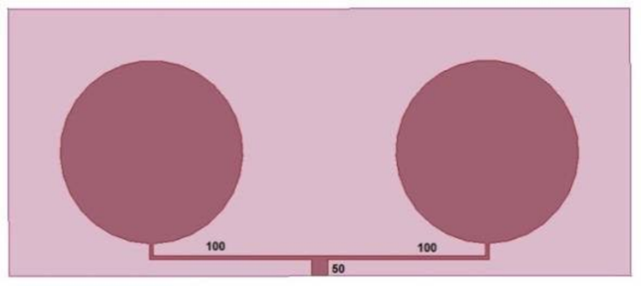 either amplifiers or attenuators [1, 12].

Figure.1. Two elements corporate feed microstrip antenna array

- DESIGN OF PLANNER ARRAY

Design Specification:
The three essential parameters for the design of a rectangular Microstrip Patch Antenna are:

Frequency of Operation
The resonant frequency of the antenna must be selected appropriately. The resonant frequency selected for design is 2.4GHz.

Dielectric constant of the substrate (εr)
The dielectric material selected for design is FR-4 epoxy which has a dielectric constant of 4.4.

Height of dielectric substrate (h)
Because of using FR-4, so height of dielectric substrate is 1.6 mm. fr is 2.4 GHz

Design procedure:
Theoretical calculation of a Microstrip patch is calculated with following equations.
  - Calculation of width (W):
𝑐
𝑊 = (1)
2𝑓 √𝜀𝑟 +1

Table.1. Microstrip antenna parameters and values
S NO | Parameter | Values
1 | Radius of patch | 17mm
2 | Effective dielectric constant | 5.55mm
3 | Effective length | 7mm
4 | Dielectric constant | 4.4mm
5 | Inter element spacing | 62.5mm
6 | Frequency | 2.4GHz
7 | Height | 1.6mm
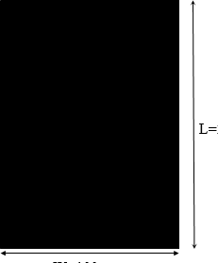
Figure.2. Proposed planner antenna array ground

The shape of the radiating element is rectangular planar array with the application of fractals to the rectangles. The ground plane has been fixed to a length of 53.2 mm. The radiating element is fed by 50Ω microstrip transmission line has a Centre width6=3mm
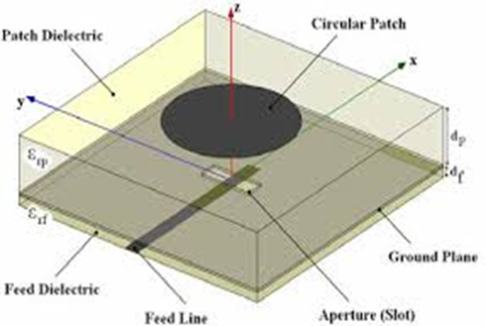
𝑟 2
Where c is velocity of light, fr is operating frequency of 2.4 GHz and dielectric permittivity is 4.4.
  - Calculation of effective dielectric constant (𝜀𝑟𝑒𝑓𝑓): Figure.3. Proposed corporate feed microstrip patch

𝜀𝑟𝑒𝑓 =
𝜀𝑟 + 1
+
2
𝜀𝑟 − 1 2
[1 +
12ℎ 1/2
𝑤 ]

Antenna
The optimal dimensions of the designed antenna are as

Where effective dielectric constant and h is the Thickness of
the dielectric substrate.
  - Calculation of effective length (Leff):
Follows: radius of the circular patch is 17mm and inter element spacing is 63.2mm.
On the back of the substrate, complete ground plane is used. The dimension of

𝐿𝑒𝑓𝑓 = 𝑐
2𝑓 𝜀
𝑟√ 𝑟𝑒𝑓𝑓
  - Calculation of length extension (ꕔL):
Ground plane which is printed in the back side of the substrate
- is chosen to be W × L, where W=53.2mm and L=53.2mm.

(𝜀𝑟𝑒𝑓𝑓 +0.3) [𝑤 +0.264 ] 4. SIMULATION RESULTS

∆𝐿 = 0.412ℎ ^{ℎ}
(𝜀𝑟𝑒𝑓𝑓 −0.258) [𝑤 +0.8]
ℎ

The designed antenna is a1x2linear Array. The Antenna

  - Calculation of actual length of patch(L): Consists of 2 elements array which are separated from each

𝐿 =c/2𝑓𝑟√𝜀𝑟

Substrate with dielectric constant of 4.4. The HFSS design model of the antenna is described below:



Figure .4. Two element Planner array HFSS model
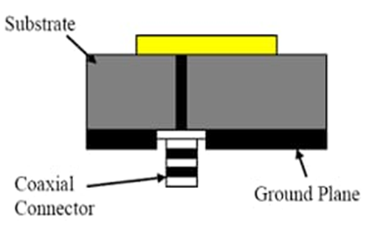
Figure.5. Ground planner array
The Antenna is designed using complete ground plane rather than going for the partial ground plane. The ground plane has been fixed to a length of 53.2mm and a width of 53.2 mm. The Partial Ground in the hfss model has been shown in the figure.

Return Loss:
The return loss obtained for the planar array antenna is shown in the figure below
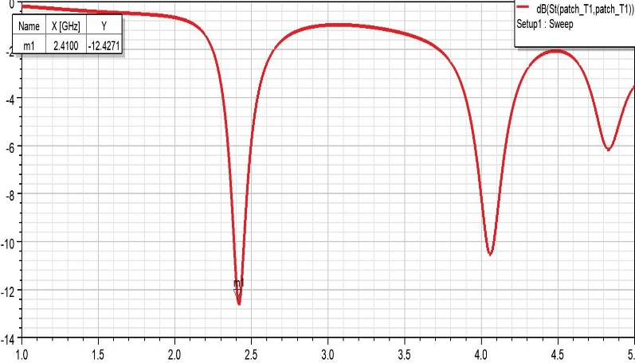

Antenna showed a return loss of -12.43dB at 2.40GHz, - 14.61dB at 8.100GHz, -10.27dB at 8.8750GHz and -11.4127dB at 9.55GHz.

Table.2. Return loss of planer array antenna
s no | Frequency in GHz | Return loss in dB
1 | 2.40 | 12.43
2 | 8.100 | -14.61
3 | 8.8750 | -10.27
4 | 9.55 | -11.412

Antenna Gain
The gain of antenna plays a major role, it defines the area of coverage and the directional characteristics of the designed antenna. The 3D polar plot of the antenna is shown in the figure below:

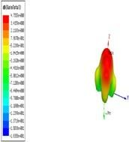

Figure.7. 3D polar plot
Normally, the gain of above 3dB is desirable for any practical application. The designed antenna showed a gain of 5.67dB at 2.40GHz and the above plot described the 3dB polar plot from 0 to 360 phase variations.

Radiation Pattern:
The Radiation Pattern describes the directional characteristics

of the antenna. The designed antenna obtained directional
Characteristics in a particular direction at an angle of 35⁰. The

designed antenna radiation is shown below
Radiation Pattern 1
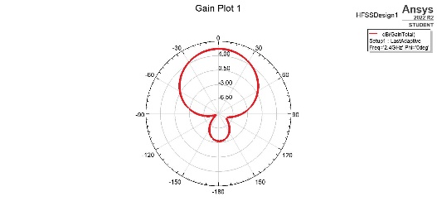

HFSSDesign1

Figure.6. Return loss Figure.8. Radiation pattern
The planar 2 element array antenna has been designed for the frequency of 2.4 GHz for which the distance between the antenna elements has been fixed to 62.5mm the antenna showed a deviation from the original designed which is due to the feed network that has been used to excite the antenna. Though the desired return loss is -10dB the antenna designed got a better return loss which is very useful and can be used in that particular frequency when it satisfies other constrains.

- CONCLUSION
The unique feature of this microstrip antenna is its ease to get higher performance. The proposed designed antenna is simple, minimal size and highly efficient for the applications in 2.4 GHz frequency ranges. The acceptable parametric outcomes such as the Return Loss, Gain and Efficiency for the corporate feed patch antenna are obtained. From the comparative study of different analysis of corporate feeding technique, it is concluded that microstrip antenna simulated using HFSS Suite provides a bandwidth enhancement of around 20db. And also, ithas achieved the best return losses at the desired frequency region, which is at 2.4 GHz. In future, the work will be carried out for antennas with different feeding techniques and the planner microstrip antenna array.

- REFERNCES
[1]. P. Subba Lakshmi, Rajkumar: “Design and Characterization of corporate feed rectangular microstrip patch Array antenna-IEEE international conference on emerging trends in Computing communication (2019).
[2]. Pradeep Kumar, Neha Thakur: “Micro strip Antenna for
2.4 GHz wireless applications”. International journal of engineering Trends and Technology volume 4 issue 8(2019).
[3]. Lalit Kaushal, Ritesh k Mishra: Linear Arrays of rectangular Microstrip patch antennas: Analysis and performance assessment, international journal of innovations of Engineering and Technology volume 5 issue 4 (2020).

[4]. Ramansyah.A, Benny Motiora: Designing and manufacturing microstrip antenna for wireless communication at 2.45GHz, International journal of computer and Electrical Engineering volume 3,No.5(2021).

[5]. Deepti Saxena1, Sweta Agarwal. “Low-Cost E-Shaped Microstrip Patch Antenna Array for WLAN” International Journal of Advanced Research in Electrical, Electronics and Instrumentation Engineering. Vol. 3, Issue 4, April 2019.

[6]. A.Dalli, L. Zenkouar, S. Bri “Conception of Circular Sector Microstrip Antenna and Array” International Journal of Microwaves Applications.Volume 1, No.1, 2020.
[7]. Ei Thae Aye *, Chaw Myat New “Rectangular microstrip patch antenna array for RFID application using 2.45GHz frequency range” International Journal of Scientific and Research Publications, Volume 4, Issue 6, June 2021.

[8]. Satya Prakash Sinha, Mukesh Kumar, Jolis Gupta “Design Of 1x2 Shaped Rectangular Micro strip Array Antenna For GSM Application” International Journal of Scientific & Engineering Research, Volume 6, Issue 5, May-2021.

[9]. Balanis “Antenna Theory - Analysis and Design,” 2019. [10]Adnan N Affanidi, Abdhullah M Dobai: “Rectangular microstrip patch antenna array with inset for cellular phones” Journal of Electronic Systems Volume 5 Number 1 March 2020.

