Online Platform for Coding Competition

1Mohit Verma
Department of Information and
Technology,
Vidyavardhini College of Engineering and technology,
Vasai, Maharashtra, India.
varmamohit122@gmail.com

2Aayush Vishwakarma
Department of Information and
Technology,
Vidyavardhini College of Engineering and technology,
Vasai, Maharashtra, India.
ayushvishwakarma1999@gmail.com

3Rayyan Ranje
Department of Information and
Technology,
Vidyavardhini College of Engineering and technology,
Vasai, Maharashtra, India.
rayyanranje@gmail.com

Abstract— Now a days many Engineering Institution try hard to fill the education gap between syllabus and industry needs. So, they carry out extra-curricular activities such as Coding Competitions, Hackathons, etc. Coding Competitions are one of the best ways to develop problem solving skills and to develop healthy competition among students. Many coding platforms exist as of today but they do not ensure secure and fair means of practice for students. The goal of our project is to provide an anti-cheating secure platform where candidates will not be able to practice any unfair means. We will achieve this by mutual authentication between user and server and securely deliver the coding questions to the user from the server.

Keywords— Coding Competition, anti-cheating, mutual authentication
INTRODUCTION
Online coding competitions have changed the way programmers and developers test and enhance their skills. Due to advancement of technology, these platforms enable programmers worldwide to participate in coding challenges remotely, showcasing their skills and talent without geographical barriers. One of the main advantages of online coding competitions is the elimination of expenses regarding travel and staying at the competition venue. Time and money is saved as any individual with an internet access can participate from anywhere across the globe. Competitions can be conducted seamlessly by the organizer without any issues which results in a better competition.
Another key benefit of online coding platforms is the fairness it guarantees for every participant, regardless of their location or background. These platforms offer different types of coding challenges and the level of difficulty can be selected by the programmer according to their skills. Based on the results, participants can analyze their strengths and weaknesses. Moreover, companies that are looking to hire skillful coders, these competitions can prove to be a useful recruitment tool. These competitions provide the luxury of saving time and resources for the recruiter . Rise of online coding platforms has led to the development of many platforms such as HackerRank, Topcoder, and Codeforces, offering coding challenges across various domains. To summarize, an online platform for coding competitions helps us to provide programmers and developers with a convenient and effective way to enhance their skills, showcase their talents, and gain recognition within the coding community.

By offering fairness for every contestant, eliminating geographical barriers, and presenting a diverse range of coding challenges, these platforms offer valuable opportunities for both individuals and recruiters.

Aim of the system: Following are the main aims of the system.
- The process of fetching the required data and the interaction between database records needs to be effective and fast
- Every student will have his separate account. It will be necessary to store this data in a secure manner
- Offer a seamless and effective platform without any issues
DESIGN AND IMPLEMENTATION
The two main stakeholders of this system are students and the administrator. This platform for coding competitions comprises of an online application that provides a user-friendly interface for both students and administrator. Administrators can organize and manage coding competitions, set the rules and set the duration. We have used Codemirror that is a JavaScript library that provides the participants with a code editor but it can only provide one language which is Java. Participants can enter the competition by entering the code that is made public by the administrator to all the participants, make their coding profiles, and submit their answers to question that has been provided by the administrator.
The platform as of now supports Java language in the code editor. This web application also facilitates automated testing and scoring of the answers submitted by the participants.
The code submitted by the participant is executed in a secure environment to ensure fairness. This prevents participants from gaining any important information on the administrator’s server or from affecting the performance of other participants' submissions.
System design: In this phase, the overall design of the system is explained using sequence case and use case diagrams.

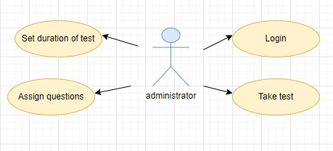
Fig 1: Use-case diagram for administrator

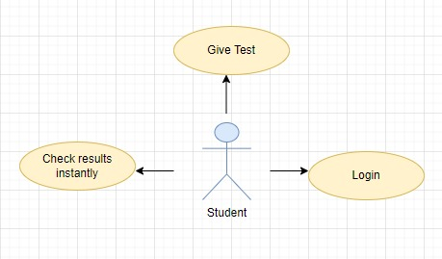
Fig 2: Use-case diagram for student

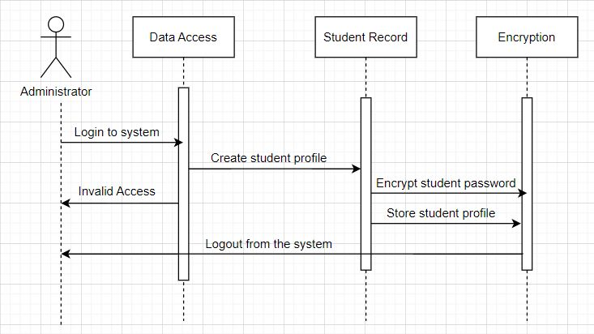
Fig 3: sequence diagram- password generation

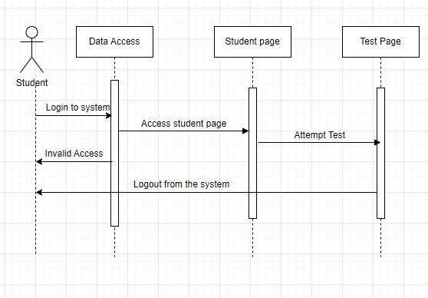
Fig 4: Sequence diagram-student login

Fig 1 explains all the possible uses of an administrator. The admin has access to several features that allow them to conduct and monitor the coding competition on the web app. The main use cases are as follows: registering the students as well as himself, assigning questions, organizing tests, and to set the duration of test.
Fig 2 explains all the possible uses of student. Student has access to several features that allow them to participate in the coding competition on the online platform. The main use cases are as follows: creating profile, attempting tests, and checking results instantly.
Fig 3 explains the process of password generation by the administrator. Student can login to the system by entering his name and email id. The request will be marked as invalid if wrong credentials are entered.
Fig 4 explains the process of accessing the test page. Student can login to the system by entering his name and email id. If correct credentials are entered along with the code given by the admin, then the student can access the test page. The request will be marked as invalid if wrong credentials are entered.

SIGNIFICANCE
Overall, such platforms prove to be very important for coders to hone their skills, collaborate with others, and likely promote their careers. Online platforms completely remove the geographical barriers and anyone with an internet connection can participate in such a contest. Such competitions have proven to be a great platform for companies and recruiters to hire skilled and deserving candidates. Participating in such contests will lead to development of innovative ideas and technologies. Winning a competition can prove to be massive gain of confidence in the participant. These competitions can help in creating a collaborative environment and bring like minded people together allowing them to share their innovative ideas and knowledge.

RESULT & DISCUSSIONS


Fig 5: Initial Test page

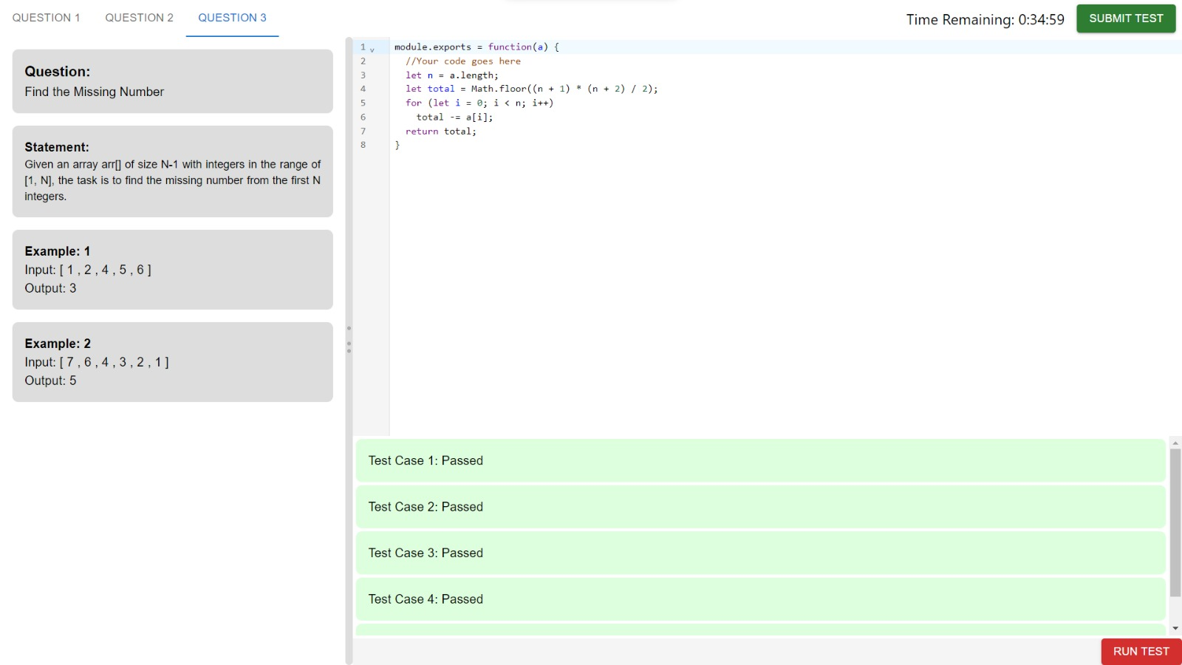
Fig 6: Test page (Code Editor)


Fig 7: Warning Page

Fig5 is the page from where a user can register for a test. A student must enter his name, email id and a unique test code given by the administrator to enter the test.
Fig6 is the page where user can attempt the test on the following code editor.
Fig7 is the warning page. If a user attempts to cheat while giving the test, they will have ten seconds to return back to the test page otherwise it will be flagged as a copy case.

We conducted a coding test using CodeBuddy. Our target audience were second-year and final-year engineering students, and we chose CodeBuddy for its secure and user-friendly environment. CodeBuddy's anti-cheating security features played a crucial role in ensuring fair and honest competition during the test. These features provided us with the assurance that the results of the test were a true reflection of the students' abilities, without the influence of external factors. In addition to its security features, CodeBuddy's user-friendly interface and intuitive design made the test-taking process simple and easy for the students. This allowed them to focus on the task at hand, without the added stress of navigating a complicated platform. Overall, our experience using CodeBuddy for the coding test was a positive one.

CONCLUSION
This research paper indicates that it is very convenient and practical for an organizer to conduct a coding competition in an online platform. In-person coding competitions must handle several setbacks which an online platform eliminates. However, this web app also has certain limitations such as requiring a stable internet connection and providing only a single language in the code editor. Regardless of such limitations an online platform for coding competitions has already proven to be a valuable tool for both participants and organizers. Overall, such platforms have already shown an increase in popularity which will ultimately lead to creation of new technologies and innovation in the future.
REFERENCES

- Partheeban, N., & SankarRam, N. (2014). e-Learning management system using web services. International Conference on Information Communication and Embedded.
- Ahmad, M., Shamsi, A., & Hussain, F. (2017). Evaluation of online coding competition platforms: A comparative analysis. International Journal of Computer Applications
- Huang, S. H., Yeh, C. H., & Chang, Y. S. (2018, August). Design and implementation of online programming contest platform. In 2018 IEEE 4th International Conference on Computer and Communications (ICCC)
- Zhang, X., Liu, Z., & Xue, Z. (2017, August). Development of online coding competition platform based on cloud computing. In 2017 IEEE 3rd International Conference on Control Science and Systems Engineering (ICCSSE)
- Gupta, S., & Nair, N. (2020). Online coding platforms and their effectiveness in programming education. International Journal of Emerging Technologies in Learning

