A.C. Power Generation through Solar Cells
Sagar Rathod, Om Nishad, Lalit Patil, Kartik Bansode, Kshipra Pandey
Department of Electrical Engineering
Atharva College of engineering,
sagarrathod937@gmail.com,nishadom873@gmail.com, lalitpatil3526@gmail.com, Kartikbansode317@gmail.com

Abstract— This AC solar panel consists of regular solar cells whose arrangement is in circular fashion mounted on a plain base. Connection of this cells is such that half of the cells are in one group forming a positive group in which cells are in series connection and half of the cells are in another group forming a negative group in which cells are also in series then these two groups are connected in anti-series connection. A disc is mounted on top of this cells which is a spinning disc, then this disc is connected to a DC motor. This motor is given supply by a buck boost circuit which is getting supplied by another set of solar cells. The disc is having slots to allow the sunlight pass through it to energize the solar cells. When the disc rotates it energize the solar cells alternately hence it produces AC power. To increase efficiency of this setup a solar tracking system is also introduced which is LDR circuit controlling DC geared motor. This DC motor controls the base of the solar cells so that the cells get the maximum solar radiations.
Keywords— Solar Cells, DC motor, Buck Boost Circuit, Sun tracking, Arduino Uno, LDR circuit.

- INTRODUCTION
During the last few years, solar energy had a great impact on India. Solar energy is benefiting the number of people in villages by fulfilling their cooking, lighting, and agricultural requirements, and as well as suburban and urban areas are also benefiting the solar energy by installing solar panels on building rooftops and railways rooftops to produce lighting energy. Solar energy also supports the sustainable growth of India meeting the government agendas and the solar sector has also emerged as a significant player in power generation through grid integration.
The main problem which hinders the use of solar energy is the cost of conversion from photons to electrical energy into a suitable form which is required by particular operation. The cost factor also hinders the use of solar energy which includes solar panels, its installation, inverters, MPPT control, battery and phase synchronizers. Losses also play an important part in solar conversion from DC output of solar to AC input of household applications.
We can eliminate these conversion losses from DC to AC by generating solar energy directly in AC form. In this type of conversion, a rotating disc is used to rotate above the solar cells with the help of the motor, which directly converts the solar energy into AC power without any use of the inverter. This makes the system simple and effective for use as well as economical.
- Proposed System
A. Block Diagram
Mechanism to
Cover
Solar cells
Load
Solar Input
Solar to Electrical
DC motor

Sun Tracking system

Fig. 1. Block diagram of proposed system
The block diagram of this proposed system consists of a DC motor, Disc, PV cells and a sun tracking system which consists of a linear actuator, LDR, Arduino Uno and motor driver.

B. Solar Input
The photons which are radiated from the sun are the never-ending source for PV cells for the conversion of energy. This greatly impacts the use of fossil fuels. The PV cells are made up of semiconductor devices and photons dislodge an electron from these cells. As electrons dislodge it starts to create a potential difference in the PV cells and a flow of electricity occurs.

C. DC Motor
Here the DC motor is used to rotate the mechanism which is used to cover the PV cells. Dc motor is coupled with this mechanism which means this motor will drive the mechanism. The supply for the DC motor will be given by a set of solar cells.

D. Mechanism to cover solar cells
This mechanism is of disc shape which has cuts in it. This cut portion of the disc allows the photons to strike the solar cells through it. When the disc spins the solar cell sets alternately get exposed to light which as a result creates AC power.

E. Solar cells
Here in this project two sets of solar cells are used and arranged in such a way that when disc rotates it generates output in AC power.

III. AC Generation
A. Disc Arrangement
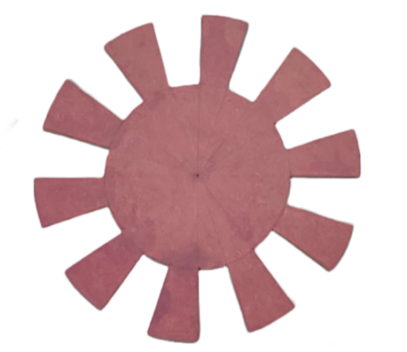
Fig. 2. Mechanism to cover solar cells
From the above figure we can see that the disc is flat in shape and it is made up of material which can block sunlight and its circumference is such that it covers the solar cells arrangement. The disc has a weight such that the DC motor is able to rotate it without withstanding any pressure on its shaft. The disc is of non- reflective material hence no light reflection and refraction is happening on PV cells. The disc has cut-outs which correspond to the area of a single PV cell which allows total exposure to sun and total blocking of sunlight. The disc is coupled to the DC motor from the middle portion of it.

B. Panel Arrangement
The AC generator is using solar cells that have a wooden base. The base can be made of other materials as well which are non-conductive in nature. On the base solar cells are arranged in a circular fashion and in the middle of this circle there is threading for the fitting of the DC motor. In this project rectangular shaped solar cells are used but it is to be noted that solar cells can be used in other shapes as well such as pie wedge or triangular. Now to couple the DC motor and rotating disc a piece of wood block is used which is drilled to be fit in the motor shaft.

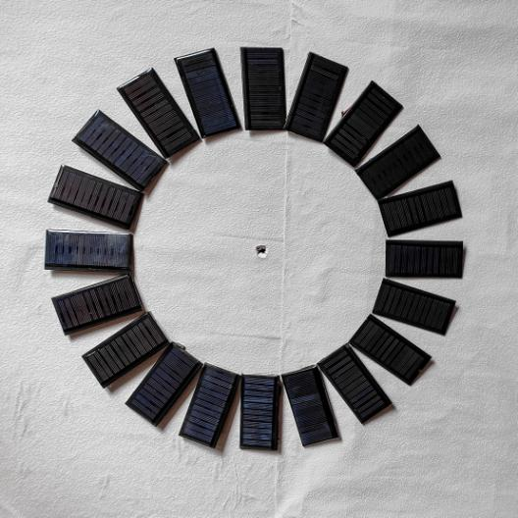
Fig. 3. Panel arrangement
C. Solar cell Arrangement
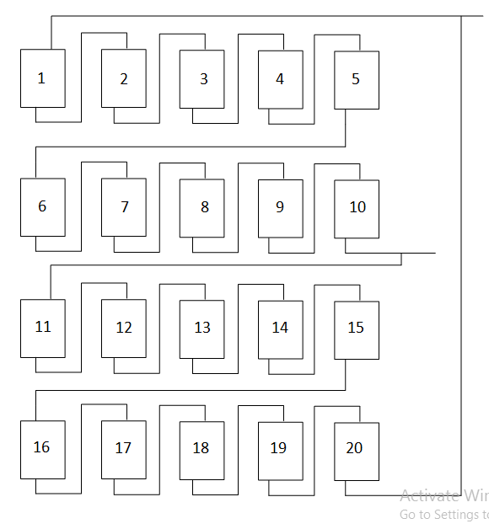
Fig. 4. Solar cell arrangement
Solar cells are divided into two sets. The cells from 1 to 10 are connected in series forming set 1 and cells from 11 to 20 are also in series forming set 2. Now positive output of set 1 is connected with negative output of set 2 and negative output of set 1 is connected with positive output of set 2. Thus they form a series opposition connection. This series opposition helps to bring the voltage level to zero which helps in achieving the sinusoidal waveform. They are placed alternately on the panel for example Adjacent to cell 1 cell 11 will be placed. When the disc rotates it will shade a portion of another set while simultaneously un-shading another set. Whose resultant output will be subtraction of both sets output.

D. Linear actuator
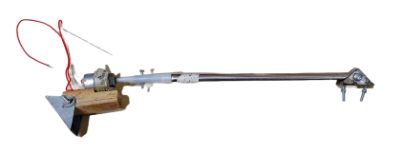
Fig. 5. Linear actuator
A linear actuator is used to move the panel in order to track the direction of the sun. In this linear actuator a dc motor is used to control the upward and downward motion. A thread rod is coupled with the shaft of the motor and an outer pipe is used in which this thread rod is fitted. When the DC motor moves in a clockwise direction the pipe moves in an upward direction through the thread of the rod and when the motor moves in an anticlockwise direction the pipe moves in a downward direction.

E. LDR circuit
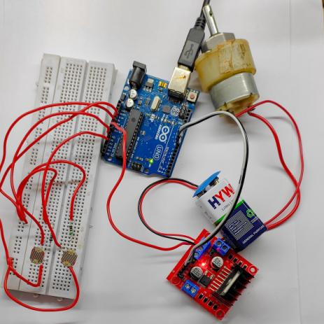
Fig. 6. LDR circuit
In this circuit two LDRs are used for single axis control only. The analog outputs of LDRs are given to Arduino analog pins which it uses as analog input. Then these signals are converted to digital output and then these signals are fed to the motor driver circuit which consists of LM2596 IC which controls the motor direction. This motor driver is given a power supply by a 9v battery and the ground of the motor drive and Arduino Uno are shorted together as they are using different power supplies. When LDR 1 detects the light motor rotates in a clockwise direction and when LDR 2 detects light the motor rotates in an anticlockwise direction. This motor is fixed in a linear actuator which controls the axis of the panel.

- Model Testing

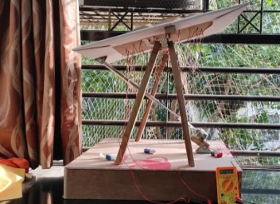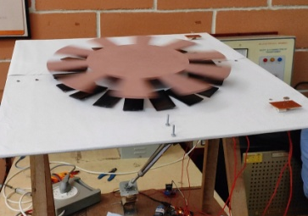
Fig. 7. Sun tracking and panel arrangement
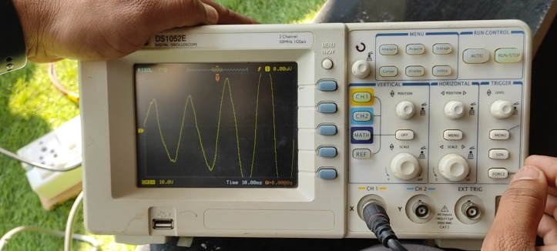
Fig. 8. DSO output
The above figure shows the prototype model for AC generation through solar cells with a sun tracking system using a linear actuator. The output was tested using DSO. As we can see that the output was in sinusoidal waveform.

- Result
Following is the solar cells specification which is used in this project.

Table. 1. Specification of solar cells
Specification | Value
Operating Voltage | 6V
Working Current | 60mA
Maximum Voltage | 8V
Dimensions | 80mm x 40mm
Material | PVC
Shape | Rectangular

Following were the test results obtained by using panel at a fixed angle versus using the panel with the sun tracking system.
Table. 2. Test results
Time  (Hours) | Output Voltage  (Without tracking system) | Output Voltage  (With tracking system)
08:00 | 66V | 80V
09:00 | 72V | 90.5V
10:00 | 80V | 96V
11:00 | 87.3V | 100.5V
12:00 | 93.2V | 113.7V
13:00 | 98V | 121.3V
14:00 | 100.5V | 116V
15:00 | 108V | 110V
16:00 | 102V | 100V
17:00 | 85V | 90V
18:00 | 70V | 75.2V

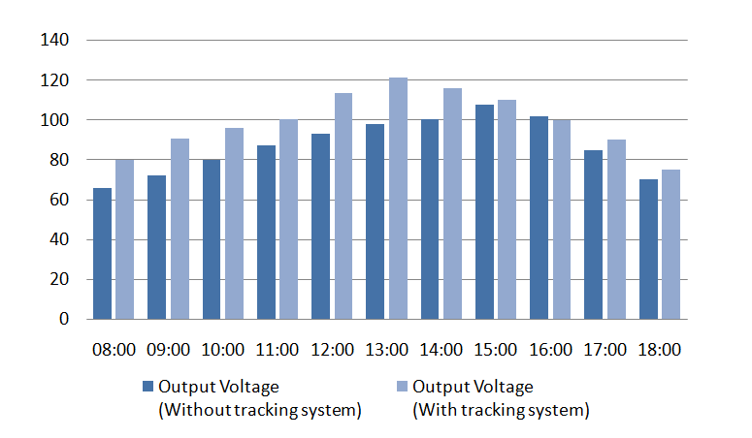
Fig. 9. Power Output Comparison
Hence from the above table we can see that efficiency of the panel increases with the use of the sun tracking system as well as shadow formation on the solar cells from the use of rotating disc is also eliminated.

- Conclusion
From this project we can cope with the increasing demand for electricity. We have successfully implemented the AC generator through solar cells. It has a main advantage of bypassing the inverter which in turn reduces the cost of the system. This prototype was meant to show the concept of anti-series connection and generation of ac power in the process. Further advancement in solar cell manufacturing can increase its output power like manufacturing solar cells in a pie wedge shape so solar cells cover more area on the panel. Considering the geographical location of India, it has huge benefits for generation of energy through solar because India is in the tropical range hence it receives more sunlight. With the further advancement in this project we can reduce dependency on other power plants.

REFERENCES
- ITS, “Renewable Energy, DC Converter & Maximum Power Point Tracking”, Surabaya, 2019.
- J. K. Tharamuttam and . A. K. Ng, “Design and Development of an Automatic Solar Tracker,” Energy Procedia, vol. 143, pp. 629-634, 2017.
- V. Devabhaktuni, M. Alam, S. S. S. R. Depuru, R. C. Green II, D. Nims, and C. Near, "Solar energy: Trends and enabling technologies," Renewable and Sustainable Energy Reviews, vol. 19, pp. 555-564, 2013.
- Jason Allen Oliver, “Device, System And Method For Directly Generating Alternating Current Electricity From Photovoltaic Cells ”,17 Jul 2012 International Journal of Engineering Research in Electrical and Electronic Engineering (IJEREEE) vol. ED-11, pp. 34-39
- Reference Book:-B. L. Theraja, A. K. Theraja, Textbook of Electrical Technology”, AC and DC Machines, vol. 2, pp. 15471548, Nov. 2011, S. Chand Publications
- S. Seme, G. Štumberger and J. Voršič, "Maximum Efficiency Trajectories of a Two-Axis Sun Tracking System Determined Considering Tracking System Consumption," in IEEE Transactions on Power Electronics, vol. 26, no. 4, pp. 1280-1290, April 2011.
- A. Kassem and M. Hamad, "A microcontroller-based multi-function solar tracking system," 2011 IEEE International Systems Conference, Montreal, QC, Canada, 2011, pp. 13-16.
- Z. Zhen et al., "The Effects of Inclined Angle Modification and Diffuse Radiation on the Sun-Tracking Photovoltaic System," in IEEE Journal of Photovoltaics, vol. 7, no. 5, pp. 1410-1415, Sept. 2017
- Kumar, V.S.S. and Suryanarayana, S., 2014. Automatic dual Axis sun tracking system using LDR sensor. International Journal of Current Engineering and Technology, 4(5), pp.3214-3217..
- Safa Skouri, Abdessalem Ben Haj Ali, Salwa Bouadila, Mohieddine Ben Salah, Sassi Ben Nasrallah, Design and construction of sun tracking systems for solar parabolic concentrator displacement, Renewable and Sustainable Energy Reviews, Volume 60, 2016, Pages 1419-1429, ISSN 1364-0321

