POWER FACTOR CONTROLLER

O.S.Chavan¹, Shirole Prasad2 Omkar Potdar ³, Pawar Dnyaneshwar⁴ , Lohakare Shivpratap

¹Professor, ^{1,3,4,5} Students, Department Electrical Engineering, Government Polytechnic Nanded, Maharashtra, India -------
***

Abstract - : The microcontroller using a relay driver. It displays time lag between the In this proposed system, two zero crossing detectors are used for detecting zero crowing of voltage and current. The project is designed to minimize penalty for industrial units using automatic power factor correction unit. The microcontroller used in this project belongs to Arduino family.
The time lag between the zero-voltage pulse and zero-current pulse is duly Generated by suitable operational amplifier circuits in comparator mode is fed to two interrupt Pins of a microcontroller. The program takes over to actuate appropriate number of relays from Its output to bring shunt capacitors into load circuit to get the power factor till it reaches near Unity. The capacitor bank and relays are interfaced to current and voltage on an LCD. Furthermore, the project can be enhanced by using thyristor control switches instead of relay Control to avoid contact pitting often encountered by switching of capacitors due to high in rush Current.

- INTRODUCTION
Embedded Technology is now in its prime and the wealth of knowledge available is Mind-blowing. However, most embedded systems engineers have a common complaint. There are no comprehensive resources available over the internet which deal with the various design and implementation issues of this technology. Intellectual property regulations of many corporations are partly to blame for this and also the tendency to keep technical know-how within a restricted group of researchers.

An embedded computer is frequently a computer that is implemented for a particular

Purpose. In contrast, an average PC computer usually serves a number of purposes: checking Email, surfing the internet, listening to music, word processing, etc… However, embedded systems usually only have a single task, or a very small number of related tasks that they are programmed to perform. Every home has several examples of embedded computers. Any
appliance that has a digital clock, for instance, has a small embedded microcontroller that performs no other task than to display the clock. Modern cars have embedded computers onboard that control such things as ignition timing and anti-lock brakes using input from a number of different sensors. Embedded computers rarely have a generic interface, however. Even if embedded systems have a keypad and an LCD display, they are rarely capable of using many different types of input or output. An example of an embedded system with I/O capability is a security alarm with an LCD status display, and a keypad for entering a password.
An embedded system can be defined as a control system or computer system designed To perform a specific task. Common examples of embedded systems include MP3 players, navigation systems on aircraft and intruder alarm systems. An embedded system can also be defined as a single purpose computer.

LITERATURE SURVEY:

  - ANALYSIS, OPTIMIZATION AND CONTROL OF GRIDINTERFACED MATRIX-BASED ISOLATED AC-DC CONVERTERS
Conventional low-frequency transformers or line-frequency transformers (LFTs) have proven to be a robust solution to stepup/step- down the voltage and provide electrical isolation between two networks in the conventional unidirectional power system, where the power flows from the transmission network to distribution network and the distribution network feeders in turn distribute power to consumers [38].
However, in the modern power system the unidirectional power flow is violated when the DERs' power production exceeds the local demand in the microgrid/nanogrid.

COMPONENT SELECTION:
  - TRANSFORMER:- The transformer is used for connecting this system directly to 220V AC. It steps down 220V into 12V.
A transformer is an electrical device that transfers electrical energy at one voltage from one circuit to other at a different voltage merely by magnetic coupling; the transfer of energy doesn’t involve any kind of motion.

Transformers are analogous to gear box (used to convert torque and hence speed). Transformers step up or step down the voltage and therefore vary the current. As the product of speed and torque remains constant, product of voltage and current also remains constant.

RECTIFIER:
Single-phase circuits or multi-phase circuit comes under the rectifier circuits. For domestic applications singlephase low power rectifier circuits are used and industrial HVDC applications require three-phase rectification. The most important application of a PN junction diode is rectification and it is the process of converting AC to DC. This project use two rectifier with two diodes and one capacitor of each transformer. In this work bridge rectifier is used due to its merits like full wave rectification and high stability. For a single half of the cycle only two diodes will be in forward bias condition.

REGULATED POWER IC LM7815
Datasheet:
7815 is a voltage regulator integrated circuit. It is a member of 78xx series of fixed linear voltage regulator ICs. The voltage source in a circuit may have fluctuations and would not give the fixed voltage output. The voltage regulator IC maintains the output voltage at a constant value. The xx in 78xx indicates the fixed output voltage it is designed to provide. 7815 provides +15V regulated power supply. Capacitors of suitable values can be connected at input and output pins depending upon the respective voltage levels

HEAT SINK:
A heat sink is a piece of metal engineered to dissipate the maximum thermal energy into the ambient surroundings. It assists a component to remain below its maximum operating junction temperature by drawing this energy away, thereby preventing damage through excessive temperatures. All electronic components dissipate heat, and usually their package (body) is sufficient to dissipate it into the surroundings, however voltage regulators such as a 7805, 7812, LM317T, require assistance if they are to operate to their extreme limits.

RELAY

A relay is an electrically operated switch. Many relays use an electromagnet to mechanically operate a switch, but other operating principles are also used, such as solid-state relays. Relays are used where it is necessary to control a circuit by a low-power signal (with complete electrical isolation between control and controlled circuits), or where several circuits must be controlled by one signal. The first relays were used in long distance telegraph circuits as amplifiers: they repeated the signal coming in from one circuit and re-transmitted it on another circuit. Relays were used extensively in telephone exchanges and early computers to perform logical operations.

LED LIGHT

Light emitting diodes (LEDs) are semiconductor light sources. The light emitted from LEDs varies from visible to infrared and ultraviolet regions. They operate on low voltage and power. LEDs are one of the most common electronic components and are mostly used as indicators in circuits. They are also used for luminance and optoelectronic applications. Based on semiconductor diode, LEDs emit photons when electrons recombine with holes on forward biasing. The two terminals of LEDs are anode (+) and cathode (-) and can be identified by their size.

BC 547 TRANSISTOR

BC547 is an NPN bi-polar junction transistor. A transistor, stands for transfer of resistance, is commonly used to amplify current. A small current at its base controls a larger current at collector & emitter terminals.
BC547 is mainly used for amplification and switching purposes. It has a maximum current gain of 800. Its equivalent transistors are BC548 and BC549. The transistor terminals require a fixed DC voltage to operate in the desired region of its characteristic curves.

ACS712 CURRENT SENSOR
The Allegro® ACS712 provides economical and precise solutions for AC or DC current sensing in industrial, commercial, and communications systems. The device package allows for easy implementation by the customer. Typical applications include motor control, load detection and management, switch mode power supplies, and overcurrent fault protection. The device is not intended for automotive applications.

- SCHEMATIC DIAGRAM:

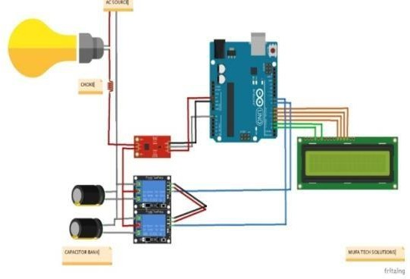

Fig. 5 Real photo while making connections

WORKING METHODOLOGY:

APFC Panel has microcontroller based programmable controller which switches the capacitor banks of suitable capacity automatically in multiple stages by directly reading the reactive load (RKVA) which works in the principle of VAR sensing tends to keep up the PF to 0.99 Lag.

PHOTO OF ACTUAL CIRCUIT SETUP:

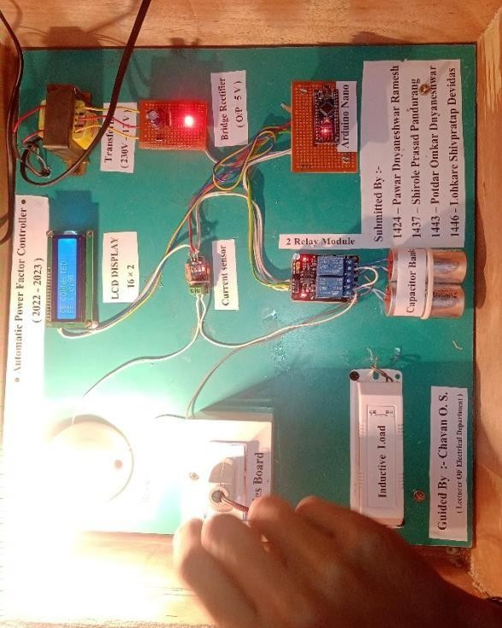

- ADVANTAGES AND DISADVANTAGES:

Advantages :
    - Losses are reduced.
    - Improve voltage.
    - Increases system capacity.
    - Reduces electricity bill.

Disadvantages;
    - They have a short service life ranging from 8 to 10 years
    - They are easily damaged if the voltage exceeds the rated value.
    - Once the capacitors are damaged, their repair is uneconomical.

CONCLUSION:

It can be concluded that power factor correction techniques can be applied to the industries, power systems and also house holds to make them stable and due to that the system becomes stable and efficiency of the system as well as the apparatus increases. The use of microcontroller reduces the costs. Due to use of microcontroller multiple parameters can be controlled and the use of extra hard wares such as timer, RAM, ROM and input output ports reduces. Care should be taken for overcorrection otherwise the voltage and current becomes more due to which the power system or machine becomes unstable and the life of capacitor banks reduces.

REFERENCES

➢Microcontroller ( theroy and application ) By Ajay V Deshmukh
➢The tata McGraw-Hill companies ➢ “The ATMEGA 328p Microcontroller and Embedded systems” by Muhammad
➢Ali Mazidi and Janice Gillispie Mazidi , Pearson Education
➢Circuitstoday.com
➢Edaboard.com
➢Vegarobokit.com
➢Electronics.com
➢Developershome.com
➢Seminarproject.com

