Power Monitoring and control System Using IoT
R. Mounika¹, P. Sravanthi¹, P. Ravali¹, Ch. Hema Sree¹, Dr. D. Yugandhar²
¹Student, Department of Electronics and Communication Engineering, Aditya Institute of Technology and Management college, Tekkali, Srikakulam Andhra Pradesh, India, 532201
²Professor & Associate Dean (Alumni, C.G.&H. E), Department of Electronics and Communication Engineering, Aditya Institute of Technology and Management college, Tekkali, Srikakulam Andhra Pradesh, India, 532201
Abstract: -
Internet of things has been a great use in the modern world and the importance of IoT is increasing day by day. The wastage of energy is a very serious concern, and energy consumption of all our appliances are in huge level. So, proper usage of this resource is of immense important. And this increase in power requirement has pushed the researchers and industrialist to design low power systems with smart power management. In this paper, design of a smart system for energy conservation is proposed to reduce the energy consumption which is based on some distributed components like sensors, micro controller and google sheets. The smart power management system can monitor, measure and control electricity usage in real-time. With this proposed system, users can automatically and manually control the unwanted real-time electricity usage, which can also be viewed through graphical representation.

Key words: - Sensors, IoT, Arduino IDE, ESP32, Google sheets, Power management system

I Introduction
The main source of development and advancement in this technological world is electric energy. The power requirements evolve with technology, and the demand for power rises daily. Both the domestic and industrial sectors experience these power demands. According to the most recent Annual Energy report, the demand for residential electricity is expected to rise by 24% over the next few decades. Due to rising energy consumption, there is a growing need for electric energy, and the supply of fossil fuels is decreasing. Additionally, there have already been widespread major blackouts due to the mismatch between demand and supply as well as a lack of automation and monitoring tools. As more home appliances and consumer electronics are installed, residential energy consumption tends to increase very quickly. So, power must be used efficiently and this requires systems that consume energy efficiently. One possible solution for energy crisis is efficient utilization of energy. This can be done only if every individual contributes to power saving. That is, they should not waste power unnecessarily. Only if this is done then there can be efficient utilization of energy and energy crisis can be reduced. So the society needs to be educated on power saving and the problems due to power wastage. A further step towards power saving is by imposing penalty for power wastage. It can be imposed on industries and households. And most of the countries are trying to develop and execute various projects to conserve energy.

Smart Meters were designed and improved to address the issues with standard electric meters. Consumers will receive power warnings based on hourly power use.

So as a step towards the conservation of power we are designing a meter, and these meter is crucial for determining each household or commercial energy usage. When inhabitants are obvious of their everyday actions. The monthly answer provided to customers is insufficient since consumers will be unaware of how much energy they have spent. The primary purpose of smart meters is to cut down on domestic power usage to a normal level. Consumer behaviour may be studied and evaluated with its expanding market attention. To enhance user behaviour, power usage patterns can be simplified. With the installation of smart meters, the power market may be reorganized, saving both energy and carbon dioxide emissions.
This project presents both hardware and software integration. The software monitors power consumption and the consumption of home appliances and controls systems with an overcurrent relay and notification of possible errors. The developed system consists of Arduino IDE, Wi-Fi module (ESP32), relay, current sensor, voltage sensor and liquid crystal display (LCD). The Arduino IDE is used to program custom coding to implement the outputs. The ESP32 is also a very high-performance microcontroller that receives and transmits data via the Internet to various modules and some other platforms. But in this case, the ESP32 Wi-Fi module is used as a platform that is famous for its IoT applications.

The outputs of this meter can be displayed in two ways: they are - LCD and IoT implementation. Where the LCD displays voltage, current and power consumption. It shows detailed monitoring of electrical quantities such as voltage, current, power and energy. IoT combines internet connection of mobile devices and multi-sensor remote control with smart home technology. Where a website or mobile app is used to visualize the data and trigger an alarm. One current or circuit overload can be detected based on pre-developed IoT applications where consumer alarms are triggered.

II Related work

This section discusses literate survey and explains things related to IoT energy monitoring devices. For a better future, where energy saving is practiced and electricity use is very efficient and effective, makes it possible to develop these projects.

A power management and control system based on wireless sensor networks was proposed by Kim et al [1]. In order to give users access to real-time electricity consumption information, wireless sensors were used to continuously sense and update electricity data, which was then transmitted via a ZigBee module. Additionally, users were given remote monitoring and control of home appliances through a web service.

Soliman et.al. [2], they explored the concept of Smart Home through integrating IoT with Web services and Cloud computing. Their approach consisted of embedding intelligence into sensors and actuators using Arduino platform, networking smart things using ZigBee technology and facilitating interactions with smart things using Cloud services for easy access in different locations. The approach was successfully used for demonstrating services for measuring home conditions, monitoring home appliances, and controlling home access. The infrastructure can be adopted for or adapted to other applications.

Sindhuja and Balamurugan [3] created the system to use cloud data storage for IoT-based smart power monitoring and management. An ARM-based controller interfaced with Hall Effect current sensors is used to monitor the power used by different appliances, and the data is stored in a cloud database. Home appliance power control is accomplished by actuators like relays, which a client can control with the aid of a web server by creating Remote Procedure Calls between the client and server. With the help of IoT features, the designed system allowed the client to watch and manage their home's appliances from anywhere, reducing energy waste.

Z.A. Khan [4] developed a smart electricity monitoring and control system for use in intelligent buildings. This system effectively monitors and regulates how electrical equipment is used in a senior living facility. By integrating sensor modules, it was possible to monitor the electrical parameters of home appliances. The yield signals from these modules were then incorporated and linked to a ZigBee module for wireless transmission of the data regarding the electrical parameters to the host PC, where it was then saved in a database. The system's goal was to determine the areas with the highest daily peak power use rates and to provide a solution that would allow the system to reduce usage and make better use of resources that were already subject to a cap.

Suryadevara [5] proposed a design for a real-time smart tracking and controlling system for home electrical appliances. This system interfaces with manufactured sensing modules to watch electrical parameters of home equipment and transmits data wirelessly via the ZigBee protocol to a central controller. This system used various methods to implement the controlling mechanisms of the appliances in order to determine the amount of power consumed. Through a website, the system was successfully used for remote monitoring and control of appliances. Consumers found it simple to use and activities were efficiently handled by local and remote user interfaces.

III Proposed work
The purpose of this system is to go through the energy consumption to help make a green and clean environment and further to help in sustainable development.

METHODOLOGY
In proposed system, for monitoring part, current and voltage across each load is monitored in order to observe power consumption in every hour or every minute or whenever user would like. This may provide a facility of controlling the electrical bill by monitoring overall power consumption of a house. The system use to connect the current sensor and voltage sensor for monitoring power consumption of every load in order to be able to observe which load in an exceedingly household is consuming more power. Current sensor is going to be connected synchronously and voltage sensor will connect in parallel with the load. So equal current and equal voltage will move to each load. The used sensor (current) fetches the time to time condition and the readings from AC source and the other sensor (voltage) will fetch the voltage readings of the same source. The usage of current and voltage are displayed on Blynk dashboard. We will use Blynk application for providing program so one can easily monitor the ability and switch off the high-power consuming load if that load isn't in use.

While coming to the control of power, upload a time table with the help of cloud where the timings were given to use electricity. In those particular timings only the electricity will be consumed from the power supply and the remaining timings there is no supply of current. If in any mandatory situations if we need electricity, then we can manually switch on the power supply. We have done this control method by considering the educational institutions.
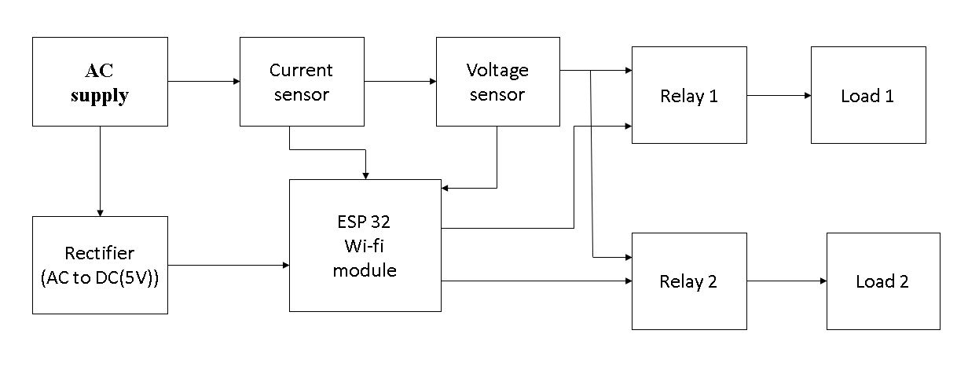
Fig-1: Block Diagram

The above block diagram consists of AC source from which we get power for loads, one current sensor, a voltage sensor, ESP32 microcontroller, two relay modules and two different loads. The current sensor and voltage sensor will give the power value which will be given to the controller to turn on or turn off the loads. The load can be operated from remote distance using IOT Blynk application. In this approach the system is not using any kind of physical switch to turn on or turn off the loads hence loads can be operated through IOT dashboard. Two relays are used to connect the respective load with controller. These relays will help to control overloading situation and prevent load from the damage. In the system, current sensors are used to measure the incoming and outgoing current flowing through energy meter. The loads can be controlled by using switching mechanism with the help of relays. ESp32 controller will give the control signals to relay for operation.

SYSTEM OVERVIEW

CURRENT SENSOR
SCT-013 is a non-invasive, split-core clamp type AC ​​current sensor that can be used to measure AC current up to 100 amperes. Current transformers (CT) are sensors for measuring alternating current. They are particularly useful for measuring the electricity consumption of an entire building. Current sensors SCT-013 can be attached directly to a live or neutral wire without the need for high voltage electrical work.

VOLTAGE SENSOR
ZMPT101B AC voltage sensor is best for project where we need to measure accurate AC voltage with voltage transformer. It is an ideal choice for measuring AC voltage as an open source platform using Arduino/ESP8266 In many electrical projects, the engineer directly deals with measurements that have few basic requirements, such as high galvanic isolation, wide range, high precision, good consistency.

ESP32 MODULE
ESP32 is a series of low-cost and low-power system-on-chip microcontrollers with integrated Wi-Fi and dual-mode Bluetooth. The ESP32 series uses either the Tensilica Xtensa LX6 microprocessor in both dual-core and single-core variants, the Xtensa LX7 dual-core microprocessor or the single-core RISC-V microprocessor and includes built-in antenna switches, RF balun, power supply, amplifier, silent receiving amplifier, filters and power management modules.

LCD DISPLAY
LCD (Liquid Crystal Display) is a type of flat panel display that uses liquid crystals in its main mode of operation. LEDs have a wide variety of consumer and commercial uses, as they are commonly found in smartphones, televisions, computer monitors and dashboards.

ARDUINO IDE
It is a software that allows us to write code according to our needs and then upload the code to our hardware. It creates a connection between the hardware (Arduino) to download the code and execute it. Codes executed by this software are called sketches. These codes are encrypted in a text editor and saved as name.ino. The lower part in the lower right corner helps to show the drive we set up and the serial port in use. Toolbar buttons help us check encrypted data, save encrypted data, and display previously saved encrypted data.

BLYNK APPLICATION
Blynk is used in IOT (Internet of Things). It is used to check the data of the produced system through the panel, to save the data and to the memory.
The components of the application are-
User Interface - displays executable information in formats that we customize according to our vision and needs.
Blynk Server - It establishes a connection between the hardware and the device used on the panel.
Blynk Libraries - It stores all the information needed to run the hardware on the IOT panel.

CONCLUSION:
Smart energy monitoring system includes ESP32 module, a current sensor, a voltage sensor, WI-FI, blynk application. This proposed system reads the power levels through the current sensor and voltage sensor respectively. This meter calculates the amount of power utilised which can be controlled through the blynk application connected to the cloud, and also the user can experience the management of power via the pre-included time table through the blynk application installed in the users mobile. The proposed system consumes less energy and it will also reduce manual work. With this proposed system user can receive day to day energy consumption directly to the mobile application. In this way we reduce human effort needed to record the meter reading which are till now recorded by visiting the home individually.

RESULT:

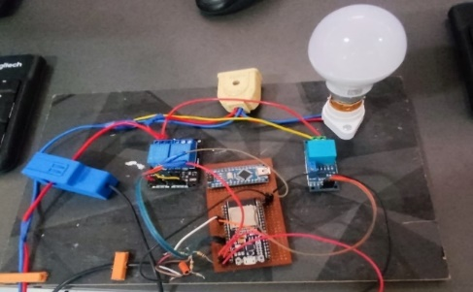
Fig 2: proposed system prototype

The above figure represents the proposed system prototype of smart power management system. All the sensors are connected to microprocessor and load is connected to the working sensors. The working for monitoring of our proposed system was verified.

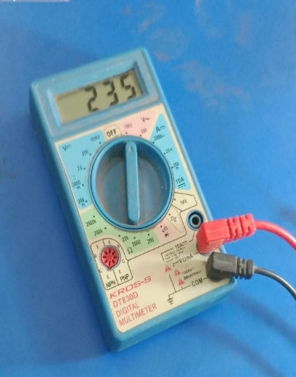
Fig 3: Value of given voltage

The above figure represents the multi-meter, with the practical values obtained after connecting to the load, which will be further compared with the obtained meter values.

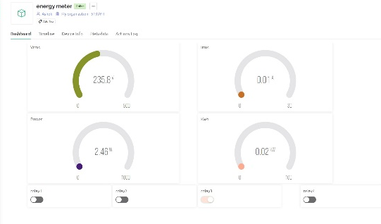
Fig 4: Value of voltage used by the load

The above IoT dashboard shows the consumption of power by the connected load. Here the connected load is a bulb. We can monitor the power consumption of load from any distance with the help of the above IoT blynk application and can turn OFF or turn ON whenever required.
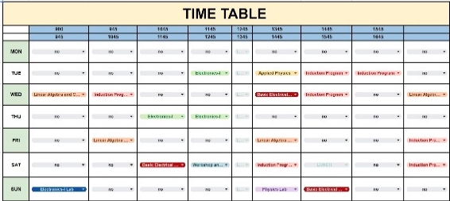
Fig 5: Representation of scheduled Time Table

The above figure represents the controlling of the meter which is based on TIME TABLE. The working of this time table basically operates the switches. The meter switches ON when there is a class, and it automatically turns OFF all the appliances when there is no class working.

References
1]Woong Hee Kim, Sunyoung Lee, Jongwoon Hwang

“Real-time Energy Monitoring and Controlling System based on ZigBee Sensor Networks”, International Symposium on Intelligent Systems Techniques for Ad hoc and Wireless Sensor Networks, vol. 05, pp 749-797,2011.

2]Moataz Soliman, Tobi Abiodun, Tarek Hamouda, Jiehan Zhou, Chung-Homg Lung” Smart Home: Integrating Internet of Things with Web Services and Cloud Computing”, International Conference on Cloud Computing Technology and Science, vol. 02,2013.

3] Putta Sindhuja, M. S. Balamurugan “Smart Power Monitoring and Control System through Internet of things using Cloud Data Storage”, vol. 08, pp 1-8,2015.
4]N. Javaid; A. Sharif; A. Mahmood; S. Ahmed; U. Qasim ,Z.A. Khan “Monitoring and Controlling Power Using ZigBee Communications”, International Conference on Broadband, Wireless Computing, Communication and Applications,vol. 09,2012.

5] Munhaw Kam,Munhaw Kam, Nagender Suryadevara, S.C. Mukhopadhyay,S.P.S. Gill “WSN based utility System for effective monitoring and control of household power consumption”,vol.05,2012.

6]B. N. Rao and R. Sudheer, "Energy Monitoring using IOT," 2020 International Conference on Inventive Computation Technologies (ICICT), Coimbatore, India, 2020.

7]Nikita Nanasaheb,Sasane,Swati N Sakat,Nemane Shital ,Prabhat Kumar Pallav,Vipul Ranjan Kaushik “IOT Based Energy Meter Billing and Monitoring System-A Case Study”,2017.

8]Vangelis Marinakis and Haris Doukas, “An Advanced IoT-based System for Intelligent Energy Management in Buildings”, 2018.

