VISION AND VOICE RECOGNITION BOT USING TINY ML
Fadhl ur Rahman¹, Waasif ur Rahman²
¹Electronics and communication Engineering & B.S AbdurRahman Crescent Institute of science and technology
²Electronics and communication Engineering & B.S AbdurRahman Crescent Institute of science and technology

---------------------------------------------------------------------***---------------------------------------------------------------------
Abstract - Due to ever-increasing number of visually impaired people, the demands of assistant robots have been growing significantly. For the visually impaired, “independent living” which is the key to rebuild the dignity and self-confidence that can be achieved by assistant robot. This project describes the design and development of a personal assistant robot, which is controlled by voice commands to find and determine the relative location of the object in the indoor environment. The proposed assistant robot is a semi-humanoid robot consists of cameras on its body. The cameras are used for autonomous movement, object detection, distance measurement, and motion planning. The prototype assist the visually impaired people by finding the necessary objects through voice command in indoor environment. To justify the proposed system and measure its performance, successful experiments were conducted in indoor environments.
Key Words: Prototype, Robot
1.INTRODUCTION

To assist the visually impaired people by finding the necessary objects using a physical robot through voice command in indoor environment. With the voice command, the physical robot finds out the target object along with reference object and gives the necessary relative location of the object to the user successfully. In overall, the physical BOT can act as a personal assistant for the people with visual impairment in indoor environment. To add to that this bot has a vision based security system to help the visually impaired identify the people in the room. And the best and the innovative part is, we build this framework with the help of TinyML, Embedded Machine Learning also Known as TinyML, is the current new technology where big neural Machine learning network is dumped into Microcontrollers

2. Body of Paper
Proposed system
With the help of TinyML Framework, a state-of-the-art field that brings the performative power of ML to shrink deep structured learning networks to fit on tiny hardware. It is a new approach to edge computing that investigates the deployment and training of machine learning models on edge devices. With the Use of TinyML we can Squeezes Machine Learning Models onto Resource-Light Microcontrollers.

The body of the broadside consists of add up to sections that present the main outcomes. These sectors should be organized to best existent the material.
The first step is to create dataset or identify suitable dataset for both object detection and voice classification. Then the dataset is trained using Machine learning framework suitable for edge devices. In our project we used ESP32-CAM and Arduino Nano 33 BLE Sense as microcontrollers to dump the ML framework. Edge Impulse Platform is used for training the dataset and to create TinyML framework.
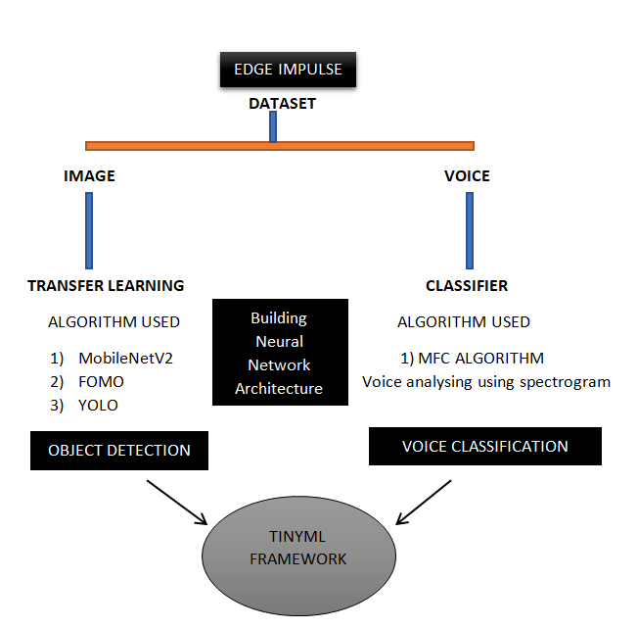
2.1Object Detection and Classification
Object Detection is a computer vision task in which the goal is to detect and locate objects of interest in an image or video.
Object detection was performed with the help of YOLO and Mobile Net V2 algorithm. YOLO algorithm works on four approaches such as Residual blocks, Bounding box regression, Intersection Over Unions or IOU for short and Non-Maximum Suppression.
In edge Impulse, to design the impulse for object detection, we use the input block as Images, processing block as Image block and Learning block as Transfer learning.

IMAGE AND TRANSFER LEARNING BLOCK
In our project we trained the Images which are labeled as ‘pencil’, ‘phone’, ‘tester’ and others. The data was collected with both mobile phone and Arduino Nano 33 BLE sense attached with ov7670 camera. The data undergoes successful processing under Image block. Below is the Feature explorer of MFCC Block

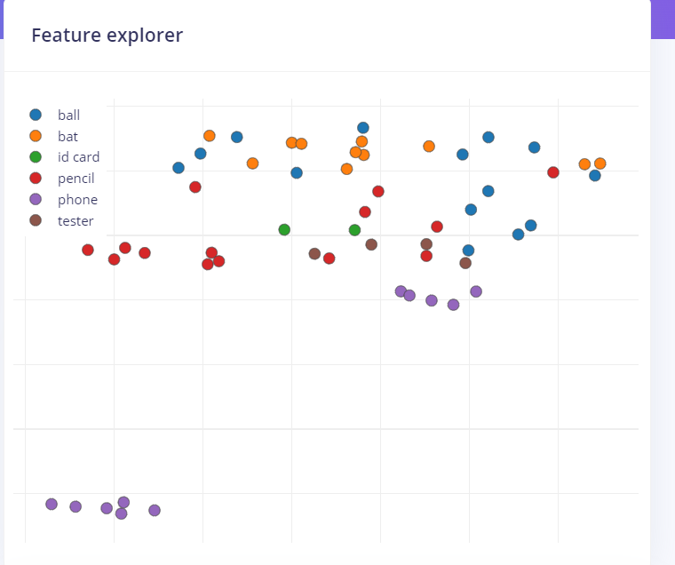
Fig-1 Feature explorer of Image Block
The neural network for object detection was created with the help of transfer learning , learning block with input layer consisting of 27,648 features with the help of Mobile Net V2 model consisting of 7 output classes.

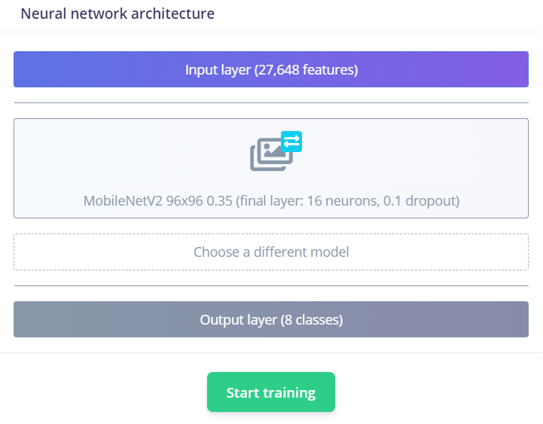
Fig-2 architecture model for transfer learning
2.2 VOICE CLASSIFICATION
Voice Classification of the voice dataset was performed with the help of MFCC algorithm.
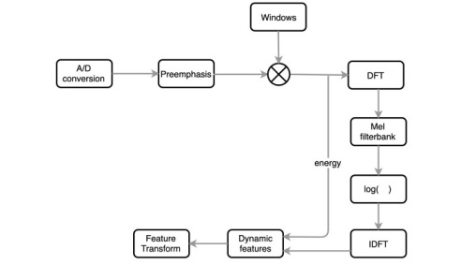

In edge Impulse, to design the impulse for voice classification and processing detection we use the input block as Time series, processing block as MFCC block and learning block as classifier. The neural network for Image Classification was created with the input layer consisting of 650 features with the help of 2D convolutional layer (8 filter, 3 kernel size,1 layer) of 4 output classes.
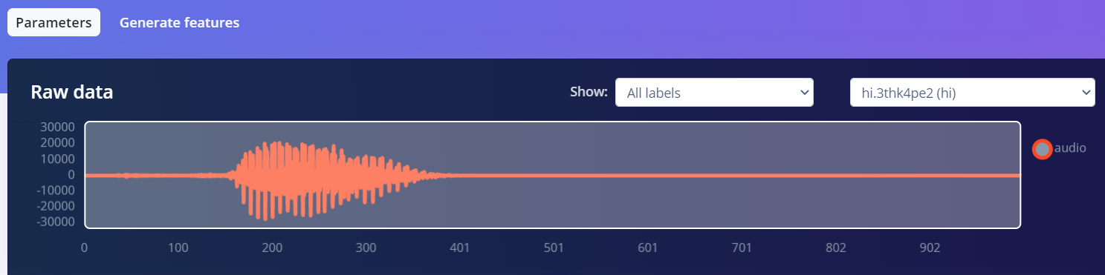
Fig-4 sample raw data of voice

MFCC AND CLASSIFIER BLOCK
In our project we trained the voices which are labeled as ‘green’, ‘red’, ‘yellow’ and noise. The data was collected with both mobile phone and Arduino Nano 33 BLE sense. The data undergoes successful processing under MFCC block. Below is the Feature explorer of MFCC Block

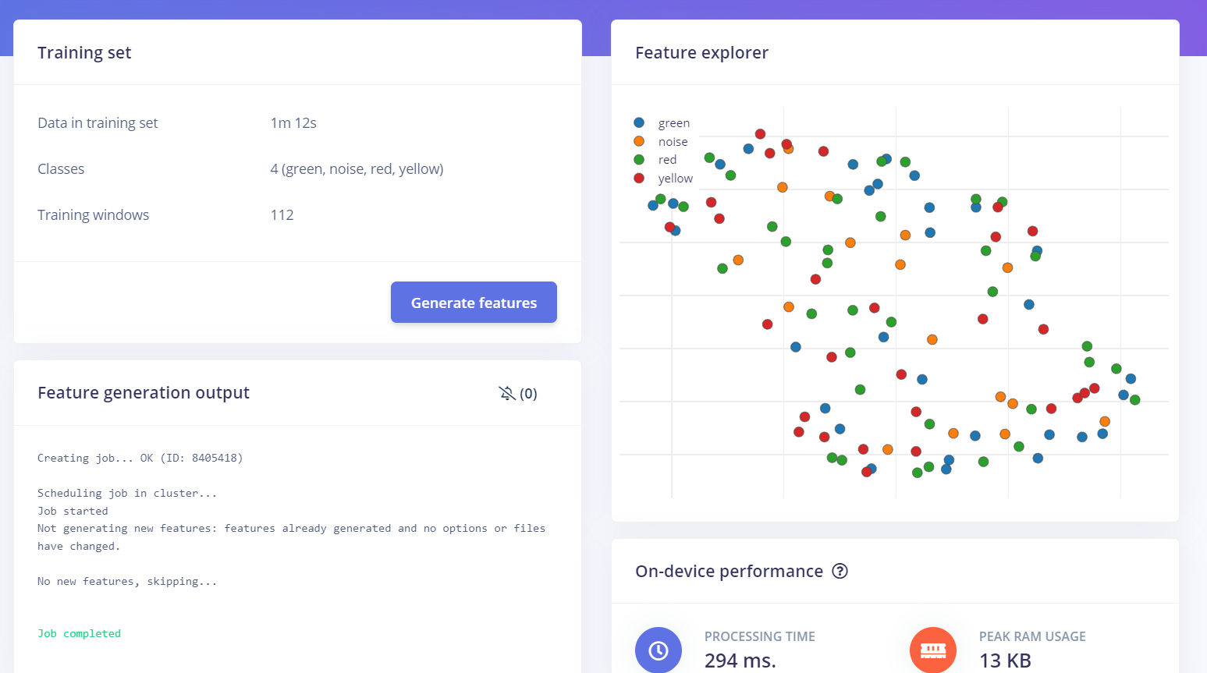
Fig-5 feature explorer of MFCC block

3.RESULTS:
After successfully obtaining the feature explorer from both Image and MFCC block, we obtain the confusion matrix table and data explorer graph after training.

Table -1:Confusion Matrix- voice classification

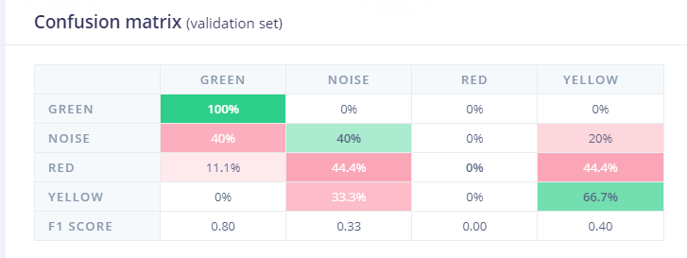

Table -2:Confusion Matrix- Object Detection

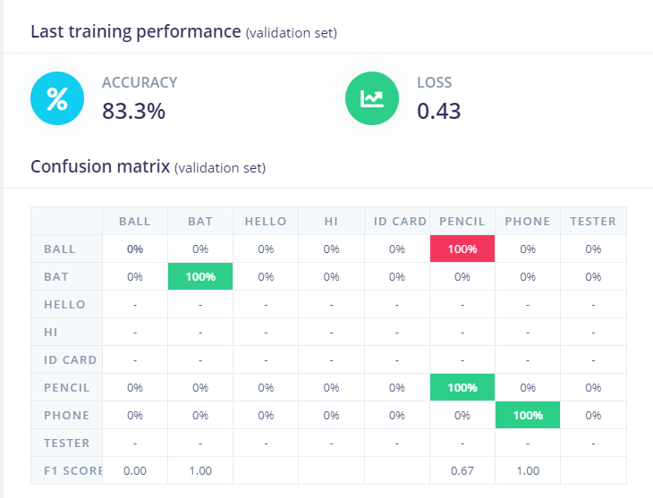

DATA EXPLORER

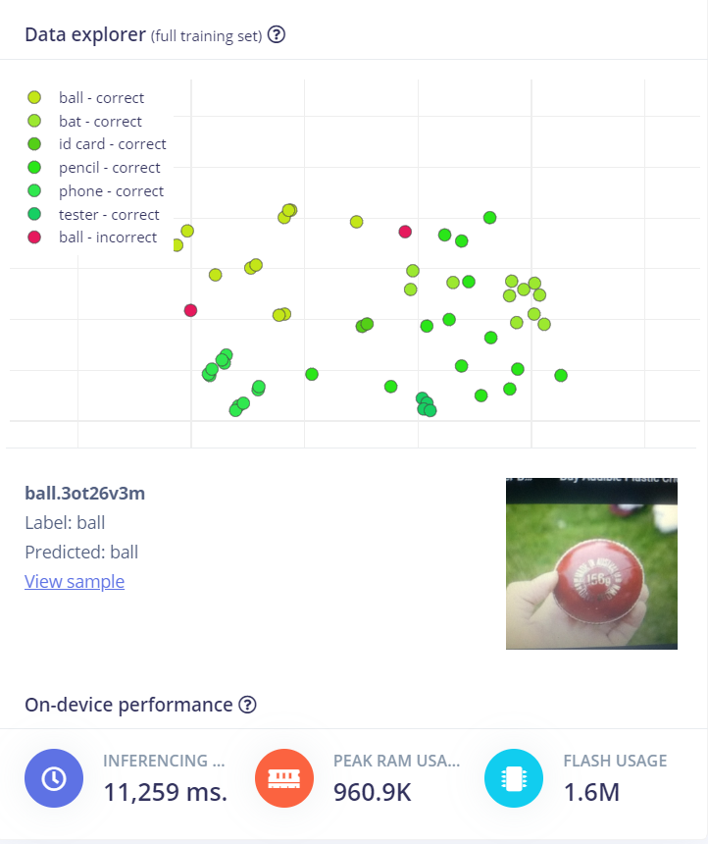
4.Hardware Implementation

The Tiny ML framework developed from edge impulse is downloaded as Arduino library. The voice classification neural network is deployed into Arduino Nano 33 BLE Sense.
The object detection framework is deployed into ESP32-CAM. The live object detection can be visible using ST7735 display. Using any communication protocol we can communicate between Arduino Nano 33 BLE sense and Arduino UNO. The bot is developed by using simple prototype model wich includes robot chassis and motor. The bot is further developed by adding Suitable IR sensor and Ultrasonic sensor for distance measurement, obstacle detection robot movement. Further development for hardware implementation is current being done.
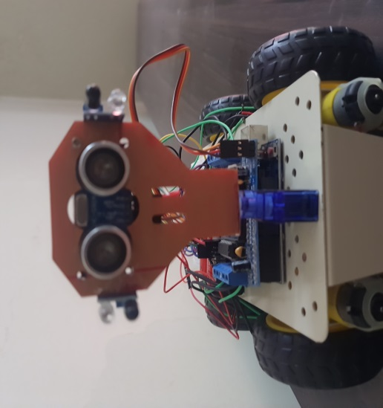
Fig 7 – Prototype Model of BOT

5. CONCLUSIONS

The proposed semi humanoid robot helps in vision recognition and runs based on voice control. Such system can be applicable for visually impaired people as a personal assistant and can be used for public welfare also. Further development and advancement can be brought by giving 100 percent accuracy for both object and voice classification. By implementing such a huge neural network ion a simple microcontroller we are bringing new advancement in embedded systems. By using this Tiny ML framework we are able to achieve Latency, reliability and Privacy.

ACKNOWLEDGEMENT

I ‘am grateful to my Supervisor Mr. DR. P.K Jawahar, who helped me throughout this project with their invaluable patience and Feedback.
I thank all the panel members who reviewed my project and generously provided Knowledge and expertise.
I ’am extremely grateful to my university and my department who allowed me to take up this project in the department AI-IOT laboratory.
REFERENCES

- Davis, S. Mermelstein, P. (1980) Comparison of Parametric Representations for Monosyllabic Word Recognition in Continuously Spoken Sentences. In IEEE Transactions on Acoustics, Speech, and Signal Processing, Vol. 28 No. 4, pp. 357-366
- X. Huang, A. Acero, and H. Hon. Spoken Language Processing: A guide to theory, algorithm, and system development. Prentice Hall, 2001.
- Bathija, A., & Sharma, P. G. (2019, November 30). Visual object detection and tracking using Yolo and sort. International Journal of Engineering Research & Technology. Retrieved October 7, 2022
- G. Signoretti, M. Silva, P. Andrade, I. Silva, E. Sisinni and P. Ferrari, "An evolving tinyml compression algorithm for IOT environments based on data eccentricity", Sensors, vol. 21, no. 12, pp. 1-25, 2021.

