Fire Extinguisher Robot (By Arduino-UNO)

Avdhoot Sujeet Gire
Tanmay Jaywant Ghadge
Aditya Rahul Durge
Ravindra Bhavarlal Solanki
Students of Third Year Computer Technology
Bharati Vidyapeeth Jawaharlal Nehru Institute of Technology Pune- 411043

Guided by : Mr A.P.Shinde
Head of Computer Technology Department
Bharati Vidyapeeth Jawaharlal Nehru Institute of Technology Pune- 411043

Abstract- According to the National Crime Records Bureau (NCRB), it is estimated that more than 10000 deaths have been caused because of fire accidents every year in India. Robots are designed to find the location of fire, before it goes out of control. It could be used to work with fire fighters to reduce the risk of injury to victims. Detection of fire and trying to extinguish the fire is a very dangerous job for the fire extinguisher and it may also risk his life. This project aims for giving technical solution The development of robot is divided into three elements which is the hardware, electronic, and programming. The robot has two DC motors for driving system and castor wheel for giving direction. Arduino IDE language was used to determine the robot movement from the sensors input.It has different types of sensors like flame sensor.
Keywords—Arduino, Robot, Flame Sensor

I. INTRODUCTION
Autonomous Fire Detecting and Extinguishing Robot developed to be a human intervention-less assistance to the work of searching and extinguishing fire.There are several fire fighting systems available for firefighting at residential areas Our proposed system is a small robot which can be used to control the fire from spreading the initial stage of an incident of fire. By using such robots the work of fire detection and extinguishing missions can be carried out without placing the life of fire fighters at a stake and dangerous conditions. In addition to this, small size and autonomous control enables the robot to be used when fire occurs in small and narrow spaces with hazardous environment which are difficult to be accessed by humans. Moreover, this robot can increase the capacity, security,workability, effectiveness and quality of the task of firefighting.
II. LITERATURE SURVEY
Sr. No. | Title of Paper | Author & Year | Future Scope
1. | Design and Manufacture of Indoor Intelligent Fire Fighting Robot. | Ligand Chen  2022 | The Indoor fire fighting robot achieves the expected result of the comprehensive debugging.
2. | Autonomous Fire Detecting and Extinguishing Robot. | Mukul Diwanji, Saurabh kisvon Kar, Chhaya Khandelwal Wal  2019 | To use this robot in practical real time situations.
3. | Automatic Fire Extinguisher Robot. | B.Swetha Sampath  2011 | To implement this system and it’s principle on a humanoid robot to avoid human loss during vast fire.

III. REASEARCH GAP
- Availability and quick response
- High Controlling Capacity
- Avoid Human Loss

IV. OBJECTIVES

- To design a robot which can search, detect and extinguish fire immediateland develop a program using ARDUINO to control the movement of the robot automatically. Besides, lean how to connect microcontroller and othe sensors and actuators.
- To design the robot that includes the flame sensor to detect the fire.
- To analyze how the robot performance to detect the fire in front of the roboand extinguish it by sprinkling water upon it.

V. MOTIVATION OF WORK
- In our daily life “Fire Extinguisher” is an important Rescue Operation .
- Using Fire Extinguisher the Accidents happening in the world it Helps to save human life to avoid and stop Fire Incidents by using these technique of Fire Extinguisher Robot .

VI. HARDWARE REQUIREMENT
1. Arduino Uno board
2. IR based Flame Sensors (Three units)
3. (SG90)Servo Motor
4. Motor Driver L293D5. Robot Chasis of Metal
6. Breadboard
7. DC Motors (Two units)
8. Wheels (Two units)
9. Castor Wheel
10. 12V DC Pump
11. 5V Relay
12. 4V 1.5Ah Lead Acid Battery
13. Switch and Connecting wires
14. Container for keeping Water
15. Silicon pipe for water delivery

VI. SOFTWARE REQUIREMENT
- The Arduino Integrated Development Environment (IDE) is an open-source software, which is used to write and upload code to the Arduino boards.
- The IDE application is suitable for different operating systems such as Windows, Mac OS X, and Linux. It supports the programming languages C and C++.

VII. SYSTEM ARCHITECTURE
- In our project the main component is an Arduino-UNO.
- The Arduino-UNO) is an open-source hardware and software component that designs and manufactures single-board microcontrollers for building digital devices
- Sub Hardware like MQ2 Smoke Sensor , IR Flame detector, SG90 Motor, DC Motor, etc. are used.

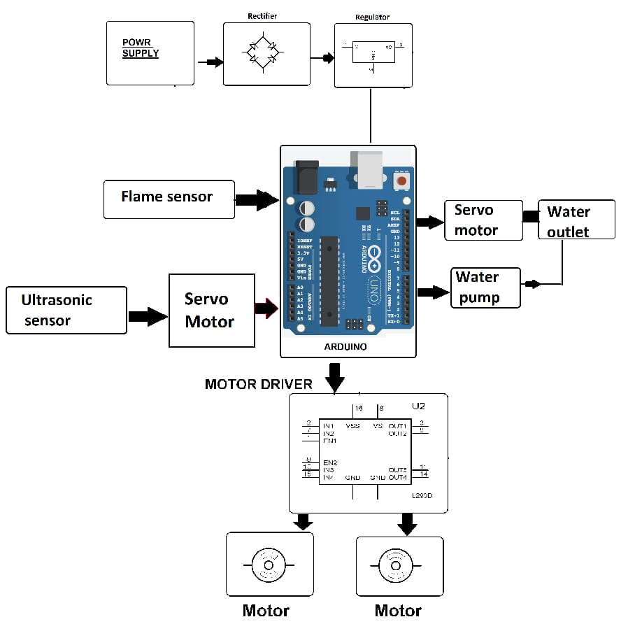

VIII. EXPECTED RESULT
The Fire Fighting Robot is effective enough to fight against fire on a small scale. It can sense fire flame better at darker places. It is made as a preventer robot. Because it can detect fire instantly and can extinguish it before spreading

IX. SCOPE AND LIMITATIONS
This project is based on fire detection and extinguishing robot. This project have much scope to improvise it by adding gps system which sends fire alert to the nearest fire station in form of text message The capabilities of flame sensors are limited. The distance limited for water delivery action is up to 80 to 100 centimeters. This project is more suitable for residential purposes due to its structure and design.

X. CONCLUSION
In this project the objectives are achieved successfully This project have its limitations but it operates very well without any snag and glitch. By adding some features mentioned above it is possible to use this robot in practical real time situations.

XI. REFERENCES
- Base paper - Mukul Diwanji, Saurabh Hisvankar, Chhaya Khandelwal, “Autonomous Fire Detecting and Extinguishing Robot”, - IEEE
- Ligang Chen, “Design and Manufacture of Indoor Intelligent Fire Fighting Robot”, - IEEEPRAMOD BN, HEMALATHA KN, Poornima BJ, Harshitha R
- PRAMOD GN, “FIRE FIGHTING ROBOT”, - IEEE

