HAND GESTURE CONTROLLED POWERPOINT

PRESENTATION USING OPENCV

Dr. Swati Bhisikar
Department of Electronics and Telecommunication,
Jspm’s Rajarshri shahu college of engineering (Tathawade) Pune, India
swatibhisikar@gmail.com
Tanvi Sawant
Department of Electronics and Telecommunication,
Jspm’s Rajarshri shahu college of engineering (Tathawade) Pune, India tanvisawant2001@gmail.com

Shreya Sawant
Department of Electronics and Telecommunication,
Jspm’s Rajarshri shahu college of engineering (Tathawade) Pune, India shreyasawant186@gmail.com

Sayali Narale
Department of Electronics and Telecommunication,
Jspm’s Rajarshri shahu college of engineering (Tathawade) Pune, India nsayali18.02@gmail.com
Abstract- A PowerPoint presentation with a slideshow is an
attractive and effective technique for speakers to persuade the audience in today's digital age. Slides can be controlled with tools like a mouse, keypad, laser pointer, etc. The disadvantage is that managing the devices requires prior device knowledge. A few years ago, gesture detection became increasingly important for controlling software like media players, robots, and games. The utilization of gloves, markers and other objects is enhanced by the hand gesture recognition system. However, the use of such gloves or markers increases the system's cost. This system's proposed hand gesture detection technology is based on artificial intelligence because the hand is more visible, it can better draw the audience's attention.
Keywords: OpenCV, hand gesture recognition, HCI, presentation slides, Machine Learning.

INTRODUCTION
As a new method of human-computer interaction, hand gesture recognition has gained popularity in recent years because its automaticity, naturalness, and ease of use without the need for input via keyboards and mice. For instance, examining lip movements can be used to determine the language being spoken, and hand gestures are also used in gaming [1]. Although there are several methods for recognizing hand gestures today, including wearables like rings, armbands, gloves, leap motion, controller-based motion detection like the Wii-mote, and conventional methods
For instance, examining lip movements can be used to determine the language being spoken, and hand gestures are also used in gaming [2]. A photograph that has the foreground removed. The verified gesture is then utilized to confirm the gesture's sign. The purpose of the proposed study is to integrate artificial intelligence (AI) into a hand gesture recognition system and utilize it to control digital displays solely using hand gestures.

LITERATURE SURVEY
According to a review of numerous different strategies mentioned by the researchers, the primary goal is to assist speakers in making an excellent presentation with increased computer interaction. This study examined how human-computer interaction (HCI) affected the advanced literacy environment at the University of Southampton in the UK. The use of HCI at Southampton University has been beneficial, and studies have shown that becoming comfortable with the basics of HCI improves a stoner's productivity and commerce. Finally, it may be concluded that HCI has affected literacy as it has affected other related environments [4]. "Machine Learning in Python: Main Developments and Technology Trends in Data Science, Machine Learning, and Artificial Intelligence" was presented by Sebastian Raschka, Joshua Patterson, and Corey Nolet. To improve the anthology and advance the field of Python machine learning, they covered widely used libraries and generalities that were gathered together for comprehensive comparison [9]. Xueson in 2010 of the use of artificial intelligence (AI) in education. This study provided a content analysis of studies with the goal of exposing how artificial intelligence (AI) has been used in the field of education and exploring the problems and trends associated with implicit AI investigation in education [10].

The concept of using both static and dynamic gestures to control a power point display was put forth by Jadhav & Lobo. To take and identify pictures Utilizing segmentation approach. Additionally, a motion detection slide-changing feature is introduced [1]. Using the Kinect sensor, Zhou Ren, Junsong Yuan, Jingjing Meng, and Zhengyou Zhang presented "Robust Part-Based Hand Gesture Recognition". They demonstrated a capable hand gesture recognition system that makes use of the Kinect detector. Finger-Earth Mover's Distance, a new unit of measurement for distance (FEMD), which portrays the hand shape as a hand with each cutlet portion as a cluster and penalizes the empty cutlet-sssssssssssFEMD grounded hand motion recognition system operates in 0.0750s per frame and achieves 93.2 mean delicacy when applying the thresholding corrupted cutlet finding approach [3]. The authors of Harika et al. proposed and took a methodical approach to vision-based gesture recognition for computer-assisted slide presentation. There are several methods utilized, including the Kalman filter, the HSL color model, and skin color sampling. When accuracy is taken into account, the suggested model has a success rate for skin color detection of approximately 72.4%,a success rate for single fingertip detection of about 74.0%, a success rate for moving slides of about 77%, and a success rate for controlling the finger pointing of about 80%.[4]. A technique to Recognize Hand Gestures Using Machine-Learning Algorithms was proposed and taken by Wahid et al. If we look at the accuracy of this suggested model, the SVM method outperformed NB, RF, KNN, and DA in terms of classification accuracy, with scores of 97.56% for original EMG features and 98.73% for normalized EMG features. [5].Using Tensor Flow and OpenCV, Ajay Talele, Aseem Patil, and Bhushan Barse presented their paper, "Detection of Real Time Objects." This research presented a state-of-the-art computer vision-based fully obstacle detection method for cellular generation and its components. Based only on appearance, each character picture pixel is assigned to either a barrier or an obstacle. In this study, a novel method for obstruction identification using a single webcam camera was provided [6]. Ali Kadem Abbas, Hamed AlSaediH. An author by the name of Hassin Al Asadi presented "A new hand motions recognition system." They unveiled a cheap device to celebrate the hand motion instantly. The system is often separated into five ways: one for image acquisition, another for pre-processing, a third for hand region detection and segmentation, four for feature birth, and five for counting the figures of fritters and gestures identification. The paper successfully addressed the issues of gyration, exposure, and scaling and obtained identical outcomes when employed with either hand. The apparatus that was handed out simply required a laptop webcam and bare hands, making it incredibly versatile for stoners. The system's findings revealed that the rate of recognition was 96.6%, and this outcome is thought to be genuinely good when compared to other Papers about exploration [7]. In their publication, "Automated Hand Gesture Identification using a Deep Convolutional Neural Network model," Dhall et al. discovered the hand gesture technology and the convolutional neural network that were used to create a hand gesture recognition application. The author of this research employed a CNN, which contains several levels, including an input layer, an output layer, and several hidden layers in-between. Convolutional layer, which identifies and extracts features from pictures, is the first hidden layer. Max pooling layer is used for dimensionality reduction [8].

METHODOLOGY
Processing Before Images:
Pre-processing is meant to raise the overall image quality so that we can study it in a much more thorough way. Pre-processing will help us subdue unwanted distortions and improve a few crucial components.
Pre-processing will help us eliminate unwanted distortions and improve a few components that are crucial to the actual application we are working on. Those characteristics could change depending on the application.

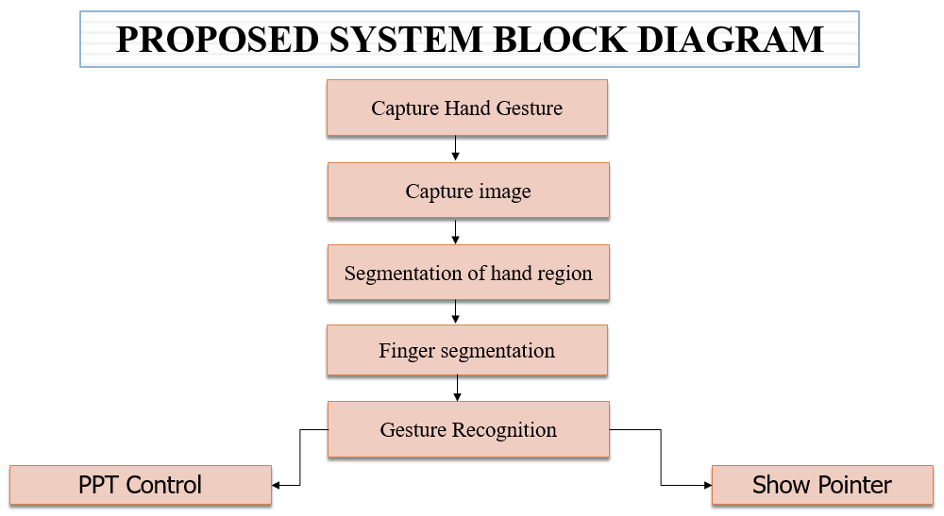
Fig 1. Flow of the System

Image pre-processing procedures:
- Choose a portion of the input image where we can look for hands by drawing a boundary around it.
- The slide won't be changed until the user makes a gesture in front of the camera.
- The slides will change after the hand gesture is recognized.

Working:

• To perform hand movements, the user places their hand parallel to the webcam.
• The surrounding area needs to be appropriately lit in order to minimize error and extract the hand region from the video.
• After that, the background should be free of any elements with skin tones in order to extract the hand from the video.
• To ensure higher-quality video, the webcam's resolution is maintained at 640 x 480 pixels.
• The background in a real-world setting could be made up of various components. In order to separate the hand region from other regions, a background subtraction is therefore carried out. Presentation Controlled by Hand Gestures Using OpenCV
• Webcam video is captured in the RGB color space. Due to the ease with which the skin-related regions may be recognized in the HSV color model, this movie has been converted to it.
• The rules for skin segmentation are then put into practice. The hue and saturation values need to be in the range of correspondingly, 0.1 to 0.9 and 0.4 to 0.6.
• The segmented binary image of the hand's centroid is determined as follows. The hand region is enclosed by a bounding box that is drawn.
• The length of the largest active finger is determined by subtracting the centroid's y coordinate from the bounding box's y co-ordinate, if the hand is vertically oriented.
• A binary image is created when the regions are identified as skin. All other non-skin sections are black, whereas the skin regions are represented by the color white.
• The hand region is assumed to be the greatest connected area that is recognized as skin.
• This reveals the hand's segmented region, which is the area of interest. This is necessary for gesture recognition.

IDE USED
PyCharm
PyCharm is a dedicated Python Integrated Development Environment (IDE) that offers a wide range of essential tools for Python engineers and is securely integrated to create an environment that fosters effective Python, web, and data science development.

Libraries

- OpenCV
Open Source Computer Vision Library is a image processing library and a way of teaching intelligence to machines and making them see things just like humans. OpenCV primarily deals with images and videos. These digital images are stored in a matrix, so when a computer sees a picture it sees it in the form of pixel matrix. It is a free library that has been used to complete tasks including face recognition, object tracking, landmark recognition, and many others.
cap = cv2.VideoCapture(0)

- Handdetector
It is used to detect the right hand and left hand. The hand landmark model performs precise keypoint localization of 21 3D hand-knuckle coordinates inside the detected hand regions.

- NumPy
Numpy is a highly optimized library for numerical operations. Array structure is important because digital images are 2D arrays of pixels. It provides a high performance multidimensional array objects and tools for working with these arrays which makes the processing of arrays easier. It offers a vast library of advanced mathematical features to use on such data structures, such as arrays and matrices, and it gives Python efficient information systems to ensure trusted computations with arrays and matrices.
Kernel = np.ones((3,3),np.unit8)

To define range of skin color in HSV:
lowerskin = np.array([0,20,70], dtype=np.unit8)
upperskin = np.array([0,255,255], dtype=np.unit8)

- OS
The OS module in python provides functions for interacting with the operating system. The OS module is a module that contains several functions that are used to execute OS-related tasks. Basically its main purpose it to interact with your operating system.

Hardware specifications
- Webcam: A video camera can be used to stream images or videos in real time to or across a network. In this proposed system, we would initially take pictures of the hand motions the user made while using the webcam.
- Processor: at least an Intel Pentium 4
- RAM: 1 GB or more
- Hard disc: 20GB minimum

RESULT
Gestures:
- Pinky Finger: By doing this gesture presentation will show the previous slide. (Ref. Fig.1).
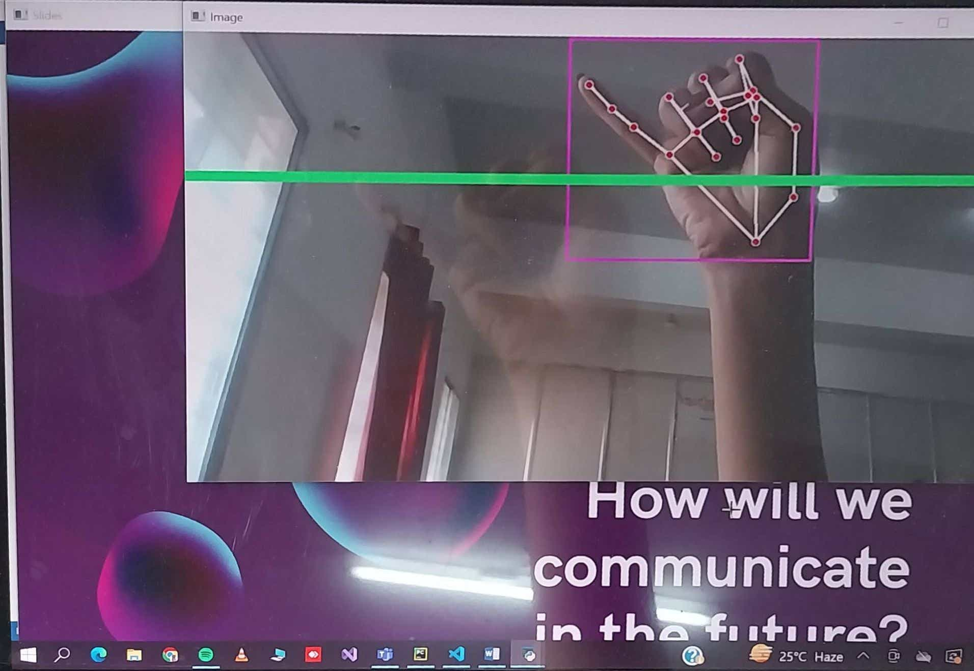
Fig1. Pinky Finger Gesture

- Index Finger: By moving this figure we can draw on the slides (Ref. Fig.2).
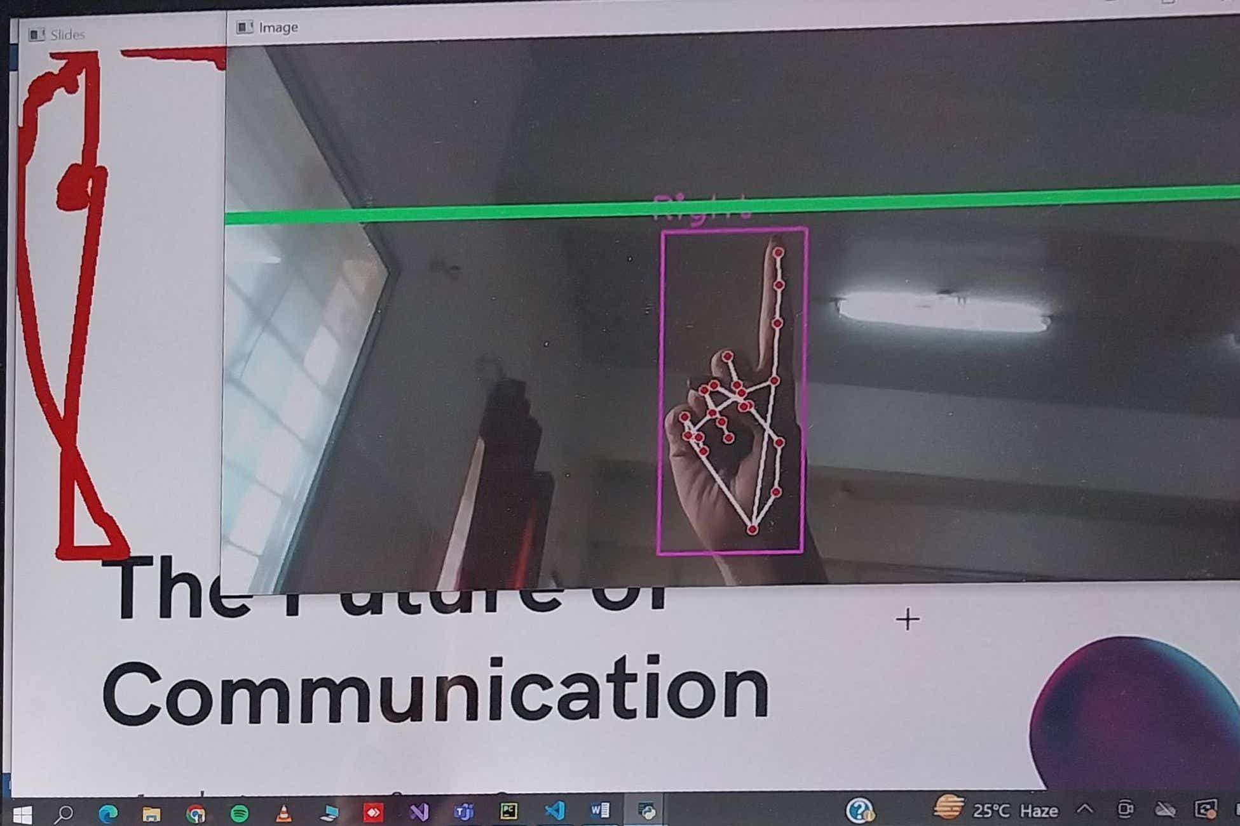
Fig 2. Index Finger Gesture

- Thumb: By doing this gesture we can change the presentation to next slide. (Ref.Fig.3)
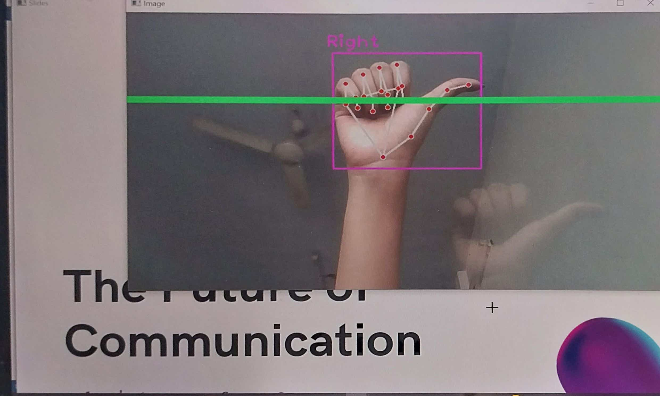
Fig. 3. Thumb

4) Index and Middle Finger: This gesture shows a pointer. (Ref. fig.4)
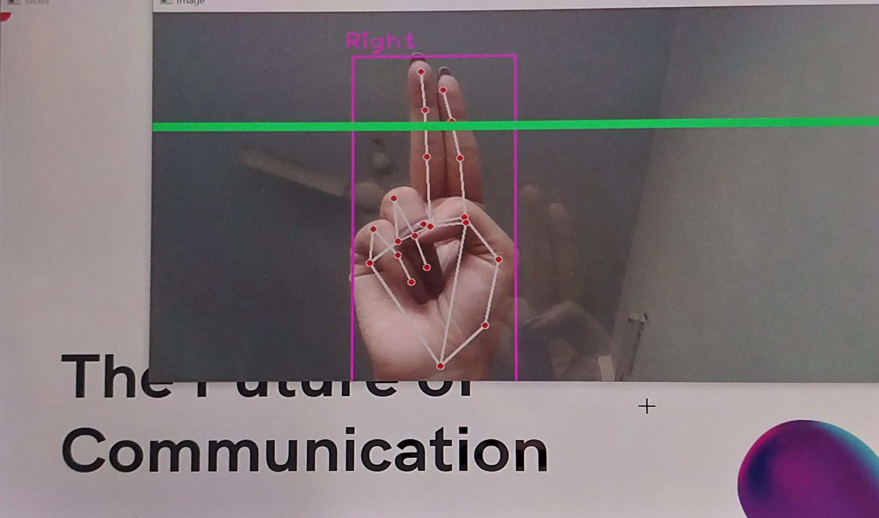
Fig. 4. Index and Middle Finger

5) Three Finger: This gesture is used as an eraser. (Ref. fig. 5)
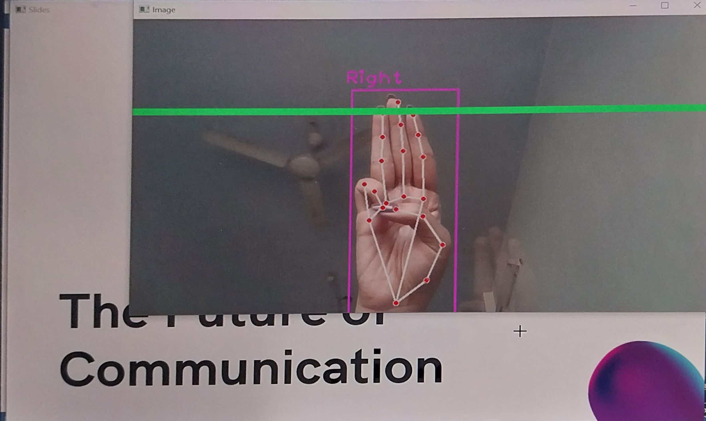
Fig. 5. Three Finger

6) Palm band: This gesture is used to stop the drawing. (Ref. fig. 6)
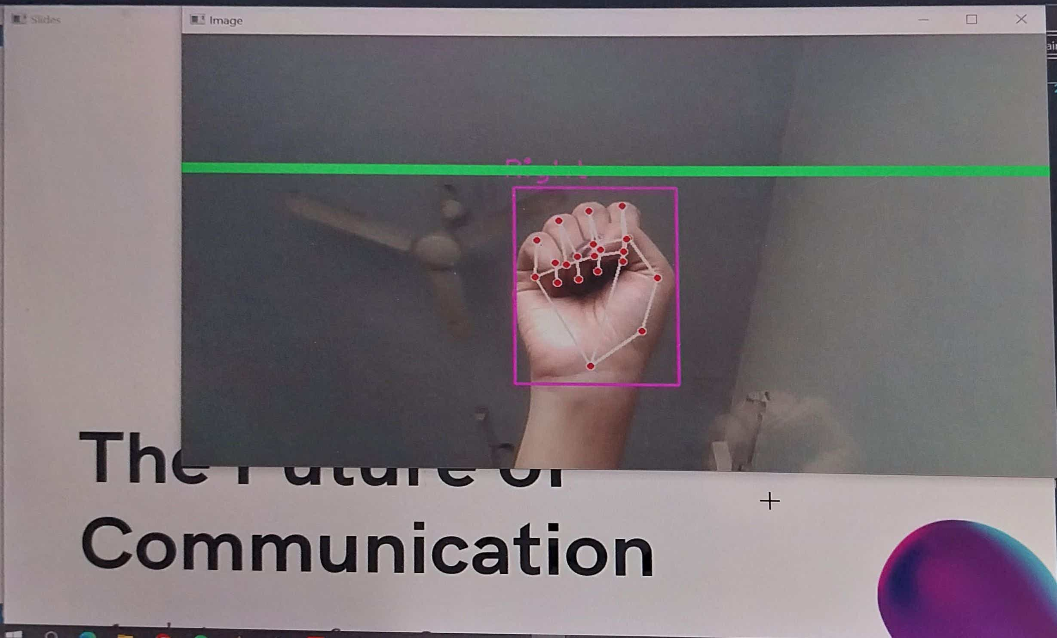
Fig. 6. Palm band

Accuracy of Gestures

DISCUSSION
When compared to other technologies, hand gestures are more natural in interaction since they are an essential component of body language. Interaction is simple and doesn't require any additional equipment when using hand motions. This system's proposed hand gesture detection mechanism uses AI. The speaker could present more readily if they used hand gestures. This system's goal is to create software that will enable presenters to control presentation slides using a variety of hand gestures. With this program, you won't need a keyboard, mouse, or even a remote control to change slides.

CONCLUSION
Presentation is simple with the suggested method, "Hand gesture controlled PowerPoint presentation." The speaker will be able to switch between slides within businesses or other settings where presentations are required for work.

ACKNOWLEDGMENT
I would want to express my gratitude to everyone who helped me along this suggested framework. I appreciate their thoughtful leadership, invaluable developmental audit, and friendly encouragement throughout the suggested framework. You have my eternal gratitude in this regard.

REFERENCES
- D. Jadhav, Prof. L.M.R.J. Lobo, Hand Gesture Recognition System to Control Slide Show Navigation IJAIEM, Vol. 3, No. 4 (2014)
- M. Harika, A. Setijadi P, H. Hindersah, Finger- Pointing Gesture Analysis for Slide Presentation, Bong-Kee Sin Journal of Korea Multimedia Society, Vol. 19, No. 8, August (2016)
- Md.F. Wahid, R. Tafreshi, M. Al-Sowaidi, R. Langari, An Efficient Approach to Recognize Hand Gestures Using Machine-Learning Algorithms, IEEE 4th MECBME, (2018)
- D.O. Lawrence, and Dr. M.J. Ashleigh, Impact of Human-Computer Interaction (Hci) on Users in Higher Educational System: Southampton University as A Case Study, Vol.6, No 3, pp. 1-12, September (2019)
- I. Dhall, S. Vashisth, G. Aggarwal, Automated Hand Gesture Recognition using a Deep Convolutional Neural Network, 10th International Conference on Cloud Computing, Data Science & Engineering (Confluence), (2020)
- Ren, Zhou, et al. Robust part-based hand gesture recognition using kinect sensor, IEEE transactions on multimedia 15.5, pp.1110-1120, (2013)
- Ajay Talele, Aseem Patil, Bhushan Barse on the Detection of Real Time Objects Using TensorFlow and OpenCV, Asian Journal of Convergence in Technology, Vol 5, (2019)

- Ahmed Kadem Hamed AlSaedi, Abbas H. Hassin Al Asadi, A New Hand Gestures Recognition System, Indonesian Journal of Electrical Engineering and Computer Science, Vol 18, (2020)
- Sebastian Raschka, Joshua Patterson and Corey Nolet, Machine Learning in Python: Main Developments and Technology Trends in Data Science, Machine Learning, and Artificial Intelligence, (2020)
- Xuesong Zhai, Xiaoyan Chu, Ching Sing chai, Morris Siu Yung Jong, Andreja Istenic, Michael Spector, Jia-Bao Liu, Jing Yuan, Yan Li, A Review of Artificial Intelligence (AI) in Education from 2010 to 2020, (2021)
- Abidhusain Syed, Zamrrud Taj H. Agasbal, Thimmannagouday Mellinger, Bheemesh Gudur, author suggested the use of sensors in robotics. They are used to determine the current state of the system. In this paper, flex and accelerometer sensors are used to control the slide operations by making four different kinds of gestures, (2019)
- Bhavina Patel, Vandana Shah, Ravindra Kshirsagar, author suggested that “Speech” and “gestures” are the expressions, which are mostly used in communication between human beings. We are controlling the slides in four different ways using four different hand gestures. This project helps in bridging communication gaps between deaf and normal people, (2011)
- Asanterabi Malima, Erol Özgür, and Müjdat Çetin, “A fast method for vision-based hand gesture recognition using for robot control”, Signal Processing and Communications Applications, 2006 IEEE 14th, April 2006.
- Xioming Yin, Singapore Institute of Manufacturing Technology and Xing Zhu, Agilent Technologies Singapore Pte Ltd, “Hand pose recognition in gesture-based human-robot interaction”.
- Xian Cao, Eyal Ofek and David Vronay, “Evaluation of alternative presentation control techniques”, Microsoft Research Asia, China.
- Siddharth Swarup Rautaray and Anupam Agrawal, “A Vision based hand hesture interface for controlling VLC media payer”, Indian Instititue of Information Technology.
- Robert Y. Wang, “Real-time hand tracking as user input device”, Computer Science and Artificial Intelligence Laboratory, MIT, USA.
- Baudel, T., & Beaudouin-Lafon, M. (1993) Charade:Remote control of objects using free- hand gestures.Communications of the ACM. 36(7), p. 28-35.
- Jianjie Zhang, Hao Lin, Mingguo Zhao, “A fast algorithm for hand gesture recognition using relief”, 6th international conference on Fuzzy systems and knowledge discovery, volume 1.
- Hae Youn Joung and Ellen Yi-Luen Do, “Tactile hand gesture hand gesture recongnition through haptic feedback for affective online communication”, College of Architecture, Georgia Institute of technology, USA.
- Desmond Chik, Jochen Trumpf and Nicol N. Schraudolph, “Using an adaptive VAR model for motion prediction in 3D hand tracking”, 8th international IEEE conference on automatic face detection and gesture recognition, September 2008.

IEEE conference templates contain guidance text for composing and formatting conference papers. Please ensure that all template text is removed from your conference paper prior to submission to the conference. Failure to remove template text from your paper may result in your paper not being published.

