Foreign Exchange Rate Prediction based on Sentiment Index
of Social Feed using Machine Learning.
Diksha Parekh¹,Neha Kale²,Arfiya Shikalgar³,Yash Karande⁴,Sheetal Sapate⁵, Anil Shinde⁶

^{1,2,3,4} Dept. of Computer Technology, B.V.J.N.I.O.T, Pune, Maharashtra, India.
⁵ Lecturer; Dept. of Computer Technology, B.V.J.N.I.O.T, Pune, Maharashtra, India.
⁶HOD; Dept. of Computer Technology, B.V.J.N.I.O.T, Pune, Maharashtra, India.
---------------------------------------------------------------------***---------------------------------------------------------------------

ABSTRACT: The importance of predicting foreign currency exchange rate is evident in both academic and business sectors, despite financial time series data being known to be chaotic, noisy and dynamic. They are also important in trade worldwide and for international transactions. We investigate the relationship between Twitter content categorized as sentiments, such as Buy, Sell and Neutral. Our research show that it is possible to predict trend of exchange rates using machine learning and sentiment analysis, where Twitter data by itself could be used to predict trends.

KEYWORDS: Social media, FOREX, Machine learning, Twitter, Sentiment analysis

- INTRODUCTION

Foreign exchange market refers to the market formed by market participants engaged in foreign exchange transactions. The purpose of trading includes investments and trade, speculation, and hedging. Trading at the right time with correct approach can gain profit but a trade without knowledge can cause heavy loss. The foreign exchange market is by far more complicated as compared to stock or bond markets. Predicting the foreign exchange rate includes predicting the performance of entire economies. Although there is no guaranteed FOREX prediction formula, many algorithms and AI techniques such as ANN (Artificial Neural Network), HMM (Hidden Markov Model), SVM (Support Vector Machine), sentiment analysis have been applied to predict the exchange rate seeing the behavior and patterns of price within historical data. “Foreign exchange numbers are driven by a large number of complicated factors, including human psychology, and understanding them requires not so much a grasp of the economic fundamentals as of the irrational way in which people can behave when they join in crowds”
Hence, prediction of the financial market movement has become a challenging task. One of the most fundamental concepts of economics is the rule of supply and demand.

Foreign exchange rate works similarly on the same principle currency values tend to rise with the increase in demand and tend to fall with the decrease in demand. Factors such as speculation stock market, political stability and performance, current account and balance of payments, and interest rates affect the demand for currency change. Now days social media is being in demand day by day and valuable along with their mass data. At the same time, researchers, analysts, and investors are working on currency exchange rate forecast for a long time. We will try to determine if an analysis of the information found on different social media and news can be used as an input in the decision-making process for investing decisions.

The aim of this paper is to investigate, identify and evaluate valuable features and patterns in price movement performance of US Dollar exchange rate (USD) parity by analyzing the relevant data gained from social media with¬¬ sentiment analysis. The main contribution of the paper is the application of Twitter sentiment analysis on the foreign exchange market from an emerging economy. One benefit of studying the foreign exchange market is that, due to the huge FOREX volume, the possibility of misinformation is expected to be lower than in stock market analysis.

- LITERATURE SURVEY

In recent years, sentiment analysis has received considerable attention, not only from scientific researchers, but also from practitioners in marketing and advertising. Also in the last few years, Social media has become the most common platform for sharing data and information across the Universe. Social media plays a vital role for the person who wants to put their opinions about any current or real actions
Different techniques have been proposed to predict the financial market. With the continuous development of data mining technology, and deep learning theory, machine learning algorithms and sentiment analysis techniques that has grown in recent years.
The large information accessible on long range interpersonal communication locales that consider individuals to express their emotions, conclusions and views have motivated specialists to to examine tweets. The work done in paper allows comparing different classifiers to classify a huge number of English tweets related to particular products into positive as well as negative sentiments. Using sentiment features rather than conventional text classification gives high accuracy. This system is used to rank satisfactory classifiers for sentiments and helps business organizations for making their future business plans related to the product [1].

The author Ashwini Kumar, Vishnu Tyagi and Sanjay Das proposed a CNN-BiLSTM method for the sentiment analysis of Twitter data having 1.6 million annotated tweets. The accuracy is 81.02 for classifying tweets as Negative or Positive on benchmark dataset. Their novel approach uses LSTM based neural network with few of parameters attains modest results and outperformed against statistical machine learning methods [2].

In the year 2020 Department of Information Science and Engineering Bangalore, Karnataka, INDIA proposed a machine learning model that uses Random Forest for stock price prediction using Twitter reviews. These reviews include emotions i.e. polarity and the comment about the product. The PSO was employed iteratively as global optimization algorithm to optimize Random Forest for stock price prediction and then plotted all the data related to results and the training part. Based on the surveys and comparisons done with all the other machine learning models for the stock price prediction using twitter, in order to analyze and predict based on the public mood using sentimental analysis in order to get an overview of the public mood the tweets are classified into positive, neutral and negative[3].

In 2021 A Prediction Model of CNN-TLSTM was made for USD/CNY Exchange Rate Prediction. This paper selects the opening price of USD/CNY exchange rate, the highest price of USD/CNY exchange rate, the lowest price of USD/CNY exchange rate, the closing price of USD/CNY exchange rate, the closing price different stock prices which affect the of USD/CNY exchange rate from a specific interval of time, are used as experimental data to predict the USD/CNY exchange rate closing price of the next trading day [4].

Analysis of tweet sentiment is an important field of price forecasting studies. Because of the large amount of news updates per minute about Bitcoin, using Twitter in the sentiment analysis for Bitcoin is becoming a significant step for most researchers. Text mining and classification techniques on Twitter data are therefore needed which can predict the best sentiment. Study research observed that there is a strong correlation between the Bitcoin percentage shift and Twitter sentiment.[5].

In 2022 a study was performed on sentiment analysis and emotion detection on tweets related to cryptocurrency. Sentiment analysis of cryptocurrency holds potential significance as it is widely used for predicting the market price of the cryptocurrency which necessitates sentiments classification with high accuracy. The proposed model achieved the highest performance for sentiment analysis with a 0.99 accuracy score and the highest precision and recall of 0.99 and 0.98, respectively. Similarly, LSTMGRU outperforms all other models in terms of correct and wrong predictions for both sentiment analysis and emotion detection [6].

- SYSTEM ARCHITECTURE

The methodology used for foreign exchange price prediction using sentiment analysis. Sentiment analysis is contextual mining of text which identifies and extracts subjective information in source material, and helps to understand the social sentiment related to forex prices only while monitoring online conversations. For training purpose data will be collected and stored in the csv by the data scraper. The data collected for processing would be stored in an array, but as an array is a linear data structure sequential execution would have consumed a lot of time and kept the processor executing., Pandas library from Python would save a lot of time as it performs processing tasks in a parallel manner. In this way we prepare data for training purpose.
Machine Learning algorithms (for Prediction):
Regression:
Simple Linear Regression: It is used when we need to predict the value of a variable which is reliable on the value of other variable. The variable we want to predict is the outcome variable. In linear regression there is only one reliable variable and it becomes difficult to predict the price rates over future.
Multiple Linear Regression: Multiple regression can be a good option as we have multiple dependent variables and there is a chance of increasing accuracy. But as here we have to deal with time-series data multiple linear regression won't be an optimal solution.
Long short term memory also called as LSTM are special RNN .used for long term dependencies. LSTMs are best for dealing with time series data and making predictions best on past transactions of values. the accuracy of LSTM is remarkable.

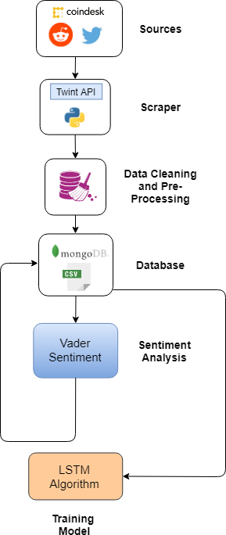

Fig 1. System Architecture
The detection phase now begins, where real-time tweets are plugged into the model and the model predicts the price over the next few hours after which we run the scheduler. In order to get real-time tweets, the scheduler runs the twitter scraper in crontab on a remote server which is built using the twint library. We then feed the tweets to the sentiment analysis model and then we take the mean of all sentiment index for that time period, which is fed to the machine model, and finally we get the predicted price.

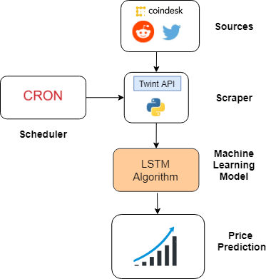

Fig 2. Real Time Scheduler

- DATA ACQUISATION FOR TRAINING THE MODEL

- DATA SCRAPING

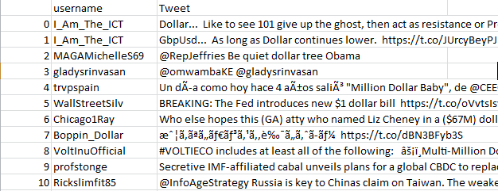

Fig 3. Data from Twint
This study uses tweets from Twitter to predict the exchange rate between the US dollar (USD) and the
Indian rupee (INR). Using the Python module Twint, we first gather a dataset from Twitter that contains tweets from various influencers with more than 50000 followers. 7,800 samples in total were gathered. Twitter offers the research community text analysis of tweets using a variety of factors. Twint Python package was used to extract tweets based on the necessary criteria. From 01.01.2019 to 31.12.2022, we extracted tweets with the hash tags USD/INR, #USD/INR, Dollar, and #Dollar as shown in Tab. 2.

Second, using a Python module called Scrapy, we extracted a publically accessible exchange rate dataset from the (http://www.forex.com.pk) based on the exchange rate between the US dollar and the Indian rupee. The rates were gathered between January 1st, 2017, and December 31st, 2022. The dataset of prices includes four different sorts of pricing for each day: the closing price, the opening price, the highest price, and the lowest price for that specific day.

- Sentiment Analysis

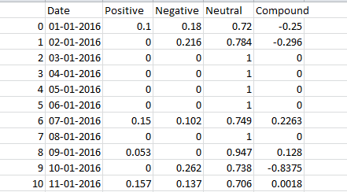

Fig 4. Sentiment Analysis
The next step is sentiment analysis, which has two stages. First, the text in the Twitter data is chaotic and full of noise, including HTML tags, special characters, accented letters, numbers, hyperlinks, extra-wide spaces and tabs, and emojis. Sentiment analysis is impacted by this noise. As a result, each tweet's text is put through a stopword removal process using the NLTK library using ‘nlppreprocess’. In the next phase The text is then provided to VaderSentiment, an NLTK module that generates sentiment scores based on the terms we selected for sentiment analysis, in the following stage. Four parameters—Positive, Negative, Neutral, and Compound—are included in each tweet's output. The previously listed parameters are the specific weights that represent how the user behaved in the tweet.
We receive numerous sentiment values for each day because there are many tweets each day; therefore, we compute the mean sentiment values for each day, as shown in fig [4].

- Mapping of Tweets and Prices

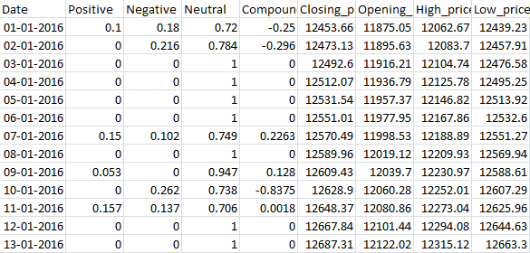

Fig 5. Mapping

Following sentiment analysis, a training dataset is generated by converting tweets to Indian Rupees and mapping the US Dollar price to that. Price mapping is one of the most crucial components because these tweets cause changes in FX prices. Due to tweets from the previous day, there are differences in price patterns. The tweets must be mapped with the USD/INR price dataset.

So, mapping is carried out as follows:
tweets_from_today => price(tomorrow).
This mapping method will aid in forecasting tomorrow's prices.

- REAL TIME SCHEDULER

The next step is the detection phase, during which the model receives real-time tweets and uses them to make predictions about the price movements over the coming hours. Once this is done, the scheduler is run.. To obtain real-time tweets, the scheduler executes a Twitter scraper on a remote server via crontab. This server is constructed using the twint library. Next, we input the tweets into the sentiment analysis model and calculate the average sentiment index for the corresponding time period. This value is then passed to the machine learning model, which produces the predicted price.

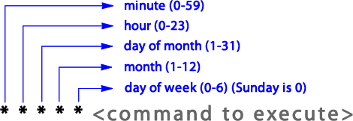

Fig 6. CronTab Scheduler Command

As the scheduler executes periodically the following steps are executed –

- The data is extracted using the Twint Library, starting from the current system time and going back 'n' number of hours.

- Pre -processing of extracted data.

- Perform Sentiment Analysis then find it’s mean .

- It retrieves the current USD/INR price from wsj.com and then associate it with the corresponding sentiment values.

- The mean value is provided as input to the machine learning model, which then generates the predicted price for the following day.

- EXPERIMENTAL ASSESSMENT

By using the sentiment value and its associated actual USD/INR values from each day in the past, our software seeks to forecast USD/INR prices. The best machine learning algorithm for this project is LSTM because the training data is time-series in nature and includes sentiment and price trends. (Long short-term memory). Missing time/date frames can be handled by LSTM while still retaining model correctness. As a result, LSTM is the machine learning algorithm of choice when training data containing time-series components

- Training Model:

The 1559 tuples in the dataset used to train the model include the date, the positive, negative, neutral, and compound sentiment ratings, as well as the expected price of bitcoin for the following day. The 1559 tuples in the dataset used to train the model include the date, the positive, negative, neutral, and compound emotion ratings, as well as the USD/INR exchange rate for the following day. The data are normalised between 0 and 1.

TensorFlow was used as the backend for training. For each tweet and news article that is used as input during the training phase, our sentiment analysis model generates several sentiment values because it is built to combine different characteristics. The multi-feature model gives improved accuracy in its sentiment analysis predictions when compared to a single-feature model.

This project has the potential to be utilised as a bot for real-time trading in the future because it includes a real-time scheduler that extracts data and produces real-time forecasts of the USD/INR price. The model can use its algorithm to optimise returns by buying and selling at the right times using the amount that the user provides for trading.

Although this model was created particularly to anticipate the USD/INR exchange rate, it might be modified and used to forecast other currencies. Therefore, investing in other currencies as well as the US dollar will yield benefits.

- Prediction Output

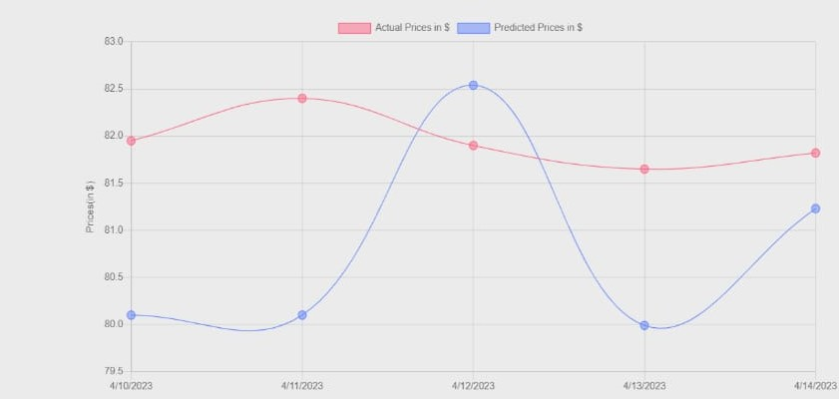
Fig 4. Predicted Prices

- CONCLUSION

By examining sentiment from Twitter and news sources, the LSTM model has been successfully used to forecast USD/INR prices in real-time. The real-time scheduler continuously runs on the server, extracting data and making predictions using the machine learning LSTM model. On a website, the forecasts are displayed as a graph.

ACKNOWLEDGEMENT

We would like to thank Mrs.S.D.Sapate for her invaluable input and support throughout the research process. Her insights and expertise were instrumental in shaping the direction of this project.
In addition, we would like to extend our sincere thanks to all of the authors in our study, who generously shared their time, experiences, and insights with us. Their willingness to engage with our research was essential to the success of this project, and we are deeply grateful for their participation.

REFERENCES

[1] Jingyang Wang, Xiaoxiao Wang,Jiazheng Li, Haiyao Wang,”A prediction model of cnn-tlstm for usd/cny exchange rate prediction”,School of Information Science and Engineering, Hebei University of Science and Technology, Shijiazhuang 050018, China,School of Mechatronics, Xiamen Ocean Vocational College, Xiamen 361100, China, May 2021.

[2] Omkar Kudale, Nikhil Yadav,Srishti Gupta, Aditi Rao,”Twitter sentiment analysis using machine learning for product evaluation”.InProceedings of the Fifth International Conference on Inventive Computation Technologies (ICICT 2020),IEEE Xplore Part Number:CFP20F70-ART; ISBN:978-1-7281-4685-0.2020.

[3] Vishu Tyag,Sanjay Das,.Ashwini Kumar..Sentiment analysis on twitter data using deep learning approach.In 2020 2nd International Conference on Advances in Computing, Communication Control and Networking (ICACCCN). December,2020.

[4] Niveditha N Reddy, Naresh E, Vijaya Kumar B P, “Predicting stock price using sentimental analysis through twitter data” Department of Information Science and Engineering Bangalore, Karnataka, India.September,2020.

[5]. Otabek Sattarov, Heung Seok Jeon,Ryumduck Oh,Jun Dong Lee, “Forecasting bitcoin price fluctuation by twitters sentiment analysis,” 2020,International Conference on Information Science and Communications Technologies (ICISCT), November 2020

[6]. Crypto currency related tweets using ensemble lstm-gru model,” IEEE Access ( Volume: 10), 07 April 2022.

