Evolution Of shopping – bricks and mortars to online shopping

Baisakhi D
Assistant Professor
Center for Management Studies, Jain Deemed-to-be Universities
baisakhi_2015@cms.ac.in

Accamma CG
Assistant Professor
Center for Management Studies, Jain Deemed-to-be Universities
accamma_cg@cms.ac.in

Abstract:
This study looks at how shopping has changed through time, from traditional brick and mortar establishments to the development of e-commerce. It investigates how customer behavior shifts and technical advancements have affected the retail sector. This study examines changes in customer preferences, purchasing habits, and the creation of new shopping platforms using primary and secondary data sources. Additionally, it looks at the difficulties and chances that the retail sector will face as it tries to adjust to an era of quick technological development. In general, this study sheds light on the future of shopping and its potential effects on businesses, shoppers, and the whole economy.

Design:
Online purchasing and e-commerce have increased over time. We carried out the study to comprehend the alterations and shifts in buying on numerous web platforms.

INTRODUCTION &
OVERVIEW:

In the world of retail, brick and mortar stores will always have a role. Customers prefer to physically interact with products, try them on, feel the materials, and judge the fit for themselves. Everything about this is much more appropriate for an in-store encounter than an internet encounter. Yet, stores no longer have to be primarily concerned with in-store inventory depth.

Besides from speed, immediacy, and ease of access, the internet is helpful for other things like product information, comparison, transparency, and consumer information like reviews. Moreover, for buying at anytime, anyplace.

Each has its place, but the point where brick-and-mortar and e-retail come together is where things start to become really interesting. As a customer, I can access the online store and all of that information, transparency, and insight primarily through mobile.

DIFFICULTIES AND OPPORTUNITIES DO THESE CONVERGENCES BRING

If the same things can be acquired elsewhere, the merging of internet and brick-and-mortar stores could pose a challenge to merchants. Prices can be compared by customers. Convergence, however, can also be a benefit because customers can learn far more in-depth details about the product while I'm in the store.

Recognizing the benefits that having a digital device enables us to provide the user with is the opportunity. For instance, we might currently "tax" a customer who attempts to make an online purchase while at a store by having them pay shipping costs, even if the store might only be able to waive those costs at the cash register.
Similar to how they may receive credit for a retail transaction but not for an in-store mobile web buy. To ensure that customers don't waste time or money and that employees are rewarded for the proper behaviors, systems and processes must be centered around the customer.

Hence, there is an incentive misalignment. The incentives that encourage actions that are great for the customer and best for the store are frequently not set up by stores. Finding a way to link customer convenience with retailer operations and goals is part of the problem and opportunity.

TRANSITION FROM A MULTICHANNEL APPROACH TO A BRICKS AND MORTAR RETAIL PERSPECTIVE
Finding a method to admit there is a problem and accept that perhaps something isn't functioning as well as it could is the first step with many aspects of change.

To take a step back, scrutinize everything, consider all the points of contact, and consider whether something is actually effective, a company must be intensely focused on its customers. Be prepared to own up to this. Look at the traffic, look at the behaviors, look at how customers are responding to what you're doing, not just in transactional ways but in behavioral ways.

Retailers can increase the potential for value creation based on actual customer behavioral data. There is so much data available
about customer intent, mindsets and behaviors.

How to enhance product management and optimize the store experience itself, and how users interact with the site's key functions are actually where the company shines. It opens up possibilities for the store, the virtual four walls, and the virtual experiences that they enable, as well as for many of the day-to-day levers that control how these businesses run both online and offline as more and more of these behaviors and data are brought to light.

We've talked about how traditional brick-and-mortar retail might be threatened or enhanced by online retail.

EFFECTS DIGITAL RETAIL HAD ON BRICK-AND-MORTAR RETAIL

It's amazing to us that many of the things we do in physical stores haven't moved online. The product catalogue and transactional side are what have changed. But, developing fantastic brand experiences online, inspiring imagination, and fostering serendipity is still very young. Meaningful personalization is comparable in this regard. The arithmetic behind product recommendations, such as "customers who buy this also buy that," has been solved. It's hardly humanistic personalization, though. Only presentation optimization is involved. It is nevertheless shocking that there is no tailored focus on content and experiences.

The greatest multi-channel and digital retailers need to start examining the attitudes that customers have when they visit their sites and how they interact with them there.

BRICK-AND-MORTAR RETAIL WILL ULTIMATELY BE COMPROMISED BY E-COMMERCE

Several controversial claims have been made, claiming that anything that can be done offline can now be done online and that the death of brick-and-mortar stores is inevitable. It isn't accurate, in my opinion. Brick and mortar stores are fantastic for so many reasons, including the simplicity of browsing a huge selection of goods, the tactile nature of being able to touch, feel, smell, and try things out, and the social component of buying.

Physical retail will undoubtedly undergo significant change, in my opinion. When it comes to same-day and on-demand delivery, perhaps retailers start to resemble more of a showroom. So, the store's fulfilment and delivery processes are not its most crucial components. The design of the store is centered on delivering memorable experiences, which may entail smaller stores in terms of square footage or alternative product displays.

There will be significant changes in the function of a store, but I can't see a scenario in which people wouldn't want to be able to physically see and touch goods as they buy.

IDEAL RETAIL EXPERIENCE
The main objective is to provide the customer with the finest service possible under their terms. This entails learning as much about them as they're willing to share, including their preferences, likes, and goals.

Customers only want to be respected and to see important information presented to them in a timely and appropriate manner. Give them what they want if they ask for a lot of assistance and involvement. Let them take the initiative if they want to run the relationship. Even if it's challenging, every merchant must continue to strive for it at all points of contact.

REVIEW OF LITERATURE:
The wealth of information, reviews, and ratings available today allows consumers to thoroughly research products before purchasing. According to this study, 97% of digital consumers and 90% of traditional consumers Do your research online before visiting a store, Amazon Prime is huge and will have over 140 million members worldwide this year. Digital consumers are more likely to research customer reviews than traditional consumers looking for special offers and coupons. Seeking knowledge, younger generations build shopping lists based on consumer feedback, while older generations compare prices. social satisfaction
Consumer shopping behavior also influences the way people use social platforms to voice their opinions in nearly every interaction. Retailers should use social sentiment to monitor, engage and improve customer service.
A BRP study found that from the age of 18, he thought 61% of 37-year-old shoppers would share a positive experience on social media, while a 38-year-old consumer was 29% more likely than her. There is only one. When it comes to negative experiences, 56% of digital consumers use social platforms to vent, compared to only 27% of traditional consumers who post complaints. The survey highlights that nearly two-thirds of all shoppers said they would stop shopping at a retailer entirely after a bad experience. Critical Insights into Consumer Shopping Behavior for Retail Marketers
The lesson that needs to be learned is analytics, regardless of whether your major demographic is young or old. If your target audience is 18 to his 37, they want to know about their likes, dislikes, and past purchases to tailor their experience. If your buyers are part of a crowd of 38, use data to know when and what they're buying, anticipate their needs, stock what they're looking for, and offer savings need to do it.
Remember, digital consumers value automation and technology to enjoy a smooth shopping process. As you focus more on the traditional consumer, offer optimal customer support, inventory, and promotions to build your brand's loyalty in a digital world with many options. Expertise
In our private lives, we are all consumers, who visit stores regularly and have a lot of experience in offline and/or online shopping. As explained by Lilien (2016), this is a very different situation than his B2B researchers face. A major benefit of this face-to-face experience is the ability to identify discrepancies between what you teach in retail courses and what you observe in the marketplace. For example, retail textbooks assume that consumer goods should be sold as centrally as possible. However, Gielens, Gijsbrechts, and Dekimpe (2014) found that popular foods (manufactured and owned by national brand manufacturers and clearly positioned as such) are sold in his one retail chain. We have observed an increase in the number of exclusive contracts. Following this observation, they developed a framework for identifying potential gains and losses for both retailers and manufacturers involved in such contracts, and also how to develop loser compensation mechanisms. Developed. Similarly, a major tissue manufacturer at one point proudly advertised that it puts the same effort into manufacturing PL products as its own (domestic) brand. Production contracts (if any) are best kept confidential. Inspired by this apparent contradiction Deleersnyder, Geyskens, and Dekimpe (2014) examined the rationale (and expected benefits) underlying PL production by major domestic brand manufacturers. .
business analyst report
In addition to personal experience and observations, retail researchers also benefit from extensive (but not always consistent) coverage of the industry by business analysts. For example, Edge Retail Insight (formerly Planet Retail RNG) tracks her 2000+ major retailers worldwide and publishes both daily news updates and summary reports on a wide range of retail trends. Similar reports are regularly published by Euromonitor, AC Nielsen, AT Kearney, IRI, etc.2 Not only do these reports contain a wealth of information, but they also regularly set conflicting expectations. It provides a natural opportunity to position research.

RESEARCH METHODOLOGY

We have conducted a survey with a group of people with different lifestyles on online shopping and their experience with it. (64 responses)
RESEARCH OBJECTIVES –
- Preference shifting from shopping in bricks and mortar stores to online shopping apps/ websites and Platforms most preferred to shop online.

- Analyse how many people shop online and how frequent they do so.
- Gather data about the kinds of products usually bought online and the quality,
- Online shopping customer satisfaction.

The survey mainly gathered data mainly in the areas of -
- What attracts people to shop online.
- Their satisfaction with online shopping
- Difference between product description and product
received.

SAMPLE SIZE -
We have conducted a survey with a group of people with different lifestyles on online shopping and their experience with it. (64 responses)

Data analysis and interpretation
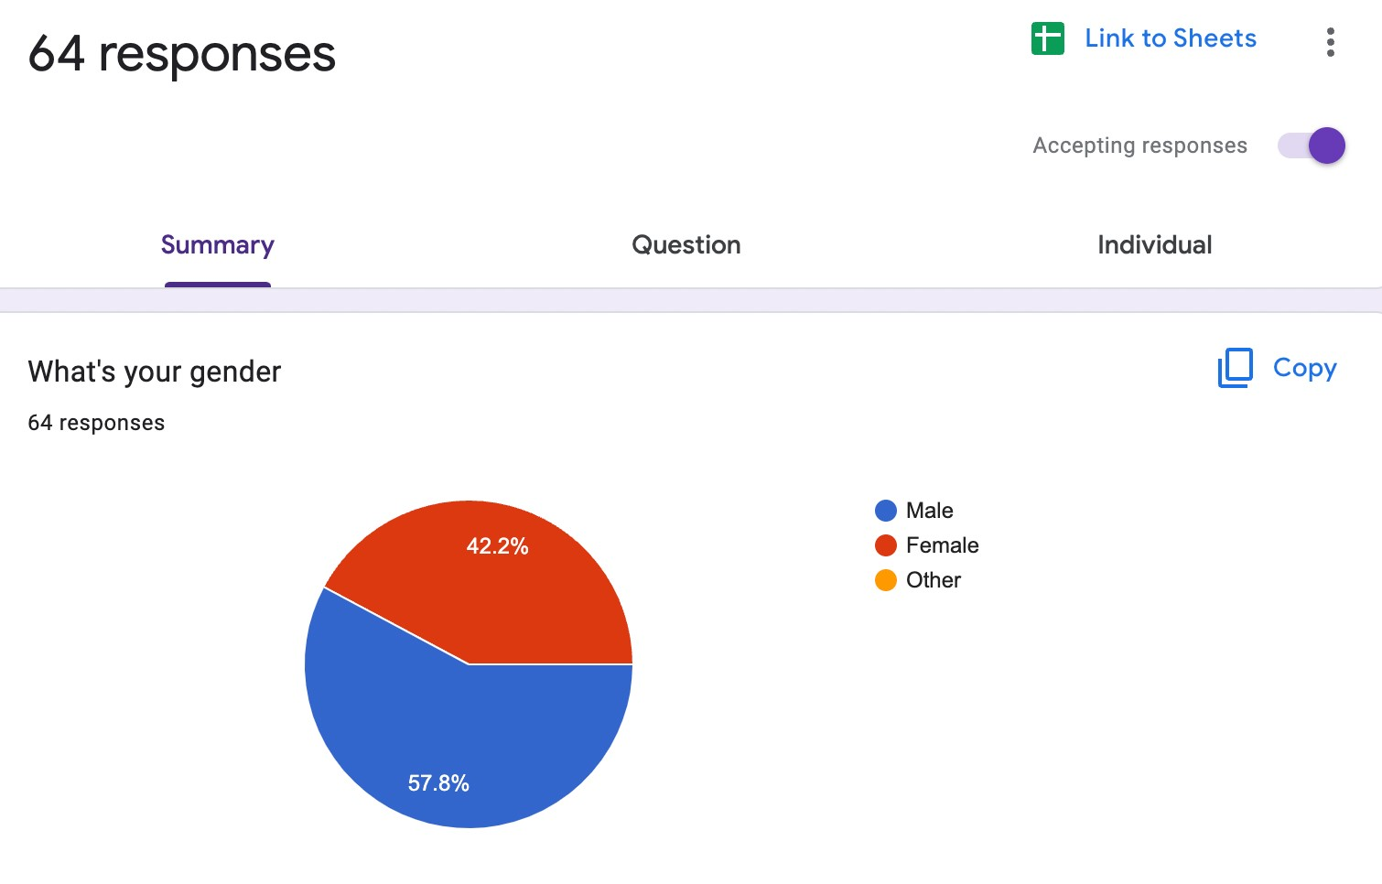
Most of the participants in the survey conducted were male.

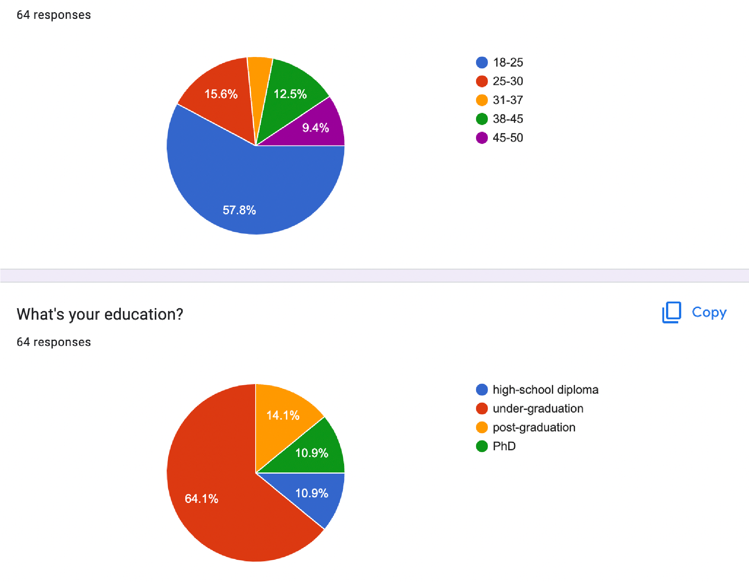
Most of the participants in the survey conducted were between the age of 18-25 and are doing an undergraduate degree.
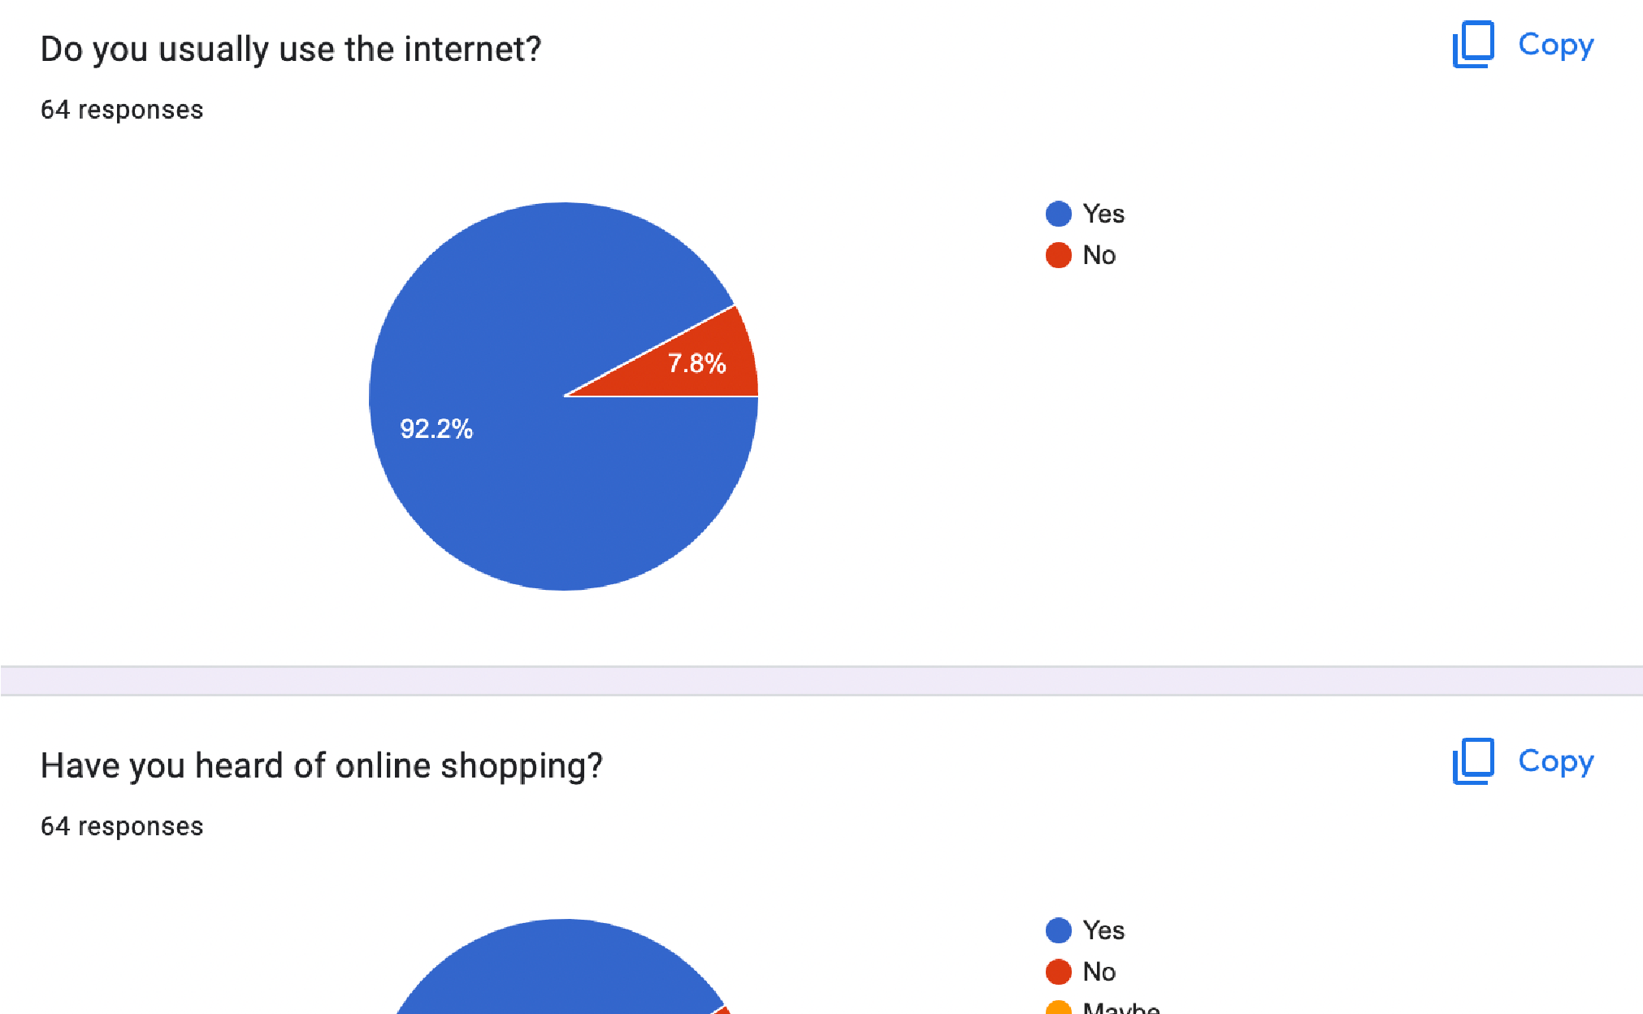

Most of the participants in the survey conducted usually use the internet and have heard about online shopping but 7.8% don’t use the internet and 9.4% haven’t heard about online shopping.
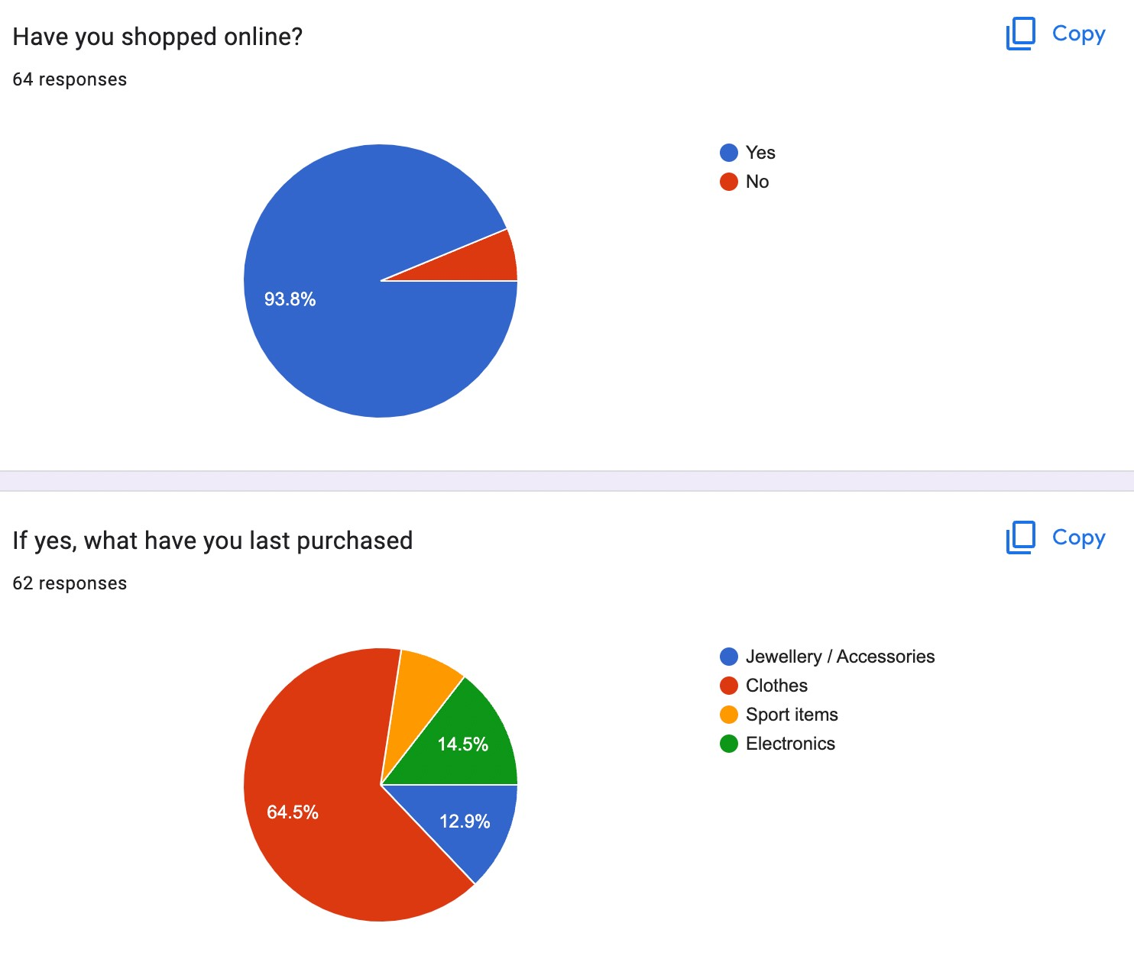
Most of the participants who have shopped online have shopped for clothes, followed by electronics and accessories. The least purchased items are sports items.


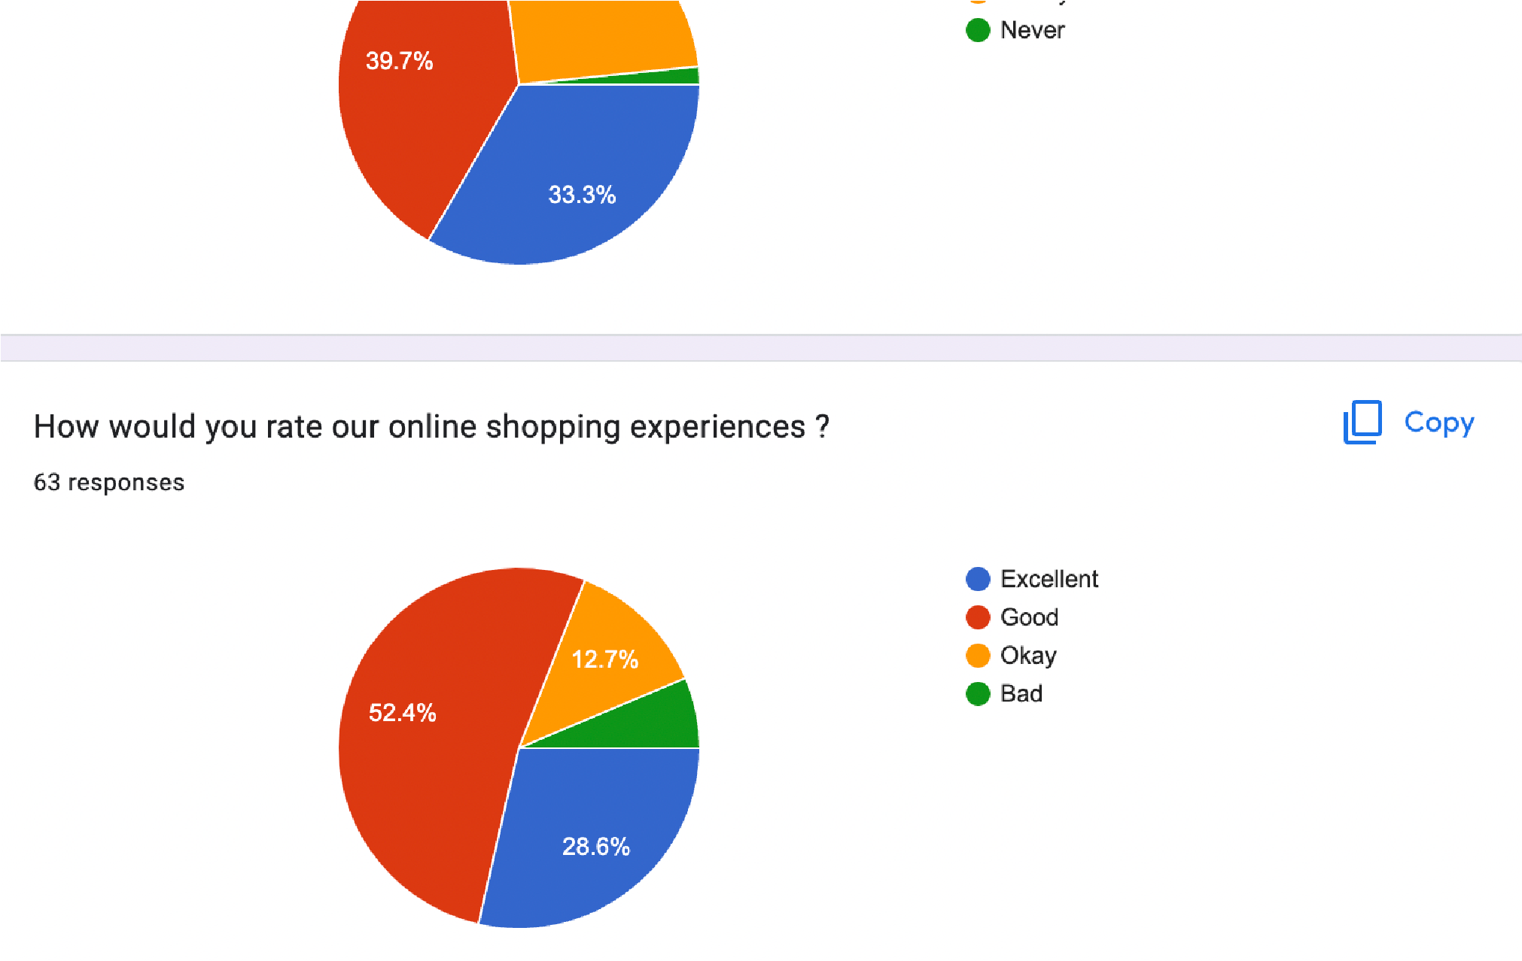
About a third of the participants in the survey conducted shop online every 2-3 months followed by a third who shop once a month. They all mostly have a positive experience with shopping online
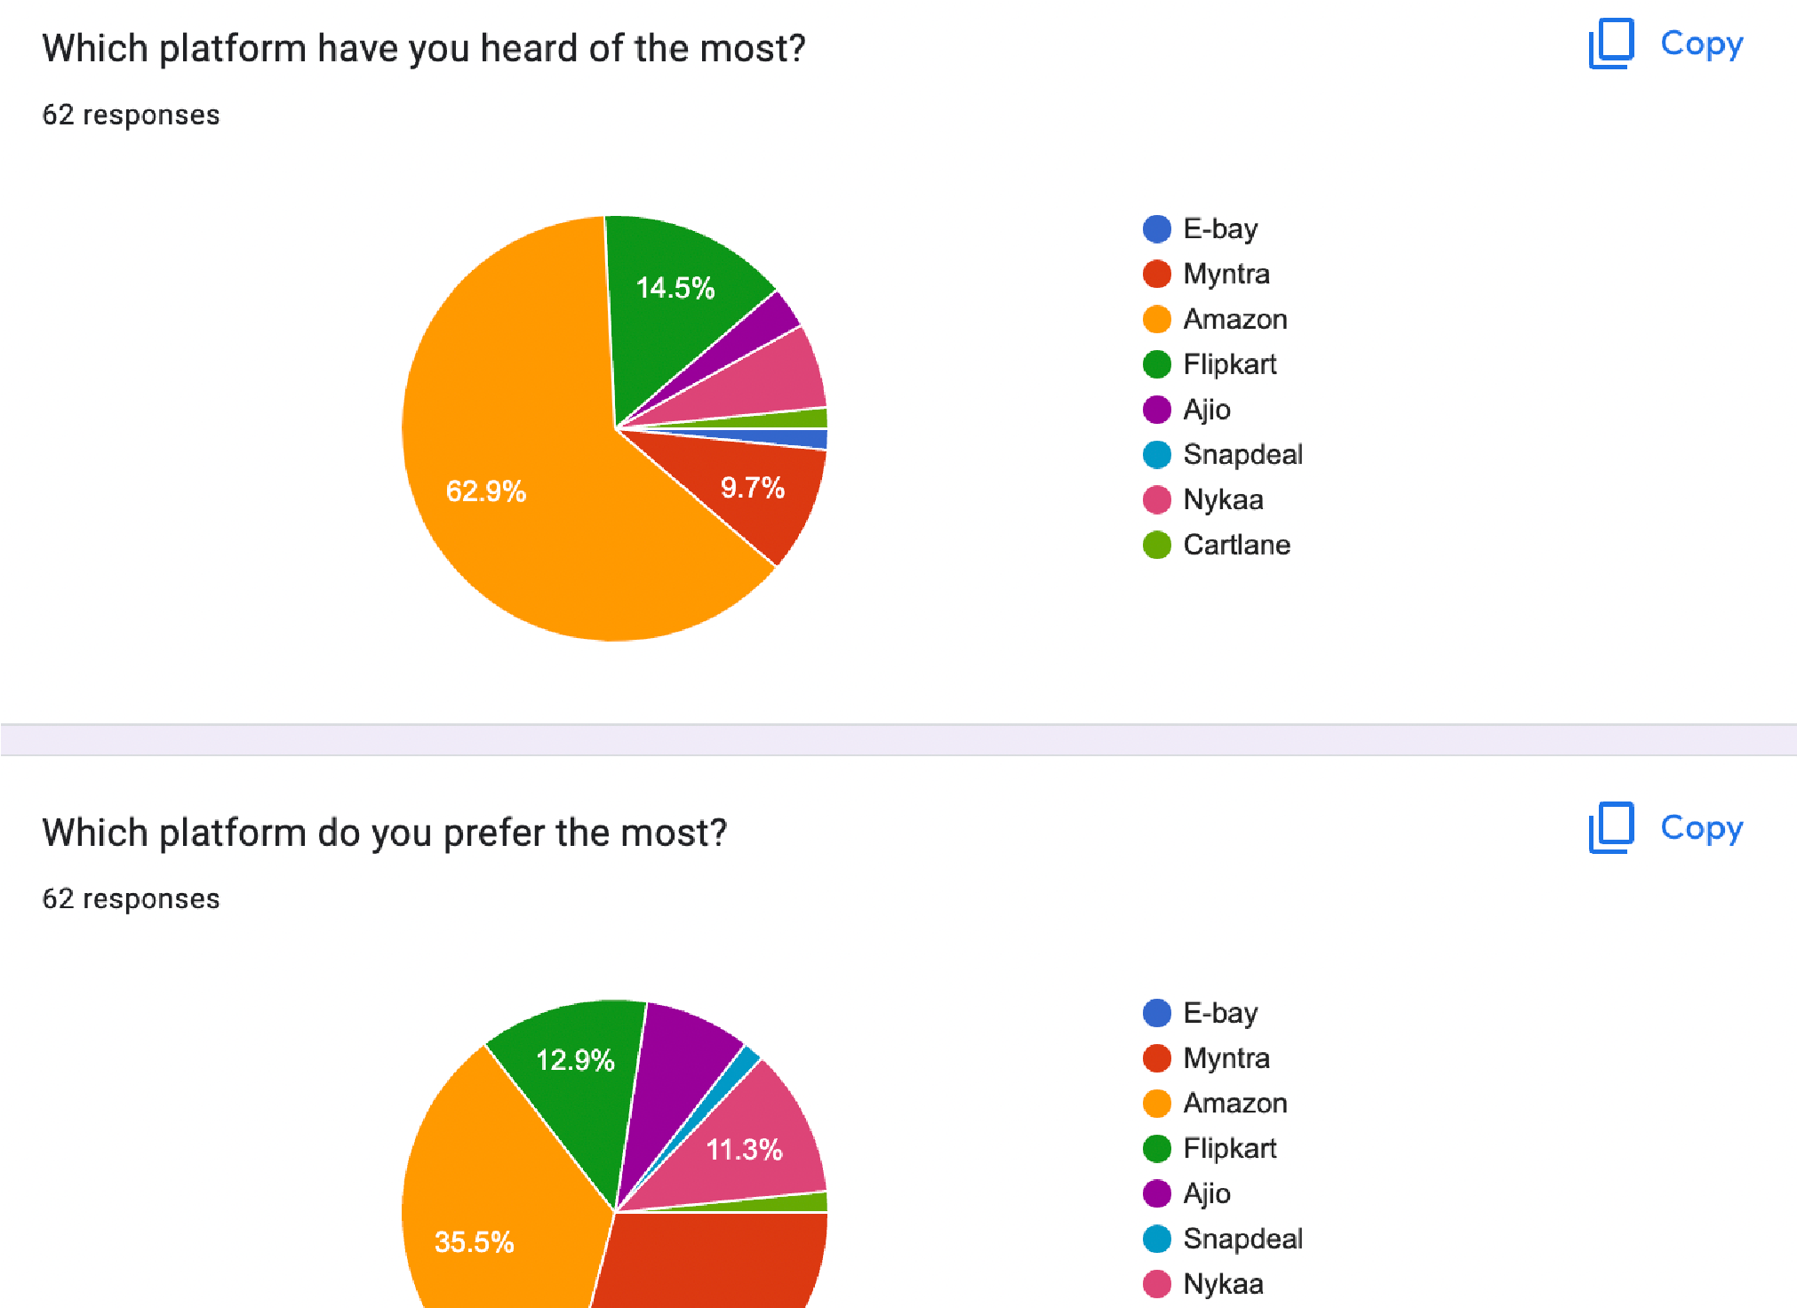
Most of the participants in the survey conducted have heard about and prefer amazon the most.
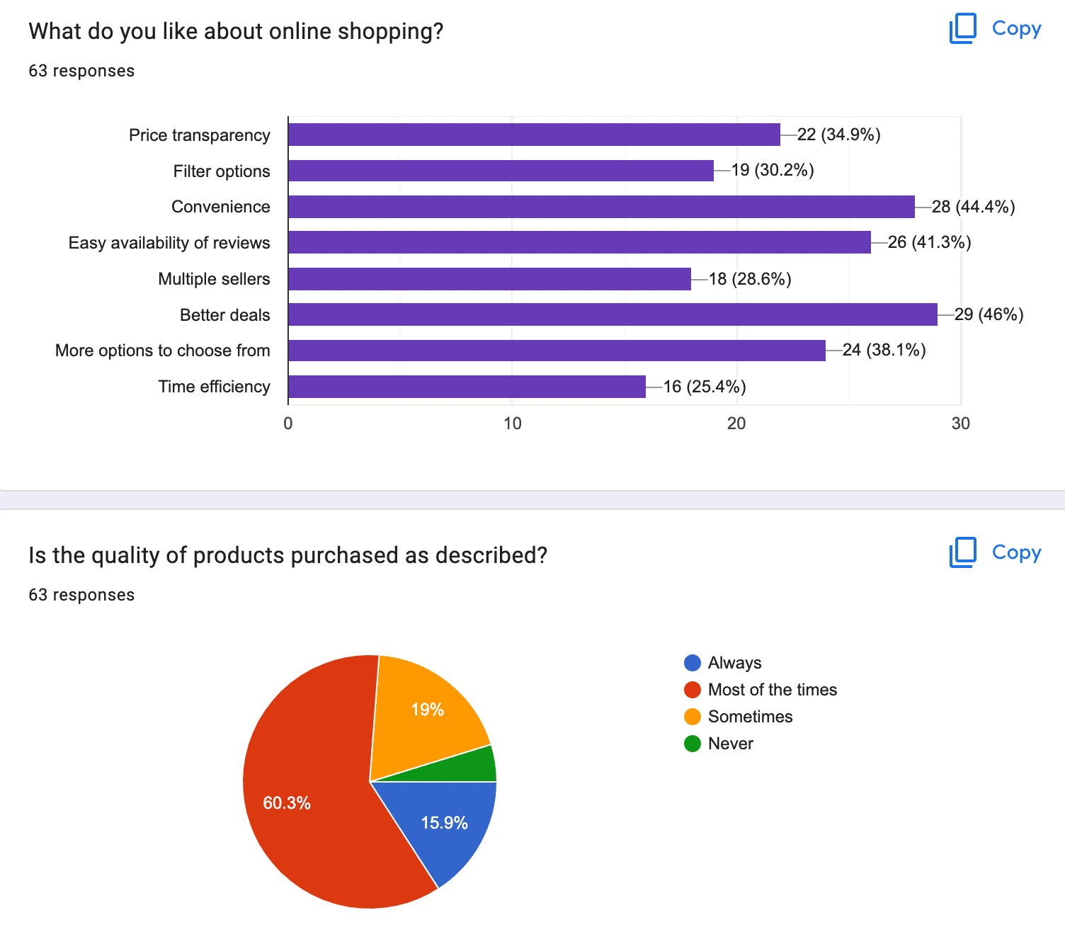
The reason why the participants like online shopping is majorly because of better deals followed by convenience and the factor least affecting is time efficiency.
According to the survey, the quality of the products purchased online are as described most of the times.


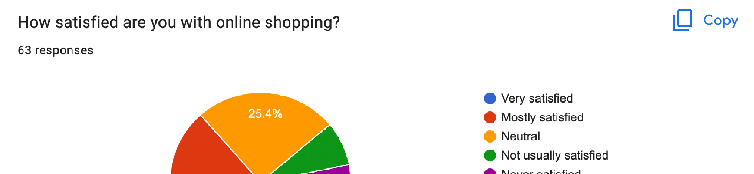

Most of the participants in the survey conducted are mostly satisfied with online shopping and a vast majority remain neutral towards it.
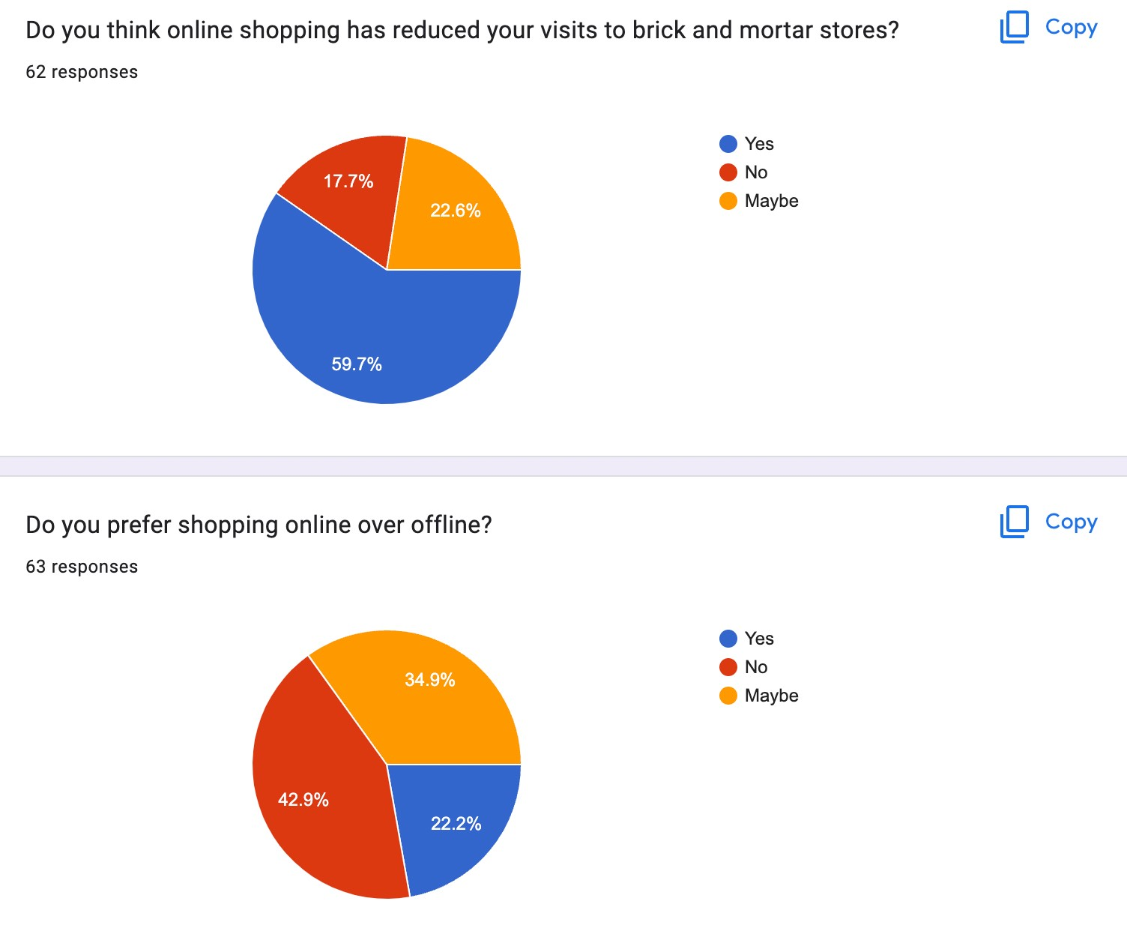
Although online shopping has majorly reduced visits to brick and mortar stores, participants still prefer shopping in stores rather than online.
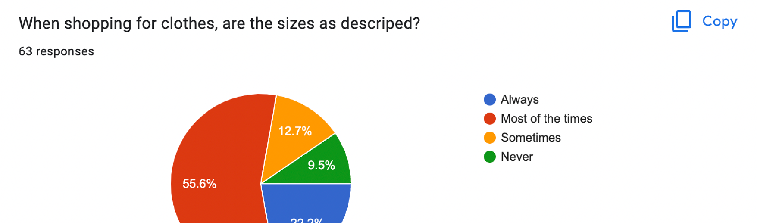
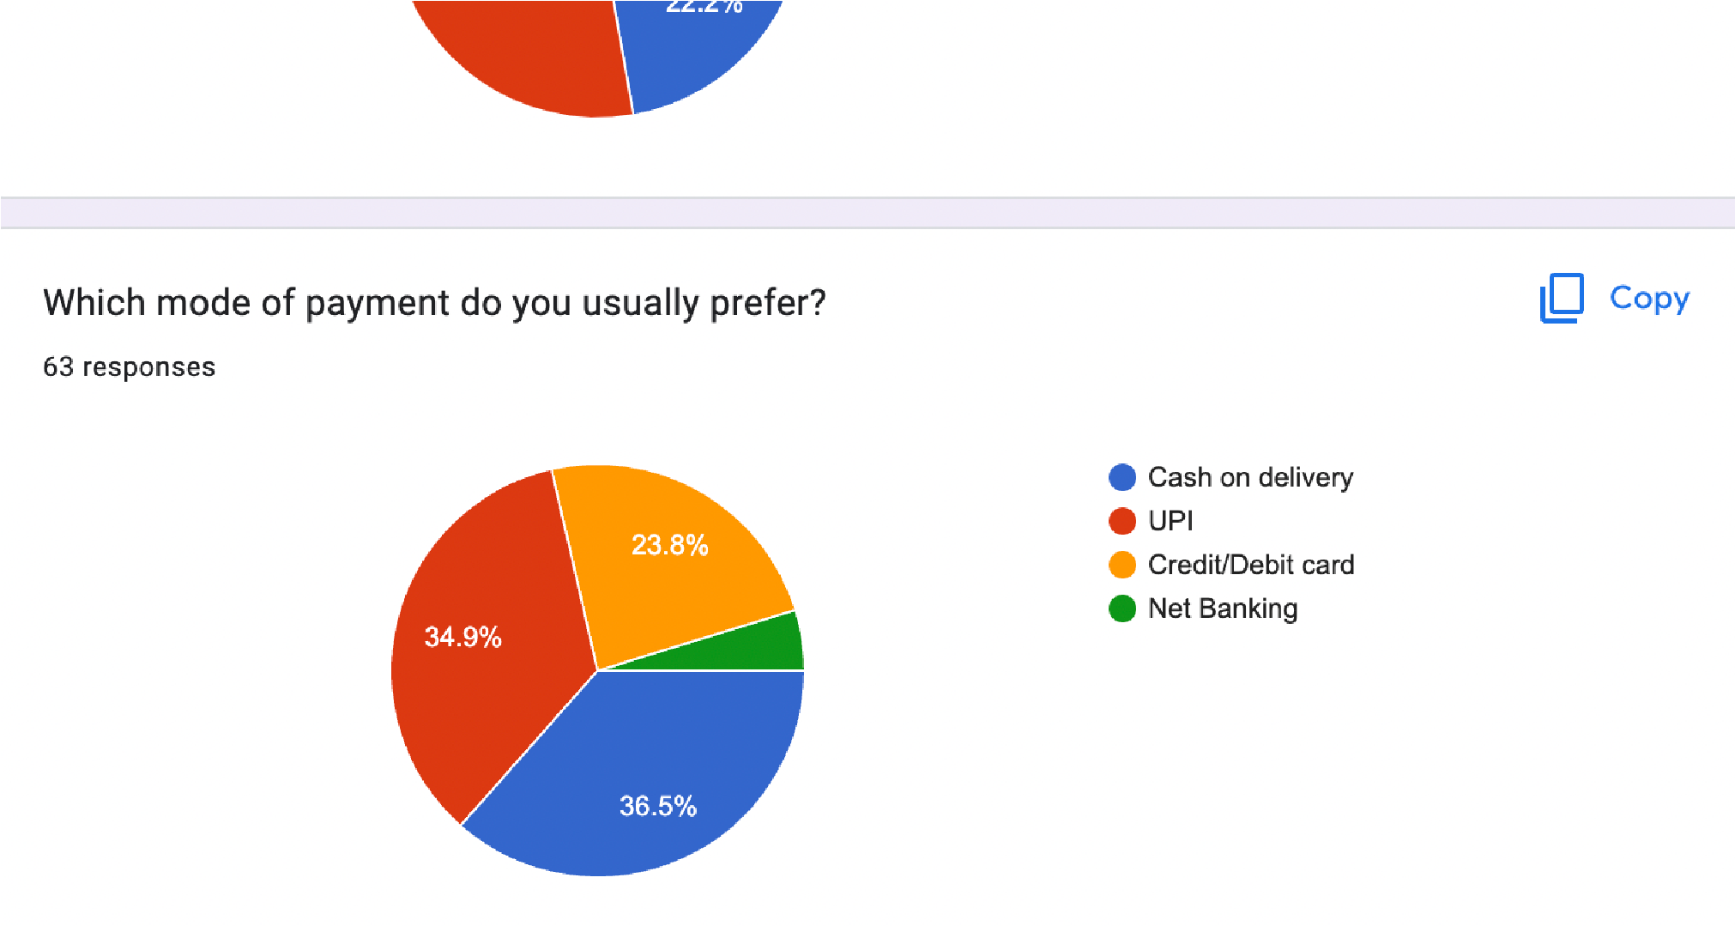
According to the survey, the sizes of the clothes are as described most of the times.
Most of the participants in the survey conducted majorly prefer cash on delivery followed by UPI as modes of payment.
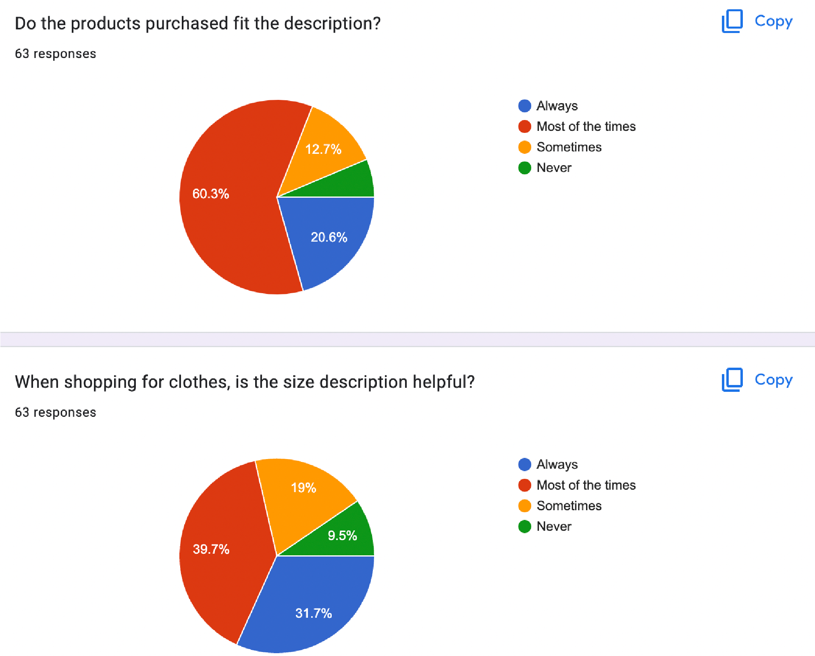
According to the survey, the product size descriptions help most of the times and the products majorly fit the said descriptions.

Findings:
The evolution of shopping from brick-and-mortar stores to online shopping has been a fascinating development over the last few years. Here are some of the key insights and trends in this space:
• The shift to online shopping: Over the past decade, there has been a significant shift to online shopping. A study by the National Retail Federation found that 69% of Americans have shopped online, and 25% said he shopped online at least once a month. Additionally, online sales are growing faster than in-store sales.
• Convenience is key: One of the main drivers of online shopping growth is convenience. Consumers can shop from the comfort of their own home at any time of the day or night. This is especially appealing to busy consumers who don't have time to visit physical stores.
• Price Comparison: Online shopping allows consumers to easily compare prices from various retailers. This increases competition and in some cases drives down prices. This made it easier for consumers to find deals and save money when making purchases.
• Personalization: Online shopping has enabled retailers to personalize products for individual consumers. By tracking consumers' browsing and purchasing history, retailers can provide personalized recommendations and promotions tailored to their specific interests and preferences.

• Seamless shopping experience: Online retailers are constantly working to improve their customers' shopping experience by offering features such as free shipping, easy returns, and one-click ordering. This makes online shopping more seamless and user-friendly, contributing to its growing popularity.
• Challenges for brick-and-mortar retail: While online shopping is on the rise, brick-and-mortar retail is also facing challenges. Many traditional retailers have struggled to adapt to the changing retail environment, and some have been forced to close. However, some companies have embraced online shopping and found ways to integrate it into their overall business model.
Overall, the evolution of shopping from physical stores to online shopping has had a profound impact on the retail industry and how consumers shop. As technology advances, online shopping will continue to grow and may become an important part of the retail industry.

SUGGESTIONS:
Here are some suggestions for research on the evolution of physical stores to online shopping:
1.overview of shopping, from the days of bazaars and marketplaces to the rise of department stores and malls. We then highlight the recent evolution from bricks-and-mortar to online shopping, highlighting the key events and trends that have driven that change.
2. Consumer Behavior: Find out how the shift from bricks-and-mortar to online shopping has affected consumer behavior. For example, you can explore how online shopping has changed the way consumers browse and purchase products and interact with retailers and brands.
3. Technology: Examine the role of technology in the evolution of shopping. This may include analyzing the evolution of e-commerce platforms and payment systems, and using data analytics and machine learning to personalize your online shopping experience.
4. Impact on traditional retailers: Discuss the impact of online shopping on traditional brick-and-mortar retailers such as department stores and shopping malls. This could include examining the challenges these retailers faced in adapting to the rise of online shopping and the strategies used to stay relevant. 5. The Future of Shopping: Finally, consider the future of shopping and how it might evolve. This could include discussions of new technologies such as augmented and virtual reality and the growing trend towards sustainable and ethical consumer behavior.
Covering these topics provides a comprehensive overview of the evolution of shopping from bricks-and-mortar to online shopping, and how technology, consumer behavior, and traditional retailers have been impacted by this shift. can provide insight into

CONCLUSION:
In summary, the shift from physical stores to online shopping has had a profound impact on the retail industry and how consumers shop. Online shopping is becoming more and more popular due to its convenience, price comparison, personalization and seamless shopping experience. This led to a significant increase in online sales, which grew faster than in-store sales. However, traditional retailers are facing challenges adapting to this new situation, forcing many to close. Nevertheless, some retailers have found ways to successfully integrate online shopping into their business models and remain relevant. Moving forward, emerging technologies such as augmented and virtual reality will likely continue to shape the way consumers shop, and the trend toward sustainable and ethical consumer behavior may continue. Overall, the development of shopping from stationery to online shopping has seen attractive developments in recent years and will continue to shape retail.

References
Acolia, G. R., The Enigmatic Entrepreneurial Profit Factor, Property Tax Journal, 1984, 3, 21-25. The Enigmatic Entrepreneurial Profit Factor Property Tax Journal 3 21 25
American Institute of Real Estate Appraisers, The Appraisal of Real Estate, Chicago: AIREA, eighth edition 1983. The Appraisal of Real Estate,
American Institute of Real Estate Appraisers, The Appraisal of Real Estate, Chicago: AIREA, ninth edition 1987. The Appraisal of Real Estate,
American Institute of Real Estate Appraisers, Standards of Professional Practice, Chicago: AIREA, 1985. Standards of Professional Practice,
Anderson, P. M., Association of Shopping Center Anchors with Performance of a Non-anchor Specialty Chain's Stores, Journal of Retailing, 1985, 61, 61-74. Association of Shopping Center Anchors with Performance of a Non-anchor Specialty Chain's Stores Journal of Retailing 61 61 74
Ang, J. and P. Peterson, The Leasing Puzzle, Journal of Finance, September 1984, 39, 1005-66. The Leasing Puzzle Journal of Finance 39 1005 66
Appraisal Foundation, Uniform Standards of Professional Appraisal Practice, Chicago: AIREA, 1985 Uniform Standards of Professional Appraisal Practice,
Babcock, F. M., The Valuation of Real Estate, New York: McGraw-Hill, 1932. The Valuation of Real Estate,
Bacon, R. W., An Approach to the Theory of Consumer Shopping Behavior, Urban Studies, 1971, 8, 55-64. An Approach to the Theory of Consumer Shopping Behavior Urban Studies 8 55 64
Bacon, R. W., Consumer Spatial Behavior, New York: Oxford University Press, 1984. Consumer Spatial Behavior,
Beebe, R. L., The Assessor and the Shopping Center: Valuation Issues and Problems, presented at the International Association of Assessing Officers Legal Seminar, San Francisco, October 1988.
Bell, T. L., S. R. Lieber and G. Rushton, Clustering of Services in Central Places, Annals of the Association of American Geographers, 1974, 64, 214-25. Clustering of Services in Central Places Annals of the Association of American Geographers 64 214 25
Benjamin, J. D., A Theory and Empirical Test of Retail and Office Lease Contracting, Ph.D. dissertation, Louisiana State University, 1988.
Benjamin, J. D., G. W. Boyle and C. F. Sirmans, Price Discrimination in Shopping Center Leases, Journal of Urban Economics, 1992, 32: November, 299-317. Price Discrimination in Shopping Center Leases Journal of Urban Economics
Benjamin, J. D., Retail Leasing: The Determinants of Shopping Center Rents, Journal of the American Real Estate and Urban Economics Association, 1990, 18:3, 302-12. Retail Leasing: The Determinants of Shopping Center Rents Journal of the American Real Estate and Urban Economics Association 18 302 12
Benjamin, J. D. and K. M. Lusht, Search Costs and Apartment Rents, Journal of Real Estate Finance and Economics, Spring 1993, 6, 189-97. Search Costs and Apartment Rents Journal of Real Estate Finance and Economics 6 189 97
Berry, B. J., The Geography of Market Centers and Retail Distribution, Englewood Cliffs, NJ: Prentice-Hall, 1967. The Geography of Market Centers and Retail Distribution,
Berry, B. J., and H. G. Barnum, Aggregate Relations and Elemental Components of Central Place Systems, Journal of Regional Science, 1962, 4, 35-81. Aggregate Relations and Elemental Components of Central Place Systems Journal of Regional Science 4 35 81
Berry, B. J., H. G. Barnum and R. J. Tennant, Retail Location and Consumer Behavior, Papers and Proceedings of the Regional Science Association, 1962, 9, 65-106. Retail Location and Consumer Behavior Papers and Proceedings of the Regional Science Association 9 65 106
Berry, B. J. and W. L. Garrison, Recent Developments of Central Place Theory, Papers and Proceedings of the Regional Science Association, 1958, 4, 107-20. Recent Developments of Central Place Theory Papers and Proceedings of the Regional Science Association 4 107 20
Boulding, K. E., Economic Analysis, New York: Harper and Row, fourth edition 1966. Economic Analysis,
Bower, R. S., Issues in Lease Financing, Financial Management, 1972, 2, 25-33. Issues in Lease Financing Financial Management 2 25 33
Brealey, R. and S. Myers, Principals of Corporate Finance, New York: McGraw-Hill, third edition 1988. Principals of Corporate Finance,
Brealey, R. and C. M. Young, Debt, Taxes, and Leasing—A Note, Journal of Finance, December 1980, 35, 1245-50. Debt, Taxes, and Leasing—A Note Journal of Finance 35 1245 50
Brown, J. D., Going-Concern Value in the Congregate Care Industry and R41c, Appraisal Journal, April 1987, 5, 286-91. Going-Concern Value in the Congregate Care Industry and R41c Appraisal Journal 5 286 91
Brown, S., Retail Location Theory: The Legacy of Harold Hotelling, Journal of Retailing, 1989, 65, 451-70. Retail Location Theory: The Legacy of Harold Hotelling Journal of Retailing 65 451 70 Brueckner, J. K., Inter-Store Externalities and Space Allocation in Shopping Centers, Journal of Real Estate Finance and Economics, July 1993, 7, 5-16. Inter-Store Externalities and Space Allocation in Shopping Centres Journal of Real Estate Finance and Economics 7 5 16 \
Bucklin, L. P., The Concept of Mass in Intra-Urban Shopping, Journal of Marketing, 1967, 31, 37-42. The Concept of Mass in Intra-Urban Shopping Journal of Marketing 31 37 42
Chamberlin, E. H., The Theory of Monopolistic Competition: A Reorientation of the Theory of Value, Cambridge, MA: Harvard University Press, 1933. The Theory of Monopolistic Competition: A Reorientation of the Theory of Value,
Chiang, R., T. Y. Lai and D. C. Ling, Retail Leasehold Interests: A Contingent Claim Analysis, Journal of the American Real Estate and Urban Economics Association, 1986, 14:2, 216-29. Retail Leasehold Interests: A Contingent Claim Analysis Journal of the American Real Estate and Urban Economics Association 14 216 29

