ULTRASOUND NERVE SEGMENTATION USING DEEP LEARNING
Praful Gawane, Gufran Khan, Kalpesh Patil, Swaraj Shinde, Prof. Madhuri Patil
‘Degree Student, Department of Information Technology, MGM’S College of Engineering and Technology, Navi Mumbai, Maharashtra, India
‘Assistant Professor, Department of Information Technology, MGM’S College of Engineering and Technology, Navi Mumbai, Maharashtra, India
ABSTRACT:

The precise segmentation of nerves through ultrasound imaging has gained significant interest, as it can contribute to the efficacy of regional anesthesia, minimize surgical trauma, and expedite post-operative recovery. The purpose of this paper is to draw attention to the challenges associated with treatment methods that rely on ultrasound scans, which are frequently used in the medical field due to their broad range of applications and cost-effectiveness. In this paper, we propose an improved u-net network called a mini-u-Net which is a deep learning method for segmentation of ultrasound images and scans so that we can reduce the side effects of narcotics on our body by correctly finding the nerve to be operated. Our app will be able to accurately locate these nerve clusters by Deep Learning algorithm i.e., Convolutional Neural Network so that this alternate pain management solution can be accessible without needing a radiologist.

INTRODUCTION:
We are proud to present our project focused on ultrasound nerve segmentation – a cutting-edge technology that has the potential to revolutionize medical imaging. Our mission is to provide resources and education to those in need, and this technology can help in that mission. Our ultrasound nerve segmentation technology can provide insight into the human body that was not previously possible, allowing doctors to make more informed decisions and provide better patient care.
Ultrasound scans are mainly used to diagnose and analyze the internal body structures like muscles, nerves etc. So, to accurately operate the internal body structure based on ultrasound scans is very important.
To operate these body structures doctors, have to use narcotics to reduce the pain for the patient but these narcotics have many side effects on our body. This paper introduces the method for nerve segmentation in the ultrasound images and scans so that we can reduce the side effects of narcotics on our body by correctly finding the nerve to be operated.
Digital image processing has become an important part of the medical imaging. With the help of image segmentation, we can highlight the important part in any medical image that is useful for the doctors to study.
Through the use of ultrasound, clinicians can gain insight into the unique anatomy of an individual patient surgery, and it is possible to use this information for improving regional anesthesia. After surgery, patients are typically prescribed opioids in order to alleviate pain and aid in the recovery process. Opioids, however, have many adverse health effects such as nausea/vomiting, liver damage, and physical dependence. Alternative solutions for pain mitigation exist but require radiologists to locate nerve clusters in ultrasound images which is quite expensive.
EXISTING SYSTEM:
Even though there are many systems that have been developed till now using different technologies like Deep Adversarial Networks, Deep Probabilistic Programming (DPP) and U-net neural networks, approaches like Random Under-Sampling (RUS) and Support Vector Machine (SVM) classifier using algorithms such as Principal Component Analysis (PCA), the accuracy of the models are low as compared to the one using Convolutional Neural Network (CNN).
The overall accuracy of these methods indicated that the proposed model outer-forms all the other methods in the classification. CNN tends to be a more powerful and accurate way of solving classification problems. Following the training and testing stages of SVM, certain systems experienced difficulty with processing the data due to limitations in their hardware capacity.
With artificial neural networks, concrete data points must be explicitly provided thus increasing the number of parameters to be learned during training. Also, the use of traditional methods involved lot of human labor which is ruled out using CNN and u-net.
PROBLEM STATEMENT:
If a patient undergoes surgery they might need to be anesthetized during surgery and post-surgery too to mitigate the pain from surgery. To alleviate the discomfort associated with surgery, a local anesthetic is typically administered to the patient. This type of anesthetic numbs only the specific area of the body where the surgery is being performed, allowing the patient to remain conscious during the procedure. Our app will be able to accurately locate these nerve clusters by Deep Learning algorithm i.e., Convolutional Neural Network so that this alternate pain management solution can be accessible without needing a radiologist to locate nerve clusters.
The crux of our project is to detect the nerve clusters in the human body and segment them accordingly. This segmentation is very useful for accurate medication of a patient after a surgery or before a surgery.
To build an end-to-end system where a person would just be feeding the ultrasound image of the region and a deep learning model will segment the nerve present in the image.
PROPOSED SYSTEM:
The purpose of this project is to identify the nerve present in the ultrasound image. With the help of classier we can predict whether the nerve is present in the given image or not. If the image contains a nerve, the specific region is displayed.
Traditional image segmentation methods include threshold segmentation, edge based seg-mentation and region-based segmentation. Most of these methods are based on the artificial feature extraction of images, such as color and texture information. However, the features of artificial design are often shallow (not deep features), which makes traditional methods have great limitations and the space for performance improvement is very limited.
The appearance of deep learning has greatly promoted the development of semantic segmentation of medical images. The FCN (Fully Convolutional Networks for Semantic Segmentation, FCN developed by the CNN (Convolution Neural Network, CNN), pioneering the application of deep convolutional neural networks from image classification to image semantic segmentation. Since then, new frameworks and algorithms based on deep neural networks have emerged one after another. Among them, unet (U-Net: Convolutional Networks for Biomedical Image Segmentation) and Signet are the outstanding representatives in the field of image segmentation. In our project we will be using the U-Net. The project focuses on the approach based on image processing using deep learning algorithm CNN for identification.
we will filter the image data set that we have got from any source like database etc. then we will apply the segmentation algorithm for edge detection in the images. After that we will fit this segmented data into a machine learning algorithm to train the system.
The detailed description for each step is as follows:

Image preprocessing: In this module we have applied some preprocessing techniques to the ultrasound images. Ultrasound images often exhibit speckle noise, making it challenging to extract useful information from them. So, for this purpose we have used some filters for the images so that we can reduce this speckle noise form ultrasound image.
Nerve Segmentation: After applying the image preprocessing, we get the preprocessed images which do not contain any type of noise. These images can be further used for image segmentation. For image segmentation or to segment the nerve area from the ultrasound images we have used edge detection algorithm or canny operator algorithm in python that can detect the edges very efficiently with the help of the Sobel operator. The input images are being converted into 2D arrays. In this we have given input for train and test images and these images are converted into arrays and then saved in the form of arrays. This we have achieved with the help of python NumPy array. Now we will give this data as an input to the machine learning algorithm to train the system. For training the system the array of train images will be given to the fit model of machine learning algorithm and the predict model will predict out of learning on the test images.
Architecture Diagram:
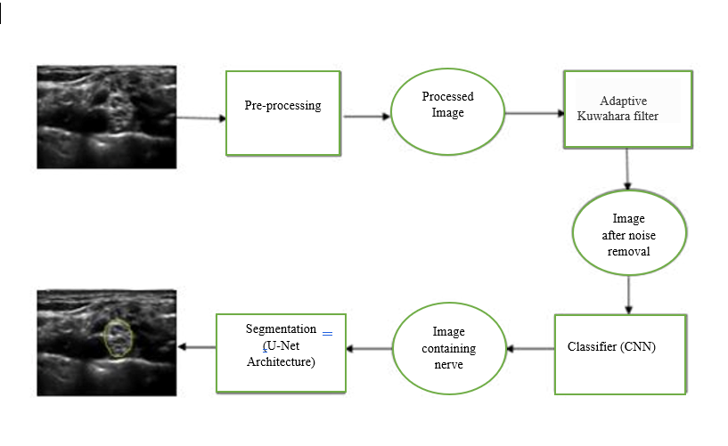
Fig .1
(Architecture diagram)
Module:
The proposed model will fetch input in the form of ultrasound image from the user and
it is given to classier. If nerve is detected, it is passed on to the segmented and mask as output is predicted, else `No nerve found' is displayed.
Results:
We read a black-and-white image as a 3d image. After that we convert it into NumPy array and display the input image and its masked image along with its shape.

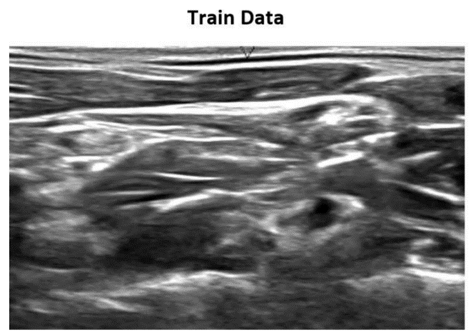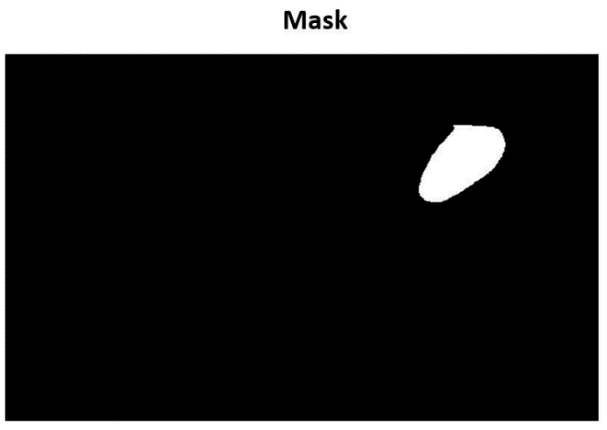
Fig .2
(Tested Image)

Accuracy:
1. The two losses both loss and Val loss are decreasing and the two acc: acc and Val acc
are increasing. So, this indicates the modeling is trained in a good way.
2. The Val acc is the measure of how good the predictions of your model are. So, in this case, it looks like the model was trained pretty well after 10 epochs, and the rest training is not necessary.
We convert a Image instance to a NumPy array If the image size is smaller than the target size it will be stretched to t the desired size in RGB format and normalize the image in range [0, 1] with unnecessary dimensions reduced.

CONCLUSION:
In the proposed paper the nerve area in the ultrasound image has done with the help of different modules. So that it can help doctors to detect easily the nerve area where they have to inject any medicine. We have chosen the best possible combination of methodologies to improve the results. In our paper, we propose an improved u-net network called a mini-u-net network. In order to preserve the low level features of the original image data, the numbers of the concatenation between the expansive path and the contracting path is decreased into 3, and compared with the original u-net and the 4 concatenations of u-net on the Kaggle 2016 neural image dataset, it was found that the mini-u-net works better, and then we compare the performance of the mini-u-net and the networks in the two papers, we have found that u-net can also achieve better results while keeping the dataset unchanged. First, as an improved network, its working mechanism needs to be strictly proved by mathematics to prove that our interpretation of its optimization mechanism is in accordance with scientific basis. Then, a newly proposed network needs to have a wide range of adaptability, and we have to test its performance on other datasets. Finally, due to the shallowness of the network, mini-u-net may perform poorly on high-complexity picture datasets.

REFERENCES:
[1] "A More Streamlined U-net for Nerve Segmentation in Ultrasound Images " by Yun Wang, Chang Wei and Zhi-jian Wang, China, 2014.
[2] "Fine-tuning U-Net for ultrasound image segmentation: di erent layers, di erent outcomes." by Mina Amiri, Rupert Brooks, and Hassan Rivaz, June 2015.
[3] "Automatic Nerve Segmentation Of Ultrasound Images" by Mariya Baby and Jereesh A.S, ICECA 2017.
[4] "Identi cation of Nerve in Ultrasound Images Using U-net Architecture " by Akhilesh Kakade, Jaysidh Dumbali , ICCICT 2018.
[5] "Ultrasound Nerve Segmentation of Brachial Plexus Based on Optimized ResU-Net" by Rui Wang, Hui Shen and Meng Zhou, S.Chand and Company PVT.LTD, New Delhi, 2008.
[6] "Coarse-to-Fine Stacked Fully Convolutional Nets forLymph Node Segmentation in Ultrasound Images" Yizhe Zhang, Michael T. C. Ying, Lin Yang, Anil T. Ahuja, Danny Z. Chen, 2016
[7] "U-Net" www.wikipedia.com [8] "Ultrasound nerve segmentation" www.medium.

