Automatic Filling And
Weighting Machine
Prasad Babar, Bhagyashree Sonawale,
Dept of ECE, Dr.J.J. Magdum College of Engineering, Jaysingpur. Maharashtra,India
Prof . P.P. Belagali
Associate Prof, Dept of ECE, Dr. J.J. Magdum College of Engineering, Jaysingpur. Maharashtra,India

• ABSTRACT:
Many small scale food production business owners and small land medium scale grocery store owners do the process of weighing and packaging their product manually. Small and Medium scale food production business owners who particularly produce items like ‘Chiwda’, etc has to do the weighing, filling and packaging process manually. This project aims to develop such a machine which automatically weighs and fill the food with the help of microcontroller and sensors. Then idea is to manually place the bag, then automatic weighing and filling is done. The purpose of doing this project is to reduce human efforts and time consumption. Decreasing machine cost is the major advantage of project. The machine design is based on simple mechanisms and it can be installed easily. The speed of weighing is result more production and business. This process will reduce the number of paid workers.

⬥ INTRODUCTION :
Nowadays, automation in the industry becomes the global trend in manufacturing. The Automatic Weighing Machines are fully automatic multi-head weighing machine. The machine is used for packing, seeds, vegetables, dry fruit packaging, pharmaceutical and coffee industry. Automation is certainly the necessity as today’s manufacturers face razor-thin profit margins. Companies must automate in order to deliver what today’s customer is demanding when he wants it and at the price he wants to pay.
The increase in manufacturing is led by the automation as well as low wages, customization, mass production, flexibility and information. The entire weighing process is done with the help of electro pneumatics and motors. The control for the hardware is to be process by the programmable logic controller via the computer. The whole system executes the following processes:
- Automation using the microcontroller.
- Filling of material into the bag.

- RELEVANCE OF THE WORK :
This machine can be used in many industries some of them are written below, but scope of using this machine is not limited to this only.
  - Small scale food production industries.
  - Automatic Weighing and filling machine manufacturing industries.
  - Pharmaceutical industries.
  - Farmers can use it directly their agricultural products.
  - Can be used in medium scale manufacturing industries.

- LITERATURE REVIEW:

Sr. no. | System name | Author and year | Techniques | Benefits
1 | Design of a small scale cereal packaging machine suitable for  developing countries | Tawanda  Mushiri and  Charles  Mbohwa  Johannesburg  2015 | creating a  small-scale cereal packaging machine. | The invention has particular application to automatic weighing and packaging and sealing using cheaper and more efficient alternative of  food packaging machinery.
2 | Automation of  Packaging and  Material Handling  Using  Programmable  Logic Controller | Melchizedek  Alipio,  Angelo A.  Beltran Jr.,  De La Salle  University,  Manila,  Philippines | automation of packaging and material handling using  a  programmable logic controller. | Is to replace the manual system being used in the Industry,  compare the time, and manpower  requirement for both the existing system with the proposed automated system.
3 | Design and  Development of  Cost-Effective  Automatic  Machine for Powder  Packaging’ | M. R. Saraf,  V. V. Ruiwale, V. V. Kulkarni and S. M.  Kulkarni | weighing mechanism | simple design and the use of low-cost reliable components, the machine is developed in lesser cost as compared to other conventional machines.
4 | ‘Simulator for a packing and  weighing system of granulated powders | Rafael Couto Rodrigues de  Oliveira,  Claudio Garcia | stochastic processes | to evaluate proposed improvements in the  PWS, aiming at reducing overweight and underweight.

• PROBLEM STATEMENT:
The Automatic Weighing Machines are fully automatic multi-head weighing machine The machine is used for weighing and filling of seeds, vegetables, dry fruit weight , pharmaceutical and coffee industry. Automation is certainly the necessity as today’s manufacturers face razor thin profit margins. Companies must automate in order to deliver what today’s customer is demanding when he wants it and at the price he wants to pay. The increase in manufacturing is led by the automation well as low wages, customization, mass production, flexibility and information.

⬥ METHODOLOGY:
- Making rough sketch of the model.
- Collecting the required components after making the list
- Programming on Arduino Nano.
- STAGE 1
  - Making of the uppermost hopper which will be used for storage.
  - Opening closing mechanism for the hopper.
- STAGE 2
  - Selecting the kg,s and no. packets through android Application.
- STAGE 3
  - A weighing plate to hold the stuff to be measured is attached to the load cell.

⬥ BLOCK DIAGRAM:

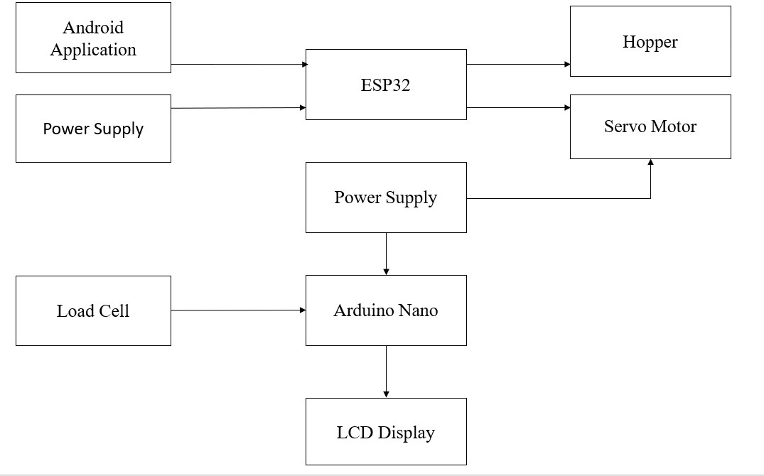
Bluetooth Terminal
Fig. Block diagram for Automatic Filling &Weighing Machine
- COMPONENTS:
- Hopper : Hopper’ is defined as a container which generally tapers downward and is able todi scharge the material stored in it at the bottom. It is used for storing the material which is to bed is pensed. There a son foru sing hopper in the set pes of machinesis, duet oil tapering shape at the bottom, the amount of material falling from the container can be controlled, making the process more uniform. Hopper increases the collection quantity. Hopper walls are coated and protect the material sin side it from contamination.

- Servo Motor :
Since MG995i a servo motor providing precise rotation over 180º range its applications are many and in the a few are state below.
The servo is suited for designing robotic arm in which wear and tear of motor is high. Being metal geared, the servo has long life and can be installed on system like robotic arm were motor work is huge.
The servo is also suited to be used in drones and toy planes. Having a satisfying torque which isenough to overcome air resistance and control wings of plane, the servo is preferred in toy planes and drones which need precision control no matter the condition.

- Arduino Nano :
Arduino Nano is another popular Arduino development board very much similar to the Arduino UNO. They use the same Processor (Atmega328p) and hence they both can share the same program. The Arduino board is designed in such a way that it is very easy for beginners to get started with microcontrollers. This board especially is breadboard friendly,
and that's why it is very easy to handle the connections. Let’s start with powering the Board.

- Load cell :
A load cell is a transducer that is used to create an electrical signal whose magnitude is directly proportional to the force being measured. The various types of load cells include hydraulic load cells ,pneumati cload cells and strain gauge load cells.
This is a standard load cell for measuring weight up to 5 Kg. The output of the load cell is in mili-volts and cannot be directly measured by a micro-controller. So an ADC with high resolution or ani nstrumentation amplifieris required to make the output of the load cell readable to a micro-controller.

- LCD Display:
An LCD (Liquid Crystal Display) screen is an electronic display module and has a wide range of applications. A 16x2 LCD display is very basic module and is very commonly used in various devices and circuits. A 16x2 LCD means it can display 16 characters per line and there are 2 such lines. In this LCD each character is displayed in 5x7 pixel matrix. The 16 x 2 intelligent alphanumeric dot matrix displays is capable of displaying 224 different characters and symbols. This LCD has two registers, namely, Command and Data.
Command register stores various commands given to the display. Data register stores data to be displayed. The process of controlling the display involves putting the data that form the image of what you want to display into the data registers, then putting instructions in the instruction register. In your arduino project. Liquid Crystal Library simplifies this for you so you don't need to know the low-level instructions. Contrast of the display can be adjusted by adjusting the potentiometer to be connected across VEE pin.

- HX711 Module :
HX711 is an electronic scale module, whose working principle is to convert the measured changes in resistance value changes, through the conversion circuit into electrical output. Simple structure, easy touse ,stable and reliable performance, high sensitivity and measurements peed and soon.

- ADVANTAGES AND APPLICATION:

ADVANTAGES :
    - Fully automated system thus reduce the human labour.
    - Save time
    - More accuracy
    - simple control / Lower Operator Interaction

APPLICATIONS:
    - Industry
    - Grocery store or malls
    - For Business owners

- CONCLUSION :
Low-cost automatic weighing machine which can perform operations of weighing, bag filling with maximum efficiency is manufactured. The operating of this machine is simple and chances of error in weight calculation areal most negligible. The time consumption and efforts required forth e manual weighing and packaging are minimized .Limitations will be there due to the practical difficulties in programming of the project according the availability of the materials and components. This set up can be further improved to a sorting system that sort s the item s based on the other physical consideration. This can be achieved using the various sensors. In industry it can be used for sorting of various objects, tools, with high degree of accuracy and quality with a automation.

- REFERENCES:

  - Tawanda Mushiri, Charles Mbohwa, International Conference on Operations
Excellence and Service Engineering Orlando, Florida, USA, September 10-11, 2015. [2] Shashank LingappaM.,Vijayavithal Bongale,Sreerajendra,InternationalJournalofA dvancedMechanicalEngineering.ISSN2250-3234Volume4,Number7(2014),pp.803811
  - Melchizedek Alipio, Angelo A. Beltran Jr., De La Salle University, Manila, Philippines. Automation of packaging and material handling using a programmable logic controller.
  - M. R. Saraf, V. V. Ruiwale, V. V. Kulkarni and S. M. Kulkarni. Weighing mechanism.
  - Rafael Couto Rodrigues de Oliveira, Claudio Garcia. Stochastic processes.
  - https://www.instructables.com/How-to-Interface-With-5kg-Balance-Module-orLoad-C.
  - https://www.electronicwings.com/arduino/lcd-16x2-interfacing-with-arduino-uno
  - https://www.google.com/search?q=arduino+and+lcd+connection&sxsrf=ALeK k02rPCsZ1nU0JCEFsOJ47bX
  - PwvRYw:1620821255817&source=lnms&tbm=isch&sa=X&ved=2ahUKEwjS yMnZjcTwAhVVIbcAHcqHDtIQ_AUoAXoECAEQAw&biw=1536&bih=722 &dpr=1.25#imgrc=QigjS8Hwxmtn-M.

