Classification and detection of Pest-Net for large scale multiclass pest using deep learning

Pritam Kumar
Computer Science And Engineering
Sathyabama Institute Of Science And Technology
Chennai, India
Pritamkumar1234@gmail.com

Dr. Vijay Ramlingam
Computer Science And Engineering
Sathyabama Institute Of Science And Technology
Chennai, India

ABSTRACT
India Agriculture accounts for a disproportionate share of GDP, hence crop yields need to be high. Pests represent a significant danger to food supplies because they reduce agricultural yields and deplete food of essential nutrients. Safety. Because of these problems, many farmers will lose their lives, which will have a dramatic effect on our economy. It is crucial to keep a close eye on the crops at all times so that you can respond quickly to any insect problems with the right pesticide. Early identification of pests would be a huge benefit to farmers in preventing the contamination of crops with pesticide. Farmers may profit from AI-based solutions that increase agricultural output because of artificial intelligence's significance in resolving massive difficulties in the agriculture area. In this study, we focus on the Mobile Net V2 method for pest classification, which involves bending the picture and extracting attributes of pests to place them into distinct groups. Mobile Net V2 outperforms competing pre-trained models, as shown by the experimental outcome.
Keywords: - Pests identification, deep learning, CNN, beneficial pests, harmful pests
INTRODUCTION:
Agriculture, the "backbone" of every economy, drives national prosperity and sets the bar for living conditions. Certain production factors, such as pests, fertiliser, or water, are always required for crop production. The effects of pests on agricultural progress are discussed in this study. To that end, it presents the deep learning method for determining which pests are hazardous and which are helpful and then categorising them accordingly. However, most farmers are not well-educated enough to recognise the difference between hazardous and helpful insects, so they eliminate both.
LITERATURE SURVEY:
[1] Grouping of Pomegranate Diseases Based on Back Propagation Neural Network, suggested by S.S.Sannakki and V.S.Rajpurohit, essentially chips away at the approach for dividing the relinquished area and colour and surface are used as the

highlights. Here, a neural organisation classifier was used for the clustering. Categorization is shown to be 97.30% accurate after being converted to L*a*b from RGB, which is the primary advantage. The main disadvantage is that it's only used for a few number of harvests.

[2] Hu's minutes are used as a specific attribute in the "Cotton Leaf Disease Detection employing Pattern Recognition Approaches" paper by P.R. Rothe and R.V. Kshir sagar. The BPNN classifier Takes care of the numerous class concerns while the dynamic shape model is employed to confine the essentiality within the contaminated region. Finding that 85.52 % is the mean of a set.
[3] Leaf Disease Identification and Grading using Computer Vision Technology and Fuzzy Logic, Aakanksha Rastogi, Ritika Arora, and Shanu Sharma. The given-up area is divided using a K-implies grouping, surface highlights are extracted using a GLCM, and illness is reviewed using a Fuzzy reasoning. They used a fake neural network (ANN) classifier, which is useful for determining how dangerously contaminated a certain leaf is.
PROPOSED SYSTEM:
Tensor Flow, a powerful library written in Python, was used in the creation of the suggested model. Like existing CNN designs, the suggested model consists of three layers: an input layer, a hidden layer, and an output layer. We present a model with 4 Convolution layers and 4 activation functions. Four max polling layers, a flattened layer, and a fully linked layer connecting to the output layer make up the model.

RELATED WORKS:
From picture categorization to pesticide recommendation, researchers have recently placed a premium on the use of AI techniques. Several strategies for early pest identification have been developed by researchers from across the world who are invested in the growth of the agricultural industry. A. Jayme Garcia Arnal Barbedo's convolutional neural network (CNN) technology has been utilised to recognise and count moths in pheromone traps. The technique used a sliding window and claimed that CNN generated a probability for the existence of a moth in each visual patch. Using computer vision, researchers like Hong Zeng have created methods for automatically extracting, analysing, and comprehending relevant information from a single picture or a series of images. Because of this, inference time was reduced by a factor of ten and accuracy was improved. As opposed to more conventional ML methods, the authors' suggested approach achieved greater accuracy with less computational overhead. Insect classification results were then compared to those obtained by using pre-trained versions of deep

Learning architectures including Alex Net, ResNet, Google Net, and VGG Net. To avoid overfitting, we additionally use data augmentation strategies including reflecting, scaling, rotating, and translating the input data. Analysis of hyper parameters' ability to boost the suggested model's precision was also performed.

METHADOLOGY:
In this article, we use the IP102 dataset, which contains over 75,000 photos. The dataset consists of a collection of pest picture classes, each of which is separated from the others based on a number of distinguishing features. We evaluate four distinct pest classes and allocate 200 photos to each class during the training phase before releasing them into the test phase. Images of pests taken from the IP102 dataset are shown in Fig. 1.
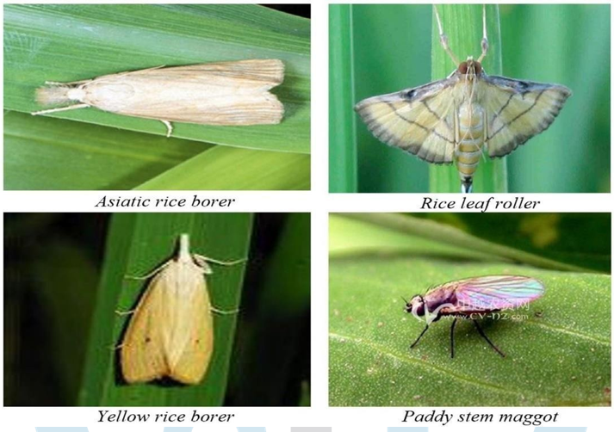

Figure1: Dataset of the Pests
We give in fig. 2 below an architecture demonstrating the flow of categorization, detection of pests, and recommendation of appropriate pesticide to encourage farmers to take use of modern Figure2: Architecture of Pest Classification and Detection
Technologies in order to identify pests early and avoid the loss of crops. A photo from the given dataset will be uploaded, then pre-processed to correct the image's proportions before the pest's characteristics, such its length, width, and area, are retrieved. The next stage is a training phase, during which MobileNet V2 is utilised to educate the system to identify pests based on their class.
Figure2: Architecture of Pest Classification and Detection
EXPERIMENTAL RESULTS:
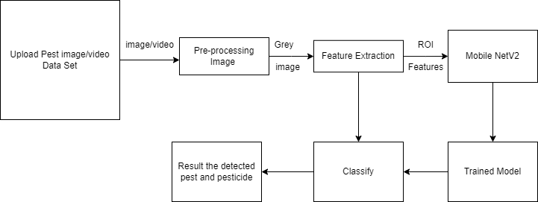
We took IP102, a freely available internet dataset, and narrowed it down to only four of its 22 possible classifications. There are 200 pictures of each class in the database. The MobileNet v2 model tested the data used in pest categorization, pesticide recommendation, and weather forecasting. As can be shown in Fig. 3, the accuracy of predictions of the pest in the test stage was much improved by allocating 80% of the data to training and 20% to testing. In addition, the outcomes are shown here, such as the use of pesticides to protect crops from damage and the identification of the species' preferred environment. The accuracy, loss, and outcomes from training and testing are shown in Figure 4 and Figure 5 below.
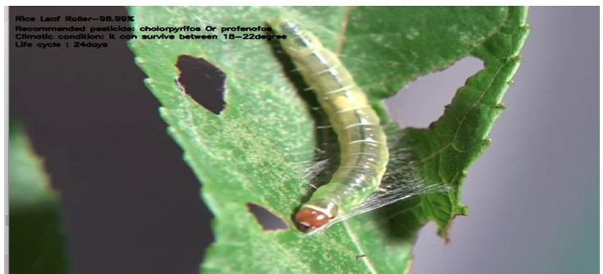

Figure 3: Prediction of Rice Leaf Roller
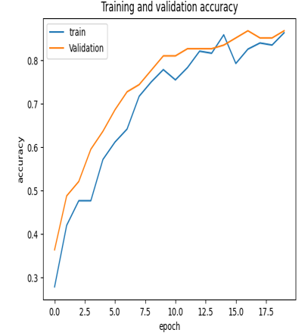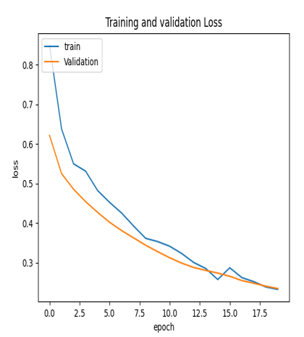
Figure 4: Result of Training and Validation Accuracy Figure 5: Result of Training and Validation Loss
CONCLUSION:
In this research, we examine how five distinct groups of pests were identified and categorised with the use of machine learning methods and pesticide recommendations. In order to increase the precision of our results, we utilised MobileNet V2 to restructure and pre-process all of the bug photos. The presence of darkness, leaves, mud, etc. in major agricultural field crops is a significant challenge to achieving better accuracy in insect categorization in real-time field. Hence, farmers must consistently inspect their crops and the progress of pests for signs
of harm. The use of AI in farming is on the rise, and it's already helping farmers tackle some of the industry's biggest challenges head-on. Technology like this is essential in India, where there is a vast population to feed, and agricultural deterioration must be prevented at all costs. Eventually, farmers will be able to identify the signs of pests and the best ways to prevent them with the aid of machine learning algorithms.
REFERENCES:
- “Detecting and Classifying Pests in Crops Using Proximal Images and Machine Learning”, Jayme Garcia Arnal Barbedo, Embrapa Agricultural Informatics, Campinas, MDPI, 2020.
- “Application of Deep Learning in Integrated Pest Management: A Real-Time System for Detection and Diagnosis of Oilseed Rape Pests”, Yong He, Hong Zeng, Yangyang Fan, Shuaisheng Ji, Jianjian Wu, Hindawi,2019.
- “Plant diseases and pest detection based on deep learning”, Jun Liu, Xuewei Wang, BMC, 2021.
- “Insect classification and detection in field crops using modern machine learning techniques”, Thenmozhi Kasinathan, Dakshayani Singaraju, Srinivasulu Reddy Uyyala, KeAi, 2020.
- “Shallow and Deep Learning Architecture for Pests Identification on Pomelo Leaf ”, Quoc Bao Truong ,Tan Kiet Nguyen Thanh, Minh Triet Nguyen, International Conference on Knowledge and Systems Engineering (KSE), 2018.
- “Detection Of Vegetation Areas Attacked By Pests And Diseases Based On Adaptively Weighted Enhanced Global And Local Deep Features”, Yanshuai Dai, Li Shen, Yungang Cao, Tianjie Lei Wenfan Qiao , IEEE, 2019.
- “Crop pest classification based on deep convolutional neural network and transfer learning”, K. Thenmozhi,
U. Srinivasulu Reddy, Elsevier, 2019.
- “Crop Diseases and Pests Detection Using Convolutional Neural Network”, Pruthvi P.Patel, Dineshkumar
B. Vaghela, IEEE, 2019.
- “An Image Recognition Algorithm of Soybean Diseases and Insect Pests Based on Migration Learning and Deep Convolution Network”, Mingyuan Xin, Yong Wang, IEEE, 2020.
“Insect classification and detection in field crops using modern machine learning techniques”, Thenmozhi Kasinathan, Dakshayani Singaraju, Srinivasulu Reddy Uyyala, China Agricultural University, 2020

