Optical Character Recognition (OCR) with Text Generation using Tesseract and PDF Editing Web Application using Flask

Priya Sharma, Nishita Garg & Kartavya Chauhan
Department of CSE
Graphic Era (deemed to be) University
Abstract: Optical Character Recognition (OCR) is the process of extracting text from an image. The main purpose of an OCR is to make editable documents from existing paper documents or image files. The project is about OCR. It stands for "Optical Character Recognition." OCR is an input device used to read a printed text. OCR scans the text optically, character by character, converts it into a machine-readable code and stores the text on the system memory and converts it into Document. The technology of optical character recognition (OCR) was used to transform printed text into editable text. The objective of OCR is to achieve modification or conversion of any form of text or text-containing documents such as handwritten text, printed or scanned text images, into an editable digital format for deeper and further processing.
Keywords: character recognition; feature extraction; feature matching; text extraction; character extraction, edit, reorder, delete page(s).

- INTRODUCTION
Optical character recognition (OCR) is the electronic conversion of images of textual content into digitally encoded text using specialized software program. OCR software enables a computer to convert a scanned file, a virtual picture of text, or any some other virtual image of text into machine-readable, editable records. OCR typically entails 3 steps: commencing and/or scanning a file in the OCR software program, spotting the document inside the OCR software program, after which saving the OCR-produced record in a format of your choice. OCR techniques are especially used in text and/or statistics mining initiatives, textual comparisons, and is a critical resource for developing on hand documents for blind and visually impaired humans.
OCR software program can take benefit of artificial intelligence (AI) to put in force more advanced techniques of intelligent character recognition (ICR), like identifying languages or types of handwriting. The system of OCR is most used to show hard replica legal or historic files into pdf files in order that users can edit, layout, and search the documents as though created with a phrase processor.
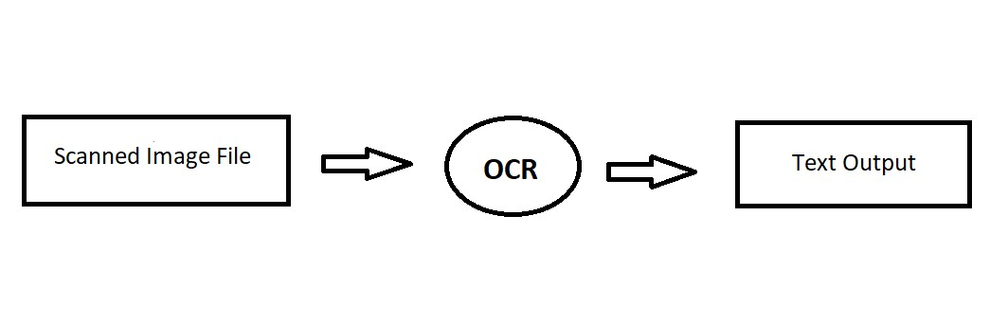

Fig.1 Process Flow
- PROBLEM STATEMENT
To develop an Optical Character Recognition (OCR) System to provide an efficient and enhanced Web Application tool for the users to perform Document Image Analysis, document processing by reading and recognizing the characters in research, academic, governmental, and business organizations that are having large pool of documented, scanned images. Irrespective of the size of documents and the type of characters in documents, the product is recognizing them, searching them, and processing them faster according to the needs of the environment.
Also provides additional features for converting a .pdf file to .docx (Word) file and pdf editing features.
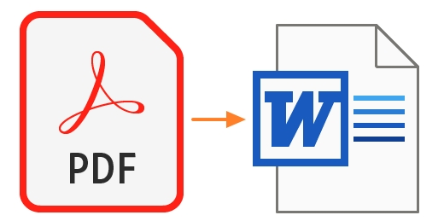
Fig. 2 .pdf to .docx conversion
- HARDWARE AND SOFTWARE REQUIREMENTS

- Hardware Requirement

- Processor: Intel(R) Core (TM) i3-6006U CPU @ 2.00GHz2.00 GHz (Minimum)
- Ram 8GB (Minimum)

- Hard disk: 80GB (or) Higher

- Software Requirement

- Visual Studio Code
- Python
- Google Colab
- Anaconda

- Operating System: Microsoft Windows/Linux

4. METHODOLOGY:-

  - Libraries used:-

- Tesseract OCR
Tesseract is a character recognition engine that can read scanned text and convert it into digital text. It is open-source software that is released under the Apache License 2.0. Tesseract is available for various operating systems, including Windows, Linux, and Mac OS X. Hence, Tesseract is a popular tool to recognize text in images, such as scanned documents and digital photos. Tesseract is accurate and efficient, and it can handle a variety of languages.

- OpenCV
OpenCV (Open-source computer vision) is a library of programming functions mainly aimed at real-time computer vision. OpenCV in python helps to process an image and apply various functions. Here we will learn how to use contours to detect the text in an image and save it to a text file. OpenCV package is used to read an image and perform certain image processing techniques.

- Flask
Flask is a small lightweight python web framework that provides useful tools and features that make creating a web application in python easier. It gives developers flexibility and more accessibility to new developers since you can build a web application quickly only on a single python file. Hence, the major use of flask is to develop web applications in python. One of the major advantages of flask is a fast debugger and an inbuilt server.

- NumPy
NumPy is a general-purpose array-processing package. It provides a high-performance multidimensional array object, and tools for working with these arrays. It is the fundamental package for scientific computing with Python. It is open-source software.

- Pandas
A Pandas Data Frame will be created by loading the datasets from existing storage, storage can be SQL Database, CSV file, and Excel file. Pandas Data Frame can be created from the lists, dictionary, and from a list of dictionaries etc. Pandas Data Frame is a widely used data structure which works with a two-dimensional array with labeled axes (rows and columns). Data Frame is defined as a standard way to store data that has two different indexes, i.e., row index and column index.

- PDF
Personal Document Format is currently an open-source standard created by Adobe. While the ability for a PDF to contain text and images is very useful for some applications, this is an unnecessarily, robust quality that only adds to the file size. A TIFF is much more desirable because it is can specifically only contain images.

The Process of OCR

In the following, we will show how optical character recognition works and explain the main steps of traditional OCR technologies.

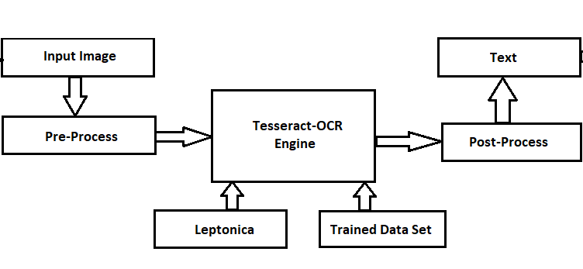
Fig. 3 OCR Process Flow

1. Scanning the Document
This is the prime step of OCR which connects to a scanner to scan the document. Scanning the document decreases the number of variables to account for when creating the OCR software since it standardizes the inputs. Also, this step specifically enhances the efficiency of the entire process by ensuring perfect alignment and sizing of the specific document. This initial step can also include object detection, to focus subsequent vision processing tasks on specific image areas.

2. Refining the Image
In this step, the optical character recognition software improves the elements of the document that need to be captured. Any imperfections such as dust particles are eliminated, and edges, as well as pixels, are smoothed to get a plain and clear text. This step makes it easier for the program to capture data while being able to clearly “see” the words being inputted without, for instance, smudges or irregular dark areas. Such image processing tasks are essential in all types of vision pipelines, to sharpen or auto-brighten images. OpenCV provides a toolset that is often used for such tasks.

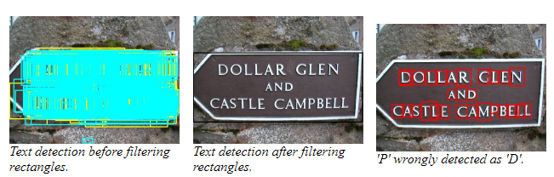
Fig. 4 Text detection before and after filtering rectangles [16]

3. Binarization
The refined image document is then converted into a bi-level document image, containing only black and white colors, where black or dark areas are identified as characters. At the same time, white or light areas are identified as background. This step aims to apply segmentation to the document to easily differentiate the foreground text from the background, which allows for the optimal recognition of characters.
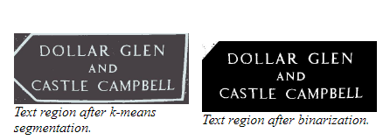
Fig. 5 Text after k-means segmentation (left) and binarization (right). [16]

4. Recognizing the Characters
In this step, the black areas are further processed to identify letters or digits. Usually, an OCR focuses on one character or block of text at a time. The recognition of characters is carried out by using one of the following two types of algorithms: Pattern recognition. The pattern recognition algorithm involves inserting text in different fonts and formats into the OCR software.
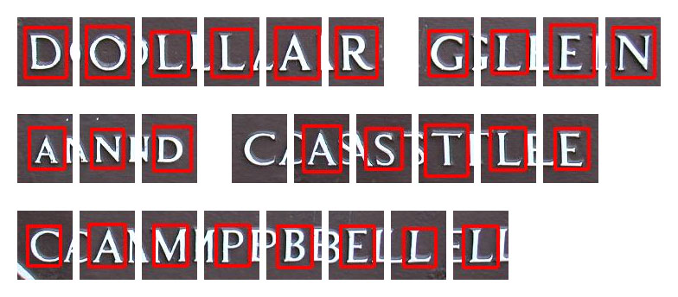
Fig. 6 Final Letter Recognition and Segmentation [16]

- RESULTS:-
The Project work began with the discussions of the desired features and making wire frames of the overall Web Application. The wireframe design included web pages of the web application with a landing home page which will display basic information of the products, an upload page with suggestions and uploading area upon which it will redirect to result page which will include the textual output generated from the input image and finally the about us page with the information about the group, its members and the project guide.
Then actual work began with installation of the required libraries and modules which included installing Python, OpenCV, tesseract, Flask, Microsoft Visual Studio Tools, VS Code Editor.
The coding tasks carried out are mentioned as follows: -
- Created a virtual environment for development of the web application with the help of flask.
- Imported other libraries as we progressed with the work based on the requirement.
- Created the app.py which will be main module of connecting all other individual components and act as a communication mediator.
- The ocr_.py was developed to house our main optical character recognition modules and carry out desired operations.
- Work with the front-end was also started by the time and the starting/ landing page of the app i.e., home page was developed which be seen in the figure below.
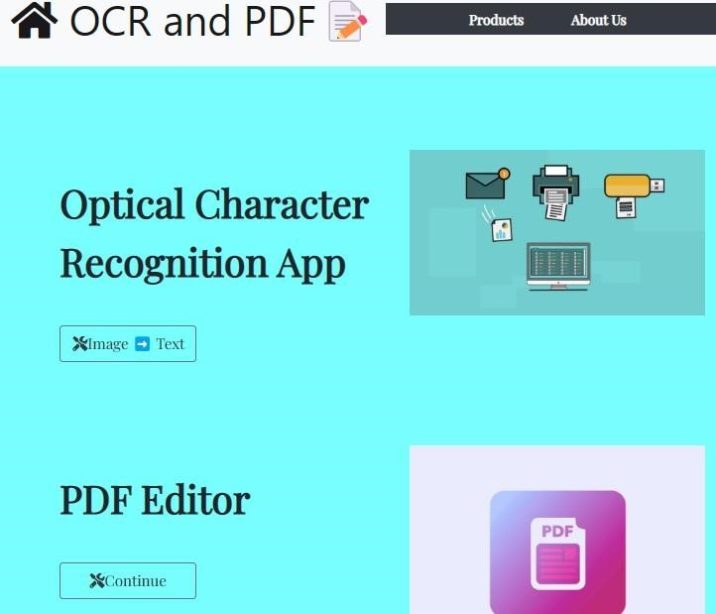

Fig.7 Home Page
- The upload page was made to handle the upload file operation and also suggest the optimal requirements to the user.
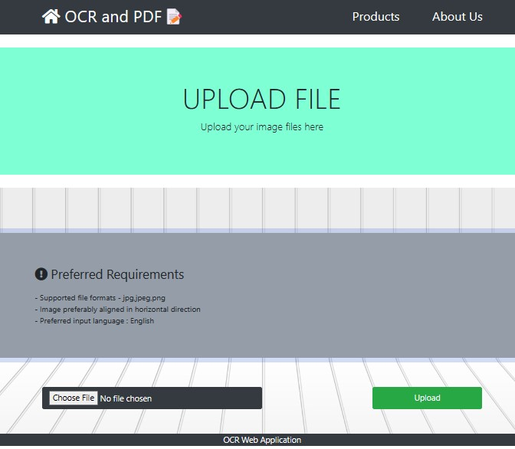
Fig.8 Upload Page

- The Result page was made to handle the output produced which show the textual data from the image input that was uploaded and gives facility to copy the identified data to the clipboard. The text generated can also be customized and can be obtained in a downloadable pdf format.
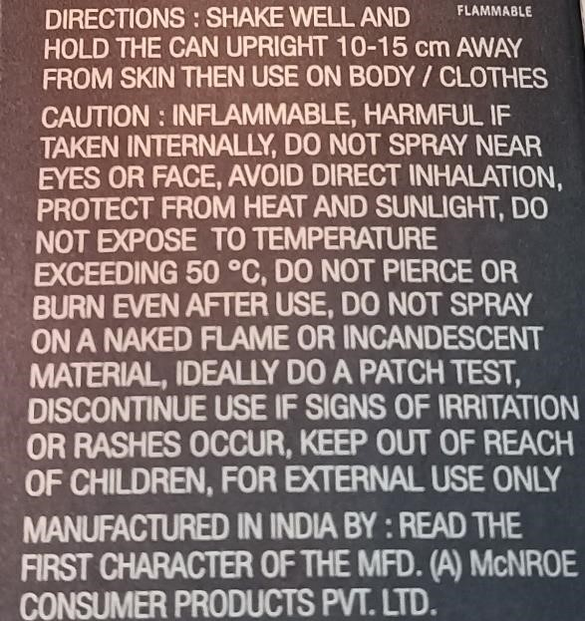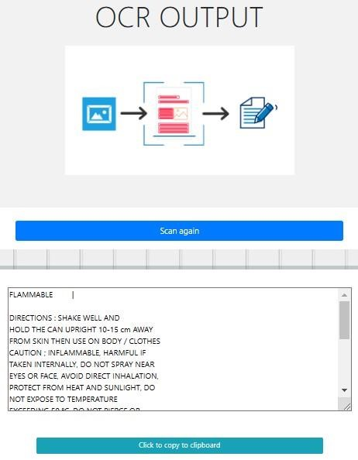
8.

Its demonstration can be seen as follows.

Fig.9 Input Image Fig.10 Text Output

9.This Feature converts the Pdf into Word file and also generate downloadable docx File. The upload page was made to handle the upload function which had option to choose file and then the docx will be downloaded.
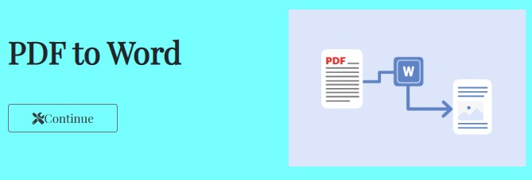
Fig. 11 Pdf to Word Tool



Fig.12 Upload Page
- This Feature Delete or remove a page(s) from the Pdf file. Read a Pdf as an Input File and write the pages needs to be removed separated by comma and then modified pdf will be downloaded.


Fig.13 PDF Page Remover Tool
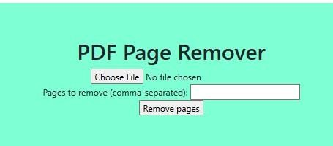

Fig.14 Upload Pdf

- This Feature reorders pages in a PDF document in the desired order of pages. Upload Pdf and input the desired page order separated by commas and then reordered pdf will be downloaded as shown in Fig 3.7

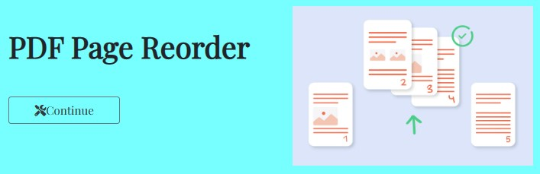
Fig. 15 PDF Page Reorder Tool

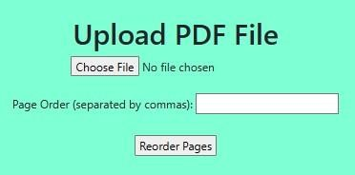

Fig. 16 Upload Pdf File

10. All the resultant files can be easily downloaded and saved to the system as shown in figure below.
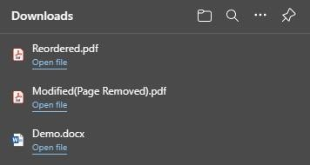

Fig.17 Downloaded files.
- Finally, the About Us page was made to show the basic information about the group, its members and the project guide as can be seen in the image below.
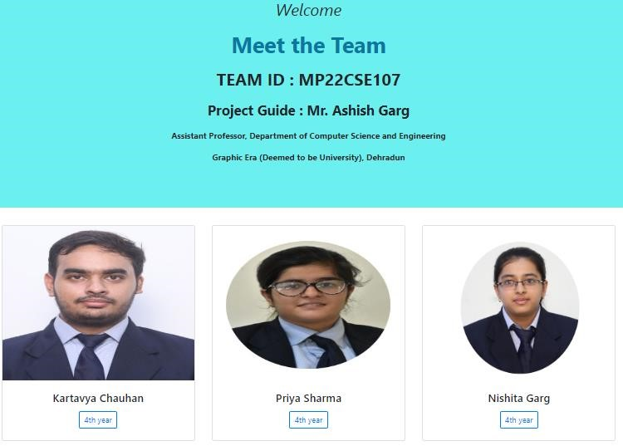

Fig.18 Team Page

- CONCLUSION

The purpose of this research was to do electronic conversion of images of textual content into digitally encoded text using Optical character recognition. In this we also added some additional features that
1. Converts the Pdf into Word file and generates downloadable docs File.
2. Delete or remove a page from the Pdf file.
3. Reorders pages in a pdf document by reversing the order of pages and generate downloadable new pdf.
4. Make all resultant new files available in downloadable form.
Future exploration to this research will be to explore some more additional features related to this and integrate them with this.

- REFERENCES

- Ye Q, Doermann D. Text detection and recognition in imagery: A survey. IEEE transactions on pattern analysis and machine intelligence. 2015 Jul 1;37(7):1480-500.
- Moravec K. A Grayscale Reader for Camera Images of Xerox Data Glyphs. InBMVC 2002 Sep (pp. 1-10).
- “Optical Character Recognition Techniques: A Survey” Sukhpreet Singh M. Tech Student, Dept. of Computer Engineering, YCOE Talwandi Sabo BP. India.
- OCR System: A Literature Survey “Survey of OCR Applications” by Amarjot Singh, Ketan bacchuwar, Akshay Bhasin.
- OpenCV, Open-source Computer Vision library. In http://opencv.willowgarage.com/wiki/, 2009
- Shinde AA, Chougule DG. Text Pre-processing and Text Segmentation for OCR.
[8] Trier ØD, Jain AK, Text T. Feature extraction methods for character -recognition-a survey.
- Bradski, G., & Kaehler, A. (2008). Learning OpenCV: Computer Vision OpenCV
- Library. California: O'Reilly Media Inc
- Tesseract-OCR, [Online]. Available: https://tesseract-ocr.github.io/tessdoc/. [12] Open-Source Computer Vision (OpenCV) [Online]. Accessed on 29 Sep 2022:
https://www.geeksforgeeks.org/opencv-overview/
- Open-Source Computer Vision (OpenCV) [Online]. Accessed on 21st April 2022:
http://opencv.willowgarage.com/wiki/
- Text Detection and Recognition report by Radhakrishna Achanta.
https://ivrlwww.epfl.ch/research/topics/text_reading.html
- Using Tesseract-OCR for Text Recognition with Google Colab: Michangiolo Mazzei

