Energy Saving with Voice assistance and using sensor
1st Hemavathi Udaiyar,2nd Pradnya Parmekar,3rd Mandar Rawool, 4th Sangeeta Kotecha
Department of Electrical Engineering
Atharva college of engineering,
hemavathiudaiyar1013@gmail.com, pradnyaparmekar1969@gmail.com, mandarr2000@gmail.com

Abstract—This document is introduction to Energy conservation. Energy Conservation is the idea of using less power and more efficiently. Turning off the light and fan when you leave the room, unplugging appliances when they’re not in use prefer walking instead of using vehicle for shorter distance are such examples of energy conservation. Our project is all about the first example mentioned above, we have made a Prototype of controlling light and fan through sensing our motion, using google voice and turning on/off the light and fan manually when not required. our project can be controlled by Google assistant as well it is an additional point to project which makes it more efficient and practical to be used by people nowadays and our main motto of energy conservation is also satisfied.
- INTRODUCTION
3rd largest producer of energy in world is India with generation of 1,383.5 TWh generated by utilities. As there is increase in population as days go by there is increase in consumption of food, electricity and many more things. It is necessary to conserve energy for future use, for this automation has been used. Automation has many different parts like light management, wireless communication, safety equipment, power saving, human machine interference ( HMI ). It can be programmable or non- programmable. Power saving modules can be used to save energy by connecting them to appliances so they use minimum energy and give maximum output.
- LITERATURE SURVEY
A. Energy conservation
Energy conservation is to save, conserve or use energy efficiently so the cost and use of energy is reduced. it includes turning off appliances when not required or using naturally found like sunlight, natural wind etc. There are many ways to conserve energy by turning off lights, using power saving appliances, using refrigerator on full load, using energy efficient windows, refrigerator, etc.
III. AUTOMATION
Automation is a technology where human interference is very less and most of things are controlled by AI or sensors it uses human machine interference. Its uses advance technology and machinery Automation are classified into 4 groups mainly into three groups of fixed, flexible or programmable automation Fixed automation is used where the process is same and doesn’t changes i.e. fixed process and sequence, its expensive initially while setup but its gives high production cost and productions are usually in bulk. Flexible automation contains various programs and more complex steps, different types of products or different types of commands can be executed here. Programmable automation the process, the sequence, the work can be altered as per the user requirement.
A. Importance of different automation
Flexible - no time lost with changes in product and flexibility Fixed-high level production, low cost per production programmed - suitable for batch production.
- helps in power savings.
- safety of workers is high.
- it is too competitive.
- requires smaller environment.
- output production is increased. 6) human error is decreased.
B. Home automation types
- IoT
- application control
- door access/ gate access
- smart home
- irrigation control systems
- alarm system
C. Components used
- Sensors - PIR sensor - Passive infrared sensor is a motion sensor which senses movement of body by sending waves which are invisible to naked eyes, it is very commonly used. Range varies from 250, 360, 180 .
- ESP32- It is a integrated microcontrollers it is cheap and very small. it has WIFI and Bluetooth module. it has dual core microprocessor, low noise amplifier, filters, it requires 10 to 240 MHz it uses low power, and wireless connection.
- 4 channel relay- It gets activate when low voltage is passed through it, it controls various applications working on 5 v.
- Arduino - It is open source hardware and open source software with microcontroller, processors and analog/digital pins (input and output pins ). It uses c++ coding and supports IDE.
- Lamp/ fan - 2 each 40 watts CFL blub are connected and a fan.
D. Working
- Part a sensor with Arduino
Connect pir sensor with 2 channel relay and Arduino using female pins with the code. The pir sensor will disseminate the infra-red rays which are inconspicuous to eyes. And give out high value ie 1 to Arduino will get trigger and the lights will turn on. If no mobility is found the sensor will send low value (0) and this will make lamps to trigger off. These process will be of interval of 5 minutes.
- Part b Using ESP 32 We connect ESP32 with relay, we are using Senric pro software after making account on software following steps Click on dashboard -¿ click on rooms -¿ click on add rooms -¿ give specific name and save details -¿ u can add more rooms using same process Notification about the devices can be obtained and all rooms will have its own unique code Then write the code, add wifi name and wifi password with credential and the app key With all rooms unique code Connect the google assistant and link the account and u can start.
- part c Merging of two
E. Advantage
- power is saved, safety is high , comfortable .
- flexibilty of new devices
- its is voice controlled
- monitoring is possible
- saves money
- Having a better control of your lighting can reduce costs by 30-50
- Faults are automatically reported and rooms that are unoccupied no longer waste energy.
- benefits of a wireless switch is of course the fact they can be installed with relatively low levels of disruption
F. Figures
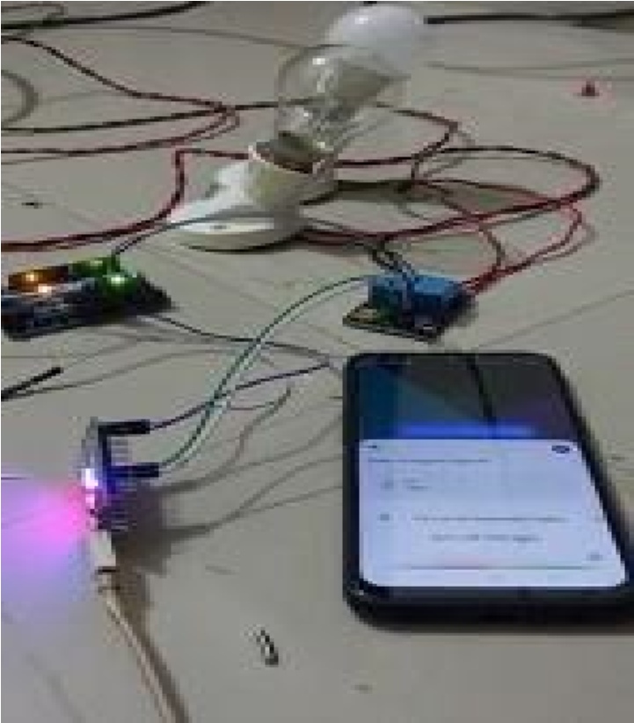
Fig. 1. using google voice.

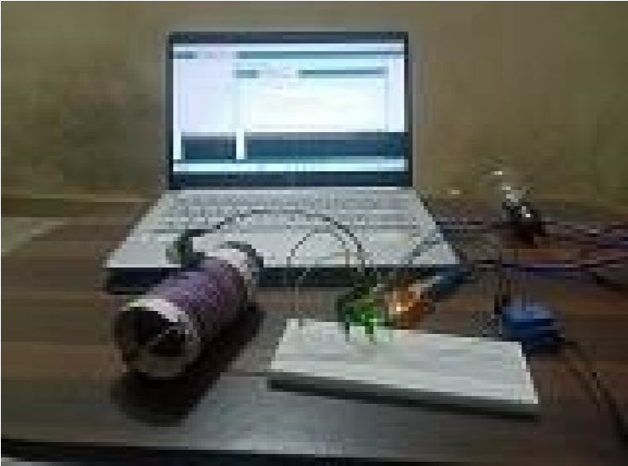
Fig. 2. using sensor
REFERENCES
- Linda Pipkorn, Trent Victor, Marco Dozza and Emma Tivesten,” Automation Aftereffects: The Influence of Automation Duration, Test Track and Timings”VOL. 23, NO. 5, MAY 2022.
- Ramya.L.N,” Energy Conservation – A Case Study”,November 2015
- YU-HSIU LIN 1, HUEI-SHENG , TING-YU SHEN1,”A Smart Home Energy Management System Utilizing Neurocomputing-Based TimeSeries Load Modeling and Forecasting Facilitated by Energy Decomposition for Smart Home Automation”,date of publication 3 November 2022.
- Ben Kehoe, Student Member, IEEE, Sachin Patil, Member, IEEE, Pieter Abbeel, Senior Member, IEEE, and Ken Goldberg, Fellow, IEEE,”A Survey of Research on Cloud Robotics and Automation”.VOL. 12, NO.
2, APRIL 2015.
- MUHAMMAD JAVED IQBAL 1 , MUHAMMAD MUNWAR IQBAL, IFTIKHAR AHMAD ,MUNEER AHMAD , (Member, IEEE), N. Z. JHANJHI 4 ,SULTAN ALJAHDALI , (Member, IEEE), AND MEMOONA MUSHTAQ1 ”Smart Home Automation Using
Intelligent Elec- tricity Dispatch”
- Y. Yorozu, M. Hirano, K. Oka, and Y. Tagawa, “Electron spectroscopy studies on magneto-optical media and plastic substrate interface,” IEEE Transl. J. Magn. Japan, vol. 2, pp. 740– 741, August 1987 [Digests 9 th Annual Conf. Magnetics Japan, p. 301, 1982].August 31, 2021. [7] Karishma Yadav, Rajat Johri,”SENSORS FOR HOME AUTOMATION”,Volume 1, Issue 4.
- Jha Ashish , Bababe Adam , Ishan Ranjan,”Smart Street Light Management System Using LoRa Technology”, March 2017.
- Amin Al Ka’bi, ”Management of Electrical Lighting System Using Programmable Logic Controllers”,June 2021.
- Aniela Kaminska and Andrzej Ozadowicz,”Lighting Control Including Daylight and Energy Efficiency Improvements Analysis” Nov2018.
- M. Matsive Ali, MD. Rhineul Islam, Ashikur Rahman,”Low Cost Temperature and Humidity Estimator with Atmega8
Microcontroller”,Volume 5 Issue 4, May-June 2021.

