Car rental web application

¹ Sadhana.K , ² Mr. Dr. D. Swamydoss
- Student, Department of Computer Application Engineering., Adhiyamaan College of Engineering (Autonomous), Hosur, Tamil Nadu, India
- Head of the Department, Department Master of Computer Application Engineering, Adhiyamaan College of Engineering (Autonomous), Hosur, Tamil Nadu, India

Abstract:Moving on, this car rental project system project in PHP focuses mainly on dealing with customers regarding their car rental hours and certain transactions. Also, it displays all the available cars on the home page whereas the users cannot view unavailable cars until and unless the user returns the rental car. The project is divided into two categories: Customer Login and Employee Login. In an overview of this web app, the employee has full control of the system. Talking about the project, a customer can simply log in or register their accounts. He/she can view available cars, select any one and proceed for rental after selecting various conditions, dates, etc. After all, the customer can rent a car by filling up the given forms. The customer can view all his rental records and history once after logging onto the system. In addition, the customer needs to return the cars using the system because all the records are carried throughout the system. At last, the system prints an invoice stating all the information with total costs.
Keywords:car, rental, virtual platform, service, the customer.
1. Introduction
Mission Statement Car Rentals, strive to provide our customers with a safe, reliable, and affordable rental car experience. We aim to exceed our customers' expectations through exceptional customer service and a wide selection of quality vehicles. Services Offered: Car Rentals offers a variety of rental car options, including compact cars, sedans, SUVs, vans, and trucks. We also offer long-term rentals for customers who need a vehicle for an extended period.The primary target market includes business travelers and vacationers who need reliable transportation during their trips. We also cater to residents who require a rental car for special occasions or as a temporary replacement vehicle. Car Rental stands out from the competition by offering competitive rental rates, excellent customer service, and a large selection of vehicles to choose from. We also offer convenient pickup and drop-off locations, making it easy for customers to rent and return their vehicles.Core values include honesty, integrity, reliability, and a commitment to customer satisfaction. We strive to provide our customers with a positive rental car experience, and we take pride in offering quality vehicles that are well-maintained and safe to drive. Overall, Car Rentals is dedicated to providing our customers with a convenient and hassle-free rental car experience. We aim to be the go-to choice for rental cars in our community, and we're committed to upholding our high standards of service and customer satisfaction.

2. LITERATURE SURVEY
System Analysis System analysis is a thorough examination of a system's different processes and their interrelationships both within and outside the system. The key question here is – why are there so many flaws in the current system? What measures should be taken to address the problem? When a user or management begins a study of the software utilizing the current system, analysis begins. Data was collected on numerous files, decision points, and transactions handled by the current system during the analysis. For example, Data Flow Diagrams, etc. are widely utilized in the system. For the collection of important information needed to create the system, training, experience, and common sense are necessary. The system's success is primarily determined by how well the problem is identified, fully studied, and appropriately implemented via the selection of a solution. A good analytical model should include not just methods for comprehending the problem, but also the framework for solving it. As a result, it should be extensively investigated by gathering data about the system. The suggested system should next be extensively examined in light of the requirements. System analysis is divided into four sections.
1) Initial research and system architecture.
2) Using analytic tools to do structured analysis.
3) Feasibility study.
4) Analyze the cost and benefits.
Problem Analysis We are currently creating a new system because there is no existing system at this time. There is currently no system on the market with these features and capabilities. This system is designed for a wide range of users, with a highly adaptable and adjustable solution that will ensure worldwide marketing.
Design and Development Problem Operating XAMPP. during the development process, debug the mistake. To depict a connection between two or more entities database table has a minor mistake.
Feasibility Analysis Once the problem is fully recognized, a feasibility study is carried out. The goal of the research is to see if the problem is worth fixing. It is the process of analyzing and evaluating a proposed project to evaluate if it is technically viable.
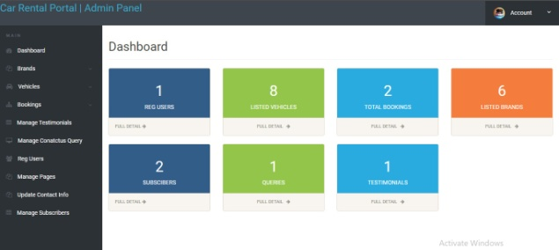
FIGURE 1: Dashboard
Economical Analysis The economic feasibility of a system is used to assess the project's or system's advantages as well as the expenses involved. A method known as cost-benefit analysis is used to accomplish this. It offers both concrete and intangible benefits, such as cost savings, increased flexibility, quicker activities, and efficient database administration. The application is on a medium scale, and it is financially possible for us to complete it. This necessitates a cost-benefit analysis. As a result, there is no issue with excessive costs or cost-benefit analyses. Software Analysis Developing web apps takes a long time. The expense of research and analysis to establish the real-world requirement.Implementation of the program on the server, as well as the expense of web servers.Data Conversion Data conversion is another expense connected with the implementation of this web application. The previously used software database must be saved and backed up so that no time or money is wasted in the implementation of the new web-based application. H. Operational Feasibility The system is operationally practical since it can be used by ordinary users with basic computer abilities who do not require any further training. We created this system with the willingness and capacity to design, administer, and run a system that is simple for end-users to use.
3.OBJECTIVE
"The car rental project is a system designed to simplify the process of renting cars. This project aims to provide an efficient platform for customers to rent cars of their choice while also ensuring that the process is seamless and secure. The system will allow customers to browse available cars, choose a pickup and drop-off location, select a rental duration, and make payments. The system will also include features such as real-time availability updates, automated booking confirmation, and cancellation policies. The project's goal is to provide a user-friendly and hassle-free car rental experience to customers while also enabling car rental companies to manage their fleets more efficiently.
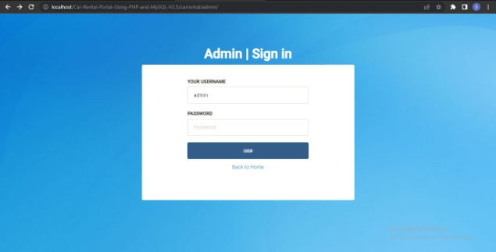
FIGURE 2: Admin sign in
"The Car Rental Project using PHP and JavaScript is a web-based system designed to streamline the process of renting cars. The project will utilize PHP for server-side scripting and JavaScript for client-side scripting, providing a user-friendly and dynamic interface. The system will allow customers to browse available cars, select a pickup and drop-off location, choose a rental duration, and make payments securely through the platform. The system will also include features such as real-time availability updates, automated booking confirmation, and cancellation policies. The project will incorporate a database to manage car and customer information, and an admin panel to manage bookings, cars, and customer accounts. The goal of the project is to provide a seamless and efficient car rental experience for customers while enabling car rental companies to manage their fleets more efficiently."
4. PROPOSED SYSTEM
Mission Statement: At DriveRite Car Rentals, we strive to provide our customers with a safe, reliable, and affordable rental car experience. We aim to exceed our customers' expectations through exceptional customer service and a wide selection of quality vehicles.
Services Offered: DriveRite Car Rentals offers a variety of rental car options, including compact cars, sedans, SUVs, vans, and trucks. We also offer long-term rentals for customers who need a vehicle for an extended period. In addition to rental cars, we provide optional features such as GPS navigation, child car seats, and roadside assistance.
Target Market: Our primary target market includes business travelers and vacationers who need reliable transportation during their trips. We also cater to residents who require a rental car for special occasions or as a temporary replacement vehicle.
Competitive Advantage: DriveRite Car Rentals stands out from the competition by offering competitive rental rates, excellent customer service, and a large selection of vehicles to choose from. We also offer convenient pickup and drop-off locations, making it easy for customers to rent and return their vehicles.
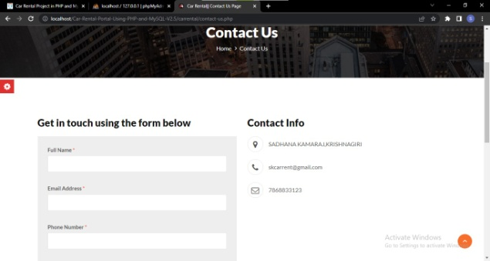
FIGURE 3: Contact page
Company Values: Our core values include honesty, integrity, reliability, and a commitment to customer satisfaction. We strive to provide our customers with a positive rental car experience, and we take pride in offering quality vehicles that are well-maintained and safe to drive.Overall, DriveRite Car Rentals is dedicated to providing our customers with a convenient and hassle-free rental car experience. We aim to be the go-to choice for rental cars in our community, and we're committed to upholding our high standards of service and customer satisfaction.
5.FUTURE SCOPE
- Develop a user-friendly website that makes it easy for customers to browse and book rental cars.
- Create a database of rental car options, including different makes and models, pricing, and availability.
- Implement a secure payment system that allows customers to make online payments for their rental reservations.
- Provide customers with easy access to information about rental car policies, requirements, and additional services.
- Develop a back-end system that enables rental car companies to manage their inventory, bookings, and customer information.
- Develop a website with an intuitive user interface that is easy to navigate.
- Create a database of rental car options, including vehicle details, pricing, and availability.
- Implement a secure payment system that acceptsmajor credit cards and other forms of payment.
- Develop a system for managing reservations, cancellations, and refunds.
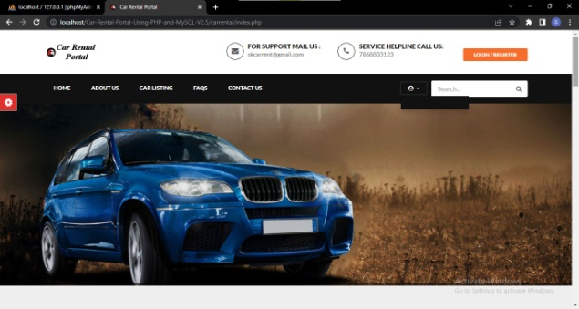
FIGURE 4: Landing page
- Create a back-end system for rental car companies to manage their inventory, bookings, and customer information.
- Provide customers with access to additional services, such as insurance, GPS, and car seats.
- Implement a search engine optimization (SEO) strategy to improve the website's visibility and ranking on search engines.

6. CONCLUSION
Phew! That was quite a journey. Hope you have got my aim and purpose because I want to introduce the car rental management system to the world. If you want some things to be customized go for it. Do not hesitate. Just ask me, and reach out to me. I will make the car rental management system on whichever platform you want. I will develop a car rental system for you. If you are looking for a real-time “Car Rental System for your business, I will happily do it.After the amount is paid by the customers, the invoice department will generate the bill for the car used and will reflect it in the customers’ accounts. This department will also keep the receipts of a new car that is brought to the system so that they can further be used for analysis purposes.
REFERENCES
[1] "PHP and MySQL Web Development" by Luke Welling and Laura Thomson - This book provides a comprehensive guide to building dynamic, database-driven websites using PHP and MySQL. It covers everything from basic syntax to advanced database queries and includes practical examples and exercises. [2] "HTML and CSS: Design and Build Websites" by Jon Duckett - This book provides a comprehensive introduction to HTML and CSS, covering the basics of page structure, layout, and styling. It includes plenty of practical examples and exercises, making it an ideal resource for beginners. [3]"JavaScript: The Definitive Guide" by David Flanagan - This book provides a comprehensive guide to the JavaScript programming language, covering everything from basic syntax to advanced features like closures and prototypes. It also includes practical examples and exercises. [4] "Learning PHP, MySQL & JavaScript: With jQuery, CSS & HTML5" by Robin Nixon - This book provides a hands-on guide to building dynamic, database-driven websites using PHP, MySQL, and JavaScript. It covers everything from basic syntax to advanced features like AJAX and jQuery. [5]"Web Development with jQuery" by Richard York - This book provides a comprehensive guide to using the jQuery library to build dynamic, interactive websites. It covers everything from basic syntax to advanced features like AJAX and plugin development. [6]One book that could be helpful for a car rental MERN (MongoDB, Express.js, React, Node.js) project is "Pro MERN Stack: Full Stack Web App Development with Mongo, Express, React, and Node" by Vasan Subramanian and Federico Kereki. [7]Thisbook covers the entire MERN stack, including MongoDB for the database, Express.js for the server, React for the client side, and Node.js for the runtime environment. It also provides practical examples and code snippets for building a full-stack web application. [8]"MERN Quick Start Guide: Build web applications with MongoDB, Express.js, React, and Node" by Eddy Wilson Iriarte Koroliova and Shama Hoque [9]"Pro MERN Stack: Full Stack Web App Development with Mongo, Express, React, and Node" by Vasan Subramanian [10] "React: Up & Running: Building Web Applications" by Stoyan Stefanov [11] "Node.js 8 the Right Way: Practical, Server-Side JavaScript That Scales" by Jim Wilson [12] "MongoDB: The Definitive Guide: Powerful and Scalable Data Storage" by Shannon Bradshaw, Eoin Brazil, and KristinaChodorow.
.

