“Future of Immunization: Role of Nepalese Pharmacists”
Sandeep Kshetri
Faculty of Pharmacy, Crimson college of Technology, Devinagar, Rupendhi

Propose
Pharmacists can play an important role in disease prevention by advocating and administering immunizations. Such activities are consistent with the preventive aspects of pharmaceutical care and have been part of pharmacy practice for over a century. These guidelines address the pharmacist’s role in promoting and conducting proper immunization of patients in all organized health care settings. The pharmacist’s role in promoting disease prevention through participation in community efforts is also discussed.
Introduction
A vaccine is a preparation of suspensions of killed or attenuated microorganisms, or products or derivatives of microorganisms, which are intended to produce immunity to a specific disease by stimulating the production of antibodies. According to the Centres for Disease Control and Prevention (CDC), vaccines are considered to be one of the most cost-effective preventive measures against certain diseases and declared top 10 public health achievements of the 20th century. Pharmacists, assist in preventing an approximately 14 million cases of vaccine-preventable diseases and 33,000 cases of death. Vaccines are considered to be a safe, cost-effective, and efficient means of preventing illness, disability, and death from certain infectious diseases.
The first COVID-19 vaccines have already begun to be introduced in countries and there are more vaccine candidates simultaneously in the pipeline for COVID-19 than ever before for an infectious disease. All of them are trying to achieve immunity against the virus, and some might also be able to stop transmission . The purpose of this article is to draw attention for the pharmacist-immunization programs in local pharmacies in response to COVID-19 vaccination and immunization programs for local populations.
Immunization Administration
Pharmacists can administer vaccines or host other health care professionals who can administer vaccines. Pharmacists must understand the legal and professional mechanisms by which authorization to administer vaccines is granted, as well as the additional responsibilities and considerations that accompany this expanded role. The feasibility of vaccine. administration by pharmacists within a particular practice site or health care system can be determined by analyzing the issues of legal authority, training, and program structure.
Legal authority
The pharmacist’s authority to administer vaccines is determined by each state’s laws and regulations governing pharmacy practice. At least 36 states permit vaccine administration by pharmacists as part of the scope of pharmacy practice.
Training
A comprehensive training program should address the following:
1. The epidemiology of and patient populations at risk for vaccine-preventable diseases
2. Public health goals for immunization (e.g., local, regional, state, and federal goals)
3. Vaccine safety (e.g., risk–benefit analysis)
4. Screening for contraindications and precautions of vaccination in each patient
5. Vaccine stability and transportation and storage requirements
6. Immunologic drug interactions
7. Vaccine dosing (including interpreting recommended immunization schedules and patient immunization records and determining proper dosing intervals and the feasibility of simultaneous administration of multiple vaccines)
8. Proper dose preparation and injection technique
9. Signs and symptoms of adverse reactions to vaccines, adverse reaction reporting, and emergency procedures, such as basic and advanced cardiac life support (BCLS and ACLS)
10. Documentation
11. Reporting to the primary care provider or local health department
12. Billing

Program structure
A vaccine administration program requires a solid infrastructure of appropriately trained staff, physical space, and written policies and procedures to ensure appropriate vaccine storage and handling, patient screening and education, and documentation. Pharmacists should be fully immunized to protect their health and the health of their patients.
Immunization Promotion
The pharmacist-immunization programs related to COVID-19 vaccination are shown in figure
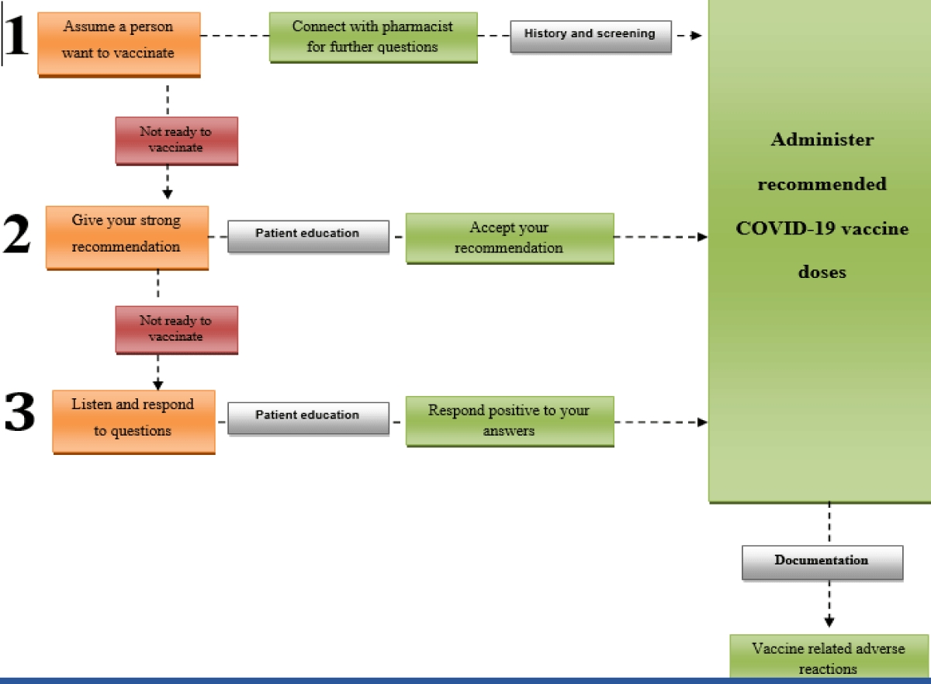
Assume a person wants COVID-19 vaccination and is interested in getting vaccinated at their local pharmacy should call pharmacist find out if vaccine is available. Pharmacist should give strong recommendations by providing answers to questions people may have about COVID-19 vaccines.
Pharmacists can also play an important role in promoting the importance of immunization in ways, which include:
- History and screening of patient
- Patient counselling
- Formulary management
- Public education and awareness
- Documentation
- Administrative measures
a) History and Screening of patient:
Pharmacists can promote proper immunization by identifying patients in need of immunization. Tasks that support this purpose consist of gathering immunization histories, encouraging use of vaccine profiles, issuing vaccination records to patients, preventing immunologic drug interactions, and screening patients for immunization needs.
Pharmacists should seek out leadership roles in some or all of the following forms of immunization screening.
- Occurrence screening, vaccine needs are identified at the time of particular events, such as hospital or nursing home admission or discharge, ambulatory care or emergency room visits.
- Diagnosis screening. This screening reviews the vaccine needs of patients with conditions that increase their risk of preventable infections.
- Procedure screening. Immunization needs are assessed on the basis of medical or surgical procedures using this type of screening
- Periodic mass screening. This type of screening is a comprehensive assessment of immunization adequacy in selected populations at a given time.
- Occupational screening. This screening method focuses on the immunization needs of health care personnel whose responsibilities place them at risk of exposure to certain vaccine-preventable diseases or bring them into contact with high-risk patients
b) Patient Counselling:
Patients in need of immunization should be advised of their infection risk and encouraged to accept the immunizations they need. Patient concerns about vaccine safety and efficacy should be discussed and addressed. Pharmacist can influence patients’ attitudes regarding immunization and inform them their need for vaccination. Patients who need immunizations should be vaccinated during the current health care contact unless valid contraindications exist. Delaying vaccination until a future appointment increases the risk that the patient will not be vaccinated. Chart notes, consultations, messages to patients, one-on-one conversations, and similar means can be used to communicate with inpatients and institutional patients.
c) Formulary Management
Pharmacist’s responsibility to develop and maintain product specifications to aid in the purchase of drugs under the formulary system. The pharmacist should establish and maintain standards to ensure the quality, proper storage, and proper use of all pharmaceuticals dispensed. Pharmacists must choose between single dose or multidose containers of vaccines on the basis of efficiency, safety, economic, and regulatory considerations. Pharmacists in institutions should develop guidelines on the routine stocking of immunologic drugs in certain high-use patient care areas.
c) Public Education:
Pharmacists have sufficient opportunities to advance the public health through immunization advocacy. Pharmacists can facilitate disease prevention strategies, because many patients visit pharmacies and are seen by pharmacists daily. Pharmacists can promote vaccination among high-risk populations in local pharmacies. Newsletters, posters, brochures, and seminars may be used to explain the risk of preventable infections to pharmacy staff, other health care personnel, and patients.
d) Documentation:
All health care providers who administer vaccines should maintain permanent vaccination records and to report occurrences of certain adverse events specified in the act. Pharmacist must record the date the vaccine was administered, the vaccine’s manufacturer and lot number, and the name, address, and title of the person administering the vaccine. Pharmacists in organized health care settings may encourage compliance with this requirement by providing reminder notices each time doses of vaccines are dispensed. Automated databases that allow for long-term storage of patient immunization information may provide an efficient method for maintaining and retrieving immunization records.
e) Administrative Measures:
Pharmacists can promote adequate immunization delivery among staff and patients by encouraging the development of sound policies on immunization. Pharmacists in local pharmacies should develop protocols that address the emergency measures in the event of vaccine-related adverse reaction
Future of immunization in Nepal
In my opinion, if government of Nepal play an important role in formulation of immunization programs that support future in fight to different diseases. An important recommendation to be considered in predicting how these pharmacist immunization programs practices will affect the future role of pharmacists and pharmacy in preventive health care is the curriculum at pharmacy schools. The curriculum at universities around the globe should incorporate the pharmacist-run immunization programs as an elective course for students. This recommendation hopes that the course will promote the awareness of the pharmacist in a preventive health role.
Conclusion
Immunizations are important in protecting patients from developing and dying from vaccine-preventable diseases, and in order to be successful, a team effort is required for all health care professionals to increase immunizations. Pharmacists are in a key place to increase awareness about the importance of vaccinations and identify those patients who can get benefit from specific vaccinations. By continually increasing awareness about the availability and importance of vaccinations, patients can make informed decisions to protect themselves and their family members.

References
- What do cows have to do with vaccines? National Institute of Allergy and Infectious Diseases. 2021 March 5.
- Mallone K, Hinman A. Vaccine Mandates: The Public Health Imperative and Individual Rights. Centers for Disease Control and Prevention. 2021 March 5.
- Bain KT, Cullison MA. Deficiencies in immunization education and training in pharmacy schools: a call to action. Am J Pharm Educ. 2009 Oct 1;73(6):110. doi: 10.5688/aj7306110. PMID: 19885079; PMCID: PMC2769532.
- State of the world’s vaccines and immunization. World Health Organization. 2021 March 5. https://bit.ly/3efKBaV
- Vaccines. World Health Organizations. 2021 March 5. https://bit.ly/2QJps0A
- Institute of Medicine Report. Shaping the Future for Health - Calling the Shots Immunization Finance Policies and Practice. 2021 March 5.
- Coronavirus disease 2019 (COVID-19): There are four types of vaccines. 2021 March 5.
- American Pharmacists Association. States where pharmacists have the authority to immunize patients. 2021 March 5.
- Knapp KK, Blalock SJ, Black BL. ASHP survey of ambulatory care responsibilities of pharmacists in managed care and integrated health systems--2001. Am J Health Syst Pharm. 2001 Nov 15;58(22):2151-66. doi: 10.1093/ajhp/58.22.2151. PMID: 11760918.
- Vaccines and Preventable Diseases. Centers for Disease Control and Prevention Web site. 2021 March 5.
- States allowing pharmacists to vaccinate. Immunization Action Coalition. 2021 March 5.
- Pharmacy Based Immunization Delivery Program. 2021 March 5.
- Hepler CD, Strand LM. Opportunities and responsibilities in pharmaceutical care. Am J Hosp Pharm. 1990; 47:533–43.
- Grabenstein JD. Pharmacists and immunization: increasing involvement over a century. Pharm Hist.1999; 41:137–52.
- Prevention and control of influenza: recommendations of the Advisory Committee on Immunization Practices. MMWR Recomm Rep. 2002; 51(RR-3):1–31.
- Use of standing orders programs to increase adult vaccination rates: recommendations of the Advisory Committee on Immunization Practices (ACIP). MMWR Recomm Rep. 200 49(RR01):15–26.
- Centers for Disease Control and Prevention. Epidemiology and prevention of vaccine-preventable diseases. 7th ed. Atlanta: U.S. Department of Health and Human Services; 2003.
- : American Society of Health-System Pharmacists. ASHP guidelines on the pharmacist’s role in immunization. Am J Health-Syst Pharm. 2003; 60:1371–7

