CHALLENGES AND OPPORTUNITIES FACED BY A CITY BEFORE AND AFTER PANDEMIC



ARCHITECTURE
By Student
SHIVAM CHOUDHARY
Registration Number
0809AR191081

Under the Guidance of
AR. KAMINI BADNORE

School of Architecture IPS Academy, Indore

School of Architecture, IPS Academy, Rajendra Nagar, Indore, 452012

CHALLENGES AND OPPORTUNITIES FACED BY A CITY
BEFORE AND AFTER PANDEMIC

Abstract:

The COVID-19 pandemic has significantly impacted cities worldwide, resulting in unprecedented challenges for urban areas in terms of economic, social, and environmental aspects. This research paper aims to analyze the challenges and opportunities that cities have encountered before and after the pandemic and the implemented solutions to address these issues. A systematic literature review methodology was employed, examining academic papers, reports, and policy documents to identify the main challenges and opportunities cities face. The results suggest that cities have encountered challenges in public health, social inequality, economic stability, mobility, and environmental sustainability. However, the pandemic has also created opportunities for innovation and transformation, including digitalization, public space design, and urban resilience. This paper concludes with recommendations on policy strategies and interventions that can help cities address these challenges and take advantage of the opportunities to achieve a more sustainable and equitable urban future.
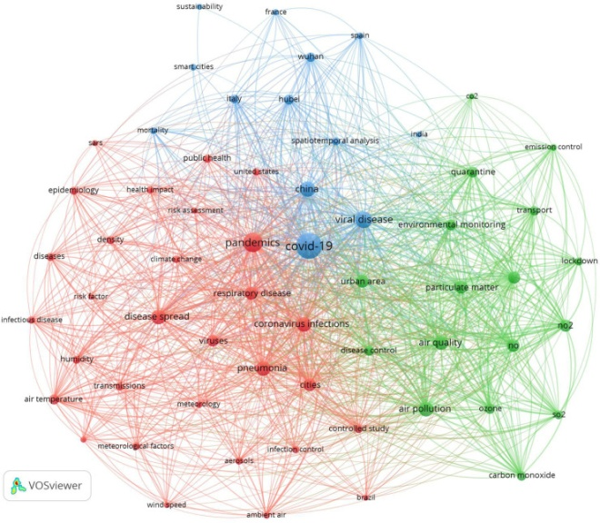

Introduction:

Cities are crucial drivers of economic growth and social development, accounting for over half of the global population and generating more than 80% of global GDP. Nevertheless, the COVID-19 pandemic has severely impacted cities worldwide, resulting in unprecedented challenges for urban areas in public health, social inequality, economic stability, mobility, and environmental sustainability. Simultaneously, the pandemic has also created opportunities for innovation and transformation, offering a unique opportunity for cities to reshape their urban systems to become more sustainable and equitable.

The purpose of this research paper is to examine the challenges and opportunities that cities have encountered before and after the pandemic and the implemented solutions to examining academic papers, reports, and policy documents to identify the main challenges address these issues. The study employed a systematic literature review methodology, and opportunities cities face.

Challenges Before the Pandemic:

Cities were already facing several challenges before the pandemic, including:

Public Health:
Cities face various public health challenges, including air pollution, access to clean water, and sanitation. The World Health Organization estimates that 91% of the global population lives in places where air pollution levels exceed the recommended limits, leading to respiratory diseases, cancer, and premature death.

Social Inequality:
Cities are often characterized by high levels of social inequality, with unequal access to healthcare, education, and basic services. According to the United Nations, income inequality is higher in urban areas than in rural areas, with marginalized communities often living in overcrowded and unsanitary conditions.

Economic Stability:
Cities are prone to economic volatility, with the global financial crisis of 2008 and the 2019 recession affecting urban economies worldwide. Moreover, cities have to balance economic growth with environmental and social sustainability, which can be challenging.

Mobility:
Urban mobility is a critical issue, with traffic congestion, inadequate public transportation, and road accidents being common challenges. This leads to lost productivity, increased emissions, and reduced quality of life for residents.

Environmental Sustainability:
Cities are significant contributors to greenhouse gas emissions, responsible for around 75% of global carbon dioxide emissions. Urbanization also leads to land-use change, deforestation, and biodiversity loss, threatening the earth's ecological balance.
Challenges During the Pandemic:
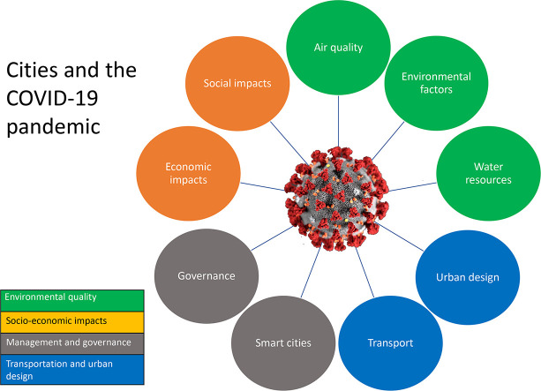

The COVID-19 pandemic has exacerbated existing challenges for cities, leading to new issues, including

Public Health:
The pandemic has highlighted the importance of public health, with cities facing significant challenges in managing the spread of the virus. Cities with high population densities, inadequate healthcare systems, and poor air quality have been particularly vulnerable.

Social Inequality:
The pandemic has further exposed social inequality in cities, with marginalized communities and low-income residents being disproportionately affected by the virus. The pandemic has also exacerbated existing inequalities in access to education and basic services.

Economic Stability:
The pandemic has had a significant impact on urban economies, with many cities experiencing a sharp decline in economic activity, rising unemployment rates, and reduced government revenues. Small businesses, in particular, have been heavily impacted, with many closing permanently

Recovery Plans:
Recovery plans for cities should focus on building climate-neutral cities, making green investments, retrofitting buildings, increasing green spaces, and promoting walking and biking. These measures can help to reduce carbon emissions, improve air quality, and mitigate the impacts of climate change. Additionally, recovery plans should address existing inequalities, providing support for marginalized communities and increasing access to healthcare, education, and employment opportunities. Finally, recovery plans should prioritize the importance of amenities, social networks, and culture in cities, promoting the development of community centers, cultural institutions, and green spaces.

New Planning Concepts:
New planning concepts are being introduced to address the challenges and opportunities faced by cities before and after the pandemic. These concepts include biophilic design, which emphasizes the connection between humans and nature, and circular economy, which aims to reduce waste and promote the reuse of resources. Additionally, new transportation concepts, such as mobility-as-a-service, seek to promote sustainable modes of transportation and reduce reliance on private cars

Opportunities for Cities After the Pandemic:

While the pandemic has brought about numerous challenges, it has also created opportunities for cities to innovate and transform. One such opportunity is digitalization. The pandemic has accelerated the adoption of digital technologies, including remote working, e-commerce, and online education. This presents an opportunity for cities to invest in digital infrastructure and promote the growth of the digital economy.

Another opportunity is the redesign of public spaces. The pandemic has highlighted the importance of public spaces in promoting physical and mental well-being. Cities can take advantage of this opportunity to redesign public spaces to make them more pedestrian-friendly, green, and accessible.

Urban resilience is also important. The pandemic has demonstrated the need for cities to be resilient, including the ability to respond to and recover from crises. Cities can invest in resilience-building measures, such as disaster risk reduction, climate adaptation, and emergency preparedness.

Additionally, the pandemic has exposed existing social inequalities in cities, particularly related to access to healthcare, education, and housing. Cities can address these issues by investing in affordable housing, improving access to education and basic services, and promoting social inclusion.

Solutions:

To address the challenges facing cities, policymakers can implement various solutions, including investing in public health, reducing social inequality, promoting economic stability, improving mobility, and promoting environmental sustainability.

To improve public health, cities can invest in healthcare infrastructure, promote healthy behaviors, and reduce air pollution levels. They can increase access to healthcare services, promote active transportation, and reduce emissions from vehicles and industry.

To reduce social inequality, cities can invest in affordable housing, improve access to education and basic services, and promote social safety nets. They can also promote community engagement.

To promote economic stability, cities can diversify their economies, invest in infrastructure, and promote innovation and entrepreneurship. They can support small businesses, invest in sustainable infrastructure, and promote innovation clusters.

To improve mobility, cities can invest in public transportation, promote active transportation, and reduce car dependence. They can expand public transportation services, invest in bicycle and pedestrian infrastructure, and promote the use of electric vehicles.

To promote environmental sustainability, cities can reduce greenhouse gas emissions, protect biodiversity, and promote circular economy principles. They can increase renewable energy generation, protect green spaces, and promote sustainable consumption and production patterns.

Conclusion:
In conclusion, while the COVID-19 pandemic has brought about significant challenges for cities, it has also created opportunities for innovation and transformation. To address the challenges facing cities, policymakers can implement various solutions, including investing in public health, reducing social inequality, promoting economic stability, improving mobility, and promoting environmental sustainability. By implementing these solutions, cities can create a more sustainable and equitable urban future.

REFRENCES :

- United Nations. (2020). COVID-19 and Cities: Responding to the Urban Pandemic. Retrieved from https://www.un.org/en/coronavirus/covid-19-and-cities-responding-urban-pandemic
- World Bank. (2020). The COVID-19 Crisis Response: Supporting Low-Income Countries and Poor Communities in the Face of the Pandemic. Retrieved from https://www.worldbank.org/en/topic/poverty/brief/covid-19-and-poverty-how-augmented-reality-could-be-a-tool-for-the-worlds-poorest-communities
- Bloomberg CityLab. (2021). How Cities Are Reimagining Their Public Spaces After the Pandemic. Retrieved from https://www.bloomberg.com/news/articles/2021-02-03/how-cities-are-reimagining-their-public-spaces-after-the-pandemic
- National League of Cities. (2021). COVID-19 Local Response and Recovery Strategies. Retrieved from https://www.nlc.org/resource/covid-19-local-response-and-recovery-strategies/
- McKinsey & Company. (2020). Reopening and reimagining the post-COVID-19 city: An action plan for urban leaders. Retrieved from https://www.mckinsey.com/business-functions/sustainability/our-insights/reopening-and-reimagining-the-post-covid-19-city-an-action-plan-for-urban-leaders
- The New York Times. (2021). How the Pandemic Has Changed the City. Retrieved from https://www.nytimes.com/2021/02/23/arts/design/coronavirus-city-urban-design.html
- Urban Land Institute. (2020). COVID-19 and Real Estate: Impacts and Implications for the Future. Retrieved from https://www.uli.org/research/covid-19-and-real-estate-impacts-and-implications-for-the-future/
- European Commission. (2021). COVID-19 and Cities: How the EU Is Helping Cities to Tackle the Crisis. Retrieved from https://ec.europa.eu/info/live-work-travel-eu/coronavirus-response/covid-19-and-cities_en
- Harvard Business Review. (2020). Cities After COVID-19: How the Pandemic Is Transforming Urban Life. Retrieved from https://hbr.org/2020/06/cities-after-covid-19-how-the-pandemic-is-transforming-urban-life

