360-DEGREE VIRTUAL
REALITY
SHREENIKESH .N
DEPARTMENT OF COMPUTER SCIENCE, SRI KRISHNA ARTS AND SCIENCE COLLEGE,COIMBATORE.

ABSTRACT
Virtual Reality (VR) is a technology that enables users to experience a computer-generated environment as if it were real. This is achieved by using head-mounted displays, tracking systems, and other input devices to create an immersive, three-dimensional world that users can interact with. VR is being used in industries, like gaming, entertainment, education, healthcare etc,... In gaming, VR provides a new level of immersion and interactivity, allowing players to experience new worlds and adventures in a way that was previously impossible Virtual reality (VR) technology has rapidly evolved in recent years, with significant advancements in hardware, software, and content development. VR offers users an immersive experience that can simulate real-world scenarios, environments, and interactions. This technology has been applied to a wide range of fields, including entertainment, education, healthcare, and training. In the entertainment industry, VR provides users with a unique and interactive way to consume media, from gaming and movies to virtual tourism and social experiences. In education, VR allows

students to experience immersive learning environments that can enhance their understanding of complex concepts. In healthcare, VR is used for therapy and rehabilitation, allowing patients to simulate real-life scenarios in a safe and controlled environment. Finally, in the field of training, VR provides a cost-effective and efficient way to train employees in various industries, such as aviation, military, and manufacturing despite its potential, there are still challenges to overcome, such as high costs, technical limitations, and the need for more compelling and engaging content. Nonetheless, the future of VR looks promising, with further advancements and new applications yet to be discovered.
KEYWORDS
VR headset, VR games, VR videos, VR education, Augmented Reality(AR),360 degree video.

INTRODUCTION
Virtual Reality, commonly abbreviated as VR, is a computer-generated simulation of a three-dimensional environment or experience. This technology uses a combination of hardware and software to create a sense of immersion, making the user feel as if they are physically present in the virtual world.
It can be used to create immersive experiences that blend aspects of the real world with the virtual world. VR technology can be used in a variety of ways, such as gaming, educational applications, medical simulations, military training simulations, and more. Through the use of VR, users can explore virtual environments, interact with objects and people, and experience the world in a more realistic way
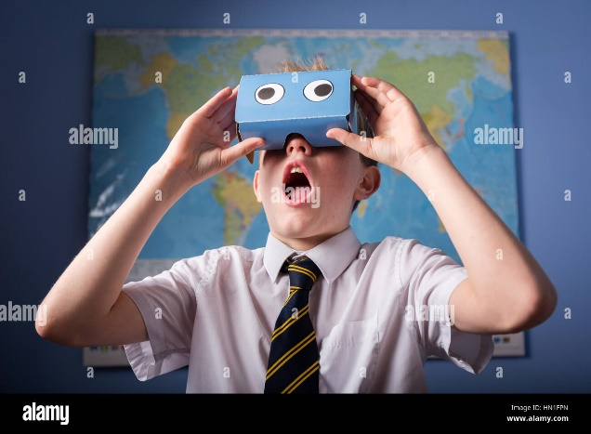
Fig1_virtual reality
Fig_2 virtual reality

VR GAMES
Virtual reality is an interactive computer-generated experience taking place within a simulated environment. It incorporates mainly auditory and visual feedback, but may also allow other types of sensory feedback such as haptic. The most popular use of virtual reality technology is for gaming. Virtual reality games allow players to enter into a simulated environment and become part of the game. This can involve exploring virtual worlds, competing against other players, or simply having fun with friends. The advantages of using virtual reality for gaming are numerous. One of the major benefits is that it allows players to have a much more immersive experience than they would be able to have with traditional gaming. Since the environment is completely virtual, players can customize their experience according to their preferences. They can choose the type of world they play in, the difficulty level, and the types of challenges they face. Another advantage of virtual reality gaming is that it allows players to experience a wider variety of games. In the past, games were limited to a few genres such as first-person shooters and racing games. With virtual reality, players can explore different types of games such as puzzle games, sports games, and even strategy games. Finally, virtual reality gaming allows players to experience games in a more social way. Players can interact with each other in ways that they would not be able to do in traditional gaming. This can include talking with each other, forming teams, and even competing against each other. Overall, virtual reality gaming is a great way for players to experience games in a more immersive and social way. It allows players to customize their experience and explore a wider variety of games. As technology continues to improve, virtual reality gaming will become even more advanced and exciting. The game could be completed by reaching a final objective or completing a final level.The player could lose interest in the game and stop playing.
FUTURE OF VR
With the advances in technology and the rapid growth of the industry, virtual reality is poised to become a key part of our lives in the near future. Companies like Oculus, HTC and Microsoft are already making strides in developing virtual reality headsets and other products for gaming, entertainment, and even educational purposes. As the technology advances and becomes more accessible, virtual reality will become even more widely adopted. In the near future, virtual reality could become a part of everyday life, with applications in healthcare, education, and entertainment. Healthcare professionals could use virtual reality to diagnose and treat patients in a more immersive way, and educators could use it to create virtual classrooms and simulations. As virtual reality continues to evolve, it's likely that the possibilities for its use will only expand. With the right resources and the right mindset, virtual reality has the potential to revolutionize the way we interact with the world around us.

USES OF VR
Virtual Reality (VR) can be used to provide a variety of immersive experiences to users. It has been used in a range of applications from gaming, to medical training, to military simulations.VR has also been used to create educational experiences, such as virtual field trips, as well as to provide therapy for people with anxiety or phobias. In addition, VR is being used to create immersive experiences in the workplace, such as virtual meetings and conferences.
CONCLUSION
Virtual reality is a powerful tool that can revolutionize the world of gaming and entertainment. It has the potential to provide an immersive and interactive experience that can bring users closer to the content they are viewing. With the development of new technologies, virtual reality is becoming more and more accessible and affordable, making it an attractive option for many. Developers are creating a wide variety of experiences that can be enjoyed by people of all ages, from all walks of life. As the technology continues to advance, the possibilities for virtual reality will only become more exciting.

REFERENCES
[1] Virtual Reality News & Reviews: https://vrscout.com/
[2] The Leading Source of Virtual Reality News:https://www.roadtovr.com
[3] Virtual Reality: https://www.wired.com/topic/virtual-reality/
[4] Virtual Reality News and Reviews: https://uploadvr.com/
[5] The Reality of Virtual Reality: https://www.vrfocus.com/
[6] B. Beckert, "Venturing into Virtual Development", Journal of Computer-Aided Engineering, pp. 45-54, May 1996.
[7] M. Sagar, "A Virtual Environment and Model of the Eye for Surgical Simulation", Computer Graphics Proceedings Annual Conference Series, pp. 205-212, 1994.
[8] Rosson, Lois (15 April 2014). "The Virtual Interface Environment Workstation (VIEW), 1990". NASA. Retrieved 23 January 2023.
[9] "Get Ready to Hear a Lot More About 'XR'". Wired. 1 May 2019. ISSN 1059-1028. Retrieved 29 August 2020.
[10] "virtual | Search Online Etymology Dictionary". www.etymonline.com.Antonin Artaud, The Theatre and its Double Trans. Mary Caroline Richards. (New York: Grove Weidenfeld, 1958).

.

