Abstract : India is home to tons of plastic waste which is deposited on the surface of rivers and lakes. From these rivers, the Ganga River accounts for 90% of the plastic that ends up in the sea. This pollution causes the destruction of biodiversity, contamination of the food chain, and spread of disease, etc. Previous solutions offer an optimal method to clean the waste, however, it comes with a cost trade-off as it uses multiple microprocessors, motors, robotic arms, and cameras to achieve the outcome. Our solution cleans the surface using a conveyor belt and a pair of sensors which overcomes the drawback of the previous solution, that is, cost. Once deployed, a person will control the bot’s movement while a sensor will detect trash. Once detected the sensor will imitate the processor to start the conveyor belt, thus clearing the trash. The proposed solution minimizes power consumption since the belt only

activates when the trash is detected.

1. Introduction
Waste is an environmental problem that always arises yearly and cannot be resolved entirely. The rubbish can clog the flow of water, causing water to become dirty and smelly so that it often overflows and causes disasters, including flooding. The proposed solution will offer efficient methods to clean the water bodies’ surfaces. The purpose of achieving the above is to:
- Provide clean water for people who live nearby.
- For underwater life to flourish.
- To restore the beauty of ponds, rivers, and small water bodies.

2 . Literature Survey
In order to understand the need for a compact, cost effective and scalable system, and before diving in to provide our own solution, we need to first understand the existing research and work done in the field. There have been numerous prototypes of Water garbage collection systems, autonomous
robots, and waste segregating. In this section, we depict a concise review performed on these existing pieces of work, encompassing mobile robots, garbage collectors and IoT based systems for similar use cases. One paper proposed a Water Surface Robot using wireless communications. The primary objective of this research was Waste Hunter Surface Robot was a semi- automatic robot with three different main functions, which were surface cleaning, purification process and water quality monitoring. The robot was semiautomatic control robot where the robot will be turned on and off, makes a movement form the input gain from the user. Wireless based controller was used with WI-FI based communication protocol to communicate between the user and the robot. The remote control used was the smart phone apps called ( Blink) virtual button keypad. The Node MCU micro-controller module was use to interface unit between the user and robot. The wireless based controller was used in WI-FI based communication protocol to communicate between the user and the robot. The remote control used was the smart phone apps called (Blink) virtual button keypad. The Node MCU micro-controller module is used to interface unit between the user and the robot. There will be several functions on the mobile apps, virtual keypad to control the robot, when the robot is connected to the WI-FI module, first button, the propeller control (virtual joystick) for the movement of the robot. One widget for monitoring the internet data connection ( ping) between Blink cloud and user interface, digital switch to turn on or off the motor pump and one virtual gauge for data quality monitoring (PH value) Another paper demonstrates the use of a different algorithm. This paper emphasis on design and fabrication details of the river waste cleaning machine. This machine has designed to wash river water surface. The remote operated river cleaning machine has designed which helps in river surface cleaning effectively, efficiently and Eco-friendly. The “River waste cleaning ma-chine” is employed where there’s waste debris within the water body which are to be removed. This machine consists of DC motors, RF transmitter and receiver, propeller, PVC pipes and chain drive with the conveyor attached thereto for collecting wastage, garbage plastic wastage from water bodies. Here they have used a Bluetooth module to control the robot via 2 DC motors at 300 RPM approx. The robot is control by an android phone application Micro-controller used is AT89S51 from 8051 family to figure during a serial communication UART mode the communication is configured on 9800 bps to communicate it with the Bluetooth module. The Bluetooth module used, HC-05 in SMD package which works on a 3.3 V and have a serial communication with any device connected thereto the communication speed can be configured on various speed via AT Command. The Bluetooth module may be a
SPP supported profile so it are often connected easily to any module or phone. In this profile the info are often sent and receive to module. The Bluetooth module is connected to the RX pin of micro-controller. The L293D may be a motor driver IC to work the motors in any direction required hooked in to the logic applied to the logic pins. The controlling devices of the entire system are a micro-controller. Bluetooth module, DC motors are interfaced to the micro-controller. The data receive by the Bluetooth module from android smart phone is fed as input to the controller. The controller acts accordingly on the DC motor of the robot. The robot within the project are often made to maneuver altogether the four directions using the android phone. The direction of the robot is indicators using LED indicators of the Robot system.

3 . Methodology

3.1 Algorithm Flow
In the first step Mobile phone is used to set the way-point for the robot using the Bluetooth module. Once the start button is pressed the robot travels according to the path loaded in the Arduino. We have combined the usage of proximity sensors with motor driver to accomplish our purpose. The ultrasonic sensor mounted on the servo rotates and remains ON during the whole process. Once the sensor detects any object on the water surface, the motor driver moves the robot in that direction and starts the conveyor belt and collect the waste. This helps us to save battery power required for the process. The weight sensor attached in the waste collector or plastic box will keep the reading of the weight. Once the weight reaches to 5kg or above, the robot will come back to the way-point set using the GPS module or either keep flowing the path. Once the robot reaches the way-point, the location co- ordinates of the robot will be sent to the mobile using GSM.
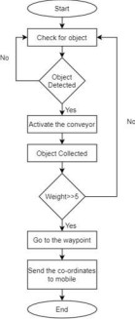
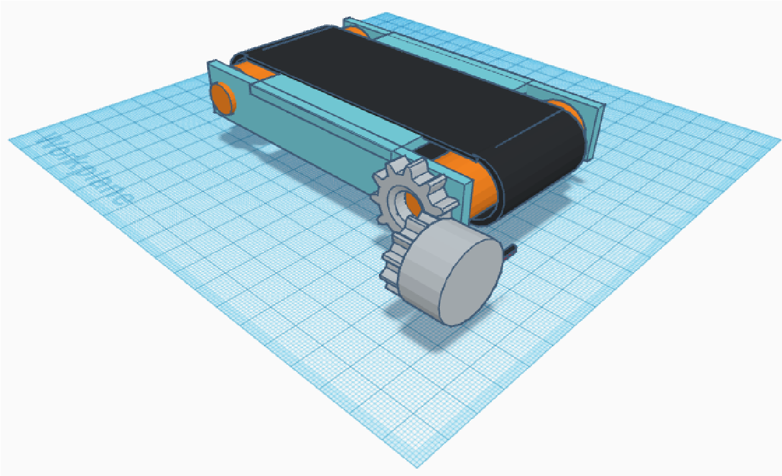
Fig. 1 : Flow chart

3.2 System Design
1) Robot Body Architecture : The robot is made on a flat wooden sheet on the top, with two wheel drive. At the front, a conveyor belt is mounted, responsible for collecting up the garbage, when detected. The flat chassis is made of a wooden sheet of measured dimensions, attached to a floating circular pipe and supports made up of small pipes. Two rotating arms or paddles are attached to it via two different DC motors. The conveyor belt is mounted with the help of 2 DC motors, on either extreme of the width of the robot. On top of the wooden sheet, contains the main ECU of the robot, with all circuitry and connections. The sheet contains a small slot, making space for the presence of an ultrasonic sensor and servo.
Fig. 2: Schematic Diagram
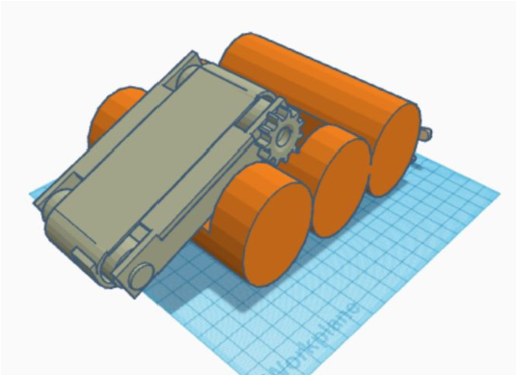
Fig. 3: Front View | Robot is controlled mainly by a Arduino UNO or MEGA. The Arduino UNO is connected to the ultrasonic sensor, L293D motor driver modules (2 in
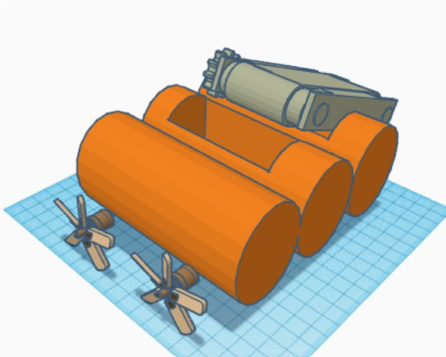
Number), GPS and GSM. The motor driver modules are each connected to 2 DC motors, which drive the wheels and also to conveyor belt for collecting waste.
Fig. 4: Back View
Robot circuitry architecture : The ECU of | the
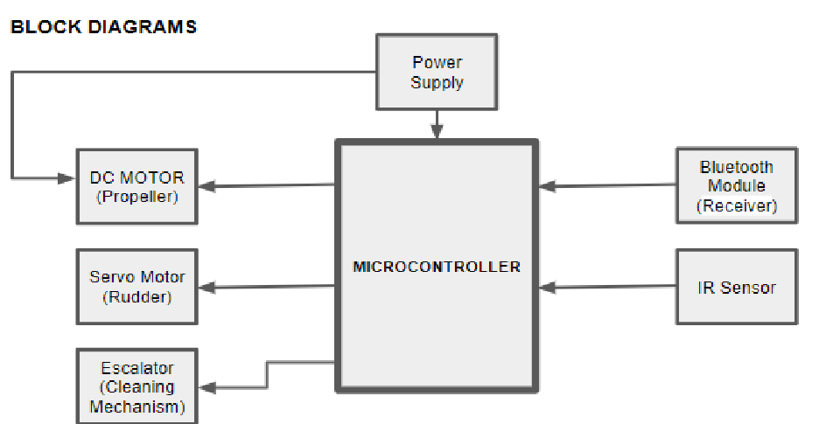 Cell Phone Bluetooth

Fig1 : Block Diagram
Fig. 5: Block Diagram 3.3 Modular Analysis The system is divided into a number of Modules. We shall analyze each of these modules in detail, as follows:
- Trajectory and motion module : The robot moves in a pre-programmed trajectory, covering its locality or zone which it is responsible for cleaning. The trajectory program is present on the Arduino UNO. The Arduino UNO sends commands to the motor drivers, which in turn controls the motors for various functionalities, such as forward, reverse, left turn, right turn and stop. In an obstacle free path, the robot continues to move forward. The trajectory may further be optimized by taking into account a
( Transmitter )
number of factors so as to cover minimum distance while accomplishing its purpose. After the obstacle is detected, depending on whether it is garbage it will take action. If the garbage is detected, then the robot will move in that direction. After collecting up the pieces of garbage, it must travel to the way-point of the assigned zone and deposit the garbage.
- Object Detection module: The motion, object detection, data communication and actuation were all performed success- fully. The given code is just for communication between a Robot and Arduino. The demonstration of garbage classification is also shown. We attached an LED to the front of the robot to indicate the detection of garbage. It was found that, whenever garbage was detected, the LED began to glow, and the conveyor w smoothly lifted up the waste using DC motors.

4 . Results and Discussion
The motion, object detection, data communication and actuation were all performed successfully. The given code is just for communication between a Robot and Arduino. The demonstration of garbage classification is also shown. We attached an LED to the front of the robot to indicate the detection of garbage. It was found that, whenever garbage was detected, the LED began to glow, and the conveyor w smoothly lifted up the waste using DC motors. 5 . Relevance to Social Benefit
The waste collecting robots are a great step forward in combat-ting pollution, the major cause of water scarcity. However, it could also be a method of improving the lives of individuals in developing countries. The most direct effect of decreased pollution is improved health as a result of increased availability of clean water, but the proliferation of trash robots could lead to economic opportunities as well. In order to deploy waste collecting robots across the planet, people are going to be needed to take care of them and take away the waste they collect. This illustrates the multi-faced benefits waste collecting robots can have in helping to lift people out of poverty.

6 . Conclusion and Future Scope
- L. ü Wen-hua, H. E. Xiao-lei, Y. U. He-jun, and L. I. Jian-ying, “Development of full automatic solar tracker and its applications
[ J],” Optics and Precision Engineering , 2008 , vol. 12.
- L. J. Chien, M. Drieberg, P. Sebastian and L. H. Hiung. “A simple solar energy harvester for wireless sensor networks,” In 2016 6th
International Conference on Intelligent and Advanced Systems (ICIAS), 2016, pp. 1-6, IEEE 2016.
- D. Geer, Propeller Handbook: The Complete Reference for Choosing, Installing and
Understanding Boat Propellers , International Marine, Maine, USA, 1989, pp: 152.
- M. Leanglum, N. Ruangpayoongsak and A.
Phunopas, “Design and Development of the Waste
The structure of the Ocean surface Trash collector Robot is presented in details. Both arms are made of plastic pipes and cause small surface wave amplitude when compared with fan or rotatory mechanism. Difference in term of mechanism has much influence on collecting system. Capability of the designed conveyor was successfully evaluated. It is also shown that both the robot driving speed and the conveyor belt speed has influence on waste scooping and the best capability of the robot is achieved at 0.38 m/s driving speed and 0.5 m/s belt speed. The maximum amount of collected bottles is 1.71 kg/minute, which is 75 percent over that of human force using a scoop net. Therefore, the Ocean Surface Trash Collector is proven capable of replacing human labor for water surface cleaning.
The robot can be controlled ad monitored by building a central server. The image processing algorithm can be used upon without any constraint in processing hardware. The system may also encompass a broad domain of use-cases. It can particularly be used for nuclear-waste collection, where human presence is unsafe. It is primarily proposed for a “smart ocean”.

References
[1] B. H. Yuan, X. H. Gao, B. Zhang and H.Y. Lin, “The Design and Realization of Small sized Water-surface Garbage Cleaning Boat,”
Journal of Long dong University , vol. 28, no. 1 , 2017, pp. 24-29.

Collector for a Surface Robot Cleaner,” Proc. of
Industrial Engineering Network Conference (IE NETWORK) , pp. 900-905, 2015.
- Explorato_Technomentis, “Automated Garbage
Collector”, Instructables . [Online]. Available:
https://www.instructables.com/id/Automated - Garbage-Collector/ [Accessed April 10, 2019].
- S. Khandare, S. Badak, Y. Sawant and S. Solkar, “Object Detection Based Garbage
Collection Robot,” International Research Journal of Engineering and Technology ( IRJET) , vol. 5, no. 3, March 2018.
- E. Rahmawati, I. Sucahyo, A. Asnawi, M.
Faris, M. A. Taqwim and D. Mahendra, “A Water Surface Cleaning Robot,” Journal of
Physics: Conference Series , vol. 1417, no. 1, p. 012006. doi: https://doi.org/10.1088/1742-
6596/1417/1/012006
- Soumya, H. M. Preeti and B. Gadgay, “Pond Cleaning Robot,” International Research Journal of Engineering and Technology (IRJET), vol. 5, no. 10, Oct 2018, pp. 1136-
1139. Available: https://irjet.net/archives/V5/i10/IRJET V5I10211.pdf
- “Trash Robots Saving the World’s Water,” Borgen magazine, July 10, 2018. [Online].
Available:
https://www.borgenmagazine.com/trash robots/ [Accessed: Jan 2020]
.

