Early Earthquake Alerting System: A Review

Ujjwal Singh¹, Ritvik Kumar² , Abhishek Chaurasiya³ and Adesh Kumar Mishra⁴
^{1,2,3,4}Department of Electrical Engineering
^{1,2,3,4} Babu Banarasi Das Institute of Technology and Management, Lucknow
Email id : singhujjwal25062000@gmail.com, Phone : 9118584654, 8887493390

Abstract: This review paper gives a brief summary of our group's Early Earthquake Alerting System project. As Earthquakes is a serious threat to living beings . They are caused by collision or movements of tectonic plates, seismic waves, which are caused in Earth’s crust by a sudden release of energy. Earthquakes can be so hazardous that they can throw living beings around and kill whole cities. Earthquakes, as we all know, are a natural occurrence that cannot be prevented. However, if we do not take appropriate action to tackle it, it can be extremely dangerous. Furthermore, seismometers can be used to track earthquakes, but they are very expensive. As a result, there should be a mechanism in place that can detect an earthquake without the use of a seismometer and warn the DMT and residents. . IOT application that allows things to talk to one another. Arduino mega was used as the micro controller in the device. The purpose of creating earthquake warning system is to declare the information about the beginning and end of the earthquake at the instant of earthquake as a tweet in tweeter and to give audible notice for the persons in the environment. At the time of the earthquake, IMU and piezo vibration instruments were used to identify vibrations. The system also came with an ESP8266 Wi-Fi module so that it could link to the internet. To find the earthquake, the system analyzes the information from vibration and IMU instruments.

Keywords: Arduino, Earthquake Warning System, Wi-Fi, IoT, Internet of things.

Introduction
Natural laws cannot be disregarded, despite numerous technological and scientific breakthroughs. Nature has compelled scientists to contemplate or foresee certain natural catastrophes. One of nature's most destructive occurrences, an earthquake can be extremely dangerous to regions close to active faults on land or offshore subduction zones. When a sizable amount of energy is abruptly released from the structure of the earth, an earthquake results. Over 20,000 aftershocks are typically recorded by the National Earthquake Information Center each year. One of the worst natural catastrophes that cause significant loss of life and property is an earthquake. Early discovery and alerting are essential for reducing earthquake losses.
We will therefore create a smart earthquake tracking and alerting system that detects earthquake tremors and remotely notifies users via buzzer and instant SMS notifications before the actual earthquake occurs.
The device is controlled by an STM32 ARM controller board. In order to create this system, we'll use a vibration sensor, GSM module, LCD display, buzzer, push buttons, and accompanying circuitry. The user may switch the device to monitoring mode once the settings are final. In this condition, the system continuously scans for aftershocks. The vibration sensor data are continuously monitored by the STM32 controller. The sensor outputs a signal that the controller can identify when it detects a vibration.
Now, the controller activates the buzzer to sound a warning and shows it on the LCD screen. In order to transmit 3 SMS alerts, the controller also interacts with the GSM module. The three registered contact numbers entered into the system during the settings portion receive 3 SMS messages as a result.
Thus, the system enables early earthquake vibration detection and transmits alerts to numerous recipients for immediate earthquake broadcasting.

2 Related Works
The laws of nature cannot be disregarded, despite numerous technological and scientific advances. Scientists are forced by nature to think about or predict specific calamities. One of nature's most destructive occurrences, an earthquake can be extremely dangerous to regions close to active faults on land or offshore subduction zones. When a sizable amount of energy is abruptly released from the structure of the earth, an earthquake results. This energy causes the earth to emit damaging seismic waves. Seismic waves have been found to include shear waves, longitudinal waves, and surface waves. the names for longitudinal and shear waves are P-wave and S-wave, respectively. Despite being the most damaging wave in nature, the surface wave moves more slowly than other waves.
It was discovered that the P-wave's forward motion and vibration path were equal, making it the fastest wave known to science. On the other hand, it is discovered that the P-wave's devastating power is modest. There are still numerous earthquake prediction research initiatives in progress. As a result, our system concentrates on detecting earthquakes, alerting the emergency response team, and giving locals a secure escape route.
An EEWES could provide alarms in the case of an earthquake, allowing school emergency coordinators to start making emergency arrangements. When warning signals are activated, the teacher chosen as the emergency supervisor will think about the evacuation procedure. (For instance, sirens and social media). In addition to coordinating the essential actions, they may alert other teachers who are in charge of evacuations. Also, the teacher must stay in close contact with the parents.
In this research, a low-cost earthquake warning system that can identify foreshocks without causing damage has been created. The created system is an IOT program that allows objects to talk to one another. The system's microcontroller was an Arduino Mega. The goal of creating an earthquake warning system is to give audible alerts to people in the immediate vicinity and to tweet information about the beginning and end of the earthquake at the moment of the earthquake. At the time of the earthquake, IMU and piezo vibration instruments were used to identify vibrations. The system also came with an ESP8266 Wi-Fi module so that it could link to the internet.
Earthquake with a destructive 9.0 magnitude that struck off the shore of northeastern Japan brought to light both the benefits and the drawbacks of earthquake early warnings. Japan introduced the most advanced seismic early-warning system in the world four years ago. Within a minute of an earthquake's beginning, the EEW system can determine an earthquake's approximate source and magnitude and can notify the general public via TV, radio, and cellphone. Additionally, it sends signals that can halt factory production lines, halt elevators at the closest level, and shut down computers automatically. An early-warning text notification can be seen in the image, which states: A Fukushima-oki earthquake has started. Strong aftershocks are expected, so please be ready. (Japan Meteorological Agency).
Masumi Yamada, an assistant professor in Kyoto University's Earthquake Hazards Division, stated that the earthquake on March 11 began at 2:46 p.m., roughly 150 kilometers off the Miyagi prefecture coast. It took 31 seconds for residents of the Tohoku region to receive the first warning via phone, TV, and radio. This gave folks a lead time of between 10 and 30 seconds before they felt the first tremors. However, Yamada notes that "many earthquakes happen simultaneously, creating problems for the system, and the EEW system did not work for tremors throughout the initial 3 hours after the mainshock." In fact, the 11 March earthquake was noteworthy for the volume and intensity of its waves. as of March 15 at midday.[4]
A P-picker processes real-time seismic data and establishes the beginning of a P-wave approach as well as its magnitude characteristics. The P-picks are then used by an associating/locating method to identify the source parameters for regional, local, and tele-seismic earthquakes. The position and magnitude are improved as more data are received and processed because a watch stander can add or modify P-wave data that is used in the algorithmic places through a graphical interface. Depending on the size and location of the earthquake, the original estimation of magnitude is based on Mb, M1, or Mwp. Additionally, wavefront spectra and aspect tensor reversals are used to calculate Mw magnitudes. In order to offer redundancy and the ability to handle earthquakes that happen near together, two similar Windows-based systems are currently in use.[5]
China's earthquake alerting (EEW) system is currently undergoing trials. It continues to struggle with typical scientific and technological issues like the difficultly in determining rupture parameters rapidly and the unreasonable estimation of the shake map, particularly for large events. The unique technological challenge of sending alarm messages at the level of tens of millions in under a second is also a significant obstacle for China's EEW system. The Science and Technology Ministry of China has started a project called "Advanced technological advancement and field display for earthquake early warning" to address these issues.[6]
An integrated geo-hazard alert system's data collecting, event detection, and correlation components are implemented by the Web-enabled Awareness Research Network project (WARN). Its ability to quickly integrate real or simulated data with research and operational models of tsunami and earthquake impacts prediction is one of its novel features. The project aims to provide urban areas, coastal towns, and important infrastructure operators with early warning. WARN is positioned in this context in Figure 1's overview of a generic alert system top-level architecture. WARN is dependent on sensors that have been put both on land and in the water. Moreover, Ocean Networks Canada's Oceans 2.0 data management system is used by Warn to gather data.
In its most basic and high-level form, WARN can be described as constantly monitoring the outputs of a variety of pertinent sensors (accelerometers, bottom pressure recorders, coastal radars), searching for the telltale signs of approaching earthquakes or tsunami waves. An alert is sent if a similar signal is found within a given time frame on over a few sensors at various locations.[7]
Indonesia's island is located on three seismic faults. Because of this, earthquakes can happen at any time and endanger human life. An effective early warning system based on seismic wave data processing is required to lower the number of earthquake fatalities. Here, seismic instrumentation consist of an Arduino minimal system and ADXL335 accelerometers. As the initial earthquake vibrations occur, the ADXL335 sensor efficiently buffers, calibrates, sends, and displays P-wave data. If there are any transmission issues, the server will request a resend. The earthquake early warning system's alert will sound if P wave data on the same scale is successfully transmitted by at least three sensors from different sites. An earthquake early alert is tailored in the running text and alarm on a sensor gadget. Being prepared and moving swiftly are crucial because there is a delay between information transmission and the earthquake. The earlier information is made public, the more time the population has to react. [8]

3 Methodology
Our goal is to create a suitable technology that can identify an earthquake before it occurs. To save the lives of millions of individuals worldwide. To create a method that would be less expensive than pricy gadgets. To create a device that operates precisely and is less likely to cause false alerts. First, the designed earthquake warning system's electronic design was created. The microcontroller was equipped with IMU and vibration sensors in order to be able to identify earthquakes. These sensors were put through testing, and their threshold levels were established. Following that, the Wi-Fi module and alarm were connected.
In order to implement the required functions, its programming was completed, and it was tested. Figure 1 depicts a simplified general diagram of the system that was developed. Figure 1 illustrates how data from the IMU and vibration sensor is sent to the Thing Speak IoT analytics platform via the Wi-Fi module when it hits the threshold value.[9]
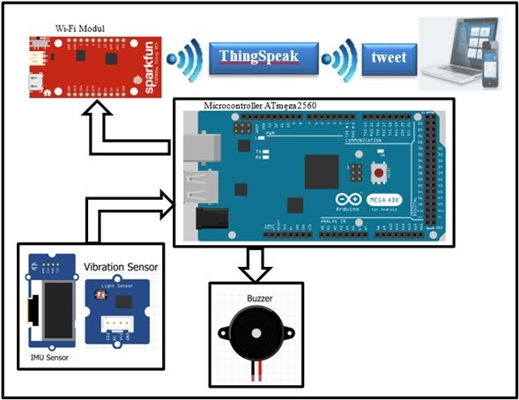
Figure 1-General Diagram of System Developed

Components

4.1 Wi-Fi Module ESP8266- In this research, ESP 8266 Wi-Fi module is utilized. One of the best modules for linking to the internet is this one. Additionally, ESP8266 can function on its own without being linked to a microcontroller or microprocessor. There are numerous variants of this module. The ESP 8266-01 version was the one employed in this research. The most popular and affordable module for small apps where common input/output ports (GPIO) are not as necessary is this one.[9]

4.2 IMU (Inertial Measurement Unit) Sensor- IMU, an accelerometer, and a magnetometer are all part of it. Each sensor typically has two or three specified degrees of freedom (DOF) for the x, y, and z axes. The amount of independent variables in the system is determined by the degree of freedom (DOF). Separate records are maintained for angular velocity from the gyroscope and acceleration values from the accelerometer.

4.3 Vibration sensor card- “Vibration sensor can be used for measurements of flexibility, vibration and contact. The module is based on PZT film sensor. When the sensor moves back and forth, a certain voltage is generated by the voltage mixer in it. Its sensitivity can be adjusted with the potentiometer on it”.[9]

4.4 Arduino Mega Control Card- The open source Arduino microcontroller is a physical programming platform that uses auxiliary parts to perform the most fundamental output applications. On this framework, Processing/Wiring language is employed [16]. A microprocessor card called the Arduino Mega is built on the ATmega2560 processor. The Arduino Mega has 54 digital input/output ports, 14 of which can be used as PWM output. There are four hardware serial interfaces and sixteen analog input pins. (UART). Additionally, the card has a reset button, one ICSP cap, one power input, a USB link, a 16 MHz crystal oscillator, and one reset button.

  - 16 X 2 LCD Display-This is a basic (16x2) 16 character by 2 line display. Black text on green background.

  - Buzzer- Beepers and buzzers are auditory signaling devices.

  - Software used-
4.7.2 THINGS TO SPEAK
    - Arduino 1.6.13 Software
    - Embedded C Language

- Electronic Design
Electronic Design In this section, electronic modules used in the earthquake warning system, their properties and duties are explained. In the design of the earthquake warning system Arduino Mega 2560 control card, Pololu AltIMU5 acceleration and gyro sensor, Piezo vibration sensor, ESP8266 wifi module and buzzer are used. Electronic design of the system is shown in Figure 2.

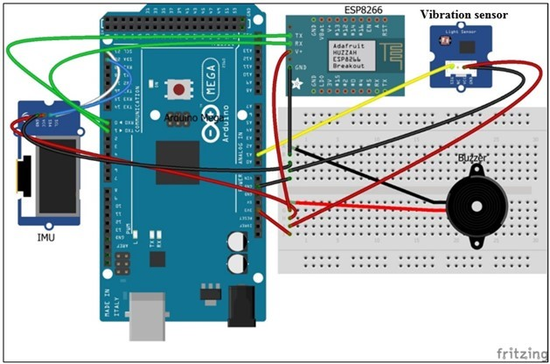

Figure 2: Electronic Design of the system

- Conclusion
There have been numerous studies on earthquake early warning systems, but none of them are flawless. The primary challenge after an earthquake is getting out of it. Providing the best escape route at that moment is crucial. The proposed system centers on a more effective method of earthquake detection, along with alerting DMT and giving residents with safety measures. In this research, an earthquake warning system was created that sends a tweet over Twitter as well as an audible alert when an earthquake occurs. The purpose of an audible warning is to warn nearby residents to take precautions in case of an earthquake. The purpose of a tweet warning is to inform a larger audience about the earthquake's epicenter, beginning, and finish times. Both the IMU and the vibration sensor are used in the developed system to identify earthquakes. This improves the accuracy and precision of seismic detection. The developed earthquake warning system has been observed to function properly as a result of the performed application and tests.

- Future Scope
The architecture proposed in the system will help to detect the earthquake few seconds earlier before it would happen and alert the citizens of the people and suggest them to take precautions to protect themselves from the losses. And also informs nearby disaster management forces to be on high alert and prepare for the consequences.

- Acknowledgment
My sincere gratitude is extended to Assistant Professor Adesh Kumar Mishra, who is leading this excellent project for me and has offered me invaluable guidance and support while I work on this research.
I also want to express my gratitude to Prof. Rafik Ahmed, who oversees the Electrical Engineering Department at the Babu Banarasi Das Institute of Technology and Management in Lucknow. I also want to express my gratitude to all the faculty members in the department.

References

- Mr. Abhishek Hadawale, Mr. Dipesh Gupta, Mr. Nikhil Chauhan, Prof. Sareen Deore , International Research Journal 2of Engineering and Technology (IRJET), Volume: 08, Issue: 04 | Apr 2021
- Mr. Syed Nasrin, Suraya Miskon, Research Paper on Developing the Earthquake Early Warning and Evacuation Systems (EEWES) for Schools, Research Gate , 2022, IOP Conf. Ser.: Earth Environ. Sci. 1103.
- Abdulkadir Karacı ,Samsun University(2019), Research Paper on IOT-Based Earthquake Warning System Development And Evaluation, Research Gate.
- In Japan Earthquake, Early Warnings Helped - IEEE Spectrum , spectrum.ieee.org
- P. Huang et al., "Real-time earthquake monitoring and tsunami warning operations at the U.S. National Tsunami Warning Center," OCEANS 2017 - Anchorage, Anchorage, AK, USA, 2017, pp. 1-6.
- S. -y. LI, J. -q. LU, J. -d. SONG, Q. MA and Z. ZHAO, "Study On New Technology Of Earthquake Early Warning," 2019 13th Symposium on Piezoelectrcity, Acoustic Waves and Device Applications (SPAWDA), Harbin, China, 2019, pp. 1-5, doi: 10.1109/SPAWDA.2019.8681853.

- B. Pirenne, A. Rosenberger, E. Guillemot and R. Jenkyns, "The web-enabled awareness research network (WARN) project early earthquake and tsunami warning at Ocean Networks Canada," 2014 Oceans - St. John's, St. John's, NL, Canada, 2014, pp. 1-7, doi: 10.1109/OCEANS.2014.7003176.
- E. Husni and F. Laumal, "The Development of an Earthquake Early Warning System Using an ADXL335 Accelerometer," 2018 21st Saudi Computer Society National Computer Conference (NCC), Riyadh, Saudi Arabia, 2018, pp. 1-5, doi: 10.1109/NCG.2018.8593038.

- Internet of Things-Based Remote Real Time Monitoring and Safety System for Earthquake and Fire Detection Conference Paper December 2019 Md. Rysul Kibria Badhon, Anadi Ranjan Barai, and Fatematuz Zhora
- IEEE.org

