ADAPTIVE BUILDING ENVELOPE
Shruti Verma

Abstract:
We are facing complex problem of energy consumption of buildings , as it is a cross section of building envelope performance, indoor environmental conditions and user demands and preferences. In order to fulfil the Energy consumption and energy package and beyond, the implementation of high-performance buildings is crucial. Adaptive building envelope solve the part of this problem. It can contribute in increase occupancy comfort and reduce energy consumption. The aim of this research paper is to discuss various strategies used in constructing adaptive building envelopes integrating architectural innovation and improved energy performance, in order to Control the physical environmental factors like heat, light, sounds, as well as improving user comfort. Two case studies are analyzed THE implementation of these strategies on constructing structures with smart material and responsive facade system and study their effects on building energy saving.
Keywords: building automation, building envelope, Indoor environment, Human comfort, Thermal comfort, Smart material, Responsive material.
Methodology
The literature survey will first discuss some terminalogies and phenomenons of high performance facades. After that, the research paper present and analyze existing ideas of adaptive envelopes, explaining an overall understanding of the concept of five adaptive building envelopes. In addition, at the same time develop knowledge of the materials and technique commonly used and how they increase performance. Finally, two case studies are presented to analyze the implementation of the these adaptive envelopes strategies and observe their effects on the building energy savings.
- Introduction
Adaptivity means to explain any change in the surrounding environment and to respond to it. This change is specified by dynamism. Architecture designed for a static set of factors does not certainly ease this adaptability to change. To achieve the high level of climatic response, this pattern has to change. Conventional buildings are constructed to promote dynamic components like solar patterns and wind variation. This generates seperation between the structure and its environment. The adaptive systems should provide better efficiency than static systems and respond dynamically to the changes happen in climatic conditions. In the highrise buildings, lack of thermal comfort and low efficiencies of HVAC systems takes place and leads to large consumption of energy.
Analyzing the effect of compromized management of shading blinds and natural ventilation on the performance of the buildings in means of energy savings and user comfort. A high-performance envelope that combine proper daylighting, shading and natural ventilation systems, has the possibility to decrease the energy used by building operations. Building skin creates a noteworthy component of a building aesthetic and visual effect , it can be vital factor that motivate architects, clients and other stakeholders to settle for this type of high performance envelopes. To achieve these goals, standards should take place at the same time as designing stage to achieve high building performance.
- Human comfort
We construct buildings to provide ourselves with a comfortable and healthy environment in which we can do well, work or relax. Building we create should have less severe indoor environment than the outdoor environment. Buildings should keep out strong winds and excessive solar radiation and keep a comfortable indoor environment and provide us with fresh air. They required to provide comfortable space as desired by the occupants. As we spend more and more of our time inside, interior human comfort have become tougher and tougher. Human comfort is depending of a number of factors:
• Thermal comfort
• Illumination
• Air quality
• Sound quality
• Sanitation
- Thermal comfort
Building envelope influenced the thermal performance or thermal comfort of a buiding. A study to improve building performance is continuously run to find design strategies for comfortable buildings in a particular place. Thermal comfort can differ by individual, someone might find to be a perfect temperature or thermal comfort could be experienced as too cold or too warm for some other person else.
- Phenomena
In order to be able to design an adaptive behaviour in for example a wall or a roof of a building one need to be aware of and understand the different phenomena that affects the building element and the materials that it is made out of. This knowledge can then be used to design building elements or entire buildings that respond to the surrounding.
- Heat transfer
- Moisture transfer
- Responses in materials

- Material and Innovations
  - Metallic Brise Soliel with Resizable Lenses
Arab World Institute
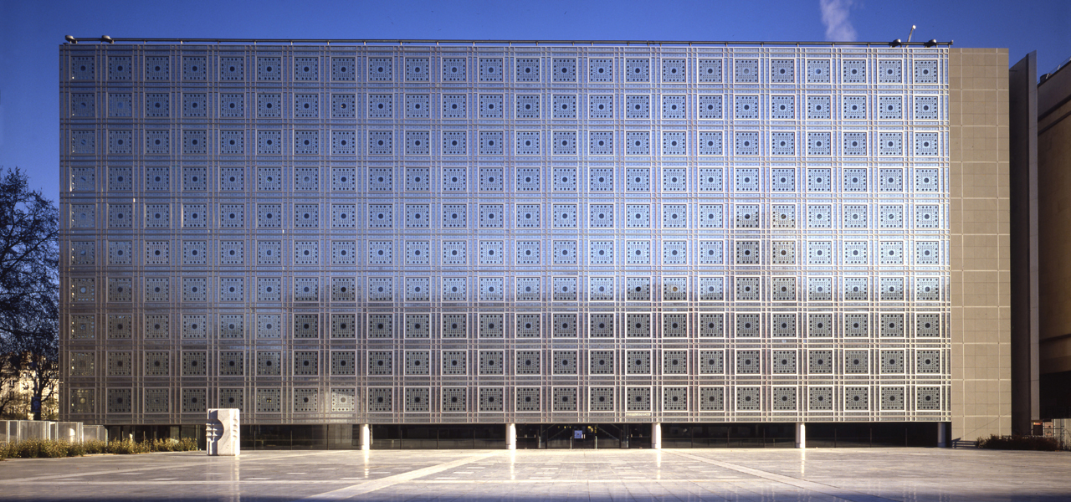
Fig -1: South Façade.
The adaptive envelope encounter a relevant and high-yielding source of research for decades. This building of Arab World Institute ,which is completed in 1987 attribute an impressively patterned façade on its south side. The outer side of south façade is glazed. Each glazed unit works mechanically and react to the amount of sunlight. Smaller units are arranged neatly around centered large opening . Each unit is connected to a central computer control, are equipped with photoelectric cells and resizable aperture.
This façade system Consist 200 units which acts as a mechanical screen which controls the amount of natural light coming inside through the façade within the units. with maximum of 18 movements per day. This system allow less light inside when receiving a large amount of sunlight and so on. The building envelope adapts to help avoid overheating while leaving a rhythmic trace of light, balance internal illumination.
  - Retractable Shading, Cooled Conservatories
Gardens by the Bays Greenhouse Singapore, 2012
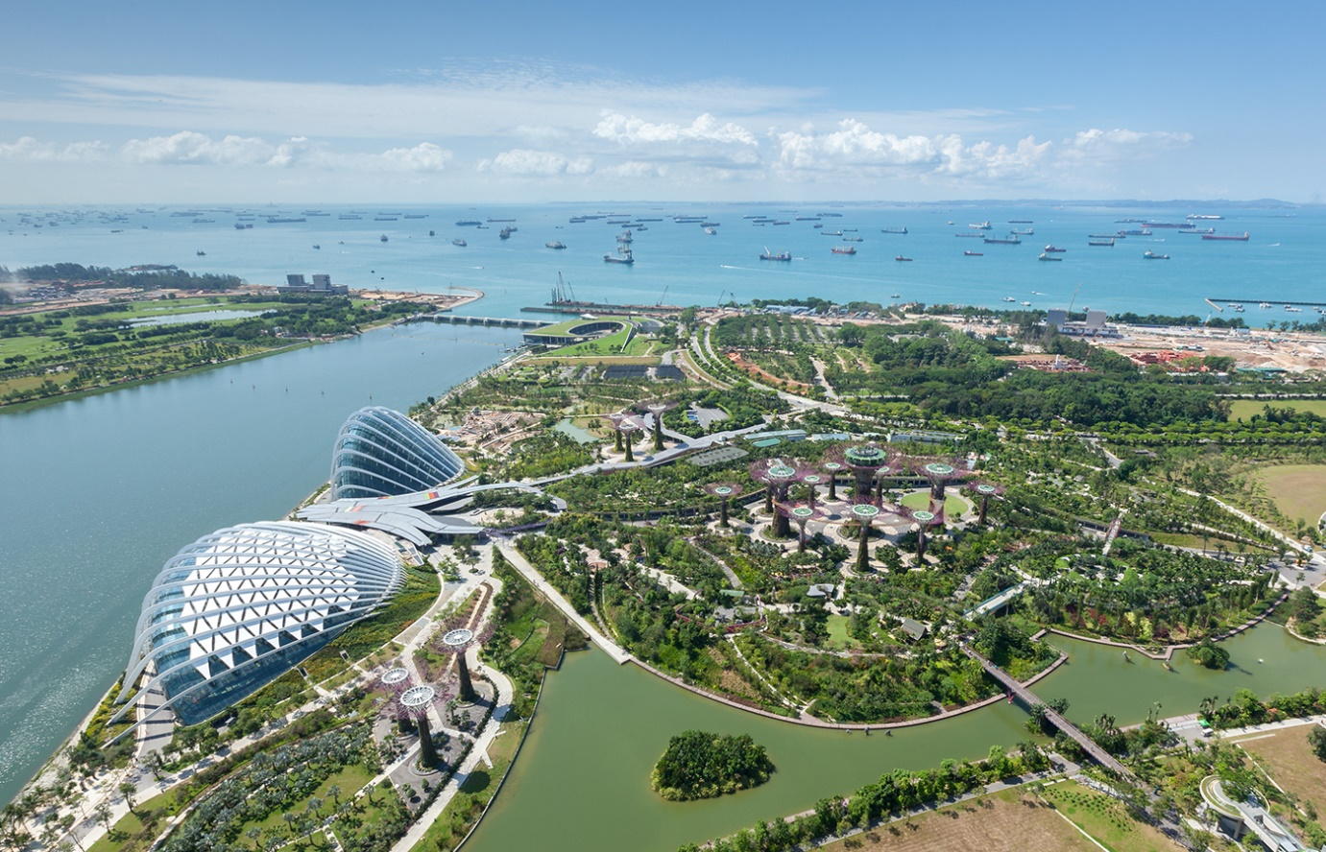
Fig -2: Aerial view of Gardens by the Bay.
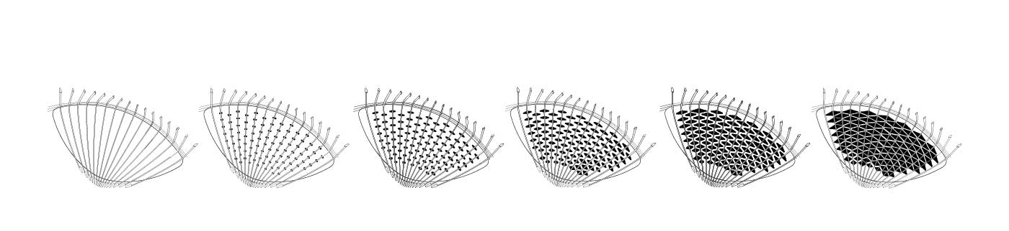
Fig -3: Possible coverages of the shading system.
The two conservatories at Gardens by the Bays recruit an adaptive shading system as well to help its microclimate control on much larger scale than IMA. Singapore has tropical climate, the design needs to provide a cooler internal environment so that the conservatories accommodate plants from both tropical and temperate climatic zones. The design employs multiple strategies like retractable shading system to reduce energy consumption on air conditioning.
A series of white steel ribs outside the Low-E glazing perform structurally while also holding the shades. The shades are kept hidden and rolled when the temperatures inside are still within the optimal range. These hidden shade system are taken out using motors to the desirable length forming a shading coverage customized for different the climatic condition of the time. The adaptive shading system contributes to the comfort of both user and visitors by avoiding excess solar exposure and glare which is the main source of overheating.
  - Rotating Solar Façade
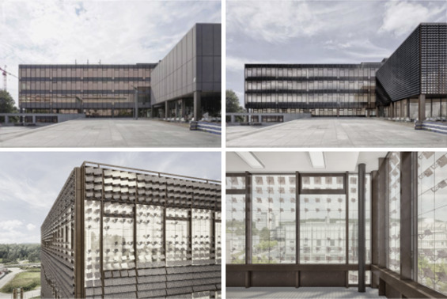
Fig -4: Visualization of the ASF applied as a retrofit
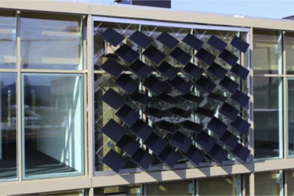
Fig-5: prototype of the ASF
The previous two projects works on motorized system which makes the projects energy efficient but required energy supply for the envelope system to function. This adaptive solar façade research present user a possible approach of façade itself can supply the energy it needs to function.
The shades consist of photovoltaic cells supported individually by soft aerial actuators that support the Photovoltaic cells with +45 degree rotation. The applied solar tracker help cell to orientate by themselves while reference sun positions at the same time. It has customizable size, shape and pattern to achieve better shading and energy performance while line up the modules with the aesthetics of the building.
  - Humidity-Reactive Bamboo Veneer as Façade Material
Manal Anis, The Pennsylvania State University, 2019
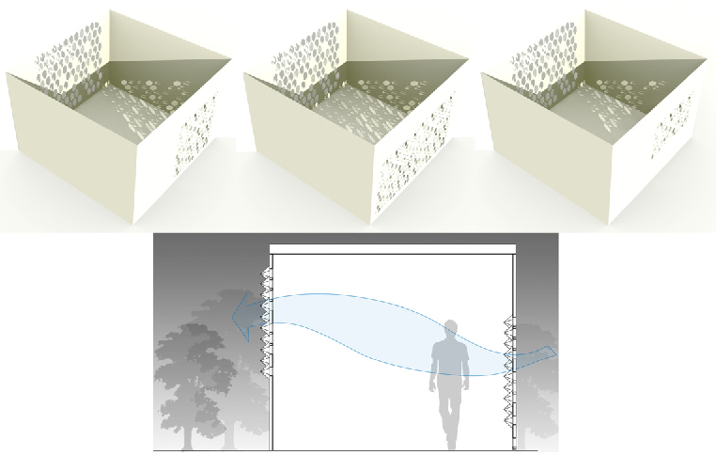
Fig -6: Possible scale of the bamboo veneer façade system. Bamboo as hygroscopically active material for warm-humid climate.
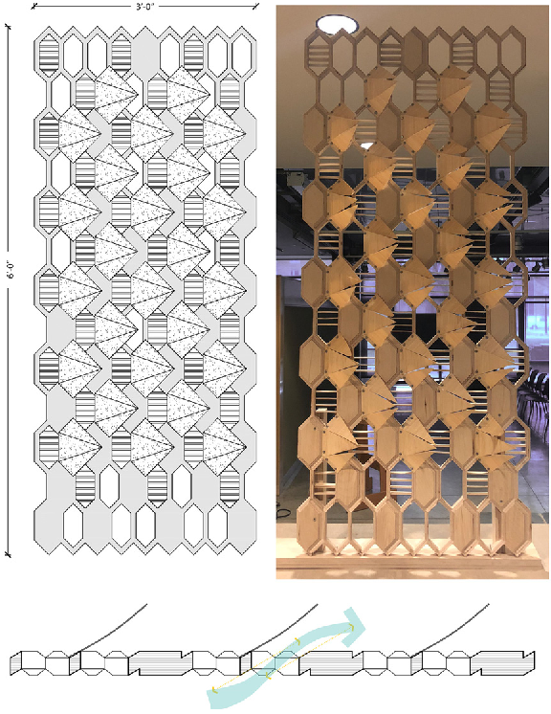
Fig -7: This is a prototype of the bamboo veneer façade system.
Bamboo as hygroscopically active material for warm-humid climate is part of the research by Manal Anis utilizes the nature of bamboo to construct façade prototypes with bamboo veneers . These veneers bend naturally when the humidity level rises create ventilation.
The nature of bamboo expanding with increasing moisture which is attached on one side of the veneer exposed, resulting in the veneer bending towards the other drier side. The veneers react to the environment and required no energy supply at all. The veneers are bonded with cellulose films, which are non-reactive to humidity. These bonds turn up the moisture level difference between two sides of the veneer and hence amplifying the bending effect. Cellulose also helps veneers return to their original forms.

- Case studies
  - The Barcelona Media-ICT building ( applying smart material)
Criteria of selection: This case study focus to control solar heat gain and enhance the indoor environment quality through adaptive building façade. This façade enhances performance of the building by using smart materials.
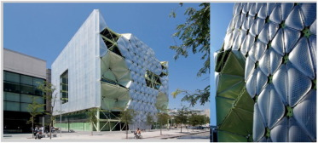
Fig -8: Media-ICT building in Barcelona.
Location: Barcelona
Principal Architect: Enric Ruiz Geli, Cloud 9
Building Type: Cultural Center
Date of completion: 2011
Adaptive System: Smart Material
The envelope is usisng pillow cladding system with polymer ETFE with pneumatic mechanized encased lamellafins which automatically triggered through light sensors when exposed to sunlight .
-ETFE (Ethylene Tetrafluoroethylene) Polymer
A translucent polymer sheeting applied as an alternative to glass and hard plastic in some new structures. In comparison to glass, ETFE permit more sunlight, has greater insulation, it costs less to construct from 24 percent to 70 percent, it weight 1/100 the weight of glass and has characteristics that makes it more flexible as a construction material.
The ETFE layer is triggered by pneumatic mechanisms as illustrated in with light meter sensors which based on the presence of sunlight, it automatically and independently actuate inflation and deflation equipment in the air chambers. In terms of energy production the light meters are independent. The cladding consist of two layers of substance on the facade that exposed to much sunlight. Those layers are automatically inflated using sensors to create 3 empty chambers. The first layer of ETFE is transparent and the second layers have a reverse pattern design which, made the façade transparent or opaque when inflated or deflated. During sunlight time, this keeps the penetration of light and heat away. This is ETFE Diaphragm system which can adjust the penetration of air through the facade, with suitable goals in terms of energy efficiency.
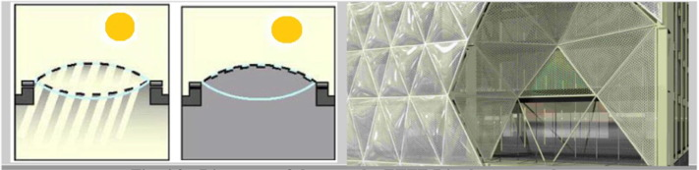
Fig -9: Diagrams of the way the ETFE Diaphragm
Observations and results
The user does not have the ability to adjust any changes made by the system. Occupants does not need to contribute to the system.
By using 2600 m2 of ETFE material, the MEDIA-TIC building generates 20% less in energy consumption and achieves a score of 43 points of the maximum 58 points predicted by the decree on environmental standard and energy efficiency for buildings. This decreases the solar factor by four times, from 0.45.
  - Al Bahar towers by Aedas (responsive facade system in adaptive building envelope)
Criteria of selection: This case study is used to embellish the execution of Responsive facade system in an adaptive building envelopes. This system control solar heat gain through the facade and enhance the indoor environmental quality .
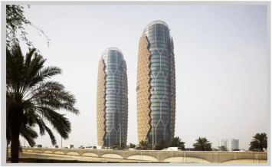
Fig -10: Al Bahar Towers by Aedas.
Location: Abu Dhabi, UAE
Architects: Aedas
Type: Office building
Adaptive System: Responsive facade system.
This initiative shading screen of the towers is managed by computer . It is positioned 2 m away from the external façade of the structure in its own additional frame an work as a curtain wall for the building . Each triangle is enclosed in micro-perforated glass which automatically respond and adjust to the motion of sun movement , thus decreasing the solar gain and glare.
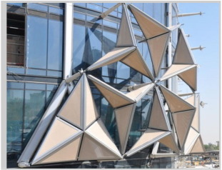
Fig -11: Shading device in Al Bahar Towers.
1000 individual shading devices are used in each tower. Each unit open and closes regularly every day with chain of extended PTFE panels, in accordance to a sequence programmed and calculated to block direct sunlight which is exposed to facade. These new limits have resulted in higher architectural and engineering collaboration with the disciplines of mechanical and electrical engineering.
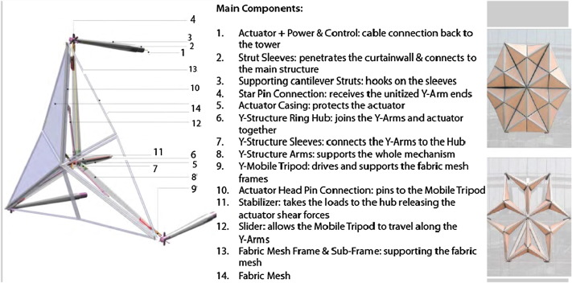
Fig -12: Detail diagram of an individual shading device
Observations and results
More than 45 percent of solar gain are restrained by these screens which result in decreasing the usage of air conditioning. In addition, its capability to filter and reduce the direct solar gain to a maximum of 300 W per linear meter has provided the designers to be more specific in choosing the type of glass. They have using tinted glass which permit more natural sunlight and decrease the need for artificial lighting.
- Conclusion
Todays buildings are adapting to high performance buildings to reach the expected level of energy performance. This adaptive building envelope is necessery in architecture increasing as :
- The adaptive building envelope utilize existing natural features and control solar heat gain through the facade and enhance the indoor environmental quality.
- The photovoltaic system is future of high performance building and the costs could be decreased in the coming days.
- The future planning and designing of high-performance buildings is supposed to require active façade technologies, providing comfortable indoor environments with decreased energy use.
Refernces
- https://www.sciencedirect.com/science/article/pii/S1110016818302230#:~:text=These%20envelopes%20are%20described%20as,can%20enhance%20the%20occupants'%20comfort
- https://www.intechopen.com/chapters/52178
- https://architizer.com/blog/inspiration/stories/adaptive-envelopes-energy-efficient-facades/
- https://encyclopedia.pub/entry/19809

