DEVELOPMENT AND FABRICATION OF REGENERATIVE ELECTRIC BICYCLE
Siddartha R Kattimani1, Arjun Ashok S2, Prajwal P3, Vivek K R4, Vijaya G5
¹²³⁴UG Students, Department of Mechanical Engineering, DSATM, Bengaluru, Karnataka, India
⁵Asst. Professor, Department of Mechanical Engineering, DSATM, Bengaluru, Karnataka, India

Abstract: An e-bike, or electric bicycle, is a bicycle that is propelled by an electric motor. A number of stages and factors would need to be taken into account when designing and making an electric bicycle with an auto-recharging system. First, the desired power output and range of the e-bike would need to be taken into consideration when choosing the design of the electric motor and battery system. The bicycle's existing frame would need to accommodate the engine and batteries, which might call for some special manufacturing. The auto-recharging mechanism's design, which connects a dynamo to a motor via a belt drive system, would then need to be created. This might entail adding a generator to the e-bike's powertrain so that it can recharge the battery while the vehicle is moving, After the design is finished, the e-bike would need to be constructed using the proper tools and methods. The frame would probably need to be welded, the battery and motor installed, and all the electrical components connected. The electric bike would be put through testing and fine-tuning to make sure everything is operating as it should. The motor, battery, and regenerative braking system would all be controlled by a computerized control system. Finally, safety measures like a safety key to prevent unauthorized access, short-circuit protection, and overcharge protection would be put in place. This is a synopsis of the design and construction of an automatic-recharging electric bicycle. The actual procedure would probably be more difficult and depend on the particular design and materials employed.
Key words: innovative, regenerating, battery, MPPT kit, lithium-ion battery, performance

- Introduction:
Due to their environmental friendliness, low price, and simple maintenance, electric bicycles have grown in popularity over the past several years. But one of the main drawbacks of electric bikes is the necessity of routine battery recharges, which can be inconvenient for riders. The design and construction of an electric bicycle with an auto-recharging system that can recharge the battery while the bicycle is in use is suggested as a solution to this problem. In order to recharge the battery, the auto-recharging system will be built to capture the kinetic energy produced by the moving bicycle and transform it into electrical energy. [1]
To ensure that the bicycle can be used for long distances without having to be frequently recharged, the battery will be built to have a high capacity and quick charging time. A display that shows the battery level, distance travelled, speed, and other pertinent data will also be installed on the bicycle. The display will be simple to read and placed so that it doesn't obstruct the rider's view of the road. Additionally, the bicycle will be equipped with lights so that it can be seen at night or in dimly lit areas. To ensure that the auto recharging mechanism is safe and reliable by MPPT device, the bicycle will be designed with safety features such as a drum braking system and a sturdy frame that can withstand the stresses associated with cycling. The auto-recharging mechanism will be tested extensively to ensure that it can recharge the battery effectively without compromising the safety or performance of the bicycle. [2]
- Methodology:
2.1 Designing the electric bicycle:
Choosing the specifications for the bike, such as its range, speed, and load capacity, is the first step in creating an electric bicycle. A design that satisfies the demands can be created after the requirements are known. As part of this, the frame must be designed, the motor, batteries, and other parts must be chosen, and the control scheme must be decided. [3]
2.2 Developing the auto-recharging mechanism:
The dynamo is integrated into the bike's frame as part of the auto-recharging system. While riding the bike, the dynamo will produce electricity, which will be stored in the batteries. A charging controller (MTTP) is another component of the system that will oversee charging and prevent overcharging of the batteries. [4]
- Working Principle:
An inventive idea that combines the convenience of an electronic bike with the sustainability of a human-powered one is an electric bike with an automatic charging mechanism that uses a dynamo. The mechanism works by converting the rotational energy produced by the bicycle's motion into power for a dynamo, which in turn powers a generator that charges the battery. A dynamo, a rectifier, a regulator, and a rechargeable battery are all components of the system. An AC voltage is produced by the dynamo, which is installed on the bicycle's wheel. Rectifiers change AC voltage into DC, which is then adjusted to the proper battery voltage level. When necessary, the electric motor is powered by the energy stored in the rechargeable battery. The dynamo spins as the bike moves, producing electricity. This power is transformed into direct current by the rectifier, which the regulator ensures is at the right voltage to charge the battery. As a result, there is no need for any external charging sources because the battery charges while the bike is in use. There are many advantages to using this auto-recharging system. It can increase the bike's range and lessen the requirement for external charging, making it more convenient to use. In addition, it encourages the use of sustainable energy by capturing the energy generated during routine use. The process lessens reliance on external infrastructure for charging, making it a workable solution in places with poor access to electricity. Overall, an auto-recharging electric bicycle powered by a dynamo is a novel idea that combines convenience and sustainability. It is a great option for individuals seeking for a more ecologically responsible means of transportation because it has the potential to increase the bike's range and promote sustainable energy usage. [5]
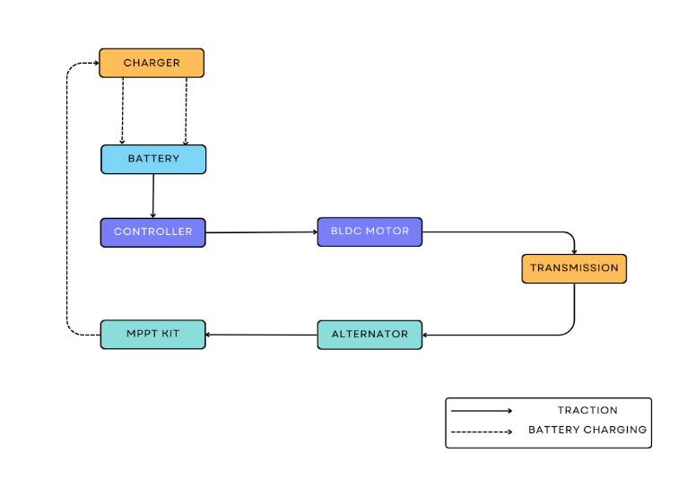fig.1: Block Diagram of the working process
As a result, we are turning to new sources of energy, such as electric power The self-charging E-Bicycle is a self-chargeable electric cycle that charges itself while running using dynamo. The dynamo is a device that generates electric power.
- Components:
The following are the components used to setup the regenerative system:
4.1 Battery management system:
An electronic regulator called a battery management system (BMS) keeps track of and regulates how rechargeable batteries are charged and discharged.
Most gadgets that employ rechargeable batteries use several sorts of battery management systems. They are also typical of datacenters, where servers are kept online by UPSs (uninterruptible power supplies). Everyday portable gadgets like cellphones and MP3 players, as well as cars, especially electric ones, come standard with battery management systems. The electronics used in battery management systems may be as basic as measuring voltage and stopping the charging process when the target voltage is attained. At that moment, they might stop the power flow; if the situation became abnormal or dangerous, they might then sound an alarm. A more sophisticated BMS keeps track of numerous variables that affect battery performance and longevity in addition to assuring operational safety. They might keep an eye on single- or multiple-cell battery systems. Individual cell conditions can be monitored and managed via multi-cell systems. For more sophisticated monitoring, logging, email alerts, and other purposes, some devices connect to computers. [6]
Factors monitored and controlled by battery management systems include:
- Main power voltage.
- Battery or cell voltage.
- Charging and discharge rates.
- Temperatures of the batteries or cells.
- Coolant temperature and flow for air or liquid cooling.
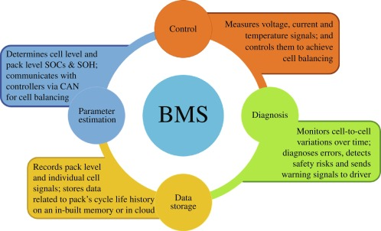fig.2: Block diagram of BMS
4.2 Wiring:
All of the electrical components of an e-bike are connected by a controller. It connects numerous sensors, the battery, the motor, the throttle, the display, and other components. The brain of the electric bike is a tiny computer. It can control how the bike works in its entirety.
The following wiring instructions given in the figure below:
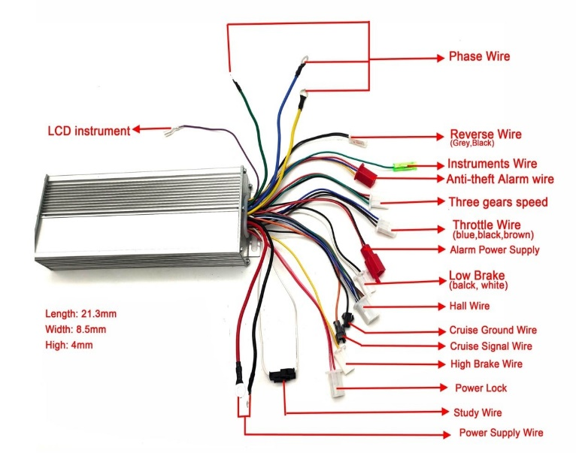
fig.3: Controller wiring instruction
And thus, wiring is carried to further devices like throttle, brakes, speed regulator, BLDC motor etc from the controller.
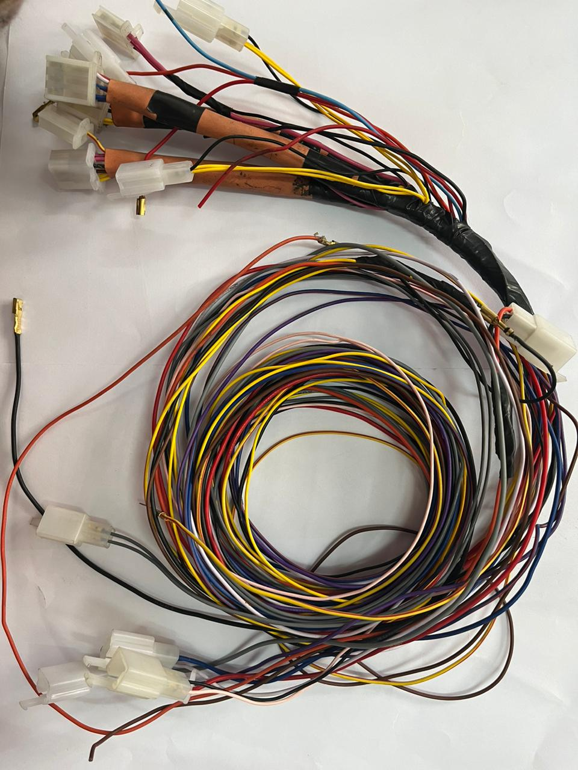
fig 4: wiring kit
4.3 Drum brake:
A brake drum is a revolving cylinder-shaped component that presses outwardly on a set of shoes or pads to create friction.
The term "drum brake" typically refers to a braking system in which shoes press against the drum's interior surface. It is commonly referred to as a clasp brake when shoes press against the drum's exterior. Though such brakes are relatively uncommon, they are sometimes referred to as pinch drum brakes when the drum is pinched between two shoes, much like a traditional disc brake. A band brake, a related design, wraps a flexible belt or "band" around the outside of a drum.
In small and compact class cars, the rear axle is where drum brakes are most frequently employed.
When the driver presses the brake pedal, the brake booster (servo system) amplifies the force and the master cylinder converts it into hydraulic pressure (oil pressure). Through tubing containing brake oil (brake fluid), pressure is delivered to the brakes on the wheels. The pistons on the four-wheel brakes are pushed by the pressure that is applied. The brake linings, which are friction materials, are pressed by the pistons onto the interior surfaces of the brake drums, which revolve with the wheels. The linings are forced onto the rotating drums, which causes the wheels to slow down and eventually come to a stop. [7]
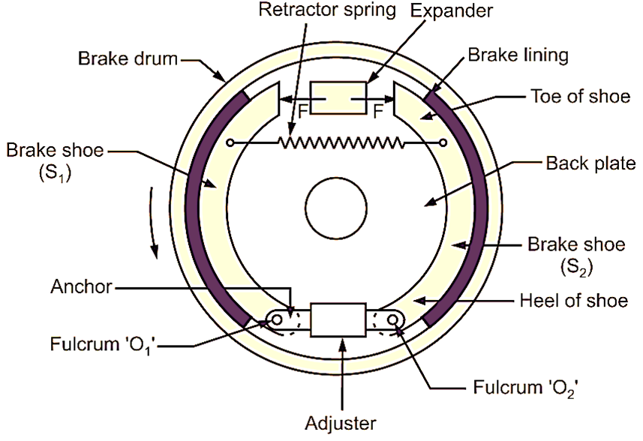
fig.5 : Drum brake

4.4 DC to DC convertor:
A DC-to-DC converter is a circuit or electromechanical device that changes the voltage level of a direct current (DC) source. It's a particular kind of electric power converter. Low-voltage batteries have very low levels of power, while high-voltage
1/7 power transmission has very high levels of power. Several hundred volts of Direct Current (DC) are frequently produced by the batteries of a Battery Electric Vehicle (BEV). However, the voltage requirements of the electric parts inside the car vary, with the majority using a much lower voltage. The radio, dashboard gauges, air conditioning, and built-in computers and displays are all examples of this. A type of power converter known as a DC-to-DC converter changes the voltage level of a DC source. It can be either unidirectional, which only sends power in one direction, or bidirectional, which can do both. A DCDC converter is also a crucial part of a BEV's architecture since it is used to switch power from a high voltage (HV) bus to a 12V low voltage (LV) bus so that the LV battery can be charged and the onboard electric devices can be powered. [8]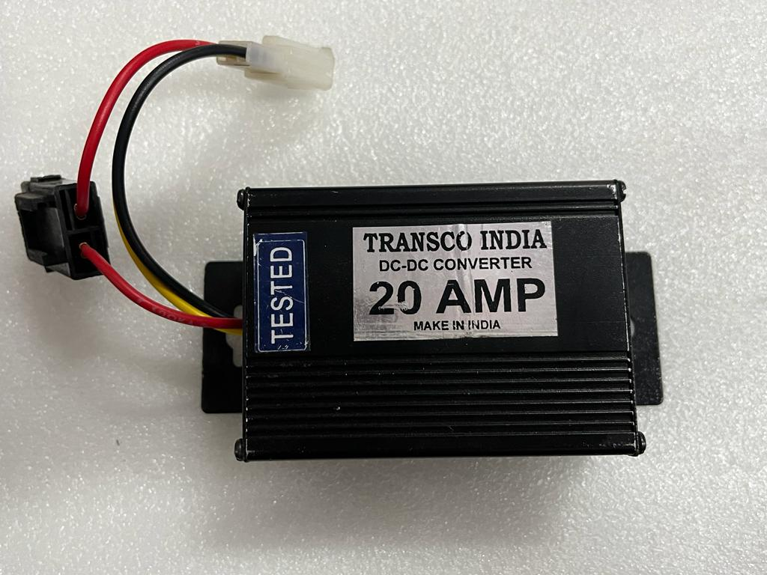
fig.6: DC-DC Converter
4.5 Battery:
The average single battery on the market has a voltage of about 3.7 volts, but frequently the operational voltage range is a little wider and there is obviously a voltage issue. Now that battery packs and modular batteries are available to enhance battery voltage, 48v lithium-ion batteries are frequently employed in high voltage batteries.
The advantages of 48V lithium-ion batteries over lead-acid batteries are their small size, light weight, high charging and discharging efficiency, safety and stability, extended service life, energy savings, and environmental protection. [10]
Depending on the cathode material, 48V lithium-ion batteries can be classified as ternary lithium batteries, lithium iron phosphate batteries, or lithium titanate batteries.
Price of a single lithium battery cell: x (3.2–3.7V * n = 48v) * m (the number of parallel cells) + shell + supplementary material + price of the protection plate The price of a single lithium cell will vary depending on the various materials and production techniques utilised by lithium battery manufacturers, which generally range from 3.2 to 3.7V. [9]
The battery has the following measurements: 23cm*16cm*18cm.
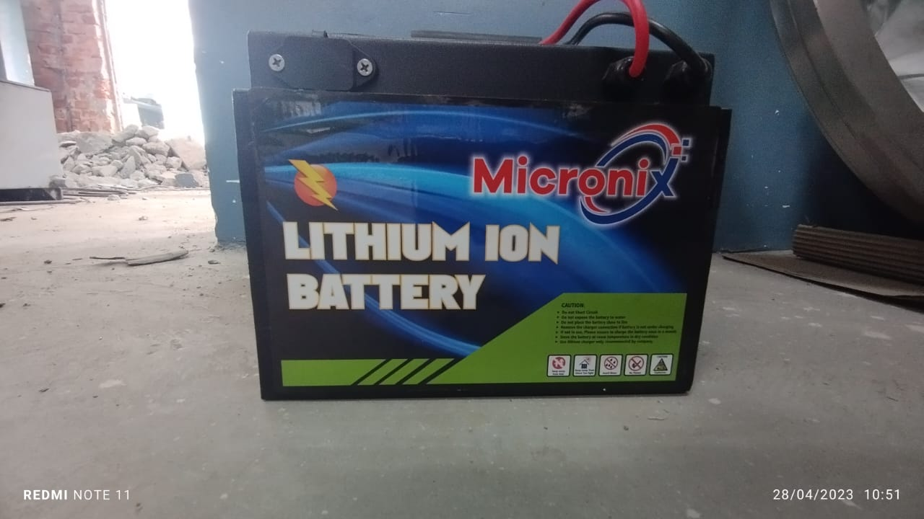
fig.7: Battery (48v)

- Thermal Management:
One of the main issues in the thermal management of electric vehicles is thought to be electric motors. Electric motor heat generation is crucial because excessive heat might harm the motor's insulation, magnets, or bearings. The safety and effectiveness of electric cars will therefore be greatly enhanced by proper thermal control. The majority of EVs nowadays use lithium-ion batteries. The energy density of lithium-ion batteries is great, and they have a long lifespan. Despite their increasing power, these batteries can still have some serious drawbacks. In the worst case situation, thermal runaway can seriously harm the product and possibly injure consumers if overheating of the battery is not appropriately controlled. Many EV companies have documented instances where an unchecked thermal runaway led to a vehicle fire. To solve the thermal problems with electric batteries, motors, and power electronics, thermal management is therefore crucial.
Thermal control increases EV battery life and enhances performance. Thus, to reduce the temperature of EV batteries, researchers created a variety of battery thermal management systems (BTMS). Forced air cooling, conductive packaging, gap pads, thermal grease, and phase change materials (PCMs) have all been investigated as methods. [11]
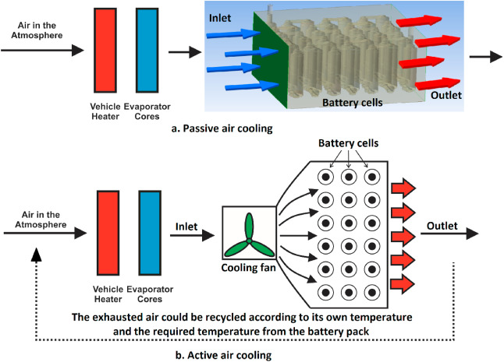
fig.8: Thermal management system
- Charging:
Our theory states that there are two methods to charge a battery: either through an alternator or a charger.
A 54.6V 10amp charger is used to charge a 48V 31.2Ah lithium-ion battery. The battery can be fully charged from 0% to 100% in 3 hours.
Because the alternator and solar panel system function as a regenerative unit, the battery can be recharged while the car is moving.[12]
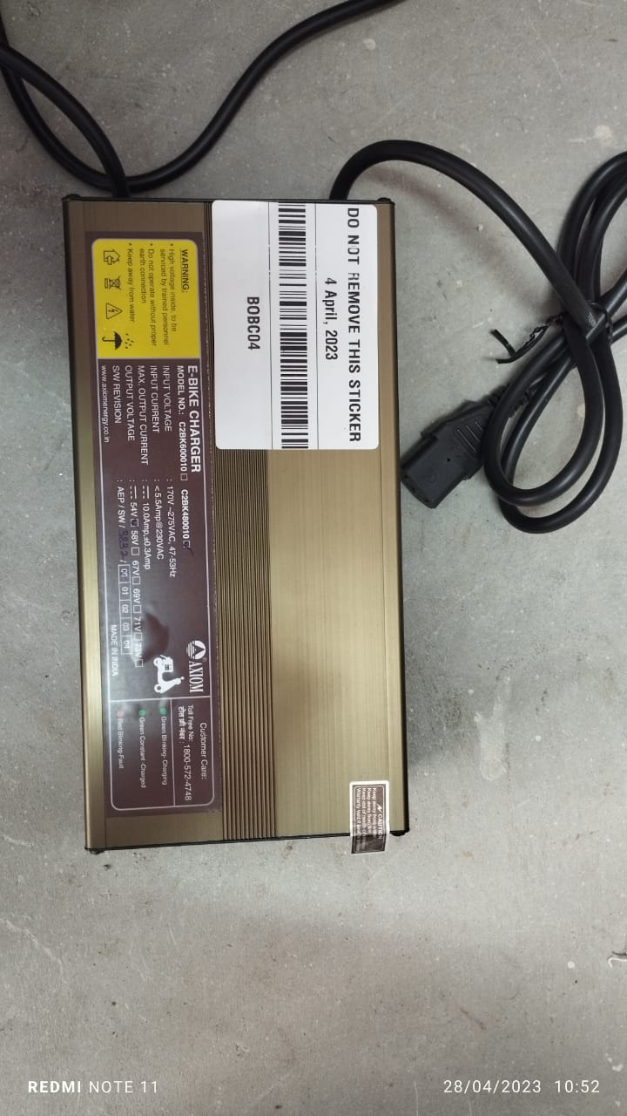
fig.9: Charger
- Result and Discussions:
- As a testing ground, we employ the design we created for an EV's regenerative system in the section above. The author of this study would significantly enhance the results for the following parameters:
- Enhanced Charge Range The electric bicycle, which is growing in popularity locally, has a shorter range of travel between 50 to 70 kilometres per charge. Because a regenerative framework is part of our plan, we can achieve a maximum range of 80 km per charge.
• Shorter charging times Right now, I'm using an alternator as an optional power source, which means that when the bike is moving from one location to the next, the alternator will be connected and will be able to charge the battery.
By doing so, we might claim that the charging time has decreased because one battery will release and another will charge during the hour of operation.
- Conclusion:
• It is clear that all automobile manufacturers are switching from conventional internal combustion (IC) engines to electric ones. However, the real issue with electric motors is how to charge the batteries. Since the battery charges while the car is running, the current study offers a solution to this issue.
• It meets the demands of the economically disadvantaged segment of society and is ideally suited for both young and old. The fact that this bicycle saves money by not using expensive fossil fuels is its most significant feature.
• Because it produces no emissions, it is environmentally friendly and pollution-free. Additionally, it is silent and can be recharged in an emergency and in inclement weather using an AC adapter. the regular reporting on the fossil fuel shortage. Making self-charging electric bicycles with this in mind. With the aid of the dynamo, it will generate electricity, power the car, and lessen reliance on fossil fuel.
- Reference:
- MacArthur, J.; Dill, J.; Person, M. Electric bikes in North America: Results of an online survey. Transp. Res.Rec. J. Transp. Res. Board 2014, 123–130.
- Pucher, J.; Peng, Z.R.; Mittal, N.; Zhu, Y.; Korattyswaroopam, N. Urban transport trends and policies in China and India: Impacts of rapid economic growth. Transp. Rev. 2007,27, 379–410.
3. Cherry, C.; Cervero, R. Use characteristics and mode choice behaviour of electric bike users in China.Transp. Policy 2007,14, 247–257.
4. Fishman, E.; Cherry, C. E-bikes in the Mainstream: Reviewing a decade of research.7291.
5. Weinert, J.; Ma, C.; Yang, X.; Cherry, C. Electric two-wheelers in China: Effect on travel behaviour, mode shift, and user safety perceptions in a medium-sized city. Transp. Res. Rec. J. Transp. Res. Board, 62–68.
6. Hatwar, N.; Bisen, A.; Dodke, H.; Junghare, A.; Khanapurkar, M. Design approach for electric bikes using battery and super capacitor for performance improvement. In Proceedings of the 16th International IEEEConference on Intelligent Transportation Systems-(ITSC), The Hague, The Netherlands, 6–9 October 2013; pp. 1959–1964.
7. Thomas, D.; Klonari, V.; Vallée, F.; Ioakimidis, C.S. Implementation of an e-bike sharing system: The effect on low voltage network using PV and smart charging stations. In Proceedings of the International Conference on Renewable Energy Research and Applications (ICRERA), Palermo, Italy, 22–25 November 2015; pp. 572–577.
8. Joumard, R.; Jost, P.; Hickman, J.; Hassel, D. Hot passenger car emissions modelling as a function of instantaneous speed and acceleration. Sci. Total Environ. 1995,169, 167–174.
9. Peine, A.; van Cooten, V.; Neven, L. Rejuvenating design: Bikes, batteries, and older adopters in the diffusion of e-bikes. Sci. Technol. Hum. Values 2017,42, 429–459.
10. Parker, A.A.; Alan, A. The Electric Power Assisted Bicycle: A Clean Vehicle to Reduce Oil Dependence and Enhance the Mobility of the Elderly. In Proceedings of the International Conference on Sustainability Engineering and Science, Auckland, New Zealand, 6–9 July 2004. Available online: http://www.thesustainabilitysociety.org.nz/conference/2004/Session5/43%20Parker.pdf (accessed on 15 June 2018).
11. Mercat, J.P. Driving Wheel for a Bicycle or the Like, including a Sensor for Measuring the Transmitted Torque, and a Bicycle Equipped with Such a Wheel. U.S. Patent 4,966,380, 30 October 1990.
12. Kumar, B.; Oman, H. Power control for battery-electric bicycles. In Proceedings of the IEEE in Aerospace and Electronics Conference (NAECON 1993), Dayton, OH, USA, 24–28 May 1993; pp. 428–434.

