ANALYSIS AND SIMULATION OF POROUS ABSORBER BY USING COMSOL SOFTWARE

NANDHINI S^{A}, AVANTHIKA R^{B}, SHNEKA K^{C}, KOWSALYA S^{D}

GUIDED BY DR. R. MANIKANDAN (B.Tech,M.tech,Ph.D,Msc,MBA,FICS,AMIE,MISTE)

DEPARTMENT OF CHEMICAL ENGINEERING,
VSB ENGINEERING COLLEGE(AN AUTONOMOUS INSTITUTION),

KARUR - 639 111, TAMIL NADU, INDIA.

ABSTRACT

The analysis and simulation of porous absorbers using COMSOL Multiphysics software is a powerful tool for predicting the acoustic performance of these materials. Porous absorbers are widely used in various industries, including automotive, aerospace, and architectural acoustics. This study presents an abstract that focuses on the simulation and analysis of porous absorbers using COMSOL Multiphysics. The main objective of this research is to investigate the effect of various parameters on the acoustic performance of porous absorbers, Sound pressure level, Scattered acoustic pressure, Incident acoustic pressure, Point pressure, Normal Impedance, Absorption Coefficient. The COMSOL software will be used to simulate the acoustic behavior of porous absorbers, and the results will be compared with experimental measurements to validate the accuracy of the simulation. The study aims to provide a better understanding of the acoustic properties of porous absorbers, and the simulation results could be used for optimizing the design of porous absorbers for specific applications.
Keywords: porous absorber, analysis and simulation, acoustic properties, comsol software.

INTRODUCTION

An absorber is a device or material that absorbs or attenuates a specific type of energy or radiation, such as sound, light, or electromagnetic waves. In the field of acoustics, an absorber is a material that is designed to reduce the reflection of sound waves and to absorb sound energy[1]. Absorbers are widely used in various industries, including automotive, aerospace, architectural acoustics, and industrial noise control.

COMSOL Multiphysics is a software tool that enables engineers and scientists to simulate and analyze physical systems in a multiphysics environment. The software provides a comprehensive platform for modeling and simulating physical phenomena involving multiple physical processes such as structural mechanics, electromagnetics, fluid dynamics, and chemical reaction[2]. The COMSOL software uses finite element analysis (FEA) to solve complex multiphysics problems. It allows users to create and solve numerical models that simulate physical systems using various physics-based modules. COMSOL also provides a graphical user interface that enables users to build models quickly and efficiently without needing to write code[2].

METHODS AND MATERIALS

The following physics and studies are used in the COMSOL to predict the required analysis.

Physics :
COMSOL software is a multiphysics simulation tool that enables users to solve complex physics problems using numerical methods. Physics is at the core of COMSOL's capabilities, as the software provides a range of physics modeling tools to simulate a wide variety of physical phenomena.
Pressure Acoustic, Frequency domain :
The Pressure Acoustics, Frequency Domain interface is used to compute the pressure variation for the propagation of acoustic waves in fluids at quiescent background conditions. It is suited for all frequency-domain simulations with harmonic variations of the pressure field. The physics interface can be used for linear acoustics described by a scalar pressure variable. It includes domain conditions to model losses in a homogenized way, so-called fluid models for porous materials, as well as losses in narrow regions. Domain features also include background incident acoustic fields, as well as domain monopole and dipole sources. The plane wave attenuation behavior of the acoustic waves may be entered as a user-defined quantity, or defined to be bulk viscous and thermal losses[2].
Study :
In COMSOL software, a study refers to a simulation scenario that defines the geometry, physics, mesh, and numerical settings for solving a specific problem. A study is a way to organize and manage the simulation process in COMSOL, as it allows users to set up, solve, and post-process simulations in a structured manner.

Frequency Domain :
The Frequency Domain study is used to compute the response of a linear or linearized model subjected to harmonic excitation for one or several frequencies[2].
Examples:
In solid mechanics, it is used to compute the frequency response of a mechanical structure with respect to particular load distributions and frequencies. For quasistatic formulations in electromagnetics, it is used, for example, to compute the impedance versus frequency. For acoustics and electromagnetic wave propagation, it is used to compute the transmission and reflection versus frequency. A Frequency Domain study accounts for the effects of all eigenmodes that are properly resolved by the mesh and how they couple with the applied loads or excitations[2]. The output of a Frequency Domain study is typically displayed as a transfer function, for example, magnitude or phase of deformation, sound pressure, impedance, or scattering parameters versus frequency.
Materials :
A Porous Absorber is a type of acoustic absorber that is designed to reduce sound reflections and echoes in a room or enclosed space. It is made up of a porous material that is able to absorb sound waves by converting them into heat energy through frictional losses[1]. Porous absorbers are typically made up of a material with a high porosity, such as fiberglass or mineral wool, which is encased in a perforated or open-faced panel. The sound waves enter the panel through the perforations or openings and then are absorbed by the porous material[3]. In this analysis, we have to use different types of foam materials like Polyester, Polyurethane, polyamide used as a absorbent and air used as a absorbate. Here is a 2D model of the porous absorber used here.
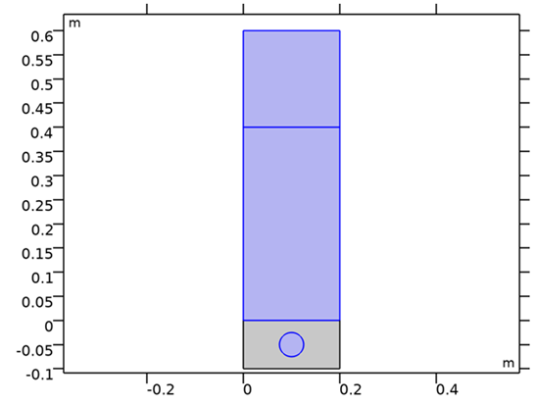
Fig 1 Air and foam domain
From the fig1 bottom rectangle box is where the foam domain above its air domain is located.
Benefits of using foam :
The use of foam in porous absorbers offers several benefits, particularly in the field of acoustic and thermal insulation. Here are some advantages of using foam in porous absorbers:
1.Sound absorption: Foam has excellent sound absorption properties due to its open-cell structure. When sound waves pass through the foam, they get trapped and converted into heat energy through friction and air resistance. This helps reduce echo, reverberation, and overall noise levels in a given space. Foam absorbers are commonly used in recording studios, concert halls, and industrial settings to control noise.
2.High surface area: Foam materials typically have a large surface area relative to their volume due to their porous structure. This increased surface area enhances the absorptive capacity of the foam, allowing it to effectively capture sound waves, as well as other pollutants or contaminants in the air.
3.Versatility: Foam absorbers can be manufactured in various shapes, sizes, and densities to suit different applications. They can be easily cut, molded, or shaped into specific forms to fit specific spaces or equipment. This versatility makes foam absorbers adaptable for use in different industries and environments.
4.Lightweight and easy installation: Foam materials are generally lightweight, making them easy to handle and install. They can be easily mounted on walls, ceilings, or other surfaces using adhesives, clips, or fasteners. The lightweight nature of foam reduces the structural load and simplifies the installation process.
5.Thermal insulation: In addition to sound absorption, foam materials also provide thermal insulation benefits. The trapped air within the foam cells acts as a thermal barrier, reducing heat transfer through conduction and convection. This makes foam useful for insulating buildings, HVAC systems, pipes, and other applications where heat insulation is desired.
6.Durability and longevity: Many foam materials are designed to be durable and long-lasting. They are resistant to moisture, mildew, and mold, making them suitable for both indoor and outdoor applications. Foam absorbers often have good resistance to chemical exposure, making them suitable for industrial environments.
7.Cost-effective: Foam absorbers are often cost-effective compared to other sound-absorbing materials. They offer a good balance between performance and affordability, making them a popular choice in many industries. Additionally, their easy installation and long lifespan contribute to their cost-effectiveness.
It's important to note that the specific benefits of foam in porous absorbers may vary depending on the type of foam used, its density, thickness, and the intended application[3].
RESULTS
Case 1: Polyamide
In this case study air is an absorbate which is passed through the absorber, polyamide used as a foam material, it is act as a absorbent. Polyamide has a moderate level of moisture absorption. It can absorb and release moisture from the surrounding environment, leading to dimensional changes.
Input Parameters:
Table 1 input parameters Polyamide
Name | Expression | Value | Description
f_max | 10[kHz] | 10000 Hz | Maximal frequency in the model
lambda_min | 343[m/s]/f_max | 0.0343 m | Minimal wavelength
theta0 | 0[deg] | 0 rad | Incident wave angle
W | 20[cm] | 0.2 m | Domain width
H | 40[cm] | 0.4 m | Air domain height
Hp | 10[cm] | 0.1 m | Porous layer height
A | 2.5[cm] | 0.025 m | Inclusion radius
Hpml | 20[cm] | 0.2 m | PML Domain Height
mu0 | 1.8e-5[Pa*s] | 1.8E−5 Pa·s | Dynamic viscosity of air
epsilonP0 | 0.995 | 0.995 | Porosity of polyamide
Rf0 | 10.5e3[Pa*s/m^2] | 10500 Pa·s/m² | Flow resistivity
tau0 | 1.0059 | 1.0059 | Tortuosity
Lv0 | 240[um] | 2.4E−4 m | Viscous characteristic length
Lth0 | 470[um] | 4.7E−4 m | Thermal characteristic length
Plot Groups
A. Total Acoustic Pressure :
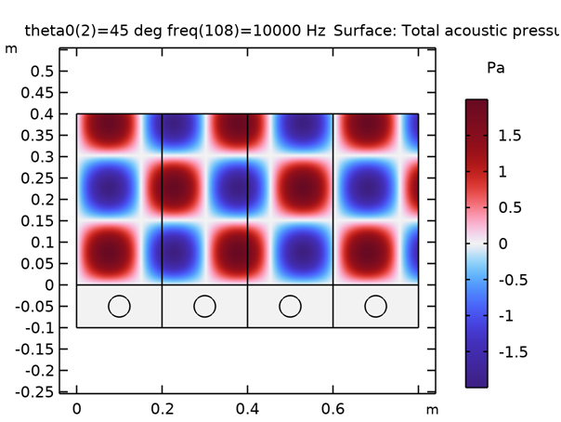
Fig 2 Total Acoustic Pressure
Here the minimum pressure is -1.5 and the maximum pressure is 1.5. If the total acoustic pressure increases, then the amplitude will increase. And if the total acoustic pressure decreases, then the amplitude will decrease. If the amplitude decreases, then the reflection of the sound wave also decreases. In the above figure, the blue color denotes the minimum pressure and there is a minimum in amplitude so the reflection of a sound wave is also minimum. The dark red color denotes the maximum pressure and there is a maximum in amplitude so the reflection of a sound wave is also maximum. The distance from the source of the sound can also affect the total acoustic pressure. As the sound wave travels further away from the source, its amplitude decreases, resulting in a lower total acoustic pressure. Conversely, if the sound source is closer, the sound wave will have a higher amplitude and a higher total acoustic pressure.
B. Sound Pressure Level :
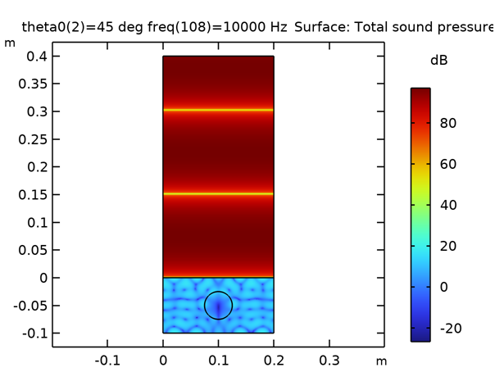
Fig 3 Sound Pressure Level (dB)
Here, the minimum sound pressure level is -20, the mid sound pressure level is 30 and the maximum sound pressure level is 80. The minimum level is denoted by the color blue, the medium level is denoted by the color green, and the maximum level is denoted by the color red. At the initial stage, it is at the minimum level then it gradually increases to the maximum level. If the sound pressure level increases, then the effectiveness of the absorber will increase. So more energy can be absorbed. If the sound pressure level decreases, then the effectiveness of the absorber will decrease. So more energy can not be absorbed. Higher sound pressure can be obtained by lower frequency level. Sound pressure level can be minimized in porous polyamide absorbers due to their ability to absorb sound waves through a process called sound attenuation. Porous polyamide absorbers are designed to have a large surface area and a high porosity, which allows them to effectively dissipate sound energy by converting it into heat. The mid-sound pressure level is attained in some areas. The sound pressure increases due to the energy transfer of the sound wave from the sound source to the surrounding medium, and it is affected by the intensity of the sound, the distance from the sound source, and the properties of the medium. As the SPL of a sound increases, it can have different effects on the human body.
C. Scattered Acoustic Pressure :
Here, the minimum scattered acoustic pressure level is -0.8, the middle scattered acoustic pressure level is 0 and the maximum scattered acoustic pressure level is 0.8. The minimum level is denoted by the color blue, the medium level is denoted by the color white, and the maximum level is denoted by the color red. In the above figure, it is obvious that it is gradually increasing from the minimum value to the maximum value. When sound waves come into contact with a polyamide porous absorber, some of the sound energy is absorbed by the material, while some of the energy is scattered or reflected back into the surrounding environment.The scattered acoustic pressure in a polyamide porous absorber can be affected by several factors, including the porosity, thickness, and density of the material, as well as the frequency of the sound waves. At low frequencies, the polyamide porous absorber will behave like a barrier, reflecting or scattering a significant portion of the sound waves. However, as the frequency of the sound waves increases, the absorber's porous structure begins to resonate, causing the absorber to become more efficient in attenuating sound waves. In general, polyamide porous absorbers are designed to minimize scattered acoustic pressure and maximize sound absorption.
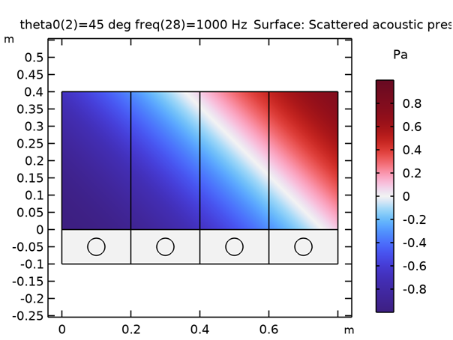
Fig 4 Scattered Acoustic Pressure
D. Incident Acoustic Pressure:
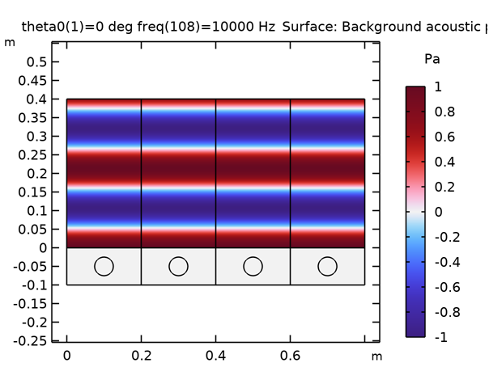
Fig 5 Incident Acoustic Pressure(Pa)
Here, the minimum scattered acoustic pressure level is -1, the middle scattered acoustic pressure level is 0 and the maximum scattered acoustic pressure level is 1. The minimum level is denoted by the color blue, the medium level is denoted by the color white, and the maximum level is denoted by the color red. It is used to find the sound absorption performance of the material. Higher levels of acoustic pressure can lead to a greater level of sound absorption. Incident acoustic pressure also affects the impedance of the porous absorber. At the initial and final stages, maximum incident acoustic pressure occurs. In Between the initial and final stages minimum and mid-level incident acoustic pressure occurs. If the incident pressure is too high, the porous absorber may reach its nonlinear acoustic range, where the absorption coefficient decreases with increasing pressure. In this case, the increased pressure causes the pores of the absorber to close up, reducing the amount of airflow and limiting the viscous and thermal losses within the absorber material. As a result, the absorption coefficient decreases, and the porous absorber becomes less effective at attenuating sound waves at higher pressures.
E. Point Pressure
Fig 6 shows the relationship between the total acoustic pressure and the frequency. The x-axis denotes the frequency in hertz and the y-axis denotes the total acoustic pressure in pascal. The scale of the above figure is, the x-axis 1 cm is equal to 10 to the power of 1 unit and the y-axis 1 cm is equal to 2 units. The blue line represents the theta 0=0 deg in point 2 and the green line represents the theta 0=45 deg in point 2. At theta 0 deg the maximum frequency is at 9 and at theta 45 deg the maximum frequency is at 12. If the point pressure increases, then the sound wave is not being sufficiently used, which is why most of the sound waves are reflected in the environment. So, the point pressure should be at the minimum value so that the sound waves are absorbed in a high manner.
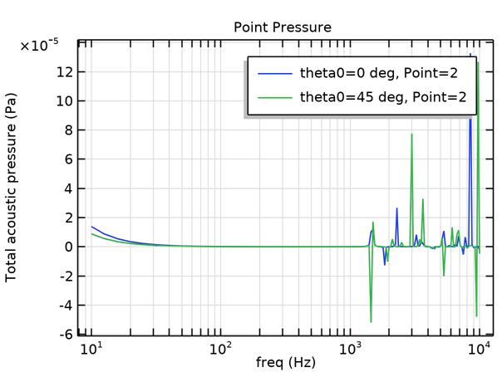
Fig 6 Point Pressure
Point pressure refers to the force applied at a specific point on the surface of the absorber. In the context of polyamide porous absorbers, the point pressure can affect the absorption properties of the material. When a point pressure is applied to the surface of a polyamide porous absorber, it can cause the pores to collapse or compress, which can reduce the material's ability to absorb sound or vibration. Additionally, the point pressure can cause deformation or damage to the material, which can also affect its absorption properties. To optimize the performance of polyamide porous absorbers, it's important to consider the distribution of pressure across the surface of the material. Uniform pressure distribution can help ensure that the pores remain open and uncompressed, maximizing the material's absorption capabilities.
F. Normal Impedance:
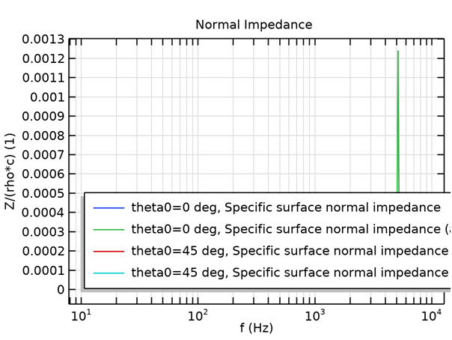
Fig 7 Normal Impedance
Here, the graph shows the relationship between the acoustic pressure and the frequency. The x-axis represents the acoustic pressure and the y-axis represents the frequency in hertz. The scale of the x-axis is 0.0001 units and the y-axis is 10 to the power of 1. In the above figure, the theta 0 deg the frequency is maximum at 0.00125. The normal impedance depends on the property of the material and the frequency sound wave. The frequency is classified into two types, they are low frequency and high frequency. At lower frequencies, the normal impedance of a porous absorber can be determined by its flow resistivity and it is very easy to determine. At higher frequencies, the normal impedance of a porous absorber can not be determined because it is affected by the porosity. So the lower frequency is very helpful to determine. In the above figure, the green line is increased at a certain point.
G. Absorption Coefficient:
Here, the graph shows the relationship between the absorption coefficient and the frequency. The x-axis represents the absorption coefficient and the y-axis represents the frequency in hertz. The scale of the x-axis is 0.05 unit and the y-axis is 10 to the power of 1. In the above figure, the theta 0 deg(green line) the frequency is maximum at 0.00459. If the absorption coefficient increases, then there is a better sound absorption performance. And if the absorption coefficient decreases, then there will be the least sound absorption performance. Polyamide porous absorbers typically have a high absorption coefficient, especially at higher frequencies. The absorption coefficient can vary widely depending on the specific material and frequency range of interest.
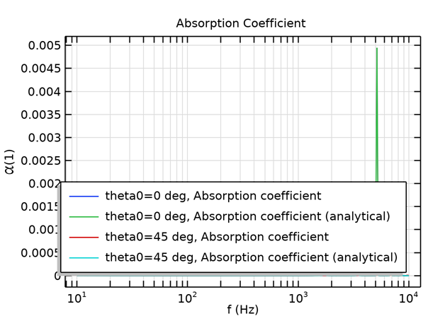
Fig 8 Absorption Coefficient
Case 2 : Polyester
In this case study air is an absorbate which is passed through the absorber, polyester used as a foam material, it act as an absorbent. Polyester can be used in the construction of acoustic panels, baffles, and other sound-absorbing materials. Its structure and arrangement help trap and dissipate sound energy, reducing echo, reverberation, and overall noise levels in a given space. Polyester acoustic panels are commonly used in environments where sound control is important, such as recording studios, theaters, and office spaces.
Input Parameters:
Table 3 input parameter of polyester
Name | Expression | Value | Description
f_max | 10[kHz] | 10000 Hz | Maximal frequency in the model
lambda_min | 343[m/s]/f_max | 0.0343 m | Minimal wavelength
theta0 | 0[deg] | 0 rad | Incident wave angle
W | 20[cm] | 0.2 m | Domain width
H | 40[cm] | 0.4 m | Air domain height
Hp | 10[cm] | 0.1 m | Porous layer height
A | 2.5[cm] | 0.025 m | Inclusion radius
Hpml | 20[cm] | 0.2 m | PML Domain Height
mu0 | 1.8e-5[Pa*s] | 1.8E−5 Pa·s | Dynamic viscosity of air
epsilonP0 | 0.995 | 0.986 | Porosity of polyester
Rf0 | 10.5e3[Pa*s/m^2] | 10500 Pa·s/m² | Flow resistivity
tau0 | 1.0059 | 1.0059 | Tortuosity
Lv0 | 240[um] | 2.4E−4 m | Viscous characteristic length
Lth0 | 470[um] | 4.7E−4 m | Thermal characteristic length
Plot Groups
A . Total Acoustic Pressure:
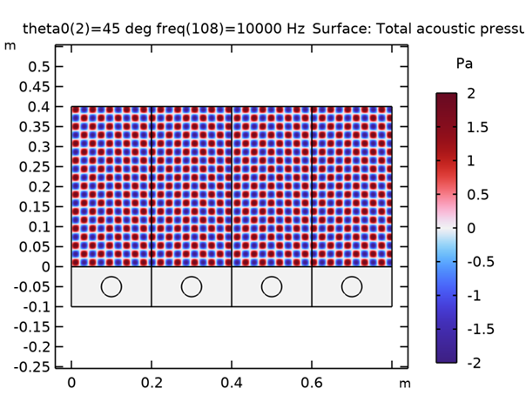
Fig 9 Total Acoustic Pressure(Pa)
From Fig 9 minimum pressure is -2 and the maximum pressure is 2. If the total acoustic pressure increases, then the amplitude will increase. And if the total acoustic pressure decreases, then the amplitude will decrease. If the amplitude decreases, then the reflection of the sound wave also decreases. In the above figure, the blue color denotes the minimum pressure and there is a minimum in amplitude so the reflection of a sound wave is also minimum. The dark red color denotes the maximum pressure and there is a maximum in amplitude so the reflection of a sound wave is also maximum. The total acoustic pressure at a given point is the sum of the pressures created by all the sound waves arriving at that point from different directions. This means that if multiple sound sources are present, their individual pressure waves will combine to produce a complex pattern of pressure variations that can result in increases or decreases in the total acoustic pressure at different points in space.
B.Sound Pressure Level :
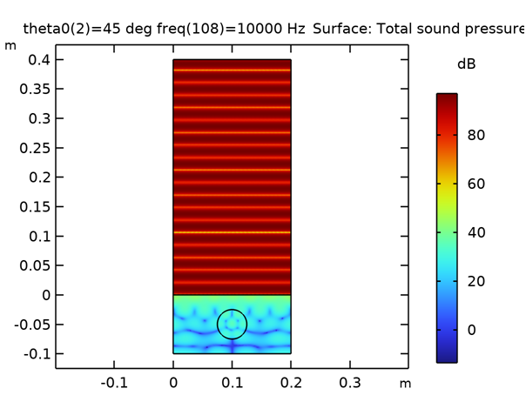
Fig 10 Sound Pressure Level(dB)
From Fig 10 minimum sound pressure level is 0, the mid sound pressure level is 40 and the maximum sound pressure level is 80. The minimum level is denoted by the color blue, the medium level is denoted by the color green, and the maximum level is denoted by the color red. The minimum sound pressure level occurs at the initial point, the middle level occurs at the 0th of y axis then the maximum level of sound pressure level occurs up to the 0.4th of the y-axis. If the sound pressure level increases, then the effectiveness of the absorber will increase. So more energy can be absorbed. If the sound pressure level decreases, then the effectiveness of the absorber will decrease. So more energy can not be absorbed. When sound waves come into contact with a porous material, such as a polyester absorber, the sound waves will penetrate into the material and cause vibration of the fibers or particles that make up the material. This vibration converts the sound energy into heat energy, which effectively reduces the sound pressure level. If the absorber is not thick enough or the space between the absorber and the reflective surface behind it is too small, sound waves can reflect off the reflective surface and be redirected back into the room, leading to an increase in sound pressure level. However, this is not a characteristic of the porous polyester absorber itself, but rather a result of incorrect design or installation.
C. Scattered Acoustic Pressure :
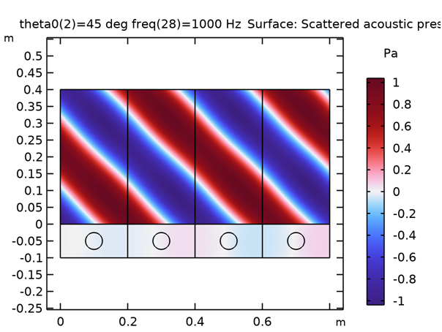
Fig 11 Scattered Acoustic Pressure(Pa)
From fig 11 minimum sound pressure level is -20, the mid sound pressure level is 30 and the maximum sound pressure level is 80. The minimum level is denoted by the color blue, the medium level is denoted by the color green, and the maximum level is denoted by the color red. If the scattered acoustic pressure increases, then the amount of sound energy reflected back into the environment decreases which means it absorbs a high amount of energy when scattered acoustic pressure increases. So that the acoustic pressure improves. In the above figure, some areas are at the minimum level and some are at the maximum level of scattered acoustic pressure. When sound waves come into contact with a polyester porous absorber, some of the sound energy is absorbed by the material, while some of the energy is scattered or reflected back into the surrounding environment. Polyester porous absorbers are designed to minimize scattered acoustic pressure and maximize sound absorption. This is achieved by optimizing the material's porosity, thickness, and density to provide the most effective sound attenuation across a wide range of frequencies.
D. Incident Acoustic Pressure :
Here, the minimum scattered acoustic pressure level is -1, the middle scattered acoustic pressure level is 0 and the maximum scattered acoustic pressure level is 1. The minimum level is denoted by the color blue, the medium level is denoted by the color white, and the maximum level is denoted by the color red.
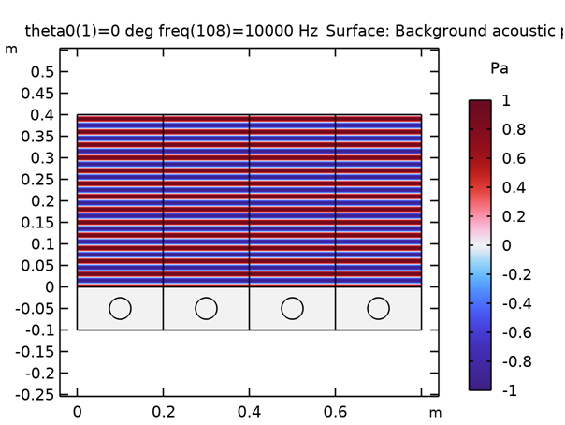
Fig 12 Incident Acoustic Pressure
It is used to find the sound absorption performance of the material. Higher levels of acoustic pressure can lead to a greater level of sound absorption. Incident acoustic pressure also affects the impedance of the porous absorber. In the above figure, only the maximum and minimum values occur. It is in the form of maximum and minimum as one by one. The incident acoustic pressure of a polyester porous absorber is the amount of sound energy that comes into contact with the absorber and is not reflected or transmitted back into the environment. It depends on several factors, including the design and properties of the absorber, the intensity and frequency of the incident sound waves, and the acoustic environment in which the absorber is located. The incident acoustic pressure of a polyester porous absorber will depend on its specific design and the characteristics of the sound waves it is exposed to. Generally, the incident acoustic pressure of a polyester porous absorber will be lower than that of a non-porous reflective surface, as the material is designed to dissipate sound energy rather than reflect it. However, the efficiency of the polyester porous absorber in reducing incident acoustic pressure will depend on its porosity, thickness, density, and other design factors.
E. Point Pressure :
Fig 13 shows the relationship between the total acoustic pressure and the frequency. The x-axis denotes the frequency in hertz and the y-axis denotes the total acoustic pressure in pascal. The scale of the above figure is, the x-axis 1 cm is equal to 10 to the power of 1 unit and the y-axis 1 cm is equal to 0.5 units
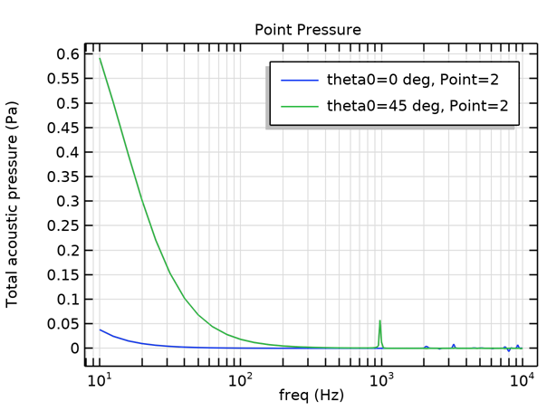
Fig13 Point Pressure(Pa)
F . Normal Impedance :
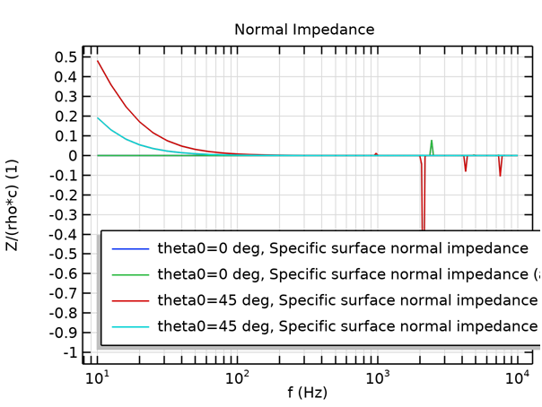
Fig 14 Normal Impedance
Here, the graph shows the relationship between the acoustic pressure and the frequency. The x-axis represents the acoustic pressure and the y-axis represents the frequency in hertz. The scale of the x-axis is 0.1 unit and the y-axis is 10 to the power of 1 unit. The frequency of theta 45 deg is maximum at 0.48 of acoustic pressure. The normal impedance depends on the property of the material and the frequency sound wave. The frequency is classified into two types, they are low frequency and high frequency. At lower frequency, the normal impedance of a porous absorber can be determined by its flow resistivity and it is very easy to determine. At higher frequency, the normal impedance of a porous absorber can not be determined because it is affected by the porosity. So the lower frequency is very helpful to determine. Polyester porous absorbers typically have a relatively low normal impedance, typically ranging from around 0.1 to 0.5 acoustic ohms. However, this value can vary depending on the thickness, density, and porosity of the material. The normal impedance of a porous absorber is also influenced by the frequency of the sound wave. At low frequencies, the normal impedance tends to be closer to zero, while at higher frequencies, it increases towards the characteristic impedance of air.
G. Absorption Coefficient :
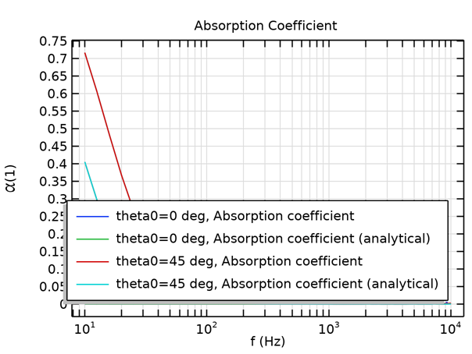
Fig 15 Absorption Coefficient
Here, the graph shows the relationship between the absorption coefficient and the frequency. The x-axis represents the absorption coefficient and the y-axis represents the frequency in hertz. The scale of the x-axis is 0.05 unit and the y-axis is 10 to the power of 1. In the above figure, the theta 45 deg(skyblue line) the frequency is maximum at 0.4 of absorption coefficient and theta 45 deg(red line) the frequency is maximum at 0.725 of absorption coefficient. If the absorption coefficient increases, then there is a better sound absorption performance. And if the absorption coefficient decreases, then there will be a least sound absorption performance. The absorption coefficient of a polyester porous absorber can depend on various factors, such as the thickness, density, and porosity of the material, as well as the frequency range of interest. It is important to carefully consider these factors when selecting a porous absorber material for a specific acoustic application.

Case 3: Polyurethane :
In this case study air is an absorbate which is passed through the absorber, polyurethane used as a foam material, it act as an absorbent. Polyurethane foam is widely used as a sound-absorbing material due to its open-cell structure. When sound waves pass through the foam, they get trapped and converted into heat energy through friction and air resistance. Polyurethane foam effectively absorbs and reduces sound reflections, reverberation, and overall noise levels in a given space. It finds applications in soundproofing studios, auditoriums, offices, and automotive interiors.
Parameters
Table 3 Input parameters of polyurethane
Name | Expression | Value | Description
f_max | 10[kHz] | 10000 Hz | Maximal frequency in the model
lambda_min | 343[m/s]/f_max | 0.0343 m | Minimal wavelength
theta0 | 0[deg] | 0 rad | Incident wave angle
W | 20[cm] | 0.2 m | Domain width
H | 40[cm] | 0.4 m | Air domain height
Hp | 10[cm] | 0.1 m | Porous layer height
A | 2.5[cm] | 0.025 m | Inclusion radius
Hpml | 20[cm] | 0.2 m | PML Domain Height
mu0 | 1.8e-5[Pa*s] | 1.8E−5 Pa·s | Dynamic viscosity of air
epsilonP0 | 0.995 | 0.989 | Porosity of Polyurethane
Rf0 | 10.5e3[Pa*s/m^2] | 10500 Pa·s/m² | Flow resistivity
tau0 | 1.0059 | 1.0059 | Tortuosity
Lv0 | 240[um] | 2.4E−4 m | Viscous characteristic length
Lth0 | 470[um] | 4.7E−4 m | Thermal characteristic length
Plot Groups
A. Total Acoustic Pressure :
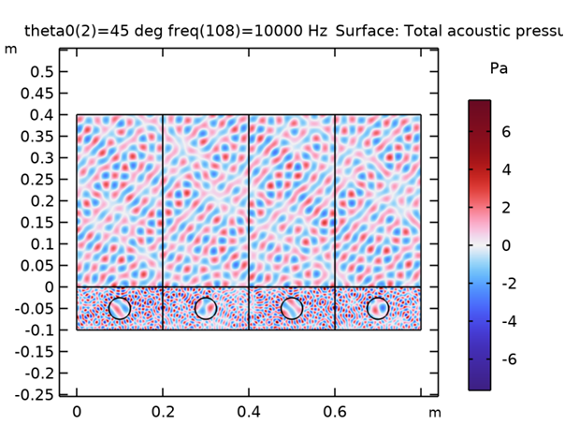
Fig 16 Total Acoustic Pressure(Pa)
From fig 16 minimum pressure is -6 and the maximum pressure is 6 and the mid-value of the pressure is 0. From the above figure, we can see that it is a combination of all the minimum, mid and maximum values. The minimum value is represented in the color of blue, the mid value is represented in white and the maximum value is represented in red. The total acoustic pressure decreases in a porous absorber using polyurethane due to the dissipation of sound energy as heat as the sound waves interact with the porous structure of the foam. When the wavelength of the sound wave matches the size of the pores in the foam, the sound wave can effectively penetrate the material and interact with a larger surface area, leading to increased absorption and a maximum in the total acoustic pressure. The total acoustic pressure in a porous polyurethane absorber is not necessarily "average" but can vary depending on several factors, including the characteristics of the porous material and the incident sound wave. It's important to note that the maximum total acoustic pressure in a porous polyurethane absorber is dependent on several factors such as the porosity and thickness of the material, the incident sound frequency and angle, and the specific geometry of the pores and fibers in the material. Therefore, careful design and optimization of the porous material are necessary to achieve maximum absorption performance.
B. Sound Pressure Level :
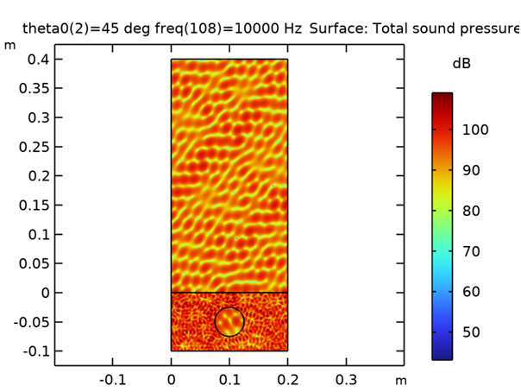
Fig 17 Sound Pressure Level(dB)
From fig 17 minimum sound pressure level is 50, the mid sound pressure level is 75 and the maximum sound pressure level is 100. The minimum level is denoted by the color blue, the medium level is denoted by the color green, and the maximum level is denoted by the color red. At the initial stage, it is at the minimum level then it gradually increases to the maximum level. If the sound pressure level increases, then the effectiveness of the absorber will increase. So more energy can be absorbed. If the sound pressure level decreases, then the effectiveness of the absorber will decrease. So more energy can not be absorbed. Higher sound pressure can be obtained by lower frequency level. In the above figure, there is no minimum sound pressure level. Mid-level and maximum levels have occurred in this material. Most mid-level are obtained by this material. Polyurethane porous absorbers can help to reduce sound pressure level through sound exhaustion. Polyurethane absorbers are designed to have a large surface area and a high porosity, which allows them to effectively dissipate sound energy by converting it into heat. The efficiency of the polyurethane porous absorber in reducing sound pressure level depends on the material's porosity, thickness, and density. The higher the porosity and thickness of the absorber, the more effective it will be in attenuating sound waves.
C. Scattered Acoustic Pressure :
Here, the minimum sound pressure level is -3, the mid sound pressure level is 0 and the maximum sound pressure level is 3. The minimum level is denoted by the color blue, the medium level is denoted by the color green, and the maximum level is denoted by the color red. If the scattered acoustic pressure increases, then the amount of sound energy reflected back into the environment decreases which means it absorbs a high amount of energy when scattered acoustic pressure increases. So that the acoustic pressure improves.
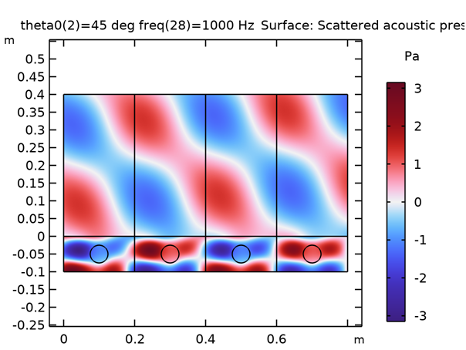
Fig 18 Scattered Acoustic Pressure(Pa)
Polyurethane porous absorbers are designed to minimize scattered pressure levels and maximize sound absorption. This is achieved by optimizing the material's porosity, thickness, and density to provide the most effective sound attenuation across a wide range of frequencies. The scattered pressure level in a polyurethane porous absorber will be lower than that of a non-porous reflective surface, as the material is designed to dissipate sound energy rather than reflect it. However, the efficiency of the polyurethane porous absorber in reducing scattered pressure level will depend on the specific design and application of the absorber, as well as the acoustic environment in which it is installed.
D. Incident Acoustic Pressure :
From fig minimum scattered acoustic pressure level is -1, the middle scattered acoustic pressure level is 0 and the maximum scattered acoustic pressure level is 1. The minimum level is denoted by the color blue, the medium level is denoted by the color white, and the maximum level is denoted by the color red. It is used to find the sound absorption performance of the material. Higher levels of acoustic pressure can lead to a greater level of sound absorption. Incident acoustic pressure also affects the impedance of the porous absorber. In the above figure, only the maximum and minimum values occur. It is in the form of maximum and minimum as one by one. When sound waves come into contact with a polyurethane porous absorber, some of the sound energy is absorbed by the material, while some of the energy is transmitted through the material and into the surrounding environment. The incident acoustic pressure of a polyurethane porous absorber will depend on its specific design and the characteristics of the sound waves it is exposed to. Generally, the incident acoustic pressure of a polyurethane porous absorber will be lower than that of a non-porous reflective surface, as the material is designed to dissipate sound energy rather than reflect it.
Fig 19 Incident Acoustic Pressure(Pa)
E. Point Pressure :
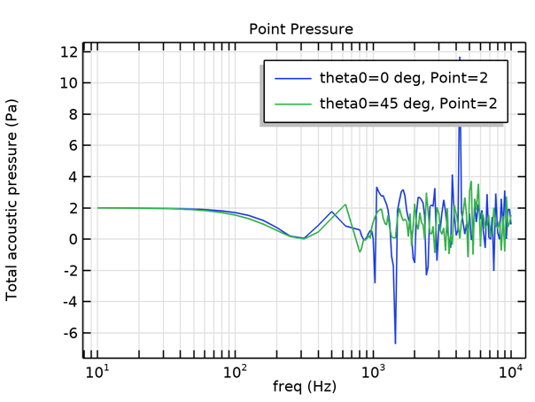
Fig 20 Point Pressure(Pa)
Fig 20 shows the relationship between the total acoustic pressure and the frequency. The x-axis denotes the frequency in hertz and the y-axis denotes the total acoustic pressure in pascal. The scale of the above figure is, the x-axis 1 cm is equal to 10 to the power of 1 unit and the y-axis 1 cm is equal to 2 units. If the point pressure increases, then the sound wave is not being sufficiently used, which is why most of the sound waves are reflected to the environment. So, the point pressure should be at the minimum value so that the sound waves are absorbed in a high manner. To optimize the performance of polyurethane porous absorbers, it's important to consider the distribution of pressure across the surface of the material. Uniform pressure distribution can help ensure that the pores remain open and uncompressed, maximizing the material's absorption capabilities. Additionally, the thickness and density of the material can also play a role in determining the optimal point pressure for maximum absorption performance.
F. Normal Impedance :
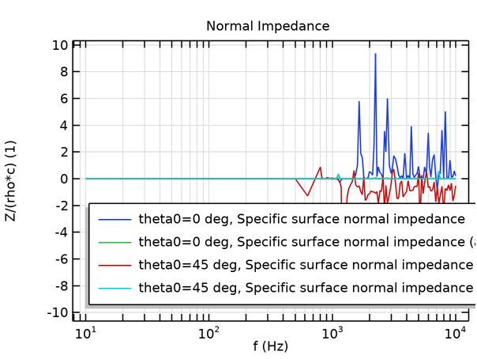
Fig 21 Normal Impedance
Here, the graph shows the relationship between the acoustic pressure and the frequency. The x-axis represents the acoustic pressure and the y-axis represents the frequency in hertz. The scale of the x-axis is 2 units and the y-axis is 10 to the power of 1. In the above figure, the theta 0 deg the frequency is maximum at 9.5. The normal impedance depends on the property of the material and the frequency sound wave. The frequency is classified into two types, they are low frequency and high frequency. At lower frequency, the normal impedance of a porous absorber can be determined by its flow resistivity and it is very easy to determine. At higher frequency, the normal impedance of a porous absorber can not be determined because it is affected by the porosity. So the lower frequency is very helpful to determine. Polyurethane porous absorbers tend to have a relatively low normal impedance, typically ranging from around 1 to 9.5 acoustic ohms. However, this value can vary depending on the specific formulation and manufacturing process used to produce the material. Similar to other porous absorbers, the normal impedance of polyurethane porous absorbers can also vary with frequency. At lower frequencies, the normal impedance tends to be closer to zero, while at higher frequencies, it increases towards the characteristic impedance of air.
G. Absorption Coefficient :
From fig 22 the graph shows the relationship between the absorption coefficient and the frequency. The x-axis represents the absorption coefficient and the y-axis represents the frequency in hertz. The scale of the x-axis is 0.1 unit and the y-axis is 10 to the power of 1. In the above figure, the theta 0 deg(blue line) the frequency is maximum at 0.9 of absorption coefficient and theta 45 deg(red line) the frequency is maximum at 0.98 of absorption coefficient. If the absorption coefficient increases, then there is a better sound absorption performance. And if the absorption coefficient decreases, then there will be a least sound absorption performance.
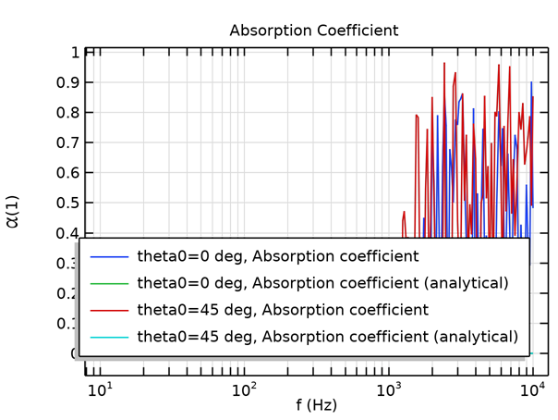
Fig 22 Absorption Coefficient
Polyurethane porous absorbers typically have a moderate to high absorption coefficient, depending on the specific formulation and manufacturing process used to produce the material. The absorption coefficient of polyurethane porous absorbers can range from around 0.2 to 0.9 across a broad frequency range.

Comparison of Porous Absorbers :
Table 4 Comparisons of porous absorber
S.No | Elements | Total Acoustic pressure  ( Pa) | Sound level Pressure  (dB)
1. | Polyamide | Min : -1.5  Max : 1.5 | Min : -20  Max : 80
2. | Polyester | Min : -2  Max : 2 | Min : 0  Max : 80
3. | Polyurethane | Min : -6  Max : 6 | Min :50  Max : 100

From table 4 The acoustic pressure is a measure of the amplitude of the sound wave, which is the amount of pressure variation from the ambient pressure level. When a sound wave passes through a porous absorber, some of its energy is absorbed by the material and converted into heat, resulting in a reduction in the amplitude or magnitude of the wave. This reduction in amplitude corresponds to a decrease in the acoustic pressure of the sound wave. Depending upon the acoustic pressure Polyurethane provides a high acoustic pressure which results in an increase in amplitude and decrease in reflection of sound waves.
At higher SPLs, the porous absorber will be more effective at attenuating the sound wave due to the greater amount of energy being absorbed by the material. This is because the sound wave has a greater acoustic pressure, and therefore, more energy that can be absorbed by the porous material. Depending upon the sound level pressure Polyurethane has a high sound level pressure which results in a high absorber effectiveness, and more energy can be absorbed.
Considering all the properties Polyurethane is the best foam which is used in the porous absorber.
Conclusion:
The analysis and simulation of porous absorbers using COMSOL Multiphysics software is an effective tool for predicting and optimizing the acoustic performance of these materials. By simulating the acoustic behaviour of porous absorbers, engineers and scientists can gain a better understanding of how these materials work and optimize their design for specific applications.
The results obtained from the simulation can be used to identify the effect of various parameters on the acoustic performance of porous absorbers, such as sound pressure level, scattered pressure level, point pressure level, normal impedance, absorption coefficient and material properties.
These results can be validated by comparing them with experimental measurements, making it possible to ensure the accuracy of the simulation. The use of COMSOL software has several advantages, including the ability to simulate multiphysics phenomena, create accurate numerical models, and provide a user-friendly graphical interface. This makes it a powerful tool for optimizing the design of porous absorbers in various industries, such as automotive, aerospace, and architectural acoustics.
References :
- T.J. Cox and P. D’Antonio, Acoustic Absorbers and Diffusers, Theory, Design and Applications, 2nd edTaylor and Francis-2009.
- COMSOL 2018 COMSOL Multiphysics® v. 5.5 p 1742
- Wang, Q., Li, Y., Li, X., Li, M., & Zhang, J. Investigation on sound absorption of porous materials using COMSOL simulation. Applied Acoustics, 137, 1-11.-2018
- Sgardoli, M., & Bison, P. Simulation of porous absorbers: Comparison between COMSOL Multiphysics and Biot's model. Journal of Sound and Vibration, 423, 292-301- 2018
- Gudur, M. N., & Rao, M. S Design of porous absorbers for high sound absorption coefficient using COMSOL Multiphysics. International Journal of Mechanical and Production Engineering Research and Development, 9(1), 327-336-(2019).

