A Comparative Morphological Characterization of Adenium obesum Cultivars
REJITHA. S¹ AND UMA DEVI. S²
¹Department of Botany, Nesamony Memorial Christian College, Marthandam, Tamil Nadu, India. E-mail: rejithastalin14@gmail.com
²Department of Botany, Sree Ayyappa College for Women, Nagercoil, Tamil Nadu, India. E-mail: umapradeep80@gmail.com

ABSTRACT
Adenium obesum (Forssk.) Roem. & Schult. is an ornamental plant and it belongs to the family Apocynaceae. It produces a lot of flowers in the summer, but they can bloom throughout the year. The genetic component expresses the phenotypic differences in Adenium obesum cultivars cultivated under identical conditions. In this study, we performed a systematical comparison of the morphological characteristics of different Adenium obesum cultivars. Research was conducted in Kanyakumari District, Tamil Nadu, India. Seven cultivars of Adenium obesum were collected from the study area. The cultivars are Cery (C), Double Red (DR), Fanta (F), Pink Peony (PP), Red Leucas (RL), Red White Edge (RWE) and Triple Red (TR). Morphological studies were conducted on the vegetative and floral parts of the specimens. The cultivars could be divided into three groups: single form, double form and triple form. The color variation and quantity of floral whorls were the two most significant morphological variances seen in seven varieties. The results of the leaf characters demonstrated that, with the exception of RL cultivars, leaves are glabrous and that PP cultivars lack a petiole. All cultivars flowers had a white to red corolla, green to red calyx, white to pink anthers, white to red apical appendage, light green to green stigma, white to red style and green to red ovary. The significance of these characters in the taxonomy of these cultivars was discussed in view of the perceived similarities in morphology between these taxa. The cultivars are difficult to distinguish based on vegetative morphological characteristics because they have a similar morphology. However, the flower morphology was clearly differentiable because the cultivars distinguishing traits were their color and number of whorls. The current study makes it more interesting to look into cultivar genotypes.
Keywords: Adenium obesum, Apocynaceae, Cultivars, Morphology, Ornamental Plants
INTRODUCTION
Adenium obesum (Forssk.) Roem. & Schult. is an ornamental plant and it belongs to the family Apocynaceae, subfamily Apocynoideae and tribe Nerieae. Adenium latinized Arabic name, aden is used as the genus name. The specific epithet refers to the obese nature of the stem base. Adenium obesum is an evergreen or drought-deciduous succulent shrub or small tree that can reach heights of up to 10 feet (3 metres). It was commonly called "desert rose." It is widely known for its deep red flowers and swollen, succulent stem. They are frequently used for bonsai and may be grown in a pot for many years. The stem base is strongly thickened with age and sometimes spreads over rocks. Desert roses produce a lot of flowers in the summer, but they can bloom throughout the year. In the colder months, they can shed their leaves.
The genetic component expresses the phenotypic differences in Adenium obesum cultivars cultivated under identical conditions. In the modern world, it is widely cultivated in many humid and tropical nations with significant importance in the ornamental market and plays an important function as an attractive plant in dwellings, particularly in India. The flower resembles a rose but is not at all related to the other members of the rose family. The flowers of this species are tubular and the color ranges from deep purple-red through pink and white. However, commercial cultivars have different colors, shapes and sizes. The flowers are produced in clusters (corymbs) at the apex of the branches for most of the year. Adenium varieties differ in flower color, petal doubleness, flowering duration and branching habit compactness. Flowers may be single, double, or even triple.
Therefore, in the present research, we study the difference between morphological characterizations of local Adenium obesum cultivars. The Adenium obesum cultivars were collected from different places in Kanyakumari district on the basis of flower color and number of whorls. Totally seven cultivars, they are Cery (C), Double Red (DR), Fanta (F), Pink Peony (PP), Red Leucas (RL), Red White Edge (RWE) and Triple Red (TR) (Plate 1).
MATERIALS AND METHODS
1. Experimental Site
Research was conducted in Kanyakumari District, Tamil Nadu, India. Kanyakumari District, the southernmost tip of Indian Peninsula, is divided into two divisions (Nagercoil, Padmanabhapuram) and six taluks namely: Agastheeswaram, Thovalai, Kalkulam, Vilavancode, Thiruvattar and Killiyoor. Location of the Kanyakumari District is bounded between 77º05^{l} and 77º35^{l} of the Eastern longitude and 8º05^{l} and 8º35^{l} of the Northern latitude. The climate of Kanyakumari district is warm and humid. The average monthly temperature ranged from 32.6°C at its highest point in May to 22.5°C at its lowest point in December. Rainfall varies from 103 cm to 310 cm and elevation varies from sea level to 1829 m above sea level. The soil is red, varying in the quantity of ferruginous elements.
2. Experimental Materials
For this study, seven local Adenium obesum cultivars were chosen. They were collected from throughout the Kanyakumari District.
3. Experimental Setup
From June to December 2022, the morphological characterization was completed. Flowers and fruits were gathered and the morphological traits were studied. 33 morphological features served as the foundation for the characterization (Table 1).
Plate 1. Selected Cultivars of Adenium obesum
C | DR | F | PP | RL | RWE | TR
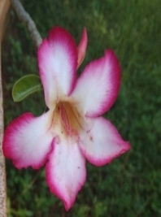 | 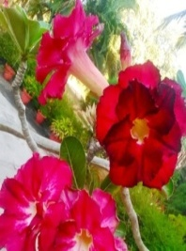 | 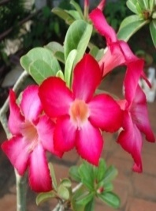 | 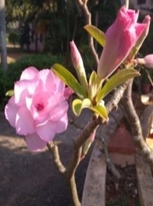 | 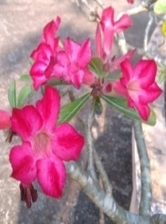 | 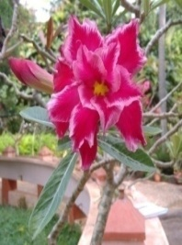 | 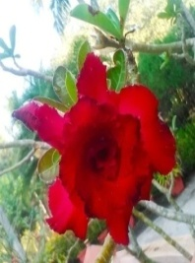

Table 1. Morphological Characters in Study
Leaf Characters
Length of blade (cm)
Width of blade (cm)
Leaf color: 1 (dark green), 2 (green with red outline), 3 (green)
Leaf shape: 1 (linear to obovate), 2 (obovate), 3 (obcordate to oblong), 4 (oblong to obovate)
Leaf apex: 1 (cuspidate), 2 (acute or rounded), 3 (retuse or rounded), 4 (emarginate or cuspidate)
Leaf base: 1 (cuneate), 2 (acute)
Flower Characters
Flower shape: 1 (trumpet), 2 (funnel)
Flower color: 1 (Red), 2 (light pink), 3 (pinkish red), 4 (red with pink outline), 5 (white with pink outline)
Flower number of whorls: 1 (single), 2 (3–4), 3 (2), 4 (3)
Length of flower (cm)
Width of flower (cm)
Pedicel color: 1 (red), 2 (light pink), 3 (greenish red), 4 (pink)
Calyx color: 1 (red), 2 (greenish red), 3 (red or light green), 4 (pink or light green)
Corolla number of whorls: 1 (3–4), 2 (3), 3 (2), 4 (1)
Corolla lobe shape: 1 (cuspidate), 2 (rounded), 3 (obtuse), 4 (acuminate)
Length of androecium (cm)
Number of anthers: 1 (5–10), 2 (5), 3 (1–5)
Anther color: 1 (white), 2 (pinkish white)
Appendage color: 1 (white), 2 (pinkish white), 3 (pink), 4 (red), 5 (light pink), 6 (dark pink)
Length of gynoecium (cm)
Stigma color: 1 (light green), 2 (green)
Style color: 1 (red), 2 (pink), 3 (light green), 4 (greenish white)
Ovary color: 1 (light green), 2 (green), 3 (reddish green), 4 (pinkish red)
Fruit Characters
Fruit: 1 (present), 0 (absent)
Fruit color: 1 (red)
Fruit shape: 1 (linear to oblong)
Length of fruit (cm)
Width of fruit (cm)
Seed Characters
Number of seeds
Seed color: 1 (yellowish brown), 2 (light brown)
Length of seed (cm)
Width of seed (cm)
Coma color: 1 (light brown)

RESULTS
The morphological characterization of the Adenium obesum cultivars studied showed a significant difference between all the cultivars.
Regarding the leaf characteristics, a difference has been noted between the cultivars. The leaf was linear, obovate, obcordate and oblong in shape. The lowest length (4.3–6 cm) of the blade was observed in cultivar C, whereas cultivar PP had the highest length (6.1–10.2 cm) of the blade (Table 2). Flowers of all cultivars had a white to red corolla, a green to red calyx, white to pink anthers, a light green to green stigma, a white to red style and a green to red ovary (Table 2, Plate 2–8). The fruit characterization revealed that all immature fruits are red in color and range in shape from linear to oblong (Plate 9). The seed with coma has a yellowish brown color, according to its description. The largest number of seeds were recorded in cultivar C and F.
Plate 2. Leaves and Flowers of Adenium obesum cultivars
C | DR | F | PP | RL | RWE | TR
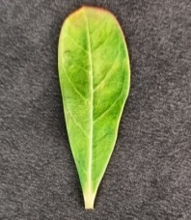 | 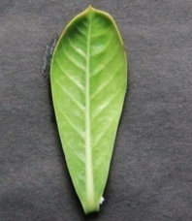 | 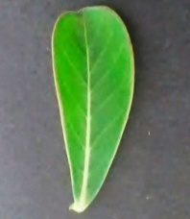 | 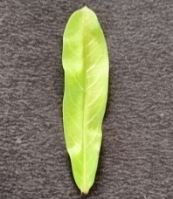 | 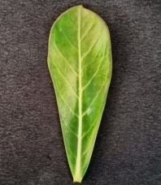 | 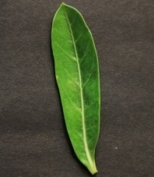 | 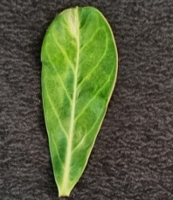
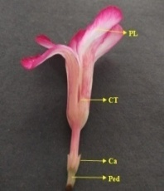 | 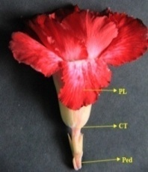 | 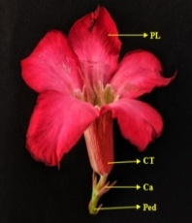 | 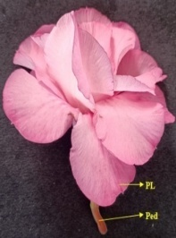 | 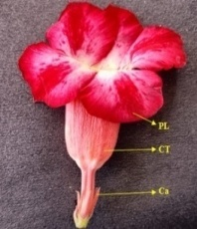 | 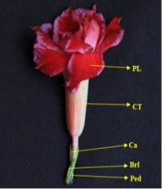 | 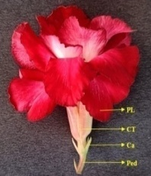
Ca- Calyx; CT- Corolla Tube; Ped- Pedicel; PL- Petal Lobe

The stem is erect, woody, branching, glabrous and greenish-gray with sticky, golden latex. The enlarged base of the stem is almost globose to conical and the base is smooth and bulbous. The leaves are alternate, spirally arranged and clustered toward the tip of the shoots. It was simple, entire, fleshy and leathery. The leaves have 5–13 secondary veins and are pinnately veined. The lateral veins are conspicuous only on the adaxial surface of the leaves and inconspicuous on the abaxial surface. Except for the RL cultivar, which has pubescent leaves on the abaxial surface, the leaves are glabrous on both surfaces. There was no petiole in the PP cultivar.
Plate 3. Calyx and Corolla cut open of Adenium obesum cultivars
C | DR | F | PP | RL | RWE | TR
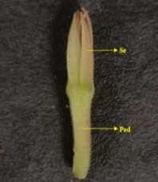 | 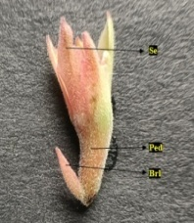 | 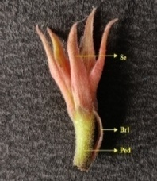 | 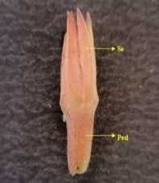 | 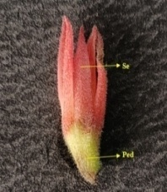 | 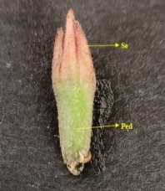 | 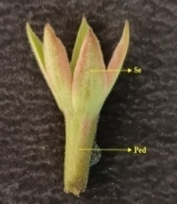
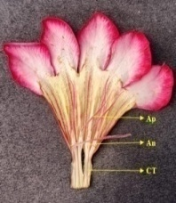 | 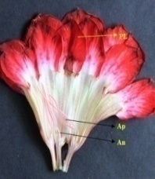 | 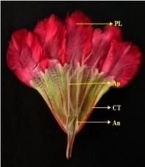 | 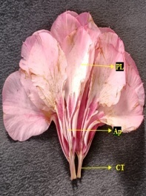 | 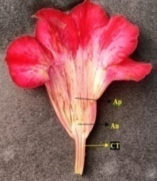 | 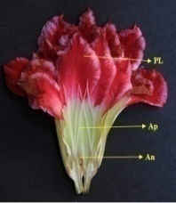 | 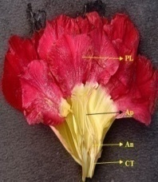
An- Anther; Ap- Appendage; Brl- Bracteole; CT- Corolla Tube; Ped- Pedicel; PL- Petal Lobe; Se- Sepal

Corymb inflorescences are clusters of flowers at the tips of the branches. The flowers are bisexual, complete and actinomorphic. According to the length and width, the TR cultivar had the largest flowers and floral parts, followed by the DR cultivar and the RL cultivar had the smallest flowers and floral parts. In some flowers, the anthers are absent, but they have an extra whorl of petals. Flowers have three whorls: the outer two are sympetalous and the inner whorl is free from the cylindrical corolla tube. The whorls are joined at the throat of the cylindrical corolla tube.
Plate 4. Androecium and Gynoecium of Adenium obesum cultivars
C | DR | F | PP | RL | RWE | TR
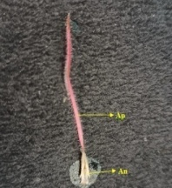 | 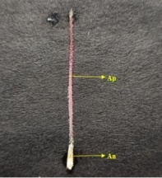 | 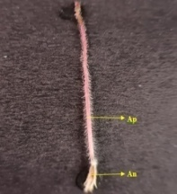 | 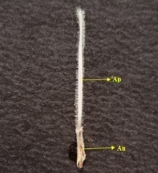 | 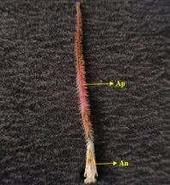 | 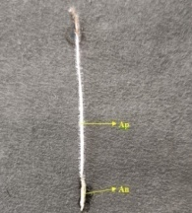 | 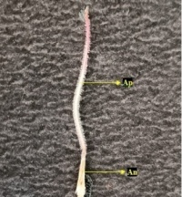
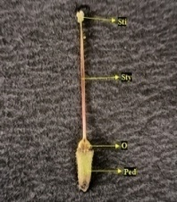 | 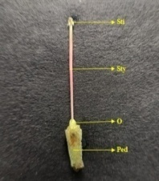 | 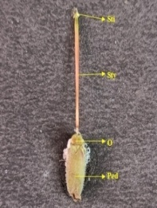 | 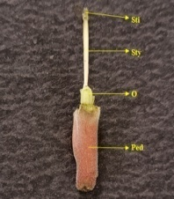 | 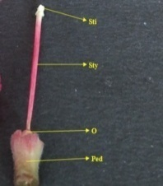 | 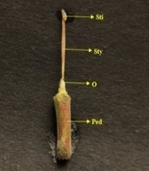 | 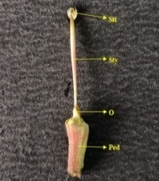
An- Anther; Ap- Appendage; O- Ovary; Ped- Pedicel; Sti- Stigma; Sty- Style

The calyx consists of five sepals (polysepalous and quincuncial aestivation). The corolla consists of 1–4 whorls of petals; each whorl of petals has 5 petal lobes. Its aestivation is twisted and it overlaps to the right (clockwise). The androecium is situated near the base of the swollen corolla tube and the anthers form a cone and cover the stigma. The anther was sagittate and pubescent. The filament is absent; the base of each anther has filaments like hairs. Each anther has long and hairy apical appendages. The gynoecium consists of two free carpels but is united by the style. The stigma was dumbbell-shaped. The ovary is superior and bilocular, with 15–18 ovules in each locule and axile placentation.
Plate 5. Fruit and Seed of Adenium obesum cultivars
C | DR | F | PP | RL | RWE | TR
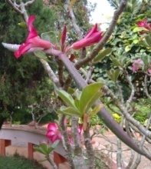 | 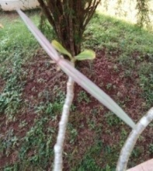 | 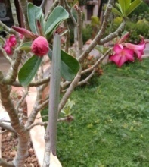 | 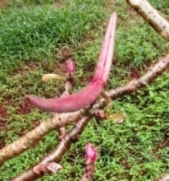 | 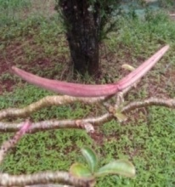 | 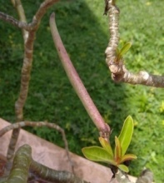 | 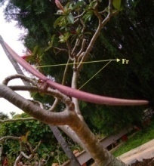
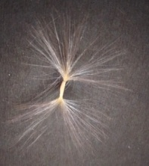 | 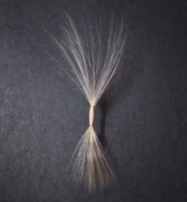 | 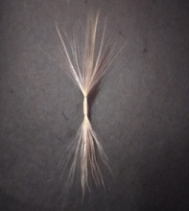 | 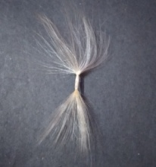 | 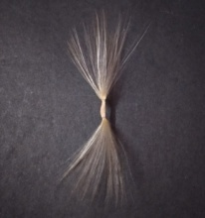 | 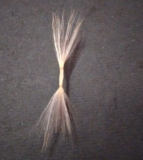 | 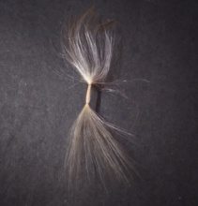

Table 2. Morphological characterization of seven Adenium obesum cultivars
Cultivars | C | DR | F | PP | RL | RWE | TR
Leaf Characters
Length of blade (cm) | 4.3–6 | 5.1–8.3 | 4.5–7.3 | 6.1–10.2 | 3.3–6.8 | 5.2–9.2 | 4.8–7.8
Width of blade (cm) | 1.7–3 | 2.6–4.6 | 2–4.1 | 1.8–3.9 | 1.2–4.1 | 1.8–2.7 | 1.9–4.2
Leaf color | 1 | 1 | 2 | 1 | 1 | 3 | 1
Leaf shape | 4 | 2 | 1 | 1 | 2 | 1 | 3
Leaf apex | 1 | 1 | 2 | 1 | 3 | 1 | 4
Leaf base | 2 | 1 | 1 | 1 | 1 | 1 | 2
Flower Characters
Flower shape | 2 | 1 | 2 | 1 | 2 | 1 | 1
Flower color | 5 | 1 | 3 | 2 | 1 | 4 | 1
Flower number of whorls | 1 | 3 | 1 | 2 | 1 | 4 | 2
Length of flower (cm) | 7.4–8.9 | 9.6–10.7 | 7.2–7.9 | 8–9.9 | 6.4–7.8 | 8.5–10.3 | 8.1–10.1
Width of flower (cm) | 6.3–7.5 | 7.8–8.7 | 3.9–4.9 | 7.1–9.7 | 4.3–5.6 | 3.8–5 | 7–9.8
Pedicel color | 4 | 1 | 1 | 2 | 1 | 3 | 3
Calyx color | 4 | 2 | 1 | 3 | 1 | 1 | 2
Corolla lobe shape | 4 | 3 | 2 | 1 | 2 | 1 | 1
Androecium length (cm) | 3–3.3 | 2.8–4 | 3.5–4.5 | 1.7–2.6 | 3.1–3.3 | 4.1–4.5 | 3.2–4.2
Number of anthers | 2 | 2 | 2 | 3 | 2 | 1 | 1
Anther color | 1 | 1 | 2 | 2 | 1 | 1 | 2
Appendage color | 6 | 1 | 3 | 2 | 4 | 1 | 5
Gynoecium length (cm) | 1.8–2 | 2.2–2.5 | 1.6–2.2 | 1.1–1.6 | 2.2–2.3 | 1.7–2.2 | 1.7–2
Stigma color | 1 | 1 | 2 | 1 | 1 | 2 | 1
Style color | 2 | 1 | 2 | 3 | 1 | 1 | 4
Ovary color | 4 | 1 | 2 | 1 | 1 | 1 | 3
Fruit Characters
Fruit | 1 | 1 | 1 | 1 | 1 | 1 | 1
Fruit color | 1 | 1 | 1 | 1 | 1 | 1 | 1
Fruit shape | 1 | 1 | 1 | 1 | 1 | 1 | 1
Length of fruit (cm) | 13.2–13.8 | 12–13 | 13–16.5 | 12.5–13 | 11.5–13 | 9.5–12 | 12–13.5
Width of fruit (cm) | 1.1–1.3 | 0.9–1.2 | 1.2–1.5 | 0.8–1.1 | 0.9–1.1 | 0.6–0.8 | 1–1.2
Seed Characters
Number of seeds | 62–80 | 45–60 | 60–80 | 50–55 | 65–75 | 15–30 | 55–65
Seed color | 1 | 2 | 1 | 1 | 1 | 2 | 2
Seed length (cm) | 0.8–0.9 | 0.9–1.1 | 0.9–1.1 | 0.8–1.1 | 0.8–1 | 0.6–0.9 | 0.9–1
Seed width (cm) | 0.2–0.3 | 0.2–0.3 | 0.2–0.3 | 0.2–0.3 | 0.2–0.3 | 0.2–0.3 | 0.2–0.3
Coma color | 1 | 1 | 1 | 1 | 1 | 1 | 1

Similarities
The similarities of the seven cultivars of the Adenium obesum are
Stem color and nature, leaf arrangement, entire margin, pinnate venation, petiole color and nature, inflorescence type, bracteole shape and nature, flower bud shape, calyx aestivation, sepal shape, nature and polysepalous, corolla aestivation, swollen and cylindrical corolla tube nature, androecium position, anther shape and nature, hairy appendages, filament absent, filament like hairs, stigma shape, superior ovary, fruit type, fruit shape and color, seed shape and coma color.
Dissimilarities
There are differences in leaf shape, color, apex, base, number of veins, blade size, petiole size, flower shape, color and size, number of whorls, flower bud color and size, pedicel color and size, bract color and size, calyx color and size, corolla size, corolla lobe shape and size, corolla tube size and color, number of anthers, anther color and size, appendage color and size, gynoecium size, stigma color, style color and size, ovary color, fruit size, seed color and size, coma size.
DISCUSSION
In this research, the morphological characteristics of seven Adenium obesum cultivars studied showed a significant morphological difference. In a remark similar to the one made in the present study, [3] observed that the stigma of Adenium obesum is hidden inside the cone formed by the anthers. Adenium obesum cultivars leaf and flower lengths were researched by [4] for 6 cultivars, while this study focused on the morphology of 7 cultivars. [2] investigated the fruit and seed morphology of Adenium obesum cultivars. According to [1], Adenium obesum fruit length varied from 15.1–25.1 cm, which was comparable, while the fruits breadth was 11.1–15.5 cm, which was different from the current study.
CONCLUSION
From this study, morphological variations were observed among the seven Adenium obesum cultivars. The cultivars could be divided into three groups: single form, double form and triple form. The color variation and quantity of floral whorls were the two most significant morphological variances seen in seven varieties. The results of the current investigation showed that the C cultivar has the smallest blade and the PP cultivar has the largest blade. The cultivars are difficult to distinguish based on vegetative morphological characteristics because they have a similar morphology. However, the flowers morphology was clearly differentiable because the cultivars distinguishing traits were its color and number of whorls. The current study makes it more interesting to look into cultivar genotypes.
REFERENCES
[1] Colombo RC., Maria Aparecida Da Cruz., Deived Uilian De Carvalho., Rodrigo Thibes Hoshino., Guilherme Augusto Cito Alves., Ricardo Tadeu De Faria, “Adenium obesum as a new potted flower; growth management,” Ornam. Hortic. (Campinas), vol. 24, no. 3, pp. 197–205, 2018. DOI: http://dx.doi.org/10.14295/oh.v24i3.1226
[2] Colombo RC., Vanessa Favetta., Lilian Yukari Yamamoto., Guilherme Augusto Cito Alves., Julia Abati., Lúcia Sadayo Assari Takahashi., Ricardo Tadeu de Faria, “Biometric description of fruits and seeds, germination and imbibition pattern of desert rose [Adenium obesum (Forssk.), Roem. & Schult.],” Journal of Seed Science, vol. 37, no. 4, pp. 206–213, 2015. DOI: http://dx.doi.org/10.1590/2317-1545v37n4152811
[3] Dimmitt MG., Joseph G., Palzkill D, “Adenium: Sculptural Elegance, Floral Extravagance,” Scathingly Brilliant Idea, Tucson, AZ, 2009, pp. 59–64.
[4] Hastuti D., Suranto., Prabang Setyono, “Variation of Morphology, karyotype and protein band pattern of Adenium (Adenium obesum) varieties,” Bioscience, vol. 1, no. 2, pp. 78–83, 2009. DOI: 10.13057/nusbiosci/n010205

