Advanced suction based static trash collector using IOT

Ms.S.Brindha¹, R.Balavenkatesh², A.Karuppusamy ³,C.Karthick ⁴, D.Abishek⁵
1-Assistant professor, Department of Electronics and Communication Engineering,
Nandha Engineering College, Erode, Tamil Nadu, India.
2,3,4,5-Student in Department of Electronics and Communication Engineering,
Nandha Engineering College, Erode, Tamil Nadu, India.

Abstract-- The level of cleanliness in the rooms should be ensured for quality living. By using this system the neatness of the living space is constantly verified by analyzing the level of the garbage in the dustbins which are placed in various parts of the rooms. This project presents a advanced suction based static trash collector using Internet of Things (IoT) technology. The proposed system is able to monitor the trash collector levels and provide real-time data to the users. This system consists of different components such as sensors, a microcontroller, cloud storage and a web-based user interface. The sensors will be used to measure the trash collector levels and the microcontroller will collect data from the sensors and send it to the cloud for storage. The web-based user interface will allow users to view the real-time trash collector levels and take appropriate actions accordingly. The proposed system can be used to reduce the amount of waste being disposed of, as users can be alerted of when the trash collector levels are reaching the capacity. It can also help reduce the cost of waste management by providing an efficient monitoring system. We can monitor the patient the through internet and smart phones.

- INTRODUCTION

Recently, there has been a lot of interest in the concept of smart waste collection. In the subject of IOT, significant efforts have been undertaken to increase the dependability and productivity of urban areas. IOT found problems like inadequate trash collection and fuel waste. In this paper, we present an intelligent garbage monitoring system that combines IOT and the cloud to eliminate the need for a lot of manual labour. The suggested Smart waste monitoring system has a moisture sensor to help separate dry and wet trash. This ingenious device, called Advanced suction based static trash collector using IOT, will help to keep the environment clean. Essentially, this system sends the user information via email about the amount of garbage that has accumulated in the trash cans. It sends an alert when a bin is full using sensors connected to the Internet of Things (IoT). The amount of time, money, and labour needed for manual trash collection and disposal may be decreased thanks to this technology. It can also assist towns in better planning their services and enhancing their environmental performance by giving real-time data. The technology can be used to assess the different waste types, monitor the amount of trash collected in a certain location, and even improve the trash collection route..

- LITERATURE SURVEY

Z. Kang et al[1] proposed to Develops a machine-learning algorithm based on ResNet-34 and three tailor-made modifications, including multi feature fusion and re-use of residual unit. The automatic garbage collection system is integrated with the required algorithm and hardware, and the system works well in the high class classification system and it is stable in the fast classification system.
N. L. Husni et al[2] proposed to the 3G-bot can send data efficiently and mobile phone can receive data directly.The rising level of waste detected can be follow the presentation of mobile phones, is different corresponds to the reading value of the sensor. They will be decreased during the percentage of litter..
M. Srilatha el at[3] purposed to the main objective of the proposed program is to maintain the level of sanitation in the city and create better healthy living conditions. We can always check the amount of garbage in the houses in different parts of the city using this device. If the most stage has been reached by means of a specific dustbin, the personnel may be informed and they can take certain movements without delay to empty it as quickly as viable.
Akanksha et al[4] purposed to the collection of rubbish together with the method of route putting i. E. Photo centralization, transferring in the direction of the rubbish until the equal covers the 70 according to cent of the middle element was done with accuracy of eighty consistent with cent. The bot changed into able to select and drop the rubbish dataset this is chosen i. E. Rubbish weight among a hundred - two hundred gm. The sensors were capable of discover when the bin(s) have been full. The bot stopped the operation, momentarily and resumed when the bins had been emptied.
E. K. Deeksha More et al[5] purposed to automated waste segregator bin using robotic arm plays the segregation into steel, dry and moist waste. The waste across the bin is detected and robot arm is used to place the waste inside the bin. This device is more modern as it consists of an automated gadget and a robot arm, making it a greater powerful and efficient device. It's far greater reliable and powerful in comparison to the present waste control system as it excludes the human paintings to segregate waste to a extremely good volume. Mistakes even as segregation can be avoided.
S. Singh et al[6] purposed to the paper affords the hardware design and implementation of a smart rubbish collection gadget. The proposed machine was capable of offer real time updates on the rubbish bin degree and process the records on the server side to calculate the ideal route for the rubbish collection containers. This affords a pathway to further tendencies of mobile based applications and entire rubbish disposal answers for smart cities.

- MATERIALS AND METHODOLOGY

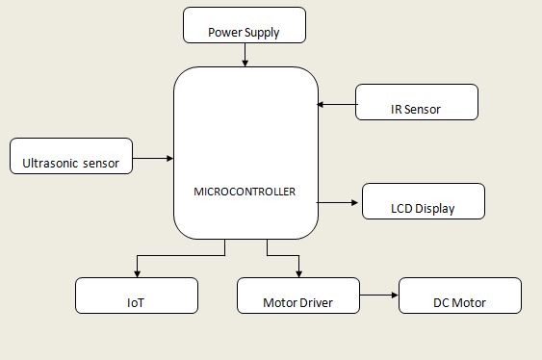
Figure 1: Block diagram
Infrared sensors(IF sensors) might be able to come across or emit IR radiation to test the surrounding place. they're able to amount that the item emits and they can hit upon the motion of the magazine of advanced studies in dynamical and management structures. all the gadgets that have a temperature greater than absolute 0 possess thermal energy and assets of infrared radiation as a result. The supply for IR is a blackbody radiator, tungsten lamps, and silicon carbide. Optical factors, such as optical lenses made from quartz lenses. Ultrasonic sensors are used especially as proximity sensors. they'll be discovered in vehicle self-parking technology and anti-collision protection structures. Ultrasonic sensors are also applied in robot obstacle detection systems, as well as in the manufacturing era. The liquid crystal display features indicate the repute of the dustbin to the person. The displaying liquid crystal display show will show 3 varieties of analyzing while the dustbin is empty. when the dustbin reaches half of the dustbin, and even as the dustbin is full. Dc cars are suitable for plenty of packages – along with conveyors, turntables, and others for which adjustable pace and regular or low-pace torque are required. moreover, they paint well in dynamic braking and reversing packages, which may be commonplace in masses of business machines. Motor drivers offer immoderate energy to the motor via the use of a small voltage sign from a microcontroller or a manipulated machine. If the microprocessor transmits an immoderate entry to the motor motive force, the cause force will rotate the motor in one route preserving the one pin as excessive and one pin as low. IoT has emerged as one of the maximum critical eras of the 21st century. Now that we can join regular gadgets—kitchen appliances, motors, thermostats, little one monitors—to the internet through embedded gadgets, seamless conversation is feasible between human beings, processes, and things. Microcontrollers are utilized in automatically controlled products and devices, which incorporate automobile engine manipulation structures, implantable clinical devices, faraway controls, workplace machines, appliances, energy tools, toys, and distinct embedded systems. nowadays almost every digital tool needs dc delivery for its smooth operation and they want to be operated on internal certain energy delivery limits. This required dc voltage or dc delivery is derived from unmarried section ac mains. A regulated energy supply can convert unregulated an ac to a regular dc (direct cutting-edge modern-day or voltage). Regulated power delivery is used to make sure that the output stays consistent even though the input modifications. A regulated dc electricity supply is likewise referred to as a linear energy delivery, it's miles an embedded circuit and includes diverse blocks.
1. Create a format plan: the first step in creating a paralysis patient speaking tool with the use of a smart glove is to offer you a layout plan. The plan has to include the kind of components to be used, which incorporates the microcontroller, ultrasonic sensor, liquid crystal display, and motor using pressure as well as the general layout of the tool.
2. Growing an architecture for the advanced suction-based static trash collector IoT: the structure for the trash collector device needs to be designed to house the wonderful additives used inclusive of the IoT controller, ultrasonic sensor, IR sensor, motor strength, and motor. The shape wants to make it feasible for each issue to acquire, manner, and transmit facts in a secure and green manner.
3. The PIC controller will be used to control the various components of the trash collector gadget. It needs to be programmed to observe facts from the ultrasonic sensor and the IR sensor, technique the information, and transmit the statistics to the IoT.
4. Connecting the additives of the garbage tracking device: the several components of the trash collector system ought to be associated with the p. C controller. This includes connecting the ultrasonic sensor, the IR- sensor, the motor force, and the motor. The connections have to be made in this sort of manner so that facts may be transferred to the various additives and the percent controller.
5. Integrating the trash collector system with the IoT: once the connections between many of the additives and the % controller were made, the trash collector gadget needs to be incorporated with the IoT. the mixing need to be carried out in this type of way so that statistics amassed by the manner of the p. C controller may be sent to the IoT for similarly processing and assessment..
6. Testing the trash collector machine: once the trash collector tracking gadget has been linked and protected with the IoT, it needs to be tested to ensure that its miles are operating properly. They take a look at the need to embody checking out the records switch among the components, finding out the combination with the IoT, and checking out the functionality of the PIC controller.
7. Screen the tool: as soon as the device is deployed, it has to be monitored to ensure that it's far running well and imparting the desired consequences. this may include accumulating records at the affected person's actions and responses to the device.

- RESULT

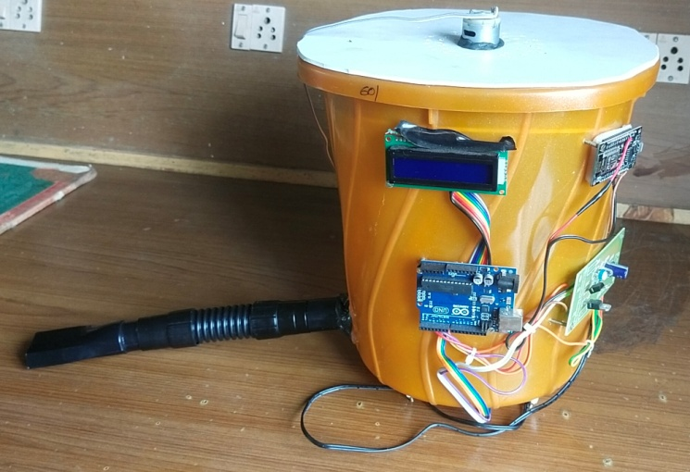
Figure 2 : Hardware implementation for proposed system
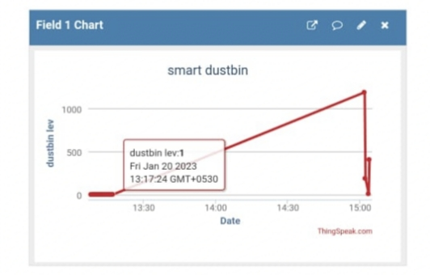 Figure 3: Garbage level of trash collector
This framework has been successfully advanced and executed. The superior suction-based static trash collector is efficaciously modulated to acquire trash mechanically. This device makes use of ultrasonic sensors to hit upon rubbish and suction into the trash. The proposed system is used for hospitals, colleges, and classrooms. the rubbish degree is shown on internet sites to look the person amassing trash.

- CONCLUSIONss
The advanced suction-based static trash collector can pay loads within the course of an easy and disinfected pollution-less environment. As the era is new in India there must be suitable cognizance and application of a few of the public in advance of the operation of this era. otherwise, touchy gadgets like sensors might be spoiled due to the tough motion of the clients. it is an automated dust bin tracking gadget to reveal the general state of affairs of the garbage bins. This gives the prison customers suitable updates on the location of the garbage boxes and subsequently eliminates the need for intermittent manual checks and overflowing garbage containers. This approach finally allows for keeping the surroundings easy. for this reason, the garbage series is made extra green, effective, and operative.

REFERENCES:
- Z. Kang, J. Yang, G. Li and Z. Zhang, "An Automatic Garbage Classification System Based on Deep Learning," in IEEE Access, vol. 8, pp. 140019-140029, 2020,

doi: 10.1109/ACCESS.2020.3010496.

- N. L. Husni, Robi, E. Prihatini, Nurhaida, A. Silvia and Firdaus, "Garbage Monitoring and Warning System," 2019 International Conference on Electrical Engineering and Computer Science (ICECOS), 2019, pp. 171-175.

doi: 10.1109/ICECOS47637.2019.8984545.

- M. Srilatha, C. Abhinav, M. Balaram and A. Sanjana, "Smart Monitoring and Collection of Garbage System Using Internet of Things," 2021 Third International Conference on Intelligent Communication Technologies and Virtual Mobile Networks (ICICV), 2021, pp. 335-342.

doi: 10.1109/ICICV50876.2021.9388438

- Akanksha, M. Gupta and M. M. Tripathi, "Smart Robot for Collection and Segregation of Garbage," 2021 International Conference on Innovative Practices in Technology and Management (ICIPTM), 2021, pp. 169-173,

doi: 10.1109/ICIPTM52218.2021.9388369
.
- E. K. Deeksha More, S. Divya, G. Kalyani and R. Gowthami, "Automatic Waste Segregator Bin Using Robotic Arm," 2018 3rd IEEE International Conference on Recent Trends in Electronics, Information & Communication Technology (RTEICT), 2018, pp. 1555-1558,

doi: 10.1109/RTEICT42901.2018.9012120.

- S. Singh, P. Baruah, S. Rai and R. K. Karsh, "Solar Powered IoT based Garbage Collection System," 2020 International Conference on Communication and Signal Processing (ICCSP), 2020, pp. 153-156,

doi: 10.1109/ICCSP48568.2020.9182257.

- M. Badve, A. Chaudhari, P. Davda, V. Bagaria and D. Kalbande, "Garbage Collection System using IoT for Smart City," 2020 Fourth International Conference on I-SMAC (IoT in Social, Mobile, Analytics and Cloud) (I-SMAC), Palladam, India, 2020, pp. 138-143, doi: 10.1109/I-SMAC49090.2020.9243387.
- P. Jajoo, A. Mishra, S. Mehta and V. Solvande, "Smart Garbage Management System," 2018 International Conference on Smart City and Emerging Technology (ICSCET), Mumbai, India, 2018, pp. 1-6, doi: 10.1109/ICSCET.2018.8537390.
- H. Jabar, R. Hassan and A. S. Sadeq, "A New Smart Waste Managing System," 2020 International Conference on Computer Science and Software Engineering (CSASE), Duhok, Iraq, 2020, pp. 209-214, doi: 10.1109/CSASE48920.2020.9142068.
- R. Sivapriyan, N. Sakshi and K. Mahesh, "Intelligent Garbage Collection Application for Smart City," 2021 International Conference on Advancements in Electrical, Electronics, Communication, Computing and Automation (ICAECA), Coimbatore, India, 2021, pp. 1-6, doi: 10.1109/ICAECA52838.2021.9675572.
- P. Ramesh, J. M. Sahayaraj, N. Subash, S. R. Mugunthan and S. J. Pratha, "IoT based Waste Management System," 2022 International Conference on Electronics and Renewable Systems (ICEARS), Tuticorin, India, 2022, pp. 587-592, doi: 10.1109/ICEARS53579.2022.9752091.

- H. N. Saha et al., "Waste management using Internet of Things (IoT)," 2017 8th Annual Industrial Automation and Electromechanical Engineering Conference (IEMECON), Bangkok, Thailand, 2017, pp. 359-363, doi: 10.1109/IEMECON.2017.8079623.

- B. S. Sasikanth, L. Naga Yoshita, G. N. Reddy and M. P.V, "An Efficient & Smart Waste Management System," 2021 International Conference on Computational Intelligence and Computing Applications (ICCICA), Nagpur, India, 2021, pp. 1-6, doi: 10.1109/ICCICA52458.2021.9697316.
- A. V.P. et al., "Automatic Waste Segregation and Management," 2020 International Conference on Computer Communication and Informatics (ICCCI), Coimbatore, India, 2020, pp.1-5,doi: 10.1109/ICCCI48352.2020.9104196.
- Z. Chang, L. Hao, H. Tan and W. Li, "Design of mobile garbage collection robot based on visual recognition," 2020 IEEE 3rd International Conference on Automation, Electronics and Electrical Engineering (AUTEEE), Shenyang, China, 2020, pp. 448-451,doi: 10.1109/AUTEEE50969.2020.9315545.

