An Iot based low cost robot for multiple household applications
Dr.Anshuman Singh,Manish kumar,Nishant Singh,Noorjahan Khatoon,Palak Kumari
(Electronics and Communication Engineering, Noida Institute of Engineering and Technology, Greater Noida, India)
Abstract: Solace is one of the central concerns of shrewd home framework. The minimal expense Robot depends on Android stage, centering at saving time and human accommodation. The family robot can be followed from a distance by clients, and controlled to complete different activity like cleaning, wiping, etc though it has a programmed highlight which will permit it to work without the need of controlling it. On adding WIFI innovation and the development of 4G organization and improvement of 5G organization, as well as utilizing Android framework application broadly, family robots in view of the Android stage will acquire broad consideration and use.

- INTRODUCTION

The world is moving with the quick advancement of development. All that will be computerized and sharp and is in a solitary tick. Robotization gadgets have turned into a fundamental piece of the home. Machines that reconsider specific capabilities take on dreary cleaning assignments, carrying association and solace to homegrown life. We have planned a devoted computerized framework for shrewd cleaning, wiping and tidying of house according to human comfort. A Robot won't just assist in cleaning or tidying yet with willing likewise be a shrewd hand of the people . A Robot which will detect the dirt and consequently clean it. A robot which will detect the hindrances and will consequently adjust the course and will alter it's course. We have remembered pretty much all the security measure. This framework is planned as a working with innovation on the logical way to completely free (nonpassive) association representing things to come. We have likewise dealt with adding a few additional highlights in it that is adding a decent smell to the house in the wake of cleaning. We have presented a framework that offsets manual control with programmed dirt and obstruction detecting, advancing regular and enthusiastic communications.Our main benefaction include:
• Saving time in this busy life of humans.
• To maintain extra hygiene and cleanliness of the house.
• Basically, to introduce a smart hand of the humans.

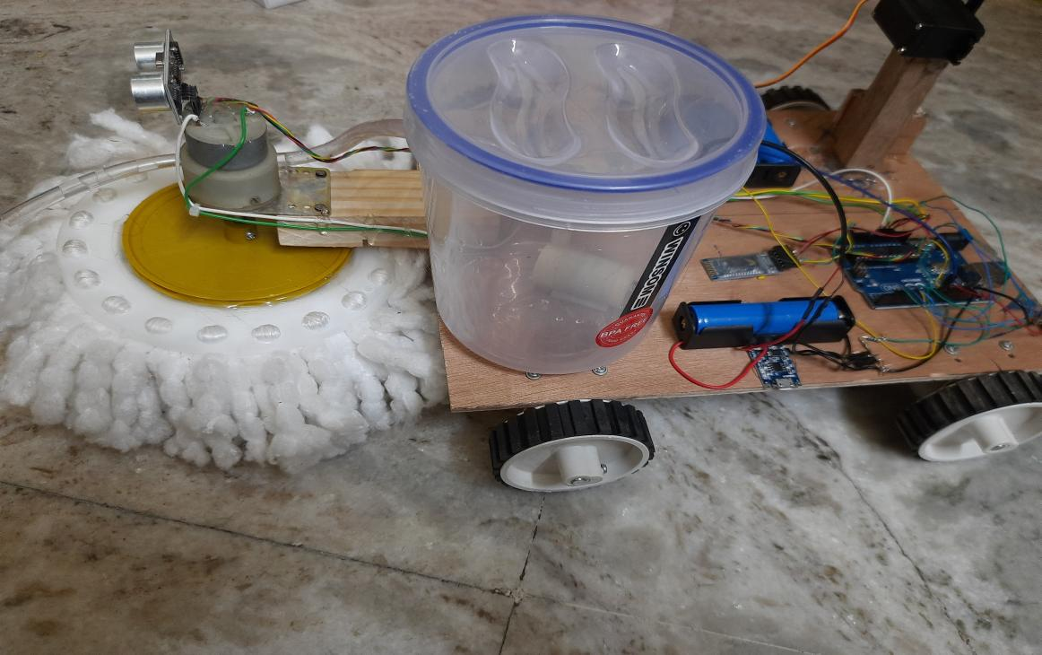

  - Cleaning
The robot is mainly designed for the cleaning purpose.It will be convenient for many of us.People are nowadays so busy in their lives that they don’t get time to clean and maintain their house.This multipurpose Iot based Robot will act as a smart hand of humans.
  - Manual mode/Automatic mode
Since this robot has to be a smart hand of humans it should be able to clean the house without keeping an eye on it.People when will not be at home or at some work then just by using the automatic mode the robot should do it’s work.Also when automatic mode not needed it should also has the manual mode by which cleaning could be done.

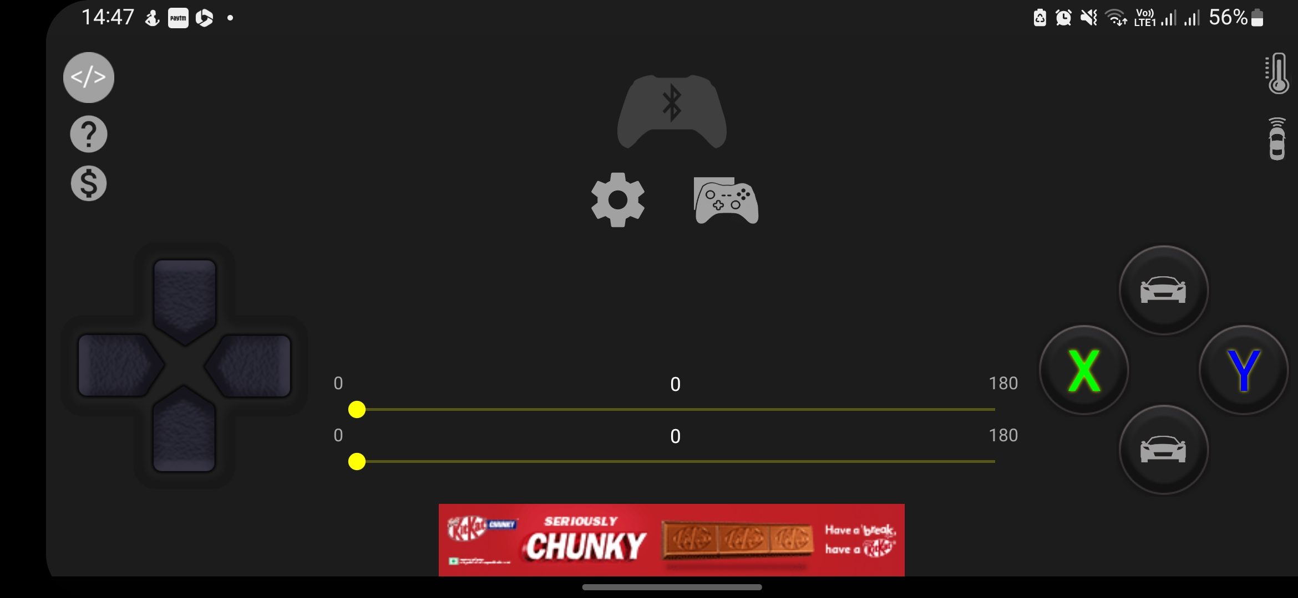

1.3 Sensing Obstacles
The robot will also be able to sense the obstacles so that while cleaning the floor if something comes into the way then it will automatically change it’s direction.
1.4 Spraying Room Freshner
The robot has also an additional feature to it that is, after cleaning the floor, it will spray the room freshener so that the room doesn’t has any odor or some sort of smell. The room will smell fresh.

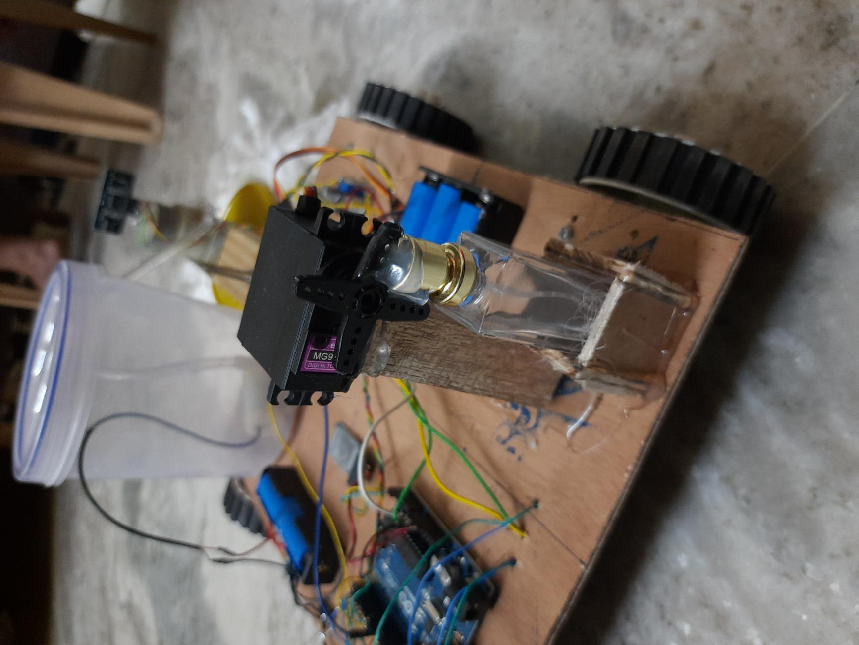

- ROBOT HARDWARE DESIGN
This Robot is particularly based on Arduino Uno, ultrasonic sensors, HC-05 Bluetooth module, motor driver, geared motors, single channel 5v relay module, wheels, diaphragm water pump, lithium-ion batteries, voltage regulator, resistors and few more components. According to the following circuit diagram, firstly we will connect the motors to the finalized base. Then after placing sensor clamps, we have to assemble the circuit on a zero PCB board. After all this, we have to connect all the components to main circuit board.

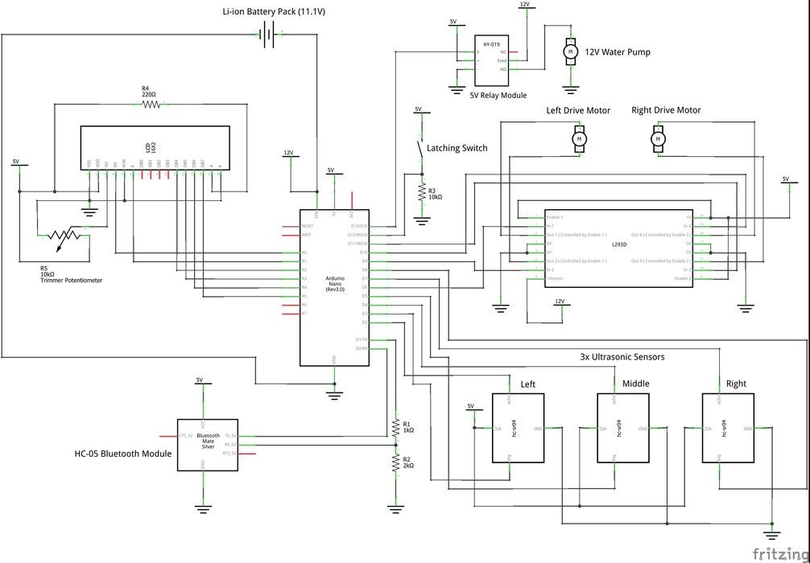
Fig2a:-circuit design of an iot based Robot

- IMPLEMENTATION

The following flowchart shows the implementation of the cleaning robot.

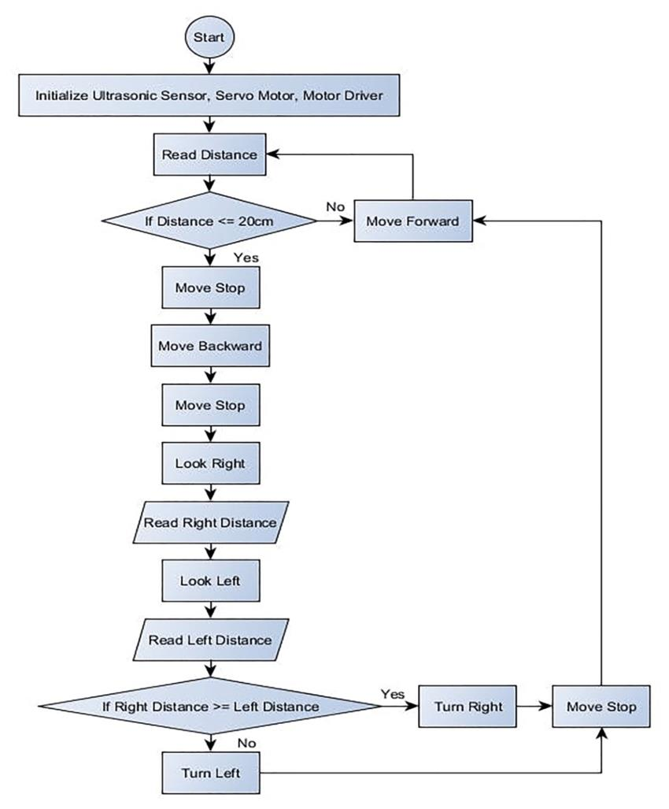
Fig3a:-flowchart of implementation of robot

- Circuit assembly: - Take a piece of board (zero PCB). Bind a few female headers and afterward, first and foremost, interface male headers parallelly to every one of the female header which compares to each nail to the Arduino. All outside parts will be connected to the male headers. Bind a few additional female headers to interface the LCD. Border a screw terminal (to interface power supply from battery), hooking switch and voltage controller to the PCB. Retouch a few male headers before the voltage controller. Presently, summarize every one of the resistors and interface everything as indicated by the schematic utilizing wires.
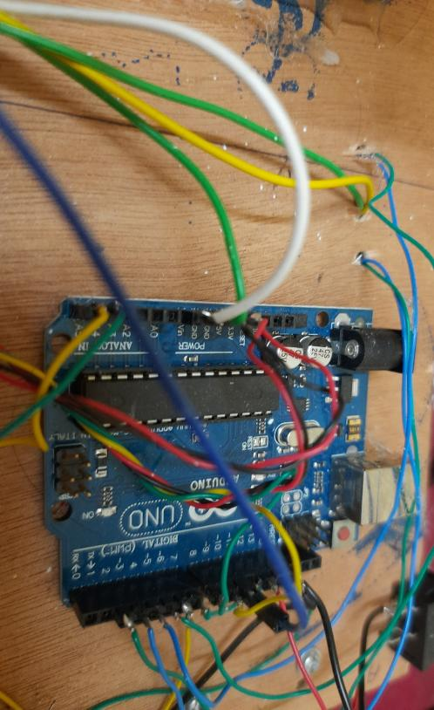

Fig3b:-zero pcb board

- Arduino Uno programming: - Firstly we will, connect the other components to the Arduino using wires. After that, the code which we have designed for the directions of the robot, will be uploaded to the Arduino.

- Water spraying mechanism: - To splash water on the mop, we utilized a Stomach siphon with an extremely basic interaction. Two lines are utilized, one is the in-way pipe that will go to the water supply and the other one is the exit plan pipe which will go to the mop. For the in-way pipe, I utilized 8mm width tubing. For the exit plan, I utilized a tight line I got from trickle suffuse framework which is associated with a little stream control fixture to control the progression of water. (Since we don't maintain that our mop should be splashed with water).A barrel shaped plastic box is utilized as a water supply.
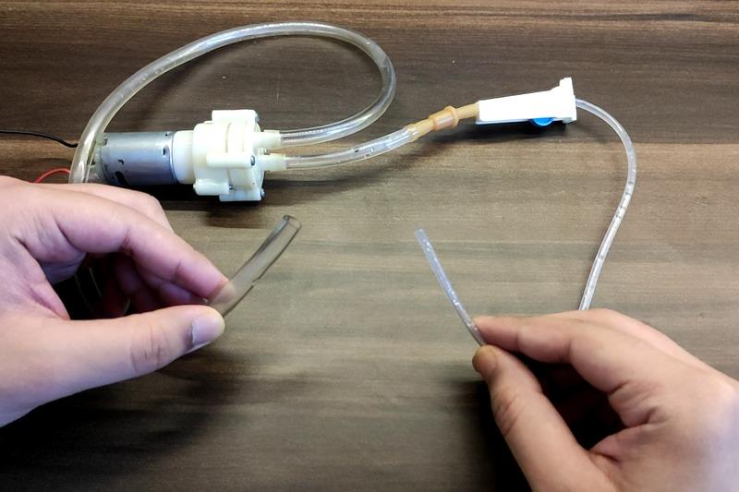

Fig3c:-water supplying diaphragm pump

- Power Supply: - For the power supply, we chose to utilize 12v Lithium-particle batteries. This is most likely the most ideal choice to control our robot since lithium batteries have high energy thickness and furthermore battery-powered. Every one of the 3 batteries are associated in series. I utilized 3 single cell holders, stuck them on the base and associated them in series. We associated a switch too to turn the robot on/Off. Ultimately, We associated the stock to the first circuit board.
E. Configure the App: For controlling the robot through a cell phone, we have utilized the HC-05 Bluetooth Module. We acquainted an application with control the development of the app named "Arduino Car." Subsequent to downloading it from Play Store, we want to make it to such an extent that it works as needs be with our robot.

- CONCLUSION
We can work on the planning and working of this undertaking by making it WiFi controlled or perhaps making the calculation more inventive. The calculation that we utilized for programmed mode is extremely fundamental and it probably won't work at times which makes the entire planning a robot squander. We can work on the code for a superior working, at the present time we have utilized Installed C yet other more dialects can be utilized. An issue which truly need to chipped away at is that when the mop was drenched with water, it would be weighty to such an extent that the wheels wouldn't have the option to push the robot. This confines us to somewhat wet the mop. We can most likely fix this issue by utilizing some more powerful engines or of significant size wheels, or putting more weight on the robot so there is more grating and it doesn't slip. Likewise, assuming we would add camera for administering it would have been a lot more straightforward for us to making it completely programmed.

REFERENCES
[1] Manya Jain, Pankaj Singh Rawat, Assist.Prof. Jyoti Morbale "AutomaticFloor Cleaner”International Research Journal of Engineering and Technology Volume: 04 Apr -2017.
[2] Manreet Kaur, Preeti Abrol “Design and Development of Floor Cleaner Robot (Automatic and Manual) “International Journal of Computer Applications (0975 – 8887)Volume 97– No.19, July 2014.
[3] Jens-Steffen Gutmann, Kristen Culp, Mario E. Munich and Paolo Pirjanian.” The SocialImpact of a Systematic Floor Cleaner.” In IEEE international workshop on advance robotics and its social impacts, Technische University munchen, Germany May 21-23, 2012.
[4]Mr.Chavan Swaroop Chandrakant, Mr.Parulekar Sharvarish Shashikan, Mr. Gavali Omkar Raju, Mr. Gokhale Shantanu Bhalchandra, Mr. Shinde Vaibhav Tanaji " Semi-Automatic Floor Cleaner with Obstacle Avoidance for Indoor Applications” International Research Journal of Engineering and Technology Volume: 05 Feb-2018.
[5] Vaibhavi Rewatkar, Sachin T. Bagde,” Design of Automated Floor Cleaning System” International Journal on Recent and Innovation Trends in Computing and Communication ISSN: 23218169 Volume: 3 Issue: 2
[6]Ajaykumar,Madhura,Mahamunkar,Rose Merlin Jose Sahima Khan “Automated Operating Room Cleaning Robot”.International Journal of Advanced Research in Electrical Electronics and Instrumentation Engineering. Vol-5,Issue 04,April 2016.
[7] Aishwarya Pardeshi, Shraddha More, Dhanashri Kadam, V.A.Patil " Automatic Floor Cleaner" IJECT Vol. 8, Issue 1, Jan - March 2017.

