ANTISLEEP ALARM SYSTEM FOR DRIVERS
Prof. Pramod Kale¹, Radha Waghmare², Sakshi Morge³, Namrata Ingle⁴ , Nayana Kaneri⁵,
Vishwakarma Institute of Technology, Pune
Department of Industrial and Production Engineering

Abstract
Driving when drowsy might result in a dangerous traffic collision. When driving alone on the highway or for an extended amount of time, however, drivers are more likely to become bored and drowsy, or even fall asleep. The majority of driver anti-sleep detection solutions on the market today are essentially earphones that make intermittent sounds, which is both unpleasant and ineffective. As a result, there is a great need for low-cost, high-performance driver sleep detection systems. As a result, we devised a plan and constructed a drowsy detection and warning system that could effectively satisfy this need.

Keywords:
Accident Prevention, Anti Sleep Alarm, Arduino Technology, Driver Safety Tool, Eye Blink Sensor.

I. INTRODUCTION
The main objective of the antisleep alarm system for drivers is to develop a project which will reduce the road accidents which are caused due to drowsy driving.The project is based on arduino technology.System works on two steps that is receiving the continuous signals from eye blinks sensors and monitoring it .On the monitored signal the arduino nano will decides the operation and executes it according to the programming which is installed in the arduino nano.First the eye blink sensors will continuously detect the eyelid moment of the driver and it will give the specific output to the arduino and then the arduino will find weather the eyes are opened or closed and if it's found to be closed for some time interval it will activate the alarm and still if the eyes are in closed state then again after some time interval it will deactivate the BO Dual shaft motor with the help of relay and the system gets executed.

II. SYSTEM MODEL
By Concentrating on sleepy driver's eye movements, an iot-based technology might prevent innumerable accident caused by their behavioural and psychological changes. It is also necessary to preserve records of the location order to take supporting action in addition to monitoring the strength of collision impacts during road accidents.

III. IMPLEMENTATION-

A. Essemtial Ingredients_

1.Arduino Nano

2.Relay

3.Piezo Buzzer

4.Battery (9v)

5.Spst Switch

6.Eye Blink Sensor

1 Arduino Nano
Arduino Nano is a small, versatile microcontroller board that is based on the ATmega328P microcontroller chip. It is designed to be used for a wide variety of electronic projects, such as robotics, automation, and DIY electronic Nano is similar in function to the

quartz crystal oscillator. It also has a USB port for programming and power supply, a power jack, an ICSP header, and a reset button. The Nano can be programmed using the Arduino software, which is an open-source programming environment based on C/C++

Overall, the Arduino Nano is a powerful and convenient tool for prototyping and developing electronic projects. Its small size makes it easy to use in compact projects, and its versatility makes it suitable for a wide range of applications.

2.Relay-
An Arduino Relay is an electronic switch that is controlled by an Arduino microcontroller. It allows the Arduino to control high voltage or high current devices supply. that would otherwise be dangerous or impractical to control directly.

A relay works by using a low voltage signal to activate an electromagnet, which in turn switches a larger, high voltage circuit on or off. When an Arduino sends a signal to the relay, the electromagnet is activated and the high voltage circuit is opened or closed. Arduino relays are commonly used in home

automation, robotics, and other electronic projects. For example, you could use an Arduino relay to control the lights in your house, turn on or off a motor or fan, or even control the power to a whole room.

3.Piezo Buzzer-
An Arduino piezo buzzer is a small electronic device that is commonly used in Arduino projects to produce sound or alert signals. It consists of a piezoelectric crystal element that is placed inside a small casing with two wires for power and signal.

When an electrical signal is applied to the piezo element, it vibrates and produces sound waves that can be heard as a tone or a beep. The Arduino microcontroller can generate the electrical signal needed to drive the piezo buzzer and produce different sounds or tones depending on the programming code. Piezo buzzers are commonly used in various applications such as alarms, timers, musical instruments, and even in electronic toys. They are popular in Arduino projects because they are inexpensive, easy to use, and can be driven directly from the microcontroller's digital output pins

4.Battery-
The Arduino board can be powered by a variety of batteries, including lithium-ion, nickel-metal hydride, or alkaline batteries. The voltage of the battery used must match the operating voltage of the Arduino board, which is typically 9 volts or 6 volts.To power an Arduino board with a battery, the battery is connected to the board's power input pins. The Arduino board then regulates the incoming voltage and provides a stable supply voltage to the attached devices. The battery's capacity and voltage will determine the runtime and the number of devices that can be powered by the battery.
In addition to mobility and portability, using a battery in an Arduino project also provides increased safety, as there is no risk of electric shock from a power outlet. It also allows for the creation of standalone devices that can operate without the need for a constant power supply.

5.Spst Switch-
A Single Pole Single Throw (SPST) switch is a switch that only has a single input and can connect only to one output.

6.Eye Blink Sensor-
An eye blink sensor is a type of sensor that is used to detect when a person blinks their eyes. The sensor typically consists of an infrared light emitter and detector, which are placed in close proximity to each other on a circuit board.

When the sensor is placed near the eye, the infrared light emitted by the emitter is reflected off the eye and detected by the detector. When the eye blinks, the amount of reflected infrared light changes, which can be detected by the sensor.

The sensor output is then fed to a microcontroller, which processes the signal and determines whether a blink has occurred or not. Depending on the programming code, the microcontroller can then perform a specific action, such as triggering an alarm. turning on a light, or sending a notification. Eye blink sensors are commonly used in various applications such as driver drowsiness detection. gaming, and assistive technology for people with disabilities. They are also popular in wearable devices such as smart glasses and head-mounted displays.

IV. LITRATURE REVIEW

1. Number of accidents due to drowsy driving
India ranks first in the number of accidents across the 199 countries and accounts for almost 11% of the accidental deaths. In which 40 % of the accidents are caused by drowsy driving.

2. Monitoring physiological characteristics
Detecting drowsy driving can be detected by 2 ways the first one is measuring changes in physiological signals or Brain waves and then identifying the current state. The second one is by using a camera which will take constant images of drivers and then by image processing drowsy driving conditions can be identified. In both cases the setup is costly and has low accuracy.

3. Study related to arduino
In this we have gained knowledge on different arduino microcontrollers, the coding part through some research papers and courses. This helped us to build the system and integrate it with all the required parts.

4. Ir sensor
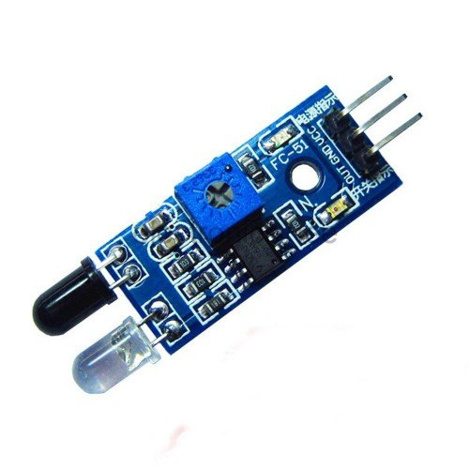
Figure.1

Infrared transmitter - a device that emits infrared rays. Similarly IR Receiver is used to receive the IR rays transmitted by the IR transmitter. One important point is both the IR transmitter and receiver should be placed parallel to each other. The signal is given to the IR transmitter whenever the signal is high, the IR sensor is conducting and it passes the IR rays to the receiver. The IR receiver is connected to the comparator. The comparator is connected with an operational amplifier. In the comparator circuit the reference voltage is given to the inverting input terminal of the circuit .The Noninverting input terminal is connected to the IR receiver. When there is an interruption in the IR rays between the IR transmitter and receiver, the IR receiver becomes not conducting. So the comparator non-inverting input terminal voltage is higher than inverting input. The comparator output is at the range of +5V. This voltage is given to the microcontroller. When the IR transmitter passes the rays to the receiver, the IR receiver becomes conducting due to non inverting input voltage being lower than inverting input. Now the comparator output is GND. So the output is given to the microcontroller. This circuit is mainly used for counting eyelid movement.

V..Methodology/Experimental
Implementing an automated system to vehicles that provides high security to drivers and passengers with the help of eye blink sensor and integrating it with arduino technology.The eye blink sensor provides continuous signal to the arduino nano.If the eyes are opened then the eye blink sensor gives low output and if the eyes are closed then its gives high outputs and if the outputs is high for some constant time then the arduino detects it as the driver is in drowsy condition then the arduino activates the buzzer for giving alarm to drivers.Now if still the driver not reacts to it then the arduino deactivates the relay which disconnects the BO Dual shaft motor and its stops.So this process is continuously repeated and avoids the accidents.

Materials/Components
-Arduino nano(figure1) is a microcontroller which is necessary in the project to control different types of components with the help of programming.
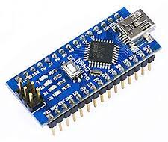
Figure 2

-Eye blink sensor(figure 2) is IR based sensor which is used to track eyelid moments with the help of IR transmitter and IR receiver and giving the specific output to the arduino.

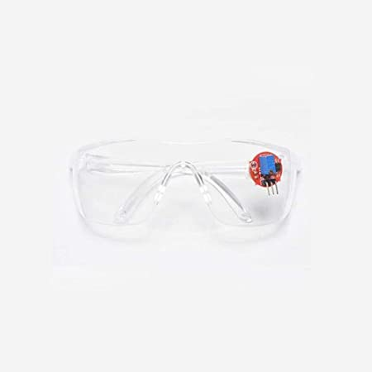
Figure 3

-1 Channel relay module used as an electric switch by taking the inputs from the arduino and operating the BO Dual shaft motor.

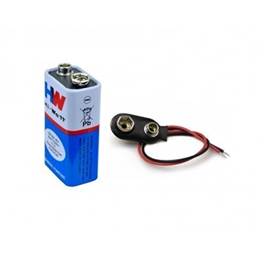

Figure 4
-Batteries are used for giving the power supply to the system.

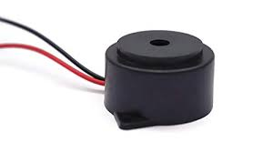
Figure 5
-Buzzer is used for giving alarm to the drivers
-Switches are used for turning the system on/off.
-BO Dual shaft motor used to represent the wheels of vehicles.

  - Block diagram

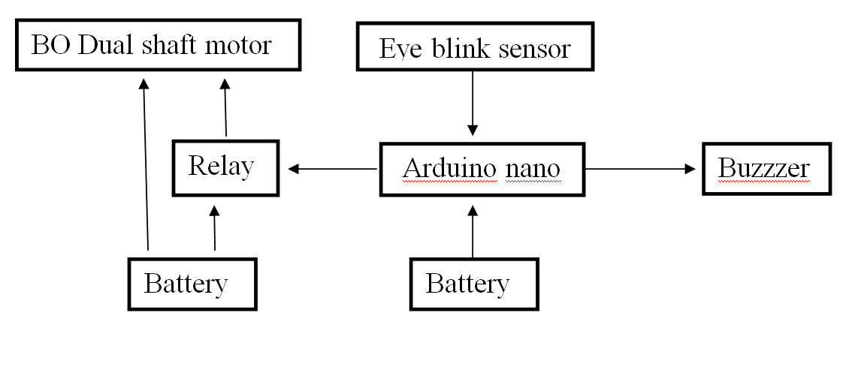Figure 6

Algorithm
Step 1-system starts
Step 2-continuously data sense from eye blink sensor
Step 3-process the sensed data
Step 4-checking the sensor state
Step 5-if eyes are opened then sensor state low
Step 6-buzzer off, relay on motor on
Step 7-if eyes are closed then sensor state high
Step 8-buzzer on,relay off motor off
Step 9-end

Circuit Diagram
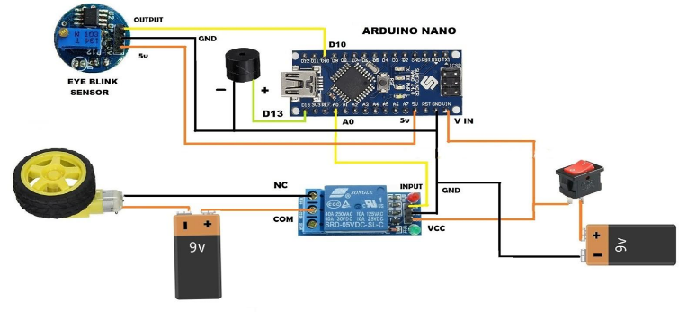

Testing
After testing the system for 100 times it is found that the system is 97% accurate and its accuracy can be increased by making the modifications in the system.

PIN DIAGRAM

In the above table we connect vcc pin of eye sensor to the vcc pin of arduino, gnd pin of eye sensor to the gnd pin of arduino, and output pin of eye sensor to the D7 pin of arduino.

Table 1: Connection between eye sensor and Arduino
Eye Sensor | Microcontroller
1. Vcc | 1 . Vcc
2. Gnd | 2. Gnd
3. Output | 3. D 7

In the above table 2, we connect positive pin of the battery to the Vin pin of the arduino and the negative pin of the battery to the gnd pin of the arduino.

Table 2: connection between battery and arduino
Battery | Microcontroller
1.(+) ve | Vin
2. (-) ve | Gnd

In the above table 3, we connect pin 1 of buzzer to Gnd pin of
microcontroller and pin 2 to the D6 pin of microcontroller

Table 3: connection between buzzer and arduino
Buzzer | Microcontroller
1.pin 1 | Gnd
2.pin 2 | D6

VI. RESULTS
The design and working of an antisleep alarm system for drivers is presented.The system avoids the road accidents caused due to drowsy driving of driver.It gives high accuracy.

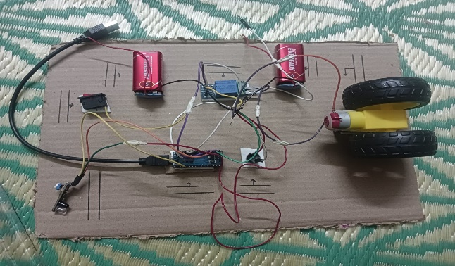
Figure .7

VII. LIMITATIONS
An anti-sleep alarm project based on Arduino Nano can help to alert a driver when they are getting drowsy while driving. However, there are some limitations to this project, such as:
False positives: The sensor used to detect drowsiness may give false positive results, for example, if the driver is not actually feeling drowsy but is blinking frequently due to some other reason.
Limited sensor range: The sensor used in the project has a limited range and may not be able to detect drowsiness accurately if the driver is wearing glasses or the sensor is not placed correctly.
Power supply: The project requires a stable power supply to operate, which can be a limitation if the power supply is not reliable or if the battery capacity is low.
Ineffective for severe drowsiness: The project may not be effective for severe drowsiness or if the driver is already asleep, as the alarm may not be loud enough to wake them up.
Dependence on code: The project's effectiveness depends on the accuracy of the code used, which may have bugs or limitations that can affect the performance of the system.
Legal limitations: Some countries may have legal limitations on the use of devices that emit loud sounds while driving, which can limit the project's use.
Top of Form Re Bottom of Form.

VIII. FUTURE SCOPE
After implementation on actual vehicles it is expected to reduce road accidents which will reduce the loss of lives and money. It can be “standardized” across all the models / classes of vehicles like transport , public sector, or even as an aftermarket accessory. In future we will use small micro camera which will replace the eye sensor and will incorporate GPS module in the device to track the location of the driver. Since the price is very affordable, we have a plan to marketing it in future.

IX. CONCLUSION
The proposed system is helpful to avoid vehicle accidents because of driver’s sleepiness using eye blink sensors. We have studied and designed the system for driver fatigue detection. If the driver becomes drowsy the eye blink sensor’s senses it and the system makes the alert and then wheels are stopped depending on the condition.

This system is an attempt to help in decreasing and/or prevent traffic accidents that happen due to drivers' drowsiness and fatigues. Using our anti sleep alarm system the drivers will be benefited and be alert while driving with a low price. We believe that our model has lots of societal impact which will reduce the accidents.

REFRENCES
[1] DRIVER FATIGUE AND ROAD SAFETY - IMPLICATION IN AN INDIAN CONTEXT Autor Rahul Dagli
Faculty of Technology, CEPT University, Ahmedabad, Gujarat, India
International Journal of Advances in Engineering & Technology, Aug., 2016
[2]The Hindu e paper article , author G. Krishnakumar, 2020
[3]Drowsy Driver Sleeping Device and Driver Alert System,Drowsy Driver Sleeping Device and Driver Alert System, 2014.
[4] A Hybrid Approach to Detect Driver Drowsiness Utilizing Physiological Signals to Improve System Performance and Wearability, Autor Muhammad Awais(University of Leeds)
Nasreen Badruddin(Universiti Teknologi PETRONAS),2017
[5] Driver Sleep Detection and Alarming System Design Review,
University of Illinois at Urbana-Champaign, 2013
[6] Driver Drowsiness Detection Based on Face Feature, Suhandi Junaedi and Habibullah Akbar Master in Computer Science, Bina Nusantara University
[7]On RGB-D Face Recognition, Gaurav Goswami, Samarth Bharadwaj, Mayank Vatsa, and Richa Singh from IIIT Delhi
[8]Driver drowsiness detection using ANN image processing,T. Vesselenyi1, S. Moca1, A. Rus1, T. Mitran1 and B. Tătaru1, 2017
[9] Online Detection of Driver Fatigue Using Steering Wheel Angles for Real Driving Conditions, Zuojin Li,1 Shengbo Eben Li,2 Renjie Li,2 Bo Cheng,2,* and Jinliang Shi1, 2017.
[10]Working Principle of Arduino and Using it as a Tool for Study and Research, Leo Louis, 2018
[11] Working Principle of Arduino and using it as a tool for study and research, Department of Electronics and Communication Engineering, Gujarat Technological University, Ahmedabad, 2016.

