Resonant frequency charger for Ozone Generation
Abhay Kumar Upadhyay Department of Electrical and Electronics Engg  Nitte Meenakshi Institute of Technology,  Bengaluru, India | Ashutosh Tiwary  Department of Electrical and  Electronics Engg  Nitte Meenakshi Institute of  Technology,  Bengaluru, India

Sujata Shivashimpiger Anil Kumar Mandal Abhishek Kr Singh
Department of Electrical and Department of Electrical and Department of Electrical and
Electronics Engg Electronics Engg Electronics Engg
Nitte Meenakshi Institute of Nitte Meenakshi Institute of Nitte Meenakshi Institute of
Technology, Technology, Technology,
Bengaluru, India Bengaluru, India Bengaluru, India

Abstract— Ozone is one of the best oxidizing agents and it leaves no harmful residue behind. This paper deals with the generation of Ozone by using high voltage (up to 3kv) and high frequency (up to 40KHz). Earlier we used to generate the ozone by applying less voltage and low frequency which causes efficiency loss, poor power factor and switching loss. We are using soft switching technology to overcome all of this causes. Therefore, in this paper we are using the power electronics in the inverter resonant circuit to produce alternating current with a high frequency(40KHz).

Keywords— Ozone generator, soft switching, Switching loss,

- INTRODUCTION
Ozone is utilised in water purifiers, air purifiers, and disinfectants. As a result, we are able to produce ozone both naturally and artificially. Since we could not naturally produce as much ozone as we required, we are now creating ozone artificially utilising the Corona discharge method. In this case, high voltage is used to supply oxygen between the two electrodes [1-4]. Ozone is produced as a result of the high voltage being produced by a step-up transformer from the 230V, 50Hz supply power. With the aid of an unregulated rectifier, the ac supply is transformed into dc. The high frequency inverter then transforms the dc into high frequency ac, which is then given to the step-up transformer. A 3KV output is produced from a 230V input using a step-up transformer. Thus, very high voltage is given to the Ozone Chamber [5-7]. Benefits of using high frequency include improving the power density delivered to the ozoniser electrode surface, which improves ozone production for a given surface area while lowering the required peak voltage [8]. This research focuses on the analysis of a parallel resonant inverter-based high frequency, high voltage power supply for an ozone generating system. By adjusting the switching frequency and modulation index of the inverter, the suggested system can alter the amount of ozone gas produced. Due to extremely high frequency (40 kHz), ozone is created artificially. thus, the high frequency results in increasing the density applied to the ozoniser electrode chamber surface and it increases in ozone production for a given surface.

synthesis of ozone to occur more smoothly and effectively by making the chamber suitable and effective enough. The current research is concentrated on the creation of a power supply converter with improved efficiency and the desired ozone production, as well as the prototype design of a model. Improvement of the supply power factor is another area of focus [8–9].

- BLOCK DIAGRAM OF OZONE GENERATOR

The AC supply is converted into DC with a help of an uncontrolled rectifier. The high frequency inverter converts the DC to high frequency AC and fed it to the step-up transformer. The step-up transformer gives 230V input to 3Kv output. Thus, very high voltage is given to the Ozone chamber. The block diagram is demonstrated in Fig.1

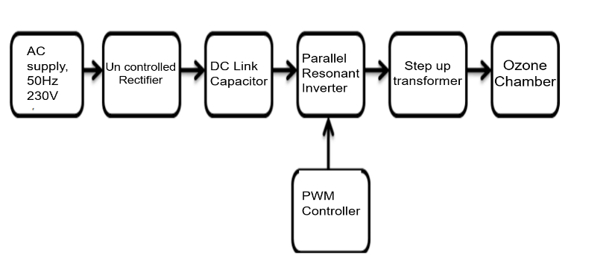

Fig.1 Block diagram of Ozone Generator

METHOD TO GENERATE OZONE

There are many ways to produce ozone, but we choose the Corona discharge method since it is both affordable and effective [7]. This approach involves passing oxygen gas between two electrodes. The oxygen molecule is changed into ozone as a result of a high voltage of up to 3kV being transmitted between the two dielectrics. The equation 3O2+energy=2O3 describes the ozone reaction. This process is mostly employed in industrial production. Ozone is produced from electrical discharge; the large amount of ozone is produced during lightening during a thunderstorm. Thus, we can say that this is the reason why we get a fresh smell after a thunderstorm.
The oxygen gas supplied to the ozone chamber determines how much ozone is created in each ozonator. The ratio of gas flow rate to ozone concentration is direct. The quality of the oxygen gas affects the concentration of ozone. Thus, ozone is created from the oxygen molecule.

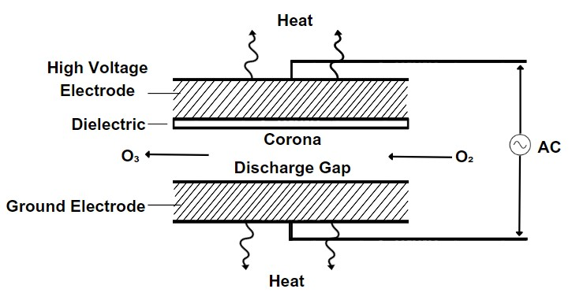Fig.2 Ozone Chamber Model

- PWM CONTROLLER DESIGN

IC 4047 is one of the popular ICs due to its low power consumption. This function offers both monotonic (one-shot) and sustained (free) modes. It has a wide input voltage range (3V to 17V), DC current input up to ±10mA and a high operating temperature range of -53°C to +122°C. Here IC is used to generate square and sine waves. It only requires a few resistors and capacitors. This IC can be used to generate clock pulses for various applications. This IC is mainly used in inverter circuits that generate alternating current from direct current. Applications of this IC include frequency separator, timing circuits, time delay applications, packet detection, frequency multiplication and frequency division. The following detail of IC is shown in Fig. 3 which describes the control unit of the model.
.
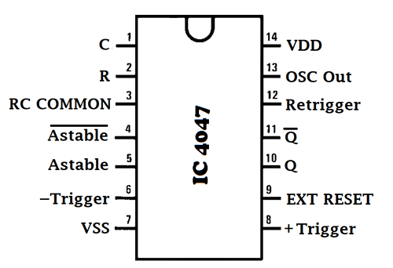
Fig.3 PWM Controller Design

The formula for finding the value of frequency of Square Wave is given below:
f = 1 / 8.8RC
f=40 KHz
So, the resistance is: R= 1 / 8.8*40,000*0.001*10⁻⁶
R=2.840 kilo ohm selected 2.8k ohm

- STEP-UP TRANSFORMER DESIGN

Primary voltage (V1) = 220 v
Secondary voltage (V2) = 3000 v
Assumed 1volt =2 turns
So primary turns (N1) = 440 turns
Secondary turns (N2) = V2/V1*N1
= 3000/220*440
N2 = 6000 turns

Transformer ratio (K) = 1:13

PWM CONTROL TO GENERATE HIGH FREQUENCY

Pulse Width Modulation is referred to as PWM. The PWM charge controller can be thought of as a switch that connects the batteries. It is simple to swiftly turn on and off the switch. As a result, the battery can be charged with the necessary voltage. The charging current slowly drops as the battery charges. The series resonant inverter circuit and the model of the rectifier component combine to generate the systematic circuit. The power value and same main circuit construction allow for the employment of the same technique in another main circuit. As needed, we can additionally use a variety of performance, preservation, and design options. In this article, In this article, PWM control mode is utilised. PWM control mode is a modulation method that creates pulses with varied widths to regulate an analogue input signal's amplitude. Phase shift pulse width modulation and frequency modulation, which may achieve high efficiency and desired frequency, are advantages of the modulation system. Many ozone generator systems today use the PWM control approach. The power supply is not compact because there is a huge transformer present, which has an impact on the system's performance. In Fig. 4 below, a quick model for achieving the frequency duty cycle is presented.

- SIMULATION MODEL

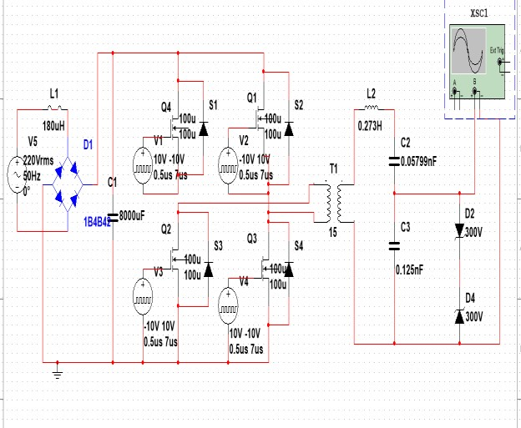

Fig.4 Simulation of main circuit

We can comprehend the effects of changing the frequency and duty cycle on the output waveform by modifying the duty cycle and frequency. The values can be obtained based on our needs. We must run the simulation in order to arrive at the necessary solution. The simulation's input is a single-phase 220V, 50Hz AC signal, and its output frequency is 44 kHz with a 50% duty cycle. After assessing and comparing the results of numerous studies, the output result provides us with the variances of various duty cycle studies, allowing us to deliver a systematic desired value.
By looking at the sine waveform of the frequency, we may measure it using an oscilloscope. The simulation's detailed result is displayed in Fig 5. A voltage vs. time graph is created, and the frequency is calculated by measuring one cycle. waveform (T2-T1).

- OUTPUT WAVEFORM
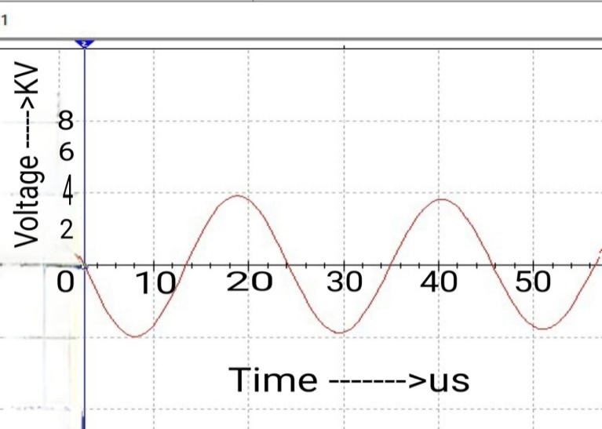

Fig.5 Frequency output of the ozone generator

As of now many Ozone generator power uses phase shifted PWM control as its main power of functional unit. As it results in changing the desired duty cycle model to get the required frequency in PWM by reducing the poor power factor and it also decreases the transformer loss. Thus, it gives us the abstract assist in controlling of the frequency of the given model.

- THEORITICAL ANALYSIS

This study, which provides a complete picture of the entire load analysis, represents the numerous methods for ozone formation and various forms of power supply. For this investigation, a typical power supply's PWM inverter-based power source was used. The operation of traditional PWM inverters, calculations for the design of high-frequency transformers, electrode structure, modelling results, and experimental data are all provided in this chapter. Therefore, the transformer side of the rectifier inverter is the final output of the sinusoidal voltage, so connect it with the sinusoidal voltage source as the input and primary side in the load equivalent model, which is frequently used to design the load circuit. The load of the LC resonant circuit is connected to the transformer's winding side.

From them, the inductance L is calculated according to the resonance conditions. The calculation process is as follows.
To get the theoretical output we first need to find the inductance value for the given frequency to estimate the required output.

It is known that the capacitance of the three capacitors is C1
= 8000μF; C2 = 0.05799nF and C3 =0.125nF. The calculate inductance value is L=0.273H for 40Khz
Therefore,
C = 0.0579nF

- PROTOTYPE HARDWARE
The hardware model of ozone generator is demonstrated in Fig.6 which concludes us to an analysis that we can generate ozone artificially by applying high voltage of 3kv and a frequency of 40Khz. The electric discharge or spark will create the ozone. The spark will split the oxygen molecule found in air into oxygen. Thus, oxygen atoms will form O3 due to the presence of high energy. In this the electric discharge will happen inside the corona chamber and it will split the oxygen molecule to form ozone. The di-electric is used to spread the flow of electrons depending upon the flow of oxygen and voltage across the chamber.

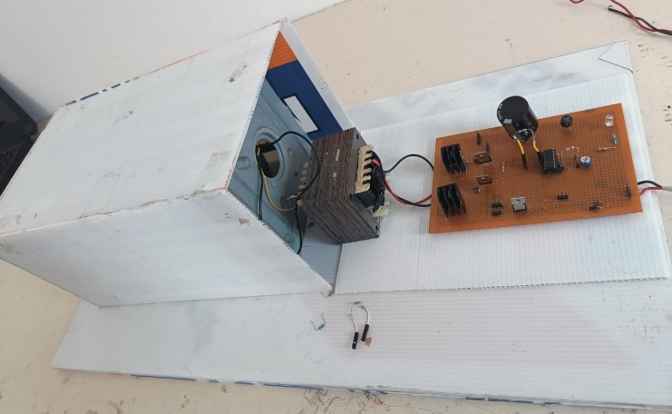
Fig.6 Hardware Model

- CONCLUSION

This study produced an ozone production resonant frequency charger. Ozone was specifically employed to purify the air. The development of high voltage, high frequency inverters for increased ozone production was the main emphasis of this article. The duty cycle of the inverter was controlled by a PWM controller in order to change the output frequency as needed. In addition, LC circuitry was employed to create sinusoidal output waveforms and soft switching. Software called MULTISIM was used to run the simulation. The systematic component is examined to arrive at the appropriate frequency value. The switching losses and low power factor can be controlled with a high frequency, which improves the system's performance and stability. Ozone is produced artificially and employed in a variety of sectors, including water and air treatment. the potential for future research in the area. Designing an interleaved boost converter-based power supply for a high-capacity ozone generating system can be one of the important research. The supply voltage will be kept constant, which has the additional benefit of increasing efficiency and lowering the required peak voltage. As a result, producing additional ozone is simple, which increases system stability.

REFERENCES

[1] Ashraf Yehia, Optimum operating conditions for the ozone generation in the dielectric barrier discharges, Int.J. Plasma Environ. Sci. Technol. 15 (2021) e03007, December 2021.

[2] Juan Antonio Aqui, Mario Ponce-Silva, Analysis and Assessment of Use of Voltage and Current Inverters Applied to the Ozone Generation in High Frequency IEEE Transactions on Plasma Science · March 2021

[3] N. Hammadi et al Journal of Engineering Science and Technology Vol. 11, No. 5 (2016) IEEE, 755 - 767 © School of Engineering, Taylor’s University

[4] Liu Xue, Wang Ziqiang. "Research on mixing power supply for ozone generator,” 2017 2nd International Conference on Robotics and Automation Engineering (ICRAE), 2017

[5] Wai, R.J., Lin, C.Y., Duan, R.Y. and Chang, Y.R. “High-efficiency DC– DC converter with high voltage gain and reduced switch stress IEEE Transactions on Industrial Electronics, Vol. 54, No.1, pp. 354–

[6] Wang, S., Konis,Y., Ishitobi,M., Shirakawa,S. and Nakaoka, M.“Current source type parallel inductor-compensated load resonant inverter with PDM control scheme for efficient ozoniser”, in Proceedings. IEEE International Power Electronics Congress, pp. 103– 110, 1998.

[7] Muhammad Amjad, Zainal Salam, “Analysis, and Implementation of Transformer less LCL Resonant Power Supply for Ozone Generation”. IEEE transactions on power electronics Vol. 28, NO. 2, February 2013.

[8] Williams, J.B. “Design of feedback loop in unity power factor AC to DC converter”, in Proceeding. IEEE Power Electronics
Special Conference, Vol. 2, pp. 959–967, 1989.

[9] Wu, J.G., Luan, T.G., Lan, C.Y. and Chan, G. Y. S. “Efficacy evaluation of low-concentration of ozonated water in the removal of residual diazinon, parathion, methyl-parathion and cypermethrin on vegetable,” Journal of Food Engineering, Vol.79, pp. 803809, 2007.

[10] Wu, X., Wang, Z. and Zhang, J. “Design considerations for dual-output quasi-resonant fly back LED driver with current-sharing transformer”, IEEE Transactions on Power Electronics, Vol. 28, No. 10, pp. 4820–
[11] T. Namihira, K. Shinozaki, S. Katsulti, etal. Characteristics of Ozonizer Using Pulsed Power. Pulsed Power Plasma Science, 2001.PPPS-2001. Digest ofTechnical.

[12] Siqi Li. Study on Model and Load Characteristics of DBD Ozone. Generator[D]. Guang Dong. Guangdong Industrial University, 2014

[13] Fating Yuan, Shihong Qin, Xiangling Yao. DBD ozone generator inverter power fundamental equivalent circuit[J]. Journal of Henan University of Science and Technology: Natural Science,2014,35(1): 36-40

[14] J. Olof Nilsson, Jan E. Eninger. Numerical Modeling of Ozone Production in a Pulsed Homogeneous Discharge: A Parameter Study. IEEE Transactions on Plasma Science,1997, 25(1): 73-82.

[15] Koudriavtsev O, Shengpei Wang. Advanced development of voltage source soft-switching high-frequency inverter for silent discharge tube loads. IEEE Power Electronics and Motion Control Conference Proceedings, 2000,32(1):302-307.

