AUTOMATED FIRE FIGHTING ROBOT

Pooja Pawar
Dept. Of ENTC VPKBIET Baramati, Pune
pooja.pawar.entc.2019@vpkbiet.org

Aditya Koli
Dept. Of ENTC VPKBIET Baramati, Pune
aditya.koli.entc.2019@vpkbiet.org

Prasad Prabhune
Dept. Of ENTC VPKBIET Baramati, Pune
prasad.prabhune.entc.2019@vpkbiet.org

Dr. S. B. Lande
Dept. Of ENTC
VPKBIET Baramati, Pune
Sudhir.lande@vpkbiet.org

Abstract—This paper demonstrate that how can we design and implement the Automated Fire Fighting Robot. Fires pose a significant threat to life, property, and the environment. As traditional firefighting methods have limitations, there is a growing need for innovative solutions to augment the capabilities of human firefighters. This research paper presents the development and evaluation of an automated firefighting robot designed to mitigate the challenges associated with fire emergencies. The proposed firefighting robot combines advanced sensing technologies, intelligent decision-making algorithms, and efficient mechanical systems to autonomously detect, locate, and suppress fires. It is equipped with a range of sensors, including thermal cameras, smoke detectors, and gas sensors, enabling real-time fire detection and identification in diverse environments. Through machine learning techniques, the robot can quickly analyze sensor data, assess the fire’s severity, and determine an optimal course of action. To suppress fires, the robot employs various firefighting mechanisms, such as water cannons, foam dispensers, and fire retardant sprayers. These mechanisms are strategically positioned on the robot to ensure effective fire extinguishment while considering safety and efficiency. Additionally, the robot is capable of navigating complex and hazardous environments using obstacle detection and avoidance algorithms.
- INTRODUCTION
The idea of integrated electronics in everyday objects is extremely attractive; Detecting fire and extinguishing it is a dangerous job that puts the life of a firefighter at risk. There are many fire accidents which firefighter had to lose their lives in the line of duty each year throughout the world. The research and development in the field of Artificial Intelligence have given rise to Robotics. The aim here is to design a Fire Fighting robot based on IOT. The robot will not only extinguish the fire but can even act as a path guider. The Robot should be able to find a fire before it rages out of control and must also reduce the risk of injury to victims. The Robot is based on Android application, used for controlling the robot and operating the camera mechanism. To have a proper and a broader view of the surrounding a wireless camera is mounted to continuously scan the surrounding. The robot is equipped with various sensors which continuously monitors to detect flame, human casualties’ temperature, humidity and extinguishes the fire if present with the help of a Water mist turbine. Fire accidents is defined as an undesirable event which

emits heat, smoke or flame. Fire accident is a major form of accident and can cause a huge number of causalities because of the danger and risk involved in rescuing victims out of the fire. When firefighting units engage in such situations there is a high possibility to loss the life of fire personnel. In everyday life, it is not feasible to always rely on human patrol for detecting and extinguishing fire at a fire accident scene. If an automated system is made to patrol the perimeter for fire accidents, then we can have an early warning system. This will be very effective in a fire accident in industries and residential areas where the fire possibilities are high. In order to achieve this, we must come up with an idea which can detect a flame, locate it and extinguish the fire immediately before it poses a threat to anything around it. For risky situations, it would be idealistic to send a firefighting robot that could quickly and efficiently find the fire and suppress it. Effective monitoring, high speed recognition, and extinguishing of fire are problems to be dealt with immediately. To reduce the risk of losing life in such situations, firefighting robots can be used. The automatic robot is designed to. avoid further spreading of the fire that could lead to possible human causalities. The objective of the project will be to design a SMS electronic Fire Protection Robot toolkit which can replace the traditional Fire Protection Robot. Another key advantage of firefighting robots is their ability to work in hazardous environments, such as chemical plants and nuclear facilities. In these settings, the robots can provide valuable data and assist with cleanup efforts without exposing humans to dangerous conditions. There are several types of firefighting robots available on the market. One popular type is the wheeled robot, which can navigate through narrow hallways and staircases. These robots are typically equipped with cameras and sensors that allow them to detect the location and intensity of fires. Another type of firefighting robot is the aerial drone. These robots can fly over burning buildings and provide real-time images and data to firefighters on the ground. They can also be used to drop water or fire-retardant chemicals on the fire. Some firefighting robots are designed to work underwater, allowing them to assist with firefighting efforts in ships and submarines. These robots are typically equipped with sensors and cameras that

allow them to navigate through the water and locate fires.In addition to their use in firefighting, fire-fighting robots can also be used for search and rescue operations. For example, they can be used to locate and rescue people who are trapped in burning buildings or other hazardous environments. This project recognizes the limitations and risks faced by human firefighters when dealing with fire incidents. By introducing a robot that can autonomously operate in hazardous environments, the project aims to reduce the potential dangers faced by human responders. The fire-fighting robot’s ability to navigate through obstacles, detect toxic gases, and analyze fire conditions in real-time enhances the overall safety of firefighting operations. Efficiency and resource management are vital factors in firefighting. The fire-fighting robot project aims to optimize the utilization of resources by incorporating advanced sensors and algorithms into the robot’s design. These features enable the robot to accurately assess fire characteristics, such as size and intensity, and determine the most effective use of water or firefighting agents. By minimizing resource wastage, the project aims to maximize the efficiency of fire response and minimize property damage.
- LITERATURE REVIEW
The literature review serves multiple purposes, including providing a theoretical foundation for our research, identifying key concepts and variables, evaluating existing methodologies, and highlighting areas that require further investigation:
[1] Karpatil, S. P., Patil, A. R., Sharma, D. D., Talib, F. (2021). “Fire Fighting Robot”. The aim was develop a system that can detect and extinguishes the fire. In this project, resources used are micro controller and motor control with reductive motor, flame detection using infrared flame sensor. Experimental work has been carried out carefully. This project is been implemented by using android application and web server. The water container is placed on the robot when the fire is detected, it sprays the water on the fire and extinguish it. This project presents the design and the implementation of a fireSfighting robot that moves towards the fire and pump out water to extinguish the fire. A memory can be used as to maintain logs of the fire incident.
[2] Aliff, M., Yusof, M. I., Sani, N. S., Zainal, A. (2019) “Development of Fire Fighting Robot (QRob)”. It has ad- vantageous features such as ability to detect location of fire automatically besides having a compact body and lightweight structure. QRob also has the ability to avoid hitting any obstacle or surrounding objects due to its provision of an ultrasonic sensor. The QRob robot can be used at a place that has a small entrance or in small spaces because it has a compact structure. The operator is able to extinguish fire using remote control from longer distance.
[3] Malagar, D., Bagh, R. R., Pal, R., Baghel, S., Takey, A., Neha, K. (2018) “Review on Fire Fighting Robot”. In this paper discusses the development of each component of the robot that is designed to find a small fire represented by a light emitting diode in a model home and extinguish it and we will talk about each component of the robot from the start signal to
the robot platform to the line following and room finding and finishing with the fire detection. The water container is placed on the robot when the fire is detected, it sprays the water on the fire and extinguish it.
[4] Junwei, T., Jintao, L. Ruimin, D., Yanling, Z. (2019) “Research on Fire Fighting Scheme of Indoor Fire Fighting Robot Based on Multi-sensor”. It sets the distance between the robot and the fire source point. It can be found Fire source point and take the initiative to start the fire extinguishing program. After the fire source point is found, the fire source can be fixed at a fixed point, and the water mist is continuously sprayed until the fire extinguishing source is extinguished. [5] Chitti, S., Rao, P. R., Padmaja, C., Kumari, D. R. (2020) “Fire Detection and Direction Control of Fire Fighting Robot”. This robot is intended to reduce the impact of fire incidents that normally originate from a small blaze, thereby saving lives and resources for people. The robot can detect fire and hit it successfully without having to crash into an obstacle. Robot can be moved by itself or it can be operated by the application. As input it takes fire and output will be pumping of the water and also it makes the buzzer sound which will makes us alert. As a resultant the Robot is identifying the flame it calms down the fire and bomb explosions occur.
- WORKING OF PROPOSED SYSTEM
The working of an automated firefighting robot involves several interconnected components and functionalities. While specific designs may vary, the following general steps outline the typical operation of such a robot:
Sensing and Perception: The firefighting robot is equipped with a range of sensors, including thermal cameras, smoke detectors, gas sensors, and possibly others. These sensors continuously monitor the environment for signs of fire, such as heat signatures, smoke, or specific gases emitted during combustion. The sensor data is processed and analyzed in real-time to detect and identify the presence and location of a fire.
Fire Localization: Once a fire is detected, the robot employs algorithms and techniques to determine the precise location of the fire within the environment. This may involve triangulation or other localization methods using multiple sensor inputs. By accurately localizing the fire, the robot can focus its firefighting efforts more effectively.
Path Planning and Navigation: The robot utilizes path planning algorithms to determine the optimal route to reach the fire location. It takes into account the layout of the environment, obstacles, and potential hazards. The path planning algorithm ensures efficient navigation, avoiding obstacles, and selecting the safest path to reach the fire.
Fire Suppression: Upon reaching the fire location, the firefighting robot employs various mechanisms and tools to suppress the fire. This may include high-pressure water cannons, foam dispensers, fire retardant sprayers, or other firefighting agents. The robot’s mechanisms are strategically positioned and designed to deliver the firefighting agent accurately and efficiently to the fire source.

Autonomous Operation and Decision-making: The robot incorporates intelligent decision-making algorithms that enable it to autonomously assess the fire’s severity, size, and other relevant factors. Based on this assessment, the robot determines the appropriate firefighting strategy, such as selecting the type and amount of firefighting agent needed. The decision-making process is often influenced by pre-programmed rules, machine learning algorithms, or a combination of both.
Safety Measures: Firefighting robots prioritize safety during their operation. They may include features such as thermal insulation to protect internal components, protective coatings to withstand high temperatures, and self-monitoring systems to detect any anomalies or malfunctions. Additionally, the robots may have built-in safety protocols to abort missions or retreat in case of unexpected hazards or threats.
Human-Robot Collaboration: Automated firefighting robots can work in conjunction with human firefighters and existing fire safety infrastructure. They can transmit real-time data to human operators or command centers, providing critical information for decision-making. The robots can be integrated with fire alarm systems, enabling synchronized responses and enhancing overall firefighting capabilities.

A. Block Diagram
The three Flame Sensors MQ06 along with the power supply is connected Relay Module, which in turn is also responsible to provide power to the other components. The Pi Cam, which is the major component for mobility of the robot is interconnected to the left right motors via an L298 Driver Motor.
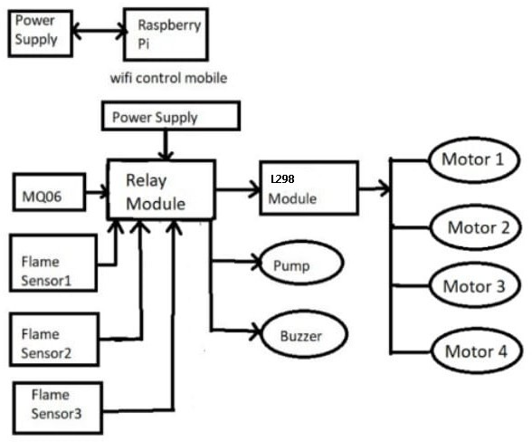

Fig. 1. Block diagram

Raspberry pi 0. It is the heart of the system because it activates all the sensors which are connected to the board with
the help of software. The main advantage of this board is it is having in built WI-FI. By this we can perform multiple operations. The SD card is easily switched for reinstalling the software. Raspberry Pi-3b is able to display images or play videos at high resolution. The block diagram of an automated firefighting robot highlights the key components that work together to detect, locate, and extinguish fires effectively while ensuring the safety of the robot and its operators. The robot has a large water tank that stores water or foam for the water pump to use.
- SYSTEM INTEGRATION
The successful implementation of our project relied heavily on a meticulous system integration process. This involved harmonizing the various hardware and software components into a cohesive and fully functional system
- Hardware Components
Hardware components play a crucial role in enabling the functionality and performance of our project, providing the necessary physical infrastructure to support our objectives. By examining the various hardware elements involved, we aim to gain a comprehensive understanding of their capabilities, interactions, and contributions to the overall system.
Raspberry Pi: The Raspberry Pi Foundation has released several models, each with different specifications. As of my knowledge cutoff in September 2021, the latest models include Raspberry Pi 4 Model B, Raspberry Pi 3 Model B+, Raspberry Pi 3 Model A+, Raspberry Pi Zero W, and Raspberry Pi Zero. The Raspberry Pi 4 Model B, for example, features a 1.5 GHz quadcore ARM Cortex-A72 CPU, options for 2GB, 4GB, or 8GB of LPDDR4 RAM, microSD card slot for storage, USB
3.0 and 2.0 ports, HDMI and composite video output, 3.5mm audio jack, Gigabit Ethernet, dual-band Wi-Fi, Bluetooth 5.0, and GPIO pins for interfacing with external devices.
Flame Sensor: A flame-sensor is one kind of detector which is mainly designed for detecting as well as responding to the occurrence of a fire or flame. The flame detection response can depend on its fitting. It includes an alarm system, a natural gas line, propane a fire suppression system. Flame sensors typically work based on the detection of infrared (IR) radiation emitted by flames.
L298 Motor Driver: L298N module is a high voltage, high current dual full-bridge motor driver module for controlling DC motor and stepper motor. It can control both the speed and rotation direction of two DC motors. This module consists of an L298 dual-channel H-Bridge motor driver IC. This module uses two techniques for the control speed and rotation direction of the DC motors.
Relay Module: A relay module is a pre-packaged electronic device that incorporates one or more relays along with the necessary circuitry for control and protection. It provides an interface between low power control signals, typically from microcontrollers or digital circuits, and high-power loads such as motors, lights, heaters, or appliances. The relay is the primary component of the module.

Pi Camera: The Pi Camera, also known as the Raspberry Pi Camera Module, is a camera accessory specifically designed for Raspberry Pi boards. It allows you to capture images and videos directly from your Raspberry Pi, expanding its capabilities for various applications. The Pi Camera connects directly to the CSI (Camera Serial Interface) port on the Raspberry Pi board.
Water Pump: In a fire-fighting robot, a water pump plays a crucial role in delivering water or fire retardant to extinguish fires. Centrifugal pumps are widely used in fire-fighting applications. They work by using centrifugal force to increase the pressure and flow of water. These pumps consist of an impeller that rotates, creating a vacuum that draws in water from the inlet and propels it outward through the outlet.
- Methodology
The following flowchart illustrates the sequence of actions and decision points involved in the operation of a fire-fighting robot.

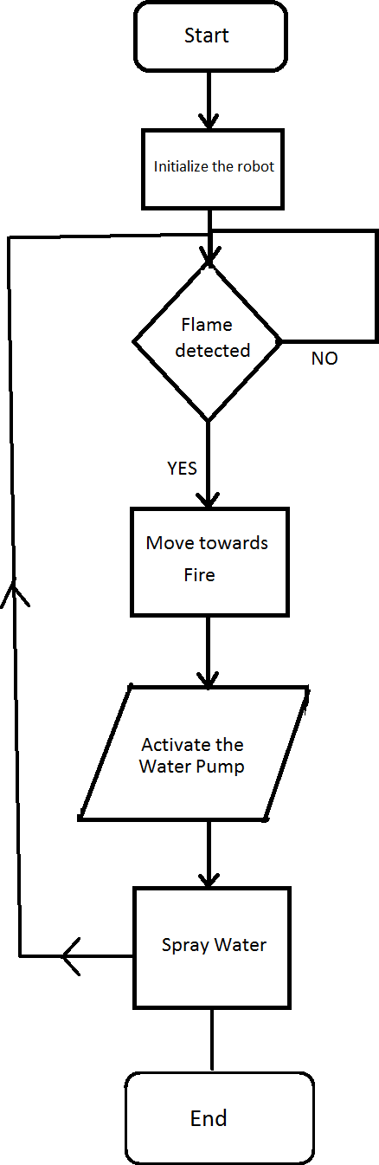

Fig. 2. Flowchart

Start Initialization: Initialize the robot’s systems, including hardware components, sensors, and communication systems. Sensor Data Acquisition: Collect data from various sensors. Fire Detection: Process the sensor data to detect the presence of fire.
Fire Detected: Check if fire is detected.
Yes: Proceed to the next step.
No: Continue monitoring for fire.
Move Forward: Move the robot towards the fire location. Activate Water Pump: Start the water pump mechanism for water spraying. Spray Water: Begin spraying water to suppress the fire.
End: Once the fire suppression is completed or the predefined criteria are met, stop the water spraying mechanism. The project concludes.

- Result
The fire-fighting robot has significantly improved the response time to fire emergencies. Its autonomous navigation and real-time fire detection capabilities allow it to swiftly reach the fire scene and assess the situation, reducing the time required for human firefighters to arrive and begin firefighting operations. This has resulted in faster fire suppression and reduced property damage. By deploying the fire-fighting robot, the safety of human firefighters has been greatly enhanced. The fire-fighting robot project focused on ensuring seamless
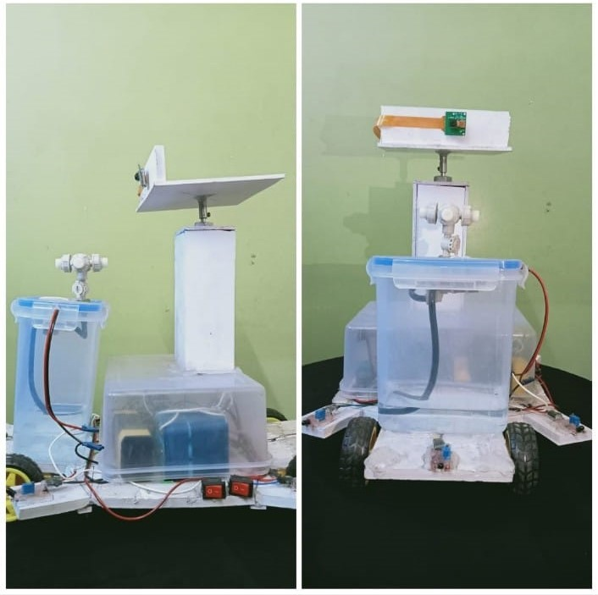

Fig. 3. Fire Fighting Robot Prototype

integration with existing firefighting protocols and systems. The robot can communicate with human operators and other emergency response systems, facilitating effective coordination and collaboration during firefighting operations. This integration enhances the overall efficiency and effectiveness of the fire response. The fire-fighting robot underwent extensive testing and evaluation to validate its performance and capabilities. Various fire scenarios were simulated, and the robot demonstrated consistent and reliable performance in extinguishing fires, navigating obstacles, and responding to emergency situations. The positive results obtained during testing reinforce the reliability and effectiveness of the fire- fighting robot.

- Future Scope
The future scope for automated fire-fighting robots is vast and includes several potential advancements and improvements. Enhanced Sensing and Detection: Develop more advance flame sensors and detectors that can accurately identify flames in different environments, including smoky or low- visibility conditions. Additionally, integrate other sensors such as heat sensors, gas sensors, and thermal imaging cameras to provide a comprehensive fire detection system. Artificial Intelligence and Machine Learning: Implement AI and machine learning algorithms to improve the robot’s ability to analyze and interpret data from various sensors in real-time. This can enhance the robot’s decision-making capabilities and enable it to adapt to different fire scenarios. Autonomous Navigation: Enable the robot to autonomously navigate complex environments, such as multi-story buildings or outdoor areas, using mapping and localization technologies. This would allow the robot to move efficiently and reach fire locations without human intervention. Collaborative Swarms: Investigate the use of multiple fire-fighting robots working together as a swarm. These robots could communicate and coordinate their actions to tackle large-scale fires more effectively and efficiently. Advanced Extinguishing Techniques: Explore innovative fire-suppression methods beyond traditional water-based systems. For example, investigate the use of firefighting foams, specialized chemicals, or even robotic arms capable of applying fire-retardant materials. Robotic Manipulation: Equip firefighting robots with robotic arms or grippers to handle objects or obstacles encountered during fire-fighting operations.
ACKNOWLEDGMENT
I came across a number of people whose contributions in various ways helped my field of research and they deserve special thanks. It is a pleasure to convey my gratitude to all of them. Thanks to our project guide. Dr. S. B. Lande whose contribution to the promotion of suggestions and encouragement, helped us to compile our project especially in writing this report. In addition, I would like to thank, for the important role of the facilitator and Head of Department Dr. Balasaheb Patil who gave the permission to access all the necessary materials to complete the project “Automated Fire Fighting Robot”. Their dedication and creativity have been crucial to the success of this endeavor. project coordinator Mr. S. D. Biradar for there helpful information, practical advice, valuable guidance and unconditional support in the process of developing project which helped us immensely throughout the journey. I should appreciate the guidance given to the other director and panel members especially in our project presentation which has improved our presentation skills. Thanks to their suggestions and advice. Finally, we want to express our gratitude to the firefighters and other first responders who risk their lives every day to protect our communities from the devastating effects of fire. It is our hope that this automated firefighting robot will serve as a valuable tool in their arsenal and help them carry out their critical work more safely and efficiently. Finally, but not least, we would like
to thank everyone who helped us and encouraged us to work on this Project
REFERENCES
- Karpatil, S. P., Patil, A. R., Sharma, D. D., Talib, F. (2021). “Fire Fighting Robot”. IJRTI (International Journal of Research Technology and Innovation) — Volume 6, Issue 4 — ISSN: 2456-3315
- Aliff, M., Yusof, M. I., Sani, N. S., Zainal, A. (2019). “Development of Fire Fighting Robot (QRob)”. IJACSA (International Journal of Advanced Computer Science and Applications), Vol. 10, No. 1.
- Malagar, D., Bagh, R. R., Pal, R., Baghel, S., Takey, A., Neha, K. (2018). “Review on Fire Fighting Robot”. IJRASET (International Journal for Research in Applied Science Engineering Technology), Volume 6, Issue IV. ISSN: 2321-9653; IC Value: 45.98; SJ Impact Factor: 6.887.
- Junwei, T., Jintao, L., Ruimin, D., Yanling, Z. (2019). “Research on Fire Fighting Scheme of Indoor Fire Fighting Robot Based on Multi-sensor”. In International Conference on PNTIM (Precision Machining, Non- Traditional Machining and Intelligent Manufacturing 2019), Volume 5.
- Chitti S. Rao, P. R. Padmaja, C., Kumari, D. R. (2020). “Fire Detection and Direction Control of Fire Fighting Robot”. In ICRAEM (International Conference on Recent Advancements in Engineering and Management- 2020), Volume 981 of IOP Conference Series: Materials Science and Engineering. Warangal, India: IOP Publishing Ltd.

