Automated Trolley Billing System

1st Siddhi Patil
Department of Electronics and Telecommunication
Jspm’s Rajarshi Shahu College Of Engineering(Tathawade),
Pune India
i.m.siddhipatil2001@gmail.com
3 ^{rd} Shivani Inamdar Department of Electronics and Telecommunication
Jspm’s Rajarshi Shahu College Of Engineering(Tathawade),
Pune India
shivaniinamdar2000@gmail.com

2 ^{nd} Ankita Ghorpade Department of Electronics and Telecommunication
Jspm’s Rajarshi Shahu College Of Engineering(Tathawade),
Pune India
ankitaghorpade012@gmail.com

4 ^{th} Prof. Sunaina Chaudhari
Department of Electronics and Telecommunication
Jspm’s Rajarshi Shahu College Of Engineering(Tathawade),
Pune India
sunainasc24@gmail.com

Abstract— In the modern world, time is the most valuable resource, hence people frequently refer to quick tasks. Billing takes a while in a mall. Because there is a lengthy queue of people wanting to be invoiced, billing products purchased at a mall takes longer and is more challenging. The "Smart Shopping Cart for Automatic Billing in Supermarket" was our original idea, which we improved in light of technological advancement. This project makes use of push buttons, switches, a liquid crystal display, an RFID reader, and a motion detection sensor. If the user wants to use the smart trolley capabilities, they must hit the Start button. The RFID reader reads the product's code when a user sets a product in the trolley to add the cost to the list, detect any flaws by feeling the product's motion and activate the alert if a flaw is discovered. Pressing the remove switch is necessary to delete a product. The product code will then be read by an RFID reader, and if there is any incorrect activity, a buzzer will activate. The counter with the fewest lines will finally be recognized and displayed by the cart LCD. The counter with the shortest backlog of clients will subsequently receive the final bill.

- INTRODUCTION
With its recent development in technological, political, social, and economic terms, the grocery industry sector is currently tremendously important to the global economy, making it one of the most practical and diverse industries worldwide. The proliferation of electronic commerce technologies has fundamentally changed how business is conducted, according to a study published in the journal "Consumer
perception of privacy, security, and trust in ubiquitous commerce." Reasons for this transformation include new mobile technologies and ubiquitous computing, business recognition of the strategic advantages provided by the implementation of communication and ubiquitous computing structures, and the emergence of new business models. The difficulties and possibilities brought about by electronic commerce in the supply chain have tainted information sharing amongst business models, harming operational effectiveness customer service, and solution creation. Businesses have progressed beyond information sharing and coordination to knowledge sharing and sophisticated cooperative techniques. The emergence of new technology like wireless networks and radio frequency identification devices (RFID) has sped up, made transparent, and improved old retail processes. With the use of technology, retailers have the chance to cut costs and provide more individualized services while also reaching customers more swiftly and precisely. The so- called new consumer was established as a result of technological breakthroughs in manufacturing, distribution, and information combined with the urbanization of contemporary society and social demographic challenges. The consumer is more knowledgeable about comparing product prices, has a wider range of brand preferences, is less loyal to merchants, has high expectations for services and client care, is independent and is more demanding of the information that is provided. The

movement of control from the makers and retailers to the consumers was evident. Because of fierce competition among larger retail chains, profit margins were minimized in order to maintain aggressive pricing and attract more customers. This is insufficient today. By fostering a closer relationship with the consumer and providing adequate responses to the clients' needs through individualized service and promotion plans that increase their satisfaction and, most importantly, their enthusiasm, one must stake their bets on offer differentiation and the adoption of client retention strategies. Small transponders known as RFID tags—or simply "tags"—respond to reader inquiries by wirelessly transmitting a serial number or other type of identifier. They are often used to label products in supermarkets and track goods in production facilities. They are typically viewed as an improved barcode. However, their potential usage is considerably more widespread. In this study, a few fresh uses for RFID technology are discussed, including tracking moving objects and finding misplaced goods. The number of RFID tags is predicted to grow into the billions over
the next several years, yet they are still merely treated like barcodes without taking into account the effect that this cutting-edge technology has on privacy This document discusses potential uses for RFID systems as well as some suggested fixes. RFID is a specific kind of wireless card that has a loop antenna and an embedded chip. The 12 digit card number is represented by the built-in integrated chip. The circuit is the RFID reader.

- LITERATURE SURVEY
The authors "Galande Jayshree, Rutuja Gholap, and Preeti Yada" suggested an RFID- based automatic billing trolley in [1]. With this concept, the system comprises of an RFID reader and goods found in malls that have RFID tags attached to them. When a customer places any item in the cart, the RFID reader will read the item's code and record the price of the item in memory. Wireless RF modules at the billing counter will communicate the whole bill data to the computer. In [2], the authors "S. Sainath, K. Surender, and V. Vikram Arvind" proposed a model for an automated shopping trolley for supermarket billing system. The automated shopping trolley is a smart trolley that integrates a raspberry pie embedded chip with two barcode scanners and a battery kit to enable selfcheckout at supermarketsUsing RFID and Zigbee modules, the authors "Mr. Yathisha L, Abhishek A, Harshit R, and Darshan Koundinaya" suggested a model for shopping cart automation in [3] to reduce
crowding in malls. In this system, RFID tags are used in place of bar codes; as soon as a customer places an item in a cart, the RFID reader scans the item, and the item's price is displayed on the LCD. The data is transferred to the primary computer using a zigbee transmitter. A model of an RFID-based automated billing trolley was put forth by the authors "Jadhav Rahul, Pradeep, Nandkumar, and Tarali ShivkumarJ" in [4]. Each RFID tag in this technology has a magnetic stripe with a unique code, and the RFID Reader module reads the tag to communicate. An appropriate replacement for the manual billing approach used in shopping malls is the automated billing system based on passive RFID. Using wireless sensor networks, the authors "Udita Gangwal, Sanchita Roy, and Jyotsna Bapat" presented a system of smart shopping carts for automated billing purposes in [5]. The authors of this study describe the use of wireless sensor networks to build a shopping card that is trustworthy, equitable, and economical. The price, name, and expiration date of the item are displayed when the customer places it in the cart after scanning it. The significance of RFID for automatic item identification and data capture is discussed by the authors "Ynajun Zuo" in [6]. To ensure the reliability of RFID readers, he created a secured tag reader authentication protocol.

- METHODOLOGY

The automatic billing for a consumer as they shop is the proposed methodology, which relies mostly on RFID and is supplemented by other basic technologies. Instead of barcodes, RFID tags are used to identify merchandise in supermarkets and malls. The shopping carts come equipped with a system that includes an RFID reader, an IR sensor, an ultrasonic sensor, a keypad, and a push button. Customers receive smart RFID cards for personal identification.

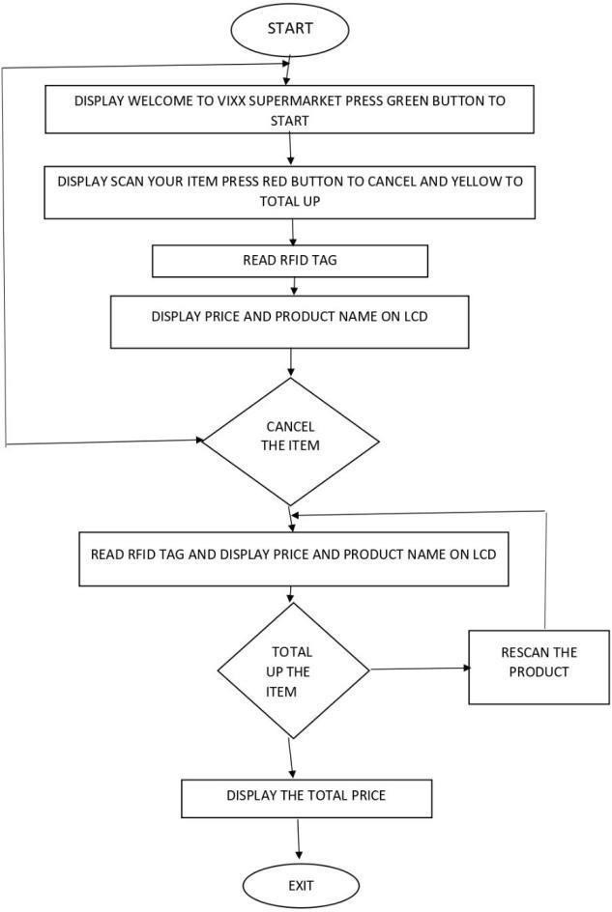
Fig. 1. Flow Chart

- HARDWARE SPECIFICATION

An eight-bit AVR-based RISC computer is utilized with the micro-controller ATMEGA32. It needs between 4.5 and 5.5 volts of DC to function. EEPROM, and 32kB of in-system non - volatile

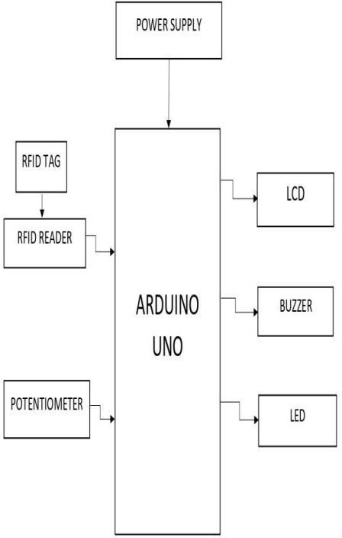

Fig 2 System Block Diagram
and a serial interface are a few of its features.The processor operates between 0 and 16 MHz. It There are 32 programmable i/o lines on the 40 pin PDIP. It has 2KB of internal SRAM, 1024B of.flash memory. Timers, A/D converters, PWM, remembers the directions and complies with them. A microcontroller's responsibility is to oversee the entire procedure using commands stored on RFID tags: These tags have a microchip that stores their specific ID number and a coil that serves as an antenna to broadcast the data they contain. Depending on whether a gadget is active or passive, it may or may not have a battery. The use of passive tags without batteries is common. The reader sends out RF signals that energise passive tags as soon as they come inside its range. The signals are reemitted to the reader together with the data after the tags are energised. RFID tags are used to identify objects specifically. The RFID reader used by RC-522 needs 5 volts DC to function and less than 50mA. It operates at a frequency of 125 kHz. It can go ten centimeters. Throughout its range, it continually generates RF signals, and anytime an RFID tag is inside its coverage area, it retrieves the data contained in the tag. Retrieving product information from RFID tags on products is the function of an RFID reader. Infrared camera: An object detecting sensor, that is. It operates in the 300GHz to 400THz frequency range and the 700nm to 1400nm wavelength range. A photodiode and an LED are present. According to the production specifications, LEDs typically emit infrared light up to a particular distance, and anytime there is a reflection of that light owing to an obstruction, the photodiode detects it The IR sensor's job is to count the items as they enter the trolley to avoid theft or misplacing. Power Adapter: The setup's dc power supply is provided by the power adapter. It performs the function of a rectifier, converting an input of roughly 240 volts AC and 30 amps into an output of 12 volts DC and 1 amp that will work for our arrangement. A power adapter's function is to deliver a consistent DC supply from an AC power source.

RESULT & DISCUSSION

The project group discussed every experimental component. The proposed system LCD is utilized to display product information, including cost and weight. The suggested model is simple to use, doesn’t

need specific training, and is readily available. The user will spend less time in the billing queue thanks to the reduction in staff. The ability to service multiple user at once benefits both customers and retailers. This intelligent billing solution guarantees both time and financial efficiency. By enabling customers to create a shopping session that lasts until the client asks it to be cleared and preserving the data of each item in the basket by employing RFID tags to make the entry, the smart trolley aims to streamline the billing process. By showing the buyer the whole price, it also helps them stay inside their budget when purchasing. As online shopping becomes more popular and less of a hassle, stores are introducing eco-friendly smart carts and smart baskets that not only help them reduce crowds but also cut down on the amount of paper used, employees needed, and money that would otherwise be wasted printing duplicates of bills. Therefore, the deployment of RFID-based smart trolleys is crucial for society's interest and welfare. Customers' purchases are displayed on liquid crystal displays along with their cost, weight, and item names. In some situations, the display will warn you that a product is out of date, in which case you should exercise caution. The elimination of printouts and the experience of shopping with a budget allows for the reduction of wasteful paper consumption. These forms are also an effective instrument for maximizing financial savings.

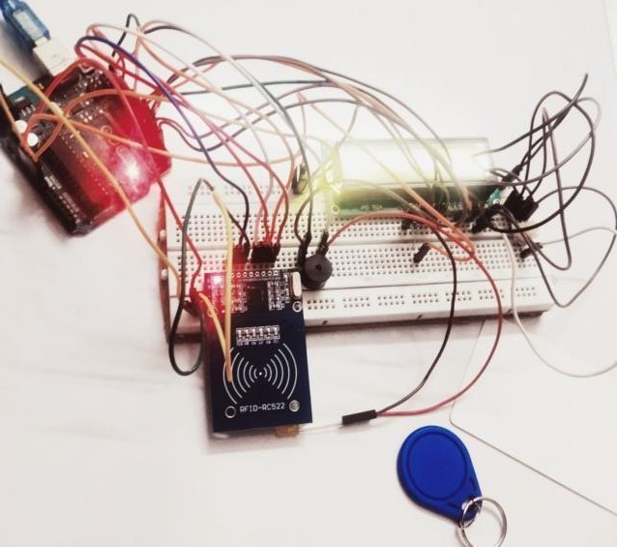

Fig. 3. Hardware implementation.

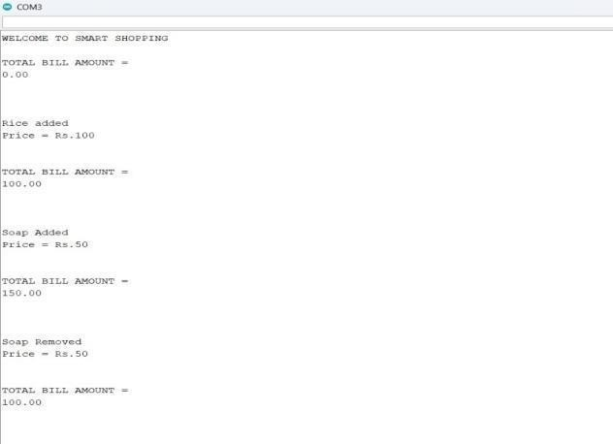

Fig 4. Software Output.

Different test cases are performed to validate if the project module gives expected outcomes.System is converted into web server using XAMPP software. Run the python script in IDLE 3.9 version which image capturing, Image processing and matching key point’s algorithm of image as shown in fig4.With this webserver will connect to SQL server where the images which has been scanned by the reader. Shown in fig.4 When we place a product in front of scanner, rfid scanner starts matching all the key points of that product, the product whose data has already stored into the backend.
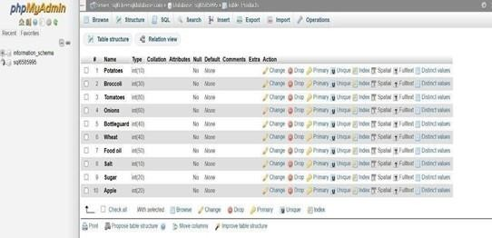
Fig 5. mySQL Database

VI . CONCLUSION

Customers who utilize an intelligent shopping cart can check out instantly on the cart, permanently avoiding the cashier and huge queues. According to the experts, customers who use the smart shopping cart may save both time and money.

ACKNOWLEDGEMENT

We’d want to use this opportunity to thank the lecturers and administrators whose continuous support allowed us to take on the challenges of finishing this project .we would like to express our sincere appreciation to our honourable head of department for enabling us to utilize college resources and for his continued assistance with our efforts. We also appreciate the help from the excellent scholars who have been overseeing this work. We are very grateful to our guide for her wise observation and practical advice for how to improve the quality of the project work.

REFERENCES

- "Arduino Based Smart Cart," International Journal of Advanced Research in Computer Engineering Technology (IJARCET), 2 (12), 2013; Ashmeet Kaur, Avni Garg, Abhishek Verma, Akshay Bansal, and Arvinder Singh.Budic D, Martinovic Z, Simunic D, Cash register lines optimization system using RFID technology, IEEE Explore, 2014.

- IOT Based Intelligent Trolley for Shopping Mall, IJEDR, 2016. Dhavale Shraddha D, Dhokane Trupti J, and Shinde Priyanka S.

- The Development of Smart Shopping Carts with CustomerOriented Service, 2016 International Conference on System Science and Engineering (ICSSE), National Chi Nan University, Taiwan. Hsin-Han Chiang, Wan-Ting You, Shu-Hsuan Lin, WeiChih Shih, Yu-Te Liao, Jin-Shyan Lee, and Yen-Lin Chen.

- Electronic Shopping Cart for Effective Shopping based on RFID, International Journal of Innovative Research in Electrical, Electronics, Instrumentation, and Management Engineering, 3 (1), 2015. Kalyani Dawkhar, Shraddha Dhomase, and Samruddhi Mahabaleshwarkar.

- Smart Shopping Trolley Using RFID, International Journal of Advanced Research in Computer Engineering Technology

