 | UNDERWATER IMAGE ENHANCEMENT USING CURRENT CONVOLUTIONAL NEURAL NETWORK | 

19EEPN6601 - PROJECT

Submitted by

JOSEPH JOSHUA C 19BEE016
SUHITHA P 19BEE085
NADISH M 20BEE332

In partial fulfilment for the award of the degree of
BACHELOR OF ENGINEERING
in
ELECTRICAL AND ELECTRONICS ENGINEERING
Dr. MAHALINGAM COLLEGE OF ENGINEERING AND TECHNOLOGY
POLLACHI - 642003
An Autonomous Institution
Affiliated to Anna University, Chennai - 600 025
May 2023

Dr. Mahalingam College of Engineering and Technology
Pollachi-642 003
An Autonomous Institution Affiliated to Anna University, Chennai-600025

BONAFIDE CERTIFICATE
Certified that this project report,
“UNDERWATER IMAGE ENHANCEMENT USING CURRENT
CONVOLUTIONAL NEURAL NETWORK”
is the bona-fide work of

19BEE016 JOSEPH JOSHUA C
19BEE085 SUHITHA P
20BEE332 NADISH M

who carried out the project work under my supervision

SIGNATURE OF HOD SIGNATURE OF SUPERVISOR Dr.M.KALIAMOORTHY,M.E.,Ph.D., Dr.J.AMUDHA,M.E.,Ph.D.,
HEAD OF THE DEPARTMENT,
Electrical and Electronics Engineering Dr. Mahalingam College of Engineering and Technology, NPT-MCET Campus Pollachi-642 003.
ASSOCIATE PROFESSOR,
INTERNAL EXAMINER
EXTERNAL EXAMINER
Submitted for the Autonomous End Semester Examination Innovative and Creative Project Viva-voce held on

Electrical and Electronics Engineering Dr. Mahalingam College of Engineering
and Technology, NPT-MCET Campus
Pollachi-642 003.

ACKNOWLEDGEMENT

We extend our gratitude to our management for having provided us with all facilities to build our project successfully. We express our sincere gratitude to our honorable Secretary Dr.C.Ramaswamy, M.E., Ph.D., F.I.V., for providing us with required amenities.

We express our profound thanks to our Principal Dr.P.Govindasamy, M.E., Ph.D., who provided us the suitable environment to work.

We express our profound thanks to our Dean (A&A) Dr.A.Senthil kumar, M.E., Ph.D., Senior professor who provided us the suitable environment to work.

We express our gratefulness to Dr.M.Kaliamoorthy, M.E., Ph.D., Senior Professor and Head of the Department, Electrical and Electronics Engineering for providing us kind advice during the development of the project.

Our hearty thanks to our guide Dr.J.Amudha, M.E., Ph.D., Associate Professor (SG), Electrical and Electronics Engineering for her constant support and guidance offered to us during the course of our project by being one among us.

We express our thanks to our project co-ordinator Dr.L.Chitra, M.E.,Ph.D., Associate Professor, Electrical and Electronics Engineering for constant support and guidance offered to us during the course of our project by being one among us.

We are committed to place our heartfelt thanks to all our faculty members, lab technicians and friends, who played the supporting role throughout the project.

TABLE OF CONTENT

CHAPTER NO | CONTENT | PAGE NO
 | ABSTRACT
 | LIST OF TABLES
 | LIST OF FIGURES
 | LIST OF ABBREVATIONS
1 | 1.1 INTRODUCTION | 1
1 | 1.2 LITERATURE REVIEW | 1
1 | 1.3 OBJECTIVE | 2
2 | 2.1 INTRODUCTION | 3
2 | 2.2 IMAGE PROCESSING | 4
2 | 2.3 IMAGE ENHANCEMENT | 5
2 | 2.4 CONVOLUTIONAL NEURALNETWORK  2.5 METHODOLOGY  2.5.1 Data Pre-processing  2.5.2 Colour Balanced Image Generation  2.5.3 Proposed Network Architecture | 5  6  6  7  8
3 | 3.1 PYTHON  3.2 SPYDER PYTHON IDE  3.2.1 Features of Spyder IDE  3.2.2 Installation of Python Spyder IDE  3.2.3 Creating a File/Starting a Project  3.2.4 Writing a Code  3.2.5 Code Cells  3.2.6 Variable Explorer  3.2.7 File Explorer  3.2.8 Configuring Spyder  3.2.9 Help panel  3.3 DATA SET  3.4 TRAINING  3.4.1 Interpretation of training code | 9  9  9  10  11  11  13  14  14  15  16  16  17  17
4 | 4.1 EVALUTION CRITERIA  4.1.1 Peak Signal to Noise Ratio  4.2 MODEL EVALUTION  4.2.1 Confusion Matrix  4.2.2 Accuracy  4.2.3 Precision  4.2.4 Recall  4.2.5 F1 Score  4.3 TESTING RESULTS  4.4 RESULT AND ANALYSIS | 18  18  18  18  19  19  20  20  21  21
5 | CONCLUSION  REFERENECS  PLAGIARISM REPORT | 25  26  28

ABSTRACT
Due to the increased development of marine resources in recent years, underwater picture improvement has received a lot of attention. Many underwater image improvement techniques based on CNNs have been presented in recent years, taking advantage of the powerful representation capabilities of CNNs. The RGB colour space configuration used by almost all of these algorithms, however, is unresponsive to aspects of the image like brightness and saturation. To solve this issue, we suggested the Underwater Picture Enhancement Convolution Neural Network, which combines both RGB and HSV colour spaces into a single CNN utilizing the image dehaze methodology.

LIST OF TABLES

TABLE NO | TITLE | PAGE NO
3.1 | Types of code cells | 13
4.1  4.2 | Parameter results  Comparison of proposed approach with other approaches | 21  21

LIST OF FIGURES

FIG NO | TITLE | PAGE NO
2.1 | Block diagram of digital image processing | 4
2.2 | Block diagram of CNN | 6
3.1 | Installing anaconda website | 10
3.2 | Choosing the correct version | 10
3.3 | Spyder IDE installation | 11
3.4 | Example of writing a program in Spyder ide | 12
3.5 | Showcasing the error in the program | 12
3.6 | To run a code | 13
3.7 | Usage of code cells | 14
3.8 | Variable explorer in Spyder IDE | 14
3.9 | File explorer in Spyder IDE | 15
3.10 | Configuration of Spyder | 15
3.11 | Help panel in Spyder IDE | 16
3.12 | Underwater image enhancement benchmark (UIEB) dataset | 17
4.1 | Raw image from UIEB dataset | 22
4.2 | Marques and albu [1] approach | 22
4.3 | Sophiya Philip [2] approach | 23
4.4 | Lee el al [3] approach | 23
4.5 | Sharma et al [4] approach | 24
4.6 | Proposed approach | 24

LIST OF ABBREVATIONS

TERM | ABBREVATIONS
CNN | Convolutional Neural Network
RELU | Rectified Linear unit
UIEB | Underwater Image Enhancement
PSNR | Peak Signal to Noise Signal
MSE | Mean Square Error

CHAPTER 1
  - INTRODUCTION
Image processing technology is the most important topic of imaging research and processing. The main objective is to artificially improve picture quality by other ways. When images are obtained through particular methods, they may become distorted and unclear. The pricey option of changing the camera lens is one way to improve the image quality. Thus, a substitute is necessary. Differentiating between and giving precedence to different parts of a picture is possible with a conventional neural network (CNN).

LITERATURE SURVEY
[1] In this paper, Photographs taken underwater frequently have poor lighting conditions, which can obscure crucial visual details and lower the quality of the image. We offer L 2 UWE, a unique single-image low-light underwater picture enhancer, which builds on our finding that local contrast information can be used to generate an effective model of atmospheric lighting. Two unique models are created, and we use them to produce two enhanced images: one that emphasises finer details and the other that focuses on removing darkness. These photos are combined while highlighting areas of higher brightness, saliency, and local contrast using a multi-scale fusion technique. In order to compare L2UWE's performance against seven cutting-edge enhancement techniques for underwater and low-light scenes, we used seven measures. In this paper, the simple maximum fusion technique produces focused images but the blurring is still a major disadvantage.
[2] Images taken underwater have greater noise due to low contrast, fog, blurry effects, and reduced visibility as a result of water's attenuating the light that travels through it. Hence, improving Underwater is more necessary to improve the image's visibility. With the use of the White balance and Fusion methods, we provide a technique in this study for improving the visibility in underwater photos. This method just uses one image. In order to lessen the greenish tint caused by higher wavelength absorption that is attenuated when it propagates through water, white balancing is used. To gain clear vision of underwater photographs, the fusion method is utilised to remove the influence of fog and blurriness. In this paper, DE scattering imaging experiment is an disadvantage, deriving input and weight measurement is not clear.
[3] In this paper, Due to light absorption and dispersion in the water medium, underwater photographs typically experience quality degradations such as low contrast, colour cast, blurring, and hazy look. Single picture-based underwater image enhancement has been difficult when used for diverse vision applications. As a result, there have been several efforts undertaken in the field of underwater image restoration. In this study, we provide a super pixel-based restoration technique employing a colour-balanced underwater image, as well as a successive colour correction technique with a low reddish artefact. In this paper, based on the property of dark pixel the intensity must be very low but it sometimes shows variable intensity.
[4] This article Due to the non-uniform attenuation of light as it travels through the water, underwater photographs typically have low contrast and severe colour aberrations. Moreover, the wavelength-dependent variation in attenuation intensity leads to the asymmetry traversal of hues. Despite the abundance of deep learning-based underwater image restoration (UIR) research, the asymmetry mentioned above has not been taken into account while designing the appropriate networks.
[5] An underwater image often suffers from quality degradation issues, such as colour deviations, low contrast, and blurred details, due to the absorption and scattering of light. In this article, we propose to address the aforementioned degradation issues via attenuated colour channel correction and detail preserved contrast enhancement. Considering the differences between superior and inferior colour channels of an underwater image, the inferior colour channels are compensated via especially designed attenuation matrices. We then employ a dual-histogram-based iterative threshold method and a limited histogram method with Rayleigh distribution to improve the global and local contrast of the colour-corrected image, thus achieving a global contrast-enhanced version and a local contrast-enhanced version, respectively. In this paper, an efficient and robust underwater image enhancement method, called MLLE is used in which the color adjustment in the enhancement is not in detailed manner.

1.3 OBJECTIVE
- To develop the underwater image enhancement using CNN.
- To study and review the existing system with advantages and disadvantages of the system.
- To evaluate the performance of the system using evaluation metrics
(PSNR, MSE).

CHAPTER 2

PROPOSED SYSTEM

2.1 INTRODUCTION
Digital images are modified during the process of image enhancement to provide outcomes that are better suited for display or additional image analysis. Many fields of technology and scientific study, including marine biological research, archaeology, the detection and control of underwater vehicles, underwater infrastructure inspection, and underwater imaging, have all shown a keen interest in underwater photography and imaging. In contrast to regular photographs, underwater photos have low visibility caused by the propagated light's attenuation, primarily because of absorption and scattering effects.
Light energy is significantly reduced by absorption, whereas light propagation direction is altered by scattering. Underwater images typically have a number of issues, such as poor visibility, low contrast, uneven lighting, bright artefacts, noise, blurring, and declining colour. They also often have a foggy appearance and contrast degradation. For certain image processing applications, such as picture recognition, it is difficult to eliminate a dominant colour while maintaining sharpness or brightness. As a result of these issues, researchers are enhancing the image contrast to use various algorithms to extract as much information as feasible.
In contrast to regular photographs, underwater photos have low visibility caused by the propagated light's attenuation, primarily because of absorption and scattering effects. Light energy is significantly reduced by absorption, whereas light propagation direction is altered by scattering. They cause a loss of contrast and a hazy look. The first stage in the suggested image enhancement is decolorizing the picture. To avoid dealing with three planes and their values in the second step and instead focus on the intensity values, the first step involves converting an RGB image to a grayscale image.
The second phase of this process involves applying histogram equalisation to the converted grey scale image, which removes the layer of a specific intensity that was casting a shadow over the entire image and obscuring important information. A convolutional neural network model is used to transform this histogram-equalized grayscale image back into a coloured RGB image. The dataset that contains underwater image data is used to train the model.

2.2 IMAGE PROCESSING
Image processing is the application of many operations to an image in order to improve it or extract relevant information from it. The input is an image, and the output could be an image or a characteristic or features, which is most likely signal processing. Image processing is the most rapidly evolving technology today. It is also an important area of research in engineering and computer science.
The image processing process is divided into three stages, which are as follows: To use image acquisition tools to import the image, Image examination and modification, as well as output that includes either an altered image or a report image-based analysis.
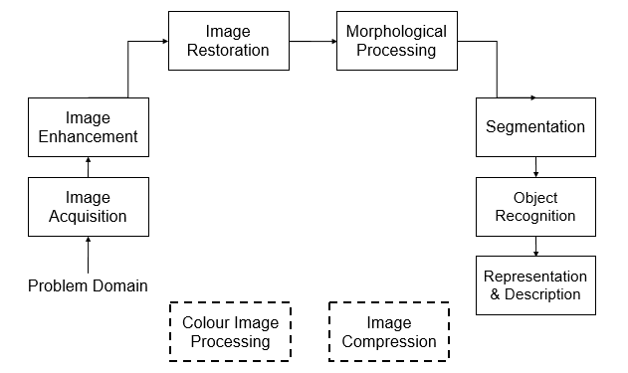
Image processing methods used include analogue and digital image processing. Analogue image processing can benefit hard copies such as prints and photographs. Image analysts use a variety of interpretive fundamentals when using these visual tools. Digital image processing techniques enable computer-assisted image manipulation. When using digital techniques, all types of data must go through three general processes: pre-processing, augmentation, and presentation, as well as information extraction.

Fig 2.1 Block Diagram of Digital Image Processing

2.3 IMAGE ENHANCEMENT
Prior to processing, image enhancement is the process of improving the quality and information content of raw data. A variety of software is used to improve images, such as filters, image editors, and other tools for changing various aspects of a full image or parts of an image.
A few basic types of image enhancement technologies simply change the contrast or brightness of an image, or edit its grayscale or red-green-blue colour patterns. Basic filters can also be used to convert a colour image to black and white, sepia tone, or add visual effects.
More advanced image enhancement software can make adjustments to specific areas of an image. Professional image enhancement software, such as Adobe's, allows designers to perform more specialised or professional image enhancements, or to pursue results for graphic design projects in which the original image is stylized or otherwise enriched. More advanced types of image enhancement tools include Wiener filters for actual image de-blurring and other complex resources for restoring or clarifying images that may be in poor condition due to sub-optimal image capture conditions, ageing, or other causes.

2.4 CONVOLUTIONAL NEURAL NETWORK
CNNs are used for image categorization and recognition because of their high accuracy. The Convolutional Neural Network is a hierarchical model that creates a funnel-shaped network before producing a fully connected layer. Which is made up of all interconnected neurons that are linked together, and the output is obtained. Using visual, speech, or audio signal inputs, CNN outperforms traditional neural networks.
Layers are classified into three types: Convolutional layer, Pooling layer, Fully connected (FC) layer. A convolutional network's first layer is the convolutional layer. More convolutional layers or pooling layers can be added after the convolutional layers, but the fully connected layer is the final layer. The CNN becomes more sophisticated with each layer, identifying larger portions of the image. The first layers concentrate on the most basic aspects, such as colours and borders. As the visual data is processed by the CNN layers, it begins to recognise larger portions or features of the item, eventually identifying the target object.

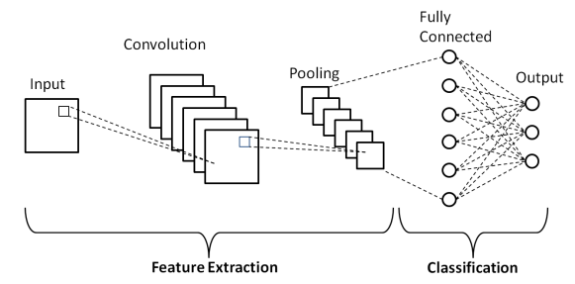
Fig 2.2 Block Diagram of Convolutional Neural Network

2.5 METHODOLOGY

2.5.1 DATA PREPROCESSING
The first step in this study is to collect degraded underwater images and corresponding reference (non-degraded) images from a publicly available benchmark dataset. The images are then resized to a fixed size (112 x 112) using the bilinear interpolation technique. Data pre-processing consists of six steps:
Data Profiling, the process of examining, analysing, and reviewing data in order to collect statistics about its quality is known as data profiling. It begins with an examination of existing data and its characteristics.
Data cleansing, the goal here is to find the simplest way to correct quality issues, such as removing bad data, filling in missing data, or otherwise ensuring the raw data is fit for feature engineering.
Data reduction, the raw data sets frequently contain redundant data resulting from different ways of characterising phenomena or data that is irrelevant to a specific ML, AI, or analytics task.
Data transformation, here the data scientists consider how various aspects of the data should be organised to make the most sense for the goal. This could include structuring unstructured data, combining salient variables when appropriate, or identifying important ranges to focus on.
Data enrichment, the data scientists apply the various feature engineering libraries to the data in this step to achieve the desired transformations. The end result should be a data set organised to achieve the best possible balance between training time for a new model and compute time.
Data validation, at this point, the data is divided into two groups. The first set is employed in the training of a machine learning or deep learning model. The second set of data is the testing data, which is used to assess the accuracy and robustness of the final model.

2.5.2 COLOUR BALANCED IMAGE GENERATION
It should be noted that CNN-based underwater image enhancement approaches are having difficulty producing enhanced images with realistic and natural colours. Because raw underwater images are always bluish or greenish in colour, CNN-based approaches struggled to produce an enhanced image with natural colours. To address this problem, we feed raw and colour-balanced images into the proposed network architecture, which results in a better enhanced image.
To generate the colour balance image from the raw image, we used a colour balancing technique. In an underwater image, the green channel is better preserved than the other two channels. By assuming that all channels in the enhanced image have the same mean, we used the following equation to generate a colour balanced image (I^{cb}) from the raw image (I^{raw}).

𝐼_{𝑟}^{𝑐𝑏} (𝑥) = 𝐼_{𝑟}^{𝑟𝑎𝑤}(𝑥) + 𝛽. (𝐼_{𝑔}^{𝑟𝑎𝑤} − 𝐼_{𝑟}^{𝑟𝑎𝑤}) ×
(1 − 𝐼_{𝑟}^{𝑟𝑎𝑤} (𝑥). 𝐼_{𝑔}^{𝑟𝑎𝑤}(𝑥) (1)
𝐼_{𝑏}^{𝑐𝑏} (𝑥) = 𝐼_{𝑏}^{𝑟𝑎𝑤}(𝑥) + 𝛽. (𝐼_{𝑔}^{𝑟𝑎𝑤} − 𝐼_{𝑏}^{𝑟𝑎𝑤}) ×
(1 − 𝐼_{𝑏}^{𝑟𝑎𝑤}(𝑥). 𝐼_{𝑔}^{𝑟𝑎𝑤}(𝑥)

where I_{r} ^{raw,} I_{g}^{raw}, and I_{b} ^{raw} are the means of the red, green, and blue channels of a raw image, respectively. 𝛽 is a parameter that is experimentally set to a constant value throughout the experiment.

2.5.3 PROPOSED NETWORK ARCHITECTURE
Two identical CNN branches are proposed in the proposed network architecture. These branches are fed raw degraded image pairs and corresponding colour balanced image pairs. These CNN branches are combined in deeper layers, and the resulting features are captured using a few additional convolutional layers. Each branch takes 112*112*3 input images and then the proposed network architecture produces an enhanced image with the same size of inputs.
The proposed network architecture includes a convolutional layer in front of each branch, with 16 filters and a kernel size of 55. Each branch of the proposed network architecture has three blocks, and the combined network has one block. The proposed network architecture has four convolutional layers in each dense block. All convolutional layers within a block have the same number of filters with equal kernel sizes.
Between convolutional layers, batch normalisation is introduced, and the Rectified Linear Unit (ReLU) function is used to activate the features. Within a block, the nth layer, like the model, obtains the feature maps of all previous layers (f₁, f₂,..f_{n-1}) and then applies a non-linear transformation function H_{n} to produce the output feature map f_{n} as follows:
𝑓_{𝑛} = 𝐻_{𝑛} ([𝑓₁, 𝑓₂, …, 𝑓_{𝑛−1}] (2)
where [f₁, f₂,... f_{n-1}] represents the feature map concatenation operation of layers 1, 2,..., n-1. Each branch's first two blocks have 16 filters, while the remaining blocks have 32 filters. Following the three blocks, the final output feature maps of the raw image branch (f ^{raw} _{mmc}) and the colour balanced image branch (f ^{cb} _{mmc}) are combined to produce the combined feature map (f ^{C} _{mmc}) as follows:
𝑓^{𝐶}_{𝑚×𝑚×𝑐} = 𝑓 ^{𝑟𝑎𝑤}_{𝑚×𝑚×𝑐} ⨁ 𝑓^{cb}_{𝑚×𝑚×𝑐} (3)
where denotes an element-by-element addition operation. Following the addition process, a block is used to capture information from the combined features. Finally, at the end of the proposed network architecture, the enhanced image is produced by a single convolutional layer. The spatial dimension of the feature maps in the proposed network architecture is kept at 112*112 in the convolutional layers and blocks.

CHAPTER 3

SIMULATION

3.1 PYTHON
Python is preferred by most data scientists and software developers due to the numerous functionalities it offers, the best of which is its open-source nature. Anyone from anywhere in the world can create their own package and make it available for others to use, thereby improving the Python backend on a daily basis.
An IDE is required for a user to write code in Python and save it to their desktop. Although, in order to run codes on your system, you must first install Python and then access it via the Windows command prompt. However, using an IDE improves the user's interaction with Python. An IDE allows you to write code in a script and then test the output by running the code in the IDE itself, with the results displayed in the output window. If a user wants to understand how a specific function works, they can refer to the help window for documentation inside the IDE, and they can also try running single liner codes in the console.

3.2 SPYDER PYTHON IDE

3.2.1 FEATURES OF SPYDER IDE
Spyder is an open-source cross-platform IDE. The Python Spyder IDE is written entirely in Python. It was created by scientists for scientists, data analysts, and engineers. It is also known as the Scientific Python Development IDE.
Spyder's notable features include: Customizable Syntax Highlighting, Breakpoint Availability (debugging and conditional breakpoints), Interactive execution allows you to run a line, file, cell, and so on. Run configurations for working directory choices, command-line options, current/dedicated/external console, and so on. Can automatically clear variables (or enter debugging mode), The Outline Explorer can be used to navigate through cells, functions, blocks, and so on. It allows for real-time code inspection (The ability to examine what functions, keywords, and classes are, what they are doing and what information they contain) After if, while, and so on, an automatic colon is inserted. All Python magic commands are supported. Matplotlib-generated graphics are displayed inline. Help, file explorer, find files, and other features are also available.

3.2.2 INSTALLATION OF PYTHON SPYDER IDE

The Python Spyder IDE is included as a standard implementation with the Anaconda Python distribution. This is not only the recommended method, but also the simplest. To install the Python Spyder IDE, follow the steps below:
Step 1: | Navigate to the official Anaconda website at https://www.anaconda.com.
Step 2: | Click on the download option available on the top right corner as shown in Figure 3.1

Fig 3.1 Installing Anaconda Website

Step 3: | Choose the version that is suitable for the OS and click download.

Fig 3.2 Choosing the Correct Version
Step 4: | After downloading the installer, you will see a Setup dialogue box. Finish the Setup by clicking Finish.
Step 5: | Then, in your system's search bar, type Anaconda Navigator and launch Spyder. When you launch it, a screen will appear as in the Figure 3.3
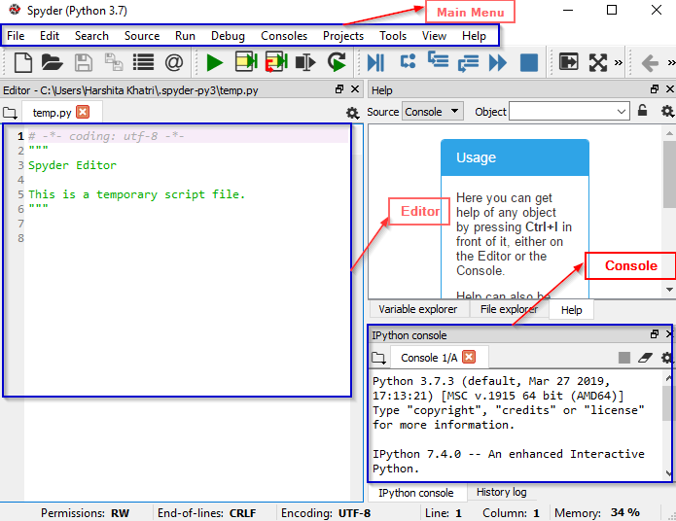

Fig 3.3 Spyder IDE installation

3.2.3 CREATING A FILE/STARTING A PROJECT
To start a new file, navigate as follows: File > New File. To start a new project, navigate as follows: Projects > New Project.

3.2.4 WRITING A CODE
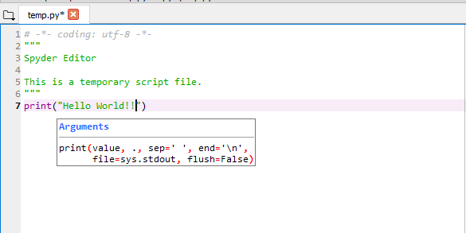
Spyder's multi-language code editor and a variety of powerful tools make writing code a breeze. As previously stated, the editor includes features such as syntax highlighting, real-time code analysis, style analysis, on-demand completion, and so on. When you write your code, you will notice that it provides a clear call stack for methods, indicating all of the arguments that can be used with that method.

Fig 3.4 Example of writing a program in Spyder IDE
The editor in the preceding example displays the entire syntax of the print function. Not only that, but if you make an error in any line, you will be notified before the line number with a message describing the problem as in the Figure 3.5.
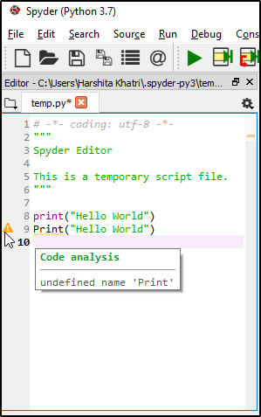

Fig 3.5 Showcasing the error in the program

To run any file, select the Run option and press the Run button. The output will be visible on the Console once executed, as shown in the Figure 3.6.
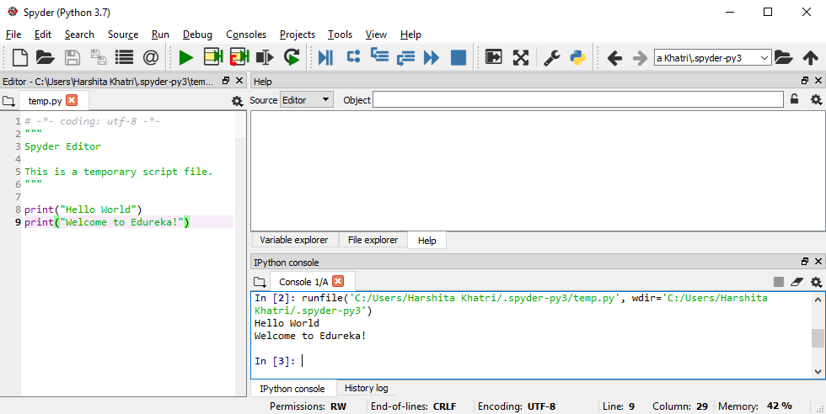

Fig 3.6 To run a program

3.2.5 CODE CELLS
You can easily define code cells by using the following table 3.1
TYPE | DESCRIPTION
#%% | Standard cell separator
# %% | Standard cell separator, when the file has been edited with Eclipse
# <codecell> | IPython notebook cell separator

Table 3.1 Types of Code cells

When you use the Standard cell separator, for example, you will see that the code has been separated as shown in the Figure 3.7.
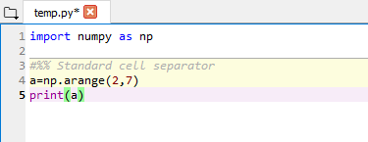

Fig 3.7 Usage of the Code cells

3.2.6 VARIABLE EXPLORER
The Variable Explorer displays all global object references from the current IPython Console, such as modules, variables, methods, and so on. Not only that, but you can interact with them using a variety of GUI-based editors.

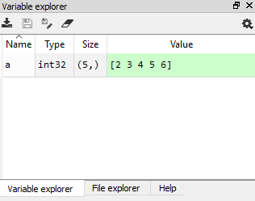

Fig 3.8 Variable Explorer in Spyder IDE

3.2.7 FILE EXPLORER
The File Explorer is essentially a filesystem and directory browser that allows you to browse, open, and manage files and folders. You can use the context menu functions to interact with them.

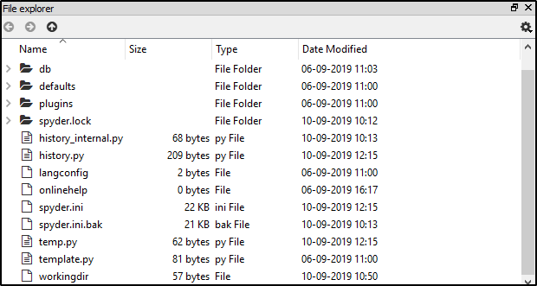
Fig 3.9 File Explorer in Spyder IDE

3.2.8 CONFIGURING SPYDER
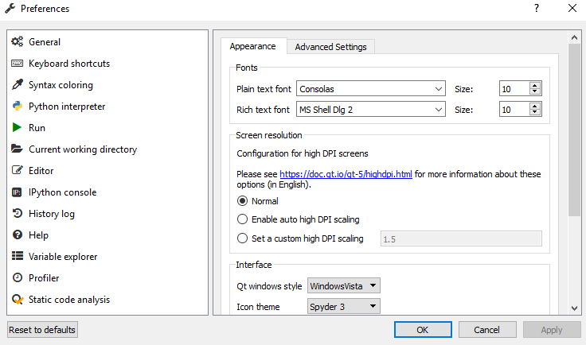
Python Spyder IDE can be easily configured by using the preferences menu options. You can change everything, including themes, syntax colours, font size, and so on. To do this, go to the Tools menu and then select Preferences. The following Figure 3.10 will appear, allowing you to configure Spyder according to your preferences:

Fig 3.10 Configuration of Spyder

3.2.9 HELP PANEL
The help pane allows you to locate and display documentation for any object. When you select the help option, you will be presented with the following options as shown in the Figure 3.11
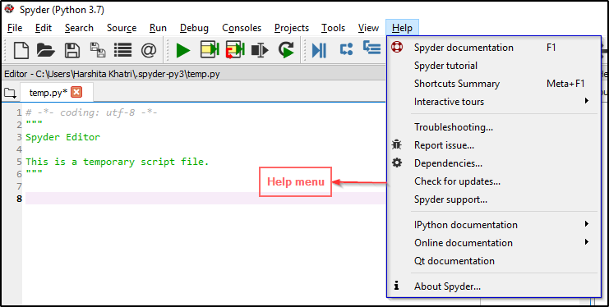

Fig 3.11 Help Panel in Spyder IDE
It has a wide range of choices that will assist you in resolving any problems you may encounter while using the Python Spyder IDE.

3.3 DATASET
Until recently, assessing the effectiveness of underwater images was a difficult task due to the lack of reference images in the benchmark datasets. As a result, even though the results are unnatural, synthetic images are used in the evaluation. The Underwater Image Enhancement Benchmark (UIEB) Dataset, which includes 890 real-world images and corresponding undegraded reference images, was recently created. All of the images in this dataset are 640 480 pixels in size. We, like other researchers, used the first 800 images for training and the remaining images for testing in the hopes of contrasting the findings. In addition, we used 20% of the training images for validation.
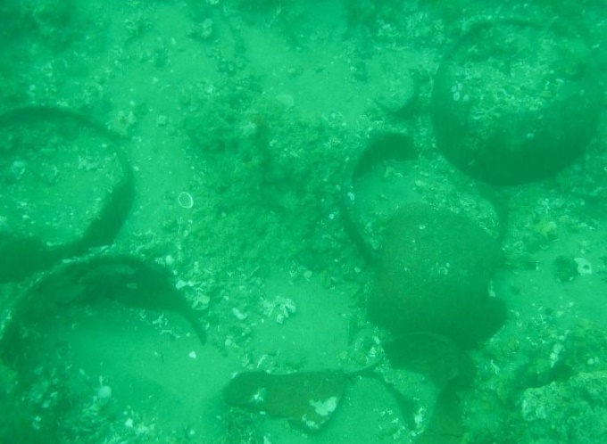
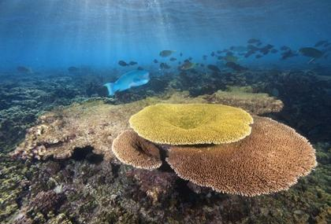
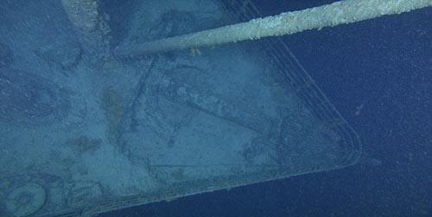
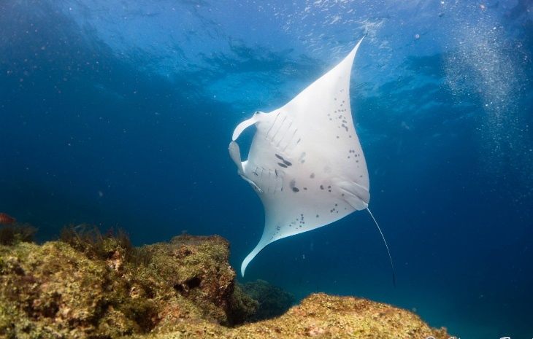
Fig 3.12 Underwater image enhancement benchmark (UIEB) dataset

3.4 TRAINING
The proposed network architecture is trained for a fixed number of epochs before testing the best performing model. In each epoch, a series of raw images (I^{raw}) and colour balanced images (I^{cb}) are fed into the proposed network architecture, and the resulting output (I^{out}) is compared to an undegraded reference image (I^{ref}).

3.4.1 INTERPRETATION FOR THE TRAINING CODE
In the training code, we have used 19 layers of model to build the block for the training they are: convolutional 2D, Max pooling, again convolutional 2D, again Max pooling, Flatten, Dense, Dropout, again repeat these for further iteration.
The results we obtain from the training code are the True positive, False positive, False Negative, True Negative, Sensitivity, Positive detection probability, Negative detection probability, False Discovery rate, Mean Squared error, Peak signal to noise ratio. Also, we can obtain the values for accuracy, precision, recall, F1 score and test accuracy.

CHAPTER 4

RESULT AND DISCUSSION

4.1 EVALUATION CRITERIA
To test the performance of the proposed approach, we used the Peak Signal-To-Noise Ratio is evaluated.

4.1.1 PEAK SIGNAL-TO-NOISE RATIO

The PSNR metric is used to compare the similarity of I^{ref} and I^{out} based on their pixel values. Peak signal-to-noise ratio (PSNR) is a measure used to evaluate how much a signal is corrupted by noise during transmission or storage. It is expressed in decibels (dB) and represents the ratio between the maximum possible power of a signal and the power of the noise that corrupts it.
PSNR is often used in image and video processing to compare the quality of an original signal with a compressed or processed version of it. The higher the PSNR value, the lower the noise in the signal is, and the closer the processed version is to the original. PSNR can also be used to determine the best compression method for a given signal or determine the optimal quality of a transmission channel. PSNR is calculated as follows:
PSNR = 10 log₁₀ (MAX² / MSE)
where MAX is the maximum value that the signal can take (for example, the maximum pixel value in an image) and MSE is the mean squared error between the original and processed signals.

4.2 MODEL EVALUATION

4.2.1 CONFUSION MATRIX
In deep learning, a confusion matrix is a performance evaluation tool that is used to analyse the accuracy of a classifier model. It is a summary of the number of correct and incorrect predictions made by the model compared to the actual class labels.
A confusion matrix is a matrix with four cells, representing true positive (TP), false positive (FP), false negative (FN), and true negative (TN).
True positives (TP) are the instances where the model correctly predicted the positive class.
False positives (FP) are the instances where the model predicted the positive class, but the actual class was negative.
False negatives (FN) are the instances where the model predicted the negative class, but the actual class was positive.
True negatives (TN) are the instances where the model correctly predicted the negative class.
The confusion matrix is useful when evaluating the performance of a binary classification model, where there are only two classes. It provides an easy way to visualize the actual performance of the model and can be used to calculate metrics such as precision, recall, accuracy, and F1 score, which are commonly used in deep learning evaluation.

4.2.2 ACCURACY
Accuracy in deep learning refers to how well the model is able to correctly predict the outcomes of the test data. It is the measure of how close the model's predictions are to the actual values in the test data. A high accuracy score means that the model is performing well and is able to accurately predict the outcomes of new data.
To calculate accuracy, the model's output is compared to the actual output of the test dataset. The percentage of correct predictions out of the total predictions made is then calculated.
However, accuracy should not be the only metric used to evaluate a model's performance as it can be misleading in some situations. Other metrics such as precision, recall, and F1 score may also be used to evaluate the overall performance of the model.

4.2.3 PRECISION
In deep learning, precision refers to the ability of a model to correctly identify true positive cases, or the proportion of true positives in the total number of positive predictions made by the model. In other words, it is a measure of the model’s ability to avoid labelling a positive instance as negative.
Precision is calculated as the ratio of true positives to the sum of true positives and false positives:
Precision = True Positives / (True Positives + False Positives)
A high precision value indicates that the model has a low rate of false positive predictions and can be considered as a reliable model in making accurate positive predictions.

4.2.4 RECALL
In deep learning, recall is a metric used to evaluate the performance of a classification model. It measures the proportion of actual positive cases that were correctly identified by the model as positive.
In other words, recall quantifies the model's ability to correctly identify all positive instances in the dataset. It is important to note that a high recall score indicates that the model has a low false negative rate, meaning it is excellent at identifying positive cases. Mathematically, recall can be calculated as:
Recall = True Positives / (True Positives + False Negatives)
where True Positives are the number of positive instances that are correctly identified by the model, and False Negatives are the number of positive instances that are incorrectly classified as negative by the model.
However, a high recall often comes at the expense of precision, which measures the proportion of true positive cases among all positive predictions. Therefore, the trade-off between recall and precision should be carefully considered depending on the specific application.

4.2.5 F1 SCORE
The F1 score is a measure of a model's accuracy in classification tasks. It is the harmonic mean of precision and recall.
In deep learning, the F1 score is used to evaluate the performance of a classification model. It is calculated as follows:
F1 Score = 2 * (Precision * Recall) / (Precision + Recall)
The F1 score ranges from 0 to 1, with 1 being the best possible score. A higher F1 score indicates that the model has better precision and recall, and is therefore more accurate. It is a useful metric for comparing different models and selecting the most accurate one for a given task.

4.3 TESTING RESULTS
The testing results for the proposed approach are mentioned in the following Table 4.1

PARAMETER | VALUE
Accuracy | 1.0
Precision | 1.0
Recall | 1.0
F1 score | 1.0

Table 4.1 Parameter Results

4.4 RESULT AND ANALYSIS
On the UIEB dataset, we evaluated the proposed approach's enhancement performance. The first 800 images, as with other researchers, are used for training, while the remaining images are used for testing. We compared the performance of our proposed approach with other approaches and the comparison is shown in the Table 4.2
APPROACH | PSNR | MSE
Marques and Albu [1] | 20.33 | 0.8
Sophiya Philip [2] | 21.45 | 0.7
Lee et al., [3] | 18.60 | 0.9
Sharma et al.[4] | 21.57 | 0.7
Proposed approach | 23.08 | 0.5

Table 4.2 Comparison of proposed approach with other approaches
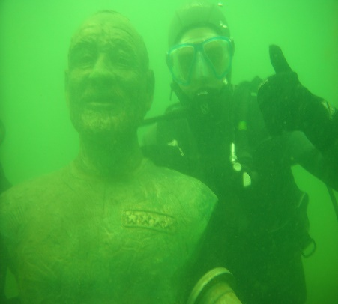
The proposed approach clearly outperforms current approaches to underwater image enhancement. When compared to existing techniques, the proposed approach produces lower Mean Square Error (MSE) and higher Peak Signal to Noise Ratio (PSNR) values.

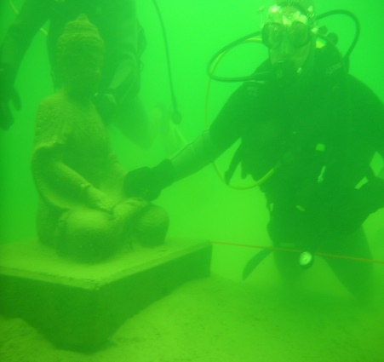

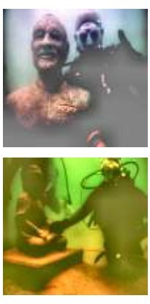
Fig 4.1 Raw Image from UIEB Dataset

Fig 4.2 Marques and Albu [1] approach
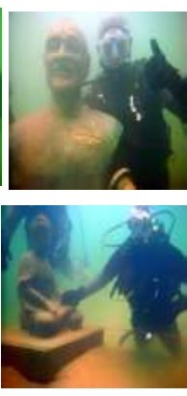

Fig 4.3 Sophiya Philip [2] approach

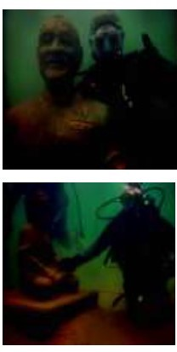

Fig 4.4 Lee et al., [3] approach
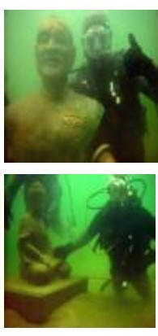

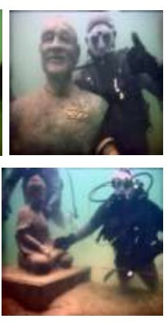
Fig 4.5 Sharma et al., [4] approach

Fig 4.6 Proposed approach

The proposed approach produces enhanced image with more realistic colour than the other approaches as shown in the Figure 4.2, Figure 4.3, Figure 4.4, Figure 4.5, Figure 4.6.

CHAPTER 5

CONCLUSION
In conclusion, the Underwater Image Enhancement using CNN method is a promising approach for improving image quality in underwater environments. The proposed method takes advantage of the deep learning technique of Convolutional Neural Networks to learn the mapping of input images to output images that are more visually appealing and useful for various underwater applications. The developed CNN model was able to produce impressive results in terms of increased visibility, colour enhancement, and noise reduction for underwater images.
The evaluation results showed that the proposed method achieved significant improvements in image quality metrics such as Mean Squared Error (MSE), Peak Signal to Noise Ratio (PSNR). The method also outperformed other traditional image enhancement techniques such as histogram equalization and colour correction.
Furthermore, the proposed CNN-based method has potential for real-world applications in underwater imaging systems such as underwater cameras, underwater drones, and submersibles. It can also be integrated into other underwater image processing algorithms for tasks such as object detection, object recognition, and scene segmentation.
In summary, the Underwater Image Enhancement using CNN method presented in this project has proven to be an effective and efficient approach to enhance underwater images. The achieved results suggest the potential of this method to contribute to advancing underwater image processing and improve the quality of images in underwater environments.

REFERENCES

- T. P. Marques and A. B. Albu, "L2UWE: A framework for the efficient enhancement of low-light underwater images using local contrast and multi-scale fusion," in Proceedings of the IEEE/CVF Conference on Computer Vision and Pattern Recognition Workshops, pp. 538-539, 2020.
- G. G. S. Sophiya Philip "Underwater Image Enhancement using White Balance and Fusion, " International Journal of Engineering Research & Technology (IJERT), vol. 08, pp. 1-5, 2019.
- H. S. Lee, S. W. Moon, and I. K. Eom, "Underwater image enhancement using successive color correction and super pixel dark channel prior," Symmetry, vol. 12, pp. 1220-1238, 2020.
- P. K. Sharma, I. Bisht, and A. Sur, "Wavelength-based Attributed Deep Neural Network for Underwater Image Restoration," arXiv preprint arXiv:.07910, 2021.
- W. Zhang, Y. Wang, and C. Li, “Underwater image enhancement by attenuated color channel Correction and detail preserved contrast enhancement,” IEEE J. Ocean. Eng., early access, Mar. 29, 2022.
- 6. Anparasy Sivaanpu, Kokul Thanikasalam, Amirthalingam Ramanan, “Underwater Image Enhancement Using Dual Convolutional Neural Network with Skip Connections” Research Gate ICAR, 2022
- W. Zhang, L. Dong, and W. Xu, “Retinex-inspired color correction and detail preserved fusion for underwater image enhancement,” Computer. Electron. Agriculture., vol. 192, Jan. 2022, Art. no. 106585.
- P. Liu, C. Zhang, H. Qi, G. Wang, and H. Zheng, “Multi attention Dense Net: A scattering medium imaging optimization framework for visual data pre-processing of autonomous driving systems,” IEEE Trans. Intel. Transp. Syst., early access, Feb. 1, 2022.
- Y. Zhao, W. He, H. Ren, Y. Li, and Y. Fu, “Polarization de scattering imaging through turbid water without prior knowledge,” Opt. Lasers Eng., vol. 148, Jan. 2022, Art. no. 106777
- X. Xue, Z. Hao, L. Ma, Y. Wang, and R. Liu, “Joint luminance and chrominance learning for underwater image enhancement,” IEEE Signal Process. Lett., vol. 28, pp. 818–822, 2021.

ANNEXURE

PLAGIARISM REPORT

