An Arduino Based Automatic Accident Detection

and Location Communication System
Pranav Gholap | Mujjamil Mulla |  | Raviraj Sawant
S.S.I.E.T. Ghogaon | S.S.I.E.T. Ghogaon |  | S.S.I.E.T. Ghogaon
Amol Kamble |  | Prof.Miss P.J.Yadav
S.S.I.E.T. Ghogaon |  | Assistant Professor  Electrical Engineering Department  S.S.I.E.T. Ghogaon

Abstract— Vehicle accidents have become one of the major issues, which cause the death of many people around the globe. Presently India is in the top-ranked in death due to road accidents. This is a serious matter, which needs to be solved to save the life of many injured people due to accidents. To solve this problem many automobile companies have done different systems such as safety airbags, seat belts, camera sensors, etc. but still the cause and the effect of the accident cannot be reduced. One of the major solutions is to provide proper medical treatment to the victim on time. According to statistics whenever any kind of accident happens, the witness of the accident hesitates to help the victim due to the long procedure of reporting and inquiry to the police. Mostly the victim is not in a condition to ask for any sort of help from others in that situation. In such a situation, the life of the victim is in danger due to the lack of proper treatment and medical facility in time. To solve this problem there is an urgent requirement of a system that automatically detects the accident and based on that information it communicates about the accident and its location to the hospital and relative without any delay. In this work, an Arduino based Automatic Accident Detection and Location Communication System (AAADLCS) is developed that continuously tracks the location of the vehicle, when any kind of accident occurs. It automatically detects the accident and based on that information it sends that location to the hospital, relatives, and to the police quickly. The key benefit of this system is its low cost, easy to implement, easy to use, processing speed, high accuracy, and its self-reliance.

Keywords—Accelerometer, Limit Switch, GPS, GSM, Arduino Uno, MEMS.
- INTRODUCTION
In modern-day, the production of the automobile industry has been increased day by day around the world. There are millions of vehicles have been produced annually. The rate of accidents is also being increased due to the increase in traffic. Many people have lost their lives in road accidents due to the lack of proper treatment. This accident on the highways and remote place cause a huge loss of lives and is a threat to society.
Generally, the traffic congestion in downtown may trigger even for a minor accident. In the metropolis, this thing becomes worse during the rush hours [1]. According to the report of World Health Statistics in 2008, the Road Traffic Injuries were in 9th rank causing death in 2004 which is expected to be in 5th rank in 2030 overtaking diabetes, HIV/AIDS, etc. depending upon the current rates [2]. Currently, car accidents are the major cause of losing life in India. In 2004, the total number of road accidents was

1 lakh. In 2008, this value was increased to 1.2 lakh, and in 2010; this value was increased to 1.36 lakh [2] (Fig. 1). Although there are different techniques to control the accident such as Anti Collision System (ACS), Adaptive Cruise Control (ACC), Antilock Breaking System (ABS), etc. but it is not an effective technique to save the lives from the accident. Presently India has become the number one position in death causes by accident. Therefore, it is a serious matter to be taken into consideration. The person injured by the accident can be saved by providing proper medical treatment on time. According to statistics, the witnesses of the accident hesitate to help the injured person because of the long process such as reporting to the police station about the accident after that inquiry takes a huge time. For this, there is a need for a system that does not depends on other people to help and rescue the victim. It may also happen the person is conscious but unable to contact the other person for help. That is why there must be an emergency facility in the car, which automatically sends the location when an accident happens for help.

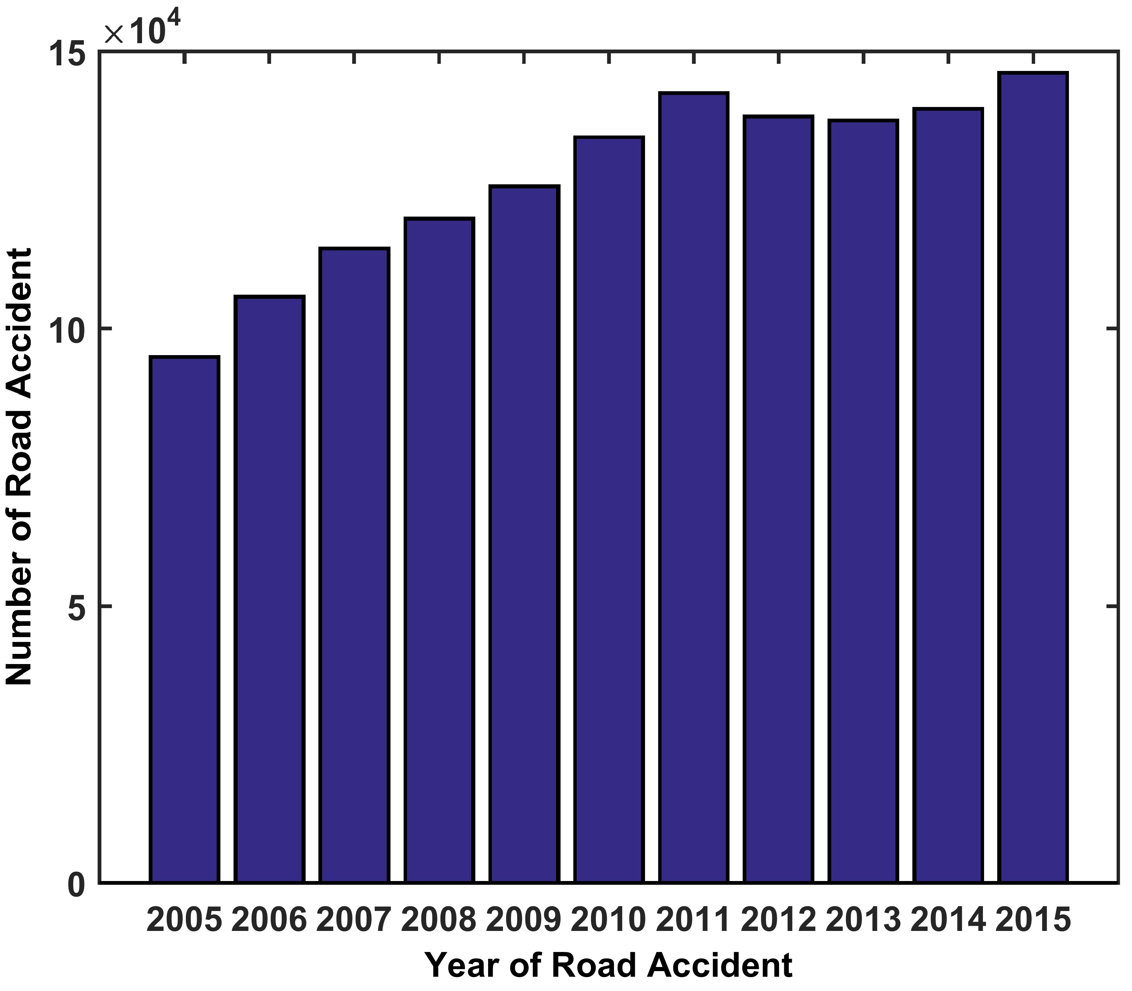
Fig. 1. Number of Road accident in India
From this, it can be stated that in most of the remote places after an accident, an injured person does not get any proper medical service. This is due to the lack of information about the place of the accident, which reduces the survival probability of that person. Therefore, it is very much necessary to get the location of the accident for taking

proper action quickly without any delay to save the life of the injured victim. However, it is difficult to track the location of the accident without implementing an electronic system. In this paper, a system AAADLCS is developed that will automatically detect and send the location of the accident when any kind of accident occurs even in remote locations
The rest of the paper includes the Literature Review in section II, System Architecture in section III, System Implementation in section IV, Results and Discussion in section V, and Conclusion in section VI.
- LITERATURE REVIEW
Many researchers have focused their work on an accident monitoring system to control road accidents and save lives. Some of the work has been discussed in this section.
In one of the work [3], the author proposed the concept of GPS receiver to get information about vehicle speed to detect an accident. The GPS system monitors and compares with previous values with Microcontroller. Decrease of speed to a certain limit then this is declared to be an accident.
In [4], the author proposed the concept of the incident detection system to detect the accident by using the car airbag sensor with GPS and GSM. In another paper [5], the author proposed the accident detection system by using the Smartphone. In [6], the author uses the sensor to prevent the accident, and the wireless module is used for reporting purposes. The main drawback of this technique is it is very much expensive and difficult to install.
In [7], the author discusses the accident is detected by using the accelerometer and flex sensor after that the location is provided to the nearest hospital, police station by using the GPS system and GSM module.
In one work [8], the author proposes that the accident is detected by using the GPS speed and map-matching algorithm. Finally, that data is sent to the Server. In this system, the GPS will automatically track the position and the vehicle speed in every 0.1-second time interval to observe the vehicle.
In another work [9], the author discusses the Real-Time Embedded System for Accident Prevention. Here the author designs an Atmega328P microcontroller system to track the location and alert corresponded people. Here the total process is done automatically which is very much helpful as after the accident the person may not able to send the location information to others [10]. Here the total process is divided into two parts one is the Receiver side and another one is the Transmitter side. Here in the transmitter side, the speed of the vehicle controlled by using the RF transmitter, which is placed at a fixed distance from the zone. Here for the security system, different types of sensors are used such as smoke sensors, alcohol sensors, and eye sensors. Here the piezoelectric sensor is used which will automatically detect the signal when the collision occurs and then it sends the

information to the Atmega320P microcontroller [11]. Finally, the location of the place is estimated by using GPS and sends information to previously stored numbers (house, hospital, etc.) [12].
In [13], the author proposed the concept of the automatic smart accident detection system. In this work, the sensor continuously observed the change in speed, movement which is analyzed in the Smartphone application. In another work [14], the author proposed the Smoothed Particles Hydrodynamics (SPH) based accident detection system. Here at first, the motion flow is captured from the videos. After that, the coherent motion field is extracted from thermal diffusion and the moving particle is approximated. Then the potential particle is obtained to detect the accident from the video. The authors [15] propose an automatic accident detection system by using street surface estimation of traffic. The technique is not effective because there was a chance of false alarming and then it will be not sure to prevent or report an accident.
In [16], the author proposes which uses module such as GPS, accelerometer, gyroscope, GSM, and auto-dialer. In this system, the MPU6050MEMS sensor is used to detect the accident by using the 3-axis accelerometer and gyroscope. And the GPS module tracks the location of the accident which is sent to emergency providers. After that, the auto-dialer feature automatically informs the victim’s family about the accident. In one of the works [17], an application was developed to detect the accident and provides the notification to the medical associates timely.
In [18] the author proposed the concept of fog based accident management system using the smartphone inbuilt sensor is used to detect the accident. In another paper [19] the author proposed the concept of smart accident detection system by using the vehicle sensor which continuously observes the speed, pressure, rotation movement of the vehicle. After that, the Smartphone analyzes the sensor data. Here the app is designed to analyze the data of the sensor to detect the accident.
- SYSTEM ARCHITECTURE
The main objective of this work is to reduce the rate of death caused by a car accident. In this work, we proposed AAADLCS for the post-accident safety and information system. As we know when an accident happens the injured victim may not be able to inform other persons for help and due to the lack of proper treatment, it may also happen that the person has to cost the life. In this kind of situation, this system is very much helpful to save lives and get medical treatment within time. The system architecture of the AAADLCS is shown in the above Fig. 2.
AAADLCS will detect the accident and will send information to others to take suitable action against it. The whole system consists of ARDUINO UNO board, Accelerometer, Limit Switch, GPS Module, and GSM Module. At the first stage, Accelerometer is used to detect the acceleration, movement, and rotation of the car. Limit Switch is used to check collision and it is triggered to send the message by using the GSM module. The main purpose

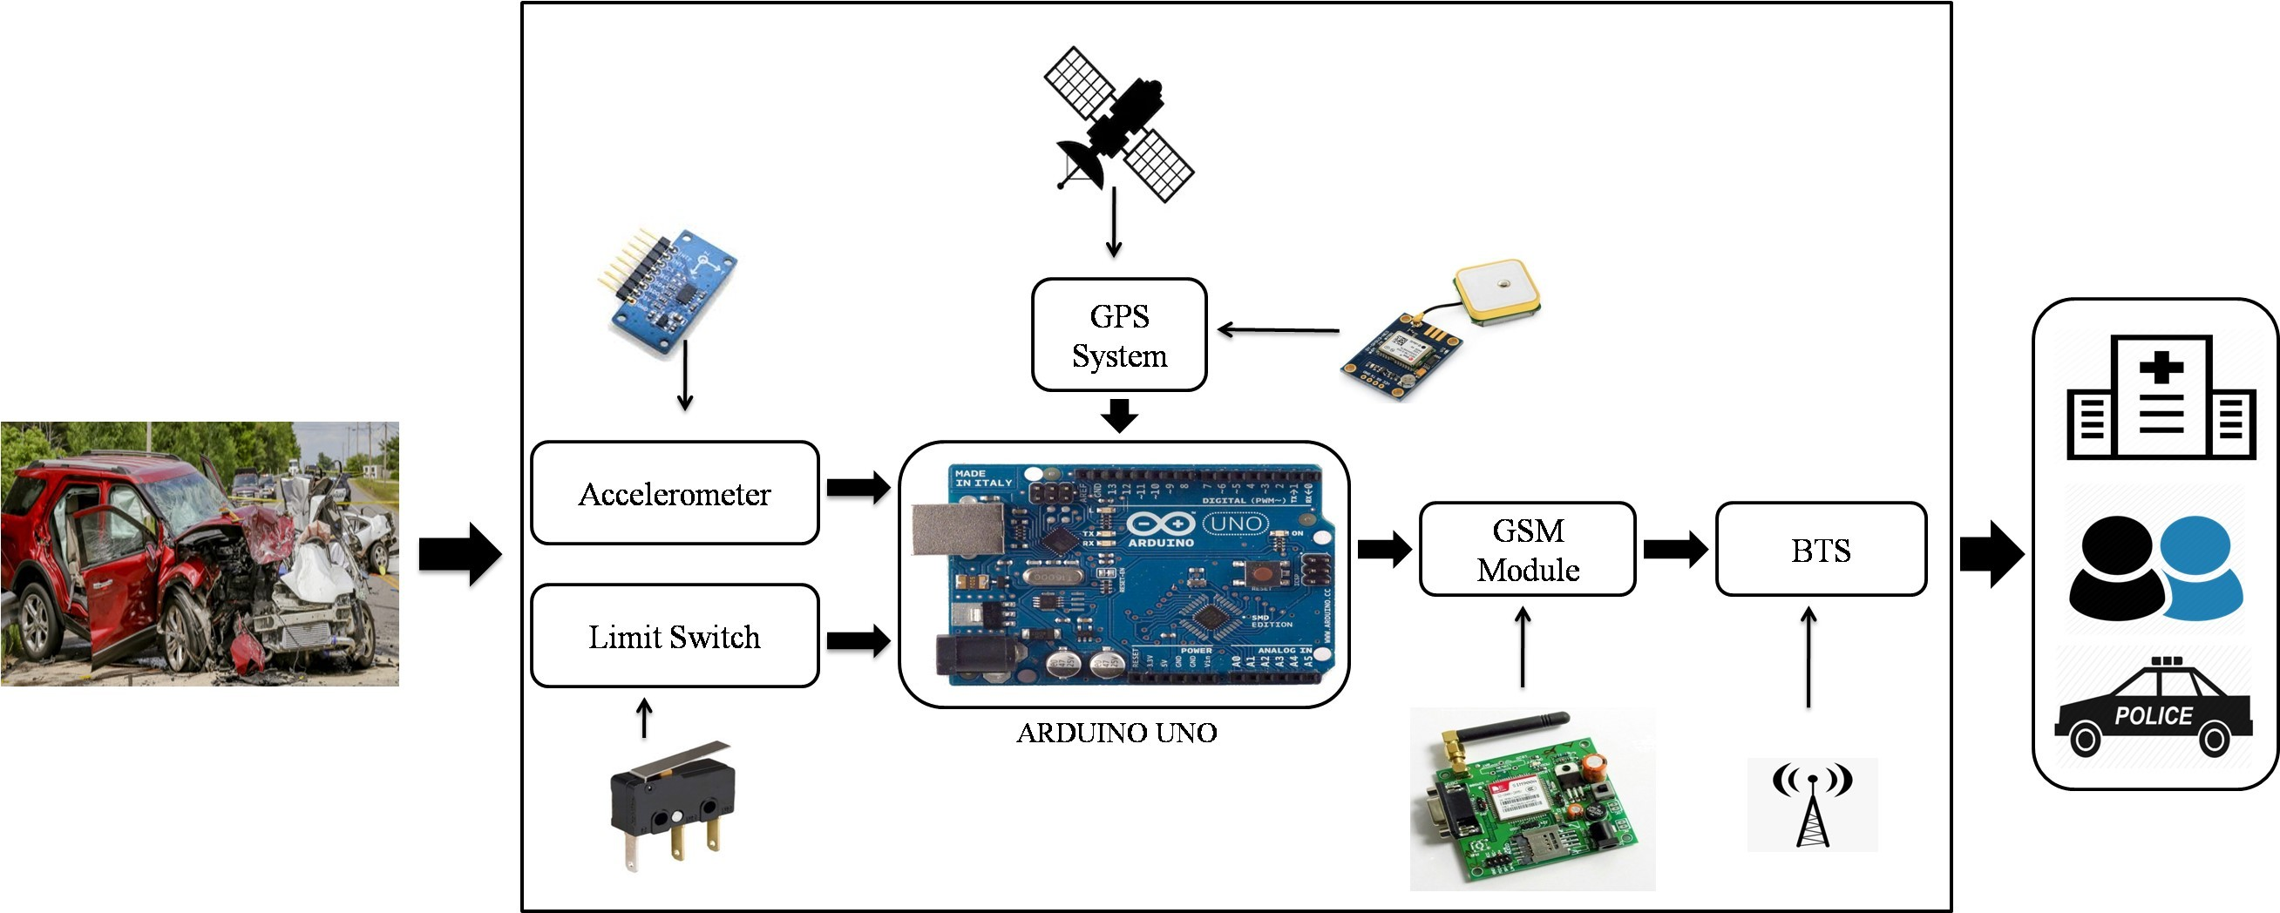
Fig. 2. System Architecture

of these sensors is to detect the accident. When the accident occurs with the car then the GPS system automatically collects the current location of the accident in terms of Latitude (North or South) and Longitude (East or West) with the time and date. After that, information is provided to the GSM Module, which sends that information to the nearby hospitals, police stations, and family members without any delay to take proper action immediately without losing time. The whole system is placed inside the car, which is not visible to others. Proper designing and packing of the system are done to protect the system from dust and water.
System Efficacy
- Immediate sending messages without any delay.
- Mobile numbers can be easily changed according to needs.
- The process is automatically activated without any human effort.
- The system worked perfectly, even any major or minor damage occurs in the vehicle.

- SYSTEM IMPLEMENTATION
The main purpose of this work is to provide automatic information for road accidents to reach the casualties for providing the medical services as soon as possible. This system is very much helpful for reducing human deaths in road accidents. Presently most automobile companies focus their work to provide efficient safety systems in vehicles. The proposed system can be very much helpful to detect the vehicle crash and when any accident occurs, it will report that to the relatives, hospital, and police station, etc. by using the text message to provide medical service to the passengers quickly. The system is a microcontroller-based system, which interacts with different sensors and modules such as accelerometer, limit switch, GPS system, and GSM module. In this system, accelerometer and limit switch are used as key components for detecting the accident. In this system, the Arduino UNO board as a microcontroller device, which is easily available and easy to implement is
used. The different part of the proposed scheme has been discussed in the following section.
- Arduino
In this system, we use the Arduino UNO board as a Microcontroller device. Presently the Arduino board has been used in different types of IoT based applications as it can be easily integrated with different types of devices (such as sensors, different modules, etc.). The programming part has been done by using the Arduino platform. It has an in- built Integrated Development Environment to interface with various types of devices. Basically, a programming language such as C is an open-source software to connect with the Arduino hardware to upload any program by using the USB cable.
- Accelerometer
The Accelerometer is an electromechanical device that is used to measure the acceleration. It may be dynamic (such as moving or vibrating) or static (such as the constant force of gravity). The accelerometer is the transducer that measures the accelerationapplied to detect the movement of the object. In this system, ADXl335 Accelerometer is used which is a 3 axis accelerometer. It is the low profile MEMS sensor consists of micro-machined structured on the silicon wafer, which is suspended by poly-silicon spring. It uses gravitational pull to determine the object coordinate with respect to earth. It has three analog pins for the three axes and two supply pins. It is mainly used for car-crashed detection, scrolling, etc..
- Limit Switch
Limit Switch is an electromechanical device (Fig. 3). It consists of actuators placed at the front and back and detects force. In our proposed system, it detects the collision due to the accident. It uses making or breaking the electrical connection depends upon the force. The main working procedure of this sensor is to detect the presence and absence of an external object for estimating the occurrence of the event.

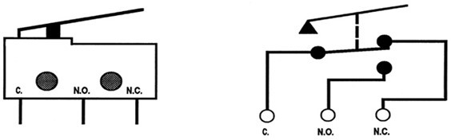

Fig. 3. Limit Switch

- GPS System
This module is very much helpful to track the location of the accident happens by using the GPS system. This data can also be used to track the speed of the vehicle, which is much helpful to detect the probability of an accident. In this system, the NEO 6M GPS module has been used to track the location of the vehicle. The key benefit of this module is it can easily be integrated with the Arduino module, easy to operate, quick response, which is very much useful to send the location to the predefined number for getting help as soon as possible. There are 27 satellites orbit from that it uses three satellites to track the location.

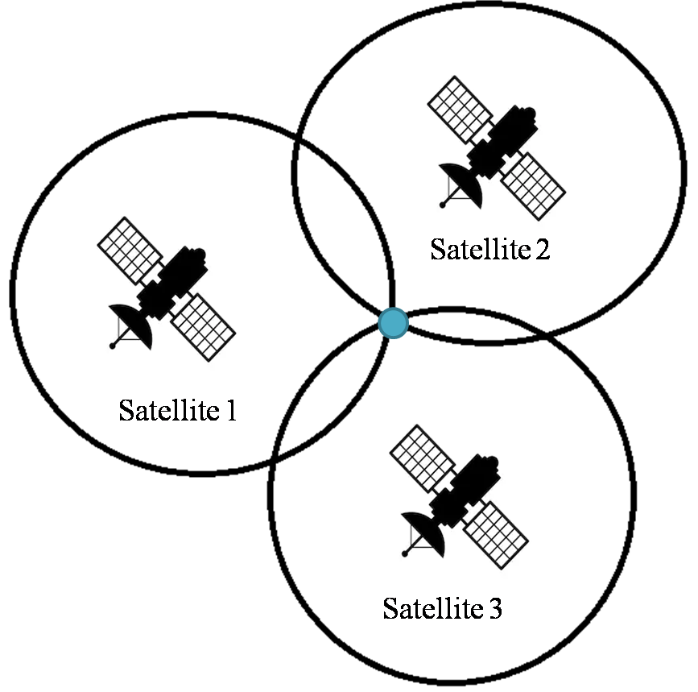
Fig. 4. Location tracking using three satellites

system, both limit switch and accelerometer are used. From the accelerometer, knowledge about the movement, acceleration, and rotation of the car is learned. The accelerometer is a 12e-based system. When an accident occurs, a large change in acceleration is generally observed. After that, the Limit switch is the trigger to send SMS. The process diagram of the system is given below (Fig. 5).
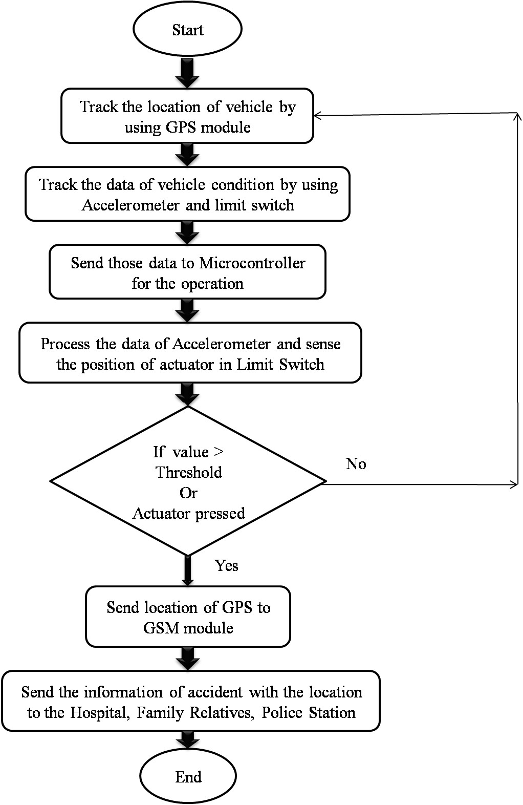

Fig. 5. Process Diagram

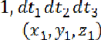
In the above equation , , represents the distance from 3 satellites while , , and are the coordinates of the three satellites and
is the co-ordinate of the location (Fig. 4). From the above equation, we can easily track the location by using the GPS module.
- GSM Module
GSM module is one kind of circuit for making the connectivity between the mobile device and the GSM system. In this module modem is the most important part, which is powered by the power supply circuit for making the connectivity with the network for sending the message. GSM based communication system is very much helpful to send the information to the police station, family member, hospital, etc. In this system, the information on the Arduino board has been conveyed. Here we use the GSM module SIM900A that is connected with the Arduino board to send/receive messages and make/receive voice calls to the predefined person. The module uses Dual-Band 900 MHz and 1800 MHz and operates at 3A power supply. In this

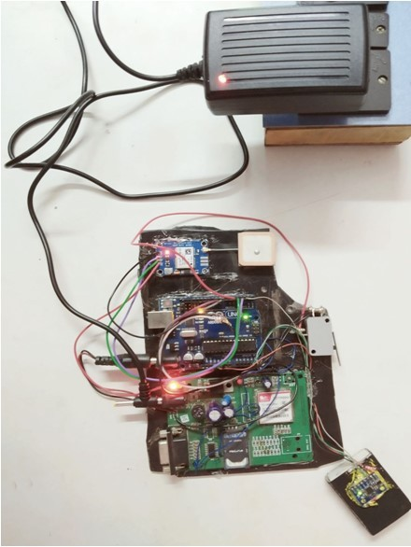

Fig. 6. Experimental setup

- RESULTS AND DISCUSSION
In this work, an experimental setup has been developed for vehicles, to continuously send the location when the accident occurs (Fig. 6). Here the experiment is conducted at five different positions and to check the accuracy of the location with the time delay it is tested multiple times. From the observations and data collected from the proposed model, some results are obtained. The system records the latitude and longitude of the places where the vehicle accidental observation is required by creating a virtual environment. In this experiment, we have taken fiftyobservations in each place to get the accuracy and average time delay of the device.
The system is modified to get a minimum amount of delay when an accident occurs so that the rescue operation can be done as quickly as possible. The difference between the time when the sensors sense the accident and receiving of the message is minimized. Thus, it is an advantage of the proposed model. The experimental result is given in Table I.

TABLE I. EXPERIMENTAL OBSERVATION

Place | Latitude | Longitude | Time Delay
P1 | 22.3023 | 88.1135 | 4.62s
P2 | 23.5359 | 87.3352 | 6.8s
P3 | 23.113 | 87.305 | 7.42s
P4 | 23.117 | 87.297 | 7.6s
P5 | 23.111 | 87.283 | 6.7s
It is observed that the result showing a very high location accuracy of the location where the accident occurs. The system also enough intelligence in detecting the occurrence of the accident and avoid false notification. Here P1, P2, P3, P4, and P5 are the five different locations where the experiment is conducted.
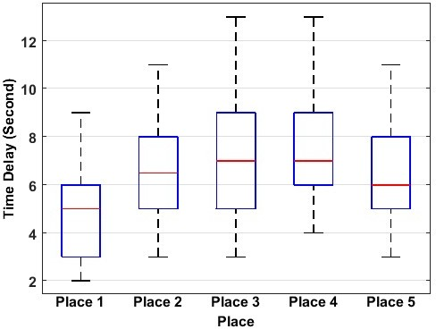
Fig. 7. Time Delay variation plot in different place

In different places, the delay of time to send the message can be varies depending upon the environment due to the signal strength of the module. In another part of the experiment, we have done 50 observations in different places to check the variability of the output. We have done statistical analysis using the box plot (Fig. 7); it is observed that the mean time delay calculated in all places comes within 7 seconds. This suggests the efficacy of the experimental device. The mean of the delay calculated at a

place from several observations is plotted in Fig. 8. Lastly, in Fig. 9 experimentally the received message format is shown. Initially, the system was developed to send latitude and longitude information as in Fig 9.a. Later it is modified to send the link of google map also as shown in Fig 9.b.
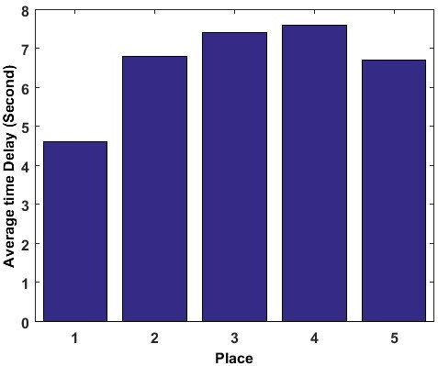
Fig. 8. Average Time Delay plot in different place
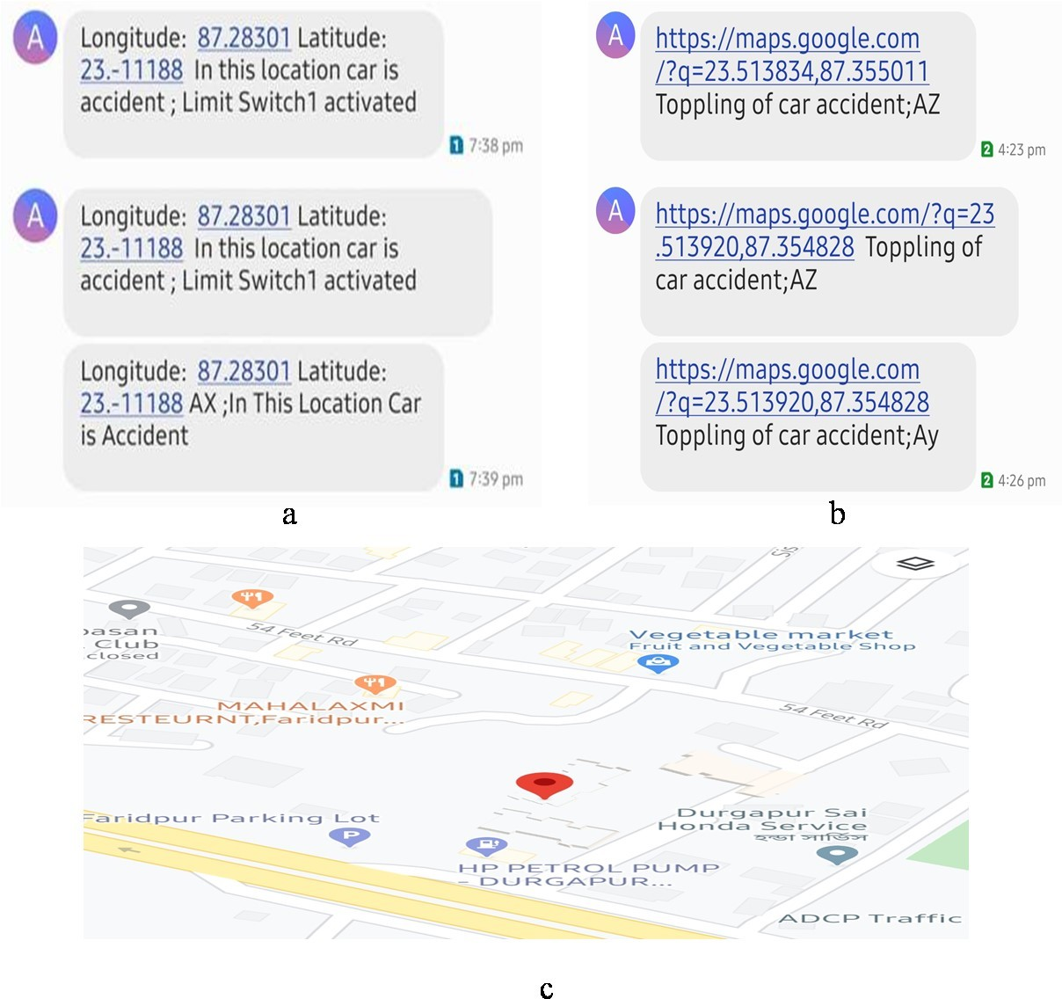

Fig. 9. Receiving accident location message (a) Message (b) Message with google map link (c) google map obtained from message

A comparison table to represent the efficacy of AAADLCS is represented in Table II.

TABLE II. COMPARISION

Scheme | Technique | Mean delay | False alarm avoidance
Accidental detection [3] | location | Not specified | Yes
Smart  vehicle[20] | Alarm | Not specified | Yes
AAADLCS | Location SMS and  google map link | 7sec max | Yes

- CONCLUSION
The objective of this work is to detect the occurrence of an accident by determining its location. Continuous location (latitude and longitude) is collected by the GPS in this work. As soon as there is an occurrence of an accident, the immediate location is sent to the emergency service provider (medical team or police station). Another aspect is to include the feature of informing the close ones such as a member of the family through this service. The AAADLCS is designed to detect the accident while maintaining the accuracy by using different kinds of sensors such as Limit Switch and 3- Axis accelerometer. The location is detected accurately within a short period. The survival rate at the casualties is indirectly proportional to the time gap between the occurrence of the accident and the reaching of the medical team there. AAADLCS has been designed efficiently so that the response time can be reduced to the maximum extent and medical facilities can be availed at the earliest.
REFERENCES
- Yongquan Chen, Yuandong Sun, Ning Ding, Wing Kwong Chung, Huihuan Qian, GuoqingXu and Yangsheng Xu "A Real-time Vehicle Safety System" IEEE/SICE International Symposium on System Integration (SII) 2012, pp. 957-962.
- "Road Accidents In India 2010" Government Of India Ministry Of Road Transport And Highways Transport Research Wing New Delhi December 2011, pp. I-53.
- Md. Syedul Amin, Jubayer Jalil, M. B. I. Reaz; “Accident Detection and Reporting System using GPS, GPRS and GSM Technology”. International Conference on Informatics, Electronics & Vision IEEE 2012.
- L. Chuan-zhi, H. Ru-fu, Y.E. Hong-wu, “Method of Freeway Incident Detection Using wireless Positioning,” in Proceedings of the IEEE International Conference on Automation and Logistics, 2008, pp. 2801 - 2804.
- C. Thompson, J. White, B. Dougherty, A. Albright, and D. C. Schmidt, "Using Smart phones to Detect Car Accidents and Provide Situational Awareness to Emergency Responders," in 3rd International ICST Conference on MOBILE Wireless Middle WARE, Operating Systems, and Applications (Mobilware 2010), 2010.
- R. K. Megalingam, R. N. Nair and S. M. Prakhya, “Wireless Vehicular Accident Detection and Reporting System,” in International Conference on Mechanical and Electrical Technology (ICMET 2010), 2010, pp. 636-640.
- BankarSanket Anil, Kale Aniket Vilas, Prof. S. R. Jagtap; “Intelligent System for Vehicular Accident Detection and Notification”. International Conference on Communication and Signal Processing, April 3-5,2014, IEEE.
- Md. Syedul Amin, Mohammad ArifSobhan Bhuiyan, Mamun Bin IbneReaz, Salwa Sheikh Nasir; “GPS and Map Matching Based Vehicle Accident Detection System”. 2013 IEEE Student Conference on Research and Development (SCOReD).
- Ancy John, Nishanth P.R; “Real Time Embedded System For Accident Prevention”. International Conference on Electronics, Communication and Aerospace Technology IEEE 2017.
- Lyla B Das,"Embedded Systems” – an Integrated Approach, First Impression, Pearson, 2013.
- Nirav Thakor, Tanmay Vyas, Divyang Shah,’ Automatic vehicle accident detection system based on ARM &GPS”, International Journal for Research in Technological Studies ISSN: - Applied (Online) Vol-1, Issue - 1, Dec 2013.
- C. Vidya Lakshmi, J.R. Balakrishnan, "Automatic accident detection via embedded GSM message interface with sensor technology " in International Journal of Scientific and Research Publications Volume 2, Issue 4, April 2012.
- Asad Ali and Mohamad Eid, “An automated system for accident detection,” in 2015 IEEE International Instrumentation and Measurement Technology Conference (I2MTC) Proceedings, May 2015.
- Habib Ullah, Mohib Ullah, Hina Afridi, Nicola Conci, and Francesco
G. B. De Natale, “Traffic accident detection through a hydrodynamic lense,” in IEEE International Conference on Image Processing (ICIP), Sep. 2015.

- J. Yoon, B. Noble, and M. Liu, "Surface street traffic estimation," in Proceedings of the 5th international conference on Mobile systems, applications and services, 2007, pp. 220-232.
- Parag Parmar, Ashok M. Sapkal; “Real Time Detection and Reporting of Vehicle Collision”.International Conference on Trends in Electronics and Informatics IEEE 2017.
- F. Aloul, I. Zualkernan, R. Abu-Salma, H. Al-Ali, and M. Al-Merri, “iBump: Smartphone application to detect car accidents,'' Comput. Elect.Eng., vol. 43, pp. 66_75, Apr. 2015.
- Bilal Khalid Dar, Munam Ali Shah, Saif Ul Islam, Castren Maple, ShafaqMussadiq And Suleman Khan; “Delay-Aware Accident Detection and Response System Using Fog Computing”. Special Section On Mobile Edge Computing And Mobile Cloud Computing: Addressing Heterogeneity And Energy Issues Of Compute And Network Resources, IEEE 2019.
- Venkata Krishna Kota, Nagendra Kumar Mangali, Thirumal Kumar Kanakurthi, A. Rakesh Kumar, T. Velayutham; “Automated Accident Detection and Rescue System”. IEEE WiSPNET 2017.
- Adnan Bin Faiz, AhmedImteaj and Mahfuzulhoq Chowdhury, “Smart vehicle accidental detection and alarming system using a smart phone,” in 2015 IEEE International Conference on computers & information engineering, Proceedings, Nov, 2015.

