A PROJECT REPORT
ON
A Study on Customer Satisfaction in Automotive Sector
By
Bhanu pratap
Roll No : 20GSOB1060049
BBA (Marketing and Automobile) : 2020-23

Under the guidance of
Prof. Reji John



GALGOTIAS UNIVERSITY
Greater Noida - 201310

DECLARTION

I hereby, declare that this research project report entitled " A Study on Customer Satisfaction in Automotive Sector” submitted by me for the partial fulfillment of the degree of Bachelor in Business Administration, submitted to
PROF. REJI JOHN is bonafide work done by me.

The empirical finding in this report is not copied from any report and is true to the best of my knowledge.

Roll No - 20GSOB1060049

Bhanu Pratap Galgotias University

Date:

Place: Greater Noida

ACKNOWLEDGEMENT

I consider myself really fortunate to have had this support during the competition of my project because the success and ultimate result of this project required a lot of direction and assistance from many people. I would like to take this opportunity to thank them for their guidance and support in everything I have accomplished.
I owe a debt of appreciation to my supervisor and mentor PROF. REJI JOHN who showed a genuine interest in my project work and helped me every step of the way till it was finished by giving me all the information required to create a successful system.Throughout the course of this study project, I have gained a great deal of knowledge, and I hope that you will find my work to be just as intriguing and educational as I .

EXECUTIVE SUMMARY

“A Research on Consumer Satisfaction in the Automobile Industry.” According to the survey’s findings, Honda and Maruti Suzuki are neck-and-neck competitors, although Maruti is far more well-known among consumers than Honda is in the premium class of car buyers. The survey process started with laying out the project’s goals and then constructing the questionnaire accordingly.
I completed all of the necessary parameters when designing the questionnaire. After this, I conducted a pilot survey with 10 consumers, and the necessary changes were made to the questionnaire. Afterwards, we started out with the final survey, and we invited respondents from all around the world to participate.

- Students
- Servicemen
- Businessmen
The report contains, at first, the brief introduction about Automotive Industry in India followed by the brief introduction of various Market Leaders in Premium Segment Motor bikes and then it goes through the subject of the report to reach at the conclusion.The methodology used for data collection was through primary and secondary sources. The primary data was collected through a questionnaire distributed amongst the students, service allied peoples and businessmen and secondary data was collected from internet, newspaper and magazines. The procedure adopted to select the sample was simple random sampling. The sample consists of 50 customers and was restricted to people residing in Noida.

TABLE OF CONTENT

Chapter No. | Name of Chapter | Page No.
1 | Introduction of Small Car Industry in India  - Factors driving the demand for small cars in India  - Current Scenario  - Importance of Cars in Life of a person | 06-15
2 | Objectives and Scope of the Study | 16-17
3 | Literature Review  - Up Coming Models of Small Cars  - Car Models in India  - Popular Car Segments in India | 18-38
4 | Current Status of Auto Industry in India | 39-43
5 | Research Methodology | 44-53
6 | Data Analysis and Interpretation | 54-64
7 | Findings | 65-66
8 | Conclusions | 67-68
9 | Recommendations | 69-70
10 | Bibliography | 71-73
11 | Annexure | 74-77

INTRODUCTION

INTRODUCTION

The little vehicle portion is one of the biggest vehicle fragments in India. Little vehicle in India dia will observer a blast in the little vehicle portion with Significant vehicle directors making their raid in India and India will have little vehicles from General Machines, VW, Fiat, Portage, Toyota, Honda, and so on. The current little vehicles would draw in important limits or would be gotten rid of to contend is characterized as a vehicle that has length between the rung of3.8 to 4 measures. It contain nearly two- third of the deals in the country. This vehicle section has developed huge amounts at a time in beyond couple of times following developing economy, farther insignificant pay and Developing further extravagant working class. The new type of immature leaders with fatter checks has prompted more buy power. immature India is blasting and vehicle sedulity is luxuriating under the sun.
Constantly 2018, In with the new vehicles counted down with utmost recent swish rudiments like ABS, airbags, programmed drive, And so on. We anticipate that every one of the vehicles will be set in the value band of Rs 3Lakh to Rs 5Lakh. Goodbye Nano is likewise set to carry out soon and the machine request stands by anxiously including machine pundits and the Indian guests. Maruti Suzuki is the uncrowned autonomous of the little vehicle sedulity in India. It has proactively made India as its assembling and products center for its little vehicles. It also has one of the biggest item portfolios in India among the wide range of various vehicle creators. It's the biggest automaker in India by deals and has different models like Alto, Cart R, Harmony, 800, and Quick. Every vehicle has told the little vehicle section with its remarkable highlights and cost factor. Maruti has made India as its little vehicle assembling and goods center. The abroad requests of Suzuki models around the world. Maruti Suzuki plans to shoot offA- Star and Sprinkle toward the finish of 2018.
Hyundai is the second biggest bus maker in India and has likewise made India as it ‟ s assembling and goods center. It right now has its assembling plant in Sriperumbudur, close to Chennai, with a current limit of 600,000 units. It To expand its product capacity by nearly another 100,000 units. Hyundai has strong deals figures in India and has witnessed further than 40 percent growth in the first four months of 2018 it. It has strong contenders for the small bus member like Santro, Getz and i10. It also plans to launch its new models of i20 and i30 in India powered with the new Kappa machine presently being used in i10. I20 is anticipated to launch some time at the end of 2018. Fiat would also launch its small bus Grand Punto by the time end with Tata Motors at its tails with a new interpretation of Tata Indica. The much awaited Tata Nano would also roll out in the last quarter of time 2018. India would also witness up! From General Motors and Jazz from Honda. Toyota is also ready to

launch its small bus by 2018 in both petrol and diesel options Renault- Nissan has also announced to launch a Nano- contender being manufactured in alliancewithBajaj.The small bus request in India is adding by hops and bounds. The indigenous request for small motorcars now occupies a substantial share of around 70 of the periodic bus product in India of about one million. The main players in the bus request like Tata Motors and Maruti Udyog are fiercely competitive and more or less all the machine companies in India that have forayed into the product of small motorcars are trying to out- do each other in terms of design, invention, pricing, and technology, in order to gain control of the small bus request in India. The biggest players in the Indian small bus request are engaging in a healthy competition, which has boosted since the Indian government decided to boost the small bus sector. In this regard, a reduction in the excise duties has been allowed of. Indeed the machine capacities are anticipated to be raised to 1500cc. The new small motorcars in India motorcars may indeed be fueled by gasoline and diesel in the future. With all these installations, it has been estimated that the indigenous bus request is going to move beyond the3.5 million mark truly soon. Suzuki, which is now heading the Indian small bus request has plans to invest an freshUS$ 650 million for disquisition and development Work in its Manesar Plant. This plant will also be used for manufacturing diesel motorcars. Suzuki has decided to enter into a common- adventure with Nissan to launch a new mini bus model in India. Indeed Hyundai Motors is on a similar investment spree for disquisition work with a adventure ofUS$ 700 million in India. The two motorcars from the Hyundai stable – Santro and Getz are formerly in the request and have been doing exceptionally well in the formerly numerous times. It's anticipated that further and further foreign companies are likely to join the healthy race in the Indian small bus request. One of the biggest players in China’s bus request, Volkswagen, has decided to invest in the Indian small bus request. It's supposed to invest a total amount of US$ 540 million and manufacture nearly 100,000 mini motorcars on and period base.

FACTORS DRIVING THE DEMAND FOR SMALL CARS IN INDIA

The increase in the demand for small buses can be attributed to the aspirational life of people which makes them strive for a auto beforehand on in life. The overall age for retaining a auto has also dropped in recent times. Further, with the growing influx of the pastoral sector, retaining a auto, at least a small auto, is a forthcoming conclusion in ultramodern India. still, since small buses are more affordable and utilitarian, the demand for them has shot through the roof. This rising demand for small buses is attracting companies like General Motors which has increased its monthly product in India to 140,000 vehicles. The Maruti 800 which is the most favored auto among the Indian middle classes can now be bought at a lower cost. Tata Motors has decided to launch amini-car in 2018, which will bring as lower asUS$ 2,200. Tata Motors is also going through a process of decision- timber, to launch a variety ofmini-cars in association with Fiat. Honda has also decided to increase its manufacturing capacity in India to 100,000 veritably soon. thus, the leaders in the request for small buses in India can be seen to engage in a price war to make further buses available to the maturity of Indian citizens. The small auto request in India is witnessing the maximum exertion and is all set for more instigative times ahead, with further players from India and abroad joining the race.

SMALL CARS IN INDIA

Chevrolet Daewoo Fiat Hyundai Mahindra-Renault

Maini Maruti Suzuki Opel Skoda

10

CURRENT SCENARIO

Not truly long agone the only motorcars that were available in India were the Ambassador and the Premier Padmini. The Ambassador is a replica of the Morris Oxford – an old British bus, while the Premier Padmini was a Fiat 1100 assembled in India. All that was inpre- liberalisation India, which was before 1991, when the first Liberalization measures were announced. ahead, the product of the Maruti Suzuki 800 Hatchback bus in 1983 – a common adventure between Government of India and Suzuki Motors of Japan, paved the way for a belle epoque in the Indian machine sector. Post liberalization, India is on every bus manufacturer’s map. The reasons are not hard to notice. presently, India is the second largest two- wheeler request and the fourth largest marketable vehicle request in the world. Not only is it the eleventh largest passenger bus request encyclopedically, but it's also anticipated to be the seventh largest by 2019. Post liberalization, multitudinous foreign manufacturers have lined up and have setup base in India. Other domestic manufacturers have also bettered product situations and are in the race for producing better models as well.
Some of the bus manufacturers who have set up base in India are Audi, BMW, Chevrolet Fiat, Ford, Honda, Hyundai, Mahindra, Maruti, Mercedes, Mitsubishi, Skoda, Suzuki, Tata, Toyota, Volkswagen, and Volvo. India’s profitable growth is roaring presently. These manufacturers have set up manufacturing installations in India, or are importing motorcars and reserves to meet the demands of this growing request. For illustration, companies like Ford are planning to make India a indigenous mecca for exports of both small motorcars as well as machines. According to Michael Boneham, President Designate for Ford India, the company plans to export the small bus and the machine for requests abroad. He indicated that one of the requests would be primarily Ford Asia Pacific Region while other requests are under consideration presently. There are multitudinous reasons for the emotional growth of the Indian
bus sedulity. Some of these are comparatively easy vacuity of vehicle finance, attractive rates of interest, and accessible installations. Competition has forced manufacturers to be innovative and responsive to customer demands and conditions. Now that India is not alien to quality and perfection, customer prospects have soared to advanced situations. Depending upon guests needs, four corridor – small, mean, ultraexpensive and sports avail vehicles presently represent the bus request in the country. A niche generality motorcars member is also arising wherein reputedre- modellers like DC Chhabria cater to individualities who wish to revise their vehicles to produce generality motorcars for their use. again, a member is also arising comprising of people who wish to upgrade to motorcars from two wheelers. Tata formerly is in the process of launching the small bus Nano to suit this member’s conditions. multitudinous other bus manufacturers analogous as Bajaj Auto are also following suit and are in the process of coming up with their specific performances to

feed to this member. presently, there is high demand for motorcars across all these corridor. With the growing economy, people left with a lot of disposable income spend it towards meeting their mobility needs analogous as motorcars. Banks and other financial institutions have an assortment of vehicle loan schemes with attractive rates of interest and accessible installations. These schemes encourage people to go in for loans to buy motorcars of their choice. also, a accessible unionBudget in the current financial time( 2018- 19) has worked in favour of the machine sector, which has seen an uptrend in deals across various corridor. The bottommost trend of new motorcars on Indian road has led to the emergence of an entirely new request in alternate hand motorcars too. multitudinous entrepreneurial and professional dealerships have sprung up in multitudinous cosmopolises in India dealing in alternate hand motorcars. The growth of the alternate hand request is not surprising. The new bus request has grown at an implausible pace in India. As mentioned, loans are easily available in the country for purchase of new motorcars. also, multitudinous people are now overhead mobile. therefore, people who were earlier part of the small bus member now have moved over to the ultraexpensive bus member, and those in this member have moved over to the luxury bus member. therefore, the trend is to get relieve of the motorcars that defined them as part of the before corridor and buy motorcars that identify them with the newer corridor. apparently, the desire for newer motorcars and models is yet another reason. People get attracted by newer models, which prompt them to acquire them. This makes them sell their current motorcars for reasonable resale values. This phenomenon benefits those who want to buy motorcars, but are not suitable to go new Bones. multitudinous companies like Maruti Suzuki( Maruti True Value) have also established resale showrooms where people can buy genuine, good condition,
alternate hand motorcars at reasonable prices. With the emergence of favorable trends in the machine sector in India, what remains to be seen is how these developments will go a long way to transform the mobility conditions of the ordinary Indian.

IMPORTANCE OF CARS IN LIFE OF A PERSON

C – Commodity that A – Assures
R – Respect

The mileage or significance of auto can be divided into-

- Social mileage – Auto fulfills the purpose of social mileage of mortal beings as people who have buses are regarded or perceived as having a high social status and they command respect.

- Value mileage – It helps in furnishing a complete travelling experience, the substance of ultramodern times is the time is pre and man is busy every man of posterior has tied schedule to meet and thus a private comfort assured way of transport which only handed by a auto becomes of precious significance in a life of a person.

- Professional mileage – It give fast convenience because they've to move presto to their destination.

- Family mileage – A means of transport for family in which family moves together, it also provid.

OBJECTIVES AND
SCOPE OF THE STUDY

OBJECTIVE OF THE STUDY

- To determine how guests are satisfied with small buses .
- To understand what point client aspires for in small buses .

SCOPE OF THE STUDY

compass OF THE STUDY Small buses are getting most preferable and likeable product by the guests not only because of its mileage and status value but also because of profitable and comfortable and safe mode of transportation, thus it come utmost important to understand what are the client preferences for small buses and what fresh features they would want in it.

LITERATURE REVIEW

Vijayakumar( 2005) has conducted a exploration study named, “ Consumer Behaviour Relating to Light Vehicles in named Urban Centres in Tamil Nadu ”. The ideal was to dissect the relationship between socio – profitable biographies of the buyers and the purchase pattern of light vehicles. He set up those who were lower than 26 times were married manly repliers and those who had education up to the council position preferred take vehicles. He has suggested that the manufacturers of light vehicles should make available the vehicles at all time and increase the deals development.

Vincent Wayne Mitcheil and Greg Herris( 2005) 130 have carried out a study on “ The Brand Preference of buses in terms of Socio – profitable Factors ”. The purpose was to help retailers understand guests auto choice processes as a function of the liaison between attributes of copping motives and threat confines which can help them develop a more coherent and clearer positioning strategy. The findings suggested that motives are linked to only four main threat confines, videlicet time, fiscal, cerebral and physical and presented substantiation for reassessing positioning strategies, giving further emphasis to brand image ”.

Deepali Singh( 2005) set up that youthful children essay to impact family Decision as soon as they retain the introductory communication chops demanded to interact with other family members. The musketeers, parents and the immediate terrain are the instruments towards the immediate purchase among them.

Schoulten and Alexander( 2005) explained the multiple confines of brand knowledge. The reality that emerges from the varied exertion in imprinting through the times is that all different kinds of information may come linked to a brand, including the following
- mindfulness – order identification and requirements, satisfied by the brand.
- stations – descriptive features that characterize the brand name product either naturally(e.g., related to product performance) or extrinsically(e.g., related to brand personality or heritage).
- Benefits – particular value and meaning that consumers attach to the brand ‟ s product attributes(e.g., functional, emblematic , or existential consequences from the brands ‟ purchase or consumption).
- Images – Visual information, either concrete or abstract in nature. studies – particular cognitive responses to any brand affiliated information. passions – particular affective responses to any brand affiliated information. stations – Summary judgements and overall evaluation to any brand affiliated information. gests – Purchaser ‟ s consumption behaviours and any other brand related occurrences.

Blackwell and Miniard( 2006) the high involvement means particular Applicability or significance of the product. It's an internal state variable and indicates the quantum of thrill, interest and/ or drive elicited by a particular stimulates or situation.

Kent and Chris( 2006) explained that the brand familiarity captures Consumer ‟ s brand knowledge structures, that is, the brand associates that live within a consumer ‟ s memory. Although numerous advertised products are familiar to consumers, numerous others are strange, either because they're new to the request place or because consumers haven't yet been exposed to the brand. Consumers may have tried or may use a familiar brand or they may have family or musketeers who have used the brand and told them commodity about it.

Maruthamuthu et al( 2006) have made a study entitled “ Consumer Behaviour And Brand Preference of buses – An Empirical Study with reference to Salem, Tamil Nadu ”. The objects of the study were to understand the brand preference for buses and to find the media influence on purchase. They set up that the guests prefer to buy due to its brand image and a maturity on them are told by TV as a medium in purchase decision.

Mittal( 2006) linked that Consumer geste inquiries have tried to define and describe purchase involvement. But it has always been appertained to as conglomeration of ideas and views.
Davy Lerouge and Luk Warlop( 2006) in their composition propose that numerous Buying opinions bear prognostications of another person’s product stations. Yet, consumers are opinions bear prognostications of another person’s product stations. Yet, consumers are frequently inaccurate predictors, indeed for familiar others.

Leszczye,etal.,( 2006) have shown that the store choice is a dynamic Decision. It can be conceptualized as a problem of deciding when and where to protect. The first decision is the traditional store position choice problem, whereas the second is the shopping trip prevalence problem relating to the timing of shopping passages. The two decision processes are identified. Store choice is dependent on the timing of shopping passages as consumers may go to a original store for short “ fill- in ” passages and go to a more distant grocery store for regular shopping passages.

Ruth and Suraj( 2006) revealed that the major profitable opinions had Come more participated and lower controlled by just one family member. utmost opinions involved collaboration of mates rather of being single- opinions. Also owing to socio – profitable changes, some opinions in the history are woman dominated in the present. Involvement is a internal state variable which has been defined as perceived particular applicability of the product to the persons needs, values and pretensions( Celsi and Olson, 2006)

Srinivasan etal.,( 2006) set up that the consumers with advanced educational situations were set up to consume further of reused products. The volume of reused fruit and vegetable products is consumed more in the advanced income group. In maturity of the homes, the buying opinions were made by the women followed by misters. The ménage expenditure and the total income significantly told the expenditure incurred on it.

Nathan( 2006) linked the relative influence of misters and women in the Purchase decision on motorcars and cabinetwork. This study shows a high position of agreement in hubby- woman comprehensions of relative places when viewed in aggregate terms, but significant differences inintra-family comprehensions of each others ‟ places.

Frank( 2006) set up that there's no significant association between the socioeconomic variables videlicet social class, coitus, intelligence, connubial status, family size and education of the buyers and their brand fidelity.

Yogesh Upadhyal( 2006) revealed that the brand fidelity is linked among further than 60 per cent of the pastoral and civic consumers in the product orders videlicet washing greasepaint, washing cleaner, bathing cleaner, soap and tooth paste/ greasepaint. The brand fidelity isn't applicable in the three product orders videlicet spices, clothes and flour and rice.

Kaur( 2007) reported that TV viewing enhanced social mobility and Social maturity among pastoral grown-ups. She has also reported that these influences are related to knowledge, status, coitus and viewing time. From the findings of the present study, it can be argued that despite big technological hops, there's still a wide socio- profitable gap between pastoral and civic requests. This could be an important reason for the differences in the stations between the pastoral and the civic consumers.

Bhatacharjee and Bansal( 2007) linked the marketers need to understand Not only the applicability of demographic or psychographic profile of pastoral consumers but also their response to marketing blend since it's more at friction with the marketers ‟ understanding of the civic request. They also remarked the dominance of periodic .

Muralidhar( 2007) has made a study entitled “ Passenger buses Distinct Signs Of Maturity ”. The objects of the study were to understand the trend of global request for passenger buses . The global auto request is growing by 2 per annum and anticipated to continue the same pattern in the near future. Further more, the global assiduity is moving towards quality in a big way. The auto assiduity generates ample employment openings in the frugality.

Sumantran( 2007) in his study named “ Passenger Auto Players Plan Expansion ” examined the performance of Passenger Auto Assiduity which is grounded on volumes rather Than perimeters The Indian consumer is extremely price sensitive. colorful sociodemographic Factors like high GDP growth, rising income situations, roaring knowledge Sector and growing urbanization have contributed towards tremendous growth of this sector.

Sanjay( 2007) observed that retailers buy large packs of consumables, open them and vend the products loose, by weight or number in pastoral area.

Velankar( 2007) in his study named “ client Service- A Perspective ” Revealed that the client choice and mindfulness have increased extensively due to open frugality, arrival of information technology and media revolution. This requires the marketing directors, to have a perfect knowledge about the products and services which requires proper and acceptable training and provocation.

Nathan( 2007) set up that the product order is an important factor in the Decision timber process. While for some product purchases, the hubby may be most influential, for others woman or other family members may decide about all or most confines of purchase. part specialization of the woman is observed to be high for purchase of groceries, cabinetwork and apparel, while that of the hubby is significant for the purchase of motorcars and life insurance.

Brodowsky and Howard Glen( 2007) studied the part of the country of origin In consumer purchase opinions. The findings were that high and low ethnocentric consumers used the country information else and hence the model could be useful for directors when choosing a position for manufacturing.

Ghosh( 2007) remarked that the cohesive social grouping in pastoral areas Suggests purchase of analogous brands by members within the group. This affects the Number of brands used in the vill and within a family. In pastoral requests there are smaller brands and one brand tends to dominate. The benefits sought by the pastoral Consumers are substantially frugality and overall quality, than specific features or determinant of quality.

Sanal Kumar( 2008) set up that the pastoral consumer uses multiple sources of information with TV as one of the important sources. The factual purchase in pastoral requests is by the manly member of the ménage, though the decision maker depends on the type of product.

James Helperin( 2010) suggests about the numerical standard – the Almighty credit score. She insists to maintain a high credit score ensures qualifying for larger loans and lower interest rates. With a low credit score, you ’ll pay further interest, make advanced down payments or not qualify to adopt at all.

Alexandru Ioan Cuza( 2011) in their exploration composition entitled “ Factors Swaying Passenger Auto Consumer Behaviour and their Use in the Environmental Public Policy ” concluded that the auto has an important symbolist to the consumer and doesn't represent only a mean of satisfaction of the transportation need. The auto is combined in the consumer ‟ s perception with his/ her personality; it defines him Her compared to the others and states his/ her belonging to certain consumer groups. This part of the auto won't be fluently changeable in the near future, so the conduct aiming to impact the consumer geste need to take this into account.

Ajoy and Kamble( 2011) in their exploration composition state that one of the most Important factors that impact purchase of passenger buses in India is the vacuity of bus finance or consumer credit. This empirical study analyses the behavioral pattern.

CURRENT STATUS OF
AUTO INDUSTRY IN INDIA

AUTO INDUSTRY IN INDIA

AUTO INDUSTRY STRUGGLING
floundering Overall product in January 2009 fell by11.92 percent over the same month last time. January deals are always further than December deals since December deals are always subdued because of „ model time change ‟ in January, which fetches better value of a vehicle in the used vehicle request. The accretive product data for April 2018 – January 2009 shows product growth of2.32 percent over April 2007 – January 2018. still, with lower prices and huge abatements, though January 2009 deals registered further than December 2018 deals, they weren't enough to make the time on time growth positive. Since the trade of bus assiduity largely depends on the backing by the marketable banks thus, the current script of liquidity crunch and real asset falls with the fiscal instrument has also contributed in reduction deals of motorcars. still, the government of the India has taken measures in the interest of the frugality to reduce the lending rate in numerous commanding banks including rate SBI is formerly give allowance to reduce the burden. Domestic Deals rubberneck Vehicles portion enlistedde-development with(-)1.21 percent development during April - January 2009 over April – January 2018. rubberneck Vehicles fell by0.62 percent, Utility Vehicles fell by7.38 percent. In any case, Multi Reason Vehicles developed by6.33 percent during this period. The deals in January 2009 for rubberneck vehicles fell by6.88 over January 2018 - With allsub-fragments enrolling negative development. The deals of Business Vehicles Section again enlisted extremede-development. The scrap declined by19.83 percent during April – January 2009 when varied with a analogous period last time. While Medium and Weighty Business Vehicles declined by29.24 percent, Light Business Vehicles also recordedde-development at(-)8.32 percent. In January 2009 business vehicles deals fell by50.96 percent varied with 2018. M&HCV fell by67.16 percent and LCV fell by30.11 percent. Likewise, transports( M&HCV) fell by14.30 percent and, unexpectedly, the more modest transports also fell by14.72 percent. Three Wheelers deals enrolled decline with development rate being(-)6.49 percent in April – January 2009. While rubberneck Transporters developed by12.32 percent during April – January 2009, Products Transporters declined at(-)39.02 percent. In January, three wheelers fell by12.29 percent over same month last time. Bikes enlisted minimum development of1.27 percent during April – January 2009. Mopeds and Bikes developed by3.36 percent and8.42 percent. nevertheless, Sedans went into a negative area at(-)0.30 percent. Electric bikes portion developed by38.40 percent. In any case, Bikes deals enrolled(-)3.95 percent development rate in January 2009 over same month last time Sends out The period from April 2018 – January 2009 saw auto sends out enrolling a development of30.47 percent with all sections away from Business Vehicles, enlisting positive development. rubberneck Vehicles and Bikes portion developed by59.55 and29.86 percent independently. Three Wheelers trades developed by10.88 percent. Notwithstanding, goods of Business Vehicles declined at(-)18.99 percent during this period. Small Auto Competition Hotting Up Among Automakers- “ Little and reasonable, subcompact vehicles have made some amazing progress from their “ econobox ” history. ” The little, section position vehicles used to offer not numerous beautifiers and raised worries over good. Yet, a blend of variables-- raised gas costs, an emphasis on smooth plans and invention promoted to immature motorists-- have helped give the “ B- vehicles ” lesser perceivability in the jam- packed bus marketable center. Japanese automakers carried three new models to display areas last time, the Toyota Yaris, Honda Fit and Nissan Versa, driving interest in

the section. The newbies joined the Chevrolet Aveo, which General MachinesCorp. works through its relationship with South Korea- grounded Daewoo, Kia Engines America’s Spectra and Rio models and the Hyundai Articulation. Vehicle suckers aren't supposed to see any significant sprinkles in the portion at the current month’s North American Worldwide Car exhibit, which starts media skulk peaks on Sunday. Two specialty little vehicles will be shown-- BMW AG will raise the shade on the new 2007 Small scale Cooper while DaimlerChrysler AG is showing its two- seater Shrewd for two, as utmost would consider to be normal to speak to clog squeezed megacity motorists. In any case, the scrap is supposed to develop. Deals of seven vehicles in the bracket were up nearly 50 in 2006, to in excess of 290,000 units, as per numbers delivered via bus information Inc. It addresses just a little cut of theU.S. vehicle request, still investigators said the new models and$ 3 a gallon gas costs the former summer made some buzz. Subcompacts have gained ground recently, following a not exactly heavenly shoot out of the Toyota Reverberation a couple of times prior. The new models range in cost from about$ 10,000 to$ 16,000 and accompany plans that beget the vehicle to feel ample and have security advancements. The vehicles generally present security challenges when struck by bigger vehicles. Be that as it may, large figures of the new subcompacts offer standard side air sacks and a many have gotten strong evaluations in crash tests by the public authority and the protection business. “ interesting that while the vehicles are more modest, they ’re such a great deal more, such a great deal more secure, ” > What they need size, the vehicles beat in invention, advantages asked by immature motorists. A many give jacks to iPods and other MP3 players and strong sound systems. The Versa, for case, offers the Bluetooth without hands telephone frame while the Aveo has choices, for illustration, warmed external glasses and controls for the sound system on the directing wheel. The solid appearance could prompt expanded subcompact creation. Honda Engine Co. vended around 28,000 acclimations of the Fit in the midst of fashion ability. Honda has not delivered any creation volumes for 2007. Portage EngineCo. has shown interest in fostering a B- vehicle for North America while Mazda EngineCorp. offers a Mazda2 subcompact in Europe-- called the Demio in Japan-- driving a many experts to prevision that the automaker will ahead long offer one in the U.S.

RESEARCH METHODOLOGY

RESEARCH METHODOLOG

Significance OF disquisition in like manner speech alludes to a hunt for Information. One can likewise characterize exploration as a logical and regular disquisition for applicable data on a particular theme. Research is a craft of logical examination, verity be told. Examination can be characterized as “ sensible and systematized application of the basics of wisdom to the general and by and large inquiries of a review, and logical strategies which gives exact bias, unequivocal systems and specialized, as opposed to philosophical means for getting and requesting the information antedating their licit and control. ”
Characterization OF Exploration Examination can be ordered into two general classes Essential disquisition It's some of the time called „ abecedarian ‟ exploration, „ theoretical ‟ exploration or „ pure ‟ exploration. It targets extending the boondocks of information and does n’t directly include down to earth issues. The pith of essential examination is that it tends to itself to fresh crucial inquiries and not to the issues with quick business eventuality. Applied Exploration It's also called „ decisional ‟ examination, arrangements and the implicit results of every other option. Different to abecedarian disquisition, it's incited by business contemplations.

ideal OF Exploration
  - To addition knowledge of a peculiarity or to negotiate new gests into it( studies with this item in view are named as exploratory or formularize exploration studies);
  - To depict precisely the rates of a specific existent, circumstance or a gathering( studies with this item in view are known as clear disquisition studies); .
  - To decide the rush with which commodity happens or with which it's related with commodity different( studies with this composition in view are known as characteristic examination studies);
  - To test a enterprise of a relaxed connection between factors( similar examinations are Known as proposition – testing exploration review).

feathers OF Exploration The essential kinds of examination are as per the following
- Descriptive versus Insightful Clear examination incorporates reviews and reality Tracking down enquiries of colorful types. The significant provocation behind clear disquisition is depiction of the situation, as it exits as of now. The ways for exploration used in graphic examination are review strategies for multitudinous

types, including near and connection ways.
- Applied versus Major Exploration can either be applied( or exertion) exploration or rudiments( or abecedarian or unalloyed) exploration. Applied exploration targets chancing an answer for a prompt issue defying a general public or a ultramodern/ business association, where as central examination is primarily upset about enterprise and with the plan of the thesis.

- Quantitative versus private Quantitative investigates depends on the Estimation of quantum on sum. private examination is upset about private peculiarity connecting with or including quality or kind

- Abstract versus experimental theoretical disquisition is that connected with a many dynamic studies Or on the other hand thesis. It's by and large employed by pundits and scholars to foster new ideas or to review being bones.

Exact disquisition depends on experience or perception alone, constantly without due respect for frame and thesis. exploration Plan An examination design directed experimentally has a particular system of disquisition from the issues distinguishing evidence to the preface of the disquisition report. This system of leading disquisition is known as the Exploration plan. As per kerlinger “ disquisition configuration is the arrangement, design, and fashion of examination imagined to get replies to acquire replies to probe questions and to control difference ”.

rudiments OF Exploration Plan
- It's Plan that determines the sources and feathers of data applicable to the disquisition issue.
- It's a system determining which approach will be employed for social occasion and examining the information.
- It also incorporates the time and bring fiscal plans since utmost examinations are finished under these two imperatives.

Kinds OF Exploration Plan
  - Exploratory exploration Exploratory exploration studies are also nominated as Formulative examination studies. The abecedarian reason for similar examinations is that of planning a more exact examination or of fostering the performing enterprises according to a functional perspective. In it the attention is on the disclosure of studies. different ways for gathering data for this disquisition are as per the following.

  - Study of supplementary information The speediest and most effective system for

viewing as conceivable enterprises from the accessible jotting. The former judges might be applicable wellsprings of data to foster new enterprises.

  - Survey of educated people or experience review It implies the study Implies the overview of individualities who have had functional involvement in the issue to be arranged.

  - Case study This exploration system has long been considered “ soft ” or Nonscientific, yet with the advanced flood tide in private examination the case has gotten more consideration.

  - Conclusive disquisition It gives data, which assists the principal with making a justified choice. The showcasing principal requirements to show up at a reasonable choice from the different optional choices. It veritably well might be finished through trial or expounding exploration plan.

  - Descriptive examination As their name suggests, are intended to portray commodity – for Ex, the rates of guests of a given item, how important item use changes with pay, age, coitus or different rates. Its examination can be partitioned into two classes Longitudinal examinations Cross sectional examinations.

  - Experimentation and Ex post Facto Exploration plan It'll allude to that examination Process in which at least one in unconfused design.

Kind of exploration conclusive – spellbinding kind of slice convenience examining Test size 100 Region of the study Noida Information multifariousness instrument Structured Survey.

What's definitive examination?
As the term recommends, satisfying examination is intended to give data that's helpful in arriving at judgments or direction. It'll in general be quantitative in nature that's to say as figures that can be estimated and added up. It depends on both voluntary information, especially being data sets that are redefined to reveal sapience into an unanticipated issue in comparison to the first one for which they were comprised, and essential disquisition, or information explicitly accumulated for the ongoing review. The provocation behind irrefutable disquisition is to give a solid or delegate image of the crowd using a substantial examination instrument.

Definitive examination can besub-separated into two significant groups
- Descriptive or measurable examination, and
- Unproductive disquisition

What's Graphic Exploration?
This examination is the most generally employed and the essential defense behind doing Hypnotism disquisition is to fete the reason for commodity that's being. For illustration, This examination could be employed to figure out the thing age bunch is copping a specific Brand of cola, whether a company ‟ s piece of the pie contrasts between geological sections Or to find the number of contenders an association that has in their marketable center. nevertheless, assuming The disquisition is to return helpful issues; whoever is directing the examination should conform to severe disquisition musts to acquire the most reliable numbers results conceivable.

What's Causal Exploration?
Relaxed disquisition investigates the impact of one thing on another and all the more explicitly, the impact of one variable on another. The disquisition is employed to hand what influence a particular change will have on being norms and permits profitable specialists to prevision Academic situations whereupon an association can predicate its field- tested strategy. For case, in the event that A dress association as of now sells blue denim pants, relaxed examination can gauge the Effect of the association changing the item plan to white. Following the disquisition, association administrators will actually want to conclude whether changing the shade of the pants To white would be productive. To add up, relaxed exploration is an approach to perceiving what Conditioning presently will mean for a business latterly on.

Accommodation Examining Accommodation examining is that procedure where the scientist is keen on getting a Reasonable conjecture of reality. As the name infers, the illustration is chosen since it's helpful. This non – liability fashion is in numerous cases employed during starter disquisition trials, without causing the expenditure and time anticipated to choose an illustration.

Information Assortment INSTRUMENT

Information employed in the disquisition is both essential and voluntary information. supplementary information is gathered from company ‟ s point, Wikipedia, Advertising journals and so on. While essential information is gathered with the backing of an systematized bean and an Overview was led on 100 repliers.

Regions covered were Sec- 18 Sec- 12 and 22 Film megacity Sec- 63 Sadarpur Rajnigandha

DATA ANALYSIS AND INTERPRETATION

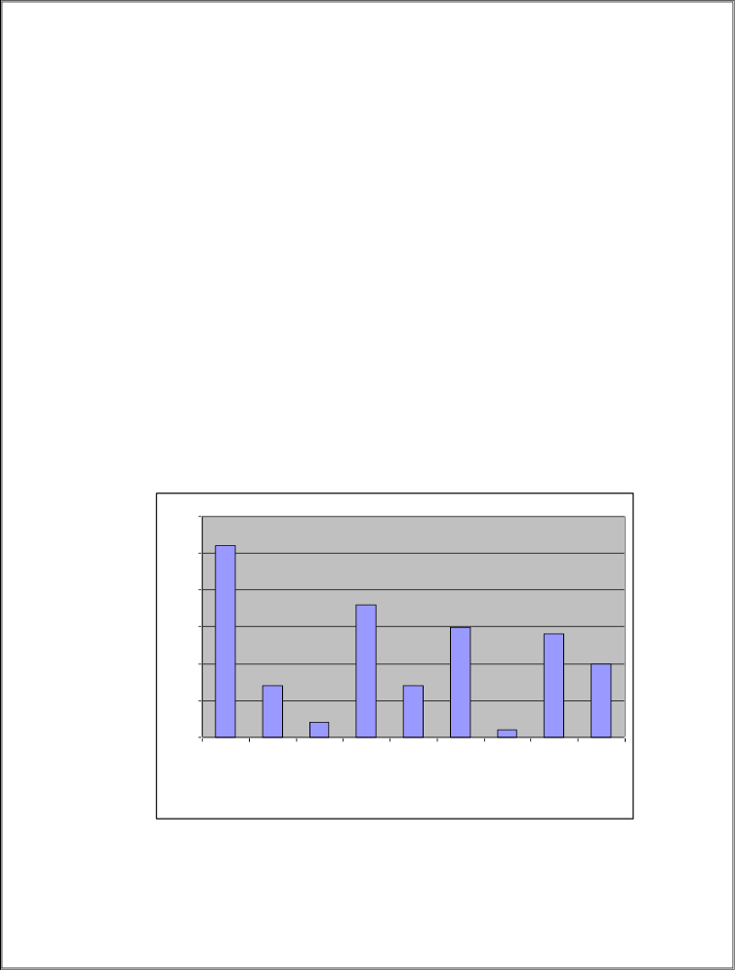
DATA ANALYSIS AND INTERPRETATION
  - Which brand and model of the small car do you have?

Santro | 26
Getz | 07
I10 | 02
Maruti 800 | 18
Zen estilo | 07
Wagon r | 15
A star | 01
Indica | 14
Spark | 10

30%
25%
20%
15%
10%
5%
0%
getz | i10 | zen
santro astar indica spark
wagon r
maruti800

Santro ( Hyundai ) leads the tally with maximum 26% market share

43

  - For how many years do you own this car?

0-1years | 17
1-3 years | 37
3-5 years | 30
More than 5 years | 16

40%
35%
30%
25%
20%
15%

10%
5%
0%
0-1 1-3 3-5 >5
years years years years

Maximum no. of customers own their car for 1-3 years.

44

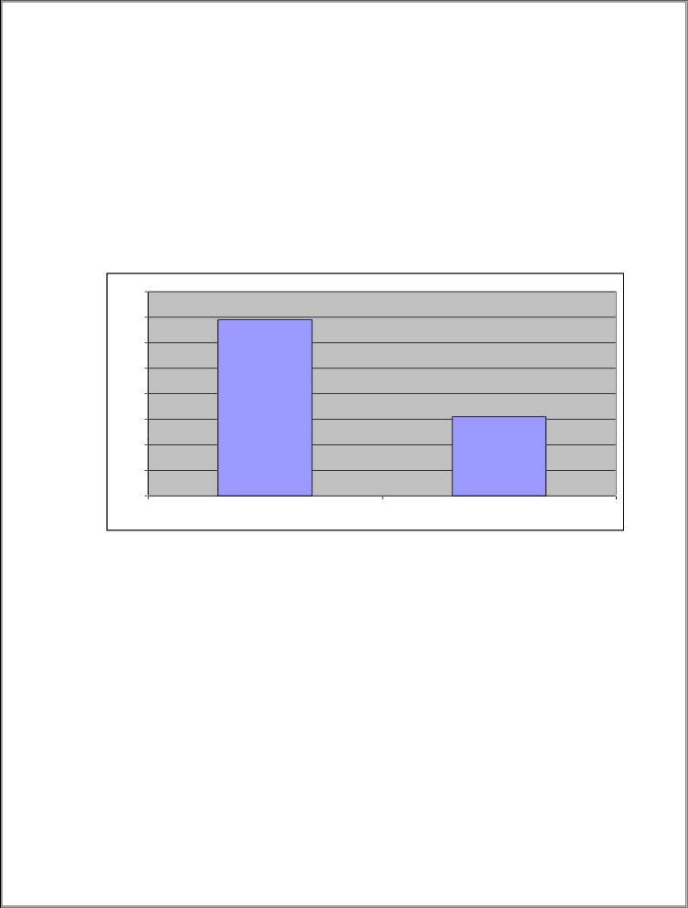
  - Are you satisfied with your decision to buy this car ?

Yes | 69
No | 31

80%

70%

60%

50%

40%

30%

20%

10%

0%
yes no

69% customer‟s are satisfied with their decision to buy this car.

45

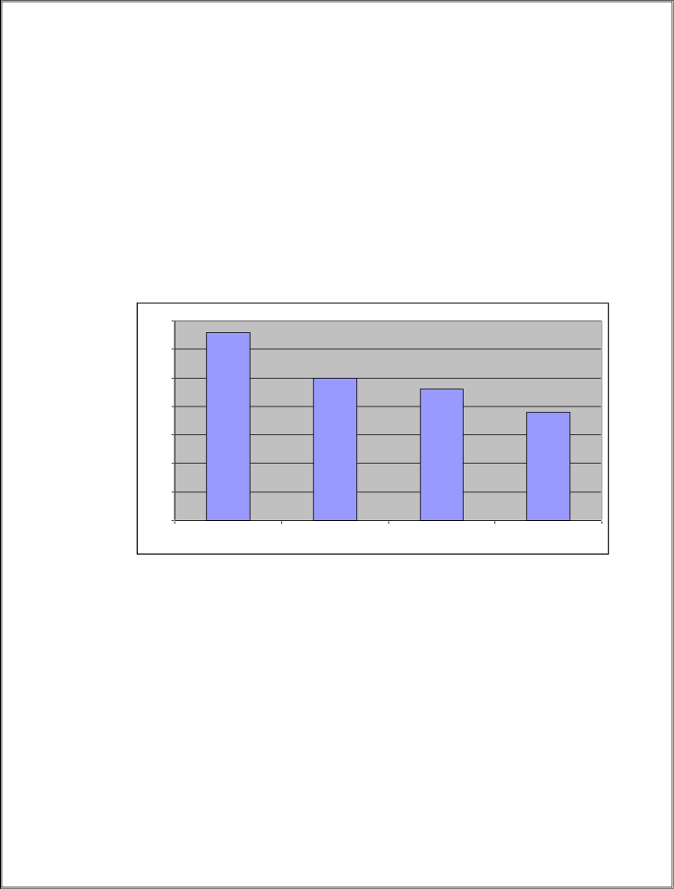
  - Any aspect which does not satisfy you?

Fuel efficiency | 33
Cost is too high | 25
After sales service is poor | 23
Miscellaneous reasons | 19

35%

30%

25%

20%

15%

10%

5%

0%
fuel effici. cost after ss. misce.

Miscellaneous reasons included interiors of the car, deficiency in functional parts etc.

46

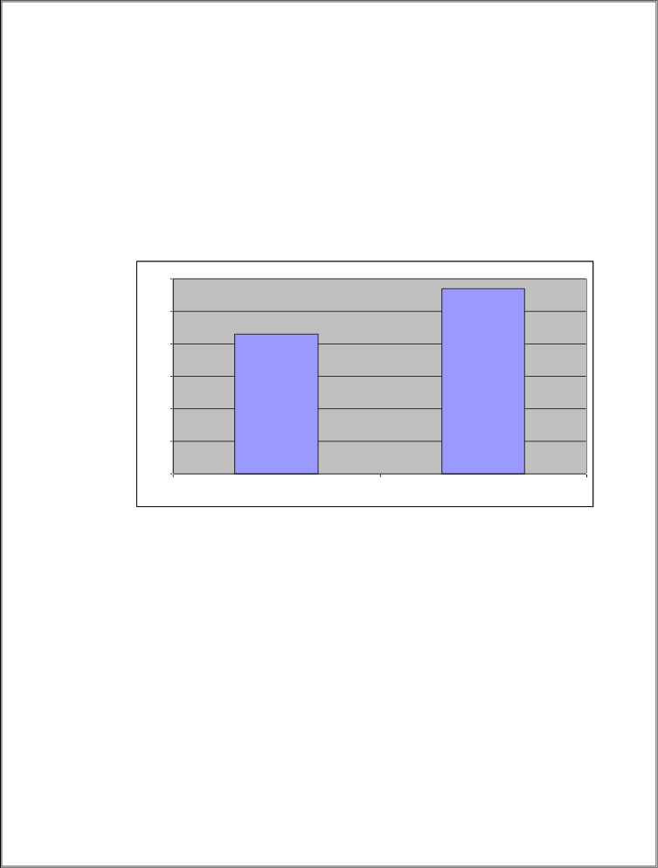
  - If you plan to buy a new car in future, will that be a small one or a luxury car ?
Small car | 43
Luxury car | 57

60%

50%

40%

30%

20%

10%

0%
small car luxury car

57% customer‟s will like to buy a luxury car in future.

47

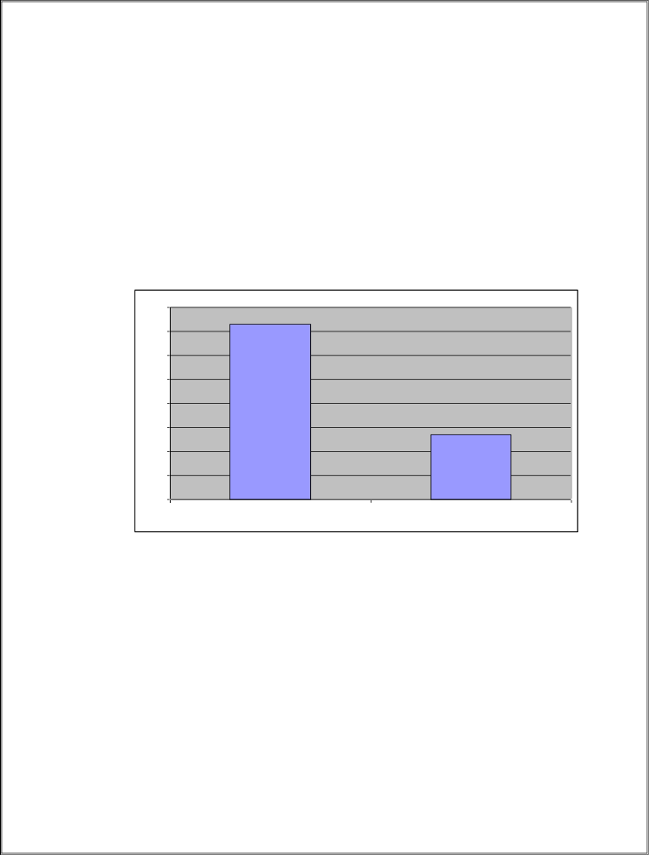
  - Do you think that more variety of small cars should be introduced in the market ?

Yes | 73
No | 27

80%

70%

60%

50%

40%

30%

20%

10%

0%
yes no

Customer‟s are interested in more varieties of small car‟s to have better Options.

48

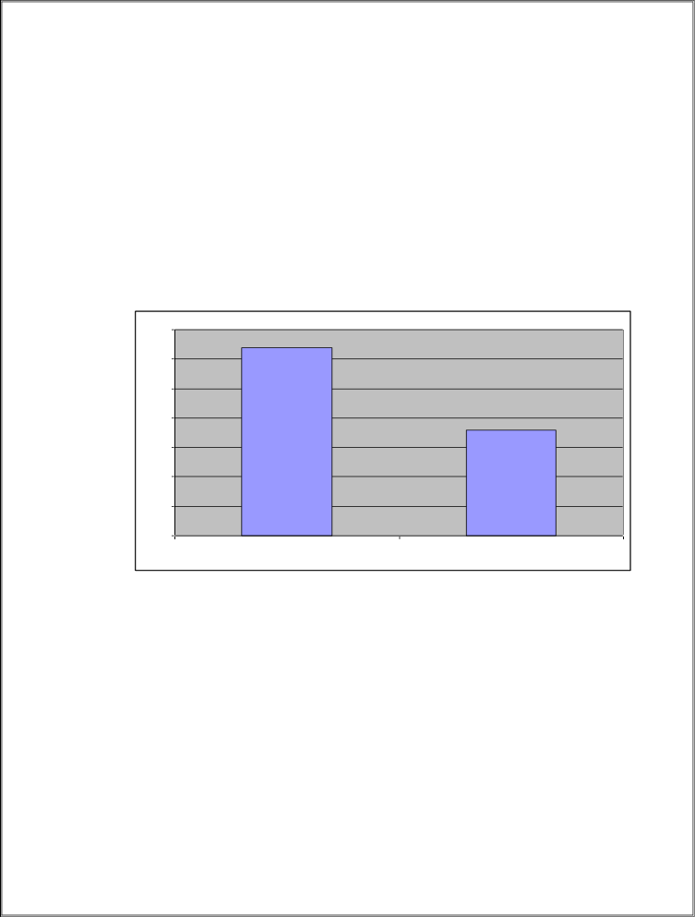
  - Do you think that inventions like TATA NANO will be successful or not?

Yes | 64
No | 36

70%

60%

50%

40%

30%

20%

10%

0%
yes no

36% customer‟s are doubtful and susceptible to the success of Tata Nano.

49

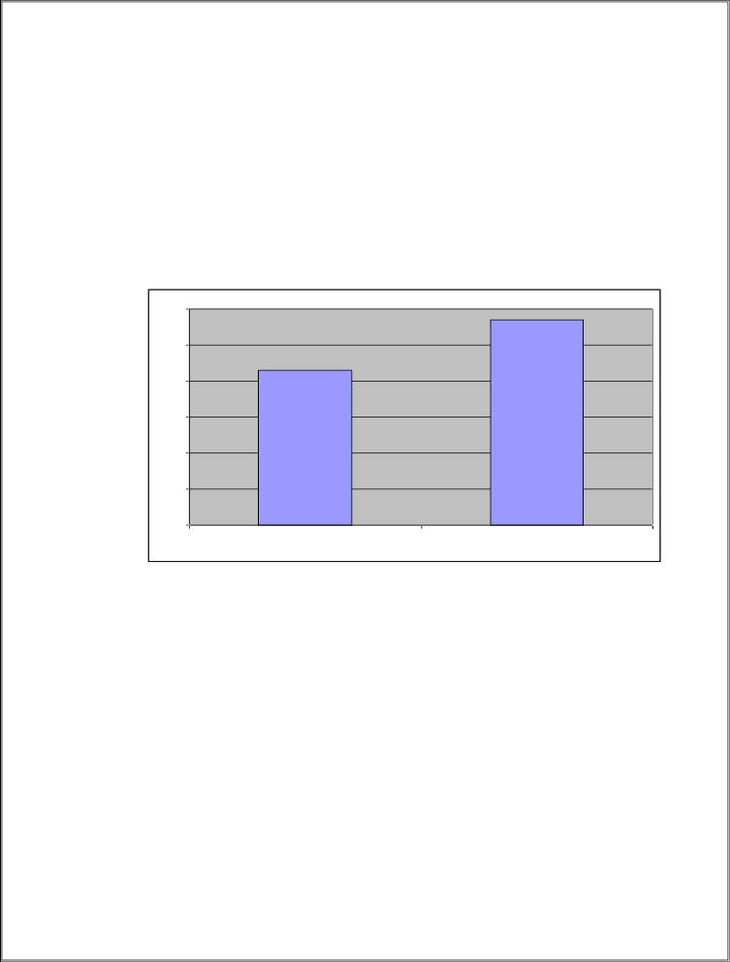
  - Do you keep a track of latest launches and reviews regarding small cars?

Yes | 43
No | 57

60%
50%
40%
30%
20%
10%
0%
yes | no

57% customer‟s do keep a track of latest happenings in the small car market.

50

  - 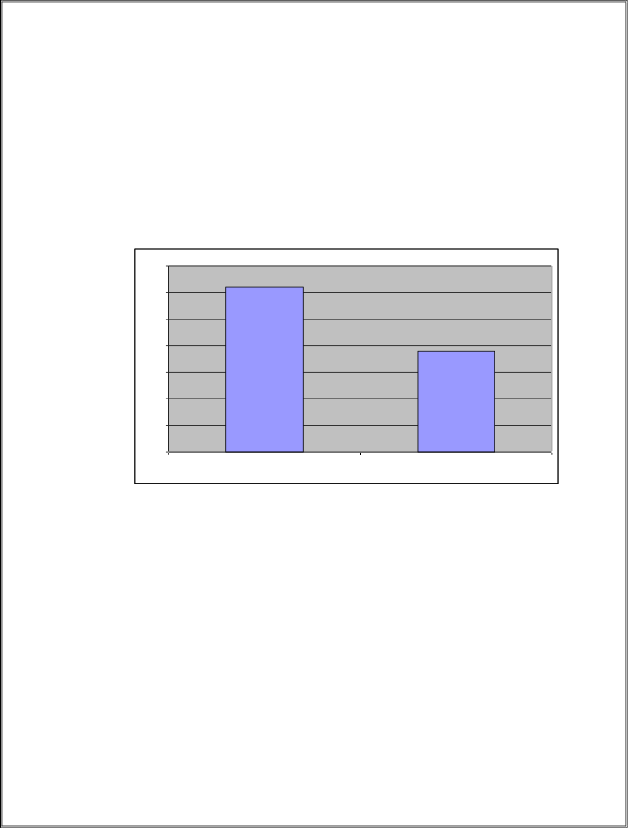Does your car provide you a requisite social status?

Yes | 62
No | 38

70%

60%

50%

40%

30%

20%

10%

0%
yes no

62% customer‟s say “yes” their car provides them a requisite social
status.

  - Do you like to suggest something?

It was an open ended question and therefore answers were varied.

51

FINDINGS

FINDINGS

  - Santro is the most favored vehicle on the lookout, traced by Maruti 800, wain R and Indica.
  - guests have bought the vehicle generally in the beyond 1- 3 times.
  - 69 guests are happy with their choice to buy the ongoing vehicle they enjoy while 31 aren't fulfilled.
  - While asked in respects to which angle the client ‟ s are disappointed, the response waseco-friendliness, cost burden traced behind deals administrations.
  - 57 client ‟ s said they might want to buy an extravagance vehicle in future.
  - Buyers are restless in respects to all the more no. of little vehicles being acquainted in the request with have further choices and multifariousness.
  - 36 client ‟ s are helpless in respects to the progress of Goodbye Nano and feel it'll weaken the picture of Goodbye.
  - 57 guests really do cover request happenings in the little vehicle portion.
  - 62 client ‟ s said OK their vehicle gives them essential profitable good

CONCLUSION

CONCLUSION

= The finish of the study can be that Hyundai Machines are the main little vehicle broker on the lookout and by virtuousness of their generally well given model, Santro are driving the Race.

= Consumer ‟ s, generally are happy with their ongoing decision latterly it tends to be reasoned that general prosecution of the area is agreeable.

= The pining among the consumer ‟ s to have further multifariousness in the scrap is areas of strength for veritably.

= guests albeit fulfilled, might want to have extravagance vehicle in future which shows their thriving craving towards that section.

RECOMMENDATIONS

  - It is recommended to small cars must provide cost satisfaction and fuel efficiency.
  - It is recommended to maximizing customer satisfaction.
  - It is suggested and recommended to better and more modified versions must continually be introduced in the market
  - It is recommended to after sales services must be efficiently provided to customers.

BIBLIOGRAPHY

BIBLIOGRAPHY

BOOKS

- Consumer Behavior by Philip Kotler 2009-10.

- Consumer Behavior 2009 by Leon G. Schiffman & Leslie Lazar Kanuk.

- Aker David, “Managing Br , Equity”, New York, The Free Press,
2018.

- Kotler, Philip “Marketing Management – Analysis, Planning, Implementation & Control, 11th Edition, Prentice Hall India Pvt. Ltd. 2018.

- The Automotive Component Manufacturers Association India (ACMA), JAN-FEB 10‟

- Automotive Engineer & Trader (Annual Number 2009) p.39-47

JOURNALS, MAGAZINES & NEWSPAPERS

- “Cars Wars II”, Business World

- Over Drive.

- Business Standard Motoring

- Auto India

- Business World

 Business Today India Today
The Times of India The Economic Times
The Hindu Business Standard Line

WEBSITES

  - www.autocarindia.com
  - www.siamindia.com
  - www.car_industry.india.com
  - www.carmarket.com
  - www.overdrive.com
  - www.hyundai.co.in
  - www.tatamotors.com
  - www.maruti.co.in
  - www.googlesearchengine.com
  - www.ibef.org

ANNEXURE

QUESTIONAIRE

  - Which brand and model of the small car do you have?
    - Hyundai (santro, getz, i10)
    - Maruti (800, Zen estilo, wagon r, a star)
    - Tata (indica)
    - Chevrolet (spark)

  - For how many years do you own this car?
    - 0-1 years
    - 1-3 years
    - 3-5 years
    - >5 years

  - Are you satisfied with your decision to buy this car?
    - Yes b. No

  - Any aspect which does not satisfy you?
    - Fuel efficiency
    - Cost is too high
    - After sales service is poor
    - Miscellaneous

  - If you plan to buy a new car in future, will that be a small one or a luxury car?
    - Small car b. Luxury car

  - Do you think that more variety of small cars should be introduced in the market?
    - Yes b. No

  - Do you think that inventions like TATA NANO will be successful or not?
    - Yes b. No

  - Do you keep a track of latest launches and reviews regarding small cars?
    - Yes b. No

  - Does your car provide you a requisite social status?
    - Yes b. No

  - Do you like to suggest something?

PERSON DETAILS:
Name - Occupation - Address -
No. of cars having - Phone no.(optional) -

