App Development for Vaccination Tracking and Record Words

Raj Walnekar
Department of Computer Engineering
Thakur college of Engineering & Technology
Mumbai, India
rajwalnekar2011@gmail.com

Manish Kumar Vishwakarma
Department of Computer Engineering
Thakur college of Engineering & Technology
Mumbai, India
vmanishk1313@gmail.com

Aakash Yadav
Department of Computer Engineering
Thakur college of Engineering & Technology
Mumbai, India
ay1117680@gmail.com

Dr. Harshali Patil
Department of Computer Engineering, Thakur college of Engineering & Technology
Mumbai, India

harshalipatil@thakureducation.org

Abstract— One of the most promising areas for mHealth is in vaccination and doctor's appointment scheduling. Vaccines are one of the most effective ways to prevent the spread of infectious diseases, but access to information about available vaccines and scheduling options can be challenging for many individuals. Similarly, regular doctor's appointments are crucial for maintaining overall health and well-being, but scheduling and attending appointments can be difficult for some individuals. This research aims to explore the potential benefits and challenges of an android application for vaccination and doctor's appointment. The app aims to provide users with easy access to information on available vaccines, scheduling options, and nearby vaccination clinic. Additionally, the app allows users to book appointments with doctors, view their vaccination records, and receive reminders for upcoming vaccinations. The study will investigate the user experience and usability of the application, examine the effectiveness of the app in increasing vaccination rates and reducing missed doctor's appointments, assess the security and privacy of personal health information stored in the app, and study the impact of the app on healthcare systems and providers. The findings of this research will provide valuable insight into the potential of mobile technology to improve healthcare accessibility and outcomes.

Keywords— Vaccine, Medical record, certification, Medicine suggestions.

Introduction
Since vaccination is a potent tool for combating pandemics, it is crucial that widespread immunization projects be implemented whenever possible. In order to tackle infectious illnesses, public vaccination campaigns rely on the notion of herd immunity. The recent coronavirus epidemic has highlighted the importance of establishing a reliable vaccination program. immunization records may be kept in one place, and people can be given certificates as proof of immunization. However, in such a scenario, the reliability of vaccination records is in issue, and different bodies with jurisdiction over records may alter the information contained within. There will be a critical need for a system that reliably saves people's vaccination records and can verify their immunization status in any location. This study makes an effort to solve the aforementioned problem by proposing a method for securely keeping vaccination records and validating a person's immunity status at several checkpoints. This would allow for the generation of a reliable vaccination report.

Literature Survey
Since long and continual advances have been made to come up with new solutions, maintaining effective immunization has been a difficulty. Historically, records have been kept physically, with individuals receiving tangible records of vaccinations. However, the issue with this method is data integrity, which is why various enforcement organizations, such as governments, ask individuals for certificates. Researched the need of simplifying and standardizing immunization documentation. In addition, the authors emphasized the need of having a digital universal record for vaccinations so that it would be simpler to give a record that would be accepted anywhere. There is a need for a standardized system, yet central data storage raises security problems, thus a decentralized solution is preferable. Groom et al. investigate the influence of access to vaccination records on rising vaccination rates.

To further understand the potential benefits and challenges of this sort of technology, a literature assessment on android applications for vaccination and doctor's appointment would entail examining previous studies on the issue. The usability and user experience of android applications for vaccination and doctor's appointment scheduling are two potential areas of concentration for a literature review on this issue. Research shows that mHealth apps benefit from a user-centered design approach.

Proof that android apps can help boost vaccination rates and decrease instances of missed doctor's visits. Vaccination and other preventative health behaviors have been found to benefit from the use of mobile technology. Android app security and privacy with regards to sensitive medical data. Strong security and privacy protections are necessary to secure individuals' health information, according to studies, and this concern for privacy is a major deterrent to the widespread use of e-Health applications. The effect of mobile health apps on service providers and healthcare infrastructure. While it's clear that e-Health apps may help make better use of healthcare resources, it's also crucial to keep in mind the technology's possible pitfalls.

Android app usage and engagement among underrepresented groups. It is crucial to think about the app's accessibility for low-income, elderly, and other marginalized populations because studies suggest that higher-income and younger persons are more likely to utilize e-Health applications. Research in this field has included some of the following. The use of a mHealth app to schedule vaccinations was found to boost coverage in recent research. The vaccination rates of teenagers were shown to increase with the use of mHealth interventions, such as text message reminders, according to another study. Vaccination and appointment scheduling mHealth treatments were demonstrated to enhance health outcomes and decrease healthcare expenses.

It is clear from the research on android apps for vaccination and doctor's appointment scheduling that mobile technology has the potential to improve healthcare access and outcomes, but it is crucial to take into account the potential challenges and limitations of this technology to ensure that it is used effectively and responsibly.

Current System | Overview | Gap
A study piloting maternal use of Immunize CA, a Pan-Canadian immunization app. | To evaluate if the use of an app could change beliefs and behaviors related to vaccination, users were asked to attempt surveys before and after 6 months of using the app. | Integration with medical treatment was not attended to in any way.
Vaccine Prioritization Using Bluetooth Exposure Notification Apps | An app was developed to use Bluetooth exposure for contact tracing, and based on that, prioritizing vaccination for people. | The accuracy of the user data was not checked very thoroughly.
An Intelligent Baby Care System Based on Smart Phone Application. | This app was built with modules about information, benefits, and schedules of vaccines, along with age groups. The users are reminded about upcoming vaccines using push notifications. | The confidentiality and safety of the users were not protected.
Vaxign: the first webbased vaccine design program for reverse vaccinology and applications for vaccine development. | This app integrated open-source tools and developed modules with user-centric interfaces. Users can add their vaccine information and questions which would be processed by PHP/HTML/SQL. The result is the given to the user. | This website that provides information about vaccinations was developed using obsolete technology, and because it makes extensive use of open-source software, the user data it contains is extremely vulnerable to being exploited.
Smartphone app uses loyalty point incentives and push notifications to encourage influenza vaccine. | A quiz was developed in the app, about the influenza vaccine to educate the users about its importance. If the users were within 200m of a pharmacy, they would be informed via notifications and visiting would give bonus points. | This application did not concentrate on the process of vaccination as a whole and did not integrate itself with any healthcare systems in order to validate the data it collected. Instead, its primary focus was on a single vaccine.
Vaccipack, A Mobile App to Promote Human Papillomavirus Vaccine Uptake Among Adolescents aged 11 to 14 Years: Development and Usability Study. | An app was developed, consisting of a vaccine tracker. Basic details about the vaccine were also included. Additionally, 26 stories were included in the app, to promote vaccination | When building this programme, user demographics were not taken into consideration at any point.
Immunization and technology among newcomers: A need assessment survey for a vaccine-tracking App. | Refugees attending a healthcare camp in Canada were requested to attempt a survey that had 17 questions about languages, homeland, demographics, and vaccination history if known. | The user interface of the programme is rather complicated, and it does not give any information on the most recent vaccines or provide any vaccination recommendations to the user based on their age group.

In addition to the studies mentioned previously, other research has also highlighted the potential of android applications to improve vaccination rates and reduce missed doctor's appointments. For example:
A study published in the Journal of Medical Internet Research (JMIR) found that an mHealth application for vaccination scheduling increased vaccination rates among participants and improved self-reported vaccination knowledge.

Another study, published in the Journal of Medical Systems, found that mHealth interventions, such as text message reminders, improved vaccination rates among adolescents and increased the likelihood of completing the vaccination series.

A study published in the Journal of Medical Internet Research (JMIR) found that an mHealth application for vaccination scheduling improved vaccination rates and reduced healthcare costs.

Overall, the literature on android applications for vaccination and doctor's appointment suggests that mobile technology has the potential to improve healthcare accessibility and outcomes, but it is important to consider the potential challenges and limitations of this technology to ensure that it is used in an effective and responsible manner. It is also important to ensure the accessibility of the app for low-income, elderly, and other marginalized communities.

Problem Statement
The biggest flaw in today’s medicine sector is that most vaccines are administered during childhood. Vaccination records are important documents to be kept for a lifetime, but the documentation of immunization events is poorly standardized. At the point of care, paper records are often unavailable, making it impossible to obtain accurate vaccination histories. Vaccination records should include batch specifications to allow the tracking of licensed vaccines in cases of recall.

Key issues

- Standardized vaccination records are needed on a global level.
- Standardized vaccination records should be universal, safe, flexible, durable, and available in emergency situations.
- To increase accessibility the whole appointment system is being converted to a digital system to get rid of the conventional method of sitting in line for long hours waiting for turns.
- Simplified digital vaccination records provide significant advantage over paper-based systems, including universal access in cases of emergency.
- User-centered vaccination records should empower patients to keep track of their vaccination record and to ask for professional advice, when needed.
- Regulatory agencies and standards organizations should be involved in the development of digital records to ensure semantic interoperability.

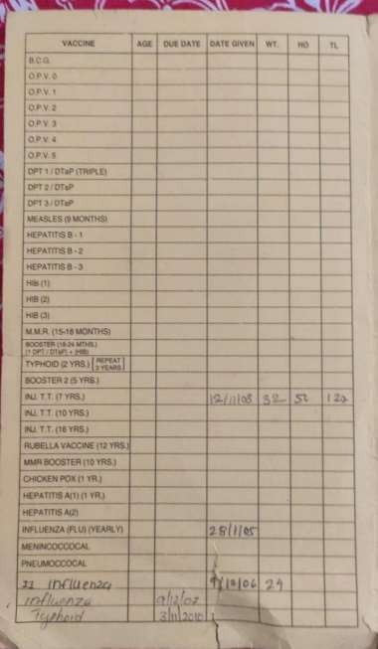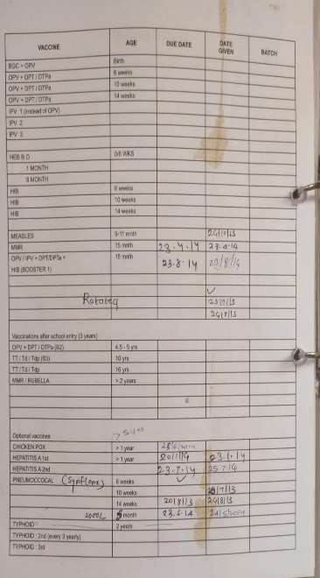

Fig 1: Vaccination Card

- METHODOLOGY

The methodology of this study will include user testing, questionnaires, and statistical analysis. User testing will be performed to see how well the app performs for the target demographic. Surveys will be sent out to users to determine the efficacy of the app in improving vaccination rates and reducing missed doctor's appointments. An empirical study will be conducted to assess the app's impact on healthcare delivery and finance, and data analysis will be used to evaluate the privacy and confidentiality of users' health records. The results of the research will be included in future iterations of the app to help developers avoid common pitfalls. The study's main objective is to contribute to the growing body of literature on the use of mobile technology in healthcare and to offer useful insights to the healthcare community and policymakers.

Based on the information from the identification of the routine vaccines, a design of the information system was created in a form of a context diagram.

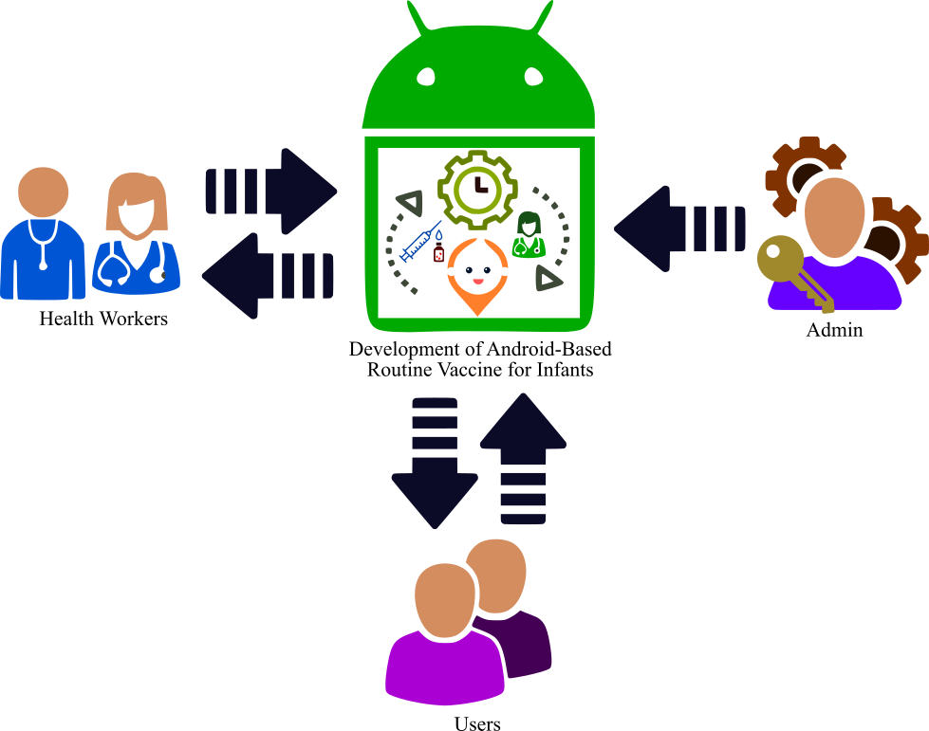

Fig 2: Context Diagram of the Android-Based Routine Vaccine for Infants
The application's flow is depicted in Figure 1. The administrator, moms or other users, and healthcare professionals make up the trio of users. immunization information, administration instructions, immunization schedules, and post-vaccination care are all available to app users. Users may practice using the app to experience the vaccination procedure virtually.

Development Process

The methodology used in the development of the application is the Fourth Generation Technique (4GT) was comprised of four major parts namely: requirements, gathering, design strategy, implementation, and testing. In the 4GT model, a program is constructed according to the specification of the developers while the source code is generated automatically.

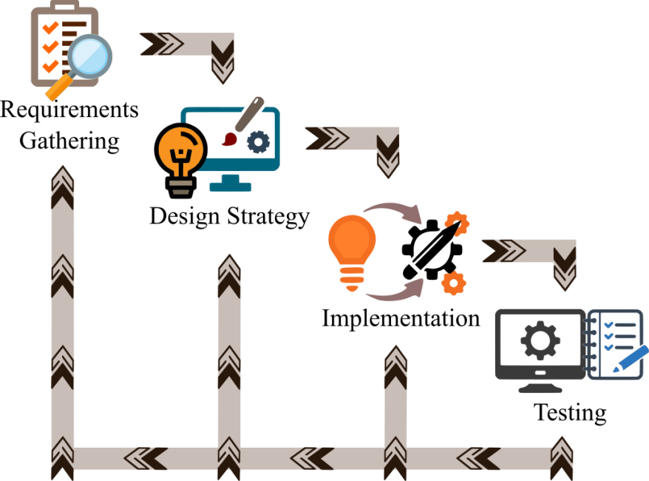

Fig 3: Fourth Generation Technique Paradigm

As illustrated in Figure 3, the fourth-generation technique (4GT) approach requires the requirement analysis step. Once the requirement analysis is done up to the expectations, its translation into the operational prototype begins. The most important phase in the 4GT approach is the customer developer approach where all the major decisions regarding the implementation, costs, and functioning of the system were taken in this phase.

Requirement Gathering: At this stage, it's crucial to define the needs for the app. The developers collected the necessary data through a variety of means, including interviews, surveys, and direct observation. In order to collect the necessary data, the developers spoke with health personnel in a variety of pediatricians. Similarly, random observations were made during the process of vaccinating newborns.

Design Strategy: After collecting all of the necessary data, the researchers created a context diagram to depict the procedure and path of the application's function flow during development. Data structures, architecture, algorithmic technique, and inter-phase features have been outlined in a series of presentations.

Implementation: A machine-readable representation of the obtained requirements and design was created. Using 4GT, the developers were able to automatically generate code to produce the desired output by representing the output in a certain way. 4th Generation Technology was used to construct the program code. The feedback from the intended app users was used to inform the development of the updated version.

Testing: The application was evaluated and tested to determine if the objective of the application development had met the needs of the health workers and users and to ensure that it is free from any error. Alpha testing was made to check the compatibility of the application in different versions of android-based platforms.

SURVEY RESULT

This research aims to explore the potential benefits and challenges of an android application for vaccination and doctor's appointment. The following research questions will guide the study:

How usable and user-friendly is the android application for vaccination and doctor's appointment scheduling?

How effective is the android application in increasing vaccination rates and reducing missed doctor's appointments?

How secure and private is personal health information stored in the android application?

What is the impact of the android application on healthcare systems and providers?
Methodology:

The methodology for this research will include a combination of user testing, surveys, and data analysis. User testing will be conducted to evaluate the usability and user experience of the application. Surveys will be distributed to gather feedback from users on the effectiveness of the app in increasing vaccination rates and reducing missed doctor's appointments. Data analysis will be performed to assess the security and privacy of personal health information stored in the app, and to study the impact of the app on healthcare systems and providers.

The sample for the study will be chosen according to the inclusion criteria. Participants will be recruited through various channels such as social media, flyers, etc. Data collection will be performed through user testing, surveys, and analyzing data from the application.

The findings of this research will provide valuable insight into the potential of mobile technology to improve healthcare accessibility and outcomes. The results of this research will be used to identify areas for improvement and guide future development of the application.

The data is collected from questionnaires which were created in google forms and circulated to various aspects of people. The following are the questions asked in the survey:

- Are you fully vaccinated from birth?
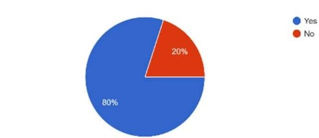

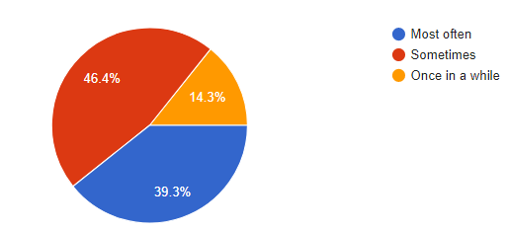

Fig. 4

- Do you keep any type of record for your vaccination?
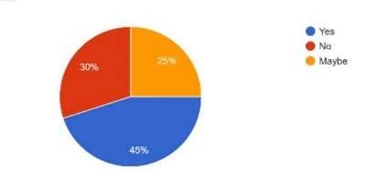

FiFig. 5

- Would you use a digitalized product which would keep all your vaccination record in one place?

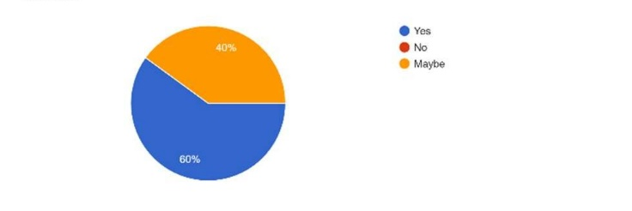

Fig. 6

Proposed System
The proposed system for an android application on vaccination and doctor's appointment scheduling would aim to provide users with easy access to information on available vaccines, scheduling options, and nearby vaccination clinics. Additionally, the app would allow users to book appointments with doctors, view their vaccination records, and receive reminders for upcoming vaccinations.

The system would be designed with a user-centered approach, focusing on usability and user experience to ensure that it is easy for users to navigate and understand. The system would include the following features:

• A booking feature that allows users to schedule appointments with doctors and vaccination clinics.

• A reminder feature that sends notifications to users about upcoming vaccinations and doctor's appointments.

• A record feature that allows users to view their vaccination records and track their vaccination status.

• A security and privacy feature that ensures the protection of personal health information stored in the app.

• A feedback feature that allows users to provide feedback on the app and its features.

The proposed system would be designed to be easy to use and navigate, providing accurate and reliable information to users. Additionally, the system would be designed with security and privacy in mind, to ensure the protection of personal health information stored in the app. The system would be tested and evaluated in real-world settings to ensure that it meets the needs of users and healthcare providers. The system would be continuously monitored and evaluated to identify areas for improvement and guide future development.

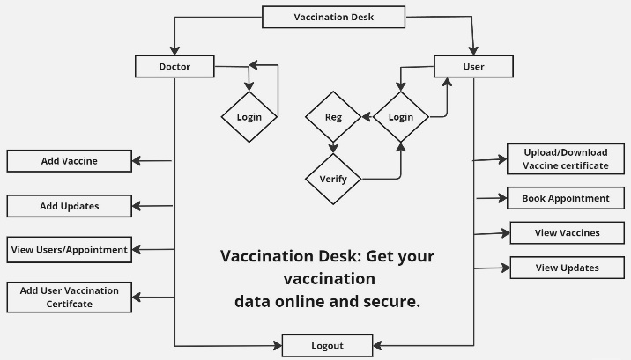

Fig. 7 Block Diagram

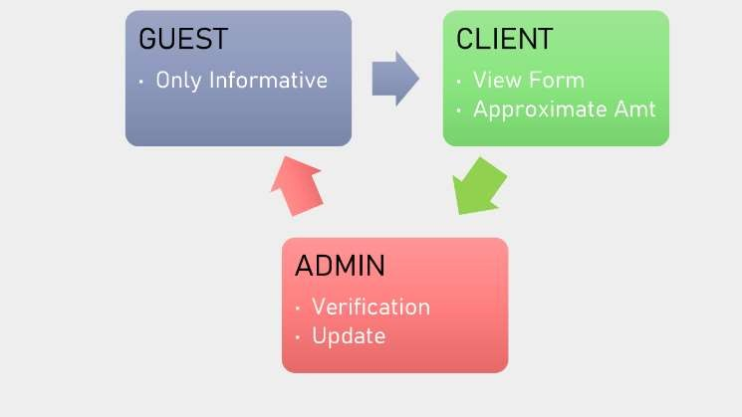

Fig. 8 Modules of Application

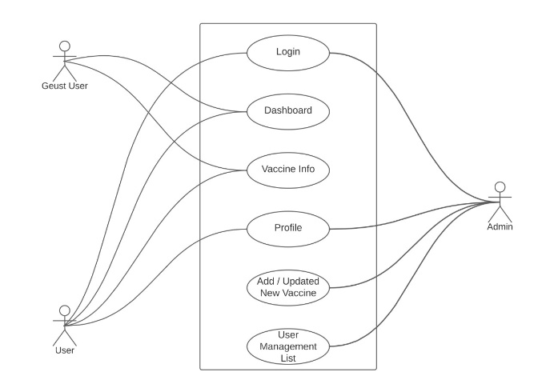
Fig. 9 Use Case Diagram

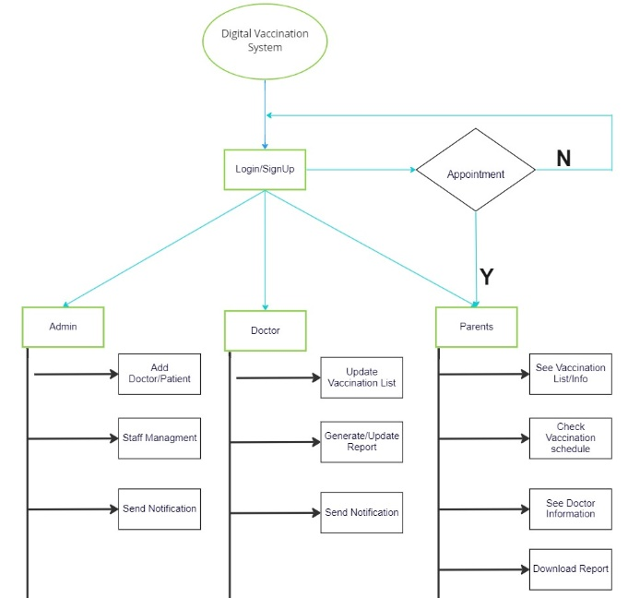

Fig. 9 Architecture Diagram

- RESULT & DISCUSSION

This paper was intended to explain the full functionality of our application. It shows the bifurcations in our implementation based on working and internal securities which will lastly lead to better user experience. The highlight features of our product would be safe preservation of our client’s vaccination records and make availability to our users would be our topmost priority.

This application would also try to reach its max capacity to make aware of the new vaccination coming up to the market. The old conventional methods would still be available to the users till they get used to the updated system.

The distinguishing factor which sets our product out of the current market would be a feature to introduce new clinics as well as doctors to the application as they subscribe to and approve of our service and facilities provided by us. This would make it more authenticated as more and more verified doctors approve this application and help us to make aware of the new vaccination coming up to the market.

The diagram ahead will show the full functionality of our product, this current design shows us all the services provided is divided into three major parts. Each having its own unique features.

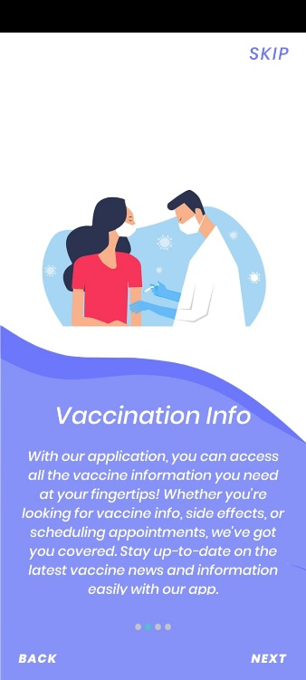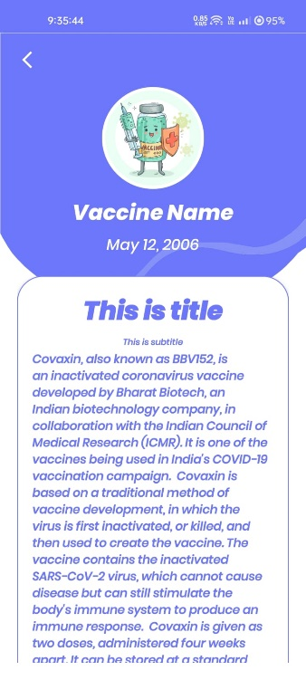

Fig. 10.2 Splash Screen

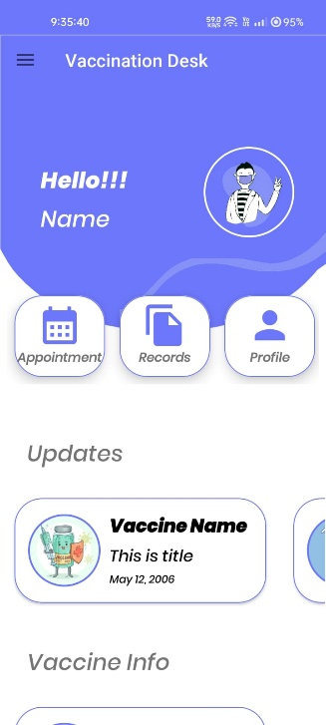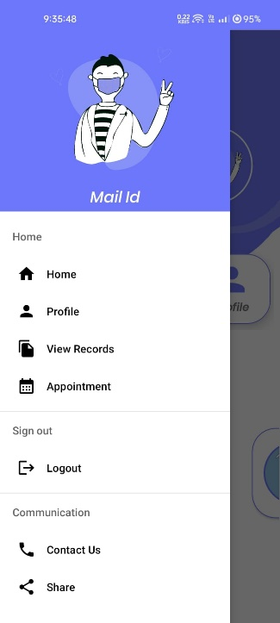

Fig. 11 Dashboard & Home Page
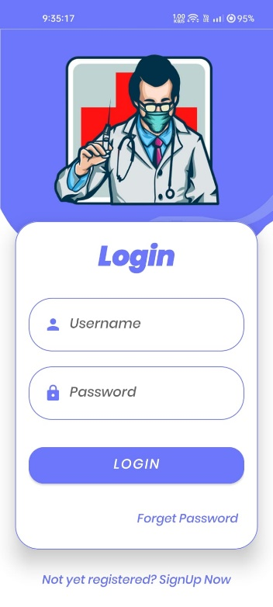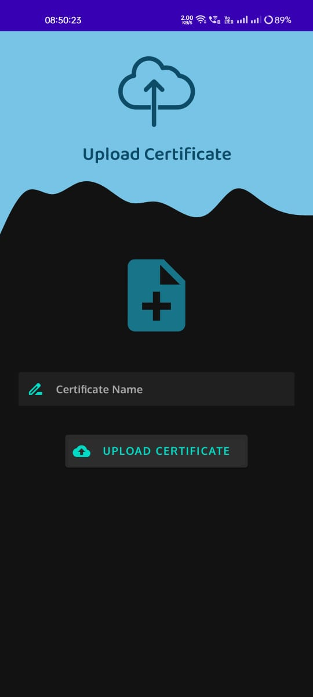

Fig. 12 Login & Upload Page

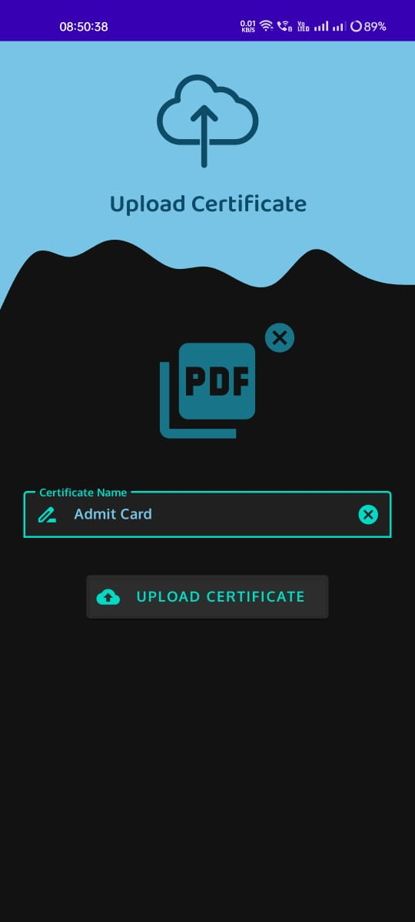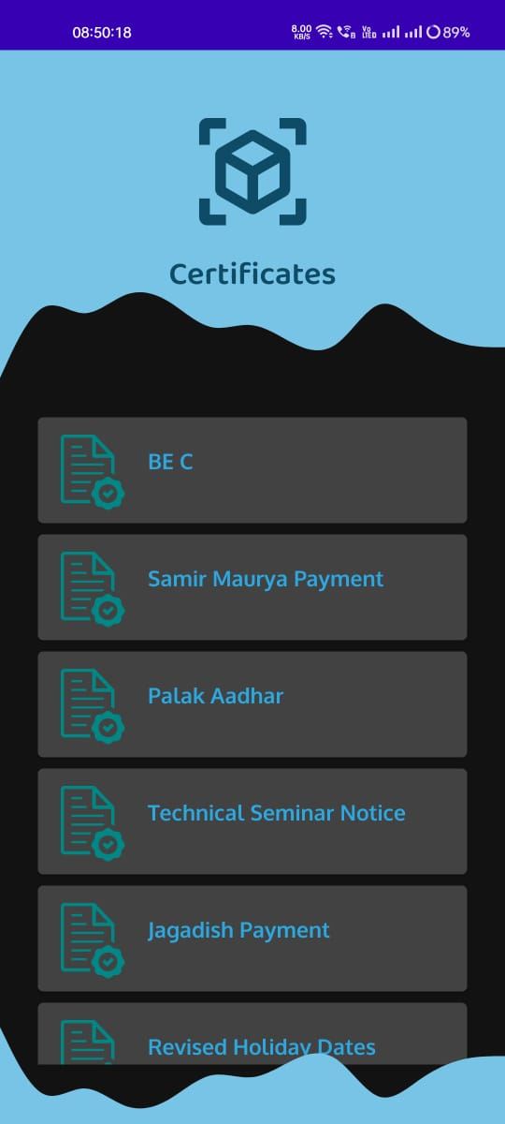

Fig.13 Certificate View
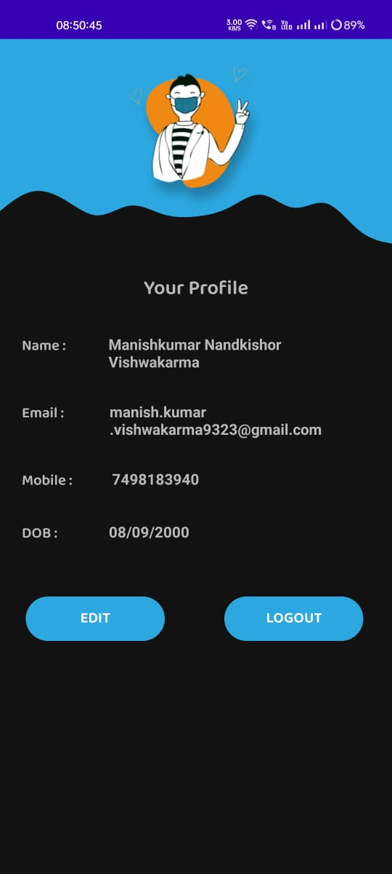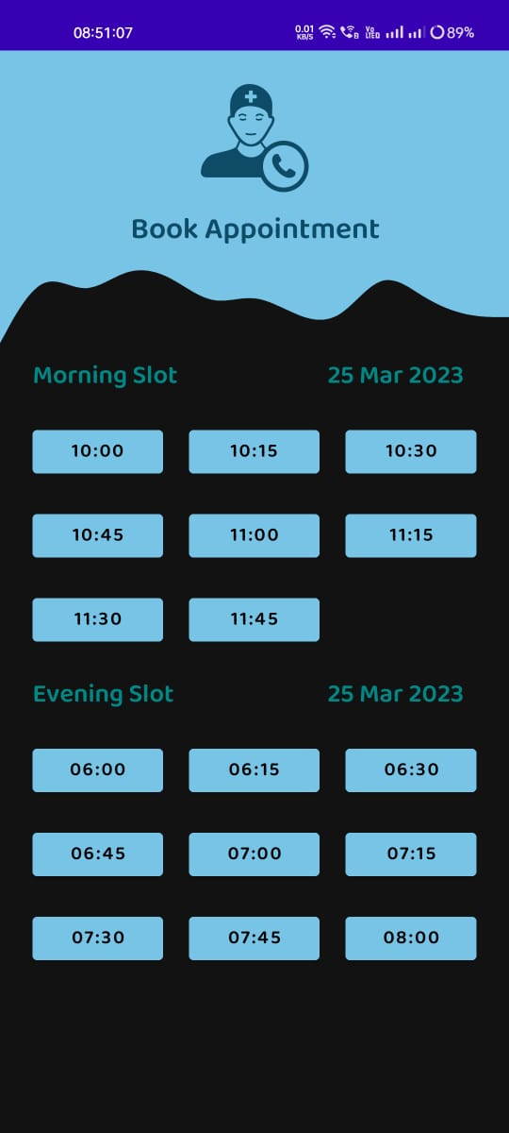

Fig. 14 Profile & Appointment

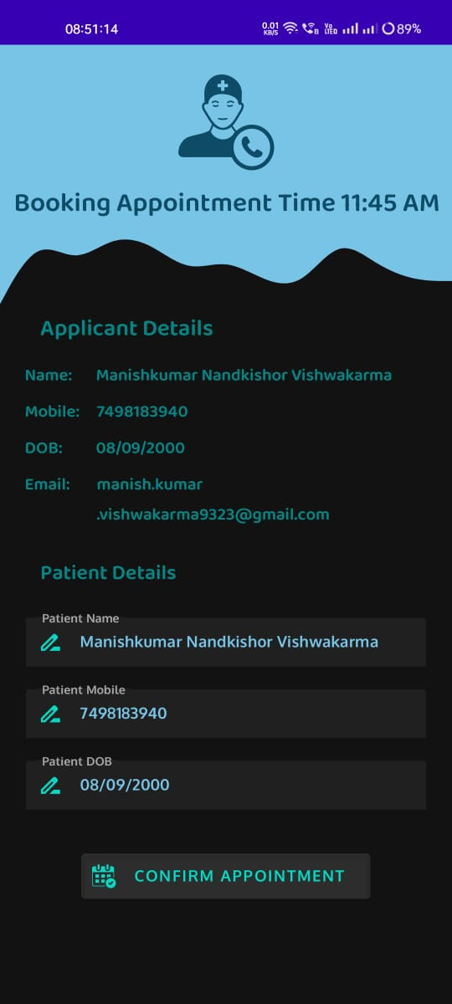

Fig.14 Edit Profile Page

- FUTURE SCOPE

Our existing solution has room for development and enhancement in the form of additional features, such as Aadhar verification for the user, which will help prevent any fraudulent activity with the user's paperwork. Even a degree verification might be provided for the physicians, allowing them to accept a charge receipt for any user once they have received their vaccination dosage.
More additional features which could be included for enhancement of our product would be as follows:
•Improving the user experience of the application, such as through personalized recommendations and reminders.

•Integration with existing healthcare systems and databases to improve data accuracy and accessibility.

•Development of algorithms to predict vaccine efficacy and side-effects based on demographic and health data.

•Analysis of the impact of the application on vaccine uptake and hesitancy, and the development of strategies to address these challenges.

•The application of machine learning techniques to optimize vaccine distribution and allocation, and to predict and prevent outbreaks.

•Examination of ethical, privacy and security concerns related to the storage and use of personal health information in the application.

•Study of the impact of the application on vulnerable populations, such as rural or low-income communities.
.

- CONCLUSION

This research aims to explore the potential benefits and challenges of an android application for vaccination and doctor's appointment. The app aims to provide users with easy access to information on available vaccines, scheduling options, and nearby vaccination clinics. Additionally, the app allows users to book appointments with doctors, view their vaccination records, and receive reminders for upcoming vaccinations. The study will investigate the user experience and usability of the application, examine the effectiveness of the app in increasing vaccination rates and reducing missed doctor's appointments, assess the security and privacy of personal health information stored in the app, and study the impact of the app on healthcare systems and providers. The methodology for this research will include a combination of user testing, surveys, and data analysis.

The widespread adoption of smartphones and mobile devices has had a significant impact on many aspects of daily life, including healthcare. An android application for vaccination and doctor's appointment scheduling could have a significant impact on improving vaccination rates and reducing missed doctor's appointments. However, there are also potential challenges to the development and use of this type of application, such as privacy concerns, the need for accurate and reliable information, and the impact on healthcare systems and providers. This research will provide valuable insights for healthcare professionals and policymakers and contribute to the growing body of literature on the use of mobile technology in healthcare.

- ACKNOWLEDGEMENT

We gratefully acknowledge the support, guidance, and encouragement of my Dissertation Guide Associate Professor Dr. Harshali Patil ma’am for this novel work.

- REFERENCE

[1] ReadyVax: A new mobile vaccine information app, ReadyVax: A new mobile vaccine information app , Robert A. Bednarczyk,Paula M. Frew,Daniel A. Salmon,Ellen Whitney
[2] Standardization and simplification of vaccination records
[3] Vaccination adherence: Review and proposed model Asma A. Abahussina, Ahmed I. Albarrak
[4] A Blockchain Based Technique for Storing Vaccination Records, Sanjib K. Deka, Subhasish Goswami, Abhinav Anand.
[5] e-Vaccine: An Immunization App, Shirin Hasan, Mir Mohammad Yousuf, Mubashir Farooq, Nishita Marwah, Syed Ahtisam Ashraf Andrabi, Hemant Kumar.
[6] Recommendation for Use of Immunization Information Systems to Increase Vaccination Rates.
[7] E-VACCINATION RECORD MANAGEMENT APP Irum Naz Sodhar1*, Azeem Ayaz Mirani1, Dua Noor1, Iqra Memon1, Mishal Malik1.
[8] Effectiveness of a smartphone app on improving immunization of children in rural Sichuan Province, China: a cluster randomized controlled trial.
[9] Use of Apps to Promote Childhood Vaccination: Protocol for a Systematic Review Use of Apps to Promote Childhood Vaccination: Protocol for a Systematic Review Authors of this article:Michelle Helena Van Velthoven 1 Author Orcid Image - Madison Milne-Ives 1 Author Orcid Image, Caroline de Cock 1 Author Orcid Image , Mary Mooney 2 Author Orcid Image, Edward Meinert 1, 3 Author Orcid Image.
[10] Ehreth J. The value of vaccination: a global perspective. Vaccine 2003;21(27-30): 4105-17
[11] S. Kumari, A. Haripriya, A. Aruna, D.S. Vidya and Nithy, M.N. (2017), "Immunize - Baby steps for smart healthcare: Smart solutions to child vaccination", 2017 International Conference on Innovations in Green Energy and Healthcare Technologies (IGEHT), pp.-1-4
[12] S. Vidhya, B. Sabarish, J. Rajivkrishnan and P. Sachin (2018), “e vaccination: Fingerprint Based Vaccination Monitoring System” International journal of pure and applied mathematics, Vol.- 118
[13] K.M. Atkinson, J. Westeinde, R. Ducharme, S.E. Wilson and S.L. Deeks (2016), “Can mobile technologies improve on-time vaccination? A study piloting maternal use of ImmunizeCA, a PanCanadian immunization app”, Hum Vaccin Immunother, Vol.-12, No.-10, pp.-2654-2661
[14] Y. He, Z. Xiang and H.L. Mobley (2010), “Vaxign: the first web based vaccine design program for reverse vaccinology and applications for vaccine development”, J Biomed Biotechnol 2010; 2010:297505
[15] L. Dale, L. White, M. Mitchell and G. Faulkner (2019), “Smartphone app uses loyalty point incentives and push notifications to encourage influenza vaccine uptake”, Vaccine, Vol.-37, No.-32, pp.-4594-4600
[16] L. Dale, L. White, M. Mitchell and G. Faulkner (2019), “Smartphone app uses loyalty point incentives and push notifications to encourage influenza vaccine uptake”, Vaccine, Vol.-37, No.-32, pp.-4594-4600
[17] L. Dale, L. White, M. Mitchell and G. Faulkner (2019), “Smartphone app uses loyalty point incentives and push notifications to encourage influenza vaccine uptake”, Vaccine, Vol.-37, No.-32, pp.-4594-4600
[18] M. Paradis, K.M. Atkinson, C. Hui, D. Ponka and D.G. Manuel (2018), “Immunization and technology among newcomers: A needs assessment survey for a vaccine-tracking app”, Hum Vaccin Immunother, Vol.-14, No.-7, pp-1660-1664
[19] M. Paradis, K.M. Atkinson, C. Hui, D. Ponka and D.G. Manuel (2018), “Immunization and technology among newcomers: A needs assessment survey for a vaccine-tracking app”, Hum Vaccin Immunother, Vol.-14, No.-7, pp-1660-1664
[20] ECDC. Vaccine Scheduler. Available from: www.vaccine-schedule.ecdc.europa.eu [Last accessed 21 August 2013]
[21] Miles M, Ryman TK, Dietz V, et al. Validity of vaccination cards and parental recall to estimate vaccination coverage: a systematic review of the literature. Vaccine 2013;31(12):1560-8

