ENHANCING THE STRUCTURAL SAFETY OF BI-TUBULAR ALUMINIUM ALLOYS WITH FILLER MATERIAL FOR AUTOMOTIVE APPLICATIONS
Baaskaran Natarajan¹, P. Vignesh², V. Vignesh³, T. Naveen Kumar⁴
¹Department of Automobile Engineering, Kongu Engineering College, Erode, Tamil Nadu, India
² Department of Automobile Engineering, Kongu Engineering College, Erode, Tamil Nadu, India
³ Department of Automobile Engineering, Kongu Engineering College, Erode, Tamil Nadu, India
⁴ Department of Automobile Engineering, Kongu Engineering College, Erode, Tamil Nadu, India

---------------------------------------------------------------------***---------------------------------------------------------------------
Abstract - The usage of foam-filled bi-tubular has gained prominence in the construction of crashworthiness systems to protect commuters in crash applications. It is also critical to increase the performance of foam filled profiles energy absorption systems. When subjected to uniaxial loads, tubular structures have good energy absorption properties; nevertheless, when subjected to oblique loading, they are extremely sensitive to global bending mode. The unique design to improve the crashworthiness parameters of circular tubular constructions subjected to direct and oblique loading by the filling foam in both the inner and outer tube. The structure was subjected to quasi-static and finite element computations with varied foam filling configurations. The effect of friction contact relation between the striker and the structure, as well as critical loading angles ranging from 0° to 15°, on energy absorption had been investigated. The results demonstrate the advantages of using foam-filled tubes with varied filling procedures. Structures with and without foam were exposed to direct and oblique force patterns. The work's outcome allows designers to improve energy-absorbing performance under various loading scenarios. The results showed that adding filler material increased the fatigue life of bi-tubular aluminum alloys substantially.

Key Words: crashworthiness, foam filled bi-tubular, explicit analysis, uni-axial loading, oblique loading

1.INTRODUCTION

The ability of the structural component to absorb the impact energy gradually has been a focus for global automakers when creating effective energy absorption systems and shock attenuation equipment. The development of energy-absorbing structure design is still a hot topic in the automotive industry. The front vulnerable spot of the structure distorted initially after a light hit in an impact scenario. if the impact intensity grows to a high impact, the entire structure would collapse. The term "crashworthiness" describes a vehicle or other structures capacity to safeguard its occupants in the event of a collision. The goal of vehicle design is to reduce the possibility of injury or death to occupants in the case of an accident. The materials and construction techniques employed in the structures or vehicles design, as well as the positioning and layout of safety features like airbags, seat belts, and crumple zones, are only a few of the many factors that affect a products crashworthiness. Crash tests, computer modelling, and accident data analysis are only a few of the tests and simulations used to assess crashworthiness. In order to increase their crashworthiness and lower the danger of damage or death in the case of a crash, vehicles and buildings are designed with the help of this information. Crashworthiness aims to protect a vehicles occupant as well as to lessen damage to it and nearby structures, as well as to lower the possibility of further accidents or injuries like fires or explosions. To make travel safer for everyone, designers can help minimize fatalities and serious injuries by enhancing crashworthiness. A structure or objects crashworthiness refers to its capacity to withstand or lessen the impact of a collision. In other terms, it refers to a vehicle, aircraft, or other object's capacity to safeguard its passengers or cargo in the event of an accident. Designing and developing safe cars, planes, and other transportation methods heavily relies on the idea of crashworthiness, which is particularly significant in the field of transportation engineering. Studying how structures behave in collisions and creating materials, structures, and safety systems that can withstand and lessen crash forces and energy are both parts of the concept of crashworthiness. The design of buildings that can absorb and dissipate energy, the use of strong and lightweight materials, and the incorporation of safety measures like airbags, seat belts, and safety cages are just a few of the strategies used to make a structure crashworthy. Since polyurethane foam can deform and absorb energy upon impact, it is frequently utilized as an impact-absorbing material in crashworthiness applications. As a result, it works well to safeguard passengers in cars during collisions. Polyurethane foam is frequently utilized in crashworthiness applications as molded foam or structural foam as shown in the Figure 1.2. In a crash, hard foam known as structural foam is utilized to controllably absorb energy and reinforce structures. On the other side, molded foam, which is a softer foam, is utilized to cushion and comfort passengers. The urethane foam is intended to crush and absorb the momentum of the impact during a collision. As a result, the occupants experience less force and acceleration, which may assist prevent injuries or lessen their severity. Due to its capacity for deformation and recovery, foam is able to soak up energy, which enables it to dissipate its energy over more time. Due to its excellent energy absorption capabilities, high strength-to-weight ratio, and simplicity of molding into complex shapes, polyurethane foam is an efficient impact-absorbing material in crashworthiness applications. In comparison to other materials like metals and composites, it is also comparatively affordable. However, elements including foam the density, its thickness, and mechanical qualities, as well as the direction and speed of the impact, can have an impact on the efficiency of the polyurethane foam in crash-worthiness applications. A vast surface area is created when the cells collapse, which absorbs and releases the impact's energy. PU foam is a great material for reusing in high-impact scenarios because of its toughness and endurance. Additionally, multiple densities and toughness levels of PU foam can be manufactured, enabling it to be customized for certain uses. In conclusion, PU foam's distinct structure and composition make it an efficient energy-absorbing medium. It is the best option for a variety of safety applications due to its adaptability, resistance, and durability

2.MATERIAL MODELLING
For experimental and numerical study, the AA6063 T6 grade tubular structure was preferred and the mechanical properties of the tubular structure was referred from the journal [3]. The various parameters of tubular structures include length (L), thickness (t), inner tube diameter (ID), outer tube diameter (OD) is all considered, where L = 180mm, t = 3mm, ID = 33mm and OD = 63mm and other material parameters used for the simulation and properties of the polyurethane foam and depicted in the Table 1 and Table 2. The Stress - Strain relation for the AA6063 was depicted in the Fig 3.
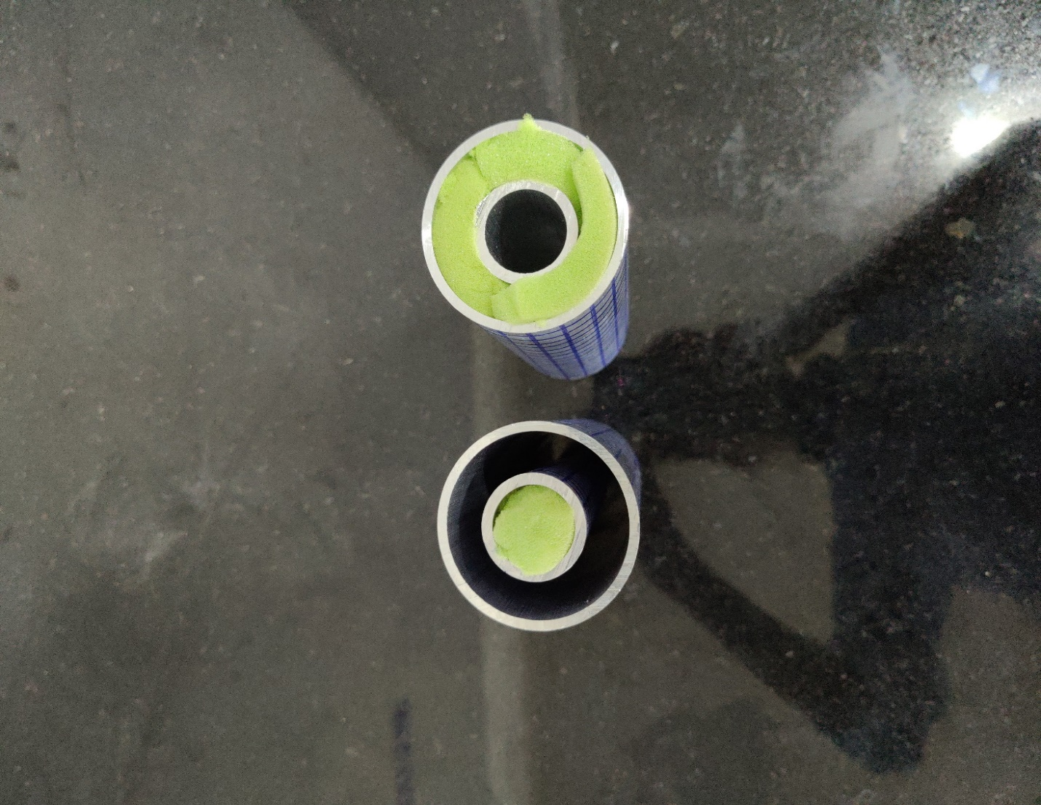
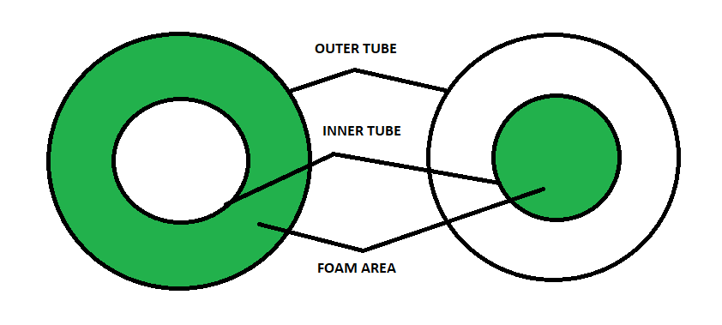
(a) (b)
Fig -1: (a) outer foam bi-tubular (OFBTU), (b) inner foam bi-tubular (IFBTU)
Fig -2: specimen used for the Experimental analysis
To obtain better energy absorption, foam arrangements were made through two different configurations and only the OFBTU was studied through experimental and numerical analysis and energy absorption results were compared to conclude which has better EA characteristics. The first specimen was bi-tubular structure with foam filled in the area between inner and outer tube and the second was inside the inner tube. The actual specimen was shown in Figure 4.2.
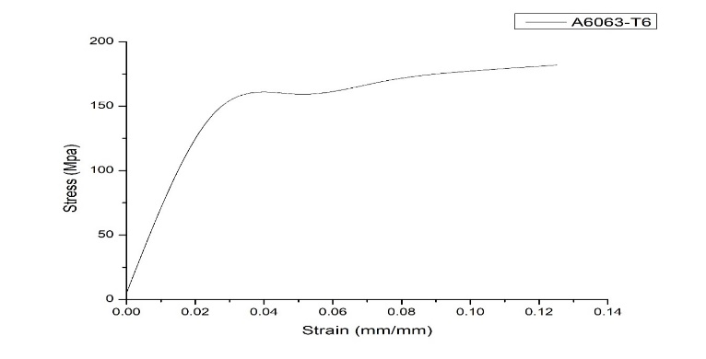
Fig -3: Stress – Strain relation for AA6063 tube

Table -1: Material parameters of AA 6063 tube
Density (ρ) | Modulus (E) | Poisson’s ratio (υ) | Yield stress (δy)
2690 Kg/m³ | 68.3 GPa | 0.33 | 72.7 MPa

Table -2: Material parameters of polyurethane foam
Density (ρ) | Modulus (E) | Poisson’s ratio (υ) | Compression Yield stress ratio (MPa)
270 Kg/m³ | 27.2 GPa | 0 | 1

The finite element study was carried out under various frictional conditions and different loading angles and the result was compared. The one default friction condition was penalty and hard contact with friction coefficient of 0.2 was used in the finite element analysis. And the other conditions were depicted in the Table 3.
Table -3: Contact condition and loading angle used in the study
Contact condition | Kinetic friction coefficient | Static friction coefficient | Loading angle
C1 | 0.10 | 0.20 | 0°
C2 | 0.15 | 0.25 | 13.5°
C3 | 0.15 | 0.15 | 15°

3.ENERGY ABSORPTION CHARACTERISTICS

3.1. Energy Absorption (EA):
EA = ∫ F(x) dx (1)
where EA is the energy absorbed, F(x) is the force vs. displacement curve during the impact, and ∫ F(x) dx is the integral of the force vs. displacement curve over the displacement range of the impact.

3.2. Specific energy absorption (SEA):
The ratio of energy absorbed (EA) to overall mass of tubular structures resulting in specific energy absorption (SEA).
$SEA= \frac{\int_{0}^{l_{max}}{F\left(l\right).dl}}{M_{bc}}$ (2)
where the M_{bc} is referred to as the entire mass test specimen.

3.3. Mean crushing force (Pmean):

The extraction of mean crushing force is based on the measurement of average forces created during the uni-axial compression of tubular structures during progressive folding.
$P_{mean}= \frac{\int_{0}^{l_{max}}{F\left(l\right).dl}}{l_{max}}$ (3)
3.4. Peak crushing force (Pmax):
$P_{max}=max (F\left(l\right))$ (4)
The peak crushing force (Pmax) can be formulated by the equation (4).
3.5. Crash force efficiency (CFE):
$CFE=$ $\frac{P_{mean}}{P_{max}}$ (5)
Crash force efficiency was defined as the ratio between the mean and peak crushing force experienced during the crushing forces. The structure with the lowest CFE was not preferred because of the higher peak crushing force transferred to the structure's bottom.

4.EXPERIMENTAL SETUP
The experimental study was carried on a TUFC – 1000 servo universal testing machine with direct load on three fabricated specimens with foam arranged in outer tube. The specimen was drawn with 1cm x 1cm grid lines to study the crush patten of the specimen. The specimen was prepared as per the ASTM – E8 standards. The test was done on the three specimens of same configuration and the average of the results are taken as final output. The Fig 4 shows the specimen mounted on the universal testing machine. To provide axial load, the developed test specimen can be feed among fixed and movable jaws. The absence of dynamic influence was ensured by limiting the compression process to a rate of loading at 5 mm/min until the constrained crash was within the quasistatic region. With the high rise in the crushing load, it is critical in obtaining the quasi-static condition with complete crushing. There is no discernible difference in the quasi-static compression process between the experimental and FE simulations. The crashworthiness indices were not significantly altered due to an energy dissipation/absorption characteristic influenced mostly by plastic deformation rather than inertia in the quasi-static compression process.
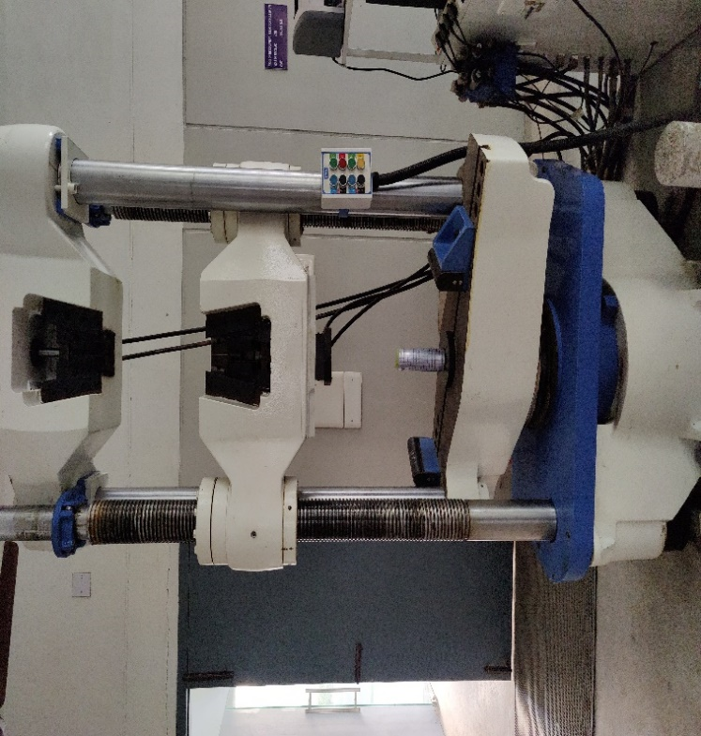
Fig -4: Specimen mounted on the universal testing machine
The movable block was given an artificial ramping velocity of 0.3 m/s, which decreases the process's time step. To regulate the velocity of the striking end in FE simulation, the AMPLITUDE and SMOOTHSTEP sub options were used.

5.NUMERICAL SETUP
This Fig 5 depicts the general discretized configuration of the generated FEM model of tubular structures used in this investigation. The numerical simulations of quasistatic uni-axial and oblique loading compression processes were carried out using the nonlinear FE algorithm ABAQUS-Explicit. The three-dimensional shell element S4R was used to simulate the tubular construction and the three-dimensional solid element was used to simulate the foam structure.
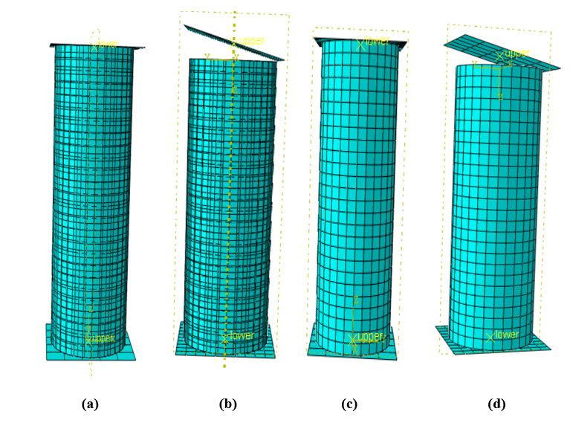
Fig -5: (a) OFBTU under uni-axial load (b) OFBTU under 15° oblique load (c) IFBTU under uni-axial load (d) IFBTU under 15° oblique load.
Mesh refining was accomplished using the advancing front technique. The rigid pressing plate on the top and bottom fixed plates was modeled using the R3D4 element. The fixed boundary condition was enabled to limit all degrees of freedom of node location on the tube's bottom side and the displacement was applied of the direction U3 on the node location of tube’s top side while all other degrees of freedom was kept zero in order to resist excessive distortion or rotation of the elements. The Fig 6 represents the foam bi-tubular modelling for numerical simulation for both the outer tube foam and inner tube foam structure.
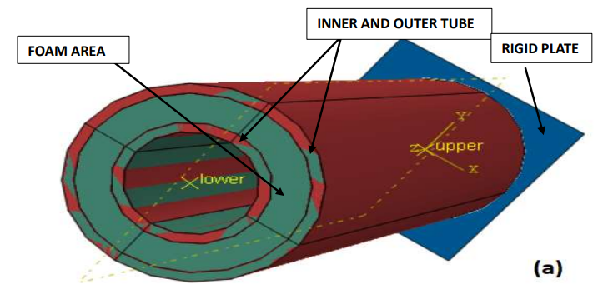
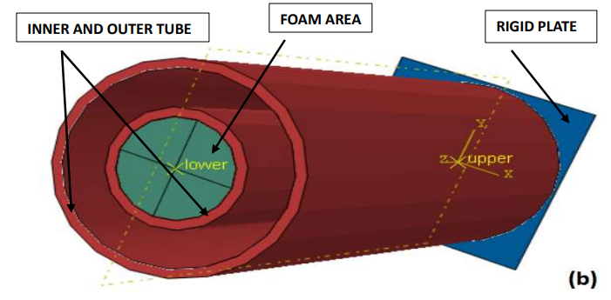
Fig -6: (a) shows the OFBTU model (b) shows the IFBTU model
6.RESULTS AND DISCUSSION
6.1. NUMERICAL RESULTS
The step by step crushing process of both the foam arrangement configuration under uni-axial and oblique loading conditions was illustrated in the below Fig 7.
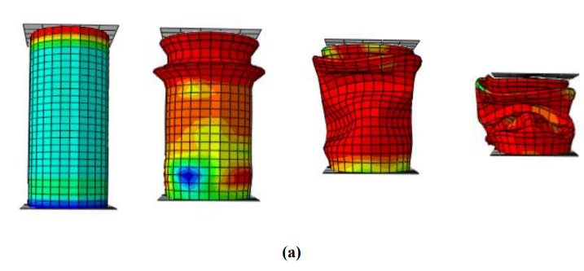
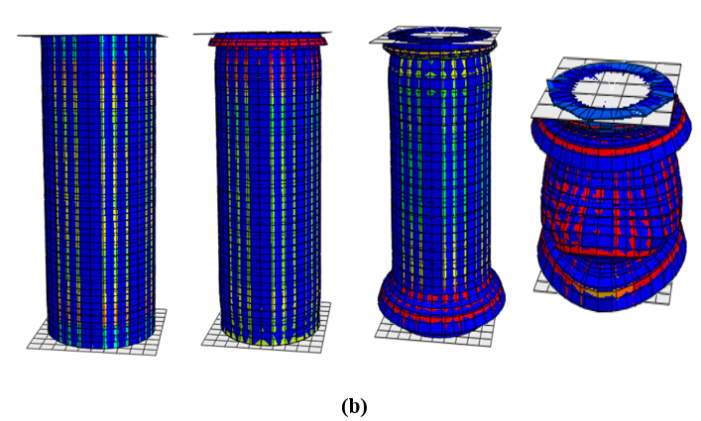
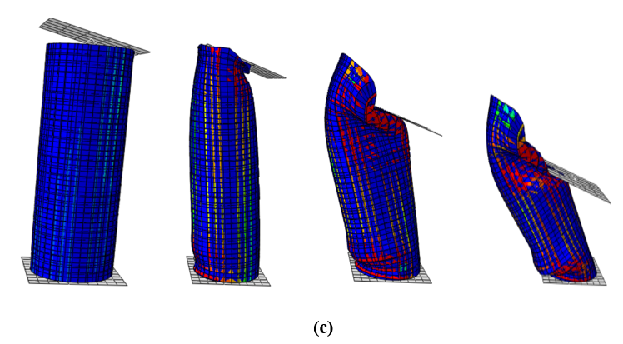
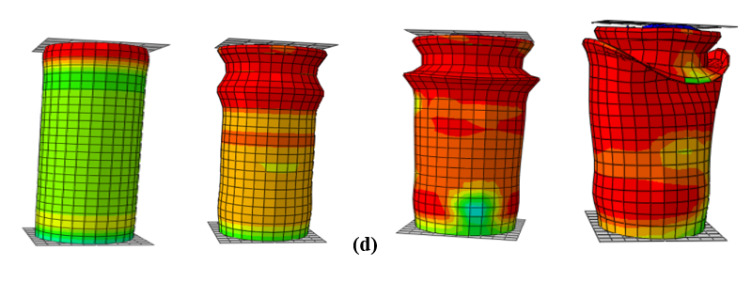
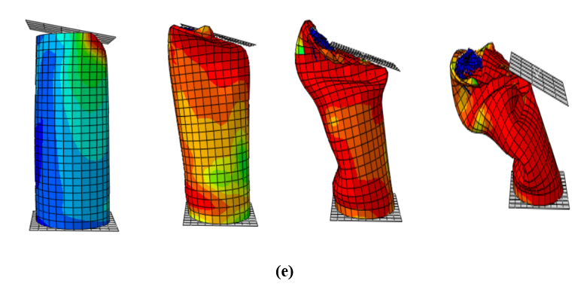
Fig -7: (a) empty bi tubular (b) OFBTU under uniaxial load (c) OFBTU under 15° oblique load (d) IFBTU under uniaxial load (e) IFBTU under 15° oblique load
The simulation was carried out about 25 different tubular configurations based on the contact conditions, based on the angle of impact and based on the foam arrangement as discussed above and the crashworthiness parameters for all the specimens were discussed and compared with one another in the Table 4 and the Force-Displacement relation for each specimen extracted from the simulation and discussed below.

Table -4: Energy absorption characteristics of all the simulated specimen
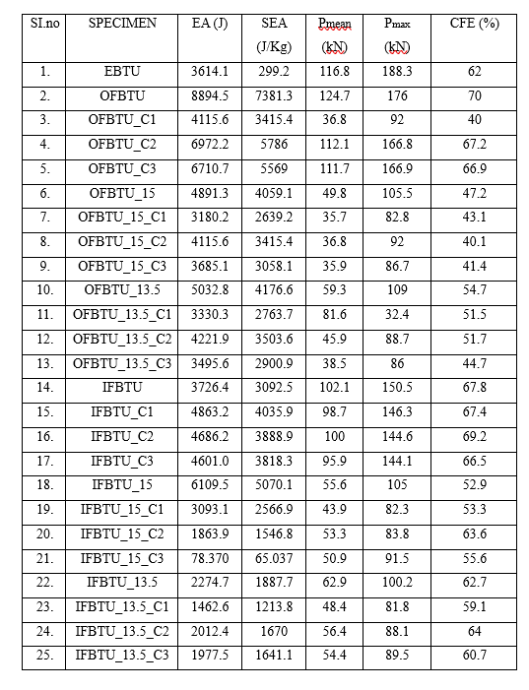
The crashworthiness parameters that obtained from the finite element analysis of the specimen’s was depicted in the Table 6.1 and compared with one another in the above graphical representations with different contact conditions and different loading angles.

6.1.1 EFFECT OF FOAM AS A FILLER MATERIAL IN BI-TUBULAR STRUCTURE
The numerical analysis was carried for both empty and foam filled (OFBTU, IFBTU) structure and comparison of the EA results was graphically represented in the Fig 8.
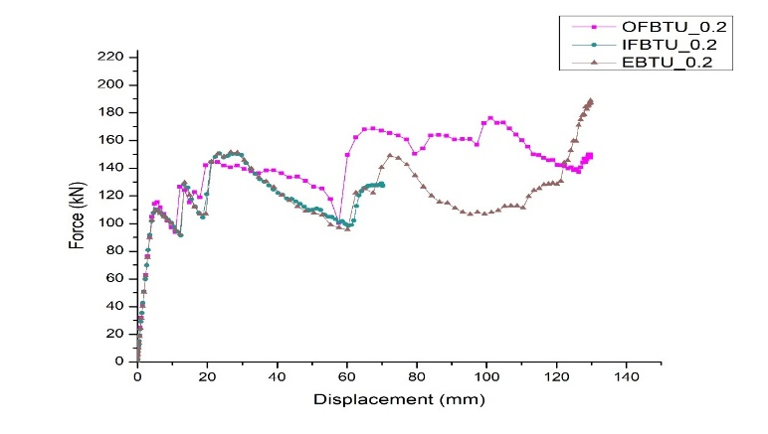
Fig -8: Relation between empty and foam filled (OFBTU, IFBTU) structures
From the above relation we conclude that compared to empty bi tubular foam filler was result in better energy absorption characteristics. The EBTU has recorded the energy absorption of about 3614.155 J while using the foam as a filler material there is drastic improvement in EA characteristics which the OFBTU has 8894.543 J and IFBTU has 3726.498 J. so we can say that foam filling was the better option to improve the crashworthiness of the structure.

6.1.2. COMPARISON OF FORCE – DISPLACEMENT RELATION UNDER UNIAXIAL LOAD AND OBLIQUE LOAD FOR OFBTU
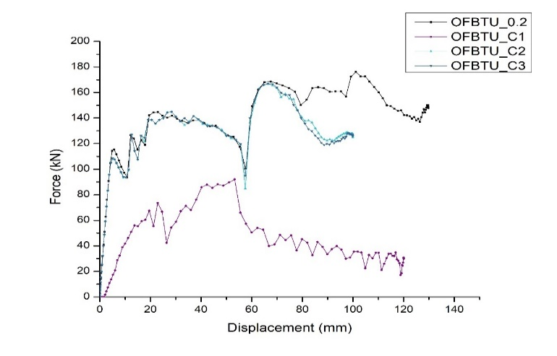
Fig -9: Relation between different contact conditions of OFBTU under oblique load
The Fig 9 shows the graphical relation between OFBTU specimen under different contact conditions under different loading angles. The main inference to be observed that the OFBTU under uniaxial load having friction co-efficient of 0.2 has better energy absorption of about 8894.543 J.
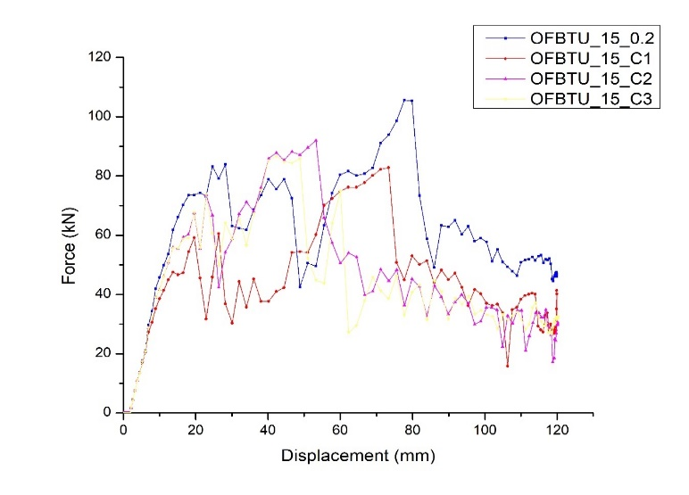
Fig -10: Relation between different contact conditions of OFBTU under 15° load

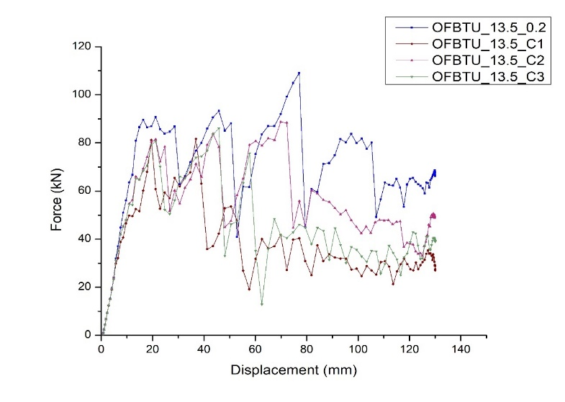Fig -11: Relation between different contact conditions of OFBTU under 13.5° load
In the Fig 10 it is to be noted that under 15° load of OFBTU the specimen having contact condition of 0.2 has recorded better energy absorption having 4891.314 J compared the poor energy absorption having 3180.29 J under contact condition (C1). Under 13.5° loading angle the of the OFBTU having contact condition 0.2 the energy absorption is recorded as 5032.846 J and least energy absorption 3330.375 J recorded in the specimen OFBTU-C1. From the above graphical representations, we can say that friction coefficient also play a major role in EA characteristics and contact condition also needs to be studied while going for foam filling applications. The Fig 11 shows the L-D pattern of OFBTU under 13.5° loading angle having different contact conditions.

6.1.3. COMPARISON OF FORCE – DISPLACEMENT RELATION UNDER UNIAXIAL LOAD AND OBLIQUE LOAD FOR IFBTU

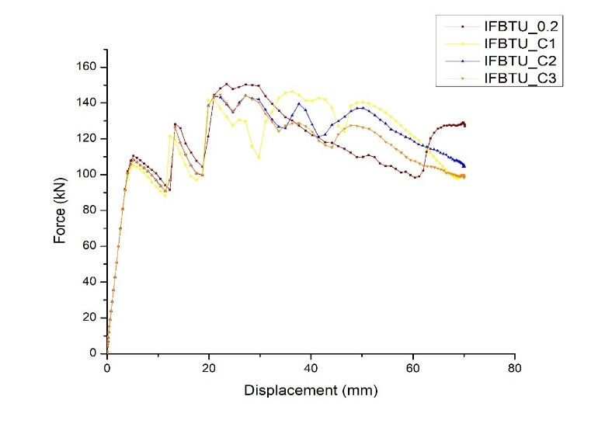Fig -12: Graphical representation of IFBTU under uniaxial load differ in contact condition
From the Fig 12 the energy absorption of IFBTU having contact condition (c1, c2, c3) is 26% greater than the specimen having 0.2 contact condition having EA of about 4863.299 J.
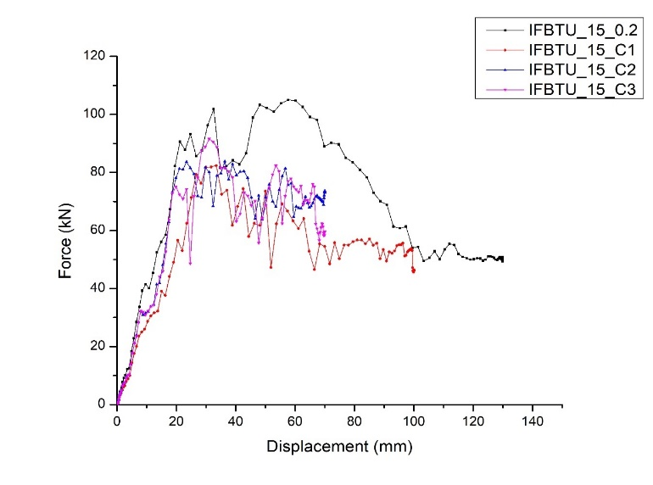Fig -13: Graphical representation of IFBTU under 15° load differ in contact condition
The Fig 13 represents the EA parameters for the IFBTU specimen under 15° oblique loading, there is an drastic improvement in the EA of IFBTU under 0.2 contact condition having 6109.568 J and the least EA was recorded in IFBTU-C3 having 78.37076 J.
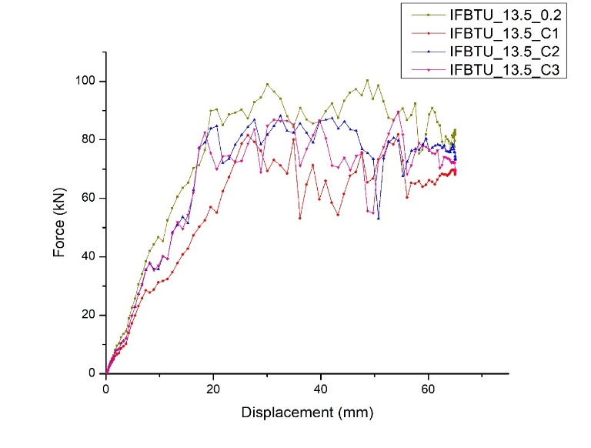Fig -14: Graphical representation of IFBTU under 13.5° load differ in contact condition
The graph in the Fig 14 shows that IFBTU-0.2 has better EA under 13.5° oblique load. So we can conclude that IFBTU also finds a suitable applications where we need a better EA characteristic structures. From the graphical representation we can say that IFBTU perform better in oblique loading condition while OFBTU perform better in uniaxial loading condition.

6.1.4. EFFECT OF FOAM ARRANGEMENT
There are two types of foam arrangement studied in this paper and the specimen’s name was given as OFBTU – outer foam bi tubular, IFBTU – inner foam bi tubular and the EA characteristics was compared and evaluated using both numerical and experimental analysis. The aluminium foam is also one of the better option for foam filling material but polyurethane foam was one of the cheapest also provide comparable results against aluminium foam.
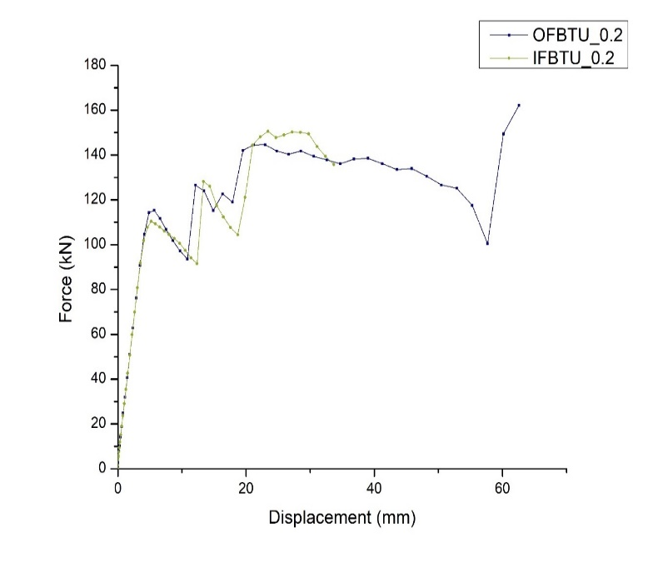Fig -15: Graphical representation of OFBTU vs IFBTU under uniaxial load
The main inference to be noted that compared to OFBTU the material failure has occurred at about 130 kN for IFBTU which shows that OFBTU has better EA characteristics compared to IFBTU.
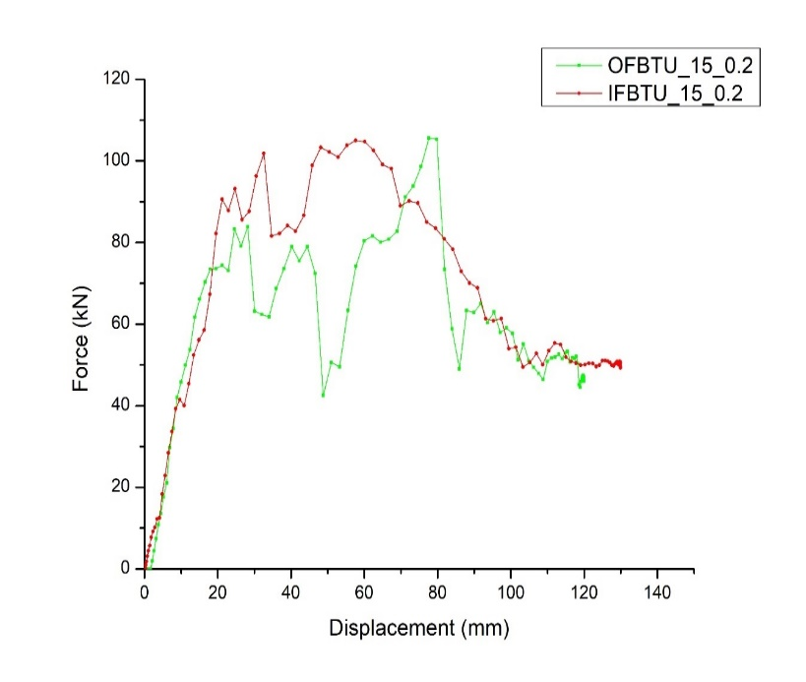Fig -16: Graphical representation of OFBTU vs IFBTU under 15° oblique load

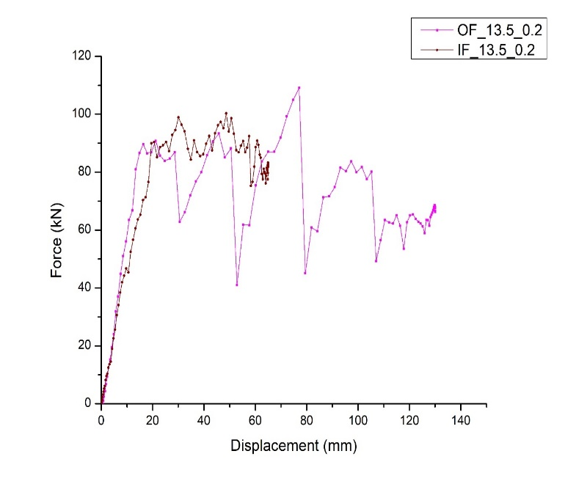
Fig -17: Graphical representation of OFBTU vs IFBTU under 13.5° oblique load
The Fig 15 shows that OFBTU has better EA compared to IFBTU under direct loading conditions, the EA of OFBTU was 50% greater than the IFBTU. Unlike 15° the OFBTU performs well in 13.5° oblique load having EA 60% greater than the IFBTU. As we discussed earlier the IFBTU performs well in oblique loading conditions compared to OFBTU as shown in the Fig 16 and 17 and the recorded EA of the specimen’s was 4891.314 J and 6109.568 J

6.1.5. EFFECT OF CRICTICAL LOADING ANGLE
The critical loading angle is the angle at which the tubular structure alters the kind of deformation mode. The determination of a defined critical loading angle is problematic due to the modest progression of the collapse mode pattern. It prompts us to refocus our attention on identifying the effective loading angle. In order to investigate the critical loading angle, a series of FEM simulations were run on varied loading angle starts ranging from 0° to 15°.
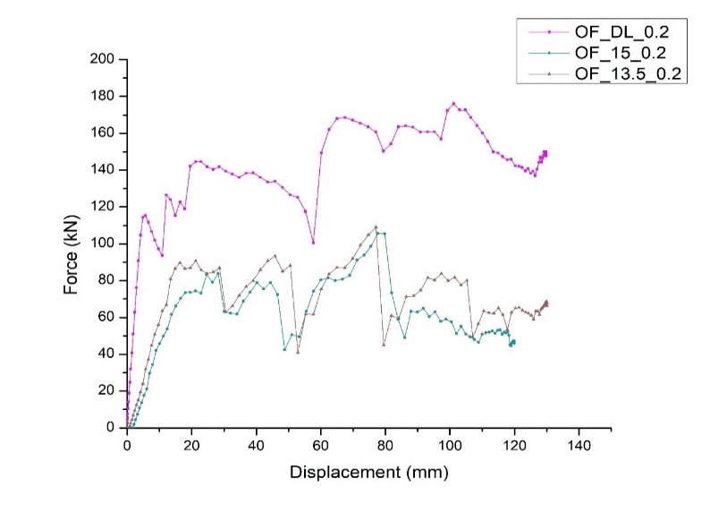Fig -18: Graphical representation of OFBTU under 0° to 15° loading conditions
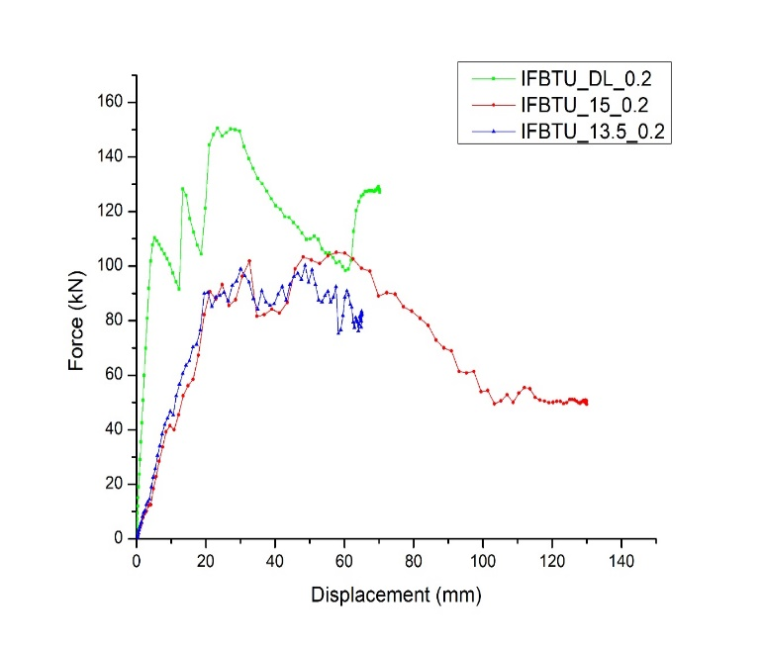Fig -19: Graphical representation of IFBTU under 0° to 15° loading conditions
From the Fig 19 it shows that OFBTU has better energy absorption under 0° loading angle and compared to 13.5° and 15° OFBTU has better EA in 13.5 ° and in the OFBTU the material failure has occurred on 90 kN at 13.5° loading angle. As same as OFBTU the IFBTU also has better EA characteristics at 0° compared to other loading angles and the material failure of IFBTU under 13.5° was occurred at 80 kN.

6.2. NUMERICAL RESULT VALIDATION USING EXPERIMENTAL ANALYSIS

Table -5: Comparison of Experimental and finite element analysis
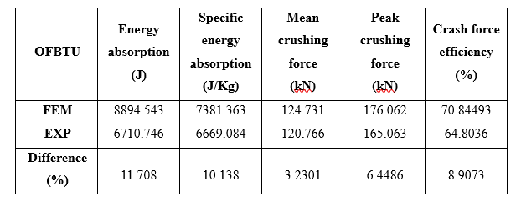

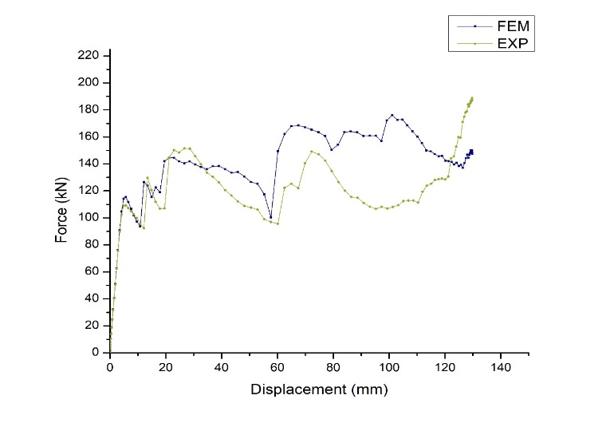
Fig -20: Graphical representation of experimental and finite element analysis
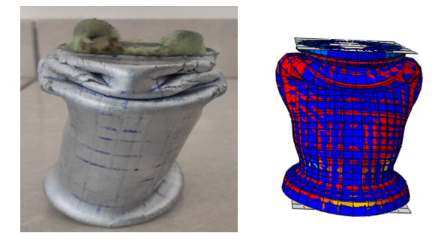Fig -21: deformed bi-tubular structure during experimental and numerical analysis.
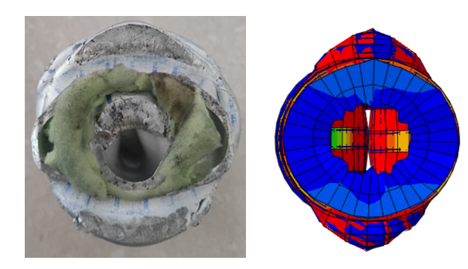Fig -22: Deformed top section during experimental and numerical analysis
The inference from the Fig 20 to be noted that there is slight variation in results experimental and finite element analysis. The energy absorption to be noted that 6710.746 J and SEA is about 6669.084 J/Kg and the mean crushing force of 120.766 kN and peak crushing force of 165.063 kN and the crash force efficiency of 64.8036 is observed. And the folding pattern of the tube structure in both the numerical and experimental analysis is compared and material failure also noted in experimental analysis. From the Fig 21 and Fig 22 we able to note that similar folding pattern was achieved from both the experimental and FEM analysis. It looks like progressive folding pattern and the specimen is not completely deformed
6.6. DISPLACEMENT – ENERGY ABSORPTION RELATION FOR THE TESTED SPECIMEN

The Fig 23 and 24 graphical representation shows the energy absorption relation between loading angle for the different specimen under different foam arrangements. And form the graphical results we can conclude that EA of OFBTU under direct load has better EA.
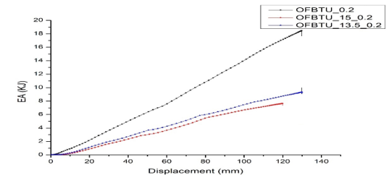Fig -23: Displacement-Energy absorption relation for OFBTU
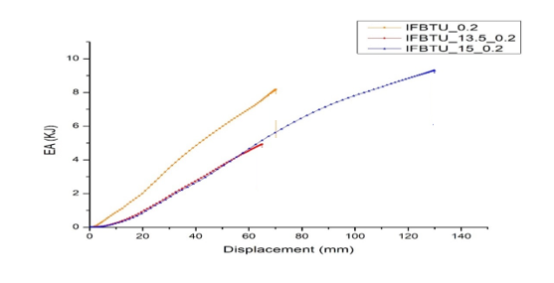Fig -24: Displacement-Energy absorption relation for IFBTU

7. CONCLUSION
This study investigated the crashworthiness of foam-filled bi tubes with varied foam arrangement techniques subjected to quasi-static uni-axial and oblique compression. The features of circular bi tubes with varied foam arrangements were revealed through a series of experimental and finite element simulations. The study looked into the important factors such as the influence of loading angle, the effect of foam layout, and contact interaction. The investigation yielded the following distinct results.
- For all tube configurations, the combined type collapse pattern occurs frequently.
- When loading conditions change, stiffness decreases due to structural integrity loss, resulting in global bending, emphasizing the requirement for adequate crash buffers designed with foam filling techniques.
- The crashworthiness performance of foam-filled bi tubes with foam configuration changed from striking end to stationary end demonstrated more energy absorption as compared to IFBTU tubes exposed to oblique loading.
- It is clear that the sequence of foam arrangement is a dominant factor in improving crashworthiness behavior in oblique loading conditions, with the remarkable outcome observed in positioning of the foam reducing from striking to stationary end, and the inferior outcome visible if the foam arrangement is changed.
- The analysis demonstrates that contact interaction has a significant impact in energy absorption characteristics, and the results were summarized for easier comparison. Furthermore, EA absorption was dramatically reduced when OFBTU came into contact under C1 contact conditions, and CFE was reduced to 40% from 70%.
- The effect of foam arrangement also plays a significant contribution in crashworthiness characteristics resulting in 70% CFE, peak force of 188.308 kN mean crushing of 124.73 kN and SEA of 7381.3 J/Kg is achieved. while the empty bi-tubular has the peak force of 188.308 kN, CFE of 62%, mean crushing force of 116.86 kN, SEA of 299.2987 J/Kg is achieved.

8. REFERENCES
[1] Barzigar, Seyed Sajad, Hamed Ahmadi, and GholamHossein Liaghat. "An analytical investigation on the crushing behavior of thin-walled tubes filled with a foam with strain hardening region." Thin-Walled Structures 182, pp-110169,2023.
[2] Alshahrani, Hassan, et al. "Quasi-static axial crushing performance of thin-walled tubes with circular hole discontinuities." Journal of Composite Materials 56.27, pp-4195-4218, 2022.

[3] Baaskaran, N., K. Ponappa, and S. Shankar. "Study of the effect of varying shapes of holes in energy absorption characteristics on aluminium circular windowed tubes under quasi-static loading." Structural Engineering and Mechanics, An Int'l Journal 70.2, pp-153-168,2019.

[4] Baaskaran, N., K. Ponappa, and S. Shankar. "Assessment of dynamic crushing and energy absorption characteristics of thin-walled cylinders due to axial and oblique impact load." Steel and Composite Structures, An International Journal 28.2, pp-179-194, 2018.
[5] Baaskaran, N., K. Ponappa, and S. Shankar. "Quasi-static crushing and energy absorption characteristics of thin-walled cylinders with geometric discontinuities of various aspect ratios." Latin American Journal of Solids and Structures 14, pp-1767-1787, 2017.
[6] Costas, Miguel, et al. "Static crushing of aluminium tubes filled with PET foam and a GFRP skeleton. Numerical modelling and multiobjective optimization." International Journal of Mechanical Sciences 131, pp-205-217,2017.
[7] Vinayagar, K., and A. Senthil Kumar. "Multi-response optimization of crashworthiness parameters of bi-tubular structures." Steel and Composite Structures 23.1, pp31-40,2017.

[8] Altin, Murat, Mehmet A. Güler, and Sinem K. Mert. "The effect of percent foam fill ratio on the energy absorption capacity of axially compressed thin-walled multi-cell square and circular tubes." International journal of mechanical sciences 131, pp-368-379, 2017.
[9] Darvizeh, Abolfazl, et al. "Low velocity impact of empty and foam filled circumferentially grooved thick-walled circular tubes." Thin-Walled Structures 110, pp-97-105,2017.
[10] Duarte, Isabel, Lovre Krstulović-Opara, and Matej Vesenjak. "Characterisation of aluminium alloy tubes filled with aluminium alloy integral-skin foam under axial compressive loads." Composite Structures 121, pp-154-162, 2015.
[11] Tarlochan, F., et al. "Design of thin wall structures for energy absorption applications: Enhancement of crashworthiness due to axial and oblique impact forces." Thin-Walled Structures 71, pp-7-17, 2013.
[12] Huang, M. Y., Y. S. Tai, and Hsuan-Teh Hu. "Dynamic crushing characteristics of high strength steel cylinders with elliptical geometric discontinuities." Theoretical and Applied Fracture Mechanics 54, pp-44-53, 2010.
[14] Bambach, Michael Richard, Hussein Haji Jama, and Mohamed Elchalakani. "Static and dynamic axial crushing of spot-welded thin-walled composite steel–CFRP square tubes." International Journal of Impact Engineering 36.9, pp-1083-1094, 2009.
[15] Ahmad, Zaini, and David P. Thambiratnam. "Dynamic computer simulation and energy absorption of foam-filled conical tubes under axial impact loading." Computers & Structures 87.3-4, pp-186-197,2009.

