

Speed of light TRAVEL- CARSOL DRIVE
Centrifugal DRIVE ACCELERATOR TO REACH SPEED OF LIGHT.

Author- Aaditya s Nair

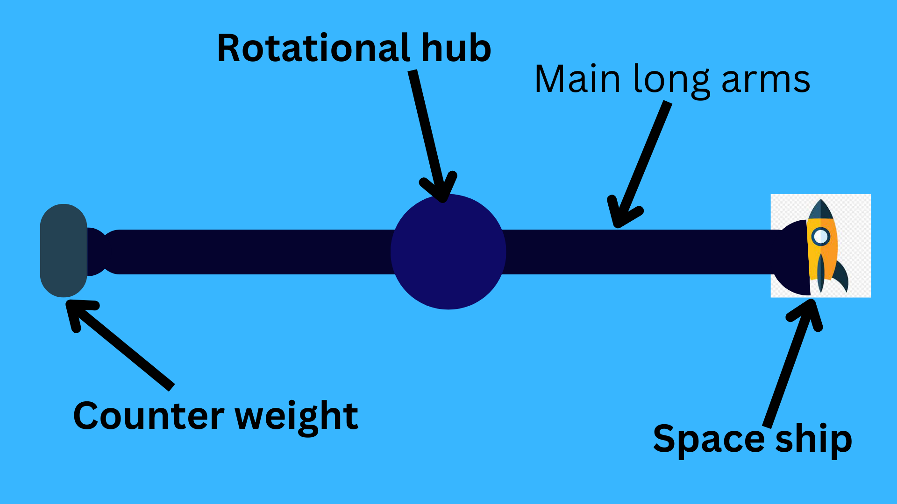Simple Illustration of the main system
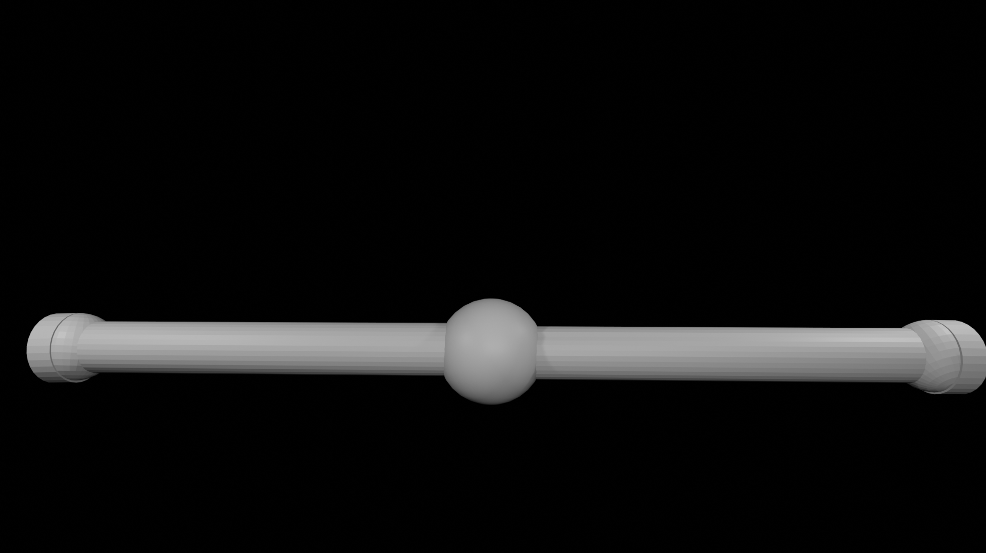Artistic illustration of the whole structure

Abstract
This Paper is written on how we can travel at the speed of light using a centrifugal structure and a nuclear electric propulsion. This Paper consists of various sections where the various parts and sections of the whole structure will be explained and how the earlier known as the unachievable speed can be achieved and in this whole matter why a dyson’s sphere/ swamp would be very important.
Introduction

Distance is one of the main key obstructions for us to travel through the universe but it's interrelated to time as everything ends up in the hands of time, why you may ask? So, let's start with an small example- voyager probe is the space probe which was launched in 5 September 1977 and in August 2012 it left the solar system, it took thi smooch time to just cross all planets but to cross the real end of the solar system it would take 14,000 to 28,000 years to reach and cross the “OORT Cloud” so, we have wasted this much time just waiting for it to leave the solar system, yes that is true that voyager probes gathered and transmitted a lot of data to the earth but they were just small flybys. Right now we are a type 0 civilization and if we continued this same pace then it would take us millions of years to become a type 1 civilization.(This drive won't be able to transport humans as right now there are no life support systems which can resist the insane amount of Gforce which is experienced by the humans in this system) This research paper is written on a concept of a centrifugal drive which basically flings the spacecraft at speeds very near to speed of light to be specific it would be from 92% to 97% speed of light depending on the weight of the payload.The Author of this Paper is Aaditya s nair. Now the next sections would have the parts and the sections of the system explained.
I am Aaditya S Nair and I am author of 2 books Rocketisium 1.0 and 2.0. This Idea struck me when I was thinking that the FTL speeds are considered unachievable so then after I started my research on this topic I invented this new type of drive.

So, till now we assumed that FTL is a speed which cannot be achieved as it would break the “laws” of science. So, we will start with the type of FTL travel which we currently know which is WORMHOLES.

FTL travel using Wormholes
(Faster than light) So, basically wormholes are a hole through 2 ends of the space time. Wormholes are considered as a method to travel at the speed of light as here instead of traveling the whole distance we will use the wormhole and use it like a shortcut through space time.
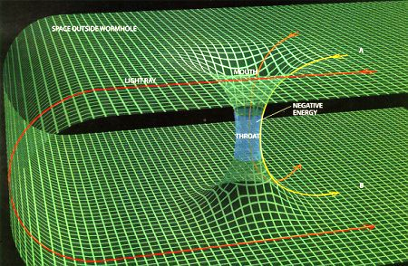
The picture shows the wormhole. Here the spacetime is warped around a tube like structure which has openings on top and bottom.To maintain this structure we need negative energy so that the most energy concentrated area (Image source- phys.org) stays open.There are many Advantages of wormhole travel and many disadvantages such as -
Advantages of wormholes | Disadvantages of wormholes
- Real FTL travel possible  - Easy to travel through without rigorous protection  - Can help in ultra massive distances | - Need Negative energy( pretty rare)  - wormholes bring with them the dangers of sudden collapse, high radiation and dangerous contact with exotic matter.  - Can’t help in short distances (like between stars ) as it wouldn’t make any sense to use it for short distances as it takes a lot of energy to maintain its state.
So as you observe the disadvantages of using wormholes outweigh the advantages. Then we come to my Idea of how to reach the speed of light CARSOL which is an abbreviation of Centrifugal DRIVE ACCELERATOR TO REACH SPEED OF LIGHT.
CARSOL
The CARSOL drive would be able to allow the spacecraft to reach the speed of light.There are many parts of this drive. The parts of the CARSOL Drive (main simplified diagram) is named as follows-
- The main rotational hub
- Main arms
- Counterweight
- Spaceship
So, the main basic concept behind this is pretty simple, we will first spin the whole structure using the rotational hub which would be attached to a planet or a huge planetary body.The whole arms would be made up of carbon nanotube reinforced carbon fiber.The main Arms would have Decouplers at both sides those decouplers would help in detaching the rocket and the counterweight. Here an question comes to the mind is why use carbon nanotube reinforced carbon fiber is that carbon fiber has 3 to 7 GPa standard but CNTs are have tensile strength of 270–950 GPa but one more question come to the mind as why don't use just CNTs instead of CNRCF (carbon nanotube reinforced carbon fiber) is that making of CNTs is slow and if we use CNRCF it would be easy relatively to make it. So in the graph below it shows that the CNTs have exponentially high strength to weight ratio (kN m kg⁻¹ ).counter weight is there to maintain the stability of the vehicle and will decouple at the release of the spaceship.After the separation of the spaceship the at speeds around the speed of light ~98 % the speed of light, the spaceship will turn on its rocket engines ( most probably an nuclear thermal or a nuclear electric propulsion
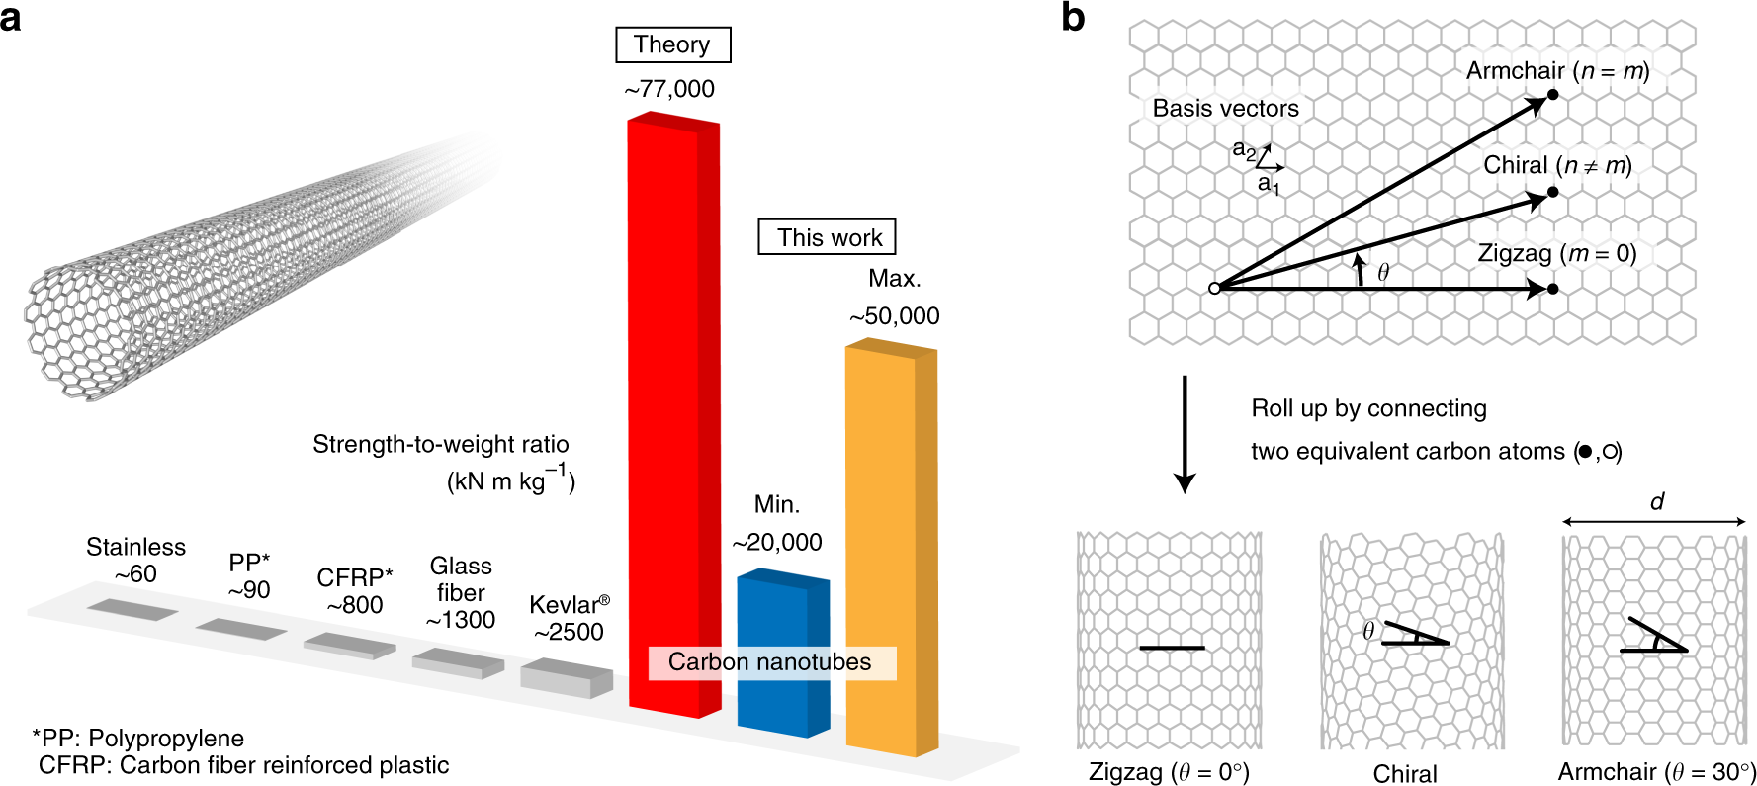The next part/system in our CARSOL drive is a huge star and its gravitational field. Here in the First use of the star is to anchor our Rotational hub so that we can pull out maximum efficiency out of the whole system instead of wasting energy for some stability control systems and here anchor means gravitational anchoring. As the mercury planet’s rotation is gravitationally locked by the sun due to its distance from the sun we have to find an optimal distance between the star and the CARSOL Drive. This CARSOL Drive would need a lot of energy (mainly electrical energy) so to get that much energy we will obviously need a dyson’s swamp. Then one more question comes to mind: why dyson’s swamp instead of dyson’s sphere? and what is dyson's swamp. So basically dyson’s sphere is not capable to hold / control its mass instead of crumpling all in itself so we will use dyson’s swamp in which we will use many mirror like satellites to reflect the light to the main concentrator and after which we will send it towards the main light and heat energy to electrical energy converter/generator by which we will be able to collect and transmit the data to the main rotation hub by which we will be able to reach the speed of light.These are the links to the video of the carsol drive in cgi- https://drive.google.com/file/d/1Qz4l12jFsnPuBtqSApKev6wig4TaOv_x/view?usp=sharing
And this is the 2nd video-
https://drive.google.com/file/d/14fQz6bdtsM63gQ9pz2JFl32NE9ic_iPG/view?usp=sharing
Result-
The result of this whole paper is that this method of using the centrifugal effects and use of the axel and wheel technique can in fact not only reach but also exceed the speed of light.
References-
Image from Phy.org of the wormhole.

