“Cloud Formation (IaC)”
Deploying a Containerized Application on Cloud

Uddesh Piprewar¹, Shubham More², Vishal Lamsoge³, Balwesh Puramkar⁴,
Gayatri Dandhare⁵, Prof. Aditya Turankar⁶
uddeshpiprewar@gmail.com¹ , Shubhammore007@outlook.com² , vishallamsoge98@gmail.com³ , balweshpuram@gmail.com⁴ , gaytridandhare@gmail.com⁵ , aditya92t@gmail.com⁶

¹B.E. Graduate (iv year), Department of Computer Science and Engineering, NIT, Nagpur
²B.E. Graduate (iv year), Department of Computer Science and Engineering, NIT, Nagpur
³B.E. Graduate (iv year), Department of Computer Science and Engineering, NIT, Nagpur
⁴B.E. Graduate (iv year), Department of Computer Science and Engineering, NIT, Nagpur
⁵B.E. Graduate (iv year), Department of Computer Science and Engineering, NIT, Nagpur
⁶Associate Professor, Department of Computer Science and Engineering, NIT, Nagpur

ABSTRACT

This study is a literature review on cloud computing trends as one of the Fastest growing technologies in the computer industry and their benefits and opportunities for all types of organizations. In addition, it addresses the challenges and problems that contribute to increasing the number of customers willing to adopt and use the technology. A mixed research study approach was adopted for the study, that is by collecting and analysing both quantitative and qualitative information within the sane literature review and summarizing the findings of previous (related) studies. Results highlights the current and future trends of cloud computing and exposes readers to the challenges and problems associated with cloud computing. The reviewed literature showed literature showed that the technology is promising and is expected to grow in the future. Researchers have proposed many techniques to address the problems and challenges of cloud computing, such as security and privacy risks, through mobile cloud computing and cloud-computing governance.

To deploy a containerized application on cloud using IaC, one needs to define the infrastructure required to run the application, such as virtual machines, network configurations, and storage resources, in code. The infrastructure code is then used to create and manage the resources in the cloud environment. One of the main benefits of using IaC is that it allows for repeatable and consistent infrastructure deployments. Changes can be made to the infrastructure code, and the infrastructure can be updated automatically, reducing the risk of manual errors and inconsistencies. It is one of the main benefits of using IaC is that it allows for repeatable and consistent infrastructure deployments. Changes can be made to the infrastructure code, and the infrastructure can be updated automatically, reducing the risk of manual errors and inconsistencies. Cloud Formation is one such tool that allows for the automated creation and deployment of cloud resources using templates written in JSON or YAML.

Keywords: - IaC(Infrastructure as Code), AWS CloudFormation, JSON, YAML, ResourceStack
- Introduction

Like on-premises infrastructures, modern Cloud infrastructures are a tangle of diverse, interdependent components: to work in harmony, instances, storage, load balancers, firewalls, databases, and content delivery networks must be correctly provisioned and configured a historically manual process that’s complex, time-consuming, and error-prone.

Managing your infrastructure with many services can be hard. Creating and managing multiple AWS resources can be challenging and time-consuming. In fact, doing those things could result in spending a whole lot of time managing your AWS resources instead of developing your applications.

AWS CloudFormation can help. As mentioned, it provides you with a simple way to create and manage a collection of AWS resources by provisioning and updating them in an orderly and predictable way. In simple terms, it allows you to create and model your infrastructure and applications without having to perform actions manually. AWS CloudFormation enables you to manage your complete infrastructure or AWS resources in a text file, or template. A collection of AWS resources is called a stack. AWS resources can be created .
All the resources you require in an application can be deployed easily using templates. Also, you can reuse your templates to replicate your infrastructure in multiple environments. To make templates reusable, use the parameters, mappings and conditions sections in the template so that you can customize your stacks when you create them.
- Create a new template or use an existing CloudFormation template using the JSON or YAML format.
- Save your code template locally or in an S3 bucket.
- Use AWS CloudFormation to build a stack on your template.
- AWS CloudFormation constructs and configures the stack resources that you have specified in your template.
Using CloudFormation templates, users can define the configuration for their containerized application, including the container images, ports, environment variables, and other settings. They can also define the networking and security configuration, such as load balancers, security groups, and IAM roles.

Once the CloudFormation template is defined, users can use the AWS Management Console or command-line tools to create and deploy the infrastructure resources. CloudFormation automates the provisioning and configuration of the resources defined in the template, making it easy to deploy and manage containerized applications on the cloud. Deploying a containerized application on the cloud requires the creation of several resources such as virtual machines, load balancers, security groups, and container registries. Creating and managing these resources manually can be time-consuming and prone to errors. By using CloudFormation, the deployment of a containerized application can be done in a more streamlined and automated manner.

2. Methodology
The AWS: Api Gateway: Method resource creates API Gateway methods that define the parameters and body that clients must send in their requests.
The proposed methodology for security management in cloud computing is based on the following components:
- security metrics hierarchy;
- security index (IndSec);
- allocation index (IndAlloc);
- management of cloud computing.
Cloud computing platforms are different from physical and virtualized computing platforms. It is essential to understand the limitation and opportunities while creating solutions for a cloud environment. It also entails the need to look again at architecting methodology.
A security metrics hierarchy is derived from the GQM methodology. A security index (IndSec) will be computed using the security metrics hierarchy, which in turn allows for the calculation of the allocation index (IndAlloc). Finally, the cloud management scheduler will use the allocation index as a reference for the resource allocation process. In the context of the life cycle of security management, a security metrics hierarchy is presented as a new form of visualization of security-related information that is collected from the cloud computing environment.
First, you’ll need a template that specifies the resources that you want in your stack. For this step, you use a sample template that’s already prepared. The sample template creates a basic WordPress blog that uses a single Amazon EC2 instance with a local MySQL database for storage. The template also creates an Amazon EC2 security group to control firewall settings for the Amazon EC2 instance.
A template is JSON or YAML text file that contains the configuration information about the AWS resources you want to create in the stack. For this walkthrough, the sample template includes six top-level sections: AWS Template Format Version, Description, Parameters, Mappings, Resources, and Outputs; however, only the Resources section is required.
The Resources section contains the definitions of the AWS resources you want to create with the template. Each resource is listed separately and specifies the properties that are necessary for creating that particular resource. The following resource declaration is the configuration for the EC2 instance, which in this example has the logical name Webserver:

Syntax

To declare this entity in your AWS Cloud Formation template, use the following syntax: -

JSON
{
"Type" : "AWS::ApiGateway::Method",
"Properties" : {
"ApiKeyRequired" : Boolean,
"AuthorizationScopes" : [ String, ... ],
"AuthorizationType" : String,
"AuthorizerId" : String,
"HttpMethod" : String,
"Integration" : Integration,
"MethodResponses" : [ MethodResponse, ... ],
"OperationName" : String,
"RequestModels" : {Key : Value, ...},
"RequestParameters" : {Key : Value, ...},
"RequestValidatorId" : String,
"ResourceId" : String,
"RestApiId" : String
}
}

YAML
{
Type: AWS::ApiGateway::Method
Properties:
ApiKeyRequired: Boolean
AuthorizationScopes: String
AuthorizationType: String
AuthorizerId: String
HttpMethod: String
Integration:
Integration
MethodResponses:
- MethodResponse
OperationName: String
RequestModels:
Key : Value
RequestParameters:
Key : Value
RequestValidatorId: String
ResourceId: String
}
}

3. Flowchart

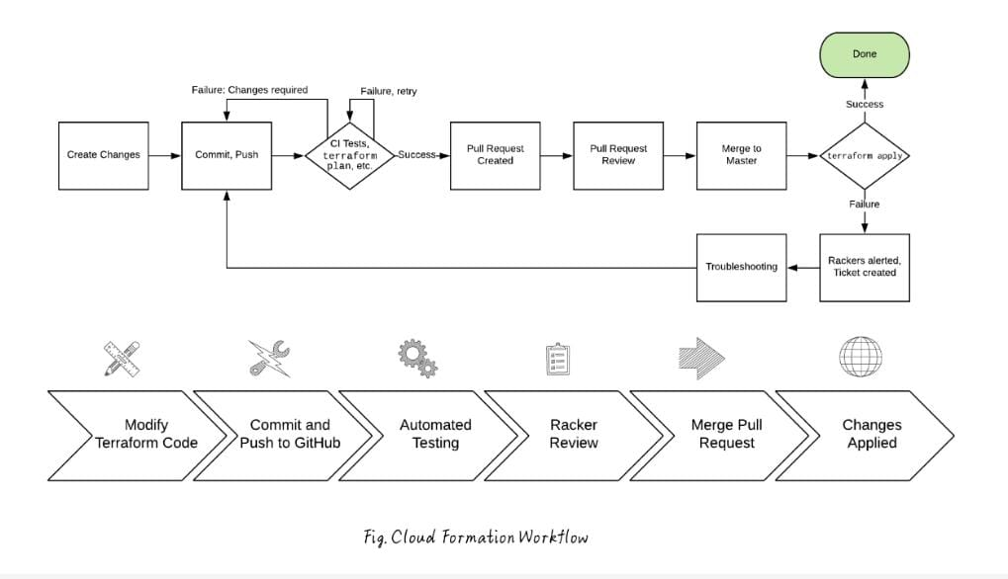

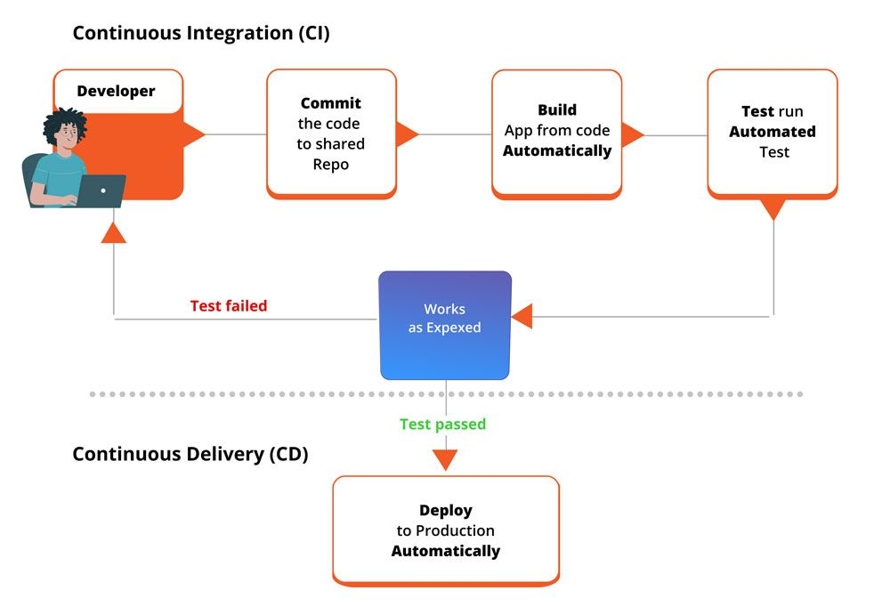

4. Why is the particular topic chosen?

Developers can deploy and update compute, database, and many other resources in a simple, declarative style that abstracts away the complexity of specific resource APIs. AWS CloudFormation is designed to allow resource lifecycles to be managed repeatably, predictable, and safely, while allowing for automatic rollbacks, automated state management, and management of resources across accounts and regions. Recent enhancements and options allow for multiple ways to create resources, including using AWS CDK for coding in higher-level languages, importing existing resources, detecting configuration drift, and a new Registry that makes it easier to create custom types that inherit many core Cloud Formation benefits.
AWS Cloud Formation is a service that helps you model and set up your AWS resources so that you can spend less time managing those resources and more time focusing on your applications that run in AWS. You create a template that describes all the AWS resources that you want (like Amazon EC2 instances or Amazon RDS DB instances), and Cloud Formation takes care of provisioning and configuring those resources for you. You don't need to individually create and configure AWS resources and figure out what's dependent on what; Cloud Formation handles that. The following scenarios demonstrate how Cloud Formation can help.
It is worth noting that Cloud Formation is not the only way to configure and deploy services on AWS. You can handle these processes manually using the AWS command-line interface, API, or Web console. Manual provisioning is the approach that teams typically take when they are just getting started with AWS and learning how to deploy services. However, as they scale their environments up in size, many teams quickly realize that they need a solution like CloudFormation to make the deployment process faster and more consistent.
CloudFormation (IaC) deploying a containerized application on the cloud can be cost-effective compared to traditional deployment methods. Containers can be easily scaled up or down depending on the application workload, which means that resources are only used when needed. This can result in lower infrastructure costs.
In this Group project we work on cloud platform AWS. here we have created Virtual Private Cloud (VPC) using terraform Tool with the help of AWS provider Amazon Virtual Private Cloud (Amazon VPC) provides a logically isolated area of the AWS cloud where you can launch AWS resources in a virtual network that we define.

As part of the project, you can develop a CloudFormation template that defines the required resources and their configurations. The template can include specifications for the container registry, the virtual machines, and the load balancer that will be used to distribute traffic to the container instances. The template can also specify the security groups that will be used to distribute traffic to the container instances. The template can also specify the security groups that will be used to control access to the resources.

5. Hardware and Software used

- Terraform:
Terraform is an open-source, infrastructure as code, software tool created by HashiCorp. Users define and provide data centre infrastructure using a declarative configuration language known as HashiCorp configuration Language, or optionally JSON. Terraform can provide support with multi-cloud via having a single workflow for every cloud. Various manages of terraform infrastructure could be hosted over Google Cloud Platform, Microsoft Azure, and Amazon Web Services, or on-prem within the private clouds like Cloud Stack, OpenStack, or VMWare vSphere. Terraform considers IaC (Infrastructure as Code). So, we need not to be worried about our infrastructure drifting away through the desired configuration.

- Docker:
Docker is a set of platforms as a service product that use OS-level virtualization to deliver software in packages called containers. The service has both free and premium tiers. The software that hosts the containers is called Docker Engine. It was first started in 2013 and is developed by Docker, Inc. Docker is an open-source platform for building, deploying, and managing containerized applications. Learn about containers, how they compare to VMs, and why Docker is so widely adopted and used.

- Gitlab/GitHub Actions (CI/CD):
GitLab CI/CD and GitHub Actions both allow you to create workflows that automatically build, test, publish, release, and deploy code. GitLab CI/CD and GitHub Actions share some similarities I workflow configuration: Workflow configuration files are written in YAML and are stored in the code’s repository. A continuous integration and continuous deployment (CI/CD) pipeline is a series of steps that must be performed in order to deliver a new version of software. CI/CD pipelines are a practice focused on improving software delivery throughout the software development life cycle via automation.
By automating CI/CD throughout development, testing, production, and monitoring phases of the software development lifecycle, organizations are able to develop higher quality code, faster. Although it’s possible to manually execute each of the steps of CI/CD pipelines is realized through automation.

- Platform:
A platform is a group of technologies that are used as a base upon which other applications, processes or technologies are developed. A platform is any hardware or software used to host an application or service. An application platform, for example, consists of hardware, an OS and coordinating programs that use the instruction set for a particular processor or microprocessor. In this case, the platform creates a foundation that ensures object code executes successfully.

- Linux:
Just like Windows, iOS and Mac OS, Linux is an operating system, in fact, one of the most popular platform on the planet, Android, is powered by Linux. Popular Linux distributions include Debian, Fedora Linux, and Ubuntu, the latter of which itself consists of many different distributions and modifications, including Lubuntu and Xubuntu. Commercial distributions include Red Hat Enterprise Linux and SUSE Linux Enterprise.

- Amazon Web Services (AWS):
Amazon web Services, Inc. is a subsidiary of amazon that provides on-demand cloud computing platforms and APIs to individuals, companies, and governments, on a metered pay-as-you-go basis. These cloud computing web services provide distributed computing processing capacity and software tools via AWS server farms. Amazon Web Services, Inc. (AWS) is a subsidiary of Amazon that provides on-demand cloud computing platforms and APIs to individuals, companies, and governments, on a metered, pay-as-you-go basis. These cloud computing web services provide various services related to networking, compute, storage, middleware, IOT and other processing capacity, as well as software tools via AWS server farms.

- Docker Hub (Repository):
Docker Hub is a hosted repository service provided by Docker for finding and sharing container images with your team. Key features include: Private Repositories: Push and pull container images. Automated Builds: Automatically build container images from GitHub and Bitbucket and push them to Docker Hub.

For Developers: Store and share your personal projects and see what the container community is building.
For Teams: Leverage private repositories to restrict content to specific users or teams.
For ISVs: Reduce friction for your developer audience. Make your software available to your customers and users with a single docker pull command.
For Enterprises: Choose certified containers from validated ISVs with cooperative support so you have the assurance to run in your production environment.

- YAML (yet another markup language):
YAML is a human-readable data-serialization language. It is commonly used for configuration files and in applications where data is being stored or transmitted. YAML targets many of the same communications applications as Extensible Markup Language but has a minimal syntax which intentionally differs from SGML.

YAML files use a .yml or .yaml extension. YAML is a popular programming language because it is designed to be easy to read and understand. It can also be used in conjunction with other programming languages. YAML has features that come from Perl, C, XML, HTML and other programming languages. YAML is also a superset of JSON, so JSON files are valid in YAML.

- HCL (HashiCorp Configuration Language):
HashiCorp Configuration Language (HCL) is a unique configuration language. It was designed to be used with HashiCorp tools, notably Terraform, but HCL has expanded as a more general configuration language. It's visually similar to JSON with additional data structures and capabilities built-in. HCL has both a native syntax, intended to be pleasant to read and write for humans, and a JSON-based variant that is easier for machines to generate expanded as more general configuration language.

- Bash (Bourne Again Shell):
Bash is a Unix shell and command language written by Brian Fox for the GNU Project as a free software replacement for the Bourne shell. First released in 1989, it has been used as the default login shell for most Linux distributions. Bash was one of the first programs Linus Torvalds ported to Linux, alongside GCC. Bash is a command processor that typically runs in a text windows where the user types commands that cause actions. Bash can also read and execute commands from a file, called a shell script. The Bash command syntax is a superset of the Bourne shell command syntax.

- IaC (Infrastructure as Code):
Infrastructure as Code (IaC) is the process of managing and provisioning computer data centres through machine-readable definition files, rather than physical hardware configuration or interactive configuration tools. The IT infrastructure managed by this process comprises both physical equipment, such as bare-metal servers, as well as virtual machines, and associated configuration resources. The definitions may be in version control system. The value of IaC can be broken down into three measurable categories: cost, speed, and risk. There are many tools that fulfil infrastructure automation capabilities and use IaC. Examples of infrastructure-as-code tools include AWS CloudFormation, Red Hat Ansible, Chef, Puppet, SaltStack and HashiCorp Terraform. Some tools rely on a domain-specific language (DSL), while others use a standard template format, such as YAML and JSON.

6. What contribution would the project

In this Group project we work on cloud platform AWS. here we have created Virtual Private Cloud (VPC) using terraform Tool with the help of AWS provider.
Amazon Virtual Private Cloud (Amazon VPC) provides a logically isolated area of the AWS cloud where you can launch AWS resources in a virtual network that we define.
Terraform can provide support with multi-cloud via having a single workflow for every cloud. Various manages of terraform infrastructure could be hosted over Google Cloud Platform, Microsoft Azure, and Amazon Web Services, or on-prem within the private clouds like Cloud Stack, OpenStack, or VMWare vSphere. Terraform considers IaC (Infrastructure as Code). So, we need not to be worried about our infrastructure drifting away through the desired configuration.
And deployed existing web application on VPC (Virtual Private Cloud) and we containerized web application using docker platform.

Docker is an open-source platform for building, deploying, and managing containerized applications. Learn about containers, how they compare to VMs, and why Docker is so widely adopted and used.

The CloudFormation template can be integrated with CI/CD tools such as AWS code pipeline to automate the deployment process. This will ensure that the containerized application is automatically deployed whenever there are changes to the code.

One of the benefits of CloudFormation is that it can provision resources automatically and consistently perform drift detection on them. It bundles AWS resources and their dependencies in resource stacks, which it then uses to offer free, built-in support for state management.

It’s important to implement security best practices when deploying a containerized application on the cloud. As part of the project, you can implement security measures such as setting up security groups, encrypting data in transit and at rest, and configuring IAM roles and policies to control access to the resources.

As part of the project, you can develop a CloudFormation template that defines the required resources and their configurations. The template can include specifications for the container registry, the virtual machines, and the load balancer that will be used to distribute traffic to the container instances. The template can also specify the security groups that will be used to distribute traffic to the container instances. The template can also specify the security groups that will be used to control access to the resources.

7. Results

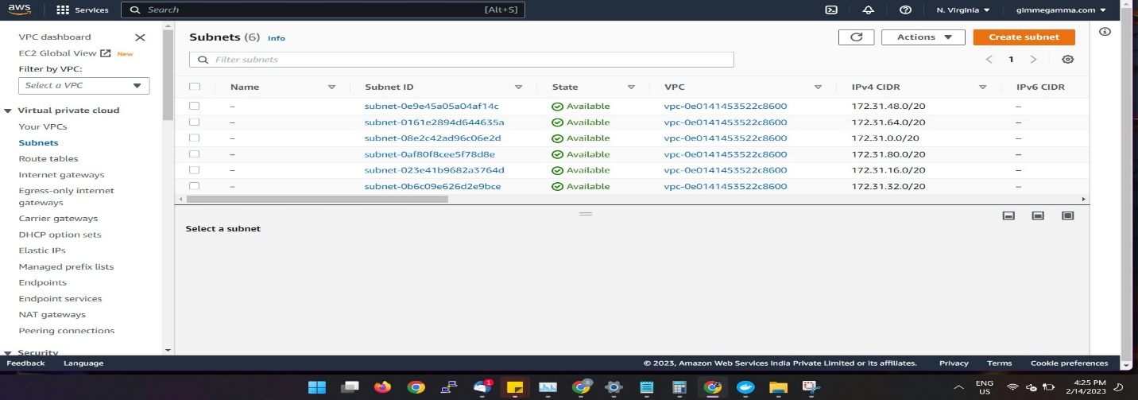

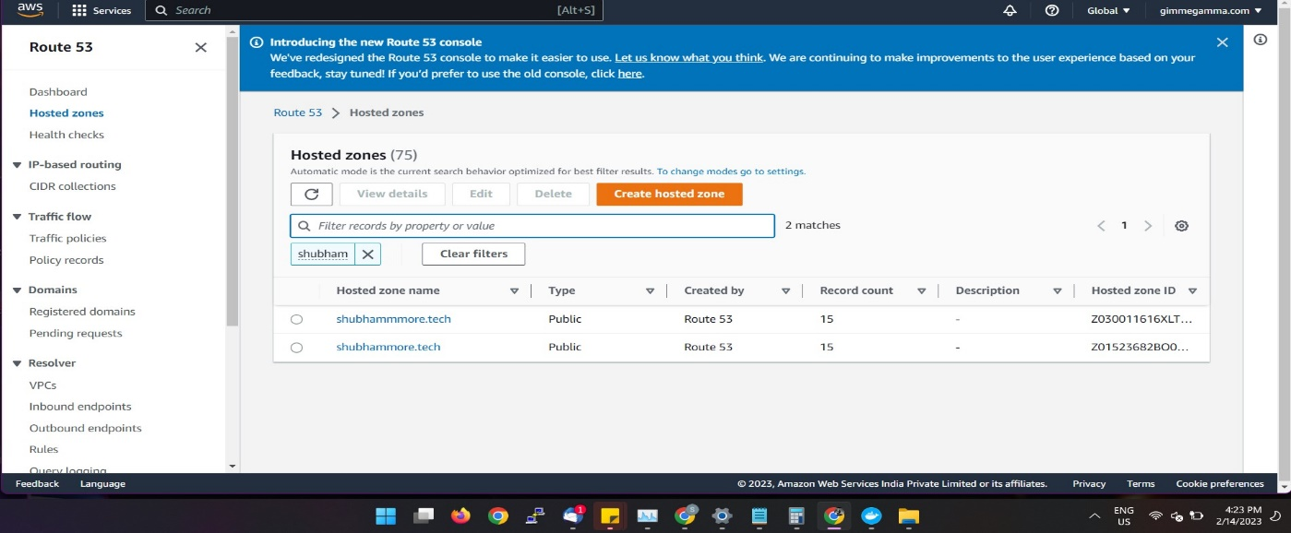

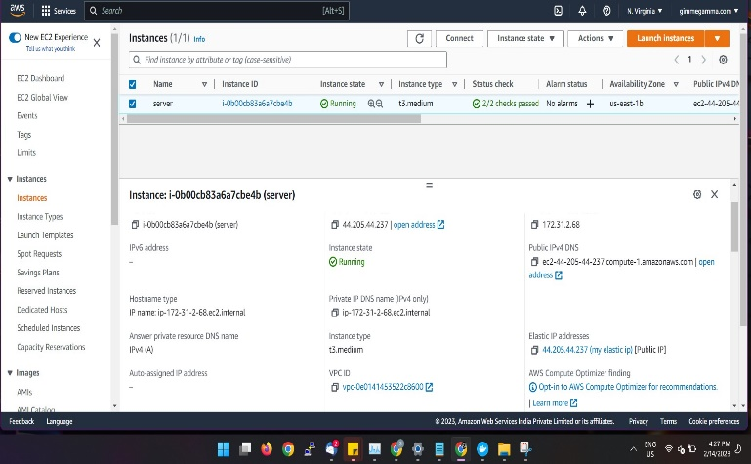

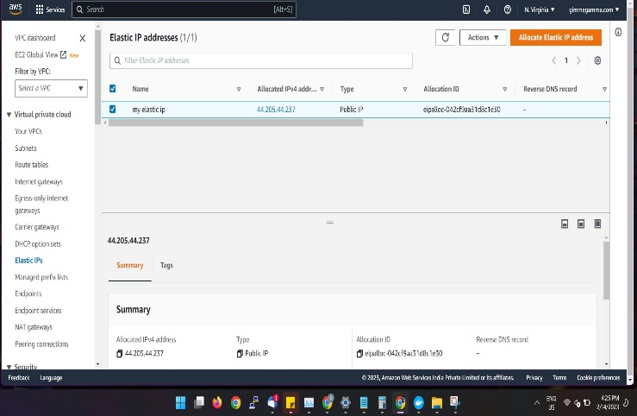

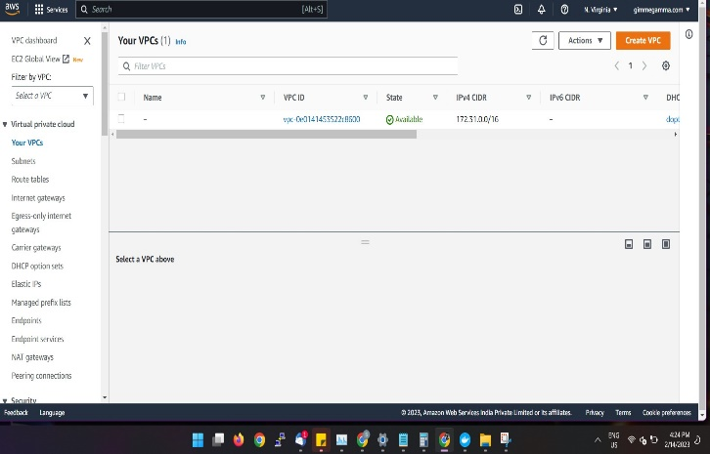

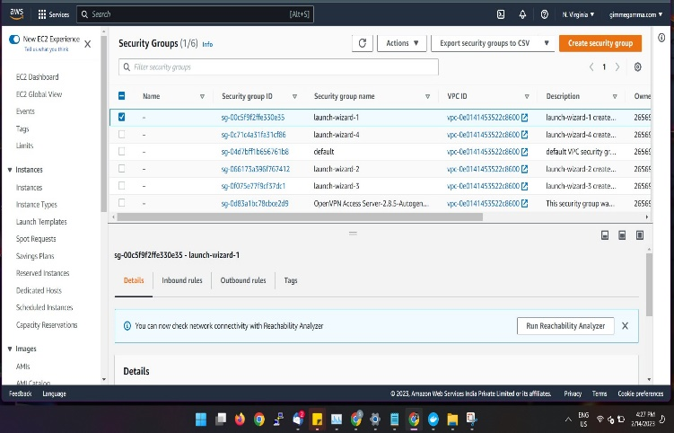

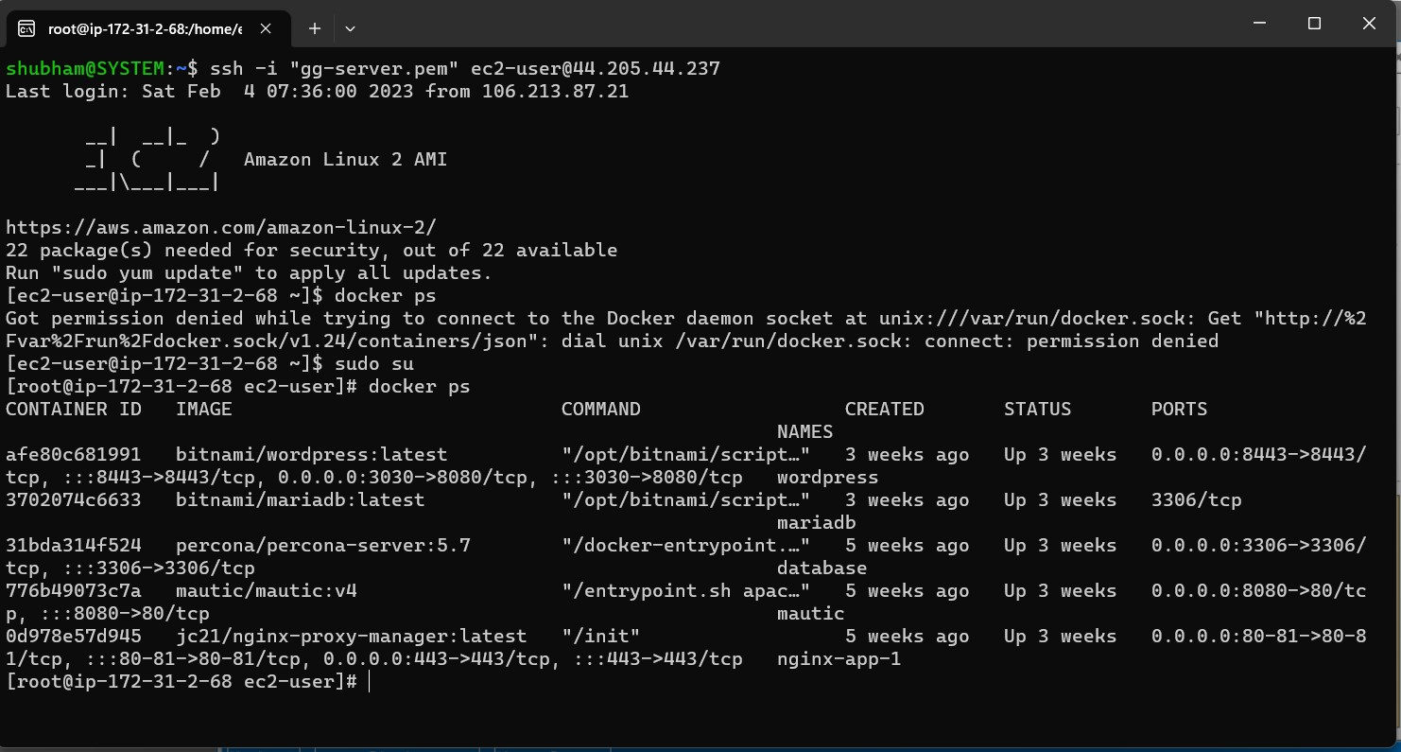

8. References
1.https://docs.aws.amazon.com/AWSEC2/latest/UserGuide/concepts.html
2.https://docs.aws.amazon.com/AWSEC2/latest/UserGuide/AMIs.html
3.https://docs.docker.com/cloud/aci-integration/
4.https://docs.docker.com/get-started/resources/
5.https://docs.docker.com/desktop/install/linux-install/
6.https://developer.hashicorp.com/terraform/docs
7.https://developer.hashicorp.com/terraform/cli
8.https://developer.hashicorp.com/terraform/cli/init
9.https://developer.hashicorp.com/terraform/cli/commands
10.https://docs.aws.amazon.com/cli/latest/reference/ec2/

