Image Deblurring Using Deep Learning
Sajad Ahmad, Shivani Kumari, Yashraj Gupta, and Md Wajahat Raza
Student, Sapthagiri College of Engineering, Bengaluru, Karnataka-560057
Dr. Praveen Kumar KV
Professor, Sapthagiri College of Engineering Bangalore, Karnataka-560057

Abstract — The proposed method is highly efficient for removing mild blur from blurred images. Blind image deblurring which is based on deep learning plays an important role in solving image blur problem. We focus on removing mild blur which will generally ruin the quality of the images. These types of blurs will occur due to out of focus lens, and slight camera motion. In the proposed method we are preparing our own blur images dataset. We have the dataset which consist of high- resolution images, then we add gaussian blur to these sharp images to degrade the quality of sharp images in order to obtain a new dataset. We will call this dataset as deblur dataset. A deep learning architecture is applied to get back high-resolution image from low-resolution deblurred images. CNN architecture is used for image deblurring.
Index Terms — image deblurring, deep learning, convolutional neural networks.

INTRODUCTIOIN

Image Deblurring is an old problem in the realm of image processing, one that continues to garner attention from academics and businesses alike. It has applications in many different real-world problems and serves as an easy way to visualize examples of a larger range of inverse problems in many fields. Image deblurring seeks to take a blurry image and restore it to its original form algorithmically. When deblurring images, a mathematical description of how it was blurred is very important to maximizing the effectiveness of the deblurring process. With real-world photos, we do not have the luxury of knowing the mathematical function by which the image was blurred. However, there exist methods to approximate how blur occurred. There are many different sources of blur in a photograph, such as motion blur, camera shake and long exposure times. Even a relatively small amount of any of these effects can be enough to ruin an otherwise good photograph. Image deblurring tools and research seek to solve this problem by taking the blurred images and attempting to restore or alter them to a sharper, clearer state. In the following section, some background information on image deblurring and associated techniques will be presented. Following that, we will discuss the results that were obtained, as well as discussing some of the

weaknesses and limitations in the investigation. Image
sharpness is undoubtedly one of the most relevant attributes defining the visual quality of a photograph. Blur is caused by numerous factors such as the camera’s focus not being correctly adjusted, objects appearing at different depths, or when relative motion between the camera and the scene occurs during exposure. Deep learning is a subfield of machine learning that has had significant impact in the field of image processing. In image processing, deep learning algorithms such as Convolutional Neural Networks (CNNs) are used for tasks such as image classification, object detection, semantic segmentation, and image deblurring. In image deblurring, a deep learning model is trained to remove blur from a blurred image and restore the original, sharp image. This is done by learning a mapping from the blurred image to the sharp image, which is then used to deblur new images. Overall, deep learning has become a powerful tool for image processing tasks and is likely to continue to play an important role in this field in the future. CNN (convolutional neural network) have become a popular choice for image processing tasks due to their ability to automatically learn useful features from the image data and their high accuracy in a wide range of tasks. CNNs are important in image deblurring because they can effectively learn the mapping between the blurred image and the sharp image. Image deblurring is a challenging problem because it requires the removal of significant amounts of noise and blur, which can cause loss of detail and resolution in the final deblurred image. By using a deep learning approach, a CNN can learn the complex mapping between the blurred image and the sharp image, allowing it to effectively remove the blur and recover the details of the image. The convolutional layers in the network can be trained to learn features that are robust to the presence of blur and noise, allowing the network to produce high-quality deblurred images. Additionally, CNNs can be trained end-to-end, allowing the network to learn the entire mapping from the input blurred image to the output deblurred image in a single pass. This makes the deblurring process more efficient and eliminates the need for complex pre-processing or post-processing steps. In conclusion, the ability of CNNs to learn complex mappings and their high accuracy make them an important tool for image deblurring tasks.

RELATED WORK
- Convolutional Neural Networks
Convolutional neural networks (CNNs) have gained popularity in image processing tasks, particularly in image deblurring. Their effectiveness in learning useful features from image data and achieving high accuracy in a wide range of tasks make them a preferred option. Image deblurring is a difficult problem that requires removing substantial amounts of noise and blur while maintaining the resolution and details of the final image. A deep learning approach that utilizes a CNN can learn the intricate mapping between a blurred image and a sharp image, enabling it to effectively remove the blur and recover the image's details. The network's convolutional layers can learn to recognize features that are resistant to noise and blur, which produces high-quality deblurred images. Moreover, CNNs can be trained end-to-end, which means the network can learn the complete mapping from the blurred image input to the deblurred image output in one go. This simplifies the deblurring process, streamlining it without requiring any complicated pre-processing or post-processing stages. Consequently, the ability of CNNs to learn complicated mappings and their remarkable accuracy render them an essential tool for image deblurring tasks.

- Deep Learning
Deep learning is a subset of machine learning that has greatly impacted the field of image processing. It has enabled the use of advanced algorithms like Convolutional Neural Networks (CNNs) for various tasks such as object detection, semantic segmentation, image classification, and image deblurring. In image deblurring, deep learning models are trained to eliminate blurs from a blurred image and restore the original, clear image. The model does this by learning the correlation between the blurred and sharp image and uses this information to deblur new images. All in all, deep learning has proven to be a powerful tool for image processing tasks and is poised to continue playing a significant role in this field.

- Image Super Resolution
Image super-resolution (SR) refers to the process of enhancing the resolution of an image while retaining its visual content. It has a wide range of applications, such as computer vision, graphics, and image processing. Various techniques exist for achieving image SR, including traditional ones like bicubic interpolation, and modern ones like single image super-resolution (SISR) methods, which utilize machine learning, particularly deep learning, to reconstruct high-resolution images from low-resolution inputs. SISR techniques, such as SRCNN (Super-Resolution Convolutional Neural Network) and DBSRCNN (Deep Back-Projection Networks for Super-Resolution Convolutional Neural Network), are founded on convolutional neural networks (CNNs) and can achieve exceptional results on diverse image super-resolution benchmarks. They are trained on vast datasets containing pairs of high and low-resolution images, and deep learning algorithms are employed to learn the mapping from low to high-resolution images. Although SISR methods demonstrate promising results, there are still challenges that need to be addressed, such as high computational requirements, the difficulty in obtaining large and diverse training datasets, and the existing limitations of SR algorithms in preserving fine details in the high-resolution output.

- LITERATURE SURVEY

[1] Yu-An Chen has developed a novel approach for deblurring images directly from raw data. The method utilizes a dataset that contains both raw and sRGB images, and the proposed model is designed to effectively exploit the unique features of raw images during the deblurring process. The author's findings indicate that the performance of current deblurring models can be enhanced by utilizing raw images for training the model. In essence, this method offers a significant improvement in the deblurring process by taking advantage of the distinctive properties of raw images.
[2] Damien Kelly has introduced a new method for blind image restoration that is specifically aimed at removing mild blur from natural images, with a particular focus on mobile phone images. The proposed method involves estimating the blur of an image and subsequently removing it. According to the author, this approach is more efficient than both traditional and modern blind image restoration techniques. The study highlights the effectiveness of the proposed method in improving the quality of images captured on mobile phones by removing mild blurring.
[3] S. Hosseini has presented a novel approach to image deblurring, which involves using a one-shot convolution filtering method to directly restore naturally blurred images. The proposed method utilizes Finite Impulse Response (FIR) and Point Spread Function (PSF) to achieve the desired results. In addition, Gaussian low pass filters are employed to address image edge deblurring and to reduce noise in the images. This approach represents a promising new direction in the field of image deblurring, with the potential to produce high-quality results in a more efficient and effective manner.
[4] Jiangxin has introduced a new approach for estimating inliers and outliers during the image deblurring process. The method employs a deep convolutional neural network that generates a confidence map, allowing for the identification of both inliers and outliers. The proposed approach has the potential to improve both blind and non-blind image deblurring processes. This innovative technique represents a significant advancement in the field of image processing, with the potential to enhance the accuracy and effectiveness of deblurring methods.
[5] Ying He has proposed a novel approach for image deblurring that does not require estimation of the blur kernel. Instead, a pair of images consisting of a blurred image and a noisy image are used as input. The blurred image is then divided into smaller patches, and each patch is analyzed and compared to the corresponding patch in the noisy image to determine the optical flow between the two images. The Gaussian mixture model (GMM) is utilized to identify the intensity distribution of each patch, which is then used to estimate the latent sharp image. This approach eliminates the need for blur kernel estimation, which can be a challenging task, especially in cases where the blur is complex and not well-defined. By utilizing the information from both the blurred and noisy images, the proposed method can effectively remove the blur and restore the sharpness of the image.

DEBLUR DATASET
For training purpose, we will prepare our own dataset and we call this dataset as Deblur dataset. First step is to prepare dataset sharp images and then we will add Gaussian blur to these sharp images to obtain new blurred dataset.
To add Gaussian blur, first we import OpenCV, NumPy, os, and tqdm libraries and modules. We need all these libraries and modules. Then we will read all the images from sharp dataset, and we will add Gaussian blur to these images using GaussianBlur () function. Finally, we will store blurred images back into the dataset. Now we have both blurred Images and their original sharp images in our dataset.
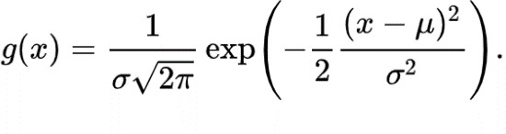
Gaussian function is:
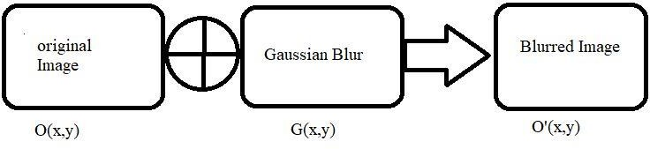
Where, σ is standard deviation.

PROPOSED METHOD

In this section, we will discuss the proposed method in detail particularly the network architecture that has been developed for image deblurring process.
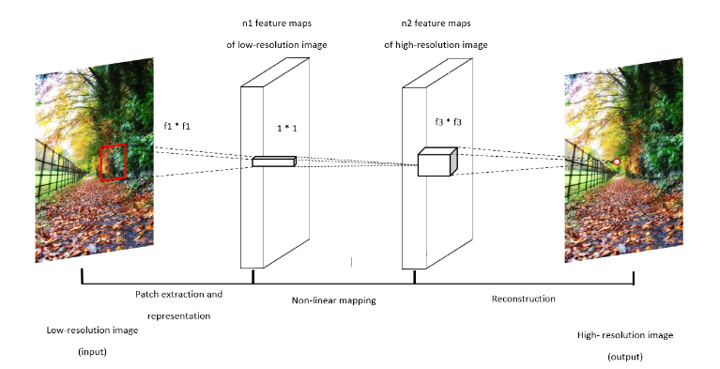
- Network Architecture
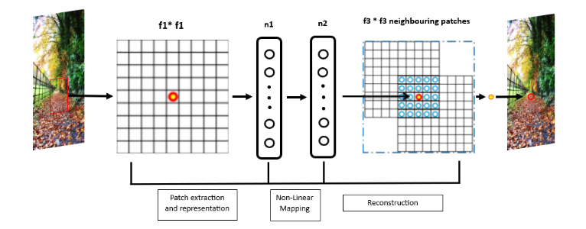
Fig. 1overview of the Convolutional neural network architecture
Fig. 2 Convolutional neural network architecture
The network architecture that has been used is shown in figure 1 and figure 2. The architecture used is DBCNN (Deep Back-Projection Convolutional Neural Network). DBCNN is a three layered convolutional neural network architecture, and the layers are discussed below:
Input Layer: low resolution blurred images are fed into the architecture for feature extraction. The input images contain Gaussian blur.
Patch extraction and representation: In this hidden layer extraction of overlapping patches from the input image is done and each patch is represented as a high-dimensional vector. A Rectified Linear Unit (ReLU) activation function F1 is used in this layer of architecture. This function operating with n1 feature maps.
Non-linear mapping: In this hidden layer output of previous hidden layer (high-dimensional vector) is taken as input and each high-dimensional vector is again mapped to another high-dimensional vector, representing the high-resolution patch. ReLU activation function is operating with n2 feature maps. This process is done for feature enhancement.
Reconstruction: This is the output layer and performs reconstruction operation. It combines all the high-resolution patches which we get as output from previous layer. The high- resolution images are reconstructed by aggregating the patch- wise representation.
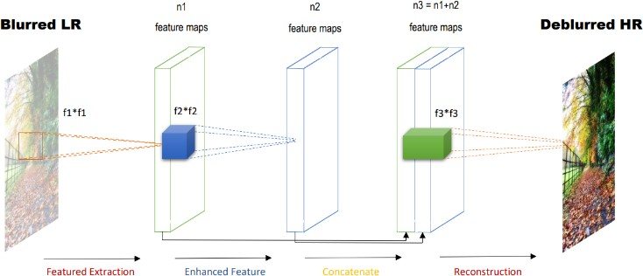
Now we will discuss each layer of the network architecture in detail.

Fig. 3 Our proposed network architecture DBCNN

first convolutional layer of the architecture (DBCNN), the following steps happen:
In the first layer extraction of overlapping patches from the input image is done and each patch is represented as a high- dimensional vector. In the second hidden layer each high-dimensional vector is again mapped to another high-dimensional vector for feature enhancement. In the third layer these patches are combined to reconstruct the final deblurred high-resolution image F(M).
Patch extraction and representation: In this hidden layer extraction of overlapping patches from the input image is done and each patch is represented as a high-dimensional vector. A Rectified Linear Unit (ReLU) activation function F1 is used in this layer of architecture. This function operates with n1 feature maps. Conventionally, the first layer is expressed as:
F1(M) = max (0, W1 ∗ M + B1)
Where, W1 represent the filters, here size of W1 is C*f1*f1* n1,
C = number of channels in the input image, f1 = spatial size of a filter, n1 = number of filters, B1 represents the biases, B1 = n1 dimensional vector and each element of B1 is associated with a filter.
Non-linear mapping: In this hidden layer output of previous hidden layer (high-dimensional vector) is taken as input and each high- dimensional vector is again mapped to another high- dimensional vector, representing the high-resolution patch. ReLU activation function is operating with n2 feature maps. This process is done for feature enhancement. In the first layer for each patch n1 dimensional feature are extracted. Then, each extracted n1 dimensional vector is mapped into an n2 dimensional vector. The second layer is expressed as:
F2(M) = max (0, W2 ∗ F1(M) + B2)
Where, size of W2 is n1*1*1*n2.
B2 = n2 dimensional vector, each n2 dimensional vector represents a high-resolution patch that will be used for reconstruction.
Reconstruction: This is the output layer and performs reconstruction operation. It combines all the high-resolution patches which we get as output from the previous layer. The high-resolution images are reconstructed by aggregating the patch-wise representation.
Final convolutional layer is expressed as:
F(M) = W3 ∗ F2(M) + B3
Where, size of W3 is n2 * f3 * f3 * C.
- DBCNN (Deep Back-Projection Convolutional Neural Network)
DBCNN can also be used for image deblurring, in addition to its use for image super-resolution. In the context of image deblurring, DBCNN can be trained to restore the original sharp image from a blurred input.
The architecture of DBCNN for image deblurring is similar to its architecture for image super-resolution. It consists of multiple convolutional layers, ReLU activation functions, and back-projection layers. The convolutional layers are usedto extract features from the blurred input image, while the back-projection layers refine the sharp image prediction generated by the feature extraction layers. The final layer combines the blurred input and the sharp image prediction to produce the deblurred output. DBCNN has been shown to achieve promising results on various image deblurring benchmarks, and its use of back- projection layers helps to preserve the fine details in the deblurred output. However, the performance of DBCNN for image deblurring may depend on several factors, including the quality of the training data, the complexity of the blur, and the computational resources available.

CONCLUSION

In conclusion, this project aimed to evaluate the effectiveness of using CNNs for image deblurring. We have shown that deep learning-based approaches can achieve state- of-the-art performance in removing non-uniform blur from images. We learned how to deblur Gaussian blurred images using deep learning and convolutional neural networks. Our experiments demonstrate the potential of CNNs for image deblurring and highlight the importance of carefully designing the network architecture and training procedure.
We have also shown that combining different techniques, such as residual networks and skip connections, can further improve the performance of CNNs for image deblurring. In future work, we plan to evaluate the performance of the network architecture that we have proposed on a larger and more diverse dataset of blurred images.
Overall, this project has provided valuable insights into the use of CNNs for image deblurring and highlights the potential for deep learning techniques to tackle complex image processing problems.

ACKNOWLEDGEMENT

We would like to express our sincere gratitude to all those who have provided their invaluable support and assistance during the course of this project.
We would like to extend our heartfelt thanks to Dr. Kamalakshi Naganna, Professor and Head, Department of Computer Science and Engineering, Sapthagiri College of Engineering and our project guide Dr. Praveen Kumar KV, Professor, Department of Computer Science and Engineering, Sapthagiri College of Engineering, who has provided constant guidance, support, and encouragement throughout the project. Their invaluable insights and suggestions have been instrumental in shaping this project. Finally, we are deeply grateful to our friends and family for their constant support and encouragement.

REFERENCES
- Chih-Hung Liang, Yu-An Chen, Yueh-Cheng Liu, and Winston H. Hsu,” Raw Image Deblurring”, IEEE TRANSACTIONS ON MULTIMEDIA, 2020
- B. Lu, J.-C. Chen, and R. Chellappa, “Unsupervised domain-specific deblurring via disentangled representations,” in Proceedings of the IEEE Conference on Computer Vision and Pattern Recognition, 2019, pp. 10 225–10 234.
- Mauricio Delbracio, Ignacio Garcia-Dorado, Sungjoon Choi, Damien
Kelly, and Peyman Milanfar, “Polyblur: Removing Mild Blur by Polynomial Reblurring” IEEE transactions on Computional Imaging,
Vol 7, 2021
- S.-D. Yang, H.-T. Su, W. H. Hsu, and W.-C. Chen, “Deccnet: Depth enhanced crowd counting,” in The IEEE International Conference on Computer Vision (ICCV) Workshops, Oct 2019.
- X. Tao, H. Gao, X. Shen, J. Wang, and J. Jia, “Scale-recurrent network for deep image deblurring,” in Proceedings of the IEEE Conference on Computer Vision and Pattern Recognition, 2018, pp. 8174–8182.
- H. Zhang, Y. Dai, H. Li, and P. Koniusz, “Deep stacked hierarchical multi-patch network for image deblurring,” in Proceedings of the IEEE Conference on Computer Vision and Pattern Recognition, 2019, pp. 5978–5986.
- S. Nah, T. Hyun Kim, and K. Mu Lee, “Deep multi-scale convolutional neural network for dynamic scene deblurring,” in Proceedings of the IEEE Conference on Computer Vision and Pattern Recognition, 2017, pp. 3883–3891.
- S. Su, M. Delbracio, J. Wang, G. Sapiro, W. Heidrich, and O. Wang, “Deep video deblurring for hand-held cameras,” in Proceedings of the IEEE Conference on Computer Vision and Pattern Recognition, 2017, pp. 1279–1288.
- C. Chen, Q. Chen, J. Xu, and V. Koltun, “Learning to see in the dark,” in Proceedings of the IEEE Conference on Computer Vision and Pattern Recognition, 2018, pp. 3291–3300.
- X. Xu, Y. Ma, and W. Sun, “Towards real scene super-resolution with raw images,” in Proceedings of the IEEE Conference on Computer Vision and Pattern Recognition, 2019, pp. 1723–1731.
- X. Zhang, Q. Chen, R. Ng, and V. Koltun, “Zoom to learn, learn to zoom,” in Proceedings of the IEEE Conference on Computer Vision and Pattern Recognition, 2019.
- D. Gong, J. Yang, L. Liu, Y. Zhang, I. Reid, C. Shen, A. Van Den Hen- gel, and Q. Shi, “From motion blur to motion flow: a deep learning solution for removing heterogeneous motion blur,” in Proceedings of the IEEE Conference on Computer Vision and Pattern Recognition, 2017, pp. 2319–2328.
- C. Ledig, L. Theis, F. Husza´r, J. Caballero, A. Cunningham, A. Acosta,
A. Aitken, A. Tejani, J. Totz, Z. Wang et al., “Photo-realistic single image super-resolution using a generative adversarial network,” in Proceedings of the IEEE conference on computer vision and pattern recognition, 2017, pp. 4681–4690.
- W.-S. Lai, J.-B. Huang, N. Ahuja, and M.-H. Yang, “Deep laplacian pyramid networks for fast and accurate super-resolution,” in Proceedings of the IEEE conference on computer vision and pattern recognition, 2017, pp. 624–632.
- B. Lim, S. Son, H. Kim, S. Nah, and K. Mu Lee, “Enhanced deep residual networks for single image super-resolution,” in Proceedings of the IEEE conference on computer vision and pattern recognition workshops, 2017, pp. 136–144.
- Y. Tai, J. Yang, and X. Liu, “Image super-resolution via deep recursive residual network,” in Proceedings of the IEEE conference on computer vision and pattern recognition, 2017, pp. 3147–3155.
- J. Caballero, C. Ledig, A. Aitken, A. Acosta, J. Totz, Z. Wang, and
W. Shi, “Real-time video super-resolution with spatio-temporal networks and motion compensation,” in Proceedings of the IEEE Conference on Computer Vision and Pattern Recognition, 2017, pp. 4778–4787.
- X. Yang, H. Mei, J. Zhang, K. Xu, B. Yin, Q. Zhang, and X. Wei, “Drfn: Deep recurrent fusion network for single-image super- resolution with large factors,” IEEE Transactions on Multimedia, vol. 21, no. 2,pp. 328–337, 2018.
- K. Zhang, W. Zuo, Y. Chen, D. Meng, and L. Zhang, “Beyond a gaussian denoiser: Residual learning of deep cnn for image denoising,” IEEE Transactions on Image Processing, vol. 26, no. 7, pp. 3142–3155, 2017.
- X. Liao and X. Zhang, “Multi-scale mutual feature convolutional neural network for depth image denoise and enhancement,” in 2017 IEEEVisual Communications and Image Processing (VCIP). IEEE, 2017, pp. 1–4.
- X. Cai and B. Song, “Semantic object removal with convolutional neural network feature-based inpainting approach,” Multimedia Systems,vol. 24, no. 5, pp. 597–609, 2018.
- J. Chen, C.-H. Tan, J. Hou, L.-P. Chau, and H. Li, “Robust video content alignment and compensation for rain removal in a cnn framework,” in Proceedings of the IEEE Conference on Computer Vision and Pattern Recognition, 2018, pp. 6286–6295.
- F. Luan, S. Paris, E. Shechtman, and K. Bala, “Deep photo style transfer,” in Proceedings of the IEEE Conference on Computer Vision and Pattern Recognition, 2017, pp. 4990–4998.
- P. Isola, J.-Y. Zhu, T. Zhou, and A. A. Efros, “Image-to-image translation with conditional adversarial networks,” in Proceedings of the IEEEconference on computer vision and pattern recognition, 2017, pp. 1125– 1134.
- J.-Y. Zhu, T. Park, P. Isola, and A. A. Efros, “Unpaired image-to-image translation using cycle-consistent adversarial networks,” in Proceedings of the IEEE international conference on computer vision, 2017, pp. 2223–2232.
- O. Kupyn, V. Budzan, M. Mykhailych, D. Mishkin, and J. Matas, “Deblurgan: Blind motion deblurring using conditional adversarial net- works,” in Proceedings of the IEEE Conference on Computer Vision and Pattern Recognition, 2018, pp. 8183–8192.
- J. Zhang, J. Pan, J. Ren, Y. Song, L. Bao, R. W. Lau, and M.-H. Yang, “Dynamic scene deblurring using spatially variant recurrent neural networks,” in Proceedings of the IEEE Conference on Computer Vision and Pattern Recognition, 2018, pp. 2521–2529.
- L. Xu, J. S. Ren, C. Liu, and J. Jia, “Deep convolutional neural network for image deconvolution,” in Advances in neural information processing systems, 2014, pp. 1790–1798.
- T. Plotz and S. Roth, “Benchmarking denoising algorithms with real photographs,” in Proceedings of the IEEE Conference on Computer Vision and Pattern Recognition, 2017, pp. 1586–1595.
- E. Schwartz, R. Giryes, and A. M. Bronstein, “Deepisp: Toward learning an end-to-end image processing pipeline,” IEEE Transactions in Image Processing, vol 28, no. 2, pp. 912-923, 2018.

WASTE PAGE

