DESIGN AND ANALYSIS OF TWO STROKE AND FOUR STROKE ENGINES COOLING FINS
Manoj M¹, Dr. Subburam V², Sathees T³
1PG Student, Department of Mechanical Engineering, Paavai Engineering College, Namakkal And 637018, India
2 Professor, Department of Mechanical Engineering, Paavai Engineering College, Namakkal And 637018, India
3Assistant professor, Department of Mechanical Engineering, Paavai Engineering College, Namakkal And 637018, India
---------------------------------------------------------------------***-------------------------------------------------------------------

Abstract - Today our world runs in this condition only because of invention of internal combustion engine. In internal combustion engine chemical energy of fuel is converted to thermal energy to give a mechanical work output. There is large amount of heat liberated during the combustion of fuel, In which only few amount of energy is converted in to useful work (60 to 80%) and the remaining heat energy is wasted. Engine life and effectiveness can be improved with effective cooling. The cooling mechanism of the air cooled engine is mostly dependent on the fin design of the cylinder head and block. Insufficient removal of heat from engine will lead to high thermal stresses and lower engine efficiency. An attempt is made to simulate the heat transfer for different materials and geometry of fins to analyze effects on rate of heat dissipation from fins surfaces. The heat transfer surfaces of Engine are modelled in ANSYS, and the main aim of this work is to study different materials and geometry of fins to improve heat transfer rate by changing fin materials under different conditions. The main of aim of this work is to study various researches done in past to improve heat transfer rate of cooling fins by changing cylinder block fin geometry and climate condition.
Keywords: ANSYS, Cooling fins, Thermal energy…

INTRODUCTION
Fins are the extended surfaces designed to increase the heat transfer rate of the body by increasing the convective surface area. Fins find their application from the small computer chips to the huge engines. The enormous application of the fins makes it an interesting and important field. Optimizing the heat transfer rates reflects the saving in power supplied and increased efficiency in case of the automobile engines. Natural convection from cylinder block may be used to simulate wide variety of engineering applications as well as provides better insight into more complex systems of heat transfer such as heat exchangers, refrigerators, electric conductors etc.
Convection may be enhanced by using the Non uniform fins instead of the conventional fins. An air cooled motorbike engine dissipates waste heat from the cylinder through the cooling fins to the cooling air flow created by the relative motion of moving motorbikes. The cooling system is an important engine sub system. The air cooling mechanism of the engine is mostly dependent on the fin design of the cylinder head and block. In Engine When fuel is burned heat is produced. Additional heat is also generated by friction between the moving parts. Only approximately 30% of the energy released is converted into useful work. The remaining (70%) must be removed from the engine to prevent the parts from melting. For this purpose Engine have cooling mechanism in engine to remove this heat from the engine some heavy vehicles uses water-cooling system and almost all two wheelers uses Air cooled engines, because Air-cooled engines are only option due to some advantages like lighter weight and lesser space requirement. The heat generated during combustion in IC engine should be maintained at higher level to increase thermal efficiency, but to prevent the thermal damage some heat should remove from the engine. In air-cooled engine, extended surfaces called fins are provided at the periphery of engine cylinder to increase heat transfer rate. That is why the analysis of fin is important to increase the heat transfer rate. Computational Fluid Dynamic (CFD) analysis have shown improvements in fin efficiency by changing fin geometry, fin pitch, number of fins, fin material and climate condition. , this temperature must be reduced to about 150-200°C at which the engine will work most efficiently. Too much cooling is also not desirable since it reduces the thermal efficiency. The availability of software like Pro-E ANSYS, MATLAB, has greatly helped in understanding the thermal distribution for various fin geometry with different material compositions enabling effective optimization of fins for a particular engine. In addition, the recent advancements in materials and its suitability to extend its application for engine has opened a new dimension for the researchers working on the engine cooling systems.
LITERATURE REVIEW
Ajay Paul, et al [1] mounted annular blades on a chamber. Led investigations and all information were given to the product. Found that specific thickness of blades gives better proficiency. Substantial number of blades with less thickness can be favored in fast vehicles than thick balances with less number. Future degree is given by them heat exchange from outside part was discovered less we can attempt to build it by giving openings and gaps.
Magarajan et al [2] studied “Numerical have a look at on heat transfer IC Engine cooling by using extended fins the usage of CFD”. In this observe, heat launch of an IC engine cylinder cooling fins with six numbers of fins having pitch of 10 mm and 20 mm are calculated numerically using commercially available CFD device ANSYS Fluent [7]. The IC engine is to start with at 150 and the heat release from the cylinder is analyzed at a wind velocity of zero km/h. It is discovered from the CFD result that it takes 174.08 seconds (pitch = 10 mm) and 163.17 seconds (pitch = 20 mm) for ethylene glycol area to attain temperature of 423 K to 393 K for to begin with. The experiment outcomes indicates that the values of heat release by way of the ethylene glycol thru cylinder fins pitch 10 mm and 20 mm are about 28.5 W and 33.90 W.

Mohsin A .Ali, Prof. S.M Kherde [3] have concluded from their review on design modification of two wheeler fins that, design of fin plays an important role in heat transfer between the cylinder to the surroundings. The fin geometry and the area of cross section affect the heat transfer coefficient to a larger extent.
In high speed vehicles, thicker fins produced swirls which increased the heat transfer and thereby increasing the efficiency of the fin. Also large number of fins with lesser thickness in high speed engines than thick fins with lesser number helped in higher heat transfer by inducing greater turbulence. Contact time between air flow and fin is also found to be an important factor for such heat transfer.

L. Dialameh et. al. [4] have conducted a numerical study to predict natural convection from an array of aluminum horizontal rectangular thick fins of 3 mm < t < 7 mm with short lengths (L 6 50 mm) attached on a horizontal base plate. Finite volume scheme is used to solve the three-dimensional elliptic governing equations of laminar flow and heat transfer. Two types of flow patterns in the channel of the fin arrays were observed based on the model verified, fluid flow and thermal structure. Effect of various fin geometries and temperature differences on the convection heat transfer from the array was determined for Rayleigh numbers based on fin spacing of 192–6784. Then correlations were developed to predict the Nusselt numbers with reference to non-dimensional parameters. It is concluded that natural convection heat transfer coefficient increases with increasing temperature differences and increases with fin spacing and decreases with fin length.

MODELLING AND MATERIAL OF FIN USING PRO/E SOFTWARE
The 3-D model is then discretized in CFD meshing tool. In order to capture both the thermal and velocity boundary layers the model is discretized using tetrahedral mesh and the domain is discretized using hexahedral mesh elements which are accurate and involve less computation effort. Fine control on the hexahedral mesh near the wall surface allows capturing the boundary layer gradient accurately. precipitation hardening aluminium alloy, containing magnesium and silicon as its principal alloying elements. Originally known as “Alloy 61S,” it became advanced in 1935. It has properly mechanical properties and exhibits weldability. It is one of the most common alloys of trendy reason use.
The normal structure of fin available in the market for two wheelers is flat structured. Our idea is that to modify the existing shape without changing material and area of fin. Our main aim is to increase heat transfer rate in engine, then only we can cool the engine easily and increase the thermal efficiency. In this paper, we are discussing the heat transfer and heat transfer coefficient of 3 fin models. The structures were modelled in PRO-E software and thermally analyzed by using ANSYS fluent software.
MATERIAL PROPERTIES
Aluminium alloys are selected for fin material as the thermal conductivity of aluminium alloys are higher. Because of unique properties, Aluminium is the best material to manufacture many automobile components. It has excellent corrosion resistance and good machinability and it possess good strength and ductility.
FINITE ELEMENT METHOD
The finite element approach (FEM) is a reliable numerical technique for analyzing engineering designs. FEM replaces a complex trouble with easy troubles. It divides the model into many small pieces of simple shapes called element. Elements percentage commonplace points known as nodes. The behavior of those elements is well – recognized under all viable support and cargo eventualities. The motion of each node is completely defined by way of translations within the X, Y, and Z route [10]. These are referred to as stages of freedom (DOFs). Analysis the usage of FEM is referred to as finite Element Analysis (FEA).
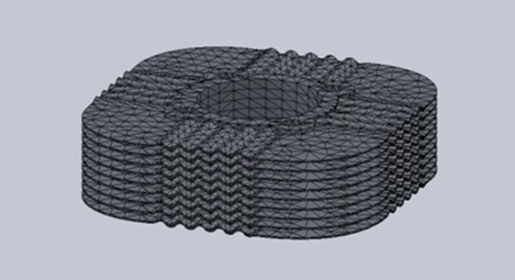

CURRENT USING BIKE ENGINES & FINS
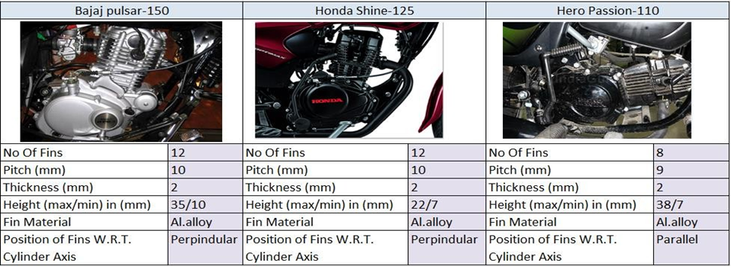

ENGINES HEAT TRANSFER IN FINS SURFACE

From the above it is observed that, Heat transfer coefficient purely depends on the fluid velocity, fluid temperature and surface reference temperature. If the fluid temperature is low heat transfer coefficient will be huge and vice versa. If the fluid velocity is high the heat transfer will be high which is called as forced convection. If the wall surface temperature is low the heat transfer coefficient will be low. The heat transfer coefficient also relies on the flow regime. The intense mixing of the fluid in turbulent flow as a result of rapid fluctuation enhances heat and momentum transfer between fluid particles, which increases the friction on the surface and convection heat transfer rate. It also causes the boundary layer enlarge. Both the friction and heat transfer efficient maximum value when the flow becomes fully turbulent. So, it will become no surprise that a special effort is made in design of heat transfer coefficient associated with turbulent flow. The flow fields and geometries for most external flow problems are too complicated to be solved analytically, and thus we have to rely on correlation based on experimental data. The availability of high-speed computers has made it possible to conduct series of “numerical experimentations” quickly by solving the governing equations numerically, and to resort to the expensive and time-consuming testing and experimentation only in the final stages of design.

CONCLUSION
In this project, we have designed a concave rectangular fin body used in a Honda unicorn Motorcycle and modeled in parametric 3D modeling software Pro/Engineer. Material of fin body is Aluminium alloy 6061. The shape of the fin is rectangular; we have changed the shape with rectangular concave shaped. The default thickness of fin is 3mm; we are reducing it to 2.5 mm and default pitch is 7mm; we are reducing pitch is 5 mm.
Thus by simply changing the fin geometry from the flat fin to the sinusoidal wavy form the heat transfer rate is greatly improved leading to less thermal stress development. Also faster as well as uniform cooling can be possible in this type of fin geometry. The engine efficiency and effectiveness can be increased because of reduction in fin size and weight. Due to the development of wavy fins with projection on the convex area of the fins more turbulence and vorticity is formed which further improve the heat transfer rate.
Thus manufacturing this type of fins will be economical and become a feasible product to our Country.

REFERENCES

[1]. Shri. N.V. Hargude and Dr. S.M. Sawant, “Experimental Investigation of Four Stroke S.I. Engine using Fuel Energizer for Improved Performance and Reduced Emissions”, International Journal of Mechanical Engineering & Technology (IJMET), Volume 3, Issue 1, 2012, pp. 244 - 257, ISSN Print: 0976 – 6340, ISSN Online: 0976 – 6359.

[2].J.Ajay Paul, Sagar Chavan Vijay, Magarajan & R.ThundilKaruppaRaj, “Experimental and Parametric Study of Extended Fins In The Optimization of Internal Combustion Engine Cooling Using CFD”, International Journal of Applied Research in Mechanical Engineering.

[3] P. Agarwal, et al. (2011). Heat Transfer Simulation by CFD from Fins of an Air Cooled Motorcycle Engine under Varying Climatic Conditions. Proceedings of the World Congress on Engineering.

[4]. Heat Transfer Aug mentation of Air Cooled 4 stroke SI Engine through Fins - A Review Paper. International Journal of Recent Development in Engineering and Technology. ISSN 2347 – 6435, Volume 2, Issue 1, January (2014).

[5] G. Babu, M. Lavaku mar. “Heat Transfer Analysis and Optimization of Engine Cylinder Fins of Varying Geometry and Material.” IOSR Journal of Mechanical & Civil Engineering. e-ISSN 2278 -1684, p- ISSN 2320 - 334X, Vo l.7 Issue 4, July - Aug.(2013),pp.24- 29.

