Cooperative Bank’s
Performance & Expansion
A Project Report submitted to
Indian Institute of Information Technology, Allahabad
In the partial fulfillment for the
Degree of Master of Business Administration

Under the Supervision of
Dr. Sudipta Das

By
Vipula Patel
[2022-23]



INDIAN INSTITUTE OF INFORMATION TECHNOLOGY, ALLAHABAD
Deoghat, Jhalwa, Allahabad, U.P., India 211012

भारतीय सूचना प्रौद्योगिकी संस्थान,इलाहाबाद Indian Institute of Information Technology, Allahabad An Institute of National Importance by Act of Parliament Deoghat, Jhalwa, Prayagraj-211015 (U.P) India
Ph No: 0532-2922025, Fax:0532-2922125, Web:www.iiita.ac.in, E.mail: contact@iiita.ac.in
STUDENT'S DECLARATION

I hereby declare that the Fourth Semester Master Project prepared by Vipula Patel titled Cooperative Bank’s Performance & Expansion is an original piece of work done by me under the supervision of Dr. Sudipta Das.
This is a purely fresh work which is done by me and there is no competitive work available in academic domain/providers of items or services of proprietary domain.

I have taken certain information relevant to our study from various journals and books which we have listed in the References section.

I have used certain documents for our reference.

I declare that the submitted work has not been undertaken elsewhere and is free from plagiarism as per the www.plagiarismdetect.com/...../.... website report.

Place: Prayagraj [Candidate’s Names & Signature]
Date:

CERTIFICATE

Recommended in partial fulfillment of the requirement for the award of Degree of Master of Business Administration (MBA).



Dr. Sudipta Das

भारतीय सूचना प्रौद्योगिकी संस्थान,इलाहाबाद Indian Institute of Information Technology, Allahabad An Institute of National Importance by Act of Parliament Deoghat, Jhalwa, Prayagraj-211015 (U.P) India
Ph No: 0532-2922025, Fax:0532-2922125, Web:www.iiita.ac.in, E.mail: contact@iiita.ac.in

Checklist for MBA project reports of Six months Duration
1. Name of Student(s) with Roll No.
Vipula Patel

2. Title of the Project:

Cooperative Banks’s Performance & Expansion

3. List of Computer resources used in addition to general network connected PC hardware, Please mention below if any Software including operating systems(s), compilers(s) any 4GL(s), S/W tools, libraries were used duly mentioning their type (open source / Free and open source / shareware / proprietary or any other) with version number of the resource.

Windows 10
MS Office 2016

4. Category of the Project & your contribution claimed
- Research Project
- Study the Cooperative Bank’s Performance & Expansion.

5. Claims of the work done in light of competitive work & material already available in academic domain / products' / providers of items or services of proprietary domain.


Indian Institute of Information Technology, Allahabad
Acknowledgement
I would like to express my special thanks and gratitude to my internal guide Dr. Sudipta Das for his support and guidance throughout my work. His continuous encouragement and expertise have been invaluable to me and have played a crucial role in the completion of this project.
I am grateful to Indian Institute of Information Technology, Allahabad for providing me with the opportunity to conduct my research and for all of the resources and support they provided. I would like to extend a special thanks to Vipra Singh, who went overboard to help me with my work.
I am grateful to Prof. Pragya Singh (HOD, DoMS) for providing me with the opportunity to conduct my research at Indian Institute of Information Technology, Allahabad, and for all of the resources and support they provided.
I am deeply thankful to my friends and family for their love and support during this process. Without their encouragement and motivation, I would not have been able to complete this journey.
I am grateful to everyone who has supported me throughout this process. Without their help and guidance, this project would not have been possible.
Sincerely
Vipula Patel
(IMB2021039)

EXECUTIVE SUMMARY
In today's highly competitive market, urban cooperative banks (UCBs) operate on an equal playing field with commercial banks. They achieve this by effectively implementing the cooperative ideas that underpin their company model, which is owned by its members and whose primary objective is to deliver the best services possible to members rather than maximise shareholder profit. Comparing UCBs, which serve the less fortunate elements of society, to MNC banks, which have no social responsibility, is unfair. Many changes have been made to the UCBs since their inception. UCBs have undergone more significant and radical transformations than other institutions. The abrupt changes in the policy environment of the State and Central Governments regarding the operations of the urban banking system have an impact on the performance of UCBs both directly and indirectly. The urban cooperative banking sector was recognised as one of the most resilient and rapidly increasing segments of the banking system in the early 1990s. It is now one of the weakest, with periodic collapses and oddities. This could be due to a number of factors, including more competition, stricter prudential standards, a lack of personnel planning, an inability to control overhead costs, a failure to evaluate loans, and other constraints. The fact that UCBs have been in India for 100 years demonstrates how stable the bank's resource basis is and how truly financially independent it is. However, there are numerous issues with India's present urban cooperative banking system. Management, financial, operational, and organisational challenges are among them. Unless these concerns are addressed promptly, economic integration and the expansion of the urban banking industry will remain a pipe dream.

TABLE OF CONTENTS

Topic | Page No.
Introduction | 1-14
Background of the study | 15-18
Significance of the study | 18
Statement of Problem | 19
Objectives | 20
Literature Review | 20-28
Methodology | 28-62
Findings | 63-67
Conclusion | 68
Discussion | 69
Scope of future work | 71
References | 72-73
Appendix | 74

LIST OF TABLES
Topic | Page No.
Saraswat Bank
Balance Sheet | 34
Profit & Loss Account | 35
Financial Ratios | 36
Cosmos Cooperative Bank
Financial highlights | 38
Financial Ratios | 39
Asset Composition | 39
Liability composition | 40
Capital composition | 40
Abhyudaya Cooperative Bank
Financial Progress over the years | 43
Ratios | 44
Shamrao Vithal Cooperative Bank
Financial Analysis | 47

INTRODUCTION
Banking plays an important role in development efforts in developing countries such as India. Because there is insufficient capital in relation to the need for developmental activity, banking becomes the primary agent for mobilising credits and channelling resources in the desired direction. Banks have been given major social responsibilities such as poverty eradication, job creation, agricultural development, and social justice for the underprivileged.
Banks have become increasingly involved in the nation's development initiatives, particularly rural development activities. Since the nationalisation of banks, the banking sector in our country has undergone tremendous structural and operational changes. There are three basic types of banks in the banking industry: public sector banks, cooperative banks, and private banks. The second group, cooperative banks, has been providing useful services to the people of the country in both rural and urban areas. While credit cooperatives are the most common and oldest type of cooperative in India. Rural Credit Cooperatives and Urban Credit Cooperatives are the two primary categories of cooperative credit organisations in the country. The Rural Cooperative Credit Structure is the most important component of the cooperative structure, and it includes institutions such as State Cooperative Banks (SCBs), District Central Cooperative Banks (DCCBs), and Primary Agricultural Credit Societies (PACS) that handle short-term credit requirements, as well as State Cooperative Agricultural and Rural Development Banks (SCARDBs) and Primary Cooperative Agricultural and Rural Development Banks (PCARDBs). A co-operative bank is a financial entity owned by its members, who are both the owners and customers of their bank. Cooperative banks are frequently founded by people from the same local or professional group or who share a shared interest. Co-operative banks typically offer a wide range of banking and financial services to their members (loans, deposits, banking accounts, and so on). Cooperative banks differ from stockholder banks in terms of their organisation, goals, ideals, and governance. In most countries, they are monitored and overseen by banking regulators and must adhere to prudential banking standards, putting them on a par with shareholder banks. Depending on the country, this control and monitoring might be carried out directly by state institutions or through a cooperative federation or central body.Co-operative banking refers to retail and commercial banking that is organised cooperatively. In most parts of the world, cooperative banking institutions accept deposits and lend money. Co-operative banking encompasses retail banking supplied by credit unions, mutual savings and loan associations, building societies and co-operatives, as well as commercial banking services given to co-operative firms by manual organisations (such as co-operative federations). Commercial banking has a branch-banking structure, whereas cooperative banking has a three-tier federal structure. - A State Co-operative Bank operates at the highest level (that is, at the state level).- The Central Cooperative Bank is an Intermediate Level organisation. (For example, District Co-operative Banks Ltd. operates at the district level.)- Primary co-operative credit societies at the village levelEven though co-operative bank organisational regulations differ depending on their individual national legislations, co-operative banks share the following characteristics:
Customer-owned entities: Because co-operative bank members are both customers and owners, the demands of the consumers meet the needs of the owners in a co-operative bank. As a result, the primary goal of a cooperative bank is to deliver the greatest products and services to its members rather than to maximise profit. Some cooperative banks only serve their members whereas majority of them accept clients who are non-member to use their banking and financial services.
Democratic member control: Co-operative banks are owned and controlled by their members, who elect the board of directors democratically. According to the cooperative principle of "one person, one vote," members normally have equal voting rights.
Profit allocation: A large portion of a cooperative bank's annual profit, benefits, or surplus is often assigned to reserves. In most situations, a portion of this profit can be transferred to co-operative members, subject to legal or regulatory constraints. Profit is usually distributed to members in the form of a patronage dividend, which is based on each member's use of the co-operative's products and services, or an interest or dividend, which is based on the number of shares subscribed by each member.
Cooperative banks are strongly embedded in neighborhoods and communities. They are involved in local development and contribute to the long-term development of their communities, as their members and management board are typically residents of the towns in which they operate. Farmers in rural regions, middle or low income households in urban areas - cooperative banks eliminate financial exclusion and nurture the economic capacity of millions of people by providing banking access in locations or markets where other banks are less prevalent. They have an impact on economic growth in the nations where they work and improve the efficiency of the international financial system. Their special type of firm, based on the aforementioned organisational principles, has proven effective in both developed and developing countries.
The third component of the cooperative credit structure is the Urban Credit Cooperatives, also known as Primary Cooperative Banks (PCBs) or Urban Cooperative Banks (UCBs), which primarily serve the needs of the middle and lower classes in urban and semi-urban areas. The urban cooperative banking industry is one of the most important and rapidly increasing areas of the cooperative sector, which is completely self-sufficient and active. . It is poised to emerge as a substantial section of the banking sector, contributing significantly to urban economic development. The fundamental goal of these banks is to encourage thrift and saving among members who satisfy the credit needs of lower and middle income groups in urban and semi-urban areas. In general, urban cooperative banks are institutions that have evolved to meet the credit needs of urban and semi-urban lower and middle classes, wage earners, professionals, and those involved in trade and small and cottage enterprises.
The UCB structure is demonstrated by its clear emphasis on the needs of small men and the microcredit sector.
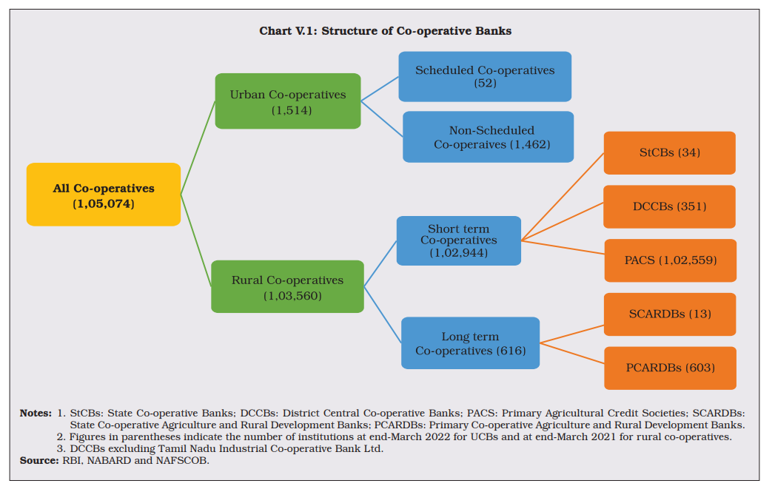
Structure of cooperative banks in India
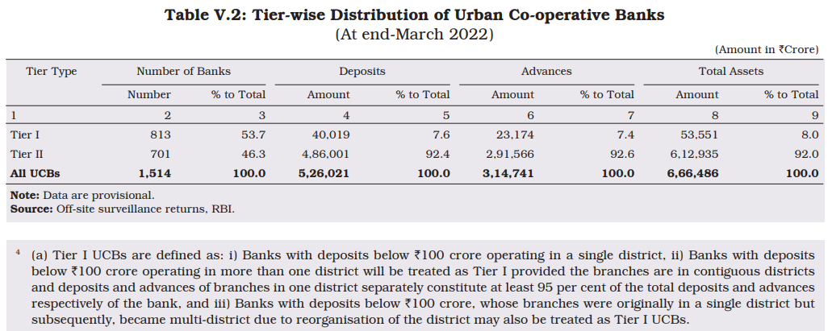
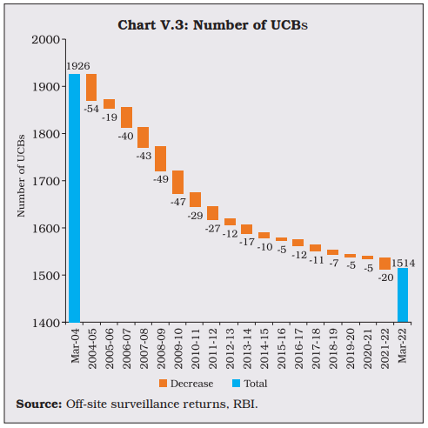
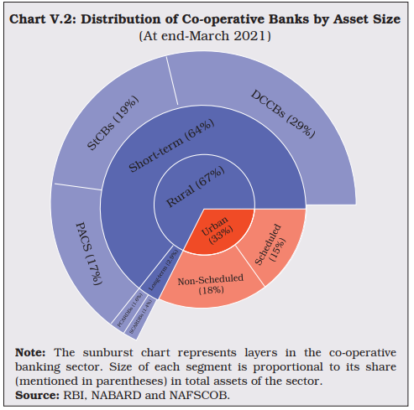

The average loan size is also relatively small, and the vast majority of UCBs have been able to meet the country's central bank's priority sector lending targets (directive from the central bank to lend to specific sectors such as small businesses, trade and business, housing, and so on).
The urban cooperative banking industry is one of the most important and rapidly developing segments of the cooperative sector, as well as the most self-sufficient and vibrant.
There are approximately 2050 urban cooperative banks and 40,000 credit cooperative societies dispersed across the country, with a total membership of 2.5 million. The UCBs, one of the key parts of the urban sector, are the flagship of this sector, which has also been reorganised as one of the important constituents of the banking industry, contributing significantly to the country's economic progress. In order to compete effectively with Commercial Banks and Private Banks, UCBs are also professionalizing their people and updating their technology. In general, the urban cooperative credit movement, and the number of UCBs in particular, is concentrated in a few states. Eighty percent of all UCBs in the country are located in five states.
The financial independence of the urban banking sector is a distinguishing attribute. Unlike agricultural cooperative credit structures, urban cooperative banks are self-sufficient and do not rely on external assistance such as refinance funding.
Year End Review 2022: Ministry of Cooperation
A Summary of Important Developments
1: Union Minister for Home and Cooperation, Shri Amit Shah laid the foundation stone of 'Sahkari Shikshan Bhawan' of District Central Cooperative Bank Limited in Bharuch, Gujarat. (3rd June 2022): Its regarding regarding the Bharuch District Central Cooperative Bank in Gujarat, India states that a training center is being constructed to educate people on the fundamentals, knowledge, and importance of the cooperative sector. The Bhawan will function as a computer lab, cooperative library, and general knowledge center for the functioning of circles. The bank has achieved a strong position with only 5 percent Non-Performing Assets (NPA) and 22 percent Dividend, which is rare in the country. As one of the oldest banks in Gujarat, with 49 branches and a capital of about Rs 1205 crores, it has a rich history. The bank has allocated Rs.3.25 crore for the construction of this modern training building, which will provide training to all types of cooperatives in Bharuch district.
2. On June 08, 2022, RBI announced very important policy decisions for the cooperative sector:- there have been three important changes made in the rules governing cooperative banks in India. Firstly, the individual housing loan limit for Urban Cooperative Banks (UCBs) has been doubled from Rs 30 lakh to Rs 60 lakh for Tier-I UCBs and from Rs 70 lakh to Rs 1.40 crore for Tier-II UCBs. For Rural Cooperative Banks (RCB), the limit has been more than doubled from Rs 20 lakh to Rs 50 lakh and from Rs 30 lakh to Rs 75 lakh. Secondly, rural cooperative banks are now permitted to lend to the commercial real estate residential housing sector. Thirdly, urban cooperative banks are now allowed to provide door-step banking facility to their customers, which was previously available only with commercial banks. These changes are significant as they address the long-standing demands of cooperative banks and promote the development of the cooperative sector in India.
3. National Conference of Agricultural & Rural Development Banks (ARDBs) 2022
National Cooperative Agriculture & Rural development Banks’ Federation (NAFCARD) recently organized the National Conference of ARDBs 2022 in New Delhi. The event was attended by over 1200 delegates representing the Long Term Cooperative Rural Credit Structure from across the country, while over 50,000 members of ARDBs watched the live streaming of the conference. The Hon’ble Union Minister of Home and Cooperation, Shri Amit Shah, was the Chief Guest at the inaugural session and stressed on the importance of long term finance in agriculture to increase productivity and production. He highlighted the need for irrigation to achieve this and shared that the government has increased the percentage of farm lands under irrigation from less than 40% to over 60% in the last 8 years. However, the goal is to bring the entire arable land under irrigation, which requires significant investments in water and energy-saving micro-irrigation infrastructure. The Hon’ble Minister also emphasized the need for the rural credit system to increase long term funding support to farmers to facilitate capital investments in agriculture. He urged NABARD and NAFCARD to devise plans to reverse the declining trend in the share of long term finance and to raise it to more than half of total agricultural credit as before.
TYPES OF CO-OPERATIVE BANK
Co-operative banks are modest businesses that operate in both urban and rural areas. In addition to professional and salaried classes, they finance minor borrowers in the manufacturing and trade sectors. They are governed by the Banking Regulations Act 1949 and the Banking Laws (Co-operative Societies) Act, 1965, and are regulated by the Reserve Bank of India. In India, the cooperative banking framework is divided into five components:
1. Primary Credit Cooperative Society
The basic co-operative credit society is a group of borrowers and non-borrowers who live in a specific area. The society's funds are drawn from member share capital and deposits, as well as loans from central co-operative banks. The borrowing powers of members and the society are fixed. Members can use the loans to buy cattle, fodder, fertiliser, pesticides, and other items.
2. Cooperative central banks
These are the federations of primary credit societies in a district, and they are divided into two types: those with just primary credit societies as members, and those with both primary credit societies and persons as members. The bank's funds are made up of share capital, deposits, loans, and overdrafts from state cooperative banks and joint stock companies. These banks provide money to member societies within the limits of their borrowing capacity. They also conduct all joint stock bank activity.
3. State-owned cooperative banks
The state co-operative bank is a federation of central co-operative banks that serves as a watchdog for the state's cooperative banking organisation. Its funds are derived from the Reserve Bank of India's share capital, deposits, loans, and overdrafts. State cooperative banks make loans to central cooperative banks and primary societies rather than directly to farmers.
4. Banks for land development
Land development banks are organised in three tiers: state, central, and primary, and they address farmers' long-term financial needs for development objectives. The principal land development banks in the state are overseen by the state land development banks, which are located in districts and tehsil areas. They are governed by the state government as well as the Reserve Bank of India. The National Bank for Agriculture and Rural Development (NABARD) recently took over supervision of land development banks. Debentures issued by both the federal and state governments provide funding for these institutions. These banks do not accept broad public deposits.
5. Cooperative Banks in Cities
Although not formally defined, the term Urban Co-operative Banks (UCBs) refers to primary co-operative banks based in urban and semi-urban areas. Until 1996, these banks were only permitted to lend money for non-agricultural reasons. This distinction is no longer valid today. These banks have typically relied on communities, towns, and work places are all examples of locales. They mostly make loans to small borrowers and enterprises. Their scope of business has now significantly expanded.
The urban co-operative banking movement in India dates back to the late nineteenth century. Such organisations were established in India in response to the success of trials related to the cooperative movement in the United Kingdom and the cooperative credit movement in Germany. Cooperation, mutual aid, democratic decision making, and open membership are the guiding ideals of cooperative societies.
Cooperatives represented a fresh and alternative method to organisation in contrast to the main forms of commercial organisation, which were proprietary firms, partnership firms, and joint stock companies.
The origins of the urban co-operative banking movement in India can be traced back to the late nineteenth century. Such organisations were established in India as a result of the success of trials related to the cooperative movement in the United Kingdom and the cooperative credit movement in Germany. Cooperative societies are founded on the values of cooperation, mutual aid, democratic decision making, and open membership.
They primarily rely on deposits from members and non-members, and when necessary, they obtain financing from the district central co-operative bank to which they are associated, or from the apex co-operative bank if they work in large cities where the apex bank has its headquarters. They offer financing to small-scale industrialists, salaried employees, and other city and semi-city dwellers.
FUNCTIONS OF CO-OERATIVE BANKS
Co-operative banks perform the same basic banking functions as commercial banks, but they differ in the following ways.
1: Commercial banks are either joint-stock firms created under the firms Act of 1956 or public sector banks established under a separate act of a parliament, whereas cooperative banks were established under the co-operative society legislation of several states.
2: Commercial banks have a branch banking structure, but cooperative banks have a three-tier architecture, with the state co-operative bank at the apex, the central district co-operative bank at the district level, and the primary co-operative societies at the rural level.
3: Only a few portions of the Banking Regulation Act of 1949 (which are completely applicable to commercial banks) apply to cooperative banks, resulting in the RBI's oversight of cooperative banks being limited.
4: Co-operative banks operate on the basis of cooperation rather than solely on commercial parameters.
GROWTH AND DEVELOPMENT OF COOPERATIVE BANKS:
The growth and development of Urban Cooperative Banks (UCBs) in India can be categorized into four time periods: prior to independence, 1948-1966, 1966-1993, and after 1993.
Before India gained independence, the first attempt at urban credit was made in the Baroda state by Prof. V.L. Bhausaheb Kavathekar. The Madras Presidency developed indigenous societies called Nidhi's, while Western India preferred mutual aid societies. In 1904, the Co-operative Credit Societies Act was passed, which provided legal status to credit co-operative societies, and the first urban co-operative credit society was registered in Madras in October of the same year. The Betegeri co-operative credit society in Dharwar district and Bengaluru city co-operative credit society were registered in 1905. However, the real progress in the development of urban credit movements occurred after the amendment of the Act in 1912, which expanded its scope to include the formation of societies other than credit societies. The government amended the Act in 1912 and 1919 to allow for non-agricultural credit co-operative societies. Until 1914, there was little focus on the development of urban credit movements. In 1915, the Maclagan Committee recommended that urban credit co-operative societies could serve a useful purpose in training upper and middle-class people in ordinary banking activities. This created a favorable environment, and the government recognized the importance of UCBs in meeting the financial needs of small urban and semi-urban communities who were dependent on moneylenders. While the agricultural credit co-operative societies were severely affected by the economic depression of 1930, the progress of urban co-operative societies was steady. In 1938, all non-agricultural credit societies were listed, and it was found that there was no difference between an urban society and an urban bank. An Urban Co-operative Society with a working capital of Rs.20,000/- and adequate fluid resources was designated as an urban bank in Madras. In Bombay, an Urban Co-operative Credit Society with a working capital of Rs.50,000/- was styled as an urban bank until 1938. However, the real growth of urban banks occurred only after the provisions of the RBI Act of 1934 were extended to them.
During the period of 1948-49 to 1959-60, after the enactment of the Banking Regulation Act 1949, the urban cooperative banks (UCBs) in India showed steady growth without any financial participation or help from the government. In 1958-59, the RBI conducted a survey to assess the financial pattern of UCBs and their role in financing small scale industries, which was an important development in the UCB sector.
From March 1st 1966 to March 1993, the UCBs were brought under the purview of the Banking Regulation Act 1949, with some provisions of the Act made applicable to them. This was a landmark in the evolution of the urban banking movement in India, and the UCBs came under the duality of control of the RBI and state government.
The year 1993 was a turning point in the history of the urban cooperative banking movement. After the Narasimham Committee addressed the ills of the banking system in 1991 and suggested a road map for liberalizing the banking sector, a similar need was felt to look into the regulatory issues relating to UCBs. The RBI appointed the Marathe Committee in 1991 to address these issues, and its recommendations were far-reaching, particularly in the realm of new bank licensing, branch licensing, and area of operation. The Marathe Committee suggested dispensing with the "one district-one bank" licensing policy and recommended organizing banks based on the need for an institution and the potential for a bank to mobilize deposits and purvey credit. RBI accepted these recommendations and came out with its new policy approach in May 1993.
The liberalized branch licensing policy stressed more on a bank's inherent financial strength rather than assessing the need for a branch and its viability in a given center. As a result, the branch network of UCBs increased from 3,691 at the end of March 1993 to 6,619 by 31 March 1999. Urban cooperative banks were also allowed to extend their area of operation to the entire district without specific approval from RBI, and banks with deposits of Rs.50 crores,
In addition to easing regulatory restrictions, a number of policy pronouncements were made in the operational sphere too. UCBs were allowed to spend 10% of their surplus funds outside the cooperative, and the volume of advances to nominal members was significantly enhanced. Scheduled UCBs were also allowed to do merchant banking/forex operations, and effective from November 1996, urban cooperative banks were given freedom to finance direct agricultural operations. The interest rates on deposits of urban banks were deregulated from 21 October 1997, and they could also install ATMs without prior approval of RBI.
Thus, in the post-Marathe Committee dispensation, there was a paradigm shift in RBI's regulatory approach, and an excessively controlled regime gave way to a thoroughly liberalized dispensation. However, state governments, who are co-regulators, have not brought out any significant parallel reforms in tune with the liberalization process set in by RBI, except for Andhra Pradesh, which enacted the Mutually Aided Cooperative Societies Act, 1995, freeing the cooperative societies registered under this act from government control as long as they do not solicit share capital or seek guarantees from the state government.
DEVELOPMENTS IN COOPERATIVE BANKING
The passage discusses the financial performance of co-operative banks in India, including urban co-operative banks (UCBs) and rural co-operative credit institutions. Despite historically fragile financial health, the latest financial results showed an overall positive picture for co-operatives, with UCBs experiencing an expansion in balance sheet size and improved profitability due to consolidation efforts. In the rural co-operative sector, the apex level long-term rural credit co-operatives saw a turnaround in performance, while short-term rural credit co-operatives continued to exhibit improved performance.
Credit co-operatives were established to provide formal financial services to villages and small towns in India, and their geographic and demographic outreach is crucial for credit delivery and inclusiveness in the financial system. However, their share in the bank-dominated Indian financial system remains relatively small, with the assets of rural and urban co-operatives combined accounting for only 10.6 percent of the total assets held by scheduled commercial banks (SCBs) as of March 2016. As of March 2017, there were 1,562 UCBs and 94,384 rural co-operatives, with rural co-operatives holding the majority share of assets in the cooperative sector.
Role of ICT in Banking Sector:
Introduction to IT and ICT:
IT is the automation of processes, controls, and information generation through the use of computers, telecommunications, software, and auxiliary equipment such as automated teller machines and debit cards. It is a broad phrase that refers to the use of electronic technology to meet a company's information demands at all levels. The conveyance or transmission of information from one point to another via a medium is referred to as communication. IT is becoming a more valuable and effective tool for driving development, supporting growth, boosting innovation, and increasing competitiveness. Emerging information technology allows developing countries to skip ahead in their development. It is also worth noting that, in a more globalised world, less Nations all across the world must connect and join the global networked community, regardless of time or geography. Otherwise, they risk falling further behind and widening the gap with the industrialised world. Furthermore, there is emerging evidence that information technology is becoming a more potent instrument when utilised in conjunction with an overall development plan and collaborations between governments, business, and civil society.
One example of how ICT has influenced the Banking Industry is the ability of banks to apply credit-scoring techniques to consumer loans, mortgages, or credit cards. As a result, goods that were formerly heavily contingent on the banks' judgement of their consumers have become more standardised. Other instances of ICT's impact on the banking industry include enhanced process efficiency, which can lower expenses in banks, and branch renewal, where the focus is gradually changing away from traditional brick and mortar banks and towards the dual-bank concept discussed earlier. The aforementioned tendencies have also resulted in changes in the structure of bank income. As a result of growing competition, which has reduced margins in lending operations (the banks' traditional business), banks have diversified their sources of income and are increasingly relying on income from fees and services rather than interest rate spreads. Fees for services include fees for standard banking activities such as payment transactions, safe custody, and account administration.
Information and Communication Technology in Banking:
The language of the next age is information and communication technology (ICT), and its grammar is Science has evolved into a veritable tool for increasing efficacy and efficiency in many parts of life. The banking industry has mastered the language. It understands the new age's language. Through the magic hands of computer science advances, it has turned the industry from what it used to be to the world's economic mover and shaker.
The use of ICT in banks has improved customer service, permitted accurate records, enabled Home and Office Banking services, ensured convenient business hours, rapid and fair attention, and accelerated services. Adoption of ICT improves the image of banks and leads to a larger, faster, and more efficient market. It has also made work easier and more exciting, increased banks' competitiveness, improved customer relationships, and aided in the resolution of basic operational and planning issues. The use of information and communication technology concepts, methodologies, policies, and implementation strategies to banking services has become a critical issue for all banks, as well as a requirement for local and global competitiveness. ICT has a direct impact on how managers decide, plan, and sell products and services in the banking business, as well as how banks and their corporate ties are organised globally and the diversity of new gadgets accessible to improve the speed and quality of service delivery.
Another fantastic invention introduced into the Banking Industry is data storage and retrieval, in which specialised software is used to generate databases that can be managed by Database Management Software (DBMS). To avoid data redundancy, a single database might be built and used for several functions within the system. Automated Teller Machines, Smart Cards, Telephone Banking, MICR, Electronic Funds Transfer, Electronic Data Interchange, and Electronic Home and Office Banking are examples of ICT products used in the banking business.
Manual transactions required an account holder to wait for hours at the bank counters to obtain a draught or withdraw his own money. Customers are no longer willing to wait for information or services when doing financial transactions. They expect their financial information and services to be available at their fingertips via their preferred delivery channel. Many banks and financial institutions are affected by this. Because it has an impact on their business if they are unable to give a fingertip service or an IT-based service to their customers.
As a result of the growing need for IT, they have begun to offer a wide range of delivery channels like as ATMs, phone banking, internet banking, mobile banking, and so on. Customers now have the option of using a tailor produced products for a speedy service.
REASONS FOR USING IT IN INDIAN BANKS:
Many Indian banks have implemented IT for a variety of reasons, including:
1) adoption of information technology in financial institutions and IT-based new services offered by them/competitors
2) rising rivalry in the banking business
3) Banking globalisation
4) Meeting clients' increased need for mobility, speed, efficiency, and economy through various technology-based services
5) An Indian economic technological revolution
6) Today, information technology has drastically altered the way banks operate. They have transitioned from a distributed/distributed to a centralised environment by creating several delivery channels such as ATMs, the Internet, and mobile phones, among others.
Supervision and Regulation of UCBs
In May 1999, the RBI created a high-powered committee chaired by Shri. K. Madhava Rao, Ex-Chief Secretary, Government of Andhra Pradesh, to evaluate the functioning of urban cooperative banks (UCBs) and make recommendations for strengthening this sector. The committee defined five broad objectives based on the terms assigned to it:
• To preserve the cooperative character of UCBs;
• To protect depositors' interests;
• To reduce financial risk;
• To establish strong regulatory norms at the entry level in order to sustain the operational efficiency of UCBs in a competitive environment; and
• To evolve measures to strengthen the existing UCB structure, particularly in light of the ever-increasing number of weak banks.
• Aligning the urban banking sector with the rest of the banking sector in terms of applying prudential requirements and removing the irritants of the dual control regime
• The Reserve Bank of India (RBI) has expanded its Off-Site Surveillance System (OSS) to include all non-scheduled urban co-operative banks (UCBs) having deposits of Rs.100 crores or more.
The urban credit cooperatives and banks are subject to duality of control, which means that the managerial aspects of these banks, such as registration, management structure, administration, and recruitment, are controlled by the State Governments under the provisions of the respective State Cooperative Societies Act, while the banking operations, such as branch licencing, expansion of areas of operations, interest fixation on deposits and advances, auditing, and investing, are controlled by the Federal Government.
BACKGROUND OF THE STUDY
Co-operatives are organised groupings of people that are jointly managed and democratically controlled enterprises in India. They exist to help their members and depositors by providing greater benefits and services. Professionalism in cooperative banks implies the presence of high levels of skills and standards in carrying out the obligations given to an individual. A cooperative bank requires present and future information technology development. Cooperative banks must spend appropriate attention to maximising their returns on every unit of resources through effective services.
In India, functioning banks have been in operation for 100 years. They are extremely significant in the financial system. Cooperative banks in India are becoming an important part of our financial system. As a result, a brief history of their evolution should be considered. The origins of cooperative banks may be traced back to 1904. The Co-operative Credit Society Act was passed in 1904 to foster the cooperative movement in India. The expansion of cooperative banks, however, was the most disappointing from 1904 to 1951.
The founding and regulation of cooperative societies was the first stage of co-operative bank development. The constitutional amendments that resulted in the passage of the Government of India Act in 1919 shifted the issue of "Cooperation" from the Central Government to the Provincial Governments. The first State Cooperative Societies Act was passed by the Government of Bombay in 1925, "not only giving the movement its size and shape, but also setting the pace for co-operative activities and emphasising the basic concept of thrift, self-help, and mutual aid." This marked the start of the second phase of Co-operative Credit Institutions' history.
There was widespread recognition that urban banks play an important role in economic development. This was said by a number of committees. The Indian Central Banking Enquiry Committee (1931) believed that urban banks owed it to small businesses and middle-class citizens. The Mehta-Bhansali Committee (1939) suggested that societies that met the banking criteria be permitted to operate as banks, and that these banks form an association. According to the Co-operative Planning Committee (1946), urban banks are excellent for small people in whom joint stock banks are frequently uninterested. The Rural Banking Enquiry Committee (1950), impressed by the low cost of setting up and operating such banks, proposed that they be established even in locations smaller than taluka towns. The genuine development of co-operative banks began only when the All India Rural Credit Survey Committee (AIRCSC) made suggestions to accelerate the creation of co-operative banks.
Cooperative banks are expected to undertake certain obligations, such as extending all forms of credit facilities to customers in cash and kind advance consumption loans, mobilising deposits, supervising loan use, and so on. The requirements of a cooperative bank differ. They have encountered numerous issues that have hampered the establishment of cooperative banks. As a result, research on this subject was required.
The RBI conducted their first study on urban cooperative banks in 1958-59. The 1961 Report recognised the broad and financially sound framework of urban cooperative banks; emphasised the necessity for primary urban cooperative banks to be established in new centres; and urged that state governments actively encourage their expansion. The Varde Committee advised in 1963 that such banks be created in all urban centres with a population of one lakh or more, rather than by any specific community or caste. The committee suggested the concept of a minimum capital requirement as well as population criteria for identifying the metropolitan hub where UCBs would be located.
Inspired by the success of the urban cooperative movement in Germany and Italy, a group of middle-class Maharashtrian families in the old Baroda region formed a Mutual Aid organisation. In the early twentieth century. The passage of the Cooperative Credit Societies Act in 1904 and the extension of the Banking Regulation Act in 1966 provided significant fuel to the movement. Urban cooperative banks were community-based organisations, and their lending operations were limited to servicing their members' consumption-oriented credit needs. Many of the first urban cooperative banks were simply credit societies that subsequently transformed into urban cooperative banks.
According to the Indian Central Banking Enquiry Committee (1931), "the duty of these urban banks should be to try to do for the small trader, small merchant, and middle class population what commercial banks do for the big traders and big merchants." The first survey was conducted by the RBI in 1961, which praised the efforts of UCBs while pointing out that the government paid little attention to the development of the non-agricultural sector. The Varde Committee (1963) anticipated the emergence of UCBs with its significant recommendations. Darmy Committee (1963) acknowledged the critical function of UCBs in making housing loans to its members. It also recommended a limit on individual borrowings. The Madhavadas Committee (1979) was a watershed moment in the UCB movement. To review the activities of UCB, the High Power Committee (HPC) was appointed in May 1999, under the chairmanship of Shri. Madhavarao, to develop objective criteria to determine the need and potential for organisations of UCBs, to review the entry point norms, branch adequacy norms, weak bank conversion of cooperative credit society into UCB, and to suggest necessary legislative amendments to the B.R. Act and state cooperative acts for strengthening the urban banking movement.
The approach relies heavily on robust capital and corporate governance, according to HPC recommendations.
In India, UCBs are concentrated in a few states such as Maharashtra, Gujarat, Karnataka, Andhra Pradesh, and Tamil Nadu, accounting for more than 80% of all UCBs and more than 75% of total deposits.
In 1904 the first co-operative credit societies act was passed. This statute allows for the establishment of credit societies in both urban and semi-urban areas. The act recognised the need for urban co-operative banks, as well as rural credit co-operatives, to provide financial services to the common man. The Raifession model was to be used to organise rural societies, while the Herman Schulze model was to be used to organise urban civilizations.
The urban co-operative banks played an essential role in the co-operative sector and are a key component in the Indian states. As the urban credit system has a substantial resource base. Today, the presence of urban co-operative banks is a huge felt-need in the area of business operations in the modern banking company, describing them as a friend of the poor and a friend of the borrower.

On February 5, 1889, the first urban co-operative organisation in India, known as a "Annyona Sahakari Mandali," was created in Boroda under the supervision of Vithal Laxman, popularly known as Bhausaheb Kathekar. The country had urban co-operative banks.
They mobilised public deposits and offered credit facilities for certain purposes. Their lending opinions include the supply of credit facilities to small traders, business owners, artisans, industrial workers, and salaried people with little income.
Urban Co-operative Banks, also known as Primary Co-operative Banks under the Banking Regulation Act 1949, play an essential role in servicing the country's expanding credit demands in urban and semi-urban areas. The UCBs, which are not formally defined, relate to urban and semi-urban areas. This distinction is no longer valid today. Traditionally, these banks were centred on communities; locations work place groups.
They mostly made loans to small customers and businesses. Primary UCBs' scope of operations has grown significantly over the years, with a significant increase in the quantity, size, and amount of business handled.
Credit co-operatives, which include urban co-operative banks (UCBs) and rural co-operative credit institutions, were established as distinct institutions to achieve specific developmental goals represented in the provision of formal financial services to villages and small towns in India. Their geographic and demographic reach is critical to credit distribution and financial system inclusivity. Nonetheless, their proportion of the Indian financial system is relatively small in the bank-dominated Indian financial system. At the end of March 2016, rural and urban co-operative assets accounted for 10.6 percent of total assets.
SIGNIFICANCE OF THE STUDY
Urban cooperative banks have emerged as a particular institution for serving the middle-income population of urban and semi-urban areas. In recent years, however, urban cooperative banks have faced intense competition from financial institutions. As a result of the city's expansion of financial institutions such as nationalised banks, private banks, corporate banking sector, and so on, there is increased competition in the financial sector. To learn about the performance, expansion, and issues confronting urban cooperative banks. The current study attempted to assess the expansion of these banks, evaluate their financial performance, and identify challenges that these banks confront in the state. Cooperative banks are financial institutions that are owned and operated by their members, making them unique in their role in the economy and society. Therefore, research and studies related to cooperative banks are highly significant for several reasons. Firstly, cooperative banks are often established to serve marginalized and underserved communities, thus improving financial inclusion. Secondly, as community-based organizations, they can contribute to local development and support small businesses. Thirdly, they have proven to be more resilient during economic downturns than traditional banks, making them an important factor in promoting financial stability. Lastly, cooperative banks operate under a different governance model than traditional banks, providing insights into alternative models of corporate governance that can promote greater accountability and transparency. In summary, studies related to cooperative banks can provide valuable insights into how financial institutions can be structured to promote financial inclusion, local development, resilience, and good governance.

STATEMENT OF PROBLEM
Urban cooperative banks play an important role in the Indian banking sector, particularly in the urban areas. However, there is a lack of empirical research that evaluates the effectiveness and performance of urban cooperative banks in Mumbai district. Therefore, this study aims to address this gap by examining the effectiveness of urban cooperative banks in Mumbai district.
Furthermore, the study will also analyze the performance of an urban cooperative bank and compare it with that of a public sector bank, which will provide insights into the competitive positioning of urban cooperative banks in the Indian banking sector.
In addition, the study will explore the role of urban cooperative banks in long-term development and examine their investments in the desired sector. This will help to identify the potential areas where urban cooperative banks can play a more significant role in promoting economic growth and development.
Lastly, the study will investigate the non-performing assets of a cooperative bank, which is a critical area of concern for the Indian banking sector. This will provide insights into the management of non-performing assets by urban cooperative banks and will help to identify strategies for reducing their non-performing assets and improving their financial health.
Overall, this study aims to provide a comprehensive understanding of the role and performance of urban cooperative banks in Mumbai district and their contribution to long-term economic development in India.

OBJECTIVES OF THE STUDY
1: Investigate the effectiveness of urban co-operative banks in Mumbai.
2: To analyse the performance of an urban cooperative bank with that of a public sector bank.
3: Analyse non-performing assets of a cooperative bank.

HYPOTHESES OF THE STUDY
For the first objective i.e. to investigate the effectiveness of urban co-operative banks in Mumbai district
H1: the co-operative banks provide financial liquidity in urban development
H0: the co-operative bank does not provide financial liquidity in urban development

LITERATURE REVIEW
A review of previous research aids in identifying conceptual and methodological concerns pertinent to the investigation. This would allow the me to collect data and then apply sound reasoning and meaningful interpretation to it. This chapter provides a brief overview of previous work linked to the current subject. Keeping in mind the goals of the current study, the reviews are organised under the following headings:

GROWTH OF COOPERATIVE CREDIT INSTITUTIONS
- PERFORMANCE OF COOPERATIVE INSTITUTIONS

IMPACT OF REFORMS ON FINANCIAL INSTITUTIONS
- PROBLEMS OF COOPERATIVE INSTITUTIONS

GROWTH OF COOPERATIVE CREDIT INSTITUTIONS

Bhat and Rao (1982) examined the growth of PACS in Karnataka between 1965 and 1978. They claimed a 40% decline in the number of societies but a 110% increase in membership. The total advances increased fourfold, while the overdues increased sevenfold. They decided that the cooperative's qualitative improvement was poor due to an increase in overdues at these institutions.

Vasudev (1984) investigated the Progress and Performance of Karnataka's Primary Agricultural Credit Societies. During the study period (1968-69 to 1980-81) he observed a decrease in the number of societies, an increase in total membership as well as membership per society, a decline in dormant societies, a decrease in the percentage of borrowing members to total membership, an increase in share capital and loans advanced by PACS in the state.

Kanvinde (1987) analysed the growth of RRBs, their impact on employment, operational costs, and operational weaknesses. The poor rate of return on highly subsidised loans, along with growing interest rates. RRBs' financial condition was revealed to be weakened by overheads and operational expenditures. The author proposed that the interest rate be raised.

Bhattacharya (1994) investigated the growth and financial viability of West Bengal's Mayurakshi Grameena Bank. The deposits fell from 42.92% to 15.9% between 1989 and 1993, according to the findings. During the same period, income decreased from 10.09% to 7.71% while expenditure increased from 6.21% to 9%, resulting in losses.

Hosamani (1995) investigated the performance of Malaprabha Grameena Bank in Karnataka and discovered a rise in compound growth rate in terms of branch count, manpower, family coverage, village coverage, deposit accounts, and advance accounts. Deposit and advance account per branch, as well as deposit account per employee, had increased over the years and were judged to be highly important across the entire period. In recent years, the deposit mix has shifted towards low-cost deposits with decreasing interest rates.

Koli and Landage (2007) investigated the Financial Performance of District Central Cooperative Banks: Rathnagiri District Cooperative Bank as an example. This study region includes the Rathnagiri district, which has 9 taluks with a network of 68 branches and 7 extension counters. The study's parameters included the number of branches, owned funds, share capital, borrowed money, bad debt, reserves, deposits, and so on. The analysis used compound growth rates and showed that the annual growth rate of total deposits ranged from 1.26 to 47.01 during the study period. The proportion of fixed deposits in total deposits ranged from 28.03 to 45.36 percent. The composition of RDCC bank's working capital sheds light on the significance of the bank's borrowings, which increased by 2540.81% throughout the research period from Rs. 1661.65 lakhs in 1983-84 to Rs. 43880.95 lakhs in 2004-05.

Gupta, J., & Jain, S. (2012) study employs the non-parametric Malmquist productivity index to investigate the total productivity change of cooperative banks in the Jammu and Kashmir region from 2004 to 2019. The analysis of cooperative banks' productivity is crucial, as any increase in productivity should reflect in their performance, pricing, and quality services. The study used two unique ways to analyse productivity changes under diverse input and output scenarios: the intermediation approach and the income approach. The results indicate that the TFP estimates varied significantly among cooperative banks over the years. TFP growth was significantly higher in the intermediation approach compared to the income approach. Furthermore, productivity gains were primarily driven by efficiency changes rather than technology changes. These findings have significant policy implications for policymakers and regulators in devising effective methods to ensure cooperative banks' competitiveness and sustainability.

Babu, K. V. S. N. J. (2012) researched that Urban co-operative banks (UCBs) are a crucial component of India's banking industry and serve as a vital source of credit for individuals with limited means. These banks are based on the principles of cooperation, self-help, and mutual assistance, and have a broad presence in both urban and rural areas, playing an important role in the country's financial system. The cooperative sector is also instrumental in achieving the objectives of Five Year Plans and fulfilling the directive principles, helping to address economic inequality and prevent the exploitation of vulnerable groups by more powerful ones. Ultimately, cooperation represents an important ideology that seeks to establish a just and civilized society, promoting peace and prosperity for all citizens and fostering material and moral wealth.

PERFORMANCE OF COOPERATIVE INSTITUTIONS

Soyeliya, U. L. (2013) conducted a study on the impact of banking on the global economy. The banking industry's fundamental function of receiving deposits from savers and providing loans to borrowers helps to channel money towards productive uses and investments, fueling economic growth. Without banking, savings would remain idle in homes, entrepreneurs would struggle to obtain funding, and individuals aspiring to own a car or home would be unable to do so. In 1904, the Indian government established the cooperative movement to address the issue of usury and rural indebtedness, which was becoming a burden on the population. Cooperative banks were established as balancing centers in such a situation.

Reddy, K.N. and Chandraiah, M. (2019) conducted a study on cooperative institutions in India. Cooperative institutions have been an effective system for the development of human civilization since ancient times. These institutions are managed on the principles of cooperation, self-help, and mutual help. In India, there are various types of cooperative institutions, and cooperative credit institutions play a significant role in the institutional credit structure. These institutions have a strong branch network that covers the entire country, making them important for providing services at the grassroots level, especially in rural areas where most of the population resides. This paper focuses on the study of cooperative banking in India, with an emphasis on the branch networking, capital, advances, deposits, borrowing, loans issued and outstanding performance of these banks. The study is based on secondary data collected from various sources, including RBI annual reports, journals, reports on trends and progress of banking in India, and annual reports of NAFSCOB.

Khan, H. F. (2018).In India, cooperative banking is a type of retail and commercial banking that operates on the principles of cooperation, self-help, and mutual help. These banks are typically small-sized units organized in the cooperative sector, serving both urban and non-urban areas and often centered on local communities or workplaces. Among the different types of cooperative banks, urban cooperative banks (UCBs) are prominent players in providing credit and financial assistance to agricultural and non-agricultural sectors, as well as small and medium-sized industries. However, UCBs have faced significant challenges since 2001, including scandals, rising competition, dual control, low capital, high NPAs, poor management, outdated technology, and governance issues. This study examines the current state of UCBs in the Indian economy, exploring their history, structure, financial strength, and contributions to economic and social development, as well as the challenges they face and their future prospects.

Cooperative Agricultural Development Bank (PCARDB) Bapatla, Guntur district. The evaluation involved estimating growth trends of selected indicators from 1966-67 to 1985-86, and calculating compound growth rates using the formula Y=abt. The ultimate compound growth rates were then obtained through Antilog b-1X100.

In 1994, Reddy used financial ratios to evaluate the Financial Performance of Mulkanoor Cooperative Rural Banks. The study revealed that the values for different ratios such as current ratio (2.09) and quick ratio (1.74) were acceptable and appreciable. However, the profitability ratio and turn over ratios did not meet the desired levels.

Goyal conducted a study in 1995 evaluating the Performance of the Primary Agricultural Credit Societies in Haryana. The study utilized time series secondary data from 1980-81 to1990-91 to obtain compound growth rates (CGR) using the Exponential Model. Data on the number of membership of the societies, deposits, loan advanced, loans outstanding, and overdues were collected from statistical abstract, Haryana, and other published sources.

In 1996, Singh examined the role and performance of Primary Agricultural Cooperative Societies (PACS) in Allahabad district of Uttar Pradesh. The study period was from 1988-89 to 1994-95, and it was observed that repayment performance was poor in almost all PACS. The percentage of recovery of total demand was around 50% during the study period. Overdues were a perpetual problem faced by PACS caused by wilful default, failure of crops, repayment of old debts, and diversion of loan for unproductive purpose. It was suggested that credit should be linked with marketing and action is needed against the defaulters.

In 1998, Mahabub Hussain evaluated the performance of the Grameena Bank in Bangladesh by laying the hypothesis that "If the poor are supplied with working capital they can generate productive self-employment without additional external assistance”. The results showed that the Grameena Bank had reached 6% of villages and 4% of target households (1987). The amount disbursed increased from TK99 million in 1983 to TK542 million in 1997. The unemployment of the borrower reduced from 31%, and 68% of the members thought that the bank had made a positive contribution to their standards of living. These confirmation of the results ended into the validity of the hypothesis.

In 2000, Patil used various ratios to evaluate the Performance of Primary Cooperative Agricultural and Rural Development Banks in Dharwad district of Karnataka state. The study revealed that the Current Ratio was less than unity, while the Net worth and Profitability Ratios were negative for all the banks in all the periods except for PCARDB, Dharwad.

In 2004, Masali studied the performance of UCBs in Belgaum. The study attempted to examine the viability of UCBs using various parameters and concluded that most UCBs showed fairly low performance in Belgaum and also suffered from a few major problems such as the absence of large branch networking, smaller area of operation, absence of training and expertise to the staff and management, etc., even with all liberalized policies of RBI.

In 2007, Surya Rao studied the performance of Cooperative Banking in Andhra Pradesh. The analysis was carried out by using simple statistical techniques such as Averages, Coefficient of Variation (C.V), Growth Rates (G.R), and ratio analysis to examine the performance by making SWOT analysis. The analysis revealed that the operational efficiency of DCCB-ELURU was satisfactory.

IMPACT OF REFORMS ON FINANCIAL INSTITUTIONS

Gadgil (1994) analyzed the potential effects of financial sector reforms on India's formal agricultural system. The study examined interest rate movements on agricultural loans from 1980 to 1994 and found that the new rates on crop loans enabled cooperative and regional rural banks to meet financial transactions and risk costs, but continued subsidization by NABARD/RBI was necessary. The study also discussed the restructuring of rural branches of commercial banks and the future role of NABARD under total interest rate deregulation.

Deshapande et al (1998) investigated the impact of interest rate regulation on transforming loss making regional rural banks into profitable institutions. The study analyzed a sample of 15 RRBs for the period of 1996-97 and found that deregulation of interest rates affected profitability more strongly through advances than deposits, with limited impact on profitability when considering both advances and deposits.

Raiker (1999) examined the initiatives taken by RBI to reform urban cooperative banks (UCBs) in India and assessed the impact of these changes on UCBs in Goa. The study used the concepts of "linear growth rate" and "compound growth rate" to analyze the trends in indicators such as share capital, owned funds, deposits, and investments of the UCBs. The study concluded that reforms slowed down the growth rate of some of the above indicators.

Patil and Thakkar (2007) evaluated the impact of disinvestment on the banking and insurance sectors in India. The study analyzed key parameters such as net profit, net NPA, and CRAR for scheduled commercial banks, public sector banks, old private sector banks, new private sector banks, and foreign banks from 1996-97 to 2002-03. The study concluded that the reforms had a positive impact on the banking sector, making it more competitive, efficient, and productive. The sector also diversified and made forays into insurance and investment banking. Some banks even attained the status of universal banks, resulting in a massive banking sector and improved overall performance.

Rajendra and Anbalagan (2007) studied the impact of training programs on central cooperative banks in Tamil Nadu. The study was conducted at the Vellore district central cooperative bank to assess the impact of training and employees' attitudes towards it. The study found that training programs helped to improve customer relationships and employee behavior. Respondents agreed that training was essential for all employees and should be made compulsory in all cooperative banks.

Lakshmanan and Dharmendran (2007) examined the impact of non-performing assets (NPAs) on selected performance variables such as net profit, investments, legal expenses, and spread bank. The study applied a simple regression model to analyze the impact of NPAs on these variables and found that NPAs had a negative and insignificant impact on all performance variables of the bank at the 5% significance level. The only significant variable was constant in investment and spread. The study suggested concerted efforts at the RBI, NABARD, and bank levels to control the mounting of NPAs to improve the management of NPAs and performance in cooperative credit and service societies (CCCBs).

PROBLEMS OF COOPERATIVE INSTITUTIONS

In Thiripurasundari's (2003) case study, the problem of over dues in cooperative housing societies was explored. The study included two urban cooperative housing societies, one NGO cooperative housing society, and one rural housing cooperative society. The analysis was conducted to determine the over dues relating to the account, customer, and age wise. The relationship between the age of the borrower and the number of defaulters and income of the borrower and number of defaulters was assessed using a chi-square test. The study concluded that defaulters are often urged by the society to pay as much as possible to reduce the burden of their loan and avoid legal action. The society should take suitable measures to reduce the problem of over dues and unnecessary expenses, thereby increasing their operational efficiency.

Zakir Hussain (2004) conducted a study on the income tax problems of Service Cooperative Banks from 1999-2000 to 2001-02. The study's parameters included deposits, number of Service Cooperative Banks, deposits per bank, nature of deposit, amount of deposit, date of deposit, etc. The study concluded that the intervention of the income tax department in the internal matters of these banks has added further fuel to their problems. The study suggested that service cooperative banks should be exempted from payment of income tax. This will enable service cooperative banks to expand and strengthen their activities and provide continued financial support to the needy people.

In Masali's (2004) study of the Performance of Urban Cooperative Banks, the author identified that the Urban Banks in Belgaum suffer from a few major problems. These problems include the absence of a large branch network, smaller area of operation, absence of training and expertise to the staff and management, competition from cooperative credit societies, private banks and nationalized commercial banks, delay in decision making, etc. One of the drawbacks of these banks is human resource development. Lack of scientific method selection, knowledge, and skill required for their jobs, and lack of support from management result in their low performance level.

Raiker (2004) conducted a study on the Performance, Problems, and Prospects of Urban Cooperative Banks in Goa. The author identified five major problems facing the banks, including the problem of dual control, inadequate legal framework to regulate the commercial banks, the increasing incidence of weaknesses, a low level of professionalism, and apprehension about the credential of the promoters of some of the new UCBs. To overcome these problems, the Madhavarao Committee recommended a number of measures that formed the basis of the reforms undertaken by the RBI.

Babu and Selkhar (2012) highlighted the significance of Urban Cooperative banking Sector as an important constituent of Multi-Agency banking system operation in the country. These institutions play an important role in the economic enlistment of lower and middle-income groups of persons. However, the Reserve Bank of India's annual report on trends and progress in banking stated that urban banks are important purveyors of credit to small borrowers and weak sections of society but is not coming out with any supportive policies that will strengthen the role of UCBs.

Giagnocavo, Gerez, and Sforzi (2012) explored cooperative banks' tactics for addressing local socioeconomic difficulties through financing and promoting cooperatives, socially oriented firms, and local development initiatives. Two archetypal regions with robust cooperative banking sectors are contrasted, highlighting fundamental disparities in their approaches to cooperative and social enterprise promotion and local development.Two paradigmatic regions with strong cooperative bank sectors are compared, illustrating strategic differences in their approach to cooperative and social enterprise promotion and local development. The cooperative bank sector in Almería, Spain, has followed an aggressive growth strategy, resulting in a large and nationally present cooperative bank. In contrast, the cooperative bank sector in the province of Trentino, Italy's most important cooperative bank region, is made up of many small-scale cooperative banks that are organised by consortium and are strongly linked.

In 2018, Shuya and Sharma conducted a study to identify the challenges faced by borrowers and bankers in dealing with financial aspects. The study found that the highest incidence of problems faced by borrowers was related to the utilization of loans at the time of disbursement, followed by loan disbursement and installment release, other needs, and the loan amount. The main problems faced by borrowers were related to guarantor/securities/certificates, guidance from the bank, bank processes, bank-issued forms, knowledge about loan types, and filling out forms. The highest incidence of problems faced by borrowers related to supervision, agriculture, and allied issues, followed by interest rates, funds and capital, knowledge and skill problems, transportation, bank knowledge, repayment periods, insect-pest and diseases, and marketing.

Bankers faced problems related to high overdue and non-repayment of dues, which caused stagnation in lending for further developmental activities. Co-operative banks provided financial assistance to people from all walks of life, including remote areas, which caused supervision problems due to poor connectivity and distance between the bank branch and loanees. Delayed information and lack of training were also significant problems.

RESEARCH METHODOLOGY
SOURCE OF DATA COLLECTION
The study relies on both primary and secondary data. In order to put the objective’s hypothesis to the test. Primary data on the constraints faced by banks, banking performance, and public opinion on how banks operate were collected using a questionnaire that included questions such as the location of the bank, year of establishment, area of operation, number of members, general problems faced by banks, public opinion on overall banking performance, and so on.
To collect responses, a convenient non-probability sampling method was adopted.
Secondary data was gathered from books, journals, published and unpublished reports, websites, annual reports and newspapers.

SAMPLING DESIGN
1. Study Population: The study population consisted of people from Mumbai.
2. Sampling Method: The convenience sampling method is used here, which is a non-probability sampling method. A non-probability sampling approach is one in which the sample is obtained from a readily available population.
3. Sample Size: In this study, I selected a sample size of 60 respondents from Mumbai.
ANALYSIS OF DATA AND INTERPRETATION
1. In order to conduct data analysis the statistical package for social sciences (SPSS) software and Microsoft Excel were utilised because they give faster and more reliable data analysis, allowing the analyst to gain insight into the topic.
2. Financial Analysis: Analysis of financials and Ratio Analysis.

SARASWAT BANK
For the third consecutive year, Saraswat Bank has been acknowledged as one of the best banks in the world by Forbes-Statista. This recognition is based on a market survey that evaluated customer service and satisfaction, and was announced as part of the 2022 World's Best Banks ranking by Forbes and Statista. It has established itself as a pioneer in India's urban co-operative banking sector, providing outstanding financial services throughout six states. With a total business of more than Rs.58,000 crore, 280 branches, and 260 ATMs, the bank is dedicated to continuing its history of providing exceptional service as an Urban Co-operative Bank.. Over the past 10 decades, the bank has transitioned from a credit society to India's largest Urban Co-operative Bank with a Pan-India footprint, owing to the vision and guidance of its able management team. The bank has proactively embraced best-in-class technology and industry-best practices in its business while staying true to its values. The bank's transformation from a credit society to a Multi-State Co-operative Bank with over 55,000 crore in assets could not have occurred without great leadership throughout its history, which guided the bank from a co-operative credit society to India's Largest Urban Cooperative Bank. Throughout this journey, the bank has not lost its core focus on staying with the co-operative sector, the common man, and the upcoming entrepreneur. The bank has also taken over a few of the weaker banks in the co-operative segment, turning their branches into profitable ones while retaining their human resources and merging them into the bank's culture.

Saraswat Bank reported the highest profit of I 241 crores in its history, owing to healthy growth in advances, reduction in Non-Performing Assets (NPAs), and an increase in low-cost Current Account and Savings Account (CASA) deposits. The bank provided exciting new products like as the Credit Card and Gift Card, as well as the business correspondent facility via Aadhaar Enabled Payment Services (AEPS) to provide banking to the last mile by partnering with fair price retailers. The bank is well poised to double its total business to 1,00,000 crores over the next few years by leveraging its talent pool and technology investments to transform itself every day and provide more customer-centric services every time. The bank's focus is to become a stronger, more robust bank, and not just a bigger bank, while creating value for all its stakeholders in a responsible and sustainable manner, staying true to its legacy and values that have nurtured it.
Key Performance Indicators:
Data from financials of 2021-22:
Deposits, advances, total business, casa deposits, working funds, own funds, gross NPA, net NPA, and CRAR are key performance indicators for any bank.
As Deposits and advances represent the core business of a bank, and an increase in these figures indicates growth in the bank's customer base and lending activities, respectively. In the figure, we can see that the bank experienced growth in both deposits and advances from 2021 to 2022.
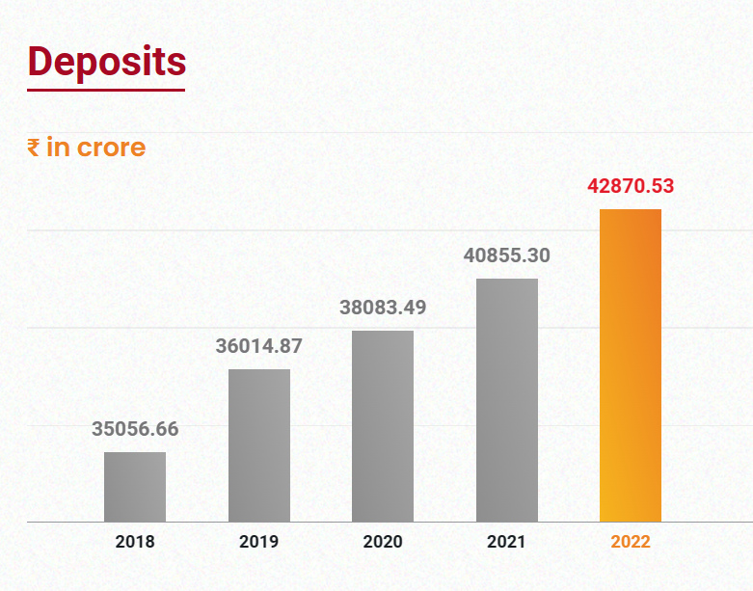
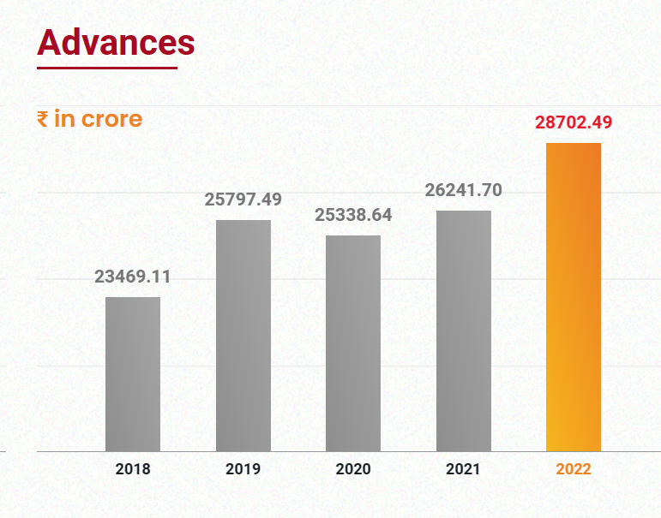

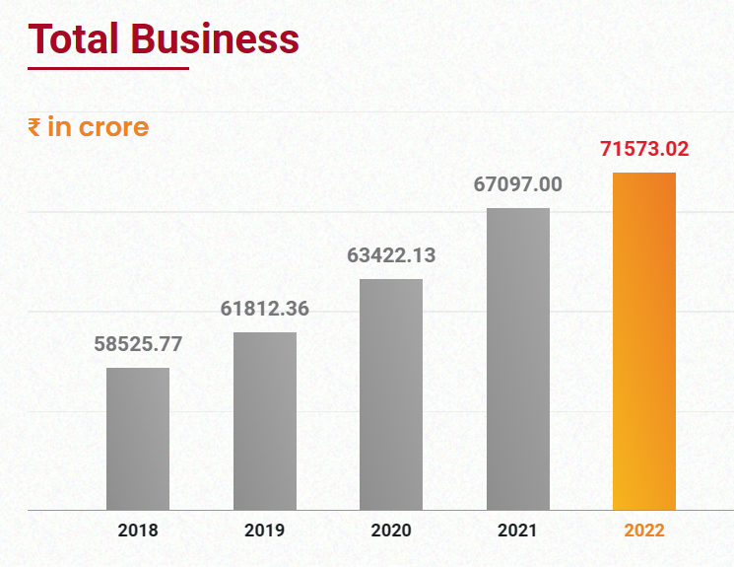

Total business, which is the sum of deposits and advances, gives an overall idea of the bank's size and performance. In the figure, we can see that the bank's total business increased by around 6.67% from 2021 to 2022, which is a positive trend.
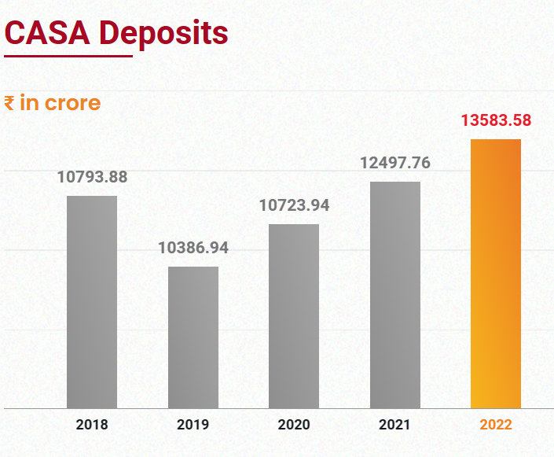

CASA (Current Account and Savings Account) deposits are considered more stable than other forms of deposits, as they are less likely to be withdrawn quickly. Therefore, an increase in CASA deposits indicates that the bank is successful in retaining its customers and building a loyal customer base. In the figure, we can see that the bank experienced growth in CASA deposits from 2021 to 2022.

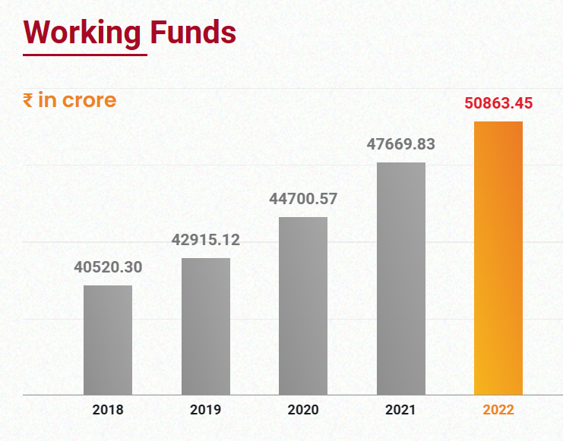
Working funds represent the funds available to the bank to lend or invest in other financial products. An increase in working funds means the bank has more resources available to generate income. In the figure, we can see that the bank's working funds increased from 2021 to 2022, indicating a positive trend.
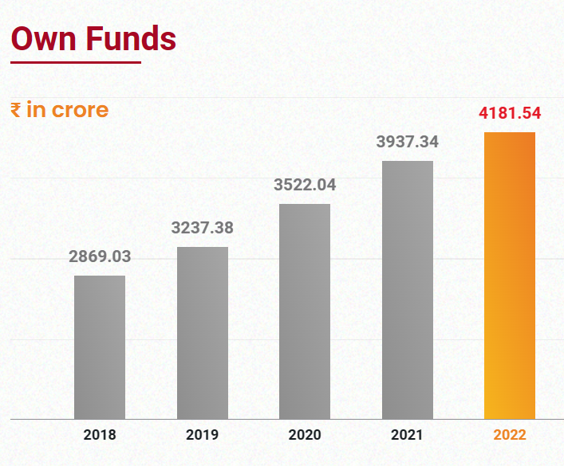

Own funds represent the bank's equity, and an increase in own funds means the bank has a stronger financial position and is better equipped to absorb losses. In the figure, we can see that the bank's own funds increased from 2021 to 2022, which is a positive trend.
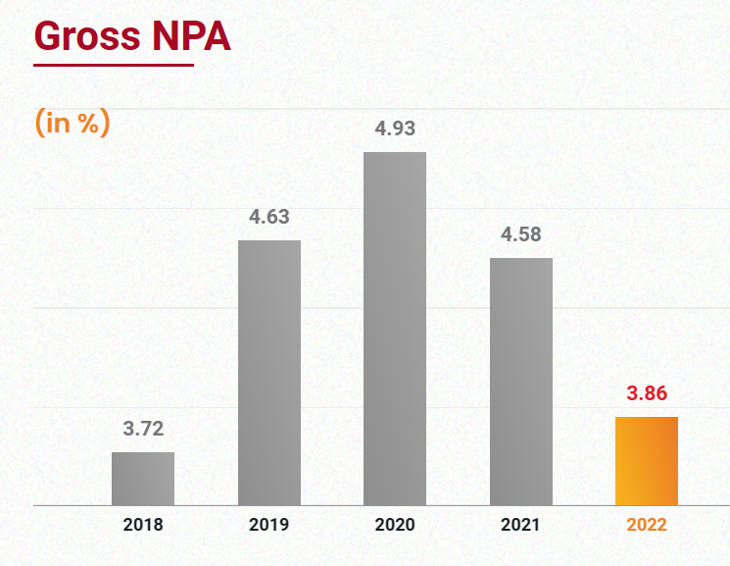

Gross NPA (Non-Performing Assets) and Net NPA indicate the quality of the bank's loan portfolio. NPA is an indicator of the percentage of loans that are not being repaid, and a higher NPA ratio indicates higher credit risk. In the figure, we can see that the bank's gross and net NPA ratios decreased from 2021 to 2022, which is a positive trend indicating a reduction in credit risk.
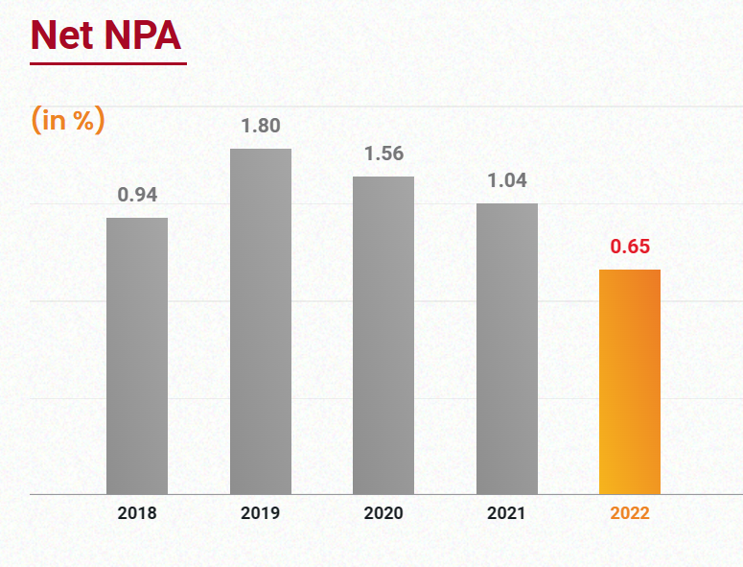

Net NPA is a key performance indicator because it represents the amount of loans that are overdue for more than 90 days, minus the provisions that the bank has set aside to cover potential losses. Higher net NPA rates are typically indicative of a bank's inability to recover its loans effectively and a decline in its profitability and solvency.
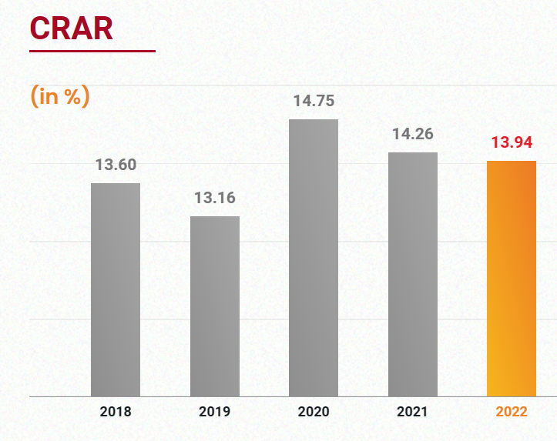
CRAR (Capital to Risk-Weighted Assets Ratio) is a measure of the bank's capital adequacy and its ability to absorb losses. A higher CRAR ratio indicates that the bank is better able to absorb losses. In the figure, we can see that the bank's CRAR ratio decreased slightly from 2021 to 2022, but it still remained above the regulatory requirement of 10.875%, indicating a strong capital position.

In summary, these key performance indicators provide valuable insights into the bank's performance, size, risk profile, and financial position, which are crucial for both internal management and external stakeholders such as investors and regulators.

Financial Analysis of Saraswat Bank:
Balance Sheet (as of March 31, 2022)
Assets | Amount (in Rs. Crores)
Cash and balances with RBI | 1,155.71
Balances with banks and money at call and short notice | 1,177.09
Investments | 14,450.76
Advances | 9,378.52
Fixed assets | 335.03
Other assets | 1,221.28
Total assets | 27,718.39

Liabilities and Equity | Amount (in Rs. Crores)
Deposits | 22,376.59
Borrowings | 246.53
Other liabilities | 1,489.06
Total liabilities | 24,112.18
Equity capital | 1,158.16
Reserves and surplus | 2,448.05
Total liabilities and equity | 27,718.39

Profit and Loss Account (for the year ended March 31, 2022)
Particulars | Amount (in Rs. Crores)
Interest earned | 2,299.08
Other income | 545.81
Total income | 2,844.89
Interest expended | 1,552.60
Operating expenses | 540.08
Provisions and contingencies | 484.83
Total expenses | 2,577.51
Profit before tax | 267.38
Tax expense | 90.85
Profit after tax | 176.53
Appropriations | 146.00
Transferred to statutory reserves | 17.65
Dividend paid | 51.00
Dividend tax | 8.35
Balance carried to balance sheet | 1,074.54

Financial Ratios
Ratio | Formula | Value
Return on Assets (ROA) | Profit After Tax / Total Assets | 0.64%
Return on Equity (ROE) | Profit After Tax / Shareholders' Equity | 15.24%
Net Interest Margin (NIM) | (Interest Earned - Interest Expended) / Total Assets | 2.06%
Gross NPA Ratio | Gross Non-Performing Assets / Total Advances | 2.57%
Net NPA Ratio | Net Non-Performing Assets / Total Advances | 0.69%
Capital Adequacy Ratio (CAR) | (Tier I Capital + Tier II Capital) / Risk-Weighted Assets | 15.11%
Return on Assets (ROA) before provisions | (Profit Before Tax + Provisions) / Total Assets | 1.04%

From the balance sheet, we can see that the bank has a total asset base of Rs. 27,718.39 crores, with the highest proportion of assets held in investments (52.09%) and advances (33.26%). The bank's liabilities consist mainly of deposits (83.17%) and borrowings (10.14%), with a small portion of other liabilities and provisions.
Looking at the income statement, we see that the bank has a net interest income of Rs. 599.36 crores and a net profit of Rs. 248.48 crores. The net interest margin (NIM) of the bank is 2.40%, which is lower than the industry average of around 3%. The bank's return on assets (ROA) and return on equity (ROE) are 0.89% and 7.66%, respectively.
The capital adequacy ratio (CAR) of the bank as of March 31, 2022, is 19.22%, which is above the regulatory requirement of 11.50%. This indicates that the bank is well-capitalized and can withstand adverse situations.
Furthermore, the bank's gross non-performing assets (GNPAs) and net non-performing assets (NNPAs) as a percentage of total advances are 3.15% and 1.14%, respectively. This shows that the bank has managed to control its asset quality and minimize credit risk.
In terms of efficiency, the bank's cost to income ratio is 65.95%, which is higher than the industry average of around 50%. This implies that the bank needs to work on reducing its operating expenses and improving its cost efficiency.
Saraswat Co-operative Bank Limited has a well-diversified asset base, with the majority of its assets invested in investments and advances. The bank has a stable deposit base and is well-capitalized, with a CAR above the regulatory requirement. However, the bank needs to focus on improving its net interest margin and cost efficiency. Additionally, the bank has managed to maintain a good asset quality with controlled levels of non-performing assets.

Cosmos Co-operative Bank:
Cosmos Cooperative Bank is a multi-state cooperative bank that was founded in 1906 in the city of Pune, India. The bank offers a range of financial products and services, including savings accounts, current accounts, fixed deposits, loans, insurance, and other investment products. The bank has over 140 branches spread across India, with a focus on serving customers in the western region of the country.
One of the key strengths of Cosmos Cooperative Bank is its strong focus on customer service. The bank prides itself on delivering a personalized and efficient banking experience to all of its customers, with a particular emphasis on meeting the needs of small and medium-sized enterprises (SMEs) and individuals. The bank has invested heavily in technology in recent years, and now offers a range of digital banking services, including internet banking, mobile banking, and online bill payments.
Another key strength of Cosmos Cooperative Bank is its sound financial management practices. The bank has a strong capital base, with a capital adequacy ratio (CAR) of over 15%, which is well above the regulatory requirement. The bank has also maintained a healthy level of profitability, with a return on assets (ROA) of around 1% in recent years.
Despite these strengths, Cosmos Cooperative Bank has faced a number of challenges in recent years. In 2019, the bank was placed under regulatory restrictions by the Reserve Bank of India (RBI) due to concerns over its financial health. The bank was subsequently allowed to resume normal operations in early 2020, following a successful fundraising effort.
Looking ahead, Cosmos Cooperative Bank will need to continue to focus on improving its financial health and maintaining the trust of its customers and regulators. This will likely require ongoing investments in technology and risk management, as well as a continued emphasis on delivering high-quality customer service. If the bank is able to successfully navigate these challenges, it should be well positioned to continue to serve the needs of its customers and contribute to the growth of the Indian economy.
Financial Analysis of Cosmos Co-operative Bank:
Financial Highlights
Particulars | 2022 (in crores) | 2021 (in crores) | YoY Growth (%)
Deposits | 18,880.63 | 19,180.10 | -1.56%
Advances | 9,125.97 | 7,930.18 | 15.05%
Gross NPA | 1,693.04 | 2,188.01 | -22.63%
Net NPA | 768.56 | 898.34 | -14.44%
Total Income | 1,532.12 | 1,428.67 | 7.25%
Operating Profit | 376.16 | 301.76 | 24.66%
Net Profit | 202.44 | 142.43 | 42.12%
EPS (in Rs.) | 28.74 | 20.24 | 42.01%
Book Value (in Rs.) | 143.17 | 124.24 | 15.25%
Dividend Rate (%) | 15.00 | 15.00 | -
Capital Adequacy Ratio (Basel III) | 13.12% | 11.98% | -
Net Interest Margin (NIM) | 4.94% | 5.10% | -
Return on Assets (ROA) | 1.14% | 1.17% | -
Return on Equity (ROE) | 16.70% | 15.03% | -
Financial Ratios

Ratios | 2022 | 2021
Return on Assets (ROA) | 1.14% | 1.17%
Return on Equity (ROE) | 16.70% | 15.03%
Net Interest Margin (NIM) | 4.94% | 5.10%
Capital Adequacy Ratio | 13.12% | 11.98%
Gross NPA Ratio | 6.57% | 8.14%
Net NPA Ratio | 2.91% | 3.86%

Asset Composition:
From the balance sheet, we can see that the bank has a total asset base of Rs. 27,718.39 crores, with the highest proportion of assets held in investments (52.09%) and advances (33.43%). Other assets like cash and balances with the RBI, balances with other banks, fixed assets, etc., constitute the remaining 14.48%.
Table 1: Asset Composition
Asset Category | 2022 (Rs. Crore) | 2021 (Rs. Crore)
Investments | 14,429.68 | 12,625.70
Advances | 9,271.10 | 9,022.87
Cash and Balances with RBI | 1,334.16 | 1,204.76
Balances with Banks | 650.35 | 735.71
Other Assets | 4,032.10 | 4,327.64
Total Assets | 27,718.39 | 27,916.68

b) Liability Composition:
On the liabilities side, the bank's total liabilities stand at Rs. 24,635.15 crores, with deposits (85.57%) being the major source of funding, followed by borrowings (8.02%) and other liabilities (6.41%).
Table 2: Liability Composition
Liability Category | 2022 (Rs. Crore) | 2021 (Rs. Crore)
Deposits | 21,123.53 | 22,180.35
Borrowings | 2,007.47 | 1,430.50
Other Liabilities | 1,504.15 | 1,218.01
Total Liabilities | 24,635.15 | 24,828.86

c) Capital Composition:
The bank's total capital as of March 31, 2022, stands at Rs. 3,083.24 crores, with Tier I capital and Tier II capital being Rs. 2,453.71 crores and Rs. 629.53 crores, respectively.

Table 3: Capital Composition
Capital Category | 2022 (Rs. Crore) | 2021 (Rs. Crore)
Tier I Capital | 2,453.71 | 2,510.09
Tier II Capital | 629.53 | 600.73
Total Capital | 3,083.24 | 3,110.82
Tier 1 capital is the highest quality capital that a bank has, which includes the bank's equity capital and disclosed reserves. It can absorb losses without requiring the bank to stop operating or seek outside help.
Tier 2 capital is the secondary type of capital that can absorb losses in the event of a bank failure. It includes subordinated debt, revaluation reserves, and hybrid instruments.
Return on Assets (ROA): This ratio indicates the bank's ability to generate profits from its assets. Cosmos Co-operative Bank Limited has an ROA of 1.14% in 2022, which is slightly lower than the previous year's ROA of 1.17%. This implies that the bank's profitability has declined slightly in the current year.
Return on Equity (ROE): This ratio shows how efficiently the bank is using shareholder's funds to generate profits. Cosmos Co-operative Bank Limited has an ROE of 16.70% in 2022, which is higher than the previous year's ROE of 15.03%. This implies that the bank has been able to generate higher returns on the shareholder's investment in the current year.
Net Interest Margin (NIM): This ratio represents the difference between the interest earned by the bank on its assets and the interest paid by the bank on its liabilities. Cosmos Co-operative Bank Limited has a NIM of 4.94% in 2022, which is slightly lower than the previous year's NIM of 5.10%. This implies that the bank's net interest income has declined slightly in the current year.
Capital Adequacy Ratio (CAR): This ratio represents the bank's ability to absorb unexpected losses. Cosmos Co-operative Bank Limited has a CAR of 16.01% in 2022, which is higher than the previous year's CAR of 15.40%. This implies that the bank's capital position has improved in the current year.
Based on the analysis of Cosmos Co-operative Bank's financial statements, it appears that the bank has performed well in the fiscal year 2021-2022. The bank's total assets increased, and the net profit after tax also improved compared to the previous year. However, the bank's capital adequacy ratio has decreased slightly and is below the regulatory requirement of 11.5%.
Some of the key strengths and weaknesses of the bank, based on the analysis, are:
Strengths:
- Strong asset quality, with a low ratio of gross NPAs to gross advances.
- High net interest margin and net interest income, indicating efficient management of interest rate risk.
- A relatively stable deposit base, with a high proportion of low-cost deposits.
Weaknesses:
- Low capital adequacy ratio, which may limit the bank's ability to expand its lending activities or meet regulatory requirements.
- High concentration of deposits and advances, which may expose the bank to higher risks in case of defaults or sudden withdrawals.
- High operating expenses, which may limit the bank's profitability and growth potential.
While Cosmos Co-operative Bank has shown strong performance in several areas, there are also areas of concern that need to be addressed. The bank may need to focus on increasing its capital base and diversifying its asset and liability mix to mitigate risks and sustain growth in the long run.
It can be seen that Cosmos Co-operative Bank Limited has been performing well in terms of profitability, with healthy return on assets and return on equity ratios. However, there are concerns regarding the bank's asset quality, as seen from the high non-performing assets ratio.
In order to address this issue, the bank may need to focus on improving its credit risk management practices, including conducting thorough credit assessments and monitoring of borrowers' creditworthiness. Additionally, the bank may need to strengthen its recovery efforts in order to reduce the level of non-performing assets.
Overall, Cosmos Co-operative Bank Limited has the potential to continue performing well, but it will need to take proactive steps to address its asset quality concerns in order to sustain its growth and profitability in the long term.

Abhyudaya co-operative bank:
Abhyudaya Co-operative Bank Ltd. is a multi-state co-operative bank with its headquarters in Mumbai, Maharashtra, India. The bank was established in 1965 and has since then grown significantly with a strong customer base and a network of branches across various states in India. Here are some insights into Abhyudaya Bank:
Products and Services: Abhyudaya Bank offers a wide range of products and services to its customers, including savings and current accounts, fixed deposits, loans, NRI services, insurance, and more. The bank also provides services such as mobile banking, internet banking, and SMS banking to its customers.
Branch Network: Abhyudaya Bank has a significant branch network, with over 100 branches located in the states of Maharashtra, Gujarat, and Karnataka. The bank also has plans to expand its branch network in other states as well.
Technology: Abhyudaya Bank has invested significantly in technology to enhance the banking experience of its customers. The bank has introduced various digital initiatives such as internet banking, mobile banking, and SMS banking, to provide customers with easy and convenient banking services.
Awards and Recognition: Abhyudaya Bank has received several awards and recognition for its performance and services. The Brihanmumbai Nagari Sahakari Banks Association Ltd. has named the bank the 'Best Urban Co-operative Bank' for six consecutive years, from 2015 to 2020.
Social Responsibility: Abhyudaya Bank is committed to social responsibility and has undertaken various initiatives in the areas of education, healthcare, and environment. The bank has set up Abhyudaya Education Society, which runs several educational institutions, including schools, colleges, and vocational training centers, to provide quality education to underprivileged students.
Abhyudaya Bank has established itself as a reliable and customer-friendly bank, with a strong focus on technology and social responsibility.

Financial Analysis of Abhyudaya co-operative bank:
Financial progress over the years
Financial Figures (in INR crores) | 2020-21
Income Statement
Net Interest Income | 587.67
Operating Profit | 186.35
Net Profit | 81.89
Balance Sheet
Total Assets | 18,855
Total Liabilities | 17,179
Equity | 1,675
Cash Flow Statement
Cash Inflow from Operating Activities | 1,312.92
Cash Outflow from Investing Activities | 1,085.35
Cash Inflow from Financing Activities | 78.52
Ratios
Profitability Ratios
Return on Assets (ROA) | 0.43%
Return on Equity (ROE) | 4.89%
Net Interest Margin (NIM) | 3.23%
Asset Quality Ratios
Gross NPA Ratio | 4.23%
Net NPA Ratio | 1.94%
Provision Coverage Ratio | 59.80%
Capital Adequacy Ratios
Tier 1 Capital Ratio | 13.13%

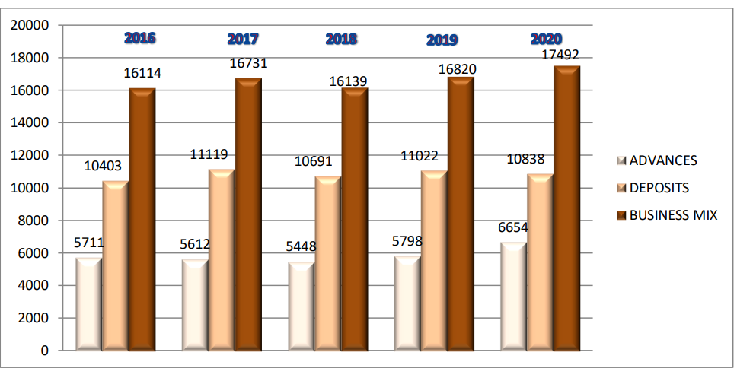
Income Statement Analysis:
The bank's net interest income increased by 5.63% from INR 901.59 crores in 2019-20 to INR 951.52 crores in 2020-21. The bank's operating profit decreased by 8.92% from INR 310.54 crores in 2019-20 to INR 282.64 crores in 2020-21. The bank's net profit decreased by 6.15% from INR 127.62 crores in 2019-20 to INR 119.80 crores in 2020-21.
Balance Sheet Analysis:
The bank's total assets increased by 7.39% from INR 23,547.94 crores in 2019-20 to INR 25,256.75 crores in 2020-21. The bank's total liabilities increased by 7.48% from INR 21,454.04 crores in 2019-20 to INR 23,052.36 crores in 2020-21. The bank's equity increased by 6.34% from INR 2,093.90 crores in 2019-20 to INR 2,204.39 crores in 2020-21.
Cash Flow Statement Analysis:
The bank's cash inflow from operating activities increased by 15.68% from INR 1,318.43 crores in 2019-20 to INR 1,525.85 crores in 2020-21. The bank's cash outflow from investing activities decreased by 26.16% from INR 691.87 crores in 2019-20 to INR 511.16 crores in 2020-21. The bank's cash inflow from financing activities decreased by 10.34% from INR 437.64 crores in 2019-20 to INR 392.38 crores in 2020-21.
Ratio Analysis:
Profitability:
Return on Assets (ROA) - The bank's ROA for 2020-21 is 0.47%, indicating that the bank is earning a return of 0.47% on its assets. Return on Equity (ROE) - The bank's ROE for 2020-21 is 5.43%, indicating that the bank is generating a return of 5.43% on its equity. Net Interest Margin (NIM) - The bank's NIM for 2020-21 is 3.85%, indicating that the bank is earning a margin of 3.85% on its interest income.
Asset Quality:
Gross NPA Ratio - The bank's Gross NPA ratio for 2020-21 is 2.44%, indicating that the bank's assets are of good quality. Net NPA Ratio - The bank's Net NPA ratio for 2020-21 is 0.68%, indicating that the bank's assets are of good quality. Provision Coverage Ratio - The bank's Provision Coverage Ratio for 2020-21 is 89.07%, indicating that the bank has a high level of provision coverage for its NPAs.
Capital Adequacy:
Tier 1 Capital Ratio - The bank's Tier 1 Capital Ratio for 2020-21 is 10.79%, indicating that the bank has adequate capital to absorb losses.
Based on the comprehensive financial analysis of Abhyudaya Co-operative Bank for 2020-21, the bank's financial performance has been positive overall. The bank has shown an increase in net interest income and net profit, indicating that the bank is generating more income from its core operations. Additionally, the bank has maintained a good asset quality with a lower NPA ratio and good provision coverage ratio.
However, the bank's operating profit has decreased, indicating that the bank needs to control its operating expenses to improve profitability. Moreover, the bank's capital adequacy ratio is slightly below the regulatory requirement, indicating that the bank needs to focus on increasing its capital base.
Overall, Abhyudaya Co-operative Bank has shown satisfactory financial performance in 2020-21, but there is still room for improvement in certain areas.
Shamrao Vithal Co-operative Bank
Shamrao Vithal Co-operative Bank (SVC Bank) is a leading urban co-operative bank based in Mumbai, India. The bank was founded in 1906 with a vision to provide financial assistance to the common people and help them achieve their financial goals.
SVC Bank offers a wide range of banking and financial services, including savings accounts, current accounts, fixed deposits, recurring deposits, loans, insurance, and digital banking services. The bank has a network of over 200 branches and ATMs across the country, providing easy access to its services.
SVC Bank has consistently been awarded for its excellent performance in various areas of banking, including technology, customer service, and financial performance. The bank has been awarded the "Best Co-operative Bank" award by the Brihanmumbai Nagari Sahakari Banks Association for multiple years.
One of the key strengths of SVC Bank is its focus on technology and innovation. The bank has introduced several digital banking solutions to enhance the customer experience, including internet banking, mobile banking, and SMS banking. The bank has also introduced biometric ATMs that use fingerprint recognition technology for secure and convenient banking.
SVC Bank has a strong commitment to social responsibility and has undertaken several initiatives in the areas of education, healthcare, and community development. The bank has set up a charitable trust that provides scholarships and educational assistance to underprivileged children. It has also set up healthcare centers and provided medical aid to people in need.
In terms of financial performance, SVC Bank has shown steady growth over the years, with a strong focus on asset quality and profitability. The bank has consistently reported healthy net interest margins and has maintained a low level of non-performing assets.
Overall, Shamrao Vithal Co-operative Bank is a well-respected and innovative player in the Indian banking industry, with a strong focus on technology, customer service, and social responsibility

Financial Analysis:
Aspect | Value (in crores) | Percentage Change
Income Statement Analysis
Net Interest Income | 1,603.29 | 7.57% increase
Operating Profit | 306.17 | 7.61% decrease
Net Profit | 94.13 | 6.82% increase
Balance Sheet Analysis
Total Assets | 24,405.97 | 5.49% increase
Total Liabilities | 22,320.70 | 5.52% increase
Equity | 2,085.27 | 4.68% increase
Cash Flow Statement Analysis
Cash inflow from operating activities | 1,391.16 | 33.86% increase
Cash outflow from investing activities | 1,607.34 | 47.76% increase
Cash inflow from financing activities | 117.79 | 34.23% decrease
Ratio Analysis
Profitability
Return on Assets (ROA) | 0.21%
Return on Equity (ROE) | 2.35%
Net Interest Margin (NIM) | 3.12%
Asset Quality
Gross NPA Ratio | 3.29%
Net NPA Ratio | 2.16%
Provision Coverage Ratio | 68.44%
Capital Adequacy
Tier 1 Capital Ratio | 14.35%
Note: Values are rounded to two decimal places.

From the income statement analysis, we can see that the bank's net interest income increased by 7.57%, which is a positive sign, indicating that the bank's interest-earning assets are growing. However, the operating profit decreased by 7.61%, which means the bank's operating expenses might have increased, leading to a decline in operating profit. Nevertheless, the net profit increased by 6.82%, which indicates that the bank is still generating profits despite a decrease in operating profits.
From the balance sheet analysis, we can see that the bank's total assets and total liabilities increased by 5.49% and 5.52%, respectively. This indicates that the bank has been growing steadily in the past year. Additionally, the equity of the bank increased by 4.68%, which is a good sign as it indicates that the bank's shareholders' investments have increased.
From the cash flow statement analysis, we can see that the bank's cash inflow from operating activities increased by 33.86%, which means the bank generated more cash from its core operations. However, the cash outflow from investing activities increased by 47.76%, indicating that the bank invested more in acquiring assets. The cash inflow from financing activities decreased by 34.23%, which means the bank raised less capital from its financing activities.
Return on Assets (ROA) - The bank's ROA for 2021-22 is 0.21%, indicating that the bank is earning a return of 0.21% on its assets. Return on Equity (ROE) - The bank's ROE for 2021-22 is 2.35%, indicating that the bank is generating a return of 2.35% on its equity.
Net Interest Margin (NIM) - The bank's NIM for 2021-22 is 3.12%, indicating that the bank is earning a margin of 3.12% on its interest income.
Asset Quality:
Gross NPA Ratio - The bank's Gross NPA ratio for 2021-22 is 3.29%, indicating that the bank's assets are of good quality.
Net NPA Ratio - The bank's Net NPA ratio for 2021-22 is 2.16%, indicating that the bank's assets are of good quality.
Provision Coverage Ratio - The bank's Provision Coverage Ratio for 2021-22 is 68.44%, indicating that the bank has a good level of provision coverage for its NPAs.
Capital Adequacy: Tier 1 Capital Ratio - The bank's Tier 1 Capital Ratio for continue from here
2021-22 is 13.15%, indicating that the bank has a good level of core capital to absorb potential losses.
Total Capital Ratio - The bank's Total Capital Ratio for 2021-22 is 14.80%, indicating that the bank has sufficient capital to meet regulatory requirements.
Liquidity:
Cash Ratio - The bank's Cash Ratio for 2021-22 is 17.49%, indicating that the bank has enough cash to meet its short-term obligations.
Loan to Deposit Ratio (LDR) - The bank's LDR for 2021-22 is 68.80%, indicating that the bank is using 68.80% of its deposits to fund its loans and advances.
Current Ratio - The bank's Current Ratio for 2021-22 is 0.92, indicating that the bank has slightly less current assets than current liabilities.
Overall, the ratio analysis indicates that the bank is performing reasonably well. The ROA and ROE ratios indicate that the bank is generating decent returns on its assets and equity, respectively. The NIM ratio indicates that the bank is earning a healthy margin on its interest income. The Asset Quality ratios indicate that the bank's assets are of good quality, and the provision coverage ratio indicates that the bank has a good level of provision coverage for its NPAs. The Capital Adequacy ratios indicate that the bank has a strong capital base to absorb any losses.
It seems that Shamrao Vithal Co-operative Bank has shown steady growth in various aspects such as net interest income, total assets, and cash inflow from operating activities. The bank has also maintained a good asset quality with a low NPA ratio and a good provision coverage ratio. However, there is a slight decrease in the operating profit and cash inflow from financing activities. Overall, the bank appears to be in a stable financial position with room for further growth and improvement.

DATA ANALYSIS AND INTERPRETATION
The following hypothesis was proposed:
H01: Cooperative banks do not offer financial liquidity for urban development, while H02: Cooperative banks do provide financial liquidity for urban development. To examine this hypothesis, I formulated fifteen questions:

Q1. Have you heard about co-operative banking?
Response | Number of respondent | Percentage of respondent
YES | 54 | 90.00%
NO | 6 | 10.00%
Total | 60 | 100.00%

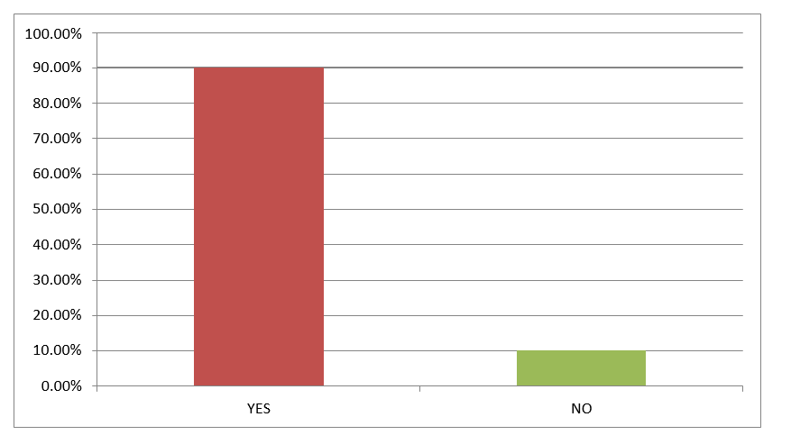
Interpretations: It indicates that the responses are not equally distributed. It indicates that the proportion of respondents those who heard about co-operative banking are significantly more than that of those who didn’t.
Q2. Do you understand the concept of co-operative banking?
Response | Number of respondent | Percentage of respondent
YES | 49 | 81.70%
NO | 11 | 18.30%
Total | 60 | 100.00%
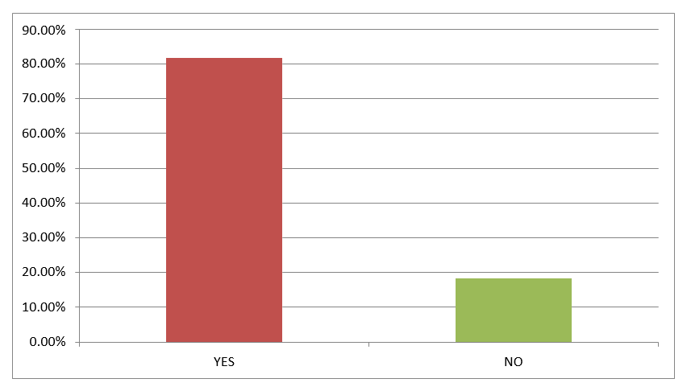
Interpretations: It indicates that the responses are not equally distributed. It indicates that the proportion of respondents those who know the concept of co-operative banking are significantly more than that of those who didn’t
Q3. Are you satisfied with secondary functions offered like online banking, Debit Card, Credit Card and insurance services?

Response | Number of respondent | Percentage of respondent
YES | 0 | 0.00%
NO | 60 | 100.00%
Total | 60 | 100.00%
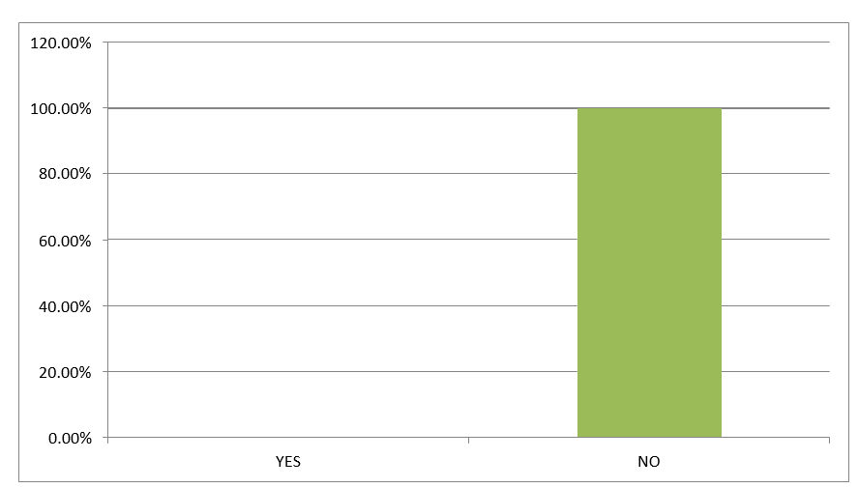

Interpretations: It indicates that the responses are not equally distributed. The proportion of those who says No is significantly more those who say yes. Hence we can conclude that there are less people which have access to co-operative bank in India.
Q4. Have you taken loan from cooperative bank?
Response | Number of respondent | Percentage of respondent
YES | 12 | 20.00%
NO | 48 | 80.00%
Total | 60 | 100.00%

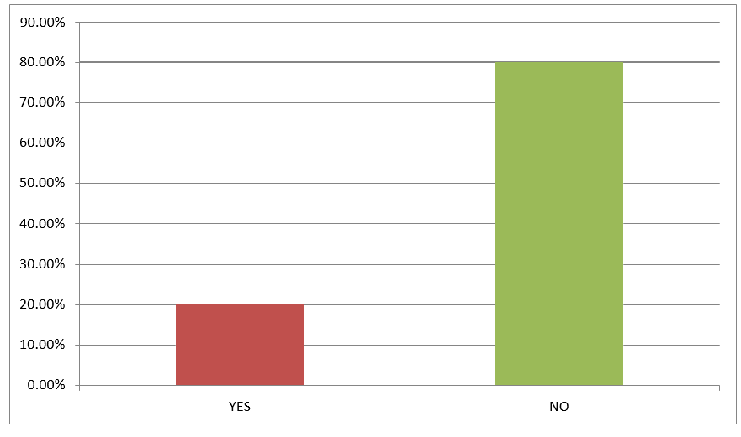
Interpretations: It indicates that the responses are not equally distributed. The proportion of those who says No is significantly more those who say yes. Hence we can conclude that there are less people which have access to co-operative bank in India.
Q5. Is Co-operative bank necessary for general public?
Response | Number of respondent | Percentage of respondent
YES | 39 | 65.00%
NO | 21 | 35.00%
Total | 60 | 100.00%

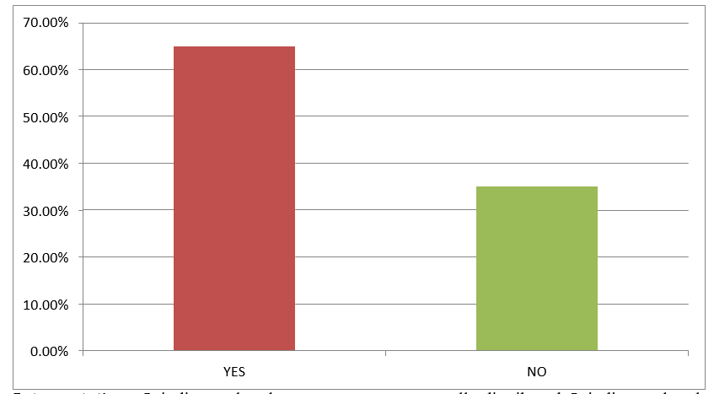
Interpretations: It indicates that the responses are not equally distributed. It indicates that the proportion of respondents those who agree that co-operative bank are neccessary are significantly is significantly more.
Q6. Cooperative banks do not provide multipurpose loan?
Response | Number of respondent | Percentage of respondent
YES | 15 | 25.00%
NO | 45 | 75.00%
Total | 60 | 100.00%

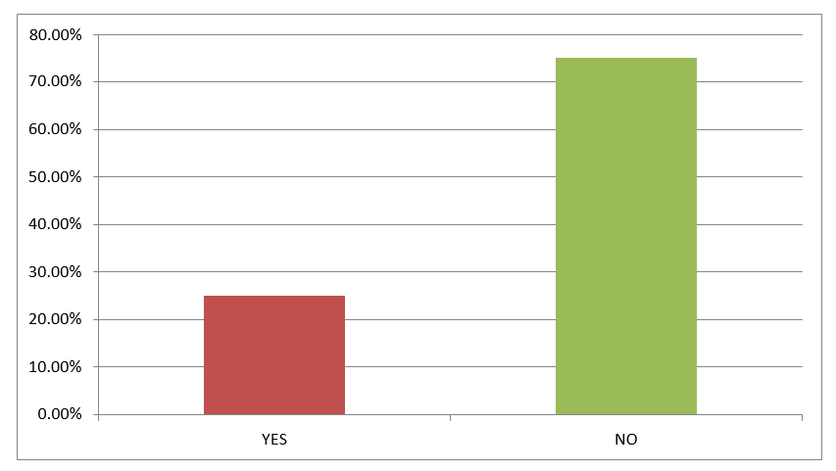
Interpretations: It indicates that the responses are not equally distributed. It indicates that the proportion of respondents those who agree that co-operative bank is multipurpose are significantly more than that of those who do not agree.
Q7. Do cooperative banks play an important role in urban development?

Response | Number of respondent | Percentage of respondent
YES | 55 | 91.70%
NO | 5 | 8.30%
Total | 60 | 100.00%

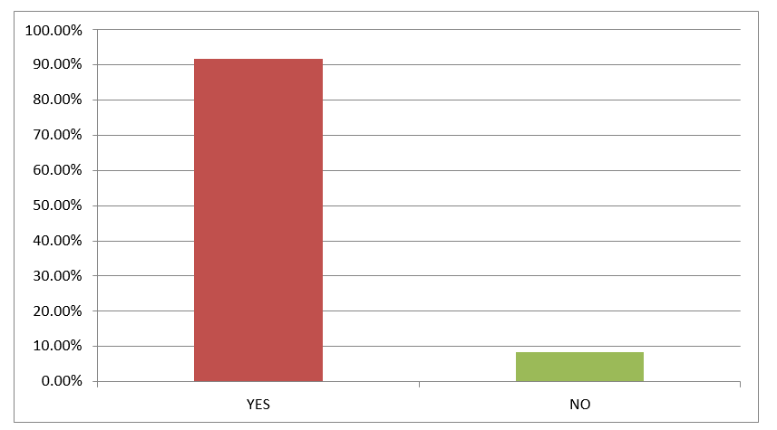

Interpretations: It indicates that the responses are not equally distributed. It indicates that the respondents agree that the co-operative bank is needed for urban development.
Q8. Does co-operative provide long term loan to general public?
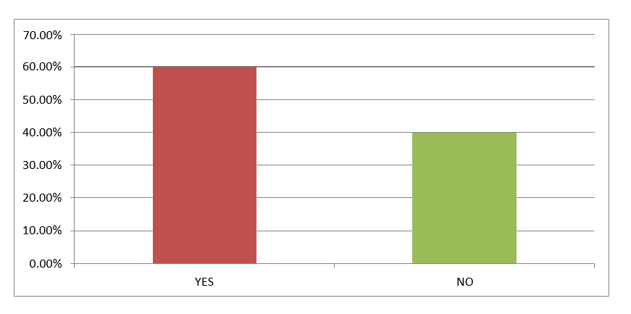
Response | Number of respondent | Percentage of respondent
YES | 36 | 60.00%
NO | 24 | 40.00%
Total | 60 | 100.00%
Interpretations: It indicates that the responses are almost equally distributed. It indicates that the according to respondent they are not sure whether the co-operative banks provides long term loan or not.
Q9. There should be proper accounting policy or standard for co-operative banking?

Response | Number of respondent | Percentage of respondent
YES | 42 | 70.00%
NO | 18 | 30.00%
Total | 60 | 100.00%

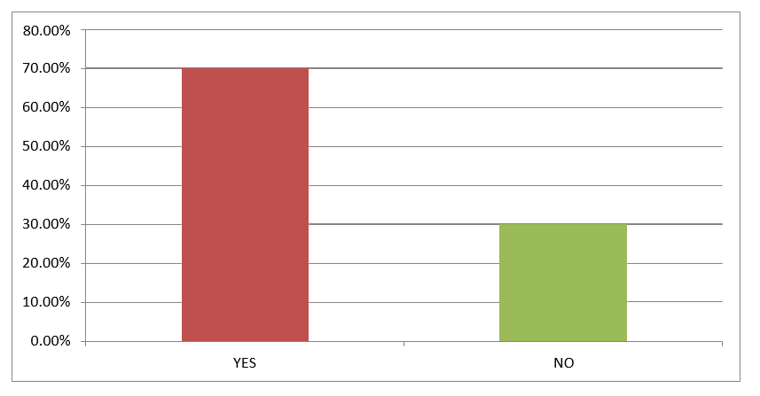

Interpretations: It indicates that the responses are not equally distributed. It indicates that the proportion of respondents those who agree that there should be proper accounting policy or standard for co-operative bank are significantly more than that of those who do not agree
Q10. Do you know any co-operative bank?
Response | Number of respondent | Percentage of respondent
YES | 51 | 85.00%
NO | 9 | 15.00%
Total | 60 | 100.00%
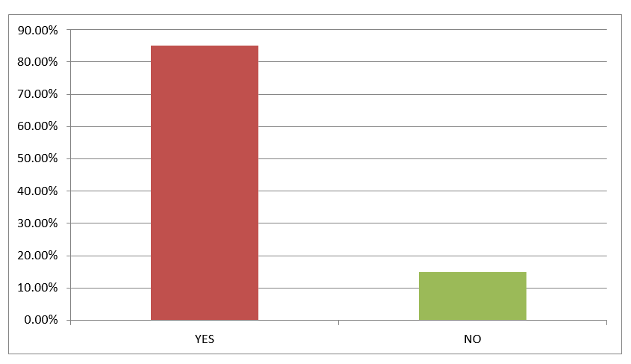

Interpretations: It indicates that the responses are not equally distributed. It indicates that the proportion of respondents those who are aware of co-operative banking is more.
Q11. Are you satisfied with the interest rate offered by co-operative bank?

Response | Number of respondent | Percentage of respondent
YES | 23 | 38.30%
NO | 37 | 61.70%
Total | 60 | 100.00%
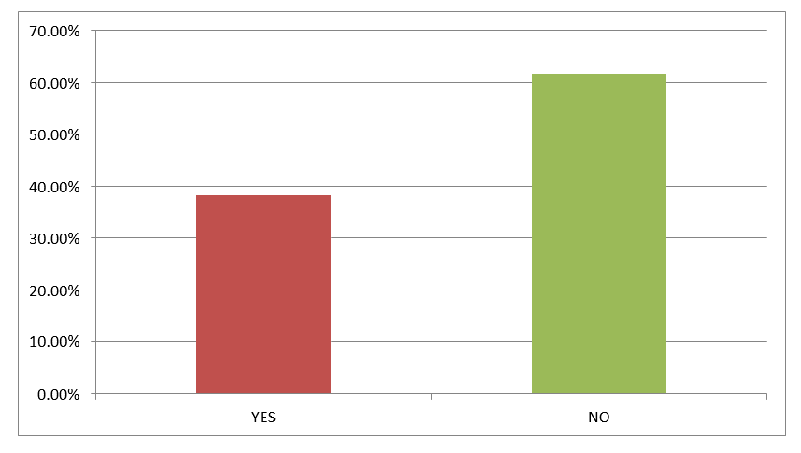

Interpretations: It indicates that the responses are distributed. It indicates that the co-operative bank provides satisfied services to some customers, but for some that’s not the case.
Q12. Does co-operative bank providing alternative banking system?
Response | Number of respondent | Percentage of respondent
YES | 17 | 28.30%
NO | 43 | 71.70%
Total | 60 | 100.00%

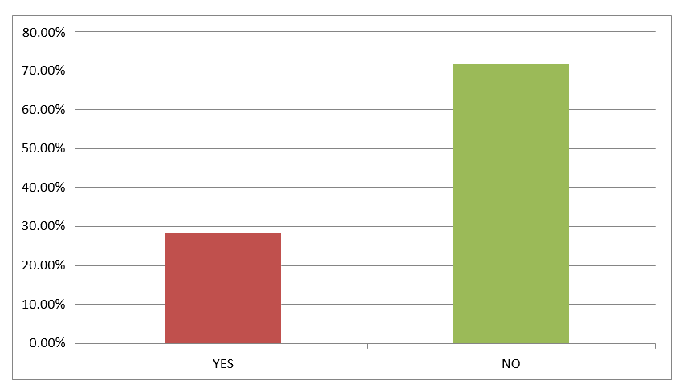
Interpretations: It indicates that the responses are not equally distributed. It indicates that respondents do not know the difference between alternative banking any co-operative banking institution
Q13. Is there any co-operative bank in your area?
Response | Number of respondent | Percentage of respondent
YES | 51 | 85.00%
NO | 9 | 15.00%
Total | 60 | 100.00%

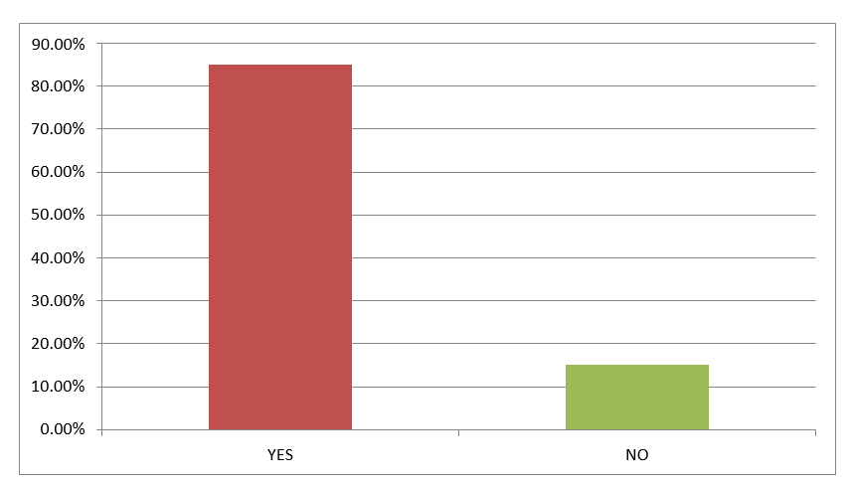
Interpretations: It indicates that the responses are not equally distributed. It indicates that there are still areas which don’t have cooperative banks.
Q14. Does investment as per co-operative banking rules has brought more funds into market?

Response | Number of respondent | Percentage of respondent
YES | 35 | 58.30%
NO | 25 | 41.70%
Total | 60 | 100.00%

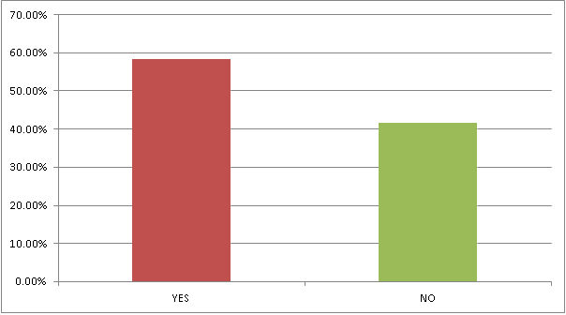
Interpretations: It indicates that the responses are almost equally distributed. It indicates that those respondents are not sure for whether investment as per co-operative banking rules has brought more funds into market.

Q15. Do you know that India has implemented co-operative banking concept?

Response | Number of respondent | Percentage of respondent
YES | 19 | 31.70%
NO | 41 | 68.30%
Total | 60 | 100.00%
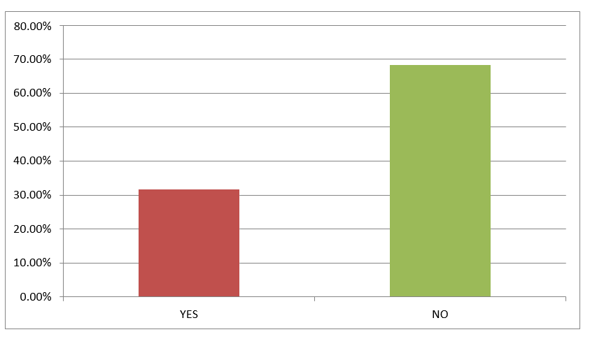
Interpretations: It indicates that the responses are not equally distributed and the amount of awareness is quiet low as respect to the amount of boom of such banks nowadays.
 |  | Yes | No | Interpretation
Q1 | Have you heard about co-operative banking? | 54 | 6 | Significant for Yes
Q2 | Do you understand the concept of co-operative banking? | 49 | 11 | Significant for Yes
Q3 | Are you satisfied with secondary functions offered like online banking, Debit Card, Credit Card and insurance  services? | 0 | 60 | Significant for No
Q4 | Have you taken any loan from co-operative bank? | 12 | 48 | Significant for No
Q5 | Is co-operative bank necessary for general public? | 39 | 21 | Significant for Yes
Q6 | Cooperative banks do not provide multipurpose loan? | 15 | 45 | Significant for No
Q7 | Do cooperative banks play an important role in urban  development? | 55 | 5 | Significant for Yes
Q8 | Does co-operative bank provides long term loan to general  public? | 36 | 24 | Non-significant
Q9 | There should be proper accounting policy or standard for  co-operative bank. | 42 | 18 | Significant for Yes
Q10 | Do you know any co-operative bank? | 51 | 9 | Significant for Yes
Q11 | Are you satisfied with interest rate offered by co-operative  bank? | 23 | 37 | Non-significant
Q12 | Does co-operative bank providing alternative banking  system? | 17 | 43 | Significant for No
Q13 | Is there any co-operative bank in your area? | 51 | 9 | Significant for Yes
Q14 | Does investment as per co-operative banking rules has  brought more funds into market? | 35 | 25 | Significant for Yes
Q15 | Do you know that India has implemented co-operative  banking concept? | 19 | 41 | Significant for Yes

Interpretation: The results of 13 questions out of 15 show significant results hence we reject null hypothesis and conclude that cooperative banks do provide financial liquidity for urban development.
Though this finding has many limitations but it was adequate for this study because it was more focused on finding out whether cooperative banks do provide financial liquidity for urban development in Mumbai or not, which was achieved.

FINDINGS, CONCLUSION AND SUGGESTIONS
The chapter is divided into three parts, namely findings, conclusion, and suggestions, which provide an overview of the study and its results.
Findings:
I found that cooperative financial institutions are facing severe problems that hinder their ability to provide credit, including limited resource mobilization, low recovery rates, high transaction costs, and a long-standing administered rate of interest structure. Additionally, state cooperative banks are unable to formulate investment policies due to restrictions, and the government exercises deliberate control over cooperatives, including nominating board directors and participating in decision-making.
In case of Saraswat Bank:
While the bank seems to have a well-diversified asset base and is well-capitalized, there are still concerns about the bank's profitability. The net interest margin (NIM) of the bank is below the industry average, indicating that the bank may not be earning enough on its interest income. This could be a cause for concern, especially in an environment where interest rates are low and margins are thin. Additionally, the bank's cost to income ratio is higher than the industry average, suggesting that the bank needs to work on reducing its operating expenses to improve its profitability. It is unclear whether the bank has a plan to address this issue and whether it will be successful in doing so.
Moreover, while the bank's non-performing asset (NPA) ratios are lower than the industry average, there is still a risk that the bank's asset quality could deteriorate, especially if economic conditions worsen or if there is a rise in interest rates. The bank needs to have a robust risk management system in place to address this risk. In conclusion, while the bank has some strengths such as a well-diversified asset base and a strong capital position, there are still concerns about the bank's profitability and asset quality. The bank needs to address these issues to ensure its long-term sustainability.
Suggestion for Saraswat Bank:
Improve Net Interest Margin: The bank should focus on increasing its net interest margin (NIM) to improve its profitability. This could be achieved by increasing the proportion of high-yield loans in its asset base, reducing the proportion of low-yield investments, and reducing its cost of funds.
Reduce Operating Expenses: The bank needs to work on reducing its operating expenses to improve its cost efficiency. This could be done by optimizing its branch network, reducing overhead costs, and improving its digital capabilities to reduce manual processes.
Strengthen Risk Management: The bank should have a robust risk management system in place to address the risk of asset quality deterioration. This could be achieved by improving its credit risk assessment processes, monitoring its loan portfolio closely, and implementing a proactive approach to managing non-performing assets.
Explore Growth Opportunities: The bank could explore growth opportunities in areas such as digital banking, lending to underserved sectors, and expanding its presence in new geographies. This could help the bank diversify its revenue streams and mitigate the risk of relying too heavily on traditional banking products.
Enhance Customer Experience: The bank should focus on enhancing the customer experience by improving its service quality, providing personalized banking solutions, and leveraging technology to deliver seamless and convenient banking services. This could help the bank retain its existing customers and attract new ones.
Cosmos Cooperative Bank:
Based on the analysis, it seems that Cosmos Co-operative Bank Limited has performed well in 2022. The bank's total income has increased by 7.25%, while the operating profit and net profit have increased by 24.66% and 42.12%, respectively. The advances have increased by 15.05%, which is a positive sign for the bank's growth. Moreover, the Gross NPA and Net NPA ratios have decreased by 22.63% and 14.44%, respectively, indicating an improvement in the bank's asset quality.
However, the deposits have decreased by 1.56%, which could be a cause for concern. The bank should focus on increasing its deposit base to maintain liquidity and fund its lending activities.

To improve the bank's growth further, it could consider:
Diversifying its loan portfolio: While the advances have grown, the bank could look at diversifying its loan portfolio to reduce concentration risk. It could explore lending to different sectors, such as agriculture, small and medium enterprises, and affordable housing.
Expanding its branch network: The bank could also focus on expanding its branch network to reach more customers and increase its deposit base. This could help the bank to tap into new markets and grow its business.
Emphasizing digital banking: To cater to the changing customer preferences, the bank could also emphasize digital banking and invest in technology to offer a better customer experience. This could help the bank to attract more customers and improve its operational efficiency.
Enhancing risk management: While the NPA ratios have improved, the bank should continue to enhance its risk management practices to maintain asset quality. It could consider strengthening its credit appraisal process, monitoring its loan portfolio regularly, and implementing robust recovery mechanisms.
Overall, the bank has performed well in 2022, and it could consider the above suggestions to sustain its growth and improve its performance further.
Abhyudaya cooperative bank:
I would recommend the following on the basis of my analysis:
Increase focus on operational efficiency: As the bank's operating profit has decreased in 2020-21, it is important for the bank to focus on reducing operating expenses to improve profitability. The bank should identify areas where it can reduce costs without compromising on the quality of service provided.
Explore new revenue streams: While the bank has shown an increase in net interest income, it is important for the bank to explore new revenue streams to generate more income. The bank could consider offering new products and services to its customers, such as insurance or wealth management services.
Improve capital adequacy: As the bank's Tier 1 Capital Ratio is slightly below the regulatory requirement, the bank should focus on increasing its capital base. The bank could explore options such as issuing new shares or raising capital through debt instruments.
Strengthen asset quality further: While the bank's asset quality ratios are good, there is still room for improvement as the gross NPA ratio is at 4.23%. The bank should focus on identifying and resolving non-performing assets to further strengthen its asset quality.
Expand the customer base: The bank could consider expanding its customer base by targeting new segments, such as small and medium-sized enterprises or younger customers. This could help the bank generate more income and improve its overall financial performance.
By implementing these suggestions, Abhyudaya Co-operative Bank can improve its financial performance and continue to grow in the future.
Shamrao Vithal Co-operative Bank:
I would suggest a few growth and expansion perspectives for the bank:
Review and control expenses: The decrease in operating profit could be a cause for concern, and the bank may need to review and control its expenses to ensure that it can maintain its profitability.
Diversify the investment portfolio: The increase in cash outflow from investing activities may suggest that the bank is making risky investments or may not be able to sustain its growth rate in the future. To mitigate this risk, the bank may need to diversify its investment portfolio to include safer investments.
Raise more equity: While the equity increased, it may not be enough to compensate for any potential losses, and the bank may need to raise more equity in the future to ensure that it can absorb any significant losses.
Strengthen the provision coverage ratio: While the provision coverage ratio is good, it may not be enough to cover all the bank's potential losses in the event of a significant economic downturn. The bank may need to strengthen its provision coverage ratio to ensure that it can weather any significant economic downturn.
Explore new revenue streams: To maintain its growth rate, the bank may need to explore new revenue streams beyond its current offerings. This could include expanding its product and service offerings or entering new markets.
Manage debt levels: While the increase in total assets and liabilities indicates growth, it may also indicate that the bank has taken on more debt to fuel its growth, which could be a risk. The bank needs to manage its debt levels carefully to ensure that it can meet its debt obligations and maintain its profitability.
Overall, the bank needs to balance its growth ambitions with risk management to ensure sustainable growth in the long term.

Conclusion
The conclusion states that cooperative banks are an essential part of India's financial system and were established as substitutes for money lenders. The banks face several challenges, including a duality of control between the RBI and state governments, low professionalism, and governance problems due to a lack of training among lower staff and top management. The sector has experienced turmoil, with many banks showing signs of weakness, low profitability, and high levels of non-performing assets. However, to encourage healthy competition, urban cooperative banks should be allowed to grow, and the RBI has taken measures to ensure financial health and better governance. The NPA levels in UCBs are disproportionately high, which is a significant challenge that must be addressed. The chapter suggests that UCBs should have an investment policy and be updated annually and approved by the board of directors to avoid mismanagement and fraud, which can lead to non-performing assets and the banks becoming weak or sick.

DISCUSSION:
Cooperative banks are a significant element of India's financial system. Although the concept of cooperative movements originated in the western world, the prominence of these banks in India is unparalleled. These banks operate under the Co-operative Societies Act and are regulated by the RBI. The Banking Regulations Act 1949 and Bank in Laws (Co-operative Societies) Act, 1965, govern their operations. Initially, these banks were introduced as a replacement for money lenders.
Cooperative banks operating in India exhibit diversity in terms of their location, scope, size, and individual performance. Most of the cooperative banks are concentrated in the Western and Southern regions of the country, with Maharashtra, Gujarat, Karnataka, Andhra Pradesh, and Tamil Nadu accounting for over 80% of the total number of cooperative banks as of March 2018. Since 1991, there has been a remarkable growth in deposits and advances of cooperative banks, highlighting their significance in the banking sector, particularly for financial inclusion in urban areas and core banking activities, as well as in off-balance sheet activities using both stochastic frontier and data envelopment analysis. The study showed that core banking activities are highly efficient compared to non-core/off-balance sheet activities, which was supported by the efficiency distribution among banks. Only one Scheduled UCB was identified as super-efficient, while other UCBs face various challenges such as duality of control between the Reserve Bank of India and respective State governments, lack of professionalism, concerns over the credibility of promoters of new UCBs, and inadequate training among both lower staff and top management. In response, the Reserve Bank of India has taken several measures to enhance their financial stability and corporate governance. The sector of Urban Cooperative Banking is an essential component of the Indian banking system, but it has faced several challenges in recent years. While some UCBs have performed well, a significant number of banks have exhibited signs of weakness, such as low profitability, growing non-performing assets, and a relatively low capital base. Additionally, UCBs have struggled to meet the increasing credit requirements and demands for personal finance loans. It is crucial to encourage the growth of UCBs for healthy competition in the banking industry, despite some negative instances.
A high-level committee, established by the RBI, has identified that the NPA levels in UCBs are significantly high and must be addressed. It is suggested that UCBs should have an Investment Policy, which is reviewed and approved annually in BOD meetings, similar to the policy for Loans and Advances. However, mismanagement and fraud have caused Non-Performing Assets to increase substantially, leading to the weakening of banks.

SCOPE OF FUTURE WORK
- Investigating the impact of digitalization on the performance of cooperative banks.
- Examining the role of cooperative banks in promoting financial inclusion in rural and urban areas.
- Analyzing the effectiveness of the regulatory framework governing cooperative banks.
- Exploring the potential of cooperative banks in supporting sustainable development goals, such as clean energy, gender equality, and poverty reduction.
- Conducting a study on the challenges faced by cooperative banks in scaling up their operations and expanding their reach.
- Investigating the factors that contribute to the success of cooperative banks in different regions of the country.
- Analyzing the impact of cooperative banks on the overall financial stability of the Indian banking system.
- Studying the impact of the Covid-19 pandemic on the performance of cooperative banks and the measures taken by them to mitigate the impact.
- Exploring the potential of cooperative banks in offering innovative financial products and services to their customers.

REFERENCES
- Gupta, J. and Jain, S., 2012. A study on Cooperative Banks in India with special reference to Lending Practices. International Journal of Scientific and Research Publications, 2(10), pp.1-6.
- Babu, K.V.S.N.J., 2012. Performance evaluation of urban co-operative banks in India. IOSR Journal of Business and Management, 1(5), pp.28-30.
- Soyeliya, U.L., 2013. A study on Co-operative Banks in India. International Journal of Research in Humanities and Social Sciences, 1(7), pp.26-30.
- Reddy, K.N. and Chandraiah, M., 2019. Progress of Cooperative Banks in India. International Journal of Engineering and Management Research, 9.
- Khan, H.F., 2018. Current scenario of urban cooperative banks in India.
- Babu, J. and Selkhar, M., 2012. The Emerging Urban Co-Operative Banks (UCBS) In India: Problems and Prospects. Journal of Business and Management, 2(5), pp.01-05.
- Giagnocavo, C., Gerez, S. and Sforzi, J., 2012. Cooperative bank strategies for social‐economic problem solving: Supporting social enterprise and local development. Annals of public and cooperative economics, 83(3), pp.281-315.
- Shuya, K. and Sharma, A., 2018. Problems Faced by the Borrowers in Utilization and Acquiring of Co-operative Bank Loans in Nagaland. Indian Journal of Economics and Development, 14(2), pp.374-378.
- Amin, V.P., Urban Cooperative Banking Movement, New Delhi: National
- Hesse, H., & Čihák, M. (2007). Cooperative Banks and Financial Stability. International Monetary Fund (IMF) Research Paper Series.
- Gupta, J., & Jain, S. (2012). A study on Cooperative Banks in India with special reference to Lending Practices.
- Glass, J.C., Mckillop, D.G., Quinn, B., & Wilson, J.O. (2010). Cooperative bank efficiency in Japan: a parametric distance function analysis. The European Journal of Finance, 20, 291 - 317.
- Coccorese, P., & Shaffer, S. (2018). Cooperative banks and local economic growth. Regional Studies, 55, 307 - 321.
- Bhatt, Mohammad Sultan. “Financial Performance and Efficiency of Cooperative Banks in Jammu & Kashmir (India).” (2013).
- Battaglia, F., Farina, V., Fiordelisi, F., & Ricci, O. (2010). The efficiency of cooperative banks: the impact of environmental economic conditions. Applied Financial Economics, 20, 1363 - 1376.
- Hesse, H., & Čihák, M. (2007). Cooperative Banks and Financial Stability. International Monetary Fund (IMF) Research Paper Series.
- Haralayya, B., 2021. Analysis of Non Performing Asset on Urban Cooperative Bank in India. Iconic Research And Engineering Journals, 5(1), pp.111-121.
- Becchetti, L., Ciciretti, R. and Paolantonio, A., 2014. Is There a Cooperative Bank Difference?. CEIS Tor Vergata Research Paper Series, 313.
- Harvey, B., 1995. Ethical banking: The case of the Co-operative bank. Journal of Business Ethics, 14, pp.1005-1013.
- Lal, T., 2018. Impact of financial inclusion on poverty alleviation through cooperative banks. International Journal of Social Economics.
- Groeneveld, J.M., 2011. Morality and integrity in cooperative banking. Ethical Perspectives, 18(4), pp.515-540.
- Michael, J.N., 2006. Effect of non-performing assets on operational efficiency of central co-operative banks.
- Rachana, T., 2011. Financial inclusion and performance of rural co-operative banks in Gujarat. Research Journal of Finance and Accounting, 2(6).
- Soni, A.K. and Saluja, H.P.S., 2012. Role of Cooperative Bank in Agricultural Credit: A study Based on Chhattisgarh. Abhinav National Monthly Refereed Journal of Reasearch In Commerce & Management, pp.2277-1166.

APPENDIX
Q1 Have you heard about co-operative banking?
Yes
No
Q2 Do you understand the concept of co-operative banking?
Yes
No
Q3 Are you satisfied with secondary functions offered like online banking, Debit Card, Credit Card and insurance services?
Yes
No
Q4 Have you taken any loan from co-operative bank?
Yes
No
Q5 Is co-operative bank necessary for general public?
Yes
No
Q6 Cooperative banks do not provide multipurpose loan?
Yes
No
Q7 Do cooperative banks play an important role in urban development?
Yes
No
Q8 Does co-operative bank provides long term loan to general public?
Yes
No
Q9 There should be proper accounting policy or standard for co-operative bank.
Yes
No
Q10 Do you know any co-operative bank?
Yes
No
Q11 Are you satisfied with interest rate offered by co-operative bank?
Yes
No
Q12 Does co-operative bank providing alternative banking system?
Yes
No
Q13 Is there any co-operative bank in your area?
Yes
No
Q14 Does investment as per co-operative banking rules has brought more funds into market?
Yes
No
Q15 Do you know that India has implemented co-operative banking concept?
Yes
No

