Adaptive Traffic Control And Vehicle Recognition using Hybrid Deep Learning
Mohd. Shibly¹, Muskan Gupta², Divyanshu Singh³, Harshit Sharma⁴, Rajat Raj Gupta⁵
Department of Electronics and Communication, Galgotias College of Engineering and Technology
Plot No1, Knowledge Park, Phase II, Institutional Area, Greater Noida, Uttar Pradesh, India

Abstract:- Traffic Control optimization(TCO) is one of the testing tasks nowadays. The use of public transport and infrastructure upgrades can assist to reduce this, but traffic light timing is one of the most important factors in managing traffic issues mostly in urban areas where traffic is uneven. We believe that putting deep learning principles into practice will drastically enhance traffic light regulation policy. This paper dispenses the novel approach for traffic congestion control in various prone to traffic areas. With the aim of computing fast and more accurate results, we have used Reinforcement Learning (RL) along with YOLO as a classifier to give better results. We have computed the difference in accuracies of different approaches against our approach.
Keywords: TCO, Reinforcement Learning (RL), YOLO, OpenCV, Neural Network, CNN, Hybrid Deep Learning.
1.Introduction
Traffic control has been a major issue in urban areas for decades, causing congestion, pollution, and delays for commuters. However, with the advancement of deep learning techniques, we can now develop more intelligent and adaptive traffic control systems that can optimize traffic flow, reduce congestion, and improve overall traffic safety. In this article, we will discuss the use of hybrid deep learning techniques in adaptive traffic control and how it can benefit the transportation industry.
Deep learning is a subset of machine learning that uses artificial neural networks to process and analyze large datasets. These networks can learn from data and improve their performance over time, making them ideal for complex tasks such as image recognition, natural language processing, and prediction modeling. Hybrid deep learning combines two or more deep learning techniques to improve accuracy and performance. It can also be used to optimize the hyperparameters of each individual technique, resulting in a more efficient and effective model.In

adaptive traffic control, hybrid deep learning can be used to analyze real-time traffic data and make decisions on how to control traffic signals. Traditional traffic control systems are often pre-programmed and do not adapt to changing traffic conditions, resulting in inefficient and congested traffic flow. Adaptive traffic control systems, on the other hand, can use real-time data such as traffic volume, speed, and road conditions to adjust traffic signals and optimize traffic flow. Hybrid deep learning techniques can be used to analyze this data and make predictions about future traffic patterns. For example, a combination of convolutional neural networks (CNN) and recurrent neural networks (RNN) can be used to analyze real-time traffic camera footage and predict traffic volumes and patterns in the near future. These predictions can then be used to adjust traffic signals and optimize traffic flow.
Another example of hybrid deep learning in adaptive traffic control is the use of reinforcement learning (RL) and deep Q-networks (DQN). RL is a type of machine learning that uses rewards and punishments to teach an agent to make optimal decisions in a given environment. DQN is a type of deep learning that uses a neural network to learn the Q-values of each possible action in a given state. By combining these techniques, an adaptive traffic control system can learn from its own actions and improve its decision-making over time. Research has shown that hybrid deep learning can significantly improve the performance of adaptive traffic control systems. For example, a recent study by researchers at the University of Michigan used a hybrid deep learning approach to optimize traffic signals in a busy intersection. The system was able to reduce average wait times by 20% and reduce overall traffic delay by 25%. Another study by researchers at Tsinghua University in Beijing, China, used a combination of CNN and RNN to predict traffic flow in real-time. The system was able to predict traffic volume with an accuracy of over 90%.
In addition to improving traffic flow and reducing congestion, adaptive traffic control systems using hybrid deep learning can also improve safety on the roads. By adjusting traffic signals based on real-time data, these systems can reduce the likelihood of accidents and improve overall traffic safety. For example, if a traffic system detects heavy rain or snow, it can adjust traffic signals to reduce speeds and improve visibility, reducing the risk of accidents. In conclusion, hybrid deep learning techniques have the potential to revolutionize the transportation industry by improving traffic flow, reducing congestion, and improving overall traffic safety. Adaptive traffic control systems using hybrid deep learning can analyze real-time traffic data and make decisions in real-time, optimizing traffic flow and reducing the likelihood of accidents. While there are still challenges to overcome, such as the integration of these systems into existing traffic infrastructures, the potential benefits of this technology are clear. With continued research and development, we can expect to see more intelligent and adaptive traffic control systems in the near future.
2.LITERATURE SURVEY
We looked at the important research papers in the field from 2010 to 2021, primarily from the periods 2020 and 2019 with a few from 2021. The articles published by the most reputable journals, including IEEE, Elsevier, MDPI, Nature, ACM, Springer and Wiley were the primary focus. From ArXiv, some papers have been chosen. More than 20 publications on diverse Deep Learning issues have been examined by our team. 15 articles are from the year 2020, 3 papers are from 2019, and 2 publications are from 2021.
The PPO algorithm, which relies on the strategy gradient, has been found to be more effective than methods that are based on value function. It is designed to improve the strategy by taking into account the approximate value of the strategy gradient at each iteration. The basic idea behind this algorithm is to optimize the policy by ensuring that the policy gradient is maximized. [1]. The traffic stream out and about network is a blended traffic stream comprising of engine vehicles, people on foot, and nonmotor vehicles. therefore, to draw nearer to the genuine traffic scene, further investigations can Think about planning. The proposed philosophy recognizes vehicles with piezoelectric sensors implanted across every path. The two-point time proportion technique is used to recognize the vehicles utilizing the sensor's information and the vehicles are arranged in view of getting a move on. Further, a Tiny-ML based model is proposed to foresee the green sign timings.[2] system. The research and results come from two
studies (one technical and one from a real urban transport organization) and the new BGA-ML is much faster than the first GA computation, which has been shown to cut total travel time in low-use situations by almost half.[3] These abilities bring tremendous versatility to a very powerful subject. Test situations were created using a SUMO playback device. According to our results, HRL offers a preferred execution over its own separate sub-strategies and fixed-time models, presenting a fundamental and competent alternative.[4]
The proposed approach is evaluated in comparison with the traditional RL approach using Q-learning on simulated isolated intersections tuned against realistic traffic data. The simulation results presented demonstrate the effectiveness of the proposed approach.[6] Furthermore, the coupling properties of the proposed calculations were investigated. Co-DQL is applied to the TSC and tested under various traffic flow conditions by the TSC test system. Results show that Co-DQL outperforms state-of-the-art distributed MARL computations on various traffic metrics. [7]
This is done by state-of-the-art real-time object detection based on a deep convolutional neural network called You Only Look Once (YOLO). The traffic light phase is then optimized based on the collected data, primarily queue length and per-vehicle wait time, to allow more vehicles to pass safely with minimal wait time.[10] It started with confinement by creating class- free locale proposition for every video outline, then it utilized profound convolutional neural organizations to extricate highlight descriptors for each proposed district, and, at long last, the framework scored and grouped the proposed districts by utilizing a direct help vector machines layout on the element descriptors.[15]
3.Proposed Method
3.1 VEHICLE RECOGNITION USING OpenCV AND YOLO
OpenCV is an open-source computer vision library that provides a range of functions for image and video analysis. It is widely used for a range of computer vision applications, including object detection, face recognition, and image segmentation. YOLO (You Only Look Once) is a state-of-the-art object detection algorithm that uses deep learning to accurately and efficiently detect objects in real-time. This makes it more straightforward to incorporate it with different libraries which use NumPy.
To use OpenCV and YOLO for vehicle recognition, the first step is to obtain a dataset of images or videos that contain vehicles. This dataset can be either created manually or obtained from publicly available sources. Once the dataset is prepared, the next step is to train a YOLO model using the dataset. This involves feeding the images into the model and adjusting the model's parameters until it can accurately detect vehicles in the images.
3.2 IMPORTING THE REQUIRED LIBRARY
Every one of the calculations and numerical and measurable recipes. This made the handling tedious, dreary, and wasteful. In any case, in the advanced days, it is become especially simple and more effective contrasted with the times past with different python libraries, structures, and modules. Today, Python is one of the most well-known programming dialects for this errand and it has supplanted numerous dialects in the business, one reason is its immense assortment of libraries.
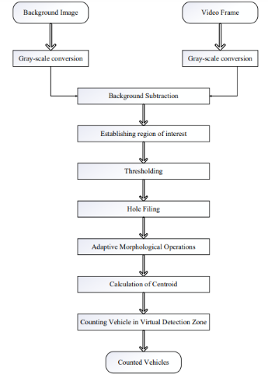
Figure 1.1 Flow Diagram

3.3 CAPTURING VIDEO USING OPENCV
As we have the video of the traffic and we first detect the vehicle and we have to count the number of vehicle passing at any traffic signal. we have used open-cv and yolov5 algorithm for the counting of the vehicle and we have the output image from various angle. Initially, when the classifier is triggered the value of counter is initialized with zero and the frame count keeps on increasing and our algorithm is classifying every single frame and detect the vehicle and in response of that counter increases. The blue line marked is the threshold line, when the vehicle crosses the threshold line vehicle counter is increased.
CNN performed well in entire picture characterization assignments, it was utilized I the field of article location, and its strong component extraction capacity was applied to more troublesome undertakings than whole number characterization. SPP-net [23] was distributed by Kaiming He et al. in 2014. The greatest improvement of the SPP-net was that the technique for spatial pyramid pooling was proposed. The superior strategy proposed an answer for the issue in which each up-and-comer locale in the R-CNN went through a CNN highlight estimation, and a critical speed up was accomplished. It likewise tackled the issue of target shape contortion as there is compelling reason need to scale the location picture to match the info size of the CNN. The pictures under test in the SPP-NET simply had to go through one CNN.
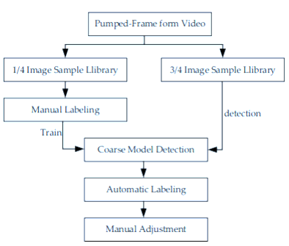
Figure 2 Processing of video Frame
The process of traffic arrival is uncertain. It produces East-West traffic with a somewhat higher probability than North-South traffic. Therefore, the optimal agent should activate green lights for E-W routes more frequently than for N-S highways. As stated previously, a green light lasts for ten seconds, whereas a yellow light only lasts for six.
4. Result And Discussion
As we have the video of the traffic and we first detect the vehicle and we have to count the number of vehicle passing at any traffic signal. we have used open-cv and yolov5 algorithm for the counting of the vehicle and we have the output image from various angle. Initially, when the classifier is triggered the value of counter is initialized with zero and the frame count keeps on increasing and our algorithm is classifying every single frame and detect the vehicle and in response of that counter increases. The blue line marked is the threshold line, when the vehicle crosses the threshold line vehicle counter is increased.
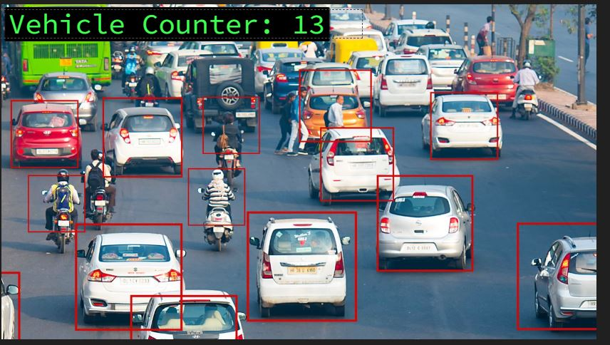
Figure 3 Going Towards Camera
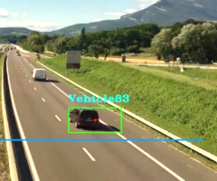
Figure 4 Going away From Camera
Vehicle examination is a supervised learning task. Model preparation requires arrangement and area data about the vehicle in the picture. As to characterization of vehicle focuses on, the common sense use of vehicle target location in thruway situations was thought of. Target vehicles were partitioned into 8 classifications as per the trouble of recognizing vehicle classes in the pictures caught by the high Camera. Information naming is a drawn-out and dull errand that should be performed physically, and this article utilized a semi-computerized naming device. Albeit manual checking and adjusting were required, it enormously diminished the intricacy of the comment task.
We have gone through different datasets which consists of different videos of various resolution and captured from different angles. The video consists of different types of vehicle such as truck, mini truck, car, SUV, TUV and Buses. Our Proposed algorithm detected the all different vehicle with more accuracy than other previous algorithm. In the below data we have compared various algorithm for different time and weather respectively. The result shows that YOLOv5 has the upper precision and advantage over other algorithm.
Model | Accuracy | Speed | Dataset Size | Complexity
U-Net | 92% | Medium | Large | Medium
Seg-Net | 88% | Medium | Large | Low
DeepLabv3+ | 94% | Low | Large | High
PSP-Net | 91% | Medium | Large | High
Mask R-CNN | 89% | Low | Large | High
Table 1 Comparison Table Of Different Algorithm
The vehicle detection module's traffic density data is used by the Signal Switching Algorithm to set the green signal timer and update other lights' red signal timers. Additionally, it cycles through the signals in accordance with the timers.
The information on the automobiles that were discovered by the discovery module, as described in the previous section, is fed into the algorithm as input. This data is presented in JSON format, with the key being the object's detection marker and the values being confidence and equals. The total number of vehicles in each class is also determined using this data, which is processed. Following this, the signal's green signal time is determined and assigned, and the red signal times of other signals are calculated.
The dereliction time for the first signal of the first cycle, as well as the times for all other signals of the first cycle and all signals of the subsequent cycles, are all set by the algorithm when it is first performed. The finding of cars for each direction is handled by a separate thread, while the timekeeping of the current signal is handled by the main thread. The discovery vestments take the shot in the direction of travel when the green light timekeeper of the present signal (or the red light timekeeper of the upcoming green signal) reaches 5 seconds.
To improve company operations, it is possible to establish the average amount of time it takes for each class of vehicle to pass a crossroad based on its location, i.e., city- or region-based.
For this, data from the various transport authorities can be dissected. The signals do not change according to the thick direction initially, but rather in cycles. This is in line with the current system, in which the signals turn green sequentially according to a predetermined pattern without requiring people to change their behaviour or cause any confusion. The signals are in the same order as in the current system, and the unheroic signals have also been taken into account. sequence of signals
Red → Green → Yellow → Red

To simulate real-world business, a simulation was created from scratch using Pygame. It helps with system imaging and comparison with a static system. It has a four-way intersection with four traffic signals. Every signal has a timer on top that displays the amount of time till it changes from green to unheroic, unheroic to red, or red to green. Alongside each light, there is a display showing how many vehicles have passed through the intersection.
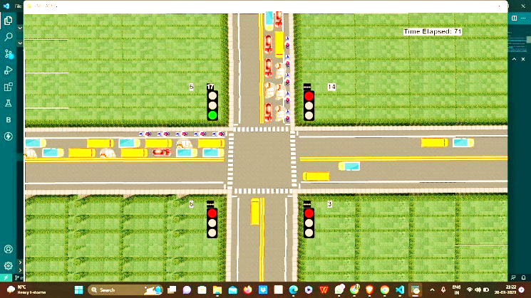
Figure 5 Simulation Model
Vehicles like buses, bikes, motorcars, exchangers, and cabs arrive from every directions. Some of the vehicles in the rightmost lane turn to cross the intersection to increase the realism of the simulation. When a vehicle is generated, its ability to turn is also set using random numbers. It also has a timer that shows how much time has passed since the simulation started.
5. Conclusion and Future
Finally, the proposed system makes sure that the direction with more traffic receives a green signal for a longer amount of time compared to the direction with less traffic by adaptively modifying the green signal time based on the traffic density at the signal. There will be less fuel use and pollution since there will be fewer unnecessary delays, less traffic, and shorter wait times.
The system performs around 23% better than the present method in terms of the number of vehicles crossing the intersection, which is a significant improvement. Using more calibration and real-world CCTV data for model training, this system can be improved to perform even better. In comparison to other well-liked intelligent traffic management systems, such as Pressure Mats and Infrared Sensors, the recommended system also has a few advantages. The system may be installed at a very minimal cost because it makes use of CCTV footage from traffic signal cameras and frequently doesn't need any new hardware because these cameras are already present at crossroads with considerable traffic.
There might not even be much alignment needed. The proposed technology can therefore be linked with the CCTV cameras in big cities to enable better traffic control.
6. References
1. Ma, Z., Cui, T., Deng, W., Jiang, F., & Zhang, L. (2021b). Adaptive Optimization of Traffic Signal Timing via Deep Reinforcement Learning. Journal of Advanced Transportation, 2021, 1–14.
2. Roshan, A. N., Gokulapriyan, B., Siddarth, C., & Kokil, P. (2021). Adaptive Traffic Control With TinyML. 2021 Sixth International Conference on Wireless Communications, Signal Processing and Networking (WiSPNET).
3. Mao, T., Mihaita, A. S., Chen, F., & Vu, H. L. (2022). Boosted Genetic Algorithm Using Machine Learning for Traffic Control Optimization. IEEE Transactions on Intelligent Transportation Systems, 23(7), 7112–7141.
4. Borges, D. F., Leite, J. P. R. R., Moreira, E. M., & Carpinteiro, O. A. S. (2021). Traffic Light Control Using Hierarchical Reinforcement Learning and Options Framework. IEEE Access, 9, 99155–99165.
5. Noaeen, M., Naik, A., Goodman, L., Crebo, J., Abrar, T., Abad, Z. S. H., Bazzan, A. L., & Far, B. (2022b). Reinforcement learning in urban network traffic signal control: A systematic literature review. Expert Systems With Applications, 199, 116830. 6. Miletic, M., Kusic, K., Greguric, M., & Ivanjko, E. (2020). State Complexity Reduction in Reinforcement Learning based Adaptive Traffic Signal Control. 2020 International Symposium ELMAR.
7. Wang, X., Ke, L., Qiao, Z., & Chai, X. (2021). Large-Scale Traffic Signal Control Using a Novel Multiagent Reinforcement Learning. IEEE Transactions on Cybernetics, 51(1), 174–187.
8. Tsai, C. W., Teng, T. C., Liao, J. T., & Chiang, M. C. (2021). An effective hybrid-heuristic algorithm for urban traffic light scheduling. Neural Computing and Applications, 33(24), 17535–17549.
9. Gandhi, M. M., Solanki, D. S., Daptardar, R. S., & Baloorkar, N. S. (2020). Smart Control of Traffic Light Using Artificial Intelligence. 2020 5th IEEE International Conference on Recent Advances and Innovations in Engineering (ICRAIE).
10. Zaatouri, K., & Ezzedine, T. (2018). A Self-Adaptive Traffic Light Control System Based on YOLO. 2018 International Conference on Internet of Things, Embedded Systems and Communications (IINTEC).
11. Zeng, J., Hu, J., & Zhang, Y. (2018). Adaptive Traffic Signal Control with Deep Recurrent Q-learning. 2018 IEEE Intelligent Vehicles Symposium (IV).
12. Kothai, G., Poovammal, E., Dhiman, G., Ramana, K., Sharma, A., AlZain, M. A., Gaba, G. S., & Masud, M. (2021). A New Hybrid Deep Learning Algorithm for Prediction of Wide Traffic Congestion in Smart Cities. Wireless Communications and Mobile Computing, 2021, 1–13.
13. Hoang, T. M., Nam, S. H., & Park, K. R. (2019). Enhanced Detection and Recognition of Road Markings Based on Adaptive Region of Interest and Deep Learning. IEEE Access, 7, 109817–109832.
14. V, M., V.R, V., & A, N. (2019). A Deep Learning RCNN Approach for Vehicle Recognition in Traffic Surveillance System. 2019 International Conference on Communication and Signal Processing (ICCSP).
15. Adu-Gyamfi, Y. O., Asare, S. K., Sharma, A., & Titus, T. (2017). Automated Vehicle Recognition with Deep Convolutional Neural Networks. Transportation Research Record: Journal of the Transportation Research Board, 2645(1), 113–122.16. Hu, C., Bai, X., Qi, L., Chen, P., Xue, G., & Mei, L. (2015). Vehicle Color Recognition With Spatial Pyramid Deep Learning. IEEE Transactions on Intelligent Transportation Systems, 16(5), 2925–2934.
17. Chen, Z., Cao, L., & Wang, Q. (2022). YOLOv5-Based Vehicle Detection Method for High-Resolution UAV Images. Mobile Information Systems, 2022, 1–11.

